INFORMATION ENGINEERING

Student: Silvia Diana Iagar
Student ID: 1805743

In the images below, the diagrams designed are meant to show how the ‘Sandwich R US’ system would work allowing them to record customer details, record any information of the catering services and events requested by the customer, record the orders places and print out customers invoices. Also, the diagram represents the supplies and ingredients purchase process in order to complete the accounting records and inventory.
The Vendor (Sandwich R Us) offers services to many Customers. For each customer there will be offers made and after the customer accepts one offer there will be a booking/order placed. Once the order has been placed the Vendor will issue an invoice for the booking.
The Vendor uses supplies and ingredients purchased from different suppliers. Once the Vendor will place a purchase order to the supplier he will received an invoice for the order made.

Entity Relationship Diagram
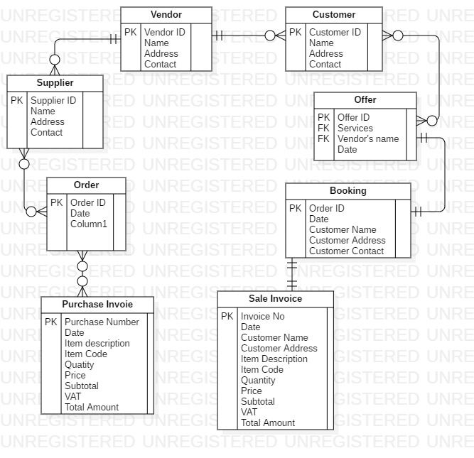

Use Case Diagram
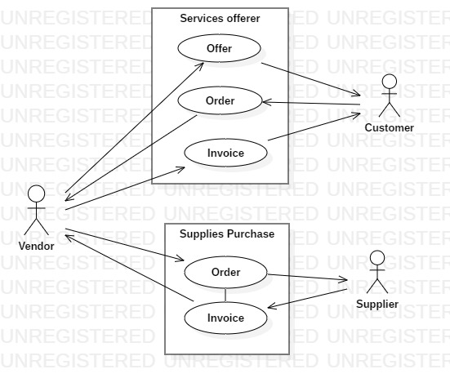

Data Flow Diagram


