Name: Laila Shaikh
Student ID: 1711576
Module Title: BMSK4001
Lecturer: Anita Naan

Introduction:
In this report I have used the Gibb’s reflective model so that I am able to put forth my experiences, ideas, views and feedbacks throughout the course in an appropriate and informative manner (Knott & Scragg, 2016).

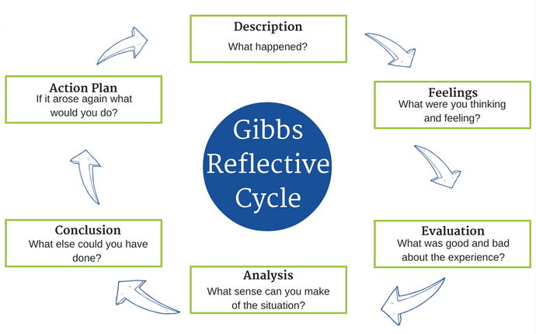
Figure 1: Source: (Knott & Scragg, 2016)

Description:
An individual can be accepted as unemployed until he is into his learning phase, once studies are done, the next step is to get employed and earn for living. As I am at the stage of completing my studies very soon, it’s now time for me to start thinking about what exactly I would be doing once my academics are over. Computers are my core area of interest. Hence, I joined a course to learn software development. These courses not only helped me with the core expertise in the subject, but also helped me with the skills that are required to help me join a business at the management level. This course has helped me with lots of academic skills required which are beneficial to successfully pursue the rest of the academic courses as well as get considered during job interviews. During the course, an assignment was given by the lecturer to the complete class to analyse and evaluate about the academic and employability skills required by us for future growth. The topic sounded very interesting, and this is when I realised that such evaluation would help me understand the skills that I already possess as well as need to develop to make sure that I can achieve my dream of becoming a software manager in future. In order to proceed with this reflective essay assignment, the first and the foremost thing I had to do was to analyse and brief all the skills and strategies that were learnt during the classes, this assignment also helped me to take responsibility of my own learning, as well as enhanced the employability skills like presentation skills, time management, reflection and so on.

Feelings:
As I started exploring with the assignment given, the most important thing that I came across is that employers look for certain specific and mandate skills in all the candidates which are – appropriate communication, work stability, leadership, research and planning, handling human relations and so on. Though these skills are important, still a manager has to be equipped with many other skills which are effective decision-making skills, analytical thinking, management skills, time management, presentation skills and many more. During my study research, I understood the fact that an effective manager is an individual who is responsible towards the development of an organisation as a whole. Appropriate plan initiations, and implementations is done by the manager, hence, making others work according to our commands, demands the manager to be a good conversationalist. This skill helps him to motivate and direct his subordinate teams towards achievement of the goals and aims determined by the higher authorities of the business. Being good in communication not only means to be able to get things done, on the other hand, good communication is also necessary to sustain in the competitive environment of the organisation where he would need to fight for the evidence and justification for his own ideas and views. Being an introvert by nature, I lack behind in this quality of good communication capability. Thus, this study has helped me in evaluating this drawback of my skills which needs serious and urgent consideration. Sound communication (verbally and written) is one of the most important and essential skill that any manager should possess in order to carry out his daily activities more efficiently and effectively. Communication includes many other factors like motivating skills, negotiating skills, interviewing skills, handling nonverbal communications and so on. This is the point where I seriously understood that my communication skills need a lot of practice and efforts of development. Making changes to my present routine and habits and converting my lifestyle into a disciplined and up-to-date format would help me develop the managerial qualities slowly and steadily. At this point I realised that famous names like Bill Gates, Steve Jobs, Mark Zuckerberg, have not evolved overnight. Lots and lots of hard work, dedication, sacrifices, compromises and above all readiness to grasp knowledge as and when available on daily basis is what made these names stand where they are positioned today. I feel blessed and thankful that our university and lectures are available to help us with the correct direction towards achieving our goals of life. We are taught many managerial skills in the academic courses which are as below;

Time Management: The capability to manage time appropriately is essential to both the students as well as the managers of business. Students like me are always surrounded with lots of assignments, courses, and other academic submissions which are to be delivered on time. Hence, our lecturers help me with scheduling my work and cultivating a habit of timely deliverance from the learning stage itself (Tracy, 2014). Hence, this habit of meeting the deadlines helps me to meet the cooperative deadlines in the business world. Managing lots of activities in the same time and still delivering effective and efficient outcomes helps me in my academics and the managers in their business activities.

Presentation skills: My lecturer Anita Naan helped me in developing the skills of presentation by assigning me to prepare presentations on academic topics and then demonstrate it in front of the class. These practices help me to gain confidence and experience of public speech. This skill is essential for a manager who is responsible towards implementation of new ideas in the business, motivation of the concerned team, allocation of work and many more. Sound presentation skills would help the manager to put forth his ideas effectively in front of his team and higher authorities.

Leadership: It is not always necessary that a good communicator becomes a successful leader; however, a successful leader is always a good communicator as well. I lack the skill of efficient communication; still I am confident that once I overcome my hesitation of free communication and develop sound communication skills, I would be able to clear my way towards being and efficient leader and manager for my concerned team. The qualities of a sound leader are inbuilt which cannot be taught by any academics or other courses (Pich & Messenger, 2017). Thus, practice and lots of learning is the only way for me to develop this skill more efficiently.
In addition to the above mentioned, the other skills required by a sound and efficient manager are – problem solving capabilities, decision making skills, analysis of primary and secondary resources, critical thinking and many more.

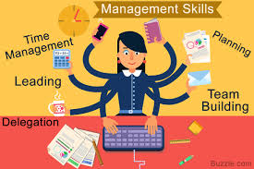
Figure 2: Source: (Abbajay, 2018)

Evaluation:
As I moved on further with the assignment, I realised that in order to make a complete and thorough list of the activities that I need to learn and develop within myself in order to achieve my set goals, it’s very essential for me to understand my own strengths, opportunities, weaknesses and threats. Thus, I decided to run a SWOT analysis on myself and evaluate more about my skills and capabilities. The below mentioned are the strengths and weaknesses as well as the threats and opportunities I found out for myself (Manktelow & Birkinshaw, 2018).

Strengths: My biggest strength in the deep technical knowledge about computers and the field that I want to master in future. In addition to this, my capability of handling my studies, lectures, classes, tuitions and still submitting my assignments on time demonstrate that I have a good time management capability. I realised that when working in a group, I am able to decide on the critical factors without anyone’s help, hence, the capability of decision making can also be added on to my strengths.

Weaknesses: Sound communication incapability is one of my weakest sections. In addition to this the fact that I have no work experience in the field I am looking forward to master in future. Though this weakness can be eliminated by joining a part time job, still handling job and studies at the same time can be a challenging task for me.

Opportunities: As we are asked to work in groups during our academic assignments, the managerial skills of team work, on-time deliverance, target settings, and so on are developed within us with the help of the academic courses. In addition to this, as mentioned above, if I opt to join a part time job in the field of management, this would help me with an experience certificate at the end of the year. Thus, my capability of being a successful employee increases as compared to other subordinate students.

Threats: Job scarcity is always a threat for freshmen’s. Big organisations always look for experienced candidates who are capable enough to handle their daily work efficiently. Thus, students who wish to do part time jobs in their preferred field do not get the chance to enhance their practical knowledge.

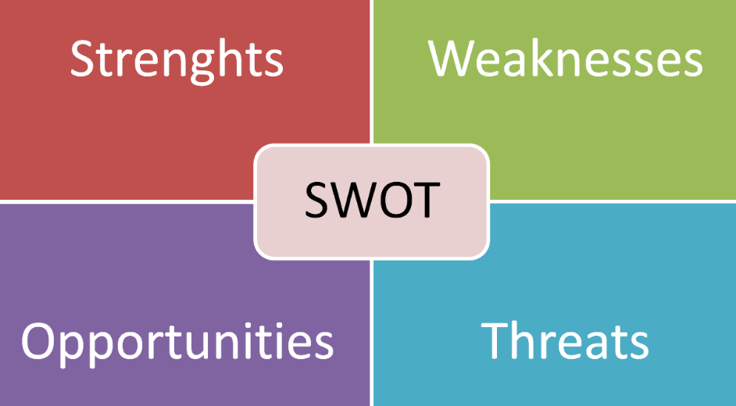
Figure 3: Source: (Manktelow & Birkinshaw, 2018)

The positive aspect of this study is that I was able to evaluate about strengths and weaknesses. Thus, this SWOT analysis would help me give appropriate direction to my studies and efforts. However, on the other hand, the negative aspect is that the scarcity of jobs combined with my poor communication skills, can hinder my opportunities of working with an organisation of my preferred field.

Analysis:
As the study progresses for this assignment, I realised that the literature theories and academic courses are very helpful in developing skills that are essential for students like me who aspire to be successful managers in future. This assignment has helped me deeply in evaluating my capabilities, qualities and skills. The SWOT analysis undertaken on my capabilities and weaknesses has helped me understand the areas that need immediate action and consideration. Though threats are something that I cannot work on personally, still working hard on developing my communication skills can reduce my threat of getting a job easily. I think that my decision of doing a part time job in a software developing organisation would be beneficial for me to enhance my knowledge practically. When I started with the assignment, I was only aware of the theoretical knowledge about the skills and capabilities required to be employed, however, this assignment has helped me apply those skills and qualities on myself and help me determine my position as an employable candidate. This study has helped me understand that the skills of a student as well as a manager are almost the same.

Action Plan:
Presently, my action plans include working hard towards my communication skills. This assignment has definitely acted as a kick start for my career path. Now I know what efforts are to be taken and to which direction. Learning is a never-ending task, hence, I have understood that a successful manager, first needs to be a successful learner, hence, taking up my further studies seriously and paying attention to each and every theories taught in the lectures in my aim and goal until I become efficient in the skills that are identified above to become a successful and efficient manager. I understand that my actions plan should include lots of practice, revision and above all dedication towards achieving my set career choice.

Conclusion:
At the end of the assignment, now I am pretty aware of my own strengths and weaknesses. As my chosen faculty is computers, I should immediately start with searching jobs that are related to this field. However, if in case I am not able to get a job in the same field, I can always opt to get experience from any available domain. Keeping my options open would help me with more opportunities and thus increase my chance to develop my skills more professionally under experienced managers. Before writing this essay I was a little afraid because I’ve never did anything like this before, my lecturer Anita Naan has helped so much by clarifying every detail thoroughly step by step to help me gain a better understanding on reflection, as well as helping me with structuring my work as I was having difficulty doing this too. Anita also helped me gain a better perception on qualitative and quantitative methods. Now I am able to apply the knowledge gained from this course and Anita to my own personal experience.

References:

Abbajay, M. (2018). Managing Up: How to Move up, Win at Work, and Succeed with Any Type of Boss. New Jersey: John Wiley & Sons.
Knott, C., & Scragg, T. (2016). Reflective Practice in Social Work (4 ed.). Exeter: Learning Matters.
Manktelow, J., & Birkinshaw, J. (2018). Mind Tools for Managers: 100 Ways to be a Better Boss. New Jersey: John Wiley & Sons.
Pich, D., & Messenger, A. (2017). Leadership Matters: 7 Skills of Very Successful Leaders. Brighton VIC: Major Street Publishing.
Tracy, B. (2014). Time Management (The Brian Tracy Success Library) (reprint ed.). New York: AMACOM.

