Intercultural Competence Report
Student Name: Constantin-Adrian Vasiliu
Student Nr.: 2229175
Module Name: Foreign Languages & Cultural Awareness
Module Code: BMIH5003
Lecturer’s Name: Heidi Prosser

Executive Summary

This research examines the basic differences between England and Morocco, inspecting leadership styles based on the findings of the GLOBE Project. The document outlines strategies to address potential difficulties in managing a multicultural workforce and provides suggestions for the London branch of the Inclusivity Hotel & Spa to facilitate the smooth transition of Moroccan team members who will be joining in April 2024.

Table of Contents
- Introduction
- Cultural Differences: England vs. Morocco
- Globe project Analysis: Leadership Styles
- Potential Challenges of Intercultural Leadership
- Conclusion
- Recommendation for Overcoming Challenges

Introduction

This study presents the results of an initial visit to the Moroccan branch of the Inclusivity Hotel & Spa, with a specific focus on differences in culture and the implications for the integration of Moroccan staff members into the London branch, commencing in April 2024. It uses the knowledge gained from the GLOBE Project's research on leadership styles in different cultures and suggests strategies for achieving effective intercultural leadership.

2. Culture Overview
This section will provide an in-depth analysis of the significant cultural distinctions between England and Morocco, covering:
Comparison between Individualism and Collectivism
England (Characterised by individualism):
Primary focuses: Individual objectives, accomplishment, self-reliance.
Teamwork is perceived as a method to achieve a shared objective, but still recognising the importance of individual contributions.
Decision-making: Typically autonomous, prioritising effectiveness and personal accountability.
Morocco (Collectivist):
Primary concerns: Maintaining unity among a group, maintaining strong familial bonds, and preserving interpersonal relationships.
Teamwork is perceived as a cooperative effort that emphasises achieving success as a group and supporting one another.
Decision-making usually involves seeking input and achieving consensus, to foster agreement and inclusion.

3. Globe’s Insights:

The GLOBE Project provides useful insights into leadership styles across many cultures. Notable differences that apply to our specific situation include:
Assertiveness: English leaders typically exhibit a higher degree of assertiveness, whilst Moroccan leaders tend to lean towards a more consultative approach.
Performance Orientation: Both cultures encourage performance, although England may place a higher value on individual accomplishments, whilst Morocco may prioritise collective success.
Power Distance: Morocco is likely to exhibit a higher power distance, where there is an expectation for clear leadership signals and a respect for hierarchy.
Uncertainty Avoidance: England exhibits an appetite for accepting risk, whilst Morocco tends to prioritise adherence to established methods.
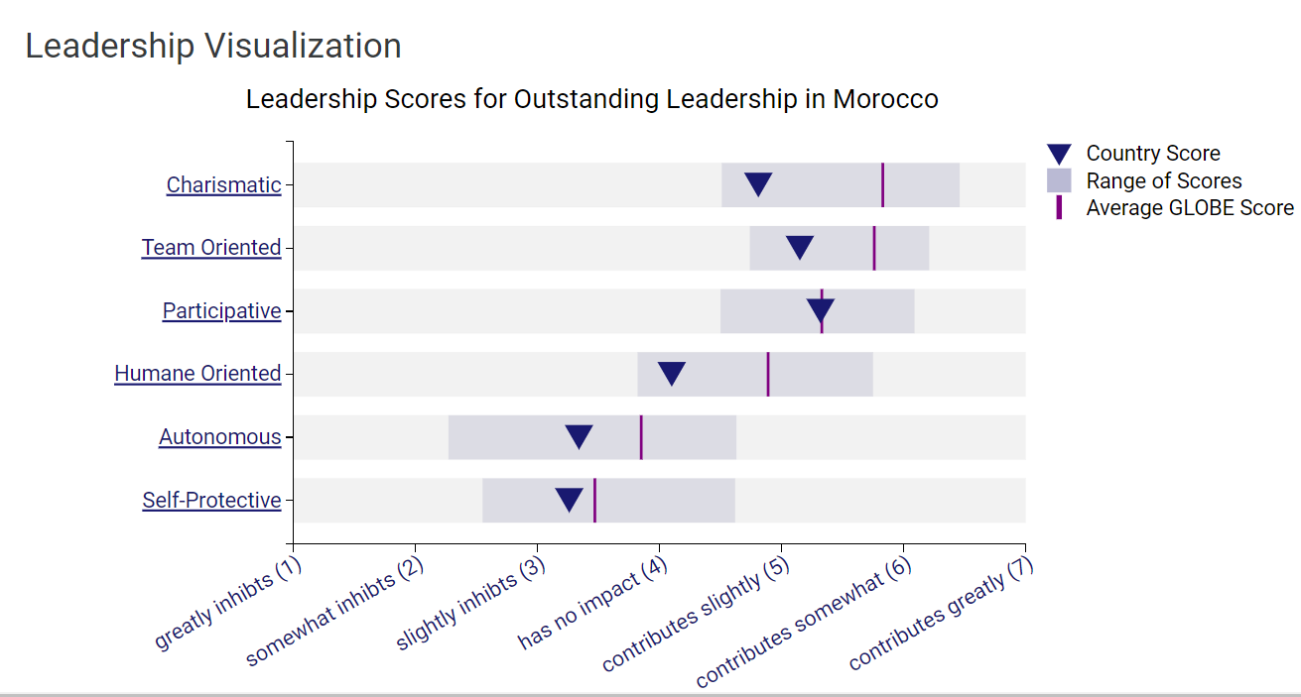
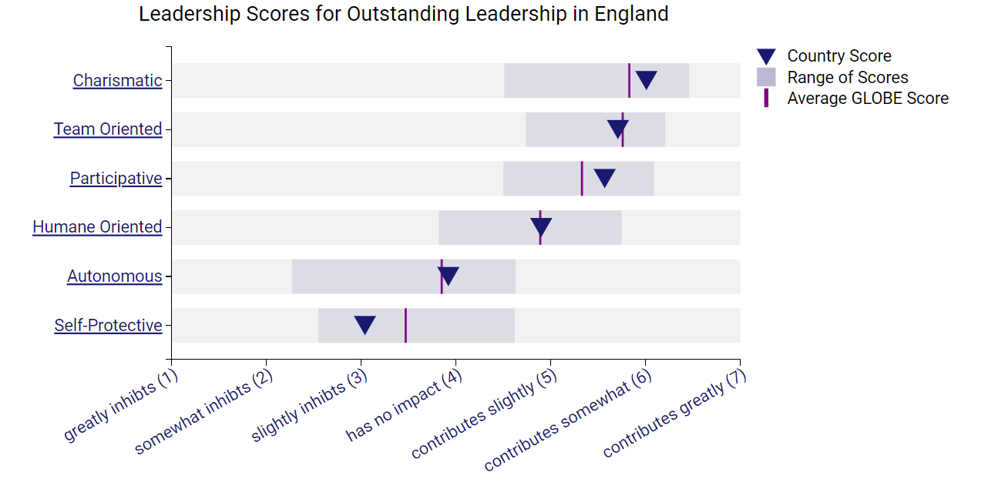

4. Potential Challenges
The integration of teams from multiple cultures has specific challenges:
Communication: Varied communication methods can result in misinterpretations and exasperation. English messages delivered in a straightforward manner may be perceived as harsh in Morocco, whilst Moroccan replies expressed indirectly may seem confused in England.
Decision-making: Varied approaches to decision-making might lead to delay or hostility. The inclination towards individualistic decision-making in England may conflict with Morocco's tendency for consultation.
Time management: Conflicting perspectives on time and punctuality can lead to tension. The rigidity of English scheduling may clash with the adaptability of the Moroccan approach.
Leadership Expectations: Discrepancies in power distance and assertiveness can result in confusion or disappointment. English leaders may be viewed as excessively authoritative, whilst Moroccan leaders may be seen as less powerful.

5. Conclusion
The process of incorporating the Moroccan crew into the London branch of the Inclusivity Hotel & Spa entails stimulating challenges and significant potential. By recognizing and accepting cultural differences, utilizing the knowledge provided by the GLOBE Project, and putting into practice the suggested tactics, the hotel can not only overcome initial obstacles but also achieve a higher degree of achievement.
Creating a harmonious and productive team goes beyond just overcoming obstacles. The aim is to utilise the potential of diversity to generate an exceptional and fulfilling experience for both customers and employees. Imagine the London branch evolving into a little representation of worldwide hospitality, where visitors from diverse regions feel appreciated and included, and where Moroccan and English staff cooperate effortlessly, acquiring knowledge from and enhancing each other's encounters.

6. Recommendations
- Cultural Sensitivity Training
Objective: Create targeted training modules that focus on essential cultural distinctions between England and Morocco, including communication patterns, societal rules, core principles, and expected behaviours.
Delivery: Provide interactive workshops, simulations, and role-playing activities to facilitate active learning and cultivate empathy. Consider the utilisation of online modules to enhance flexibility. ( Pruegger et al. 1994 )
Evaluation: Perform post-training assessments to gauge acquired knowledge and modify future programmes according to feedback.

- Collaborative Leadership
Training: Provide leaders with expertise in active listening, facilitating group discussions, and encouraging consensus while cultivating a decisive decision-making atmosphere (Okumus, 2020.).
Communication: Call for leaders to embrace a versatile communication approach that adjusts to the specific audience, employing lucidity, straightforwardness, and consideration for both explicit and implicit communication styles.
Shared decision-making: Utilise hybrid decision-making methods that integrate individual accountability with team collaboration, capitalizing on individual capabilities while maintaining inclusiveness.

- Flexible Adaptation
Communication: Set explicit protocols for communication manners, including the use of full names when addressing one another, adhering to designated response timeframes, and employing inclusive language.
Decision-making: Employ a hierarchical strategy in which minor decisions are taken autonomously, but significant ones entail collaborative team deliberations and consensus formation.
Time management: Incorporate adaptable scheduling alternatives such as establishing a set period of working hours with variable start and finish periods to satisfy diverse timekeeping preferences.

- Team Building Activities
Activities: Coordinate intercultural team-building exercises that foster cooperation, comprehension, and admiration for different points of view. Examples of instances include cultural gastronomic festivals, language exchange initiatives, or collaborative community service endeavours.
Social events facilitate casual interactions outside of work, enabling team members to engage in a relaxed setting and establish personal relationships.
Embracing diversity: Commemorate cultural holidays and major events from both cultures, fostering awareness and fostering a sense of inclusiveness.

- Mentorship Program
Matching: Create pairs between experienced staff members from both cultures and fresh recruits to offer mentorship, assistance, and cultural familiarisation.
Training: Educate mentors with proficiency in multicultural communication, adeptness in delivering constructive feedback, and expertise in resolving conflicts.
Conduct periodic meetings: Organise regular meetings between mentors and mentees to address difficulties, developments, and cultural adaptations.

References
Globeproject.com. (2020). Morocco Results - GLOBE Project. [online] Available at: https://globeproject.com/results/countries/MAR%3Fmenu=list.html#list.
Globeproject.com. (2020). Results - England GLOBE Project. [online] Available at: https://globeproject.com/results/countries/GBR%3Fmenu=list.html#list.
Pruegger, V.J. and Rogers, T.B., 1994. Cross-cultural sensitivity training: Methods and assessment. International Journal of Intercultural Relations, 18(3), pp.369-387.
Gong, Y., 2008. Managing cultural diversity in hospitality industry.
Mohsin, A., 2006, May. Cross-cultural sensitivities in hospitality: A matter of conflict or understanding. In Proceedings of International Conference on Excellence in the Home: Balanced Diet-Balanced Life, Royal Garden Hotel, Kensington, UK.
Molintas, D.H., Busser, J.A., Self, T.T. and Ghosh, A., 2023. Collaborative learning in hospitality education: A process-orientation case study. Journal of Hospitality & Tourism Education, 35(4), pp.289-301.
Okumus, F., 2020. Leadership research in hospitality and tourism. International Journal of Contemporary Hospitality Management, 32(6), pp.2029-2034.
Crisp, R.J. and Turner, R.N., 2011. Cognitive adaptation to the experience of social and cultural diversity. Psychological bulletin, 137(2), p.242.
Fapohunda, T.M., 2013. Towards effective team building in the workplace. International journal of education and research, 1(4), pp.1-12.
Harris, R., 2017. Embracing DIVERSITY for a healthy workplace. Journal of the Australian-Traditional Medicine Society, 23(1), p.28.
Sandvik, J., Saouma, R., Seegert, N. and Stanton, C.T., 2021. Treatment and selection effects of formal workplace mentorship programs (No. w29148). National Bureau of Economic Research.
Bjursell, C. and Sädbom, R.F., 2017. Mentorship programs for workplace inclusion and learning. Adult Education for Inclusion and Diversity, p.28.
‌

‌

