Week 2: The Environment – Strategic analysis of the external environment
Starting with a pause for thought:
- Why is it important for an organisation to understand its operating environment?
It has been suggested by Reeves and Deimler (2011) that ‘in a world of constant change, the spoils go to the nimble,’ there is no doubt that organisations looking for survival in uncertain times cannot afford to ignore the business environment in which they operate and the ever-growing need to be more flexible and adaptable in their approach to strategy. ‘Traditional approaches to strategy – though often seen as the answer to change and uncertainty - actually assume a relatively stable and predictable world,’ (Reeves and Deimler (2011). In the current unpredictable, changing business environment organisations question their ability to pick up the right signals to understand and bring about strategic changes.
Starting with the external environment managers need to be tuned into signals of change, quick to respond and where necessary reshape not only the information landscape of the industry in which they operate but from an internal perspective, the organisation itself in order to sustain competitive advantage in a continually changing landscape. For example, Tesco continually undertakes in-depth analyses of the purchase patterns of its 13 million members of its loyalty programme, enabling the organisation to customise its offerings for each store as well as customer segment as well as providing early warning of shifts in customer behaviour, (Reeves and Deimler. 2011).
Analysing and anticipating environmental change as well as if possible influencing such change is important for organisations in sustaining competitive advantage, managers need to appreciate the broad environmental factors that impact the organisation i.e. PESTEL framework of analysis to identify the key drivers of change. In addition organisations needs to have a thorough understanding of the industry itself and the key operators (competitors) within that industry which might be analysed by using the Five Forces Framework.
………. Another pause for thought:
- Consider your own organisation, what are the key environmental influences which are likely to be the ‘key drivers for change’ during the next 5 years?
Without a clear understanding of the key drivers for change, you will not be able to make effective decisions in response to a change(s). Building on the PESTEL framework, you might be able to reveal key issues that might impact your organisation making you aware of what might happen in the future and start you thinking of developing scenarios that might help safeguard your organisation’s position in the marketplace.
To thoroughly appreciate the industry and its operators then the strategic manager needs to go beyond the industry competitors to also consider other competitive forces, for example, customers, suppliers, potential entrants to the marketplace as well as substitute products. According to Porter (2008) this is really what defines the structure of an industry and also ‘shapes the nature of competitive interaction within an industry.’ Therefore it is Porter’s five forces framework which ‘helps identify the attractiveness of an industry in terms of five competitive forces@ the threat of entry, the threat of substitutes, the power of buyers, the power of suppliers and the extent of rivalry between competitors,’ (Johnson et al, 2011). Porter suggests that an attractive industry structure provides market players with potential for good profitability, too much competitive pressure does not provide good returns and therefore unattractive to be part of. For example, industries like airlines, textiles and hotels are unattractive as the forces are intense, on the other hand, industries like software, soft drinks and toiletries are very profitable for many organisations, (Porter, 2008). In his article entitled ‘The Five Forces that Shape Industry’ Porter proposes that a healthy industry structure should be as much a competitive concern to strategists within an organisation as the company’s own position within the marketplace. Therefore obtaining a thorough understanding of industry structure is also essential in bringing about effective strategic positioning.
In utilising the five forces framework to glean understanding of the key players within the marketplace, it can also help to broadly identify the type of industry structure which facilitates comparison of attractiveness of the industries and competitive behaviour within them. (Johnson et al, 2011). The four main industry types as suggested by Johnson et al are as follows:
- Monopolistic: ‘a monopoly is formally an industry with just one firm and therefore no competitive rivalry,’ – potentially organisations have great power over buyers and suppliers.
- Oligopolistic: ‘an oligopoly is where just a few firms dominate an industry, with the potential for limited rivalry and great power over buyers and suppliers,’ – can be very profitable depending on the behaviour of rivals within the market, although organisations in this type of industry work hard to minimise rivalry between each other, maintaining common front against buyers and suppliers.
- Hypercompetitive: ‘occurring where frequency, boldness and aggression of competitor interactions accelerate to create a condition of constant disequilibrium and change,’ with many strong challengers in the global mobile phone industry eg Apple iPhone and Google’s Nexus One.
- Perfect competition: this ‘exists where barriers to entry are low, there are many equal rivals each with very similar products, and information about competitors is freely available,’ competition is geared on price, difficult to achieve high profitability.
Still focusing on the five forces framework, it is therefore important that managers within organisations are aware of the implication of these forces for competitive strategic planning. Undertaking such analysis and gleaning in-depth understanding of the industry will help inform decision-making, for example, identification of which industries are attractive enough to enter or leave; what influence can be exerted in order to reduce rivalry; how competitors are affected differently, particularly smaller players in a market where buyers have increasing buyer power.

At this point you might here consider the industry life cycle:
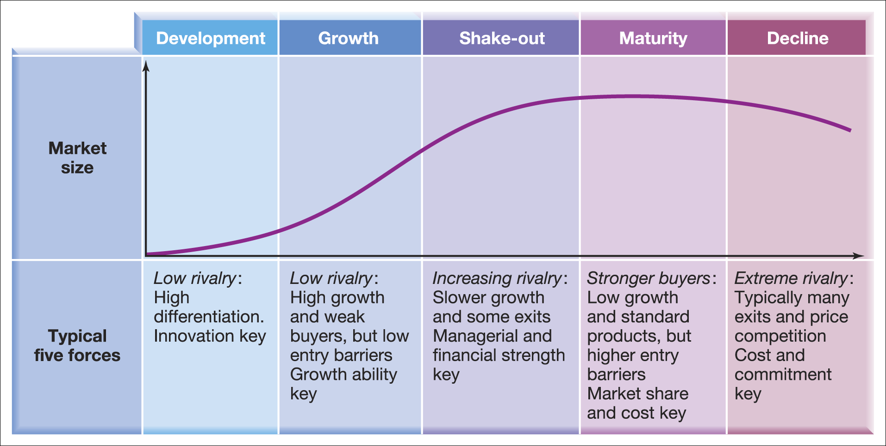
(Source: Johnson et al, 2011)

The power of the five forces varies with the stages in the industry’s life cycle, in further considering this concept, in their development stage industries start small, going through a period of rapid growth culminating in a levelling out or a shake-out period.

A similar principle to the Product Life Cycle which you will have come across in Marketing, the development stage is somewhat experimental with few players, rivals of each other but yet differentiated. The five forces are likely to be weak but become stronger as the growth rate starts to decline and increased rivalry forces the weakest of new entrants out of business. Typically successful organisations will seek to avoid the maturity stage by continually reshaping their own strategies as well as the industry in which they operate in order to sustain their competitive advantage.

Some of the above concepts and theories will now be considered in practical application and deployment within your own organisations and those familiar to you. However before proceeding you are recommended to at least read Johnson, Whittington and Sholes Ch. 3 as well as the articles below which are available on Moodle.

Further reading:

Kim W.C. and Mauborgne R. (2009); How Strategy Shapes Structure, Harvard Business Review
Porter M.E. (2008); The Five Competitive Forces that Shape Strategy Harvard Business Review (January)
Ghemawat P (2010) Finding your Strategy in the New Landscape Harvard Business Review (March)

Fu

iaogoaiboabgoai8ugaaThe

