Examine your own employment goals and possible routes for advancement/progression in your own chosen health career. Then link these roles and job description to your own skills and training in order to assess your own suitability

Section One
Own employment goals
My principal goal is to become a qualified General Nurse (GN), so that I will be able to work in hospitals, in particular, hospital and primary care clinics. This is because I have a strong desire to be able to provide direct patient care, which beckons an ability to bath and dress patients up, and also administer medications prescribed by doctors, including collection of fluid samples. Also, I want to work with physicians, thus, assist them to examine patients, manage electronic medical records, and educating patients about healthy lifestyles, including, medications and treatments. This would allow me to provide primary, acute, and specialty healthcare services to the wider diverse population.
Possible Routes for Progression
Upon securing fulltime employment, I will seek some advanced clinical training. I know that equipped with this kind of training, I will be legally authorised to diagnose illnesses, treat or enlist more advanced experts to treat conditions, all this I will achieve through an evidence-based health education patients. For it is critical that General Nurses should embark on continuing education as a means of keeping abreast of technological, methodological, and other developments in their profession. What is key to note is that nurses serve a wide sector, from healthcare providers to patients (Brown, et al, 2009). These includes counsellors, mentors, educators, consultants and researchers (Brown, et al, 2009).
With such a strong training, I know, I will be legally allowed assess patients by scanning through some medical histories, also, perform some physical evaluations, and order diagnostic tests (NHS, 2018). Under the Under UK law, only "appropriate practitioners" are legally allowed to prescribe medicine. In this context, a prescriber is defined as a healthcare professional who can write a prescriptions (NHS, 2018).
I will have knowledge and know how to pay more attention to the unique risk factors and needs of individual patients and their families and develop individualised treatment plans, follow up on courses of treatment, collaborate with other healthcare professionals, and maintain detailed records.
Section Two
Mentoring and Coaching in Health (or Health and Social Care): Background and origin
Mentor, as a word derives from the poem by Homer ‘‘The Odyssey.’’ The story was that when Odysseus decide to explore the world, he left home, little did he know that travelling may mean encountering distant wars. But Odysseus entrusted his son to his dependable and faithful advisor, whose name was “Mentor”. Consequently, “Mentor” acted the duties of a guide, tutor, teacher and dad to Telemachus, Odysseus’ son (Fox, Rothrock, & Skelton, 1992). Hence, the word mentor is used in expressing the role that means master, supporter, friend, guide, teacher, parent, coach, and confidant (Fox, et al, 1992). Nolinske (1995) argues that in the nursing profession, mentoring is a process of teaching and learning that occurs upon a long period of reciprocal and persona relationships between two nurses who are in different levels. These usually should differ personalities, age and credentials.
West-Burnham (2013) has argued that mentoring and coaching are probably the most known 'natural' way of building learning relationships. Foster-Turner (2006) points out that mentoring has long been a fundamental tool for helping people to achieve their required competencies both at pre-qualifying and post qualifying levels. These have included informal and formal mentoring as a means of supporting people’s continuing professional development (CPD).
Sparrow (2008) points out that experts and academics are currently delving into the classical and British origins of coaching and mentoring to help discover some new models to suit the complexities of modern organisations such as the National Health Service (NHS).
Sparrow (2008) notes that in the past 40 years, the sports coaching and mentoring model has been a dominant model. This is probably due to the fact that there has been early recognition that sporting needs coaching and mentoring for someone to prevail. Sparrow (2008) suggests that one contributing factor to sports model dominance is the fact that coaching writers and thinkers have repeatedly cited Harvard tennis captain-turned-guru Timothy Gallwey for his series of publications, for instance one that talks mostly about coaching and mentoring is The Inner Game. This has been hailed as representing a modern definition and application of coaching and mentoring.
Clutterbuck (2018) observes that the health sector has a long history of involvement with mentoring. The first supported mentoring programmes in Europe took place in the UK’s National Health Service (NHS) and were aimed at supporting the integration and retention of young graduate recruits. The NHS and the Health sector continue to pioneer good practice.
Foster-Turner observe that in recent years there has been an emphasis of mentoring and coaching in health and social care organisations such as the NHS. These have been encouraged by the new government policies especially in the UK which foresees the potential positive relationship between learning and the ability for public sector to meet its goals. This is precisely due to the commitment to enhance skills of the health and care services staff members by some kind of formal learning opportunities. For Foster-Turner (2006) this focuses not only in the context of direct caring relationships, but also the overall development and delivery of services in a safe, effective and integrated way.
For Foster-Turner (2006), is effective for assisting people develop their new roles such as nurse and other healthcare staff. Foster-Turner also observes that the NHS Skills escalator and Knowledge and Skills Framework emphasises some more structured coaching and mentoring support. However, there is a concern that coaching and mentoring have not been fully recognised in health and social care sector. This explains why the NHS Skills escalator and Knowledge and Skills Framework have been used to try and ensure the application and the correct use of coaching and mentoring approach (Andrews, 2015).
In regard to the Health and Social Care environment Foster-Turner (2006), identifies a number of NHS publications that examine the value of coaching and mentoring as a framework for enhancing organisational learning and life-long learning for workers. Hence, the approach is imperative in constructing system that have the capacity to meet the organisations’ goals. Foster-Turner (2006), highlights the view that while mentoring has been utilised in the Health and Social Care environments for a long time now, the work-based skills, have been realised through the introduction of the NHS ‘Skills Escalator’ (2001) and the NHS ‘Knowledge and Skills Framework’ (2004). These have precisely examined called for a structured development and performance-focused support. In turn, this has made coaching and mentoring some requisite and key skills within the NHS.
Moreover, it is also noted by Foster-Turner (2006), that, in the NHS Health and Social Care environment, coaching and mentoring have been mainly used with senior management and with specific management courses. However, this has shown a gap and desire for coaching and mentoring of people who are in the middle management level. Foster-Turner (2006) suggests that this unmet need may be a reflection of organisations’ common beliefs about what coaching and mentoring actually is.
Moreover, there is growing recognition of the relationship between the quality of the learning experience and professional competency development, professional bodies such ad in nursing have now located the need to ensure people who enable learning to happen, in educational facilities and in practice are highly trained. For instance, the Nursing and Midwifery Council; has put down some detailed and specific standards and learning outcomes of nursing and midwifery teachers development. The greater emphasis in this kind of teaching is on the role of teaching within the practice setting, alongside detailed advisory standards for mentor and mentorship, preceptors and preceptorship.
Clip Model: Research, Successes and Issue
Researchers into mentoring and coaching trace, for instance, Thorndyke, et al (2008) observe that in recent years, the concept of coaching and mentoring has developed from strength to strength. They note that coaching and mentoring has been developing from developmental theory, sport, psychotherapy, counselling, positive psychology, now nursing profession.
Thorndyke, et al (2008) notes that in the nursing profession, coaching and mentoring are now perceived as critical in hospitals for the newly qualified including in performance management and CPD. For newly student and qualified nurses coaching and mentoring are seen as crucial to development.
However, Vidal‐Salazar, M.D., et al. (2012) notes that most research studies on coaching and mentoring is currently being conducted in the domains of nursing and medicine, not only in the UK but in North America as well. Vidal‐Salazar, M.D., et al. (2012) point out that there are a number of studies that have been put out on coaching and mentoring in the last 14 years. There has been a lot of interest in developing advanced techniques of peer-coaching in the healthcare systems and student education. This has been also supported by the view that governments have been behind continuing clinical education of healthcare professionals.
Success
Stewart & Krueger (1996) argues that almost all nursing professionals who have multiple mentor experience model where mentees have experienced mentoring recognise its value and choose to access to several experienced, supportive persons. This mentor others (Stewart & Krueger, 1996). Many, if not multiple mentor experience model was similar to Hollormost, nursing leaders believe their careers benefited from description of the primary versus secondary mentors who took an interest in them.
Schwellnus & Carnahan (2014) point out that coaching and mentoring have been utilised within the education field to successfully transfer a high percentage of knowledge into practice. Furthermore, Schwellnus & Carnahan (2014) also states that, recently, in healthcare, coaching and mentoring has been applied and implemented as a method of both student training and staff CPD as well as a means of formatting knowledge translation.
Perhaps, there has been challenges to determine success from failure, for instance, identifying what has worked is a complex process as because most mentoring relationships are informal. This suggests that they usually last for a long time and are usually implicit, thus, those involved may be engaged in an informal mentoring relationship without explicitly stating it (Foster-Turner, 2006). However, Foster-Turner, (2006) also notes that evidence indicate the need to provide similar techniques and processes to make a mentoring relationship more effective. For Foster-Turner, (2006), the most essential elements that must be included in a mentoring relationship includes creating a relationship between the mentee and mentor that is punctuated by empathy, respect, trust and confidentiality. Overall, this must be accompanied by the sharing of knowledge and experience. This may imply establishing clear professional development needs and a relationship which facilitates exploration of related goals and ambitions. Furthermore, Foster-Turner, (2006) calls for the need for effective communication skills, in particular with the mentor. This should also mean that the mentor needs to have an ability to actively listen, as this could boost and aid support of mentee. Moreover, the mentor also needs to ensure that they also challenge and question the mentee whenever an opportunity to do so arises.
Wallen et al (2010) also observe that evidence base points to a number of issues that must be considered in developing not only an effective, but also a fit for purpose mentoring agenda. Wallen et al (2010) argues that gender is a factor, that research has stated that male mentors maybe more beneficial for female mentees who work in male dominated sectors and vice versa. Similarly, Wallen et al (2010) argues that mentoring someone who represents a “minority” maybe beneficial in trying to speed up their comprehension of prevailing cultural norms and expected conduct and behaviour. Stewart & Krueger (1996) argue that it is vital that the mentee develops respect for the mentor for effective mentor-relationships. This could create some ongoing, open and honest and effective communication between the mentor and the mentee. Stewart & Krueger (1996) conclude that a successful coaching and mentoring can prevail when a perceived supportiveness of the mentor is brought about. This will imply that an effective mentor, is one who seeks to nurture, care and affirm the mentee (Wang, & Odell, 2002).
Clip Model: Describe your own experience
My personal experience with a CLiP model was when I went for placement as a healthcare assistant at London hospital and was assigned a junior manager to mentor me. My job description involved observing, monitoring and recording patients' conditions by taking temperatures, pulse, respirations and weight. I also had to communicate with patients, carers and relatives. Also I had to assist with clinical duties, personal care, infection control and prevention, food, personal hygiene and overall reassurance, comfort and safety. Moreover, the work experience, was a little bit unfair to students as a student with little knowledge, basically, learning on the job, I was also expected to do most of the jobs that is often done by qualified and permanent members of staff.
Nevertheless, I took this “unfair” scenario to sharpen my clinical and professional skills as I was carrying out all my duties from the instructions of my mentor. On my first day at work, I had my first meeting with my mentor, who told gave me the hospital and NHS vision statement. He was male and his overall message was that we need to provide an excellent care delivery to patients. He said there were concerns from patients that that there was no enough staff available to talk to, or get help from. This made me prepare myself for an extra burden in terms of workload. My mentor also stated that statistics show that patients were waiting for more than five mins for a response to the call bell. He then informed me that to redress the situation a CLiP project has been enlisted to help to address this issue. In other words the Clip project was designed to reduce incidence of patients complaining of neglect, delay and lack of information. I was told that I will be part of the four students who will be provide the overall care delivery and each one of us will be allocated to a number of patients. And, also, we will be guided and directed by our coaches who will be responsible for our mentoring.
I started on a morning shift after a briefing, I had specific instructions from my mentor, I undertook holistic care of a group of patients, I documented everything I was doing, did some ward rounds, including handover to the next shift. My coach oversaw and ensured responsibility, and that I completed the documentation and that I provided support. At times he would just hang around to listen to my communication levels with patients, in one occasion he called me for a private meeting and re-equipped me with my communications skills, although he did not tell me where I went wrong, I realised I had messed up during the process of my job. He spoke very politely and using some encouraging words. At the same time I was also expected to complete a daily log of activities which were linked to my job specification and specific learning outcomes, for instance, understanding patients’ needs, condition, anatomy and physiology. I was also encouraged to explore to some other areas, including specialist places to experience the diversity of a healthcare system. This it was hoped, will facilitate the patient’s journey, at the same time increase the my experience and knowledge as well.
Moreover, in conceptualising my experience, it is key to apply Gibbs Reflective Cycle (Gibbs, 1988), which has been seen as an effective model of reflection because its clear and precise in design. This model of reflection has now become the most popular reflective technique used in healthcare and education systems.
Gibbs (1988) stated that it was not simply sufficient to have an experience as a means of learning something. He argued that failure to reflect upon personal experiences risks forgetfulness, or simply that learning is just lost. Gibbs (1988) argued that it was from thoughts and feelings that emerge from reflections that we tend to generalise and the generate concepts. Hence, Gibbs (1988) concludes that it was such generalisations that social phenomenon is effective tackled.
Figure 1: Gibbs Reflective Model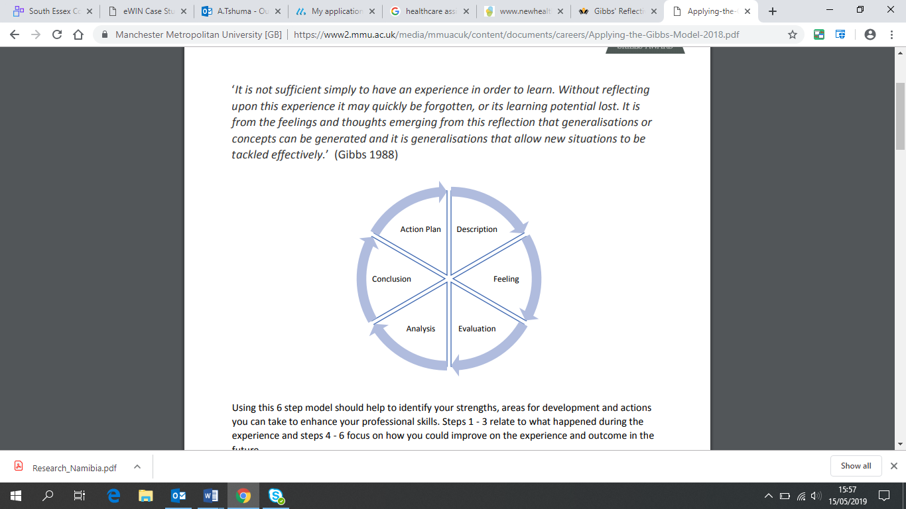
Adapted from Gibbs (1988)
According to Gibbs, (1988), Gibbs' Reflective Cycle contains six key levels which is Description (What happened?), Feelings (What was your reactions and feelings?) Evaluation (examine both bad and good points), Analysis (What sense can you make from the situation? Ideas, perceptions), Conclusions (be specific and then general), and then Personal Action Plan (Outline the steps you are going to take to apply, what you have learnt and would you apply similar approach).
Section Three
Evaluation: What lessons could NHS learn from your own ideas and experiences using Clip Model?
The Inter-professional and collaborative working needs employees to be committed to working as a team, thus learn together, listen to each other, and have an ability to respond flexibly, depending on service users’ needs. The CLiP model embodies a variety of healthcare learners including, social work, physiotherapy, social work, nursing across all disciplines, for example, child, adult, mental health and learning disabilities (Brown,. et al 2009). There are different ways to check in learning after a CLiP has taken place, information gathered can either contextualised through Gibbs Reflective Cycle (Gibbs, 1988) or fragmented into four domains, learner realisation, seeing the learning and self-awareness and group dynamics (Brown,. et al 2009).
For instance Brown,. et al (2009) suggests that those who have taken part in a CliP inspired project are most likely to have sharpened their communication skills through things like, networking and asking questions. At the same vein, Brown. et al (2009) notes that such an approach is key in improving patient care. Brown,. et al (2009) also observes that students taking part in the CLiP inspired project usually gain a greater awareness of their own role within the wider team and the importance of team working. They also feel more confident to question the role of others and the services they provide. These skills are key to Standards of nursing domain (NMC, 2010)
NMC (2010) highlights the criticality of competency framework which is a set standards for competence. It is linked to competencies that every nursing student must have before being registered at first level on the nurses’ part of the register. NMC (2010) outlines four important domains, thus professional values, communication and interpersonal skills, nursing practice and decision-making and leadership, management and team working. These can be achieved and realised through a CLiP inspired project of coaching and mentoring.
This suggests that when used effectively and well, the CLIF model can yield good results as it provides flexibility and facilitates inter-professional experiences in any general hospital settings that seeks to promote deeper and transformative learning. Barr (2002) argues that it is through Interprofessional Education that people can really learn, and learning occurs when two or more professions learn from each other, and that ways collaboration and the quality of care can be improved. Clemow & Parker (2006) argue that it is inter-professional learning that has long been advocated by healthcare academics which they have suggested could be effective as a method to improve team working in practice. Hence, there is a notion that, the Clip model could be efficient and effective model in improving inter-professional working in universities of Health and Social Care through support provided by staff in developing innovative and effective approaches to interprofessional learning and education (Clemow & Parker, 2006). Hence it can be argued that the provision of inter-professional learning and education experiences could enable students to embark on their careers in health and social care with a good understanding and skills needed to work with others to provide a high quality of care for service users. This suggest the need for universities to collaborate with the NHS Northwest Head of Quality and Interdisciplinary Learning to improve collaboration in health and social care theory and practice. According to Lobo et al (2014), an effective application of a Clip model should provide four elements of interprofessional learning, which includes, student realisation, seeing the learning, self-awareness and group dynamics. Lobo et al (2014) argues that as part of good practice it will be imperative to also build around the four themes of communication, team working, therapeutic relationships and clinical and professional skills. This suggests that a critical evaluation of the development of therapeutic relationships with patients and other members of the Inter-professional team.
CLiP occurs during mentoring and coaching, and, it can be argued that coaching empowers students’ confidence and sharpens their clinical skills, making them useful members of the workforce. CLiP can make students develop a self-awareness through encouraging them to reflect and enhance relationships (Starr, 2011). By allowing student to evaluate their own activities, coaching and mentoring reduces pressure on mentors, as a result allows students to step forward and out to deliver social care, therefore, allow mentors and coaches to take a back step, they instead observe and observe (Starr, 2011). The greatest thing about the CLiP model is that it seeks to combine together coaching and mentoring at the same time. For instance, the following Table 1 demonstrates the differences between coaching and mentoring which however, are amalgamated by CLiP model.
Table 1: Differences between a coach and a mentor.
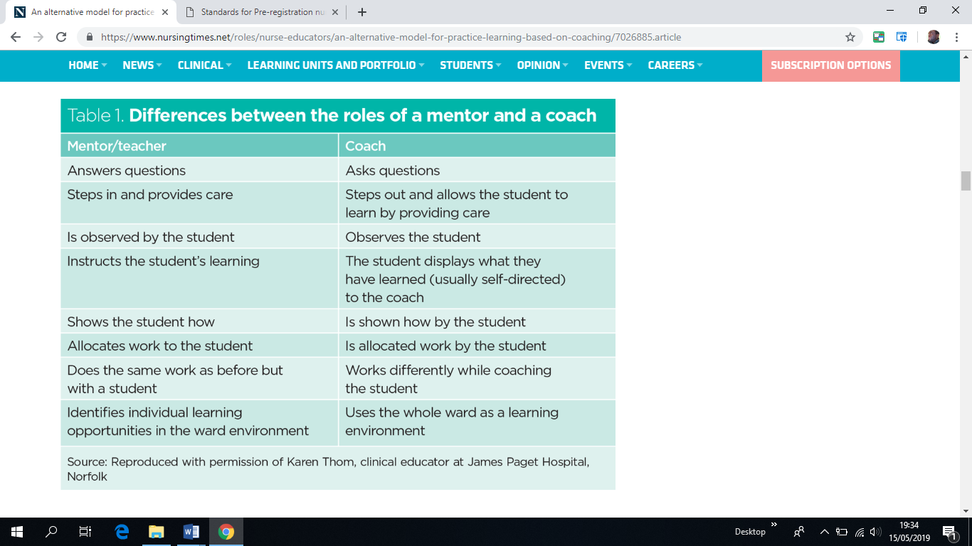
Moreover, the coaching model that distinctly uses coaching techniques without combing them with mentoring is known as OSCAR (Gilbert and Whittleworth, 2009). The usefulness of OSCAR is beyond this study.
Lobo C et al (2014) investigates the effectiveness of CLiP model through an analysis of what they refers to as the “Philosophy of Coaching”. They identify a simmering debate on the similarities and differences between coaching and mentorship, and argue that in these difference there are some that stand out. Lobo C et al (2014) observe that coaches deliberately stand back as a means of creating a student-led learning culture. In this context, simple measures like encouraging students to introduce themselves to their patients, first and then the coach following behind five minutes later reinforces this approach. Lobo C et al (2014) states that students should come to placement ready for a proper shift, which means for them they must identify learning outcomes which they desire to achieve during placements activities. They are also encouraged to articulate themselves clearly and well. Moreover, Lobo C et al (2014) observe that in exclusive coaching, thus without mentoring in it, conversation between student and coach is less, but there is more prompting, questioning and enquiring. In coaching students are encouraged to seek solutions on care issues. In coaching students are expected to assume responsibility for the care they plan and deliver while coaches are only expected to create some positive learning environment underpinned by a culture of valuing, encouraging, learning by doing, positive reinforcement enhanced by consistent and timely feedback. Lobo C et al (2014) observes that coaching is usually embedded in the ward culture as qualified and experienced nurses are provided with an opportunity to coach, yet that is not compulsory staff (Lobo C et al 2014) .
Recommendations
Heads of Quality and Inter-professional Learning, Universities in the department of Health and Social Care, Heads of School, Directors and managers of academics and, the students should all be involved to make the CLiP model a successful collaborative project.
There is also a need for the NHS and stake holders to try and ease mentor fatigue, which can be the case as more students seeks place as a requirement for their training. This could imply that there is a need for the whole team to be involved in coaching and mentoring. Student on placement should also be allowed at some point to guide themselves, so that they apply theory into practice while at the same time gaining confidence. More students going on placement, could overwhelm the management, which affect the full implementation of the CLiP project. We need to avoid staff burn out by reducing the burden of coaching and mentoring through allowing students to guide themselves.
The importance of flexible and well facilitated interprofessional experiences in practice that
promote deep and transformative learning is clear. This report offers a framework for how
and why this might be done efficiently and effectively. Four elements of interprofessional
learning (student realisation, seeing the learning, self-awareness, and group dynamics)
formed the basis of the CLIP model that was then applied to the framework built around
the four themes of communication, team working, therapeutic relationships, and clinical &
professional skills. From the Practice Education Facilitators (PEFs) came important ideas
about the context of learning, selling the idea (of IPE), relevant chatter, and learning
alliance.
The importance of flexible and well facilitated interprofessional experiences in practice that
promote deep and transformative learning is clear. This report offers a framework for how
and why this might be done efficiently and effectively. Four elements of interprofessional
learning (student realisation, seeing the learning, self-awareness, and group dynamics)
formed the basis of the CLIP model that was then applied to the framework built around
the four themes of communication, team working, therapeutic relationships, and clinical &
professional skills. From the Practice Education Facilitators (PEFs) came important ideas
about the context of learning, selling the idea (of IPE), relevant chatter, and learning
alliance.
Section Four: Conclusion
Effective coaches have helped raise standards in many schools by enabling the client to realise the transformation that he or she is trying to achieve. In recent years, the use of mentoring and coaching has become widespread across the whole school and in networks of schools as their value has been more completely understood.
The Gibbs' Reflective Cycle provides a clear picture of and structure of my learning experiences during placement. The model provides a framework for exploring and examining my experiences as a mentee. Its cyclic nature allows me as a mentee to record what I was taught by my mentor and what I experienced during my placement. It allowed me to go through some repeated experiences, learn and plan from such experiences and check if things went well or bad. This then, allows to move forward in a positive direction.

References
Andrews, V. (2015) Review of Coaching and Mentoring in Health and Social Care: the essentials of practice for professionals. http://new.coachingnetwork.org.uk/book_review/review-of-coaching-and-mentoring-in-health-and-social-care-the-essentials-of-practice-for-professionals-and-organisations/
Brown, C Wilson, Brown, N, Wilson, J (2009), Silverthorne School of Nursing, Pharmacy and Medicine, Interprofessional Education Healthcare Conference. Edge Hill University, Liverpool.
Clemow, R., and Parker, M. (2006) Webcast on authenticity and IPE for the Faculty of Health and Social Work, University of Plymouth. Learning Matters: Exeter.
Clutterbuck, D (2018), The pivotal role of mentoring and coaching in health services
https://www.davidclutterbuckpartnership.com/the-pivotal-role-of-mentoring-and-coaching-in-health-services/ (accessed 13/05/2019)
Foster-Turner, J. (2006), Coaching and mentoring in health and social care. Oxford, Radcliffe Publishing
Fox, V. J., Rothrock, J. C., & Skelton, M. (1992). The mentoring Therapy, 49(1), 39–43. relationship. AORN Journal, 56(5), 858, 860–862.
Gibbs, G. (1988). Learning by Doing: A Guide to Teaching and Learning Methods. Oxford: Oxford Further Education Unit.
Gilbert A, Whittleworth K (2009) The OSCAR Coaching Model: Simplifying Workplace Coaching. Monmouth: Worth Consulting.
Lobo C et al (2014) Collaborative Learning in Practice (CLiP) for Pre-registration Nursing Students.
NHS (2018). Who can write a prescription? https://www.nhs.uk/common-health-questions/medicines/who-can-write-a-prescription/ (accessed on 14/05/2019)
Nolinske, T. (1995). Multiple mentoring relationships facilitate Nursing 39(6), 257–261.
Nursing and Midwifery Council (2010) 16 September
Nursing and Midwifery Council (2018) Standards for Student Supervision and Assessment.
Royal College of Nursing (2015), RCN Mentorship Project 2015: From Today’s Support in Practice to Tomorrow’s Vision for Excellence.
Schwellnus H & Carnahan, H (2014), Peer-coaching with health care professionals: What is the current status of the literature and what are the key components necessary in peer-coaching? A scoping review, Medical Teacher, 36:1, 38-46, DOI: 10.3109/0142159X.2013.836269
Stewart, B. M., & Krueger, L. E. (1996). An evolutionary concept, analysis in mentoring in nursing, Journal of professional nursing, Nursing, 12(5), 311–321.
Sparrow, S (2008), Origins of coaching: Origins of the species, Employment Law Features, Learning & development, Coaching and mentoring 22 April https://www.personneltoday.com/hr/origins-of-coaching-origins-of-the-species/ (accessed on 14/05/2019)
Thorndyke, L. E., Gusic, M. E., & Milner, R. J. (2008). Functional mentoring: A practical approach with multilevel outcomes. Journal of Continuing Education in the Health Professions, 28(3), p. 157-164.
Vidal‐Salazar, M.D., et al. (2012) Coaching: an effective practice for business competitiveness. Competitiveness Review: An International Business Journal, 22, .423 - 433
Wallen, G. R., Mitchell, S. A., Melnyk, B., Fineout‐Overholt, E., Miller‐Davis, C., Yates, J., & Hastings, C. (2010). Implementing evidence‐based practice: effectiveness of a structured multifaceted mentorship programme. Journal of advanced nursing, 66(12), p. 2761-2771.
Wang, J., & Odell, S.J. (2002). Mentored learning to teach according to standards based reform: A critical review. Review of Educational Research, 72, 481-546.
West-Burnham, J (2013), Coaching, mentoring and leadership Opinion piece, National College for Teaching and Leadership
https://www.nationalcollege.org.uk/cm-mcadv-op-westbury.pdf (accessed on 15/05/2019)

Log of Contact

