

Managing a Hardware/Software Project Integrated with Enterprise and Innovation Group Project
  - Project inition
Habib Muin | 1650547 | 22/11/19

Introduction
This is a document that has been created for the project initiation. This will provide a short summary of what the proposed system will achieve and discuss what the enterprise project is. The enterprise project is a fitness app called J&J Fitness.
Objectives
The object of J&J Fitness is to allow users to comfortable use an app in order to reach their goals. These days getting a personal trainer can be quite costly. This is why the app allows the user to store videos of their workouts within the app to view. Here bellow are the goals for the app:
- App Forum
The main page of the app will have a section for users to share workout / diet plans. This allows individuals to help one another with their desired goals as well as give another user advice and share their own plans
- Login System
The app will contain a way for the users to create an account and have access to a private account where they can keep track of their goals.
- Friends System
Within the app, there would be a feature that would allow users to do competitions against their friend. Competitions such as seeing who can complete the workout first, setting each other targets and also doing workouts together.
- Diary
Keeping track of an individuals journey of fitness is important, so there will be a feature to allow users to keep track of their daily routine, how close they are reaching their goals.
The dairy can also be used to add or modify the diet plans.
- Competitions
The competition section is in conjunction with the friends feature. The competitions are held live with either individual friends or larger competitors. The workout competitions would be strength (weights), endurance (swimming) etc.

Scope
The boundaries for the project are very wide because the project is based on fitness and health. The type of work for the project bestow a platform for new clientele such as personal trainers to gather clients for themselves and other fitness industries looking to collaborate their products and merchandise.
Geographically, the app is accessible globally. This will bring in new users from different countries all over the world. The project goal is to become similar to mainstream social media apps we have today.

Constraints
There are many different things to take into consideration about the constraints of the project and how it will influence the deliverables and schedule. Here below are a few constraints:
-Time constraint, time constraints include not only the amount of time required to complete a task, but also the amount of time needed to obtain supplies and drive to meetings. [1] Scott (Project Manager) takes steps to address time factors and also improve the performance of the business.
-Knowledge, this is a common constraint which overall is quite under estimated. For example, the project J&J Fitness tried to emulate the products and also the services of MyFitnessPal, which is their top competitor, but they lack the knowledge on how to achieve the same level of success.
-Demand, the nature of demand in the market. It is important to identify the nature of the customers and their requirements through detailed market research. [1] For this position, Ruzy does research within the market in order to find what customers would enjoy.

Authority
The project has been split between 6 individuals within the group. These individuals are responsible of vital sections of the project in order to execute the project as a whole.

Project manager/sponsor: Scott Jones has the authority and control over the other 5 individual’s parts. He oversees the implementation of the app itself and sets the budget. His responsibility are to determine what’s going to work within the app and guiding the individuals along the way.

Resources
Here bellow are the key members of the project.
Project Manager: Scott Jones
The project manager manages and oversees the other departments of the organization.
Business Developer: Lloyd Johnson
Marketing: Ruzy Aktar
Ruzy researches into the marketing side of the business, keeping the project up to date on how to market the project successfully.
Business & Usability Analyst: Shaun Holborow
Lead developer: Habib Muin
The implementation of the website and also the designs of the project are made by habib.
Mobile developer: Lowri Jones
Lowri is responsible for the implementation of the app and its features within.

Gant Chart
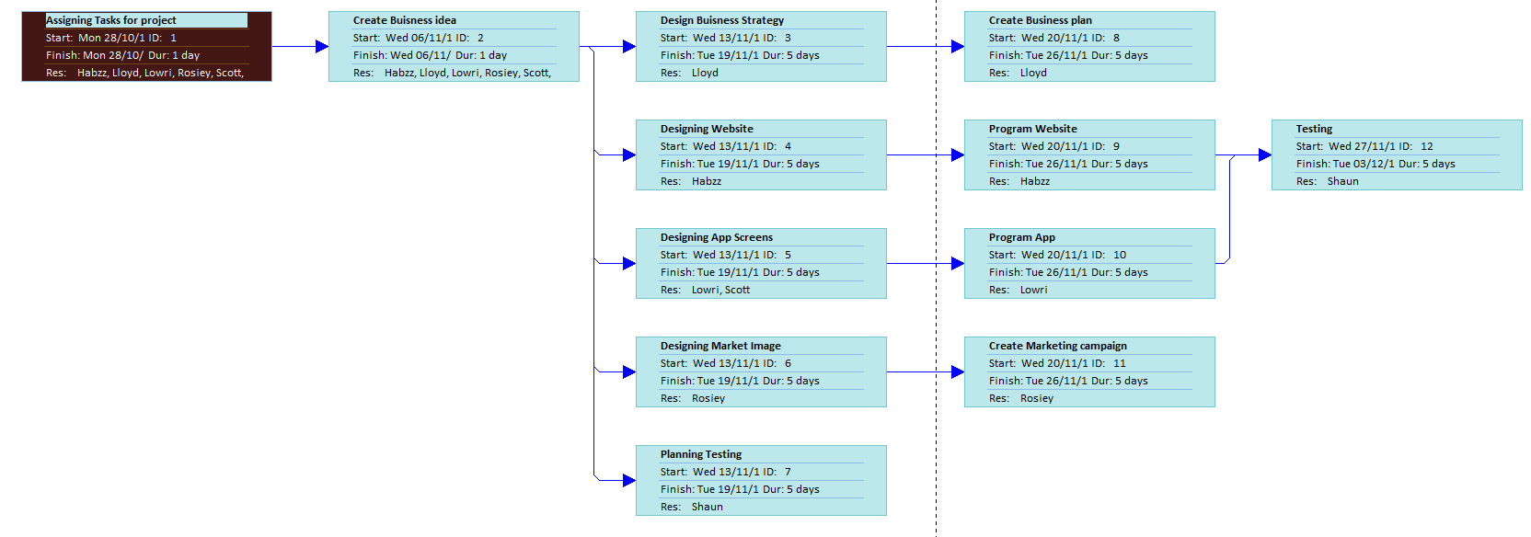

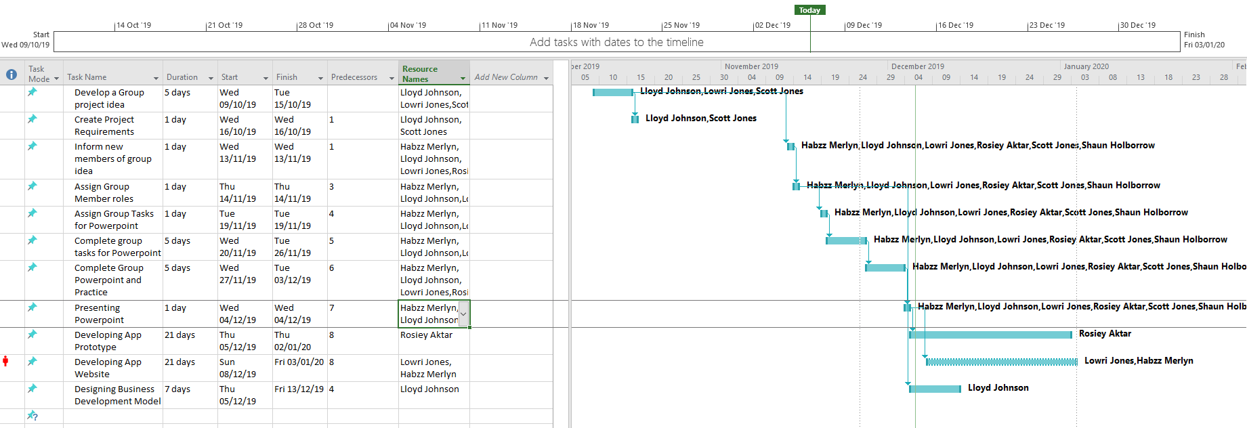

References
[1] - https://bizfluent.com/info-8366449-business-constraint.html
[2] - https://businesscasestudies.co.uk/constraints/

