Study skills
Portfolio
Charles R McCallum

Contents

- Front cover page
- The reasons for my choices
- How does music make you feel? (Summary 300 words)
- References for the summary
- Infographic (Essential skills for authoring an essay)
- Screenshots of literature from the library
- Essay outline for a 400-word document on the ‘psychological and physical benefits of owning a pet’.
- AI acknowledgement

Reasons for using materials.
I decided to use the ‘How does music make you feel’ because I listen to a lot of music in different genres, I also play a few different instruments including guitar. I have always been interested in how the ability to listen to a certain track has so much influence on how we are feeling at that specific time. Music seems to bring a world of emotions and feelings that we do not think about in other activities, it gives us sadness and joy all at the same time.

I have chosen the ‘Benefits of having a pet’ because who does not like animals? They are full of fun and yet sympathy at the same time, they make us feel loved, because their love is unconditional, even when we may be feeling sorrow, or just feeling down, a pet can give great comfort, in fact I would say that humans could learn a great deal from animals.

Music has been around for thousands of years; it is thought that the ancient Greek philosopher Pythagoras 570-490 BCE discovered the tuning arrangement for stringed instruments. In modern times, music is a fundamental part of life, from radio to various music platforms. Music can bring varied emotions and feelings, and sometimes a certain song can almost place the listener back to a time in one’s life that holds special memories.
Nendick (2022) suggests that music in different keys has opposite emotions and feelings, for example, a piece played in a major key sounds happy, whilst another piece played in a minor key sounds sad, this theory is possibly why a certain song makes the listener want to dance or to bring on a negative feeling such as cry. Studies suggest that the medial frontal cortex, ventral striatum and amygdala, the reward and pleasure areas in the brain are roused when we listen to a piece of music that we enjoy (Blood & Zatorre, 2001).
The revised BRECVEMA framework is made up of eight different responses in the listener's brain, Brain Stem Reflex, Rhythmic Entrainment, Evaluative Conditioning, Contagion, Visual Imagery, Episodic Memory, Musical Expectancy, and Aesthetic Judgment (Juslin, 2013). Since the 1950s, music has gained much interest in psychological studies, in a book authored by Leonard Meyers titled, Emotion and Meaning in Music (1956), he developed a theory that music can contribute to different emotions in one’s mood.
It is thought that a person with a negative personality (neuroticism) is more likely to have feelings of nostalgia while listening to music (Barrett et al., 2010). According to Fraile et al., (2019), music therapy can enhance memory in people with Alzheimer’s disease, by awakening memories that were thought to be lost, although early in trials, the nostalgic nature of a certain song or piece of music that has been associated with a time of happiness, seems to enhance the recall of that period of a person’s life.

Barrett, F. S., Grimm, K. J., Robins, R. W., Wildschut, T., Sedikides, C., & Janata, P. (2010). Music-evoked nostalgia: Affect, memory, and personality. Emotion, 10(3), 390–403. https://doi.org/10.1037/a0019006
Blood, A. J., & Zatorre, R. J. (2001). Intensely Pleasurable Responses to Music Correlate with Activity in Brain Regions Implicated in Reward and Emotion. Proceedings of the National Academy of Sciences, 98(20), 11818–11823. https://doi.org/10.1073/pnas.191355898
Fraile, E., Bernon, D., Rouch, I., Pongan, E., Tillmann, B., & Lévêque, Y. (2019). The effect of learning an individualised song on autobiographical memory recall in individuals with Alzheimer's disease: A pilot study. Journal of clinical and experimental neuropsychology, 41(7), 760-768.
Joslin, P. N. (2019). Blast from the Past. Musical Emotions Explained, 316–329. https://doi.org/10.1093/oso/9780198753421.003.0022
Nendick, Z. (2022, September 12). How does music make you feel? - The British Psychological Society. Www.bps.org.uk. https://www.bps.org.uk/psychologist/how-does-music-make-you-feel

‌
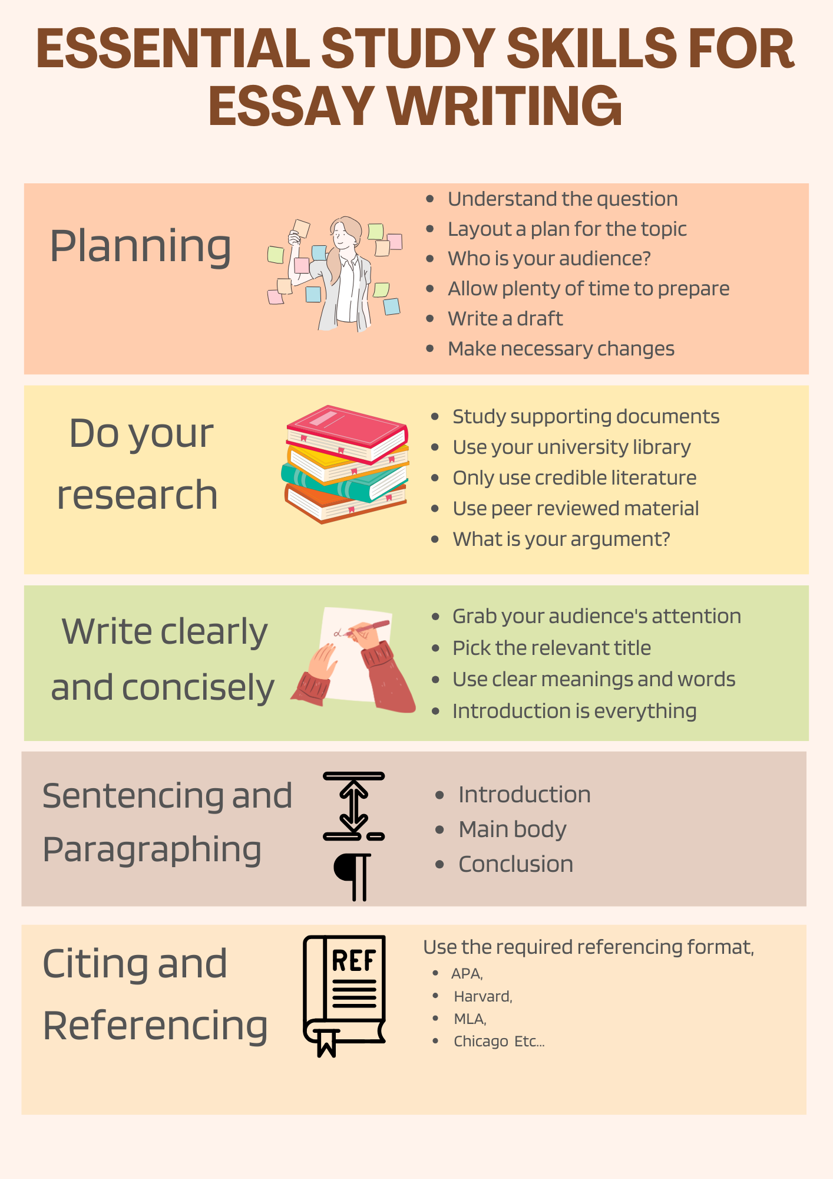

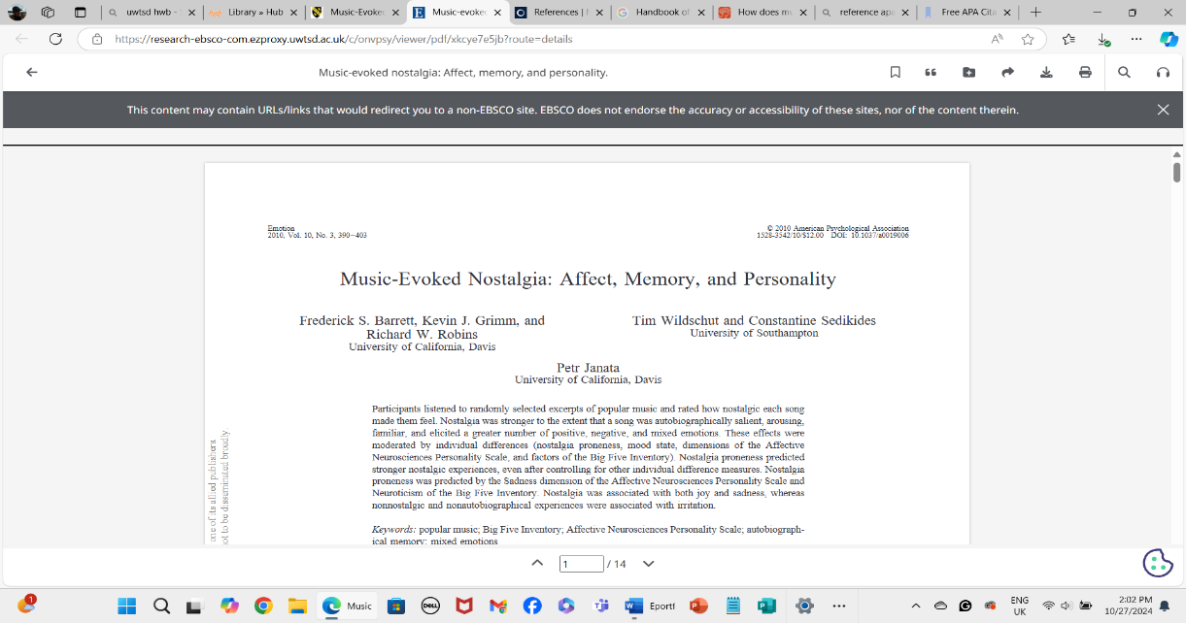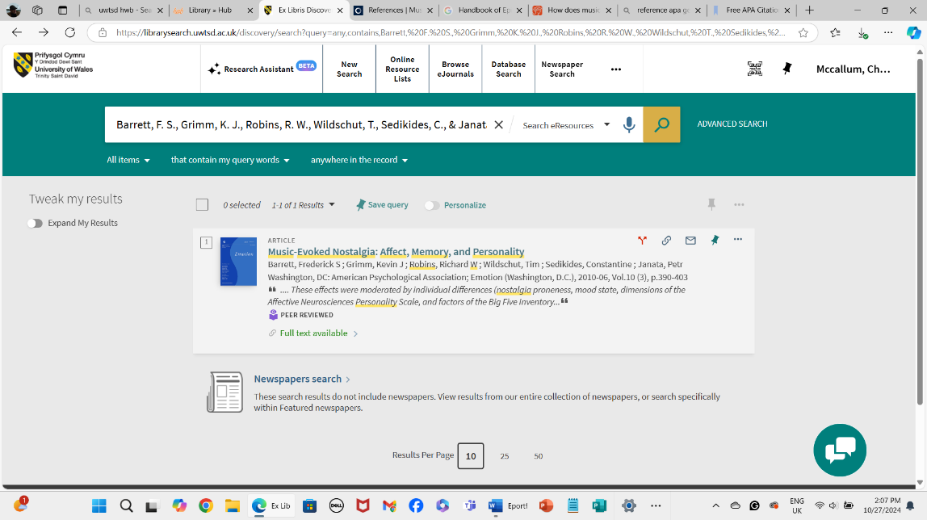

  - 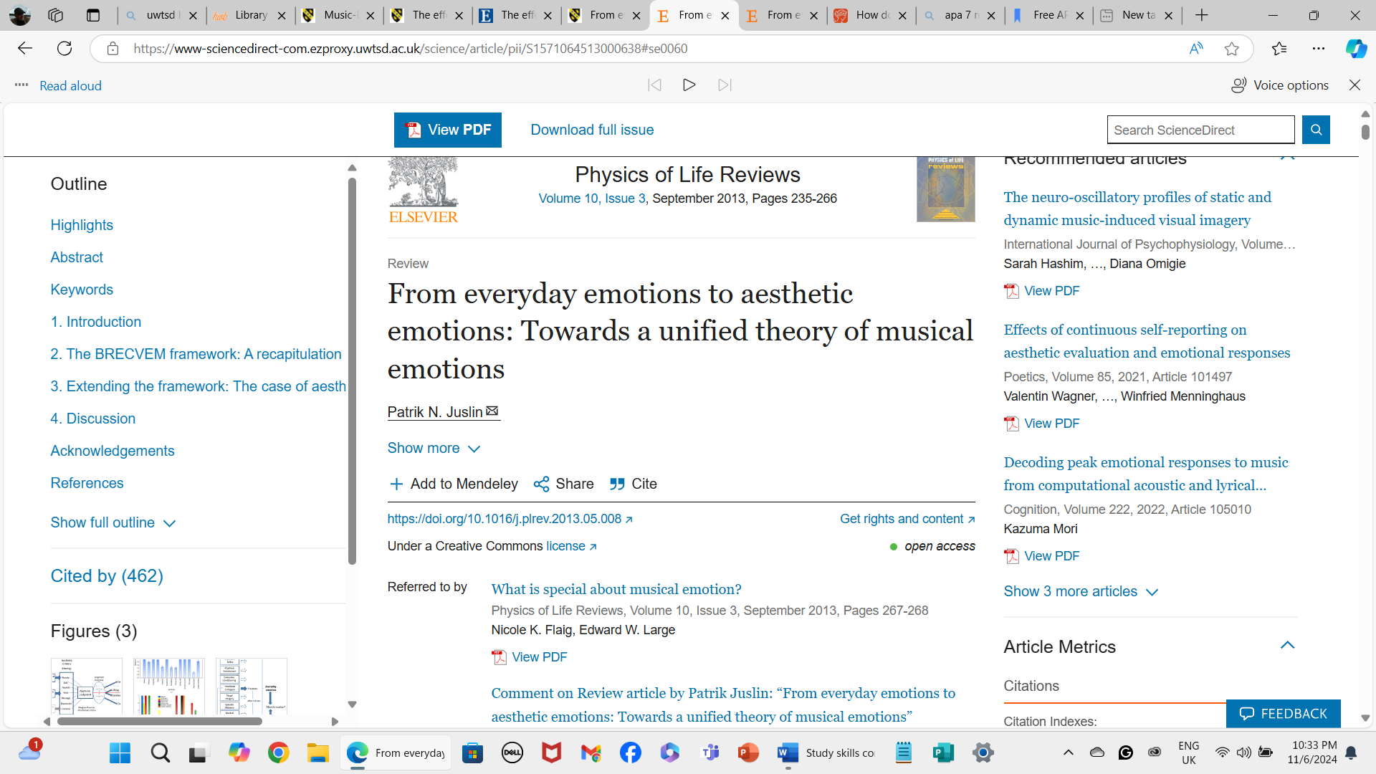

  - The Psychological, Social and Physical Benefits of Owning a Pet (400 words).

  - Introduction: Open up the discussion with the history of animals and how we have become dependent on them as much as they depend on us.
Bring points of the discussion to the surface to grab the reader's attention. (

Main body
Paragraph one
- State how humans have had pets for thousands of years (citations)
- Mention how the ancient Egyptians worshipped cats (citations)
- Talk about the diverse ways in which humans can become lonely (citations)
- Describe the different suitable breeds of dogs (citations)
- Mention how dogs and cats are good companions.
Paragraph two
- Talk about the different animal breeds when choosing an animal.
- Include the psychological benefits (citations)
- Talk about dogs for dementia and how they can help with memory (citations)
- Using supportive trials and the outcomes (citations)
- supportive information on therapy animals (citations)
- The physical benefits of walking a dog.
Paragraph three
- Talk about the psychology of pets in a wider area of brain injuries (citations)
- Talk in detail about the use of dogs for the blind (citations)
- Hearing dogs for people living with hearing impairment (citations)
- Include the work of therapy dogs in the military veterans with PTSD (citations)
- Go deeper into detail about the benefits of animals for depression and anxiety (citations)
Conclusion
Bring all the information together and argue whether more animals could indeed be introduced in different therapies for people with other illnesses and disabilities.
References in APA Styling
Canva source for infographic (2024).
Screenshots from The University of Wales Trinity St David’s Swansea library.
The use of a reference generator helped to check references. I also checked with the APA manual.

