Motorcycle technology
Motorcycle geometry analysis and dynamics handling investigation.
ACHA 4003
By: Harvey Merrett


Contents page:
Chapter 1: Introduction
Chapter 2: Geometry data, excel documents and schematic diagrams (rs250, rs660)
Chapter 3: Gear ratios from both bikes and explanation
Chapter 4: analysed characteristics between the two machines
Chapter 5: two modern motorcycles compared to each other
Chapter 6: Any alterations to be made to the two bikes
Reference list

Chapter 1:
In this assignment I will be providing some recorded and researched data regarding the geometry and dynamic handling of four motorcycles. This will include things such as centre of gravity and schematic diagrams and recorded information in graphs and on an excel spreadsheet to emphasise my research and to validate it. All the information captured will be elaborated on and explained as to why the geometry values of a motorcycle are so important and how it implements the characteristic of how a motorcycle drives and performs.

Chapter 2:
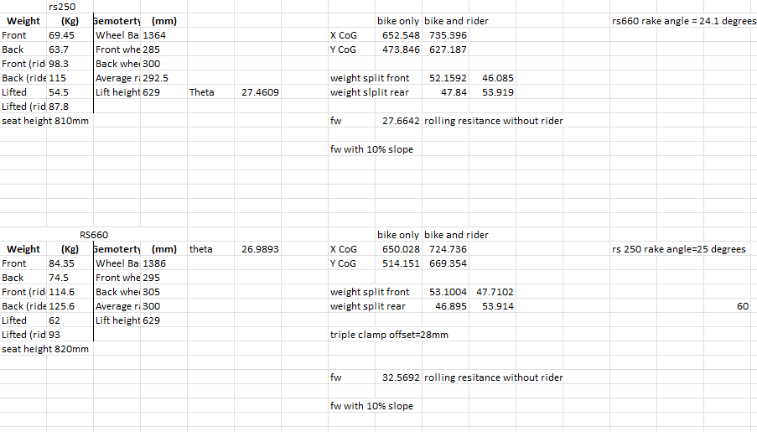
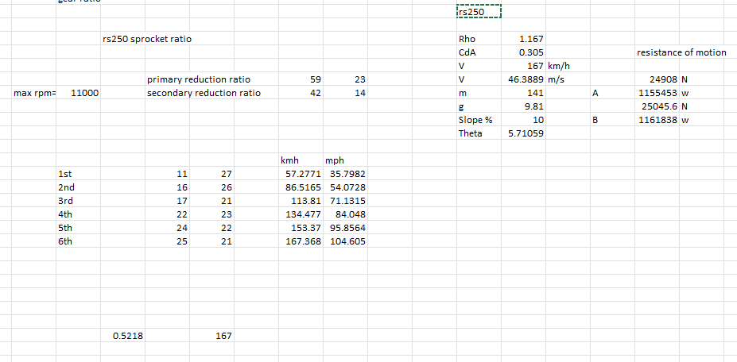

Here we can see the geometry data from the rs250 and the rs660. The data I have gathered is around the general thesis of geometry. These include, bike measurements such as wheel radius, wheel base, seat height, weight with and without the rider and all the centre of gravity measurement including the rolling resistance at a 10% slope (rs250). All this data has been gathered by myself and has been put into this spread sheet.
Centre of gravity plays a big role in how the characteristics change in a motorcycle. The measurements captured will be converted into meters and how the weight with and without a rider impacts the point of centre of gravity and how it shifts it up and down the bike.
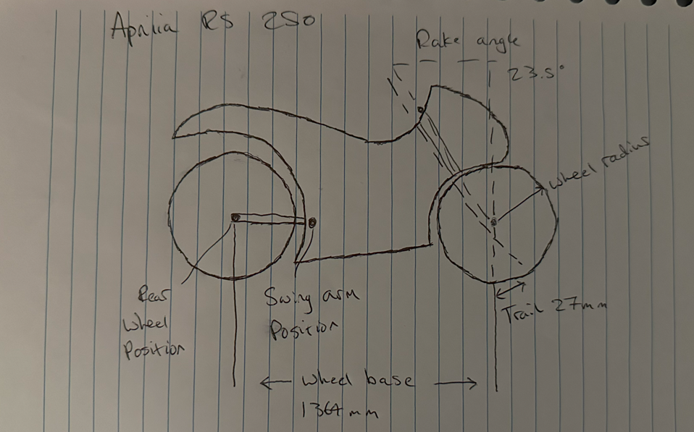
Figure 1
For the Aprilia 250 in figure 1 we can see a schematic diagram of all the data and forces and information acting upon the motorcycle. As we can see here we have information regarding the wheel base, rake and trail angles, wheel radius and swing arm position.

Chapter 3:
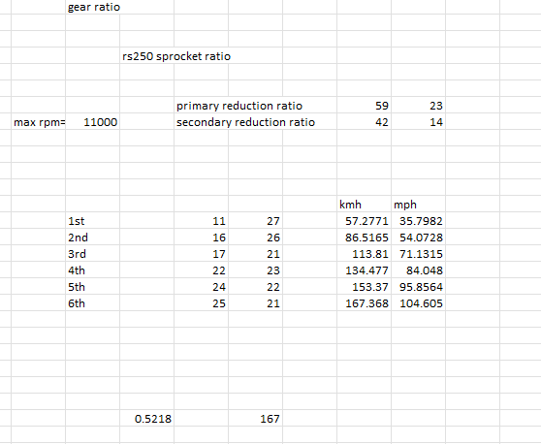
in this chapter I have been asked to find the gear ratios of a bike of my choice. The bike I have chosen is an Aprilia rs 250. the website where I had acquired the gear ratios from was www.motoryclespecs.com,tony (2001) for a 2002-2004 aprilia rs 250 and from there I had calculated the power in each gear and the maximum output as we can see in Figure 2.
Figure 2
As we can see here I have calculated the maximum speed in every bike using the reduction ratio and the gearing ratio from 1st to 6th gear. It states that the top speed that the Aprilia is able to achieve us 104.6 mph in 6th gear. Taking that into account and that it has a 11000 max rpm output then it would seem that it would not be possible to reach the stated top speed of 138 mph by motorcycle news, APRILIA RS250 (1994-2004) Review | Speed, Specs & Prices | MCN (motorcyclenews.com) , mcn staff, (2020).
This could be due to a number of factors and some of them being the coefficient of drag and friction on the motorcycle. For example there could be a negative wind meaning a rider is riding into wind in outside conditions or the position of a rider may also cause drag. Friction can also cause a viable factor due to friction meaning the wheels have having some resistance and restricting the wheels to a limited range of movement.

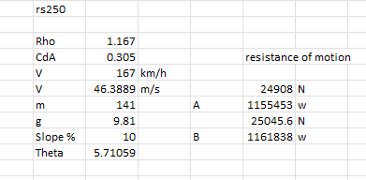
Figure 3
As we can see in figure 3 I have also calculated what power would be needed if the rs250 was also travelling up 10% incline. This was done by using theta the coefficient of drag and many more units to determine the power and by using the top speed of the rs250 to determine those figures.

Chapter 4:
As we can see from chapter one and the graphs inputted we can see a few differences between the bikes which will make the handling of the bikes different to one another. Both bikes a categorised as sport bikes but will also respond different to one another. First of al the wheel base of the rs660 is larger meaning that the front spindle to the rear spindle is longer that the rs250. There are pros and cons to having a longer wheelbase which may benefit or negatively affect riders. For example, a longer wheel base will mean that the manoeuvrability of the bike is more difficult meaning the rs250 will most likely be able to corner better that the rs660. This also does give the rs660 a upperhand in straight lines and as an example on a long straight on a circuit. The longer the wheelbase the more stability the bike will maintain at higher speeds.
Touching upon the subject previously spoken about with cornering we can see that the rs250 will have a slight upper hand due to the shorter wheelbase. We can also see from the acquired geometry data that the wheel radius of the rs660 is bigger meaning it will be able to have a smaller lean angle than the rrs250 which will suffer from having a smaller when radius.
Next we can see that the rs660 also has a smaller centre of gravity (CoG) with and without a rider compared to the rs250. A higher CoG allows more load transfer on a motorcycle meaning moving around the motorcycle. This means transferring positions is easy to do compared to a lower CoG. A lower CoG also helps the motorcycle to be more stable when braking or engine braking. Compared to this altering the swingarm can also move the CoG to the rear of the bike to make it more stable. This means both bikes are versatile in their own way. The rake angles of both bikes also differ but are very similar to eachother. The rake angle determines how fast the tyre reacts to the turn of the handle bars meaning the rs250 will be able to turn more quickly.

Chapter 5:
Figure 4
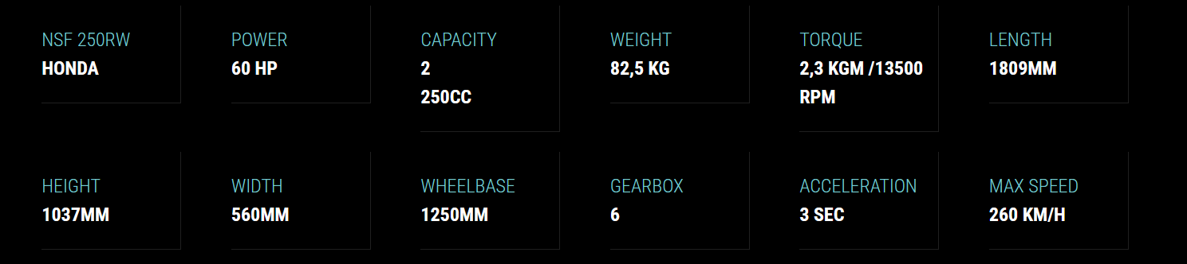

Here we can see the geometry data for a moto 3 gp bike which has a very small wheel base meaning that its very nimble. In moto 3 speed isn’t everything. From past previous experience from racing when riding a bike that tops out fairly quickly positioning is the most important thing. Being nimble on the track and saving half a second can mean the difference to these bikes. The seat height is also low meaning the rider is able to tuck lower and have a less drag acting upon the rider. The kerb weight of the bike is also light. This makes it easier to transfer weight across the bike to help the rider get into their lean angle.
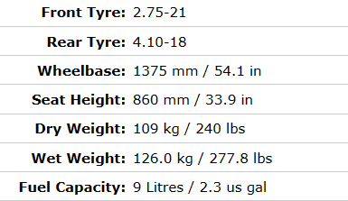
Figure 5

In figure 5 we can see the geometry data for a paris Dakar bike which Is a honda xl 125r. comparing the data we can see that the kerb weight is a lot heavier meaning it will have more stability from external weather such as wind. Due to the weight it will make the bike more stable at high speeds. Comparing this to the moto 3 bike we can see how the bikes differ in weight. We can also see that the wheel base is longer on the paris Dakar honda. This is because the bike is made to be more stable compared to the moto 3 bike. This is because the moto 3 bike is made for track purposes and is made to be nimble compared to a rigid and firm paris Dakar honda.. The paris Dakar honda will also have a significantly lower CoG as the bike is built for stability. This is because the rider is sat far back and upright and has a very high seat height.

Chapter 6:
alterations can be made to many bikes but I will elaborate on the alterations I would pick for these two bike starting with the moto 3 bike. First of all I would lower the seat height to allow a lower centre of gravity. This would give the moto 3 bike an edge on the straights as it would be more stable. Not only do I believe it would be more stable but coming out of a corner the rider will be able to transfer into the seat quicker taking squat to its advantage. I would also make the wheel base longer as they will be tailing other riders for most of the race meaning the bike would feel more stable in the slip stream.
For the paris Dakar honda I would raise the seat height to make the paris Dakar honda more nimble. The reason behind this is that they may have to dodge debris whilst racing and would need to move quickly and manoeuvre the bike out of the way. Whilst doing this I would also make the rake angle smaller to allow for a faster reaction time of the bike moving.

References:
Motorcycle Specifications Contact (motorcyclespecs.co.za) aprilia rs250,(2002), tony
APRILIA RS250 (1994-2004) Review | Speed, Specs & Prices | MCN (motorcyclenews.com) Aprilia rs250 review, mcn staff, (2020)
Honda XL 125R Paris Dakar (1983) technical specifications (moto-data.net) honda xl 125r paris Dakar, moto data team, (2020)
MOTO3 BIKE -Leopard Racing | Leopard Racing leopard racing, leopard sports S.A.(2020)

