Policing Research Project.

Are men often overlooked as victims of domestic abuse by society and how effective are the strategies to prevent domestic abuse.
Abstract.
This paper achieves an exploration and evaluation of the main key concepts surrounding are men often overlooked as victims of domestic abuse by society and how effective are the strategies to prevent domestic abuse. The key concepts covered will be what domestic abuse evidence tells us, why men are overlooked as victims and evaluating the current strategies in place.
Cerys Bowen (2203320)
BMPL6015

Cover Page.
Acknowledgements.

Firstly I would like to thank and acknowledge Mike Durke, my course lecturer, for the ongoing support and advice provided whilst completing this research project. Without this advice and support I would not have been able to complete this research project to the best of my ability.
I would also like to acknowledge and recognize all the participants that completed my questionnaire. I am thankful to every participant who took time to fill this questionnaire out. Without this the research project would not have been possible therefore, I would like to thank you all for your contribution.
Lastly I would like to thank and express how thankful I am for my friends and family for the support throughout completing my ongoing research. I would specifically like to thank them for the continuous motivation and encouragement they showed that made overcoming challenges from my research possible.

Declarations.

This work has not previously been accepted in substance for any degree and is not being concurrently submitted in candidature for any degree

Statement 1

This dissertation is being submitted in partial fulfilment of the requirements for the degree of BA/BSc.

Statement 2

This dissertation is the result of my own independent work/investigation, except where stated otherwise.
Other sources are acknowledged in the Reference Section.

Statement 3

I hereby give consent for my dissertation, if accepted, to be available for photocopying and for interlibrary loan, and for the title and summary to be made available to outside organisations.

Statement 4

I hereby give consent for my dissertation, if accepted, to be available on the university’s IT system to those who have consent to use the system.

Student’s Name: Cerys Bowen

Signed: C.Bowen

Date: 22/04/2025

Table of Contents
Cover Page. 0
Introduction 4
Objectives. 6
Literature Review 8
Methodology 16
3.2 Research Onion 16
3.2.1 Philosophy 17
3.2.2 Approach 17
3.2.3 Strategy 18
3.2.4 Choice 18
3.2.5 Time Horizon 18
3.2.6 Techniques for Data Collection, Processes and Analysis 19
3.3 Sampling 19
3.4 Reliability and Validity 20
3.5 Limitations 20
3.6 Ethics 20
3.7 Conclusion 21
Analysis 23
Conclusion 33
Reference list 35

Introduction

According to Barrow-Grint et al. (2022) domestic abuse is any patterns or incidents of abusive behaviour towards family members or an intimate partner that holds a significant high rate of crimes in the United Kingdom. Domestic abuse relates to a large amount of individual’s within communities with a high percentage of individuals previously delt with this type of crime or are currently victims. The Home Office (2022) reinforces this by stating that in England and Wales over 2.3 million individuals have experienced domestic abuse at some point in their life. Domestic abuse has been a large topic for concern regarding the high volume of individual’s within communities dealing with this type of crime. According to Hilton (2021)
domestic abuse is extremely relevant with the drastic increase that communities are facing across the United Kingdom. Therefore, there is a large interest towards the patterns and tendencies of the negative effects and impacts domestic abuse has on the victims. Hilder & Bettinson (2016) state that domestic abuse is a crime that is becoming more visible within communities with a large amount of the population speaking out about their previous experiences of being victims and seeking the appropriate support from local authorities.
According to Turner et al. (2019) there has been a large amount of research surrounding domestic abuse regarding the effectiveness of the strategies preventing domestic abuse and how effective these strategies are on reducing the amount of crime. This research will explore information regarding the current legislation surrounding domestic abuse and the strategies that the Government and higher authorities have put in place to prevent domestic abuse. This area of topic provides a large amount of research surrounding the strategies and what measures need to be put in place to tackle preventing domestic abuse. Shackelford (2021) highlights that domestic abuse is a timely and important crime that needs to be explored for the reason that this area of topic is something that majority of individual’s have either experienced or know someone that has experienced in their lifetime that needs the appropriate implementation of successful strategies to prevent this issue.
The specific focus of topic regarding domestic abuse in this research is are men often overlooked as the victims and how effective the strategies to prevent this crime are. This focus is specifically targeted on the communities stigma towards men being overlooked as victims for the reason that a large amount of research regarding domestic violence highlights that males are the perpetrators of this type of crime. This research will look at the recent few years of research for the research to be up to date and hold a more accurate representation of communities.
According to McQuigg (2022) a factor that has played a large impact on the increase in numbers of individual’s being victims of domestic abuse is the COVID-19 pandemic. The Man Kind Initiative (2021) charity states that the charity had an increase of 75% of individual’s making contact with the intensity of abuse being at it’s most extreme. With this in force a large amount of individuals struggled with the enormous effects that had been brought on victims. The COVID-19 pandemic raised concerns on behalf of the male victims mental health issues as a result of the drastic increase in the figures. As a result of the raising concerns regarding vcitims of domestic abuse £230 million was invested by the government as funding for the victims support. This was funded into various parts of communities to attempt to support preventative measures that were put in place. The Domestic Abuse Commissioner (2023) implemented a strategic plan to attempt to reach out to victims within communities. This was done by agencies playing a role in preventing domestic abuse by giving the appropriate support. This attempts to prevent domestic abuse at an early stage through early interventions with the approach of understanding, influencing, to challenge and engagae with victims that need support.
Barrow-Grint et al. (2022) states that the Policing Domestic Violence Team have implemented policing-based stratagies to attempt to support the victims as well as ensuring perpatrators are fully held accountable for their actions committed during the abuse to their partner. They cooperated multi-agency partnerships into this by involving them in every stage of holding them accountable and supporting the victim thoroughly. The Information Resources Management Association (2022) highlighted the concern of victims not seeking the correct support that are available for reasons such as not being aware of what support is available or the feeling of being ashamed. It is stated that less than 31% of victims of domestic abuse seek support from agancies or the police. This highlights the issue of preventative measures and stratagies put in place without the communities awareness of where to seek the approiate support.

Objectives.

One key aim whilst carrying out this research is to identify and research the key issues regarding how domestic abuse affects victims specifically male victims. This involves researching the strategies that are being used to prevent domestic abuse and evaluate how effective these stragaies are. A crucial part of the aim was to consider the issues with the current strategies that have been put in place in the United Kingdom and what improvements need to be made. The first objective that will need considering is what does the domestic abuse evidence about men being ‘overlooked’ as victims tell us. The second objective is to identify the reasons why men are often ‘overlooked’ as victims of domestic abuse and what issues they are faced with regarding not reporting this as a crime. The final objective is to evaluate the strategies currently being used for male victims of domestic abuse and reccommend and propose what improvements need to be made regarding the current strategies of preveting and supporting individuals suffering from domestic absue. This will come from research such as journals, books, websites and primary research regarding this area of study.
The approach to answering the research question will be to discuss the key issues regarding the affects on male domestic abuse victims. This research will include identifying and looking into the current strategies authorites have in place for the beneift of the victims. By identifying the current strategies the research will evaluate how effective these strategies are and what improvements need to be made for the welfare of the victim. The research will provide evidence of men being ‘overlooked’ as domestic abuse victims and what issues they are faced with. By looking at the issues they are faced with this will help highlight what improvements need to be recommended for the support of domestic abuse victims.

The structure that will follow in chapter two is the literature review which will be a crtitical evaluation of the current literature surroundig the topic of men being overlooked as victims of domestic abuse. Following this I will be discussing my research methods in depth within the methodology chapter.

Literature Review

To consider what does the Domestic Abuse evidence about men being ‘overlooked’ as victims tell us.

Buller et al. (2025) states that men have the least positive experience with individual’s that work for domestic abuse support system services. This is for reasons such as their accounts not being taken seriously, the lack of resources or failing to disclose all the relevant information. The appropriate support is unable to be provided if men are unable to disclose the abuse. This may come from reasons such as not thinking they will be taken seriously therefore, the appropriate support is unable to be provided. It is also stated that domestic violence support services are not always able to provide the relevant support resulting in men being turned away. This tells us that men are less likely to report being victims of domestic abuse as a result of having to overcome external and internal obstacles such as overcoming the element of fear or failure for the relavent support. According to McGarry (2017) the evidence show that men are overlooked as victims for the reason that certain services are not targetted towrads men and their stigmatization and denial make this challenging to report. Evidence also tells us that there are certain barriers that men encounter for example, being judged or being blamed for brining this abuse on themselves. According to National Institute of Health (2021) 1 in 7 men experience domestic violence as an adult and they all state that they were concerned that they would be accused of being the accuser therefore, initially avoided reporting the incident.
Duggan (2018) highlights that the ‘ideal’ victim of domestic abuse is perceived as a female. He also goes on to state that many women that experience violence during domestic abuse become exposed to a extremely dangerous environment increasing their vulnerability. This highlights that the evidence based on men often being overlooked as victims of domestic abuse tell us that women are looked at more significantly for reasons such as highlighting that women are more likely to be killed by their partners compared to men. This suggests that the evidence of an avergae of two women a week being killed by a current partner portrays that women are more likely of being victims building a stereotype that men are more likely to be a perpatrator.
Domestic abuse evidence regarding men being ‘overlooked’ as victims show that a significantly lower percentage of men use supportive measures that have been put in place for victims. The charity Man Kind Initiative (2021) reinforces this by stating that there has been a significant underuse of the Domestic Abuse Disclosure Schemes by men with only 4.4% of victims accessing IDVA services. This is for reasons that men believed that the scheme was not available for them. This came from Clare’s Law being too focused on women as victims resulting in men not feeling as though this was a method of support available for them. This significantly resulted in men being ‘overlooked’ as victims for the reason that men have not been seeking the available support due to issues such as not feeling as though the relevant support is targetted towards both genders. Fitz-Gibbon & Walklate (2017) states that the introduction of the Domestic Violence Dislcoure Scheme known as Clare’s Law was introduced in England and Wales to aim to prevent the violence between individual’s in relationships through being able to share information about prior history of violence to individual’s that request this infromation. This was introduced after the death of Clare Wood by a fatal strangulation and being set on fire by her partner after she was not provided the protection she needed after multiple communications with her local police force.
The Home Office (2024) highlights that amendment’s came alongside the introduction of the Domestic Violence Crime and Victim Act 2004 as well as the Doestic Abuse Act 2021 and the cross-government strategy ‘Call to end violence agasint women and girls.’ This highlights another issue regarding why men are often ‘overlooked’ as victims for the reason that there is a high amount of emphasis on support available for women and the lack of publicity and awareness raised regarding male victims. According to Williams (2023) these concerns came as a result of Clare Wood’s case in 2010 where the Independent Police Complaint’s Commissioner found systematic failing’s on behalf of the police prior to Clare Wood’s death. The perpetrator had previous convictions for harassment from previous partners. Leading up to Clare’s death she contacted Manchester police force on numerous occasions to complain about threatening behaviour, assault, harassment and criminal damage and nothing was done to safeguard the victim by failing to assess the risk and error made by call handlers.
On the other hand, according to the Welsh Government (2022) a piece of legislation was introduced which was The Violence Against Women, Domestic Abuse and Sexual Violence (Wales) Act 2015 (VAWDASV). A objective that was mentioned regarding attempting to tackle domestic abuse was to provide all victims with equal access to high quality response services. This is essential for the change in attitude within society to prevent victims from being kept hidden and improve prevention for gender based violence. By ensuring that early intervention is held as a priority and the relevant professionals are trained correctly male victims of domestic abuse will feel heard and supported correctly.
Hine et al. (2022) states that there is a low amount of research regarding the challenges men face being vitcims of domestic abuse and the barriers they have to face when engaging with support. This evidence tells us that men are ‘overlooked’ as victims of domestic abuse for the reason that men are deemed as hidden victims as they believe that they feel as though society struggled to recognise them as victims as a result of men typically being characterized as abusers in many scenarios. The interviews that were carried out from this research show tendancies of men feeling as though they should be represented as dominant and in control of situations therefore, this had huge impacts on how they viewed themselvesd as victims. Bates & Graham-Kevan (2019) reinforce this evidence by stating that men are not believed that they are victims, that they were repsonsible for the abuse or even such instances as support services mocking their experiences. Bates (2020) states that this suggests that because men are often blamed for their victimization from individual’s from society they suffer from extreme psychological impacts from controlling tactics and cohercive behaviour such as limiting the amount of time on their mobile devices, threatening allegations and controlling their engagement such as social activites or seeing friends and famillies. This results in men doubting their judgement of being victims and percieving that they are to blame.

Identify the reasons why men are often ‘overlooked’ as victims of Domestic Abuse and what issues they are faced with regarding not reporting this as a crime.

Douglass et al. (2020) states that a reason why men are often ‘overlooked’ as victims of Domestic Aabuse is because of the stigma behind men being dominant and aggressive in relationships. Knight et al. (2017) reinforces this with the evidence of males having a high level of testosterone corresponds with dominating motivations. This suggest that women are portrayed as individual’s that do not engage in aggression and intimate partner violence contrary to the populations opinion. This is associated with the feeling of being shamed and feeling as though they have failed their role as a husband or father role model. As a result of the social stigma there are numerous missed opportunites to idenitfy and offer suppoort for male victims. This takes us back to Darwin’s theory of sexual selection which highlights on the thoughts of violence in relationships is explained by the idea of men using violence to retain control in the relationship being the domiannt one. As men are looked at as the more likely to be violent this cancells out indiviual’s judgment of them being the victims. As a result an issue men are faced with not reporting this as a crime according to the Domestic Abuse Commissioner (2024) is that men feel as though professionals will be less likely to recognise men as victims as they believe they will not be believed or taken seriously. A challenge they are faced with is harmful gender norms and stereotyping that acts as major barriers to seeking support. This can impact victims avoiding discussing with a professional until they are in desperate need for support where the situation may be extremely dangerous. During the Covid-19 pandemic helplines saw a rise of 37% in that period of time with a rise of 61% in emails seeking urgent support from men. This reinforces that that male victims are accessing support due to reasons such as awareness being raised. The statsitics from this previous year Man Kind Initiative (2021) state that only 4.8% of male victims are being supported by local services that portray the amount of men seeking help has decreased.
Huntley et al. (2019) portrays that the needs of male victims have been comparatively neglected and caused damage to their wellbeings. It is stated that a reason why men are often ‘overlooked’ as victims of domestic abuse is for the reason that they have feared to disclose this information and that it diminishes their confidence as well as challenges their masculinity. Therefore, these factors make them feel as though they are invisible to services because of the reason that they either feel as though they are not appropriate or are not aware of the services that are available. This factor links to feelings the men have regarding that if they report this abuse then they will loose contact with their children and will disrupt their family that may have an ongoing affect on their childrens well-being. This leaves them with degraded confidence and the feeling of hopelessness with no other choice but not seeking the required support. The issues they are fcaed with are reinforced by Hammond et al. (2024) by stating that male victims of domestic abuse are viewed more harshly by society as a whole. Therefore, the infidelity causes harsh perceptions for reasons such as lack of knowledge surrounding the subject. This highlights the issue of men having doubts in professionals to respond effectively to the situations. This portrays that there’s a need in a change in communities to support men that experience domestic abuse by implementing further strategies that men feel comfortable seeking.
Perryman & Appleton (2016) states that research from six counsellors working alongside male victims of domestic abuse had a difficulty in acknowledging victimisation. It is highlighted that they are often ‘overlooked’ as victims of domestic abuse because of the lack of recognition that societies and professionals have. This results in professionals missing out on opportunities to acknowledge signs that victims may have. This arrises with the issue of assumptions being challenged and the lack of resources available for male victims. Jeffries & Bond (2015) reinforces that they are faced with the issue of support services not taking them seriously by minimising their abuse or the legal barriers when reporting. This suggest that legal systems and support services available do not always adequately respond or recognise that they are victims of domestic abuse by not recognising the warning signs being shown. Therefore, communities should encourage professional support and challenge stereotyping about masculinity surrounding men being victims of domestic abuse to avoid barriers such as devotion to their families, fear of the police is response or the feeling of being reluctant to view or re-live their experience of domestic abuse.

Evaluate the strategies currently being used for male victims of Domestic Abuse.

One strategy currently being used for male victims of Domestic Abuse according to the Home Office (2022) is the introduction of the Domestic Abuse plan. It is stated that seven million men experienced domestic abuse in 2022 that caused the government to take serious actions to tackle this issue. The government brought new funding of £230 million to ensure sufficient support for victims and introduced the Domestic Abuse Act 2021 and coercive and controlling behvaiour in 2015 as an offence. This ensures that there will be a better understanding by educating individual’s on the concepts of this issue and how essential it is to identify at an early stage. It was highlighted that authorities will be more relentless on perpatrators by placing longer sentences and ensuring that the police and criminal justice system are far easier to navigate through for the benefit for victims. Even though it is stated that they will ensure a stronger support system for male victims they state within this action plan that women are more likely to be impacted by domestic abuse and that men are more likely to be perpatrators of this offence.
It highlights that the issue of male victims feeling as though they do not fulfill the criteria of seeking the sufficient support. This is as a result of the perception of them being unlikely to be seen as victims that deter them to report to the police. There needs to be more awareness raised by authorities and the government to put an end to the stigma and it’s necessary to establish an effective plan to improve all aspects in society to ensure an improvement in the outcomes for male victims. This may be done by further increasing funding for sevices targeted to male victims of Domestic Abuse. Therefore, the Ministry of Defence (2024) proposed a domestic abuse action plan from 2024 to 2029 by implementing a plan that will inlcude sufficient strategies such as further training, supporting victims and survivors, partnering with research and data and ensuring Multi-Agency Risk Assessment Conferences run and organised by local authorities. This is a wide plan defence showing awareness in the armed forces.
Another strategy that Ross et al. (2022) states that is currently being used for male victims of Domestic Abuse is the Independent Domestic Violence Advisers that work closely with high-risk victims. The introduction of IDVA’s were for the purpose that victims have a primary point of contact that asses the level of risk they are exposed to. They support victims by implementing safety plans and supporting long and short term plans to safeguard the victims. This highlights the shift in focus towards sufficient engagement with victims experiencing domestic abuse ensuring that victims feel as though they have been heard by supporting them with sufficent solutions and advice. On the other hand, Moore (2021) states that an improvement that needs to be made regarding the current strategies of preventing and supporting male victims of Domestic Abuse is that increasing the public’s awareness and addressing the specific needs of the male victims of Domestic Abuse. Improvements such as campaigns to draw attention towards the issue arrising of male victimisation ensuring this is not portrayed in a way that will not minimize the individual’s.
North Wales Police (2020) have introduced a Domestic Abuse Action Plan to prevent the worsening effects of negative and long lasting issues caused to individual’s well being.This included ammendments such as early identification, help, safety and support, governance and accountability and a joint action plan. This is done to ensure identifying male victims early on to strengthen the initial response in various organisations and intervene at the earliest opportunity. It is highlighted that working with trusted professionals will strengthen partnership arrangements such as frontline practice. Barrow-Grint et al. (2022) states that there should be safeguarding opportunites such as strategies put in place to prevent individual’s from becoming victims or repeat victims. Therefore, by ensuring relevant information and intelligence are looked at this will prevent victimisation. This is reinforced by Hilton (2021) by stating that safeguarding opportunities should be ensured by partnership working with multi agencies with this being the most sufficient method to enable all accounts to be looked into and investigated to make sure all accounts are being picked up on. This will result in improvements resulting in agencies such as medical providers or mental health professionals working together for a benficial approach.
A recommendation regarding improvements that need to be made according to Walker et al. (2022) is improving the training for service providers for the victims. By achieving this male victim will feel more comfortable reaching out for help that will achieve communities being more accommodating to the unique needs of male victims. The training for service providers should ensure they use gender neutral risk assesment formats and ensuring up to date information and recognising warning markers of male victims. The Home Office (2018) highlights an example of the helpline LiveFearFree that was introduced by the governemnt as a service that made referals to other services for victims. This is an example of service providers being trained to support men based on their needs rather than based on assumptions that will benefit their experiences with support systems.

Methodology

The main concepts surrounding ‘Are men often overlooked as victims of domestic abuse by society and how effective are the strategies to prevent domestic violence’ were analysed in chapter two. With the stigma regarding females being victims and men being perpetrators this chapter with aim at carrying out the appropriate primary research to explore if men are often overlooked as victims. This chapter will carry out primary research regarding reasoning to why men are often overlooked as victims and how effective they believe the strategies available are to prevent domestic abuse. These objectives will ensure an accurate representation of how society observes the stigma regarding male victims of domestic abuse.

According to Bengson (2022) research methodology is systematic method about how research will be collected. This entails the procedure of how the data is collected, analysed and the framework as a whole to ensure further research is discovered to reinforce tendencies that are found. Analysing the results is done by the research onion method which according to Orth & Maçada (2021) entails highlighting the stages that are essential for developing the research and justifying the chosen research methods. This ensures the results collected have more relevance that ensures reliable infromation to be used, ethical aspects and the weaknesses are being considered.

3.2 Research Onion

According to Saunders et al. (2007) The research onion is a framework that enables the research to be divided into different sections such as the decisions that need making. This method represents the different aspects regarding justifying the chosen method being the questionnaire for research surrounding are men often overlooked as victims of domestic abuse. This will ensure that the chosen method of research is the most suitable and will sustain accurate results. Saunders et al. (2019) states that the research onion is successful in evaluating the data that has been collected to ensure questions are asked from the knowledge that has been discovered. This will ensure that the way the research question is answered will be influenced by the research philosophy.

3.2.1 Philosophy

Ryan (2018) highlights that the two key research philosophies that are suitable to the research is positivsm and interpretivism. These two research philosophies have different views regarding research methods and how the research is observed. Positivsm focuses on being a quantitative research method such as a questionnaire with an observer gaining knowledge through the results of the observations from the questionnaire from society as a whole. An advantage to this according to Wells & Giacco (2024) is that it has a systematic approach wich ensures the data is reliable and the limited data collection ensures that the observer has full control over the amount of data that will be collected and analysed. The research philosophy interpretivism is based on being a qualitative research method that focuses on reality being subjective. Matta (2015) states that interpretivism works by analyzing the actions of individuals through the process of looking at the norms of society, values and beliefs using a sociological approacch for example carrying out an interview. An advanatge to this is that it is succesful in producing a large amount of data that is reliabale due to it relying on individuals persoal thoughts and beliefs.

3.2.2 Approach

Woiceshyn & Daellenbach (2018) state that there are two approaches associated with research methods. The first being deductive wich research that has reasoning by necessity which is bassed on logic and a theory that already exists. Within deductive research it’s based on testing this information by testing the hypothesis and analysing the results with methods such as observing and data colletion to test this. On the other hand, Jebb et al. (2017) states that inductive research is where the use of data enables the findings of patterns and tendencies to create a theory or develop a theory that exists prior. This research will consist of inductive for the reason that deductive research is more suitable for looking at theories that already exist and testing their accuracy. This will ensure that the research will begin with observing that will lead to a conclusion.

3.2.3 Strategy

Lambert (2019) states that a questionnaire is a reliable research method for the reason that the set amount of questions are able to offer vast amount of data collected that is able to be analysed in a profound manner. The higher response rate enables a large amount of accurate data from tendencies and beliefs frm society allowing an accurate representation from a wide audience. A questionnaire will be an essential research method for this research to obtain and record data to explore a relaistic representation from society.

3.2.4 Choice

Lund (2023) states that the research method questionnaire is extremey effective with a response rate of one-third of the population believing that questionnaires are the most appropriate method of gathering information. This research method easily accessible and if the questionnaire is desinged in a effective manner this will result in a large amound of response rates. Therefore, this research will primarliy consist of a questionnaire being the main research method.

3.2.5 Time Horizon

Cohen et al. (2018) states that in order to successfully complete a questionnaire and collect and anylyse the data a time frame is essential. This research will include a set amount of time to complete the questionnaire wich will consist of 2 weeks. This ensures that participants taking part in completeing the questionnaire will have enough time to fill out the questionnaire and succesfully submit it. This ensures that after the questionnaires are submitted there will be a time frame of two weeks for all the data to be collated and anylysed.

3.2.6 Techniques for Data Collection, Processes and Analysis

Collins (2019) highlights that the questionnaire will ensure an accurate representation of how society observes their thoughts on certain subjects. Lambert (2019) reinforces that the research method of a questionnaire is systematic method on how research will be collected that ensures the results collected have more relevance that ensures reliable infromation to be used. The qualitative data collected will be anyalysed by the method of content analysis. According to Shaheen et al. (2019) is the method of evaluating patterns by meassuring the difference betwwen different variables. Wheras the quantitative data will be analysed through a thematic and content analysis. Cernasey & Axon (2023) describe a thematic analyis for quantitative data as a method that identifies the patterns and themes surrounding the data collected.The context of empirical research will be included which will cover the relevant theories and data observed will ensure a conclusion and the rationale behind the answers. This ensures that the questionnaire will compare and contrast the data aginst the theoretical predicitons. A crucial part is ensuring that the individuals targetted are from a wide audience to ensure the findings are a fair representation from community for the most accurate results possible.

3.3 Sampling

Stauffer (2018) highlights that the process of choosing a smaller amount of individuals within a large population to participate in answering the questionnaire is essential. This ensures that the results will be practical to analyse due to it being more time effective and easier to ensure the results have been successfully collated. Within this research the sampling method of random sampling. This is when individuals have an equal chance of being chosen. This is done digitally that ensures the individuals are chosen on a unbiased decision, the results represent society as a whole and is an accurate sampling method.

3.4 Reliability and Validity

According to Collins (2019) the questionnaire is a research method that is reliable and has valid results as it is unbiased and representative. Individuals within the society has an equal chance of being chosen therefore, the results are unbiased and the results portray a representation from society as a whole. The questionnaire is a research method that has a extremely high chace of being accurate if the random sampling method is carried out correctly and acurately. This is reinforced by Wisker (2019) stating that if measures are consistently monitered the results will be considered reliable. Methods can be implemented such as Cohen kappa method to test the reliability of the questionnaire.

3.5 Limitations

Davies & Hughes (2014) state that a limitation to a questionnaire is that there is a limited depth to the information that is provided. Therefore, the individual’s may not be able to express fully their thoughts regardig this question. To ensure this is avoided the wording of the questions must be clear to understand to avoid issues such as biased repsonses, diffiuclty interpreting the questions and answering dishoenstly. Leavy (2020) highlights the issue of the particpants not being able to expand on their answer may arise as an issue. To ensure this does not happen there will need to be questions regarding being able to expand on certain areas to why they chose the answer. If for any reason an particpant does not understand the wording of a question this may result in individual’s choosing an inaccurate answer therefore, the wording of question will have to be considred carefully to avoid inaccurate results.

3.6 Ethics

Regarding the ethical consideration to carry out the research an ethics from must be conducted firstly. This ensures that any issues that arises regarding carrying out the sufficient research are addressed in order to carry out the questionnaire. It is also essential for any individual that is answering the questionnaire and chooses to participate that they are made aware that by choosing to participate they must complete the questionnaire honestly. As a result of the nature of the topic of research the individuals have a right to opt in or out of taking part on a voluntary basis and made aware that any personal information provided will be kept disclosed and anonymous.

3.7 Conclusion

The chosen research method of a questionnaire is a sufficient form of gathering research from participants of the public. The research method is an opportunity to achieve collecting both qualitative and quantitate data that is reliable and valid form of information to support this area of topic. The limitations surrounding the use of a questionnaire have been regarded and certain measures must be followed to avoid any misconduct.

Analysis

As part of the primary research a questionnaire was conducted where 82 participants took part in answering the questions that were provided. The evidence surrounding the topic of ‘are men often overlooked as victims of domestic abuse by society and how effective are the strategies to prevent domestic violence’ have not been thoroughly looked upon providing minimum evidence. This evidence provides further clarification and evidence to suggest the findings associated with whether or not there is stigma regarding if females are more commonly known for being victims of domestic abuse. This is reinforced by Cohen et al. (2019) stating that a questionnaire is the most beneficial research method for the convenience of the public and is the most effective method for collecting data from a large amount of participants. This chapter will explore the findings and results that were carried out from the primary research conducted surrounding the reasoning to why men are often overlooked as victims and how effective they believe the strategies available are. The themes and objectives will be highlighted from the results by describing, analysing, comparing and contrasting the results that have been found.

Question. | Responses and insights.
What is your gender?  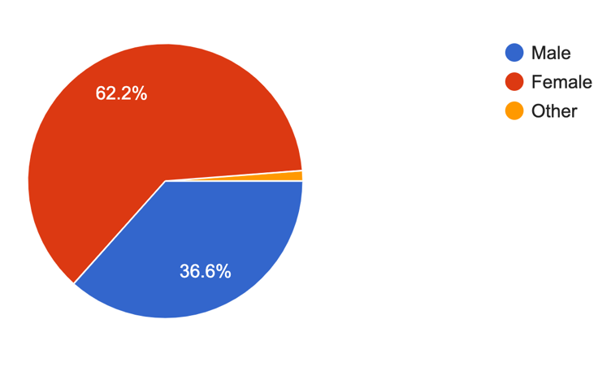 | The first question asked within the questionnaire was ‘What is your gender?’ By including this it ensured that the data collected enables sufficient trends to be recognised and provides a full understanding towards any bias that may occur during analysing data. Devlin et al. (2020) reinforces that using one gender as a target audience causes issues such as impacting the results depending on the nature of the questions asked. This could be by issues such as not addressing the populations viewpoints as a whole that can impact the result from differences between genders. The results found that 62.2% of participants were female, 1.2% chose to disclose as other and 36.6% of participants were male. From this, there will be a representation from both genders that will allow the data to reflect an accurate representation of communitties views as a whole. This allows an increased accuracy and avoids valuable insights being missed out from the data collected.
Are you a victim or have previously been a victim of domestic abuse?  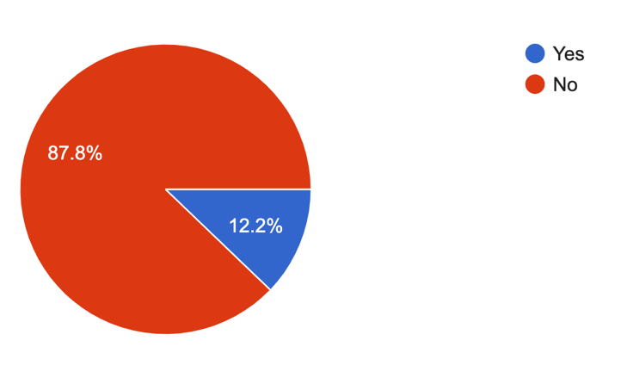 | The question showed 87.8% had chosen the option of not previously being a victim while 12.2% said that they had previously been a victim of domestic abuse. This question was essential to ensure that there was data collected on behalf of victims for first hand account answers. By receiving first hand account answers from victims this enables clear responses regarding any issues they personally experienced during the process of receiving support for the abuse they were experiencing.
Are you aware of any males that have been a victim of domestic abuse?  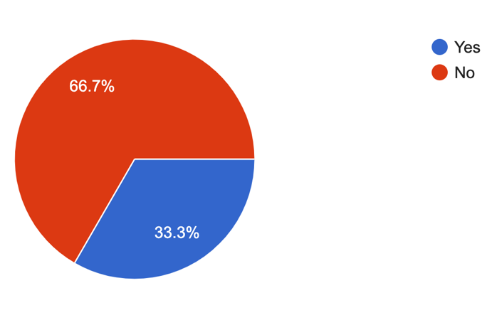 | The findings from this question showed 66.7% of participants not being aware of a male that has previously been a victim while 33.3% stated they were aware of a male that had experienced it. This question highlights areas of research within previous chapters with men feeling as though they are not eligible of seeking support and what barriers they are faced with. This also shows a representation of individual’s not being aware of any male victims that will represent their thoughts from findings such as society stigma, the press and online articles that will be benficial for this research.
Do you think domestic abuse victims are more likely to be males or females?  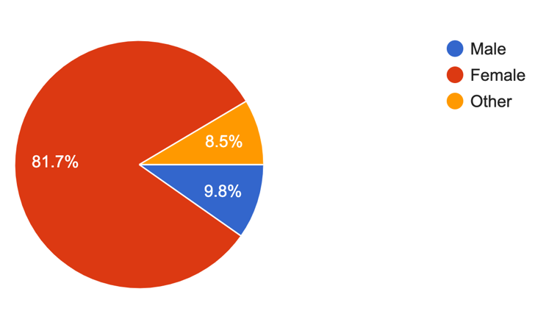 | The results show that 81.7% of participants believed that women were more likely, 9.8% belived men were more likely and 8.5% chose the option of ‘other’ of being more likely to be a victim of domestic abuse. The results show that participants as a whole believe women are more likely to be victims of domestic abuse that reinforces that the stigma of men being overlooked as victims of domestic abuse with a low percentage choosing the option of men being more likely to be a victim of domestic abuse. This portrays that domestic abuse is portrayed as a crime where perpetrators are quite often known as males. This is reinforced by Perryman & Appleton (2016) stating that men are often silenced as victims when seeking the support that suggest that their often victims that individual’s arent aware of. Therefore, the results suggest that as male victims are overlooked regarding are less likely to be percieved due to gender stereotyping due to their more aggressive nature and women being victims are far more advertised in societies.
Why do you think this? | This question enabled the participnats to explain why they choose their answer to the previous question. This provided a range of answers that included many patterns that were able to be highlighted from the results. The most common answer was that statistics show that domestic abuse is more commonly reported among women. This is reinforced by several other answers received such as inlcuding societal norms, power dynamics and historical context. Therefore this shows that women are often percieved as more vulnerable individuals in many cultures and societies which may be the reason to what can lead to a higher prevalance of abuse against them. Additionally, men may be less likely to report abuse due to fear of relation, stigma, or lack of support highlighting that a higher percentage of women report it that results with a higher coverage seen on social media and in the press online. The patterns observed from the results are reinforced by Moore (2021) that it’s the stigma we have been raised with to belive that women are more liekly to be victims and that the statistics we are aware of as communities are indisputable. On the other hand, an observation has been made to the results such as male are stereotyped as perpatrators but in reality they are ashamed to speak out that hides their identity as victims and males fear being listened and belived as victims.
What would you define domestic abuse as? | This question ensures that the participants are able to explain their knowledge regarding the defintion of domestic abuse and is able to explain their answers further regarding why they chose women as the higher percentage of victims being females. The results show that majority of participants stated that domestic abuse is physical abuse, emotionall abuse and controlling and cohersive behaviour. The other participants described domestic abuse as patterns of behaviour in an intimate relationship where an individual seeks to gain or maintain power through controlling by using psychological manipulation. This rienforces that society are aware and have been educated about the key concepts of domestic abuse. Prycroft & Gough (2019) explains domestic abuse as incidents or reoccuring incidents where controlling and coerive behvaiour, degrading and threatening behaviours take place. Comparing this to the results given this is similar in the way that the same use of language and actions are carried out. The results included the term isolating, sexual violcence, harrassment, stalking, digital abuse and use of threatening language that highlighted that the public are aware of what domestic abuse entails that ensures that the results are not misinterpreted because of individuals missunderstanding the definition.
What type of domestic abuse do you believe is more common in males? | This question provided results such as emotional, physical, verbal, controlling and coercive behaviour being the most common domestic abuse towards men. These results show that society belive that men are far more open to being controlled and emotionally abused to compared to abusive methods that werent stated such as sexual abuse, financial abuse and being maipulated. Westmarland & Burrell (2023) highlights that many aspects of domestic abuse are not made aware of and theres a specific attention towards physical abuse and that this is the only type of abuse that needs serious attention. Therefore, this suggest that the reasoning towards the pattern of majoirty choosing physical abuse suggest this is why women are looked at as more likely to be victims because the emotional and mental abuse wasn’t considered.
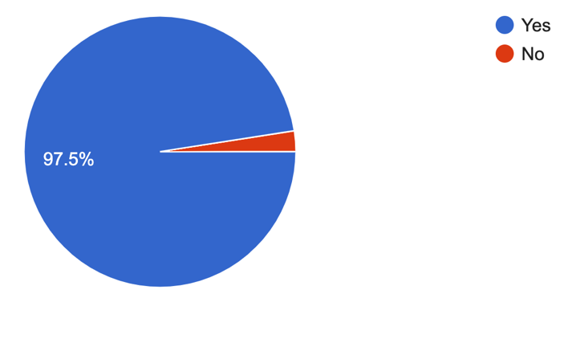  Do you believe that men are often overlooked as victims of domestic abuse? | The results provide us with the results of majority of participants believing men are often overlooked as victims of domestic abuse. The next question following on from this ‘Why do you think this?’ This enables us to have an explanation regarding why majoirty of participants believe this. The results include various of reasons for example men keeping quiet, feel as though they won’t be believed, sign of weakness, usure of where to seek support, bad experience when previously seeking help or afraid the woman will be believed over the man. Gadd et al. (2014) reinforces the observations made regarding being similar to the findings of why men often don’t seek support such as stigma, failure to be heard, don’t want to sperate families and a cultural reasoning. A concern that society portray is that menn experinec fear that when seeking support and speaking to another individual that they may not be taken seriously. This highlights the concerns the indiviuals have that act as barriers from feeling as though they can report the abuse that keeps men experiencing domestic abuse hidden.
What strategies are you aware of for supporting male victims of domestic abuse? | This question provides us with the results of the police, NHS, family members and friends, helplines and online support systems. These results show that communities are aware of the key support systmes that are implemented into our communities as a means of establishing a stronger suport system for individuals struggling. The most popular method of support was the police service but saying this all these methods suggested there are issues when providing support for men to be overlooked as victims of support. This is highlighted by Hine et al. (2022) stating that men get refused from women domestic abuse shetleters and call handlers give negative feedback and advice to the vcitims such as recent issues of stating that they ar at fault.
Do you believe there are enough domestic abuse strategies available for victims?  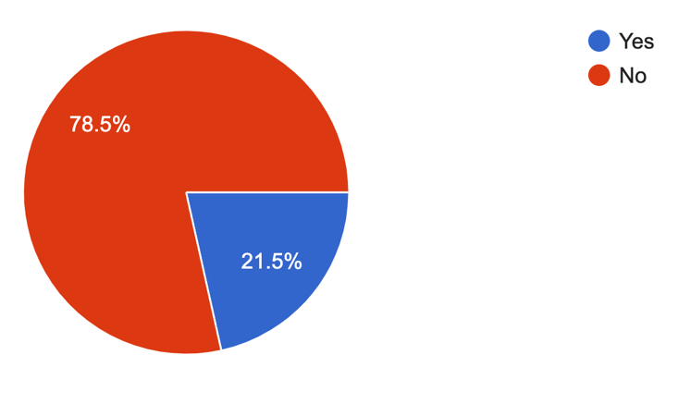 | The results show that 78.5% which majoirty of participants believed there are not enough domestic abuse strategies available to compare with 21.5% believeing there are enough strategies available. This may be reasons that they are not educated on all the relevant support systems available or don’t believe they are effective enough. This is reinforced by Hammond & Fido (2024) by stating that society believe there are more support available for women in comparison to men. This is highlighted by the ManKind initiative stating that a third of domestic abuse victims are men and when seeking support from refuges only 0.8% of these victims were offered beds. This shows that men don’t belive there is the sufficent support available such as the exaple of only 20 beds avaialble for male victims in England as opposed to 3,600 for female victims.
Do you believe there are enough opportunities for men to seek domestic abuse support? 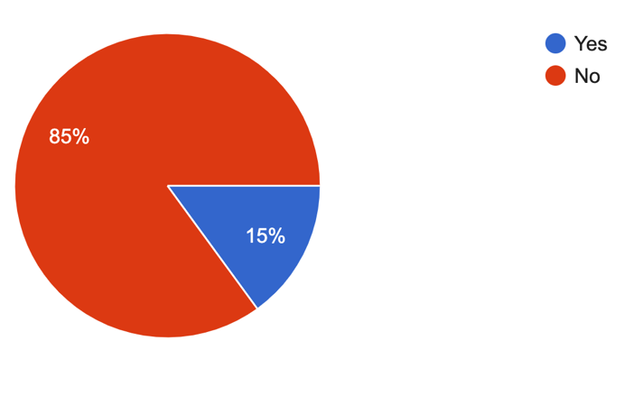 | The next question shows results of overall participants belive that there are not enough opportunities available for men to seek domestic abuse support with 85% and 15% of participants believing that there are enough opportunities for men to seek domestic abuse support. This highlights the issue of men feeling as though they are stuck in the ongoing abuse with the barrier of not feeling as though there is sufficent support available. Huntley et al. (2020) highlights this ongoing issue by stating that there is a failure to ensure that male domestic abuse victims have the basic level of suport they are required and are being failed in this department. This suggest that victims do not feel heard and feel as though this is their normality and they have no other choice but to stay in these situations.
What further strategies should be put in place for male domestic abuse support? | The results provided from participants varied from raising more awareness such as more advertisment to reducing the stigma towards females being victims. For example the same principle being put in place for both genders such as Clare’s Law being implemented for everyone that is in need. Another point raised that their should be more strategies to seek the initial sings such as the police should be visiting schools to educate children and identify whether they are experiencing domestic abuse. This is highlighted by Gabrielle (2022) by stating that partnership agencies should be more aware of the shortfalls in society such as more questioning from health services such as local surgeries. This entails partnership agancies taking caution as victims oftenly are not open about their trauma or experiences therefore, should be informed on how to pick up on warnings and traits that they show as being victims.

After observing the results from participants the data collected show patterns from observations such as a large amount of individuals believing that men are often overlooked as victims of domestic absue. The findings suggest that society as a whole have a stigma towards women oftenly being the victims of domestic abuse and at the forefront society are unsuccesful in providing support that male victims are aware of. Entilli & Cipolletta (2017) reinforce the data analysed that society believe that strategies are seen as support for women and men feel uncomfortable seeking support because of the barriers they face such as feeling ashamed, don’t want to break famillies up and financial issues. Therefore, ensuring that support is provided where these barriers can be supported and spoken about is crucial for the future of male domestic abuse victims.

Conclusion

The aim from this dissertation was to explore a topic that is widely disregarded by society which is are men often overlooked as victims of domestic abuse by society and how effective are the strategies to prevent domestic violence. With the drastic increasing numbers in the recent years of domestic abuse victims, the male victims have very minimal research. This dissertation was aimed for this area of topic being able to provide a large amount of research surrounding the strategies and what measures need to be put in place to tackle the issue of preventing domestic violence. A large focus throughout the research discovered was the stigma that individuals have regarding females being a more likely idea of a victim. This was for reasons such as societal stigma that stereotypes that men are often strong and unemotional that can deter them from reporting abuse. The aspect of limited and lack of awareness from support services tailored to male victims can make them feel isolated.
The objectives were a key element for the approach within the dissertation to research the issues regarding how domestic violence affects victims and a crucial part in considering the issues with the current strategies that have been put in place in the United Kingdom and what improvements need to be made. The objective of identifiying the reasons why men are often ‘overlooked’ as victims of domestic abuse and what issues they are faced with regarding not reporting this as a crime enabled the findings of evaluating the stratagies currently being used for male victims of domestic abuse and recommend and propose what improvements need to be made.
The dissertation enabled the achievement of discovering that domestic abuse is portrayed as a crime where perpetrators are quite often known as males. Perryman & Appleton (2016) stated in this dissertation that men are often silenced as victims when seeking the support that suggest that their often victims that individual’s are not aware of. This revealed the findings of male victims being overlooked and are less likely to be percieved due to gender stereotyping due to their more aggressive nature and women being victims are far more advertised in societies. Another achievement was discovering that women are often percieved as more vulnerable individuals in many cultures and societies which may be the reason to what can lead to a higher prevelance of abuse against them and for reasoning such as men may be less likely to report abuse due to fear of relation, stigma, or lack of support. Gadd et al. (2014) highlighted within the paper that a higher percentage of women report it that results with a higher coverage seen on social media and in the press online.
From the research collected a recommendation that should be considered according to Hammond & Fido (2024) there are not enough domestic abuse strategies available. This may be for reasons that they are not educated on all the relevant support systems available or don’t believe they are effective enough. Therefore, as society believe there are more support available for women in comparison to men more awareness such as more advertisemnt to reducing the stigma towards females being victims. Principles should be put in place for both genders such as Clare’s Law being implemented for eveyone that is in need such as the Domestic Plan being introduced with the governement bringing £230 million into further support for societies facing the struggle that The Home Office (2022) had stated. Another point raised regarding recommendations is that their should be more strategies to seek the initial sings such as the police should be visiting schools to educate children and identify whether they are experiencing domestic abuse. Gabrielle (2022) reinforced this by recommending partnership agencies should be more aware of the shortfalls in society such as more questioning from health services such as local surgeries. This entails partnership agancies taking caution as victims oftenly are not open about their trauma or experiences therefore, should be informed on how to pick up on warnings and traits that they show as being victims.
The intital question of ‘Are men often overlooked as victims of domestic abuse by society and how effective are the strategies to prevent domestic violence’ after gathering further research provides is answered with men are often ‘overlooked’ as victims of Domestic Aabuse is because of the stigma behind men being dominant and gressive in relationships. This suggest that women are portrayed as indiviual’s that do not engage in aggression and intimate partner violence contrary to the populations opinion. This is associated with the feeling of being shamed and feeling as though they have failed their role as a husband or father role model. As a result of the social stigma there are numerous missed opportunites to idenitfy and offer suppoort for male victims.

Reference list.

Barrow-Grint, K., Sebire, J., Turton, J. & Weir, R., (2022) Policing domestic abuse : risk, policy, and practice. 1st Edition ed. Oxfordshire: Routledge.

Bates, E., (2020) "Walking On Egg Shells": A Qualitative Examination of Men's Experiences of Intimate Partner Violence. Psychology of men & masculinity, 21(2), pp. 13-24.

Bates, E. A. & Graham-Kevan, N., (2019) Is the Presence of Control Related to Help-Seeking Behavior? A Test of Johnson’s Assumptions Regarding Sex Differences and the Role of Control in Intimate Partner Violence. Partner Abuse, 7(1), pp. 3-25.

Bengson, J., (2022) Philosophical methodology : from data to theory. 1st Edition ed. Oxford: Oxford University Press.

Buller, A., Ferrari, G. & Biulia, A., (2025) HEalth professionals Responding to MEn for Safety (HERMES): Mixed methods evaluation of a pilot sexual health intervention for gay, bisexual and other men who have sex with men experiencing domestic violence and abuse. Public Library of Science, 20(1), pp. 312-314.

Cernasey, A. & Axon, D., (2023) Research and scholarly methods: Thematic analysis. Journal of the American College of Clinical Pharmacy, 6(7), pp. 751-755.

Cohen, L., Manion, L. & Morrison, K., (2018) Research methods in education. 8th Edition ed. Oxfordshire: Routledge.

Cohen, L., Manion, L. & Morrison, K., (2019) Research methods in education. 8th Edition ed. London: Routledge.

Collins, H., (2019) Creative research : the theory and practice of research for the creative industries. 2nd Edition ed. London: Bloomsbury Publishing Plc.

Davies, M. & Hughes, N., (2014) Doing a successful research project : using qualitative or quantitative methods. 2nd Edition ed. London: Palgrave Macmillan.

Devlin, N., Parkin, D. & Janssen, B., (2020) Methods for Analysing and Reporting EQ-5D Data. 1st Edition ed. London: Springer Nature.

Domestic Abuse Commissioner, (2024) Our support for male victims.
Available at: https://domesticabusecommissioner.uk/blogs/our-support-for-male-victims/
[Accessed q7 November 2024].

Douglass, M., D'Aguanno, S. & Jones, S., (2020) Women as Active Agents: Female Perpetrators of Sexual Harassment and Domestic Abuse. Foundation, Evolutionary behavioral sciences, 14(1), pp. 32-49.

Duggan, M., (2018) Revisiting the 'ideal victim' : developments in critical victimology. 1st Edition ed. Bristol: Policy Press.

Entilli, L. & Cipolletta, S., (2017) When the woman gets violent: the construction of domestic abuse experience from heterosexual men's perspective. Journal of clinical nursing, 26(15), pp. 2328-2342.

Fitz-Gibbon, K. & Walklate, S., (2017) The efficacy of Clare’s Law in domestic violence law reform in England and Wales. Criminology & crimianl justice, 17(3), pp. 283-300.

Gabrielle, N., (2022) Children - the hidden or direct victims of domestic abuse?. The Journal of social welfare & family law, 44(4), pp. 512-528.

Gadd, D., Corr, M.-L. & Fox, C., (2014) This is Abuse… Or is it? Domestic abuse perpetrators’ responses to anti-domestic violence publicity. culture, 10(1), pp. 3-22.

Hammond, C. & Fido, D., (2024) Ending the stigma of male domestic violence and abuse victims: A mixed-methods study. Journal of criminal justice, Volume 93, pp. 102-102.

Hammond, C., Fido, D. & Ambrozewicz, P., (2024) Ending the stigma of male domestic violence and abuse victims: A mixed-methods study. Journal of criminal justice, 93(1), p. 10222.

Hilder, S. & Bettinson, V., (2016) Domestic Violence : Interdisciplinary Perspectives on Protection, Prevention and Intervention. 1st Edition ed. London: Palgrave Macmillan UK.

Hilton, Z., (2021) Domestic violence risk assessment : tools for effective prediction and management. 2nd Edition ed. Washington: American Psychological Association.

Hine, B., Bates, E. A. & Wallace, S., (2022) “I Have Guys Call Me and Say ‘I Can’t Be the Victim of Domestic Abuse’”: Exploring the Experiences of Telephone Support Providers for Male Victims of Domestic Violence and Abuse. Journal of interpersonal violence, 37(7), pp. 5594-5625.

Home Office, (2018) Domestic abuse: how to get help.
Available at: https://www.gov.uk/guidance/domestic-abuse-how-to-get-help
[Accessed 19 November 2024].

Home Office, (2022) Tackling Domestic Abuse.
Available at: https://www.gov.uk/government/publications/tackling-domestic-abuse-plan
[Accessed 22 October 2024].

Home Office, (2024) Domestic Abuse Act 2021: overarching factsheet.
Available at: https://www.gov.uk/government/publications/domestic-abuse-bill-2020-factsheets/domestic-abuse-bill-2020-overarching-factsheet
[Accessed 19 November 2024].

Huntley, A., Potter, L., Williamson, E. & Malpass, A., (2019) Help-seeking by male victims of domestic violence and abuse (DVA): a systematic review and qualitative evidence synthesis. BMJ open, 9(6), pp. 21960-21960.

Huntley, A., Szilassy, E. & Potter, L., (2020) Help seeking by male victims of domestic violence and abuse: an example of an integrated mixed methods synthesis of systematic review evidence defining methodological terms. BMC health services research, 20(1), pp. 1085-1085.

Information Resources Management Association, (2022) Research anthology on child and domestic abuse and its prevention. 1st Edition ed. Pennsylvania: IGI Global.

Jebb, A., Parrigon, S. & Woo, S. E., (2017) Exploratory data analysis as a foundation of inductive research. Human resource management review, 27(2), pp. 265-276.

Jeffries, S. & Bond, C., (2015) Taking the problem seriously? Sentencing Indigenous and non-Indigenous domestic violence offenders. Australian & New Zealand journal of criminology, 48(4), pp. 463-482.

Knight, E., Christian, C. & Morales, P., (2017) Exogenous testosterone enhances cortisol and affective responses to social-evaluative stress in dominant men. Psychoneuroendocrinology, 85(1), pp. 151-157.

Lambert, M., (2019) Practical research methods in education : an early researcher's critical guide. 1st Edition ed. Oxfordshire: Routledge.

Leavy, P., (2020) The Oxford handbook of qualitative research. 2nd Edition ed. Oxford: Oxford University Press.

Lund, B., (2023) The questionnaire method in systems research: an overview of sample sizes, response rates and statistical approaches utilized in studies. VINE journal of information and knowledge management systems, 53(3), pp. 1-10.

Man Kind Initiative , (2021) Male victims of domestic abuse and partner abuse: 55 key facts.
Available at: https://mankind.org.uk/wp-content/uploads/2021/04/55-Key-Facts-about-Male-Victims-of-Domestic-Abuse-and-Partner-Abuse-Final-Published-April-2021.pdf
[Accessed 25 March 2025].

Matta, C., (2015) Interpretivism and Causal Explanations: A Case from Educational Research. Philosophy of the social sciences, 45(6), pp. 543-567.

McGarry, J., (2017) Domestic violence and abuse: an exploration and evaluation of a domestic abuse nurse specialist role in acute health care services. Journal of clinical nursing, 26(15), pp. 2266-2273.

McQuigg, R., (2022) Domestic abuse: the 'shadow pandemic'. Northen Ireland legal quarterly, 73(2), pp. 341-364.

Ministry of Defence, (2024) No Defence for Abuse.
Available at: https://assets.publishing.service.gov.uk/media/65ba6fffc75d300012ca100c/14.354_MOD_DA_Action_Plan_v8.pdf
[Accessed 19 November 2024].

Moore, T., (2021) Suggestions to improve outcomes for male victims of domestic abuse: a review of the literature. SN Social Sciences, 1(10), p. 252.

National Institute of Health, (2021) Domestic Violence.
Available at: https://www.ncbi.nlm.nih.gov/books/NBK499891/#:~:text=According%20to%20the%20CDC%2C%201,sexual%20violence%20during%20their%20lifetimes.
[Accessed 24 March 2025].

North Wales Police, (2020) Domestic Abuse Action Plan 2020-2023.
Available at: https://www.northwales.police.uk/SysSiteAssets/foi-media/north-wales/other-information/domestic-abuse---action-plan-e.pdf
[Accessed 25 March 2025].

Orth, C. & Maçada, A., (2021) Corporate fraud and relationships: a systematic literature review in the light of research onion. Emerald Publishing Limited; Journal of financial crime, 28(3), pp. 741-764.

Perryman, S. & Appleton, J., (2016) Male victims of domestic abuse: implications for health visiting practice. Journal of research in nursing, 21(6), pp. 386-414.

Prycroft, A. & Gough, D., (2019) Multi-Agency Working in Criminal Justice 2e Theory, Policy and Practice. 2nd Edition ed. London: Princeton University Press.

Ross, J., Sebire, J. & Strang, H., (2022) Tracking Repeat Victimisation After Domestic Abuse Cases Are Heard With and Without Independent Domestic Violence Advisors (IDVAs) in an English Magistrate’s Court. Cambridge journal of evidence-based policing, 6(1), pp. 54-68.

Ryan, G., (2018) Introduction to positivism, interpretivism and critical theory. Nurse researcher, 25(4), pp. 14-20.

Saunders, M., Lewis, P. & Thornhill, A., (2007) Research Methods for business students. 5th Edition ed. England: Person Education .

Saunders, M., Lewis, P. & Thornhill, A., (2019) Research methods for business students. 8th Edition ed. London: Pearson.

Shackelford, T., (2021) The Sage handbook of domestic violence. Volume 1. 1st Edition ed. London: Sage Reference.

Shaheen, M., Gupta, M. & Prathap, R., (2019) Qualitative techniques for workplace data analysis. 1st Edition ed. London: Business Science Reference.

Stauffer, M., (2018) Calibration and Validation of Analytical Methods : A Sampling of Current Approaches. 1st Edition ed. London: IntechOpen.

The Domestic Abuse Commissioner, (2023) Strategic Plan.
Available at: https://domesticabusecommissioner.uk/wp-content/uploads/2023/03/DAC-Strategic-Plan-2023.pdf
[Accessed 22 October 2024].

Turner, E., Medina, J. & Brown, G., (2019) DASHING HOPES? THE PREDICTIVE ACCURACY OF DOMESTIC ABUSE RISK ASSESSMENT BY POLICE. British journal of criminology, 59(5), pp. 1013-1034.

Walker, A., Lyall, K., Silva, D. & Craigie, G., (2022) Male Victims of Female-Perpetrated Intimate Partner Violence, Help-Seeking, and Reporting Behaviors: A Qualitative Study. Psychology of men & masculinity, 21(2), pp. 213-223.

Wells, I. & Giacco, D., (2024) Theoretical frameworks used to inform qualitative mental health research: a focus on positivism, interpretivism and critical realism. BJPsych advances, Volume 10, pp. 1-9.

Welsh Government, (2022) Violence against women, domestic abuse and sexual violence: national advisers annual plan 2023 to 2024.
Available at: https://www.gov.wales/violence-against-women-domestic-abuse-and-sexual-violence-national-advisers-annual-plan-2023-2024-0
[Accessed 25 March 2025].

Westmarland, N. & Burrell, S., (2023) ‘I’m a red-blooded male’: Understanding men’s experiences of domestic abuse through a feminist lens. Criminology & criminal justice , 3(6), pp. 12-19.

Williams, B., (2023) Policing Mental Health, Vulnerability and Risk. 1st Edition ed. Hertfordshire: Critical Publishing Ltd.

Wisker, G., (2019) The undergraduate research handbook. 2nd Edition ed. London: Macmillan International Higher Education.

Woiceshyn, J. & Daellenbach, U., (2018) Evaluating inductive vs deductive research in management studies: Implications for authors, editors, and reviewers. Qualitative research in organizations and management, 13(2), pp. 183-195.

Appendix.

Appendix A-Questionnaire

I am currently a third year student at the University of Wales Trinity Saint David studying Professional Policing. I am conducting a research project on ‘Are men often overlooked as victims of domestic abuse by society and how effective are the strategies to prevent domestic abuse.’ The research collected from this questionnaire will be used as a part of my dissertation. The aim of this questionnaire is to gain further knowledge and a better understanding of individual’s views and thoughts regarding this topic. It would be much appreciated if you were able to spare some time to complete this questionnaire.

Consent
Before completing this questionnaire, if you wish to participate you must first read the information below and sign the relevant box to confirm that understand and meet the following criteria and that you wish to participate and meet .

- That you agree to take part in this research and the results will be used as research within the dissertation.
- I am above the age of 18 years old.
- That participating in this questionnaire is voluntary.
- You are free to withdraw from this research at any time.
- The answers provided will be anonymous and kept strictly confidential.
- The answers provided will be discarded in accordance with Data Protection laws.
- You are able to skip any question you do not wish to answer.
Signature ………………………

For multiple choice questions tick the correct answer.

Q.1-What is your gender?

Male
Female
Other

Q.2-Are you a victim or previously been a victim of domestic abuse?

Yes
No

Q.3-Are you aware of any males that have been a victim of domestic abuse?

Yes
No

Q.4-Do you think domestic abuse victims are more likely to be males or females?

Male
Female
Other

Q.5-Why do you think this?

_________________________________________________________________________________ _________________________________________________________________________________ ________________________________________________________________________________

Q.6-What would you define domestic abuse as?

_________________________________________________________________________________ _________________________________________________________________________________ _______________________________________________________________________________

Q.7-What type of domestic abuse do you believe is more common in males?

Q.8-Do you believe that men are often overlooked as victims of domestic abuse?

Yes
NO

Q.9-What strategies are you aware of for supporting male victims of domestic abuse?

_________________________________________________________________________________
_________________________________________________________________________________ _______________________________________________________________________________

Q.10-Do you believe there are enough domestic abuse strategies available for victims?

Yes
No

Q.11-Do you believe there are enough opportunities for men to seek domestic abuse support?

Yes
No

Q.12-What further strategies should be put in place for male domestic abuse support?

_________________________________________________________________________________ _________________________________________________________________________________ _______________________________________________________________________________

