

Module: Introduction to Health and Social Care
Module code: LCHS4003

Portfolio – Two Tasks

Student Name: Mihaela Ionita
Student Number: 2436853

Table of Contents
Task 1: Poster 1
Task 2 – Essay 2
References 4

Task 1: Poster
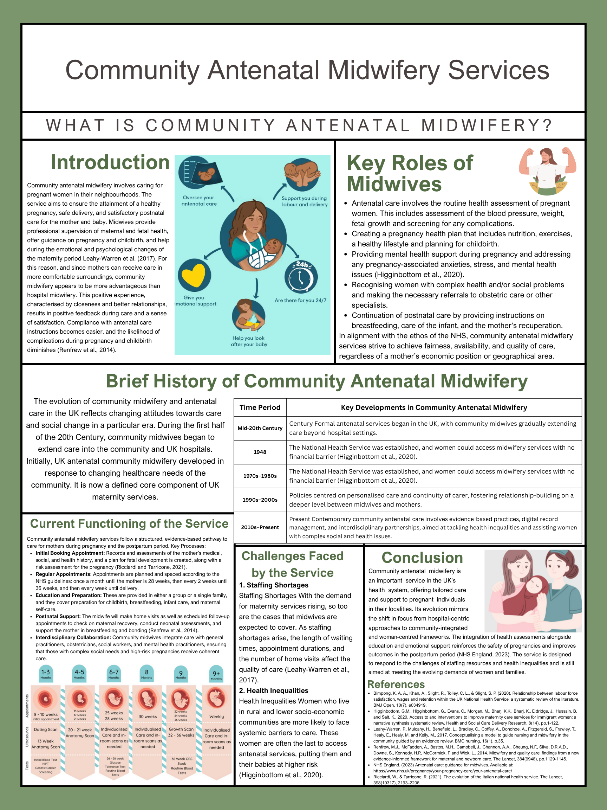

Task 2 – Essay
The Origins and Current Structure of the National Health Service (NHS)
In 1948, Britain created the National Health Service in response to the widespread consequences of the two world wars. It was also a response to the inequitable distribution of health care throughout the nation. Prior to the National Health Service, health care in Britain was determined by the social class and the financial status of the individual. Wealthy members of society had unrestricted access to health care services and paid for private health services. In contrast, the poor and working class had access to health care services only through inadequately provisioned voluntary hospitals, charitable organisations, municipal services, and other social services. The inequitable provision of health care services was precisely the reason the NHS was created (Carpenter, 2024).
Developments in the post-war period culminated in the establishment of the NHS. The war experience highlighted the necessity of public health for the productivity and social stability of a nation and the value of social solidarity. The Beveridge Report of 1942 more bluntly articulated the imperatives of the post-war period by identifying the five “giants” that needed to be slayed: Want, Disease, Ignorance, Squalor, and Idleness. Regarding the Disease giant, the report provisioned for “full and free” health service delivery to all, irrespective of financial means. The 1945 Labour government in the UK initiated the legislation to create the NHS, building on the principles of universality, comprehensiveness, and free service on delivery (Carpenter, 2024).
When delivering and funding health services and care on the basis of free availability, the NHS has removed the barriers to healthcare access and affordability. Services are offered, and healthcare resources are weighed, not on a patient's solvency but on one’s medical needs. This guarantees equitable availability to all. Moreover, the NHS integrated the system where, apart from hospitals, general practitioners and community and public health services also provided preventive and curative services together (Signorelli et al., 2020). These values continue to uphold the NHS today in its policy and service delivery.
The services offered by the NHS are a response to an expanding, ageing population, and the growing burden of long-term and chronic conditions, healthcare technologies, and the complexity of healthcare delivery. The NHS operates in vertically integrated layers in relation to governance and service delivery. NHS England oversees community health, primary care, and specialised care services. The Integrated Care Boards (ICBs), formerly known as Clinical Commissioning Groups (CCGs), arrange and provide local health services to meet the needs of the population. Healthcare service providers consist of hospitals, primary care, community health, and mental health services; intersectoral collaboration facilitates the delivery of comprehensive health care (Steenkamer et al., 2020).
Even with the achievements the NHS has made, it continues to face problems. These issues include an increasing demand, the impact of an ageing population, stretched resources, and delays in service provision. There are still access problems, particularly in remote and economically disadvantaged areas. The system problems could focus on service integration, the application of digital technologies in the health care system, and the emphasis on preventive care. These suggestions are in line with the NHS principles of comprehensiveness and equity (Steenkamer et al., 2020).
The creation of the NHS stemmed from the need for universal healthcare and the need to address the social inequalities in Britain after the Second World War. The principles of free healthcare at the point of delivery, equity, and comprehensiveness, adopted by the NHS, continue to guide the UK healthcare system. The principles of the NHS and the contemporary healthcare needs are demonstrated by the integrated governance, community services, and specialised care as part of the NHS structure. The NHS has a high level of integration and complexity. Socially, the NHS is still a fundamentally necessary system in the UK, and the system still aims to provide the population with healthcare that is free at the point of delivery, even if the system is still working with inequalities and unfulfilled demand in the workforce.

References
Carpenter, M. (2024). The Labour Movement in the National Health Service (NHS): UK. In Industrial Relations and Health Services (pp. 74–90). Routledge.
Royal College of Midwives. (2022) Community midwifery services. Available at: https://rcm.org.uk/
Signorelli, C., Odone, A., Oradini-Alacreu, A., & Pelissero, G. (2020). Universal Health Coverage in Italy: lights and shades of the Italian National Health Service which celebrated its 40th anniversary. Health Policy, 124(1), 69–74.
Steenkamer, B., Drewes, H., Putters, K., van Oers, H., & Baan, C. (2020). Reorganizing and integrating public health, health care, social care and wider public services: a theory-based framework for collaborative adaptive health networks to achieve the triple aim. Journal of Health Services Research & Policy, 25(3), 187–201.

