Iyesha Thomas (1714914)
1714914@student.uwtsd.ac.uk
Report
100%-mark, 5500-word count +/-10%
Lecturer Paul Bocij
Strategic management for sme
BMSW6104

Introduction

This report’s key objective will be to focus on and critically evaluate the strategies employed by a specific SME business, the Grayson’s Inn, located in Yardley, Birmingham, a small, independent, and local Public House, with a fully functioning kitchen and extra function room, which is currently in competition for market and customer shares within their community ,due to rival franchised Public Houses changing their services to combat the effects of the COVID-19 lockdown. This report will investigate and scrutinize the business, its hierarchy, stakeholders, structure, and prospects in order to gain a better understanding and insight into strategic management, and the advantages to be gained by employing and adapting industry theories. Recommendations and suggestions will be made along with ways for implementation, monitoring and reviewing any suggested changes. The report will use various academic and institutionally known business tools to critically assess the SME, such as advanced SWOT and PESTLE for the internal and external critiques, stakeholder analysis, power/interest grids to determine individual and company risk and rewards and academic researcher, using reliably sourced books, articles, websites, and journals.
Strategic management as defined by Lynch, 2018, “makes fundamental decisions about the future direction of an organisation: its purpose, its resources and how it interacts with the world in which it operates.”, by establishing the main aims of an organisation, you are able to plan ahead of time, ensuring that the business is not interrupted by and unexpected challenges or problems which may arise, this allows for the continuous development of the business and its future venture, to create and advantage over other business within the industry and focus on success more than failures that need rectifying . With an industry that generates over 22 billion pounds per year within the UK, (S.Locke, 2020), Public Houses, referred to as the colloquialism ‘pubs’ in this report, are lucrative businesses if managed and presented to the market well, they are versatile and due to the high demands of and on the market, are open to innovation.

Overview

Grayson’s Inn, is an independent, newly purchased, now family focused and run pub. The owner has many business ventures, ranging from food trucks to an engineering company. Formerly known as O’Mahoney Bar and Grill (What Pub, n.d) and prior to that La CC Restaurant and Bar, (Foursquare City Guide, 2020), it is still establishing itself in the area. Serving draft beers and ciders, mid-priced spirits and shot, a limited wine range and a small selection of snacks, they offer live sports, classic pub games and outstanding customer service, the Grayson’s Inn has started to gradually become recognized within the community and now create profit. Surrounded by some of the leading franchises in the market, JD Weatherspoons, Mitchel and Butlers and Greene King (Seymour, 2019), all well-established companies, in receipt of brand-loyalty from the patriots. Graysons Inn face the new challenges of establishing themselves as a permanent fixture within Yardley, as the prior property owners failed to do. Although they closed the pandemic, one re-opening they managed to retain their regular custom, however, there is a drop in new interests visiting the establishment, another challenges they face is an inactive food service, which all surrounding pubs and bars supply, however, they do possess the facilities required for this service to potentially be established. With COVID restrictions lifted, families and groups are more inclined to go out and have the option of food, decreasing the expected income of the Graysons Inn, plus their lack of online information and social presence makes it hard to market and promote any events they do hope to host. Prior to presenting new strategic plans to further develop the organisation, it must first be analysed, the managerial hierarchy within the Graysons Inn and the stakeholders share common denominators, this both simplifies yet complicates the possible success of the new strategies.

Mission and vision statement

A company’s vision refers to where it is the company strives to be in the forceable future, it is an indicator as to where the company would like to sit in the market, this is usually expressed with a statement, on that embodies basic principles and projects the expectations of the business. They are used to strategically manage, inspire and motivate those involved in the business, (Bowen, 2018). Whereas a mission statement is where a business gets to explain their core, their reason for existing in the market. They are valuable as they help to establish belief within the employees, some benefits are that this helps create a collective mind-frame, ensuring that all involved have the same priorities when it comes to work and decision making, values, work ethic and conduct, they are recognized as performance indicators, (David, et al., 2014). Unlike most companies Graysons Inn does not have a written mission statement, they have not focused on producing one either, instead they imply one, with the actions of the staff and management, the service provided and the continuous community involvement, they are instilling strong family principles and community values in their business. However, they have still managed to create a singular thought process, where all employees have the same goals, principles, and priorities, they have created a vision that is directly linked to the prosperity of the community, stakeholder, and the success in the market. Another part of the Graysons Inn’s mission is to establish a good relationship with the community and local authorities, prior to being Graysons Inn, Mahoney’s bar and Grill was well known by local authorities for breaking license agreement and requiring constant police presence.
By instilling practices that benefit the staff’s long-term achievement both personal and within the Graysons Inn. Mission statements and a companies strategic marketing are dependant on each other according to Darbi, (2012), regardless of the size of an enterprise, the mission statement and companies vission impact the growth of a business as they help to directly navigate both the direction and performance. By improving the prospects of their staff and the community, offering training and job opportunities, free room rental for community functions and fundraisers, activly donating to local charities and cause, ther contracts made with local suppliers and agencies, creating a good rapor with local authorities and police and their commitment to their customers and staff saftey and well-being, Graysons Inn hopes to hold a permenant spot amongst the local businesses and gain permenace within the market.

Strategies

In order to develop strategies, the business must first be placed within the current market and evaluate, in order to find its positioning. By understanding its stance in the market, there can be better understanding on how to gain competitive advantage within the market and over other businesses, this can help establish sustainability within the changing market. This report will be using the Porters 5 forces model to examine the position of Graysons Inn and its competitive advantages.
Porters 5 forces model is a framework created to help leverage the businesses advantages based on 5 crucial points within the industry that are essential if wanting to thrive. The 5 points of interest are the Bargaining power of the Buyer; the Bargaining power of the Seller; Threats of new Entrants; Threats of existing Competition; and the Threats of a Substitute, (Goyal, 2020).

Fig.(1) Porter's Five Forces Model (Hafezi, et al., 2017)
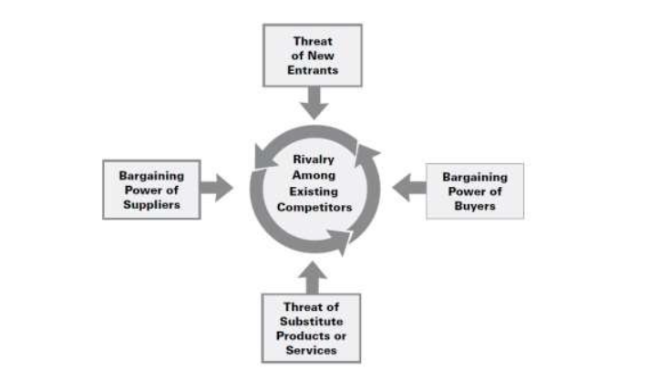
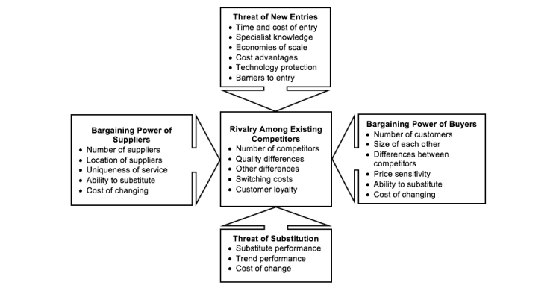
(Fig.2), Porters 5 forces with highlighted concepts (Bruijl, 2018).

Threats of new entrant
If there are new entrants to any industry always add tension to the market, by decreasing the shares available and the capability to retain them, this in return can disrupt cost, pricing and requirements to enter the market. When the impediments to access the market remain high, the threats of a new entrance are lowered, (Pringle & Huisman, 2011). One of the advantages that Graysons Inn have is that there are no Pubs local for lease or rent, the UK saw a decrease in Pubs of 15% in recent years, forcing the closure and the destruction of establishments, (Foley, 2022), with a demand for social housing, these building are being repurposed and turned into HMO’s(House in multiple occupancy), flats and hostel accommodations.

Threat of a substitute
Imitation and substitution of a product that has the same performance rate or better with comparable or replicated features and functions can impact the profitability of the industries market, it can cap pricing and effect the growth of businesses involved, others within the market may have to discount services, increase advertising and marketing, introduce new innovative ideas, and expand on services available, long-term it can have detrimental outcomes for a business, (Pringle & Huisman, 2011). With large franchises surrounding Grayson Inn, who have established themselves within the market, Graysons Inn is not under threat of a substitute. There are limited buildings available with in the local area, unsuitable for the necessary conversions required to create a pub or bar. This means the Graysons Inn can focus its efforts on customer retention and capture, establishing customer loyalty and maintaining their place in the markets local industry. By ensuring that their product is always held to a high quality and taking customer pinions into account, they can reduce the level f threat, if the customers continuously remain satisfied with the service provided, a substitute will find it hard to penetrate the market.

Threats of existing competition/ Rivalry against existing competitors
To retain a part of the market and limit your profit losses, you must be able to compete within the industry, threats from existing competitors can be seen in varying methods, such as service changes and improvement, the development of new products, new marketing strategies and also price drops and discount promotions, (Pringle & Huisman, 2011).
Graysons Inn, being independent have decided to continue supplying their customers with cheaper drinks than their competitors JD Weatherspoons and Greene King, who issued their customers with a courtesy message regarding a 10p price increase on their draft beers and ciders, this took place within the same time-frame the government issued a warning of living cost increases for the nation, (Rodger, 2022). As franchises, Graysons Inn’s competitors do not have jurisdiction or individual site control over their pricing and marketing, holding the majority of the market between them, they are obliged to review changes on a larger scale rather than individually as you would with a private company, (S.Locke, 2020). Although and advantage, Graysons Inn will have to continuously beat the competitors price, and if the financial implications change in favpur for the industry, then JD Weatherspoons and Greene King will gain an advantage, with their shares in the industry, they will be able to slash prices and offer promotional discounts that Graysons Inn is unable to contend with, a similar technique to gain market shares was used in 2021, where JD Weatherspoons offered selected drinks at 99pence, including beers and hot drinks, local independent pubs and bars where in threat of huge profit losses and some closure, this was promoted at a time when local bars where being forced to increase prices by 30p, (Forte, 2021).

Supplier Power
Limitations on suppliers with a high customer demand within the industry, especially when there are no viable substitutes available, create high supplier power, in essence the supplier can exploit this position by charging a superior rate for their services, whilst remaining valued by their buyers. (Pringle & Huisman, 2011). Fortunately for Grayson Inn there are limited breweries who supply the draft beers within the industry, were the suppliers (breweries) hold power is in the interest of Graysons Inn, they receive their supplies at the same rates as the lading competition, the only varying factors are that they do not require as much, so don’t qualify for certain bulk buying discounts, and they are able to as an independent chain, use other suppliers if their demands are not meet. Unlike their competitors who are locked into length contracts, seeing them replace many of their draft beers and ciders, despite the demand for them, (JDWeatherspoons, 2021).

Buyer Power
Customers can retain a lot of power over the acquiring of market shares, there demand for higher quality at lower prices the need for new and more enticing services and their freedom to explore the market, can impact profit margins and create further rivalry amongst competitors, this is usually detrimental to the industries overall profitability, (Pringle & Huisman, 2011). There are two industry competitors within the immediate vicinity of the Graysons Inn, (see Fig.2), this not only gives the customers multiple choices on where to frequent, but also provides them with high buyer power, they are able to impact the sales and market with demands, this is because within the local community there are limited customers compared to busy city centre. Graysons Inn will have to meet customer needs and demands in order to stay relevant within the industry, this can be done by focusing on the customers they retain, catering to their loyal patriots in order to maintain their value.

Force | Risk (Low/Med/High) | Impact (Low/Med/High) | Mitigation

- Threat of new entrants | Low | Med | - Focus on customer retention with deals and offers  - Reward customer loyalty with incentives  - Create an online presence to generate new custom
- Threats of substitute | Low | High | - Create new services  - Promotions and family focused advertising  - Explore customer expectations and actuality for improved services
- Threat of existing competition | Med | High | - Facilitate food onsite  - Create loyalty schemes on food and beverages  - Host free Community based events
- Supplier Power | Med | Med | - Source new suppliers  - Create stronger business relationships  - Negotiate long-term deals for reduced rates
- Buyer Power | High | High | - Become customer focused  - Evaluate customer feedback and suggestions  - Encourage community participation

PESTLE

Known as an external environmental scanning tool, a PESTLE can help a business to evaluate the position they are in, the external environment that businesses work within, Political Environmental, Social, Technological, Legal and Economic developments and changes, are not regulated by the business itself in any means, they are in actuality factors that can impact the business operations imminently, a PESTLE usually precedes a SWOT analysis, a tool used to determine the Strength, Weaknesses, Opportunities and Threats that may affect a business according to the external factors presented, (Perera, 2017).

Political
- The COVID-19 pandemic saw restrictions placed on the hospitality business; the Prime Minister of the UK encouraged the nation to avoid the sector, (Qureshi & Fyans, 2020), they have now been lifted, however, with COVID-19 cases increasing, there have been talks within Parliament to create a system of self-monitoring and responsibility, encouraging people to only travel for essential and necessary reason, (Finnis, 2022).

Economical
- With living cost rising in the UK, there are huge financial pressures being placed on the public, the British economy face a fuel and energy cost, (Francis-Devine, 2021) increase as well as a potential economic pressures, due to the current dispute in the Ukraine , (Francis-Devine, et al., 2022). With interest rates increasing, the impact of Brexit and COVID-19,his could potentially have the British public spending less money on luxuries and more on necessities, in order to manage with the current economy (Halstead, n.d.).

Social
- With the COVID-19 pandemic encouraging families to stay inside, the British public found new ways to socialise within their restriction. Limitations that were put on pubs were not necessary at home, alcohol being cheaper in supermarkets, incited socialising at home, more people opted to continue this cheaper alternative once restrictions were lifted, (Halstead, n.d.).

Technological
- With apps available that allow customers to order food and drinks directly to their table, pay tabs on their phones and book/reserve tables. Technology is shaping the new way in which people will frequenting pubs and bars. Not investing in technology will limit potential earnings and customer retention. Customers are always looking for new, easier, innovative ways to obtain and pay, more people are investing in contactless devices, less are carrying cash when going out.

Legal
- Hospitality legislations and requirements are continuously changing in the aid of public interest, pubs and bars are currently in a drug epidemic, with substance abuse reports on the increase, pubs have a duty of care to the public, and it is a legal requirement to discourage the sale and use of drugs within establishments, however, upholding this policy is difficult and costly, there are petitions awaiting parliamentary considerations, one of which is to increase security requirements, (extra cost to individual establishment), which may impact the outgoing cost of the hospitality sector long-term.

Environmental
- Restrictions on plastics and non-recycled materials have created a change within the industry. Pubs are under continuous pressure to keep up with the newest government anti-pollution regime, the waste produced by the industry has been criticised, prompting more sustainable methods, such as paper straws, multi-purpose plastics eco-friendly cleaning supplies, although they are not legal requirements, customer expectations have put pressure on pubs to purchase sustainable products.

SWOT Analysis
This SWOT analysis will identify key indicators that can play a role in the success of Graysons Inn accumulating market advantages. The key points recognized by this framework will be used to create and advanced SWOT, which will identify the factors needing focusing on to implement strategic growth and management within the establishment.

Strengths
- Independent infrastructure/ Controls of the entirety
- Independent financial backing, no need for loans or investors
- Ideal sought after location
- Loyal customers eager for improvements

Weakness
- Relationships with local business are basic
- Local police want to close pubs due to disruption
- Competitors are local and have access to more funds
- Do not serve food or hot drinks to the public

Opportunities
- Expand into food service
- Create an online presence
- Invest in local interest and expand the business
- Rent out function hall for secondary income

Threats
- COVID restrictions being imposed again
- Competition undercutting pricing to gain market advantage
- Economic crisis encouraging the public not to spend unnecessary
- Technological advancements within hospitality making cash obsolete as a paying method

Advanced SWOT

The purpose of an advanced SWOT further explores the impact the key highlighted points in the SWOT, then be able to prioritise specific points that can help the organisation take advantage of its position. By creating a scale and rating the importance of each point, a clearer picture should emerge, giving the company specific goals and targets to cater too.

This advance SWOT is rated from 1-4 on importance, (how significant is it currently), and weight, (how much it will impact the business), 1 being low priority and 4 being high priority.
The two figures are multiplied by each other giving a score between 1-16, the higher the score, the more importance it holds.

 | importance | Weight | score
Strength  1. Independent infrastructure/ Controls of the entirety  2. Independent financial backing, no need for loans or investors  3. Ideal sought after location  4. Loyal customers eager for improvements | 3  4  2  3 | 2  2  1  4 | 6  8  2  12
Weaknesses  1. Relationships with local business are basic  2. Local police want to close pubs due to disruption  3. Competitors are local and have access to more funds  4. Do not serve food or hot drinks to the public | 3  4  1  4 | 3  2  2  4 | 9  8  3  16
opportunity  1. Expand into Food  2. create A NICHE FOR THE BUSINESS  3.Invest in local interest and expand the business  4.Rent out function hall for secondary income | 4  2  1  3 | 3  2  2  3 | 12  4  2  9
THREATS  1.COVID restrictions being imposed again  2.Competition undercutting pricing to gain market advantage  3.Economic crisis encouraging the public not to spend unnecessary  4.Technological advancements within hospitality making cash obsolete as a paying method | 2  2  4  3 | 2  3  4  4 | 4  6  16  12

This advanced SWOT was created using the guidance of (Jurevicius, 2021).

Stakeholders

Stakeholder analysis have been steadily growing within the business industry, this is due to an increased appreciation for the individual needs off all involved in the decision-making procedures that come with stakeholder culpability (Brugha & Varvasovszky, 2000).
Graysons Inn Stakeholders Hierachy

The Graysons Inn is a family run business, this means the majority of stakeholders who hold power and influence are also taking on menial roles within the business, for example, the owner is both a customer and supplier and some the bar staff are both managers and cleaners.
Stakeholder mapping is used to determine which stakeholders require engagement and on what level, by deciding who holds power and interest and to what degree they hold it, makes it easier to strategically plan and can save time and resources. Not all stakeholders need informing of every decision, but some do. Differentiation is key, (Dolfing, 2018).
When mapping the stakeholders, for the purpose of this report, the multiple positions will be disregarded and focus will be on the main roles played, example Owner will not be categorized as a Supplier as well, as ownership wields higher power and influence.
The direction that an enterprise goes in depends on the stakeholder’s input and the influence they hold over the company, Stakeholders with high interest and influence require most interaction, this is because they wield the power to implement change and to direct the other stakeholders.
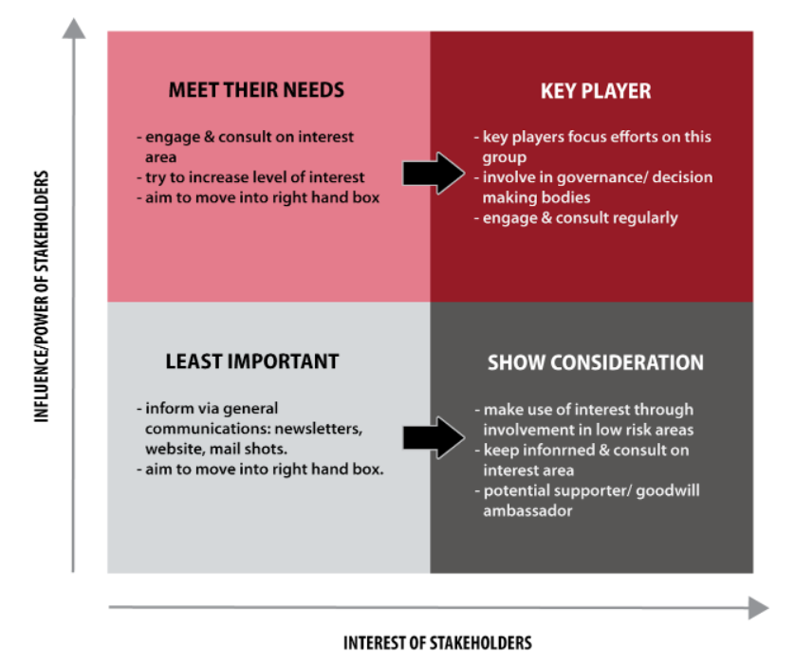

Fig.(3) Example of Stakeholder Mapping, using Medelow’s Matrix, specifying the level of engagement (Dolfing, 2018).

Mendelow’s Matrix on Graysons Inn
Management
Owner
High Powe/Low interest  Breweries  Suppliers  Local Authorities  Power  High  Keep Satisfied | High Power/High Interest  Staff  Manage Closely
Low Power/Low Interest  Security  Cleaner  Low  Monitor  (Minimum Effort) | Low Power/High Interest  Customers  Keep Informed

From the matrix, we can see whom and to what extent needs informing on decisions within the Graysons.

Growth

Strategic growth for Graysons Inn
The Ansoff Matrix is a tool used to help create strategic approaches, used to penetrate the market. Developed in the 1950’s it is still relevant and used throughout many industries today. It uses four simple points to deal with the market, (Lorendana, 2017).

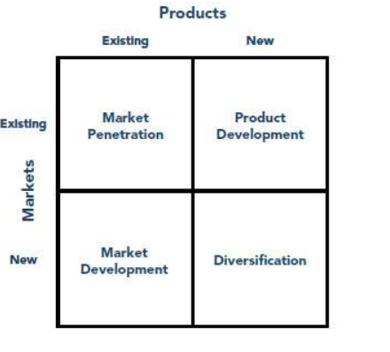

Fig.(4) Example of Ansoff’s Matrix, (Lorendana, 2017)

Market Penetration refers to the use of promotional events, discounted services and loyalty rewards as a way of capturing a larger percentage of the market.
Enticing new patrons with existing services be it international or domestic, is where Market Development is most lucrative.
The option to Diversify the market by targeting a new market and introducing new products can create a new platform to gain market success.
Or the option of Product Development, where the current market is explored, and new innovative services are produced.

Using the Ansoff matrix in tandem with the advanced SWOT and PESTLE the best way for Graysons Inn to gain advantage is to go with Market Development, this option allows them to create ways of capturing new customers.

Recommendations

Creating an online presence would be the best route for Graysons Inn, the lack of information available to customers limits their reach in the market. By establishing a social media presence, creating a website, and actively updating their information, new customers can be generated. Their competitors have a strong online presence, where bookings and events are available, as well as local information. This access and information are easy to set up and maintain. Customer retention is easier when the enterprise brands itself, the website will allow for the Graysons Inn to establish themselves and create a brand, not just a name. it creates a key place for communication with customers regarding promotions, events, and changes to schedule.

Graysons Inns competitors already have an online presence, and their customers are loyal, the customers that the Graysons Inn will entice will not affect the competitors, this means they will not have to react to the change in market. The customers they need to attract in order to increase profits are menial to those the competitors require, it will not affect the profits for their competition.

Conclusion

By using the methods that are presented in this report, the Graysons Inn can increase their market presence, profits and custom. The external analysis on the business reveal that there are many ways for them to increase their presence and for them to penetrate the market. The SWOT revealed where they are vulnerable, giving them the advantages of being able to co-ordinate any future changes and navigate them accordingly. The stakeholder analysis revealed whom in the business hold the power and has the most influence, identifying them allows for change to be me with little resistance. By employing the models presented, the Graysons Inn will be able to capture their share of the market.

(Fig.2) Mapping of immediate vicinity of Graysons Inn, highlighting competitors, William Tyler(JDWeatherspoons) Clumsy Swan (Private Limited Company),(Google, 2022).

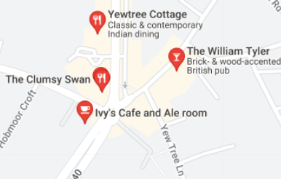

Statista market valuation
The pub industry in the United Kingdom had a total estimated turnover over 22 billion British pounds. Managed, branded and franchised pubs generate the highest revenue, compared to independent, tenanted and leased premises. The UK pub industry is forcast to grow in value by 2021.
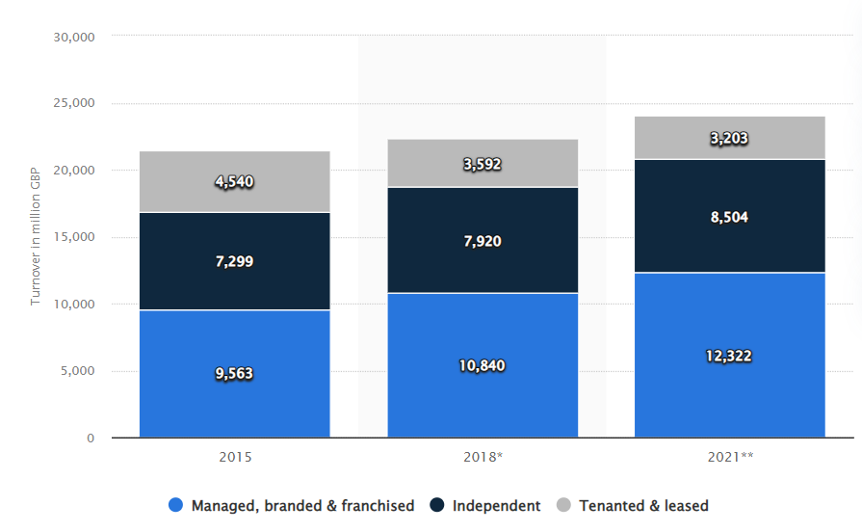
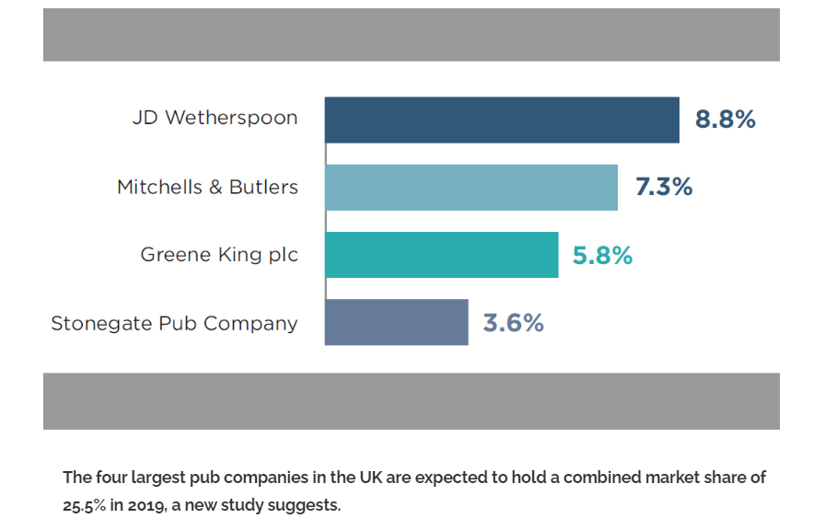
Datacrunch



