Personnel Resourcing and Development

Research Project Proposal–Impact of current challenges on the human resource department
BMIH500
Student Name:Lacramioara Petronela Maciuca
Student ID:2029141
Lecture name:Kathryn Roberts
Contents
Introduction 3
Background of Premier Inn Hotel 3
Literature 5
PESTLE analysis 5
SWOT Analysis 7
Employee lifecycle at Premier Inn 8
Evaluation 10
Conclusion 10
References 11

Introduction
The hospitality industry has experienced disruption and delays during the covid-19 pandemic which has drastically impacted the employee retention rate of many hospitality companies including Premier Inn (Sumption, 2022). Along with the impact of pandemic, the poor management, lack of training and lack of motivational strategy have lowered the employee retention rate of Premier Inn. This report will be analysing both the internal and external factors that are impacting the employee retention of the hotel for making the management understand how they should improve their strategy for retaining employee for a longer period.

Background of Premier Inn Hotel
Premier Inn is one of the United Kingdom’s largest hotel brand which provides limited hotel services. The brand occupies more than 800 hotels where there are almost 72000 rooms available (Steenbeck, 2021). In 1987, Whitbread has established the company in the name of “Travel Inn” for the purpose of competing with Travelodge. There are multiple places where the company operates hotels such as suburbs, city centres, airports etc. In 2004, Travel Inn has merged with Premier Lodge and formed Premier Travel Inn which has named “Premier Inn” in 2007. Alison Brittain is the CEO of the hotel brand. Currently, Premier Inn is encountering challenges in retaining employee for a long time since its current employee retention rate is comparatively low. The company is failing in motivating the employee to stay loyal towards the company for giving their best performance. The poor management team of is one of the reasons behind the lack of employee motivation as well as low employee retention rate (Hariadi, 2021). Complaints have arisen against the salary system as well as the working environment. Employees are not satisfied with the salary and other incentives provided to them for their contribution in the company. Besides, the working environment is not comfortable enough for the employee to work without stress. Moreover, the motivational techniques used by rivals in the hospitality industry have negative impact on the employee retention rate of Premier Inn. The demand and popularity of employees in the hospitality industry is higher in the post pandemic as well as post Brexit. Lots of employee were terminated during the covid-19 pandemic which has created labour shortage. Companies facing labour shortage are hiring skilled employee by providing lucrative offers and implementing motivational strategy as a result poor management in Premier Inn can’t win the competition. Brexit also created labour shortage since the non-British employee had to leave their job.
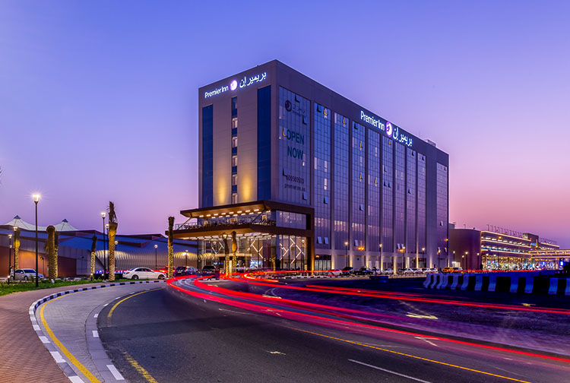
Figure01: Premier Inn Hotel Dubai.

Literature
Hospitality industry has become one of the biggest and fastest growing industries in the globe. The demand of skilled employees is rising rapidly in the hospitality industry since new businesses are emerging in the industry (Anderson et al., 2021). Even though the hospitality industry is highly competitive companies want to gain success and sustainability through implementing new and effective strategies. Human resources of an organization are the most important asset who are capable of achieving competitive advantages. They can also be defined as the life blood of both manufacturing and service companies. Employees should be kept motivated and satisfied through providing development opportunities, work environment, work-life balance, effective leadership, motivation and social life. But Premier Inn has been dealing with low employee retention rate which is why its human resources are not effectively contribution in gaining competitive advantages. Premier Inn has both internal as well as external impact on its employee retention. Identifying the reasons that’s are directly linked with poor employee retention rate is the objective of this research. It will also analyse the most effective ways of motivating employees for retaining them in the organization.

PESTLE analysis
PESTEL analysis is an effective framework used by organizations for assessing the impact of external factors including political, economic, social, technological, legal and environmental factors on the business operations (Madsen and Grønseth, 2022). Premier Inn has been facing low employee retention rate which might be due to the negative impact of external environmental factors. For finding out whether the external environmental factors have any association with the employee retention of Premier Inn a thorough PESTLE analysis will be conducted.
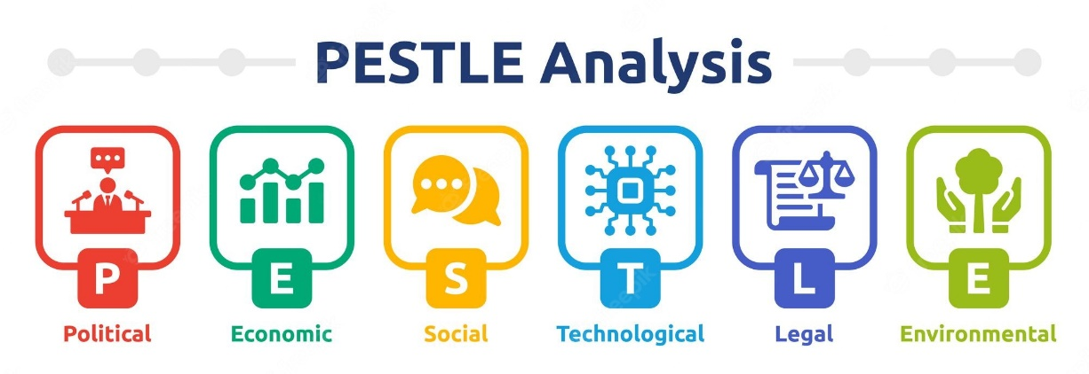
Figure02: PESTLE analysis.
Political: UK hospitality industry is significantly depended on the legislations that are imposed by the law makers of the parliament. Immigration laws, taxes, competition of the country directly influence the daily activities of the Premier Inn. The covid-19 pandemic has compelled the law makers to impose travel advisories and restrictions in any kinds of travel which has negatively impacted the overall operations of Premier Inn hotel (Reuschke and Houston, 2022). With the limited movement covid-19 regulations many tourists as well as local residents had lost their interest in using the hotel facilities. Almost all of the operations of the Premier hotel was paused at that time. The low taxes facilities of the government has supported the hotel in sustaining the negative impact of civid-19.
Economic: the booking of Premier Inn hotel were limited due to lockdown and restrictions on travelling during covid-19, global economic difficulties and a strong British sterling Pound (Cuc et al., 2022). The UK government has imposed relaxed travel advisories which is why some tourist are booking for high end hotels only for emergency. Due to the strong pound, tourists are still not that much interested in booking luxury hotels like Premier Inn.
Social: The changing behaviour of British people on preferring private accommodation more than hotels are impacting hospitality industry. Lots of customers of Premier Inn have switched to Airbnb. Poor management is responsible behind such experience which has also impacted on employee retention. Premier hotel has included some additional services in response to that behaviour. They have added massage parlour service, gyms for attracting young people (Islam et al., 2022).
Technological: The availability of advanced technology including 5G has made it possible for Premier Inn to provide online customer services for booking, checking even for cancelling. This has helped in more interactions between the employee and the customers. But the breach in information system hampers the privacy of client’s personal information which discourage many customers in using online services. The unsecure online hotel operations has increased the worries of high end customers about their safety.
Legal: The insecure data protection system in Premier Inn has influenced the customer to complain against the hotel by the utilization of General Data Protection Regulation Act which is for protecting the UK residents and visitors from any data breach (Yan et al., 2021). Premier Inn does maintain Health and Safety Acts, Gas Safety Act for ensuring safety of the visitors.
Environmental: Premier Inn uses smart technology which has reduced pressure of United Kingdom on available resources. It uses environmentally friendly factors including water-efficient showers and energy-saving lights solar energy. The use of eco-friendly energy has attracted many more customers. Premier Inn is that kind of hotel which is not facing impact of global warming due to its operations rather from other sources.

SWOT Analysis
SWOT analysis is a method which is used by organization for identifying strengths, weaknesses, opportunities and threats (Benzaghta et al., 2021). By analysing the internal factors strengths and weaknesses of an organization can be assessed while the opportunities and threats can be assessed by the analysis of external factors. Premier Inn Hotel has been impacted by both the internal and external factors which is why it is facing problems with its employee retention.
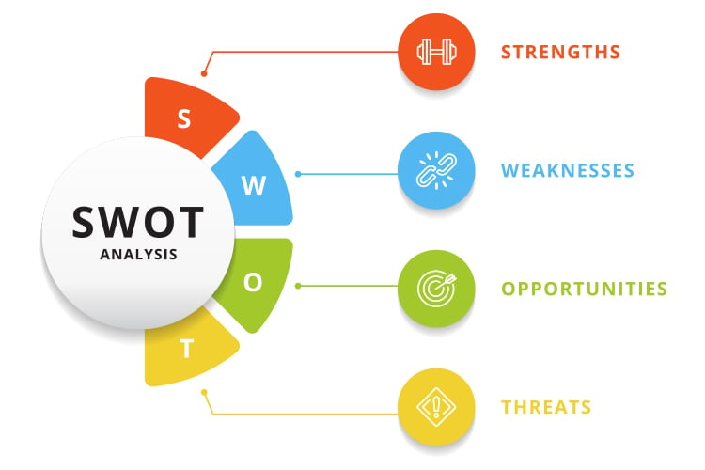
Figure03: SWOT analysis.
Strengths: There are huge numbers of diversified sites which made the customers satisfied with its services. There variety of services of the hotel which made it possible for the customers to meet their necessities as per their financial stability. The environmental friendly services is another strength of Premier Inn in attracting more customers.
Weaknesses: Less global presence compared to other hospitality industry is one of the biggest weaknesses of Premier Inn (Carlo, 2021). Besides, the potentiality of the breach of information has arisen some issues which can impact negatively.
Opportunities: There are three major opportunities for Premier Inn. Verity of strategic mergers across multiple regions in Europe and around the world mostly in Ireland and German is such a great opportunity for expanding business. The opportunity of digital marketing through the effective utilization of advanced technology can also expand business of the hotel. Commercializing positive customer services is another opportunity by providing quality customer care services in various sites.
Threats: The increasing competition is the most dangerous threats for Premier Inn since its customers are switching to Airbnb (Yap et al., 2022). Customers are complaining against the data breaching which is negatively impacting the credibility of the hotel. As a result Premier Inn might lose its customers base to the competitors.

Employee lifecycle at Premier Inn
As per the national statistics the number of vacancies have reached to 1.1 million in 2020 between July and September which has generated labour shortage for almost all of the industries (Sumption et al., 2022). Covid-19 has reduces the sales of Premier Inn as a result the hotel company has experienced minimum £1bn annual loss as sales have fallen by almost three-quarters. After the pandemic has slowed down Premier Inn stared to recover by increasing sales. But Whitbread, the owner of Premier Inn has expressed that the supply chain problems as well as the staff shortage may pose risks on the recovery of the company. During the summer and autumn, Premier Inn has experienced challenges with very high occupancy levels associated with hospitality sector staff shortages and market-wide supply chain issues. Whitbread has also said that a material number of vacancies are still available through the £12mln-£13mln of pay rises has already been written for the running year. An additional £10 million will be spent for retention bonuses for retaining hotel and restaurant stuff during the second half of 2022. Due to the pay rise, less employees have left job than anticipated. As per Whitbread, 20% workforce of Premier Inn hotel are EU national. Due to the Brexit more than 130,000 EU nationals have left UK as per ONS estimation which might create labour shortage in Premier Inn hotel (De Lyon and Dhingra, 2021). Some employees have complained against the bullying practice at workplace and the neutral role playing of the management in stamping out workplace bullying. The monotony as well as the pettiness in the workplace also discourage employee in staying at the hotel (Jones and Comfort, 2021). Premier Inn will need to employee additional 2000 employee for reception, housekeeping and kitchen. It should employee skilled and competent employee who are have maintains workplace ethics and moral. It is the responsibility of the associates of Marriot Hotel to upgrade the legality, morality and ethical standards so that a praiseworthy organizational environment can be established for retaining employee. Premier Inn should properly monitor the bullying practices and take effective measures for ensuring bullying free workplace for the employee to work comfortably.
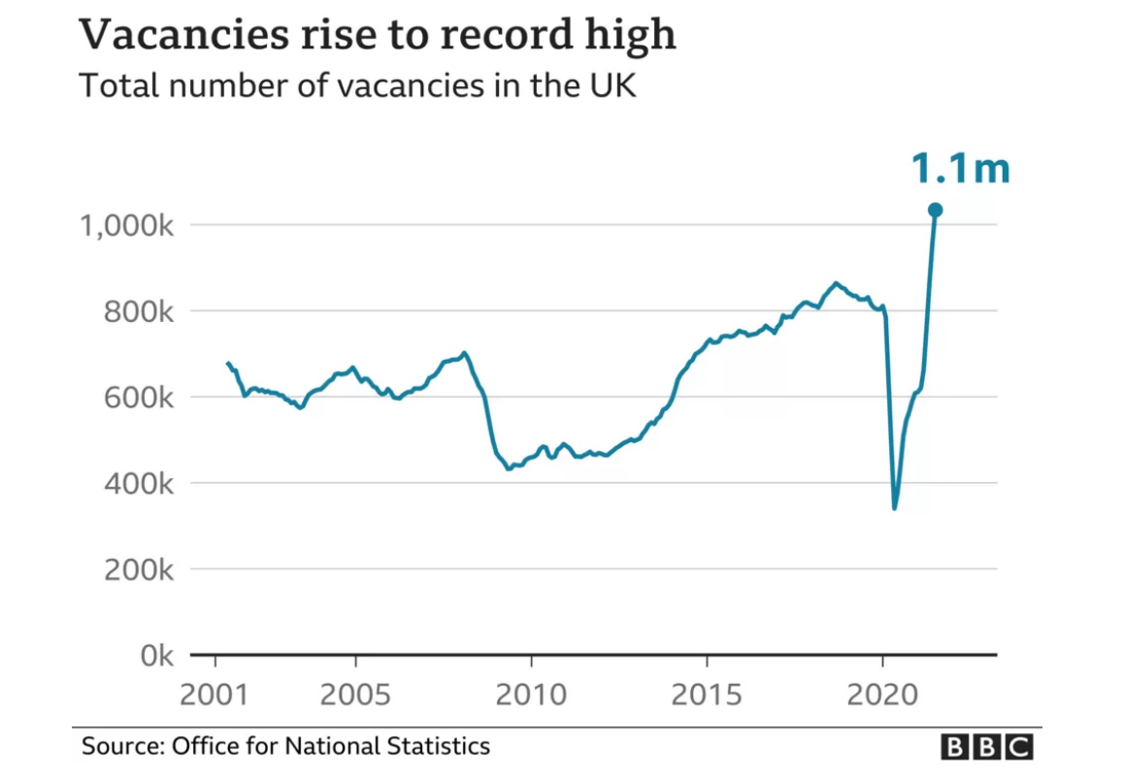
Figure04: Total number of vacancies in UK (Source: Office for National Statistics)

Evaluation
The reasons behind the problems that the Premier Inn Hotel has been experiencing with retaining its employee can be the labour shortage, impact of covid-19, Brexit, poor management of the company, lack of motivation and leadership strategy for making the employee stay at the company. The external environmental factors such as political, economic, social, technological, legal and environmental have impact on creating labour shortage in the hospitality industry. Since competitors are implementing strategies in recruiting new employee for filling up vacancies it has become challenging for Premier Inn to hire and retain employee with its traditional strategies. The strengths and opportunities of the company are not much for overcoming the weaknesses and the threats. Fierce competition with the rivals making Primer Inn vulnerable that employees are no longer feeling safe and comfortable. Recently Whitbread has taken measures for retaining employee by raising pay and declaring retention bonuses which seems to work in the future. It should also conduct business more strategically for winning the competition and for not losing both employee and customers to the competitors. The workplace environment should be made breathable, safe, comfortable and danger free.

Conclusion
Hospitality industry has a higher demand of employee which is why problems with employee retention have become very common. Employees have many options to switch since they are not loyal and ethically bound to any company. Premier Inn should ensure ethics and morale in the human resource departments so that employee fee obliged to the company to stay without being manipulated by lucrative offers of the competitors. This way Premier Inn will be able to motivate employee by providing retaining bonus and ensuring pay rise.

References
Anderson, B., Poeschel, F. and Ruhs, M., 2021. Rethinking labour migration: Covid-19, essential work, and systemic resilience. Comparative Migration Studies, 9(1), pp.1-19.
Aprilioni, J.R., 2017. Studi Deskriptif Pengembangan Sumber Daya Manusia Pada Premier Inn Hotel Surabaya. Agora, 5(2).
Benzaghta, M.A., Elwalda, A., Mousa, M.M., Erkan, I. and Rahman, M., 2021. SWOT analysis applications: An integrative literature review. Journal of Global Business Insights, 6(1), pp.55-73.
Carlo, C., 2021. Critical Success Factors in Hotel Companies: A Managerial Perspective. Journal of Tourism and Hospitality Management, 9(2), pp.1-7.
Cuc, L.D., Feher, A., Cuc, P.N., Szentesi, S.G., Rad, D., Rad, G., Pantea, M.F. and Joldes, C.S.R., 2022. A Parallel Mediation Analysis on the Effects of Pandemic Accentuated Occupational Stress on Hospitality Industry Staff Turnover Intentions in COVID-19 Context. International Journal of Environmental Research and Public Health, 19(19), p.12050.
De Lyon, J. and Dhingra, S., 2021. The impacts of Covid-19 and Brexit on the UK economy: early evidence in 2021. London: Centre for Economic Performance, London School of Economics and Political Science.
Ghandour, R., Bilal, J. and Mudassar, H., 2015. Relationship between Service Quality, Customer Retention and the role of Social Media-Case study Premier Inn Hotel (UK). Journal of Organizational Studies and Innovation, 2(4), pp.1-12.
Hariadi, D.A., 2021. Evaluasi dan Perkuatan Struktur Beton Gedung Hotel Premier Inn Surabaya Akibat Pembebanan Gempa SNI 1726: 2019 (Doctoral dissertation, Institut Teknologi Sepuluh Nopember).
Islam, M.A., Hack‐Polay, D., Haque, A., Rahman, M. and Hossain, M.S., 2022. Moderating role of psychological empowerment on the relationship between green HRM practices and millennial employee retention in the hotel industry of Bangladesh. Business Strategy & Development, 5(1), pp.17-29.
Jones, P. and Comfort, D., 2021. Modern Slavery Statements and Leading UK Hotel Companies. Athens Journal of Tourism, 8(3), pp.147-162.
Koswara, M.F., Dhewanto, W. and Nugraha, H., PROPOSED OF PIVOT STRATEGY FOR RESTAURANT BUSINESS DURING COVID-19 PANDEMIC WITH BUSINESS MODEL CANVAS ANALYSIS: CASE STUDY D’COLONEL BANDUNG.
Madsen, D.Ø. and Grønseth, B.O., 2022. PESTEL Analysis. In Encyclopedia of Tourism Management and Marketing. Edward Elgar Publishing.
Reuschke, D. and Houston, D., 2022. The impact of Long COVID on the UK workforce. Applied Economics Letters, pp.1-5.
ROROASIH, R.A., 2017. ANALISA STRATEGI ADMIN FOOD & BEVERAGE DALAM MENGOPTIMALKAN KEGIATAN ADMINISTRASI DI PREMIER INN HOTEL SURABAYA (Doctoral dissertation, Universitas Airlangga).
Steenbeck, A., 2021. Lübeck:„Premier Inn “baut direkt am Hauptbahnhof ein neues| SHZ.
Sumption, M., 2022. Shortages, high-demand occupations, and the post-Brexit UK immigration system. Oxford Review of Economic Policy, 38(1), pp.97-111.
Sumption, M., Forde, C., Alberti, G. and Walsh, P.W., 2022. How is the end of free movement affecting the low-wage labour force in the UK?. The Economics of Brexit: What Have We Learned?.
Terence, B., 2022. UK Economic Strategy Presents Opportunity for Businesses, Including Hotels, To'Level Up'.
Yan, Z., Mansor, Z.D., Choo, W.C. and Abdullah, A.R., 2021. How to reduce employees’ turnover intention from the psychological perspective: a mediated moderation model. Psychology research and behavior management, 14, p.185.
Yap, G., Saha, S. and Alsowaidi, S.S., 2022. The Competitiveness of Qatari Tourism: A Comparative and SWOT Analysis. Advances in Social Sciences Research Journal, 9(7), pp.187-210.

