Name of student: Paul Daniel Chirila

Student number: 1705947

Group members: Paul Daniel Chirila, Aron Popoiu,
Stanislav Kim, Claudiu Dobre,
Tatjana Budrekiene

Google Drive Username:
paul1705749@gmail.com
Password: UWTSD2018

Website email address:
stanislavkim11807730@gmail.com
Password: staskim1991

Task 1: Questionnaire

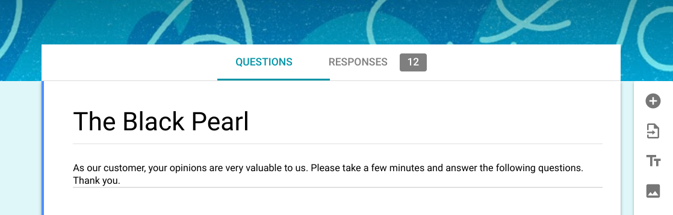

I manage by myself to gather 12 people to complete this survey, to help me to complete the task for this assignment.
My contribution to this questionnaire is 80%, and Aron Popoiu has contributed with 20%.

Question 1:

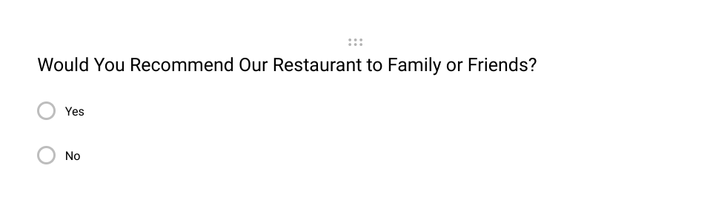

This question is basically the most important, because you will know if your customers would recommend your restaurant to others, will give you an understanding of the popularity of your restaurant. Depending on the client ’s positive or negative response you will be able to work on how to improve the restaurant.

Question 2:



This question was specifically designed to encourage customers to fill in survey about their experience at your restaurant. This tactic is vital because it helps you improve the quality, profits and build a reputation.

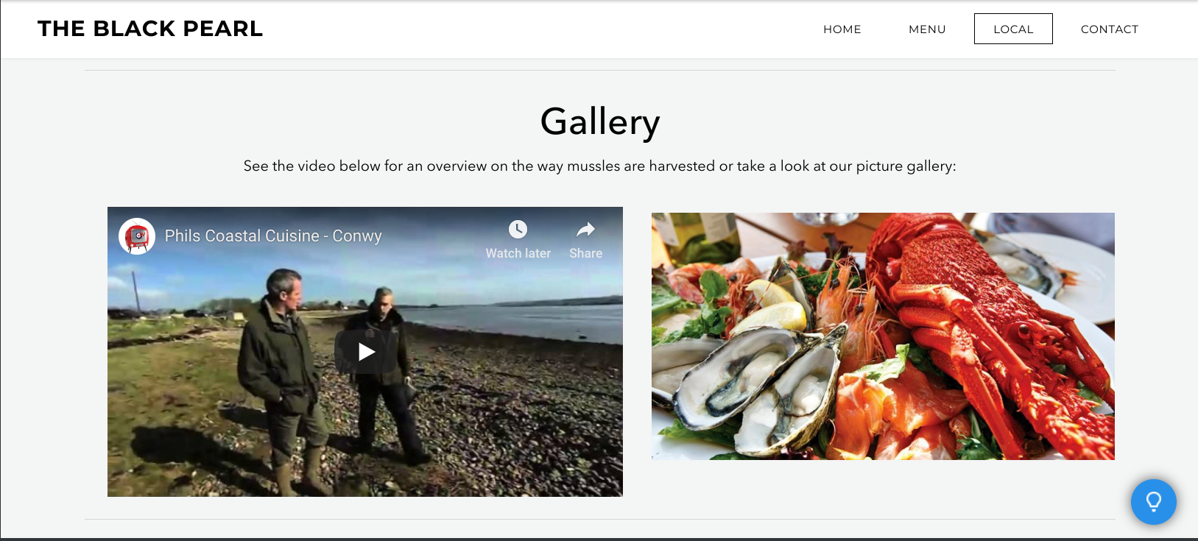
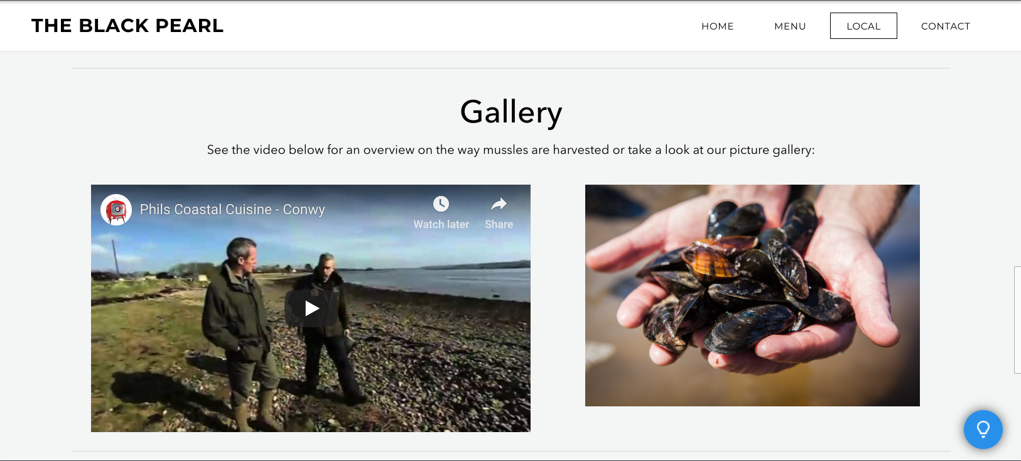
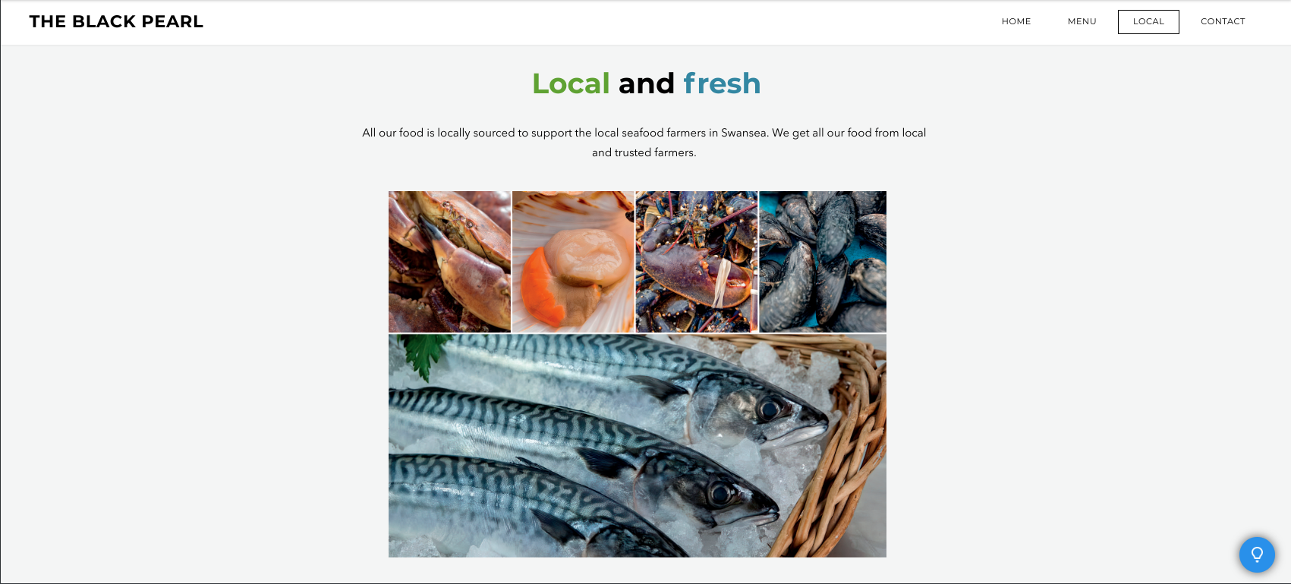
Task 2 Website: Local

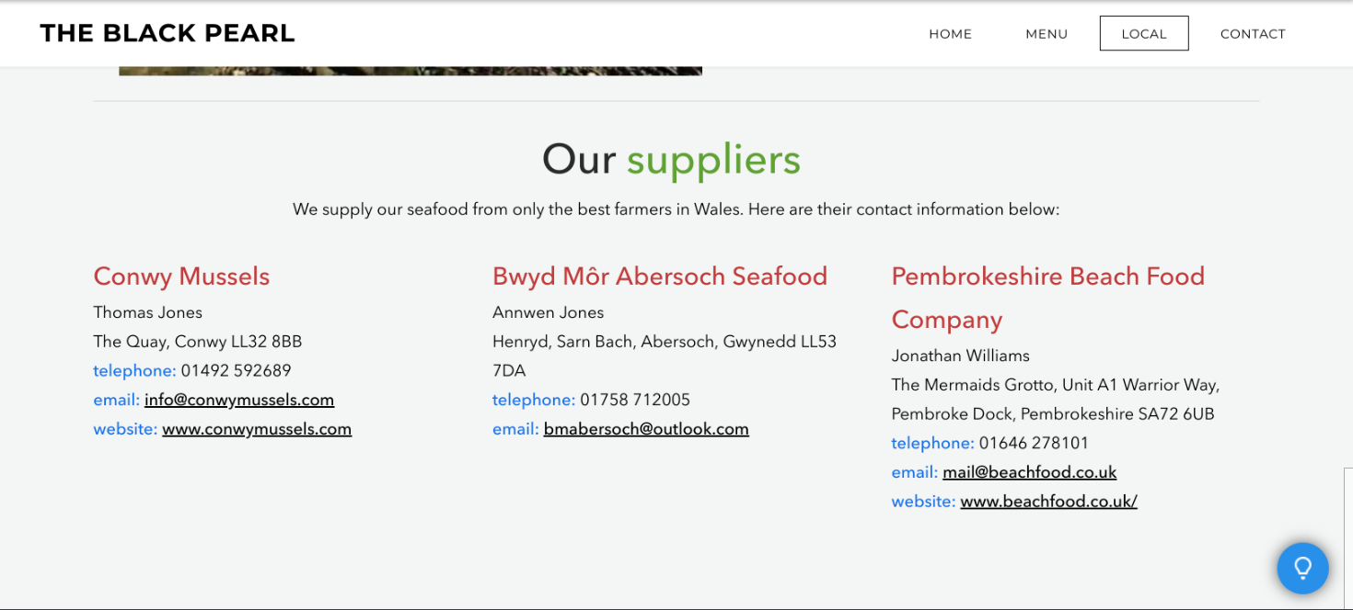

Description of how you went about choosing content, image and why.

The content is very important for your website because provides information about your product, to sell something or to offer a service. The way to provide this information is through content.
Providing users with the information that they are looking for in a clear and easy way can help keep users on your site and increase conversions.

When I first thought of choosing images to create my part of the website, I firstly looked for the best quality photographs, because people in general are attracted for color and imagery.
A great image always trump a website that looks professional.

