

ACADEMIC DISCIPLINE OF HOSPITALITY & TOURISM MANAGEMENT
BA INTERNATIONAL HOTEL MANAGEMENT
MODULE TITLE: HOTEL PLACEMENT RESEARCH PROJECT
MODULE CODE: BMIH6008
SUSTAINABLE GUEST EXPERIENCE CREATION IN THE HOTEL INDUSTRY: A STUDY OF BEST WESTERN ABBOTS BARTON HOTEL CANTERBURY
STUDENT NAME: ALEXANDRA ADRIANA POPA
LECTURER: Lisa Bassler
DATE:23/02/2025
AI acknowledgment statement
- I confirm that I have not used any AI tools in the research and creation of this assignment. I confirm that I have not presented any AI-generated materials as my own work. I confirm I have copies of my drafts, notes, and other resources I used. I may be asked to provide them as evidence.

Executive Summary
This paper aims at assessing the sustainability initiatives implemented by the Best Western Abbots Barton Hotel in Canterbury, with particular emphasis on energy efficiency, waste management and material supply. It addresses how these measures affect guest satisfaction and the hotel’s operational efficiency and provides solutions to enhance sustainability without compromising guest satisfaction within the hospitality industry. This literature review discusses sustainable guest experiences in the hotel industry, specifically energy conservation, waste management, and ethical sourcing. This paper explores how Social Exchange Theory applies to guests, discusses challenges associated with the implementation of sustainability initiatives and presents strategies to increase guests’ commitment to sustainability and address barriers in the hospitality industry. In line with the research objectives of this study, the researcher employed secondary research, netnography and self-observational data in identifying the sustainability practices at Best Western Abbots Barton Hotel. A qualitative research method classifies the guest feedback, employee observation and secondary data on guest experience of the particular hotel. Field-based case studies are employed to study actual life sustainability issues. This paper explores the Best Western Abbots Barton Hotel in Canterbury with reference to historical elements, sustainability aspect, and customers’ satisfaction. It also discusses the SWOT and PESTLE analysis of the hotel. Some of the findings include the hotel’s location, which is strategic, policy on the accommodation of pets and the environment, among others. This discussion aims at identifying the energy efficient practices, water conservation measures, waste management and guests’ participation in the Best Western Abbots Barton Hotel. There are some challenges that are as follows; High costs, usage of water in certain seasons, Single use plastics. The section outlines measures such as incentives, reportage, and local engagements as a way of improving sustainable guests’ experience. In the conclusion and recommendations section, the research presents the issues of sustainability for the hotel industry and the possible solutions such as, the use of technology, involving guests in sustainability practices, using sustainability-oriented loyalty programs, staff engagement, and local suppliers. These recommendations seek to increase the level of interaction with the guests, increase the satisfaction level of the customers and market the hotel as an environmentally friendly organisation.
Table Of Contents
1.0 Introduction 4
1.1 Background Infomation 4
1.2 Overview Of The Case Study Organisation 4
1.3 Key theme to be explored 5
1.4 Aims and objectives 5
1.6 Research Question: 6
1.7 Scope 6
2.0 Literature Review 6
2.1 The Concept of Sustainable Guest Experience in the Hotel Industry 6
2.2 Sustainability in the Hotel Industry of the UK 7
2.3 Theoretical Underpinning 7
2.4 Strategies Hotels Use to Create Sustainable Guest Experience 8
2.5 Customers' Behaviour on Receiving Sustainable Guest Experience 9
2.6 Issues Hotels Face in Offering Sustainable Guest Experience 9
2.7 Strategies to Mitigate the Challenges and Improve Sustainable Guest Experience 9
2.8 Conceptual Framework 10
2.9 Literature Gap 10
3.0 Methods: 11
3.1 Data Collection 11
3.2 Data Analysis 11
3.3 Research Strategy 12
3.4 Limitations: 12
4.0 Case Study Hotel Overview and Findings: 13
4.1 Overview Of The Organisation 13
4.2 SWOT Analysis Of Best Western Abbots Barton Hotel 17
4.3 PESTLE Analysis Of The Organisation: 19
4.4 Competitor Analysis 20
4.5 Netnography: 21
4.6 Personal Account On The Experience And Observations Of Working At Best Western Abbots Barton Hotel in Canterbury 22
5.0 Discussion: 25
5.1 Theme 1: Current state of sustainability of guest experience in the hotel industry with reference to Best Western Abbots Barton Hotel in Canterbury. 25
5.2 Theme 2: Issues persisting in offering the sustainable guest experience in the hotel industry 26
5.3 Theme 3: Effective strategies to improve sustainable guest experience in the hotel industry. 27
6.0 Conclusion: 29
6.1 Recommendations: 29
7.0 References 31

1.0 Introduction

1.1 Background Infomation
The hospitality sector pays much attention to making its operations environmentally sustainable to increase the awakening factor in guest experiences. Best Western Abbots Barton Hotel in Canterbury can be used as an example of the prospects of sustainability in the industry excluding the deterioration of the service quality. This paper analyses such measures as energy conservation, waste management, and sustainability of materials, determining the extent to which they contribute to the creation of guest satisfaction and organisational robustness. In light of the discovery of the ever-increasing demand for sustainable products by consumers in the hospitality industry, evaluating the sustainability index is useful in establishing the extent to which the framework is helpful in striking the profit-making without compromising the environment. Through comparison with other similar organisations in the industry, this analysis evaluates the ability of sustainable measures towards enhancing guests’ experience as well as the sustainability of business operations in the long-run among hotels.

1.2 Overview Of The Case Study Organisation
The Best Western Abbots Barton Hotel is a gothic architecture structure that was built during the Victorian era in Canterbury and it encompasses two acres of garden. So, one could conclude that thanks to the location of the hotel it is rather convenient when it comes to choosing a place for the night in the city centre. From the traditional rooms, it has the double standard, the twin single, single use and the executive suites, which are the most luxurious. Recent development that has taken place in the building are the up to date Westfield Bar to improve guest amenities. However, the recent remodeling has affected the main dining area as it is currently closed; however, other eating venues are available (Abbots Barton Hotel. 2025). A beautiful structure as well situated, certain parts of the hotel are still in construction even if at a slow pace.

Figure 1.2: Best Western Abbots Barton Hotel in Canterbury
(Source: Instagram.com. 2020)

1.3 Key theme to be explored
The research focuses on identifying the sustainable practices which are implemented in Best Western Abbots Barton Hotel in Canterbury. Some of the focused areas are: adoption of green practices, the guest’s perception of the outcomes, and achieving the ultimate managerial challenge of delivering luxury and sustainability. In addition, the study also seeks to establish how these practices affect the hotel brand image and organisational effectiveness.

1.4 Aims and objectives
Aims:
- The purpose of this study is to evaluate the current state of sustainability measures in this hotel and specifically assess how these measures influence guest satisfaction within Best Western Abbots Barton Hotel in Canterbury.
1.5 Objectives:
- To identify the current state of sustainability of guest experience in the hotel industry with reference to Best Western Abbots Barton Hotel in Canterbury.
- To evaluate the issues persisting in offering the sustainable guest experience in the hotel industry.
- To recommend effective strategies to improve sustainable guest experience in the hotel industry.

1.6 Research Question:
How can Best Western Abbots Barton Hotel in Canterbury enhance its sustainable guest experience by identifying current sustainability practices, addressing existing challenges, and implementing effective improvement strategies?

1.7 Scope
This paper aims to review the current practices in sustainability at the Best Western Abbots Barton Hotel in Canterbury to understand how they impact on customers’ experience. It describes barriers to the delivery of sustainable services and provides solutions for the same. The study encompasses an analysis of the hotel's environmental initiatives, guest satisfaction metrics, and operational policies. In this case, the following details the findings proffered by the study to the particular hotel; however, the implementation of the findings can be generalised to the hotel industry in its aim of striking a balance between environmental concerns and guests’ expectations. The result will be useful in the manner of integrating sustainability to the experiences of the guests as they will help in the development of sustainable solutions for the company.

2.0 Literature Review

2.1 The Concept of Sustainable Guest Experience in the Hotel Industry
Sustainable guest experience as a concept in the hotel industry therefore involves the implementation of socially, environmentally and economically responsible initiatives that would bring about positive experience for the guest while at the same time reducing the negative impacts on the environment. This concept entails the use of resources efficiently, procurement from sustainable sources, the minimisation of wastes and consultations with communities. Hotels should offer an unforgettable experience that does not have a detrimental effect on the environment or future profitability to gain competitive advantage (Moliner et al., 2019). Thus, the measures to support sustainability contribute to the hotel’s responsibility to meet the demand of new generation tourists, which is focused on environmentally friendly services (Merli et al., 2019). Hence, sustainable guest experience is an emerging topic of interest with an impact on operations and customers in hospitality management.

2.2 Sustainability in the Hotel Industry of the UK
Hospitality industry in the United Kingdom has also embraced sustainable development due to regulation, awareness of social and environmental issues, and customer demands. The Green Key certification and policies of the Sustainable Hospitality Alliance represent actions on the part of the industry towards environmental sustainability. A number of hospitality organisations have incorporated the use of renewable energy sources, water saving mechanisms, as well as the implementation of carbon reduction strategies (Kim and Kim, 2022). However, there are some problems which are currently being faced by the organisations, these are financial issues, sustainability issues in supply chain management and the issue of getting guests to cooperate on environmental issues. Nevertheless, UK-based hotels are gradually adapting to the international sustainability trends and implementing green technologies and circular economy strategies for improving organisational performance and promoting the sustainable management of resources (Khalil et al., 2024).
People’s perception towards sustainable accommodation has changed and as Statista (2024a) stated, in Great Britain 38% of travellers would be booking eco-friendly hotels by July 2024, in the following years. But as per a survey conducted in 2024, only 51% of the consumers were willing to pay a premium for sustainable hotels, and only 2% were willing to pay more than 50% extra (Statista. 2024b). This means that as awareness of the environment increases, the price factor is still a hindrance to sustainability practices in the hospitality industry. Therefore, it is notable that hotels have to introduce green initiatives and, at the same time, ensure that their prices are reasonable to appeal to consumers and meet the goal of sustainability.

2.3 Theoretical Underpinning
Thus, the Social Exchange Theory (SET) remains a helpful lens when it comes to establishing a connection between sustainability practices and guests. According to the SET theory, people’s relationships depend on the exchange of something of value, and people weigh the costs and benefits of performing the given actions (Abdou et al., 2022). The guests of houses in the hospitality industry are willing to support sustainable measures where they are in a position to gain physical and psychological benefits like better health, ethical satisfaction and better quality services (Berezan et al., 2014). Hotels, in turn, gain customer loyalty, positive brand reputation, and operational cost savings. This theory also enhances the notion of communication and guest engagement in sustainability initiatives so as to share value creating experiences.
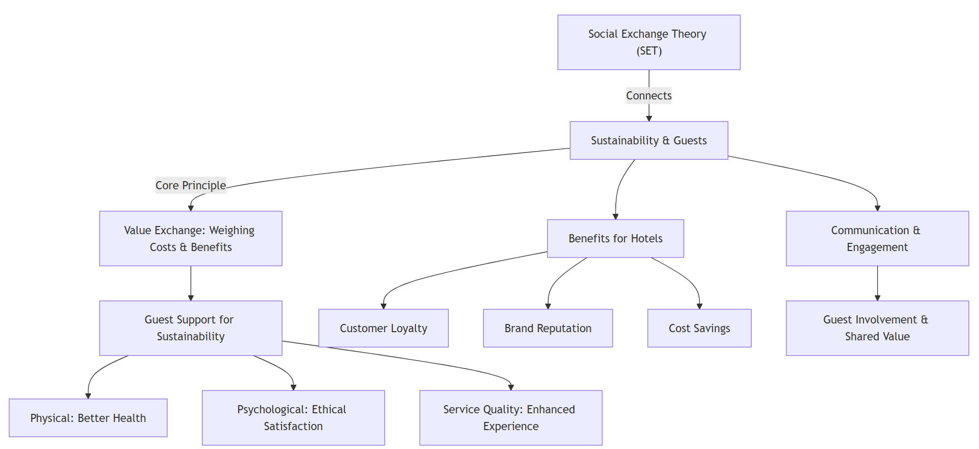
Figure 2.3: Theoretical Framework
(Source: Created By Learner)

2.4 Strategies Hotels Use to Create Sustainable Guest Experience
Several measures that hotels use to promote sustainability in guest experience involve the use of Social Exchange Theory to encourage positive interaction One approach that firms have widely adopted in the modern world is the one that deals with energy efficient systems for instance; smart lighting, climatic controls and renewable energy sources (Liu et al., 2024). On the same note, waste management such as recycling, composting and biodegradable packaging support the aspect of environmental sustainability while at the same time encouraging the guests to adopt environmentally friendly practices. However, the consideration of sustainable sourcing or sourcing for food and beverage services makes sure that ethical practices are followed in the procurement process and that there is a support to the local economy (Moise et al., 2021). In addition, hotels interact with the guests through other green initiatives like towel and linen reuse, which are well aligned with SET as a way of showing that everyone stands to benefit from sustainability (Olya et al., 2021).

2.5 Customers' Behaviour on Receiving Sustainable Guest Experience
The guests’ response to sustainable hospitality practices is moderated by perceived benefits, environmental concern and personal values. According to the previous research, sustainable customers also show a higher level of satisfaction with the hotels that they choose to stay in if they have given preference to sustainable hotels, but the quality of services should not be a concern (Merli et al., 2019). Social Exchange Theory postulates that guests are more likely to support green initiatives if they expect positive consequences which include; comfort, ethical satisfaction, and less harm to the environment (Abdou et al., 2022). However, there are chances of resistance if sustainable solutions are considered as a nuisance, expensive, or a thorn in the comfort of luxury. Communication of the effects of those sustainability initiatives can act as a connector and encourage guests to change their behaviours and embrace sustainable practices as indicated by Liu et al., (2024).

2.6 Issues Hotels Face in Offering Sustainable Guest Experience
However, there are several challenges that make it difficult to achieve the effective implementation of sustainable guest experience. The research explains one of the challenges facing the implementation of green technologies that include high initial cost which is required to invest in sources of green energy like solar panels and energy efficient structures (Berezan et al., 2014). Furthermore, it is also challenging to sustain guests’ participation in sustainability programmes as some clients may not have any concern over or interest in environmental conservation (Khalil et al, 2024). Ethical sourcing and management of wastes is an added challenge to supply chain constraints in sustainable operations. According to the Social Exchange Theory, guests may not accept sustainability measures as something positive but rather as a hindrance (Abdou et al., 2022). Hotels must thus ensure that they have proper sustainability strategies that will suit the customers and the general sustainability standards.

2.7 Strategies to Mitigate the Challenges and Improve Sustainable Guest Experience
In response to these challenges, there are several strategies that can be adopted in hotels as proposed by Social Exchange Theory; win-win strategies. Employee engagement and training education increases the effectiveness of communicating sustainable management to the guests, improving their engagement and satisfaction (Kim and Kim, 2022). Promotional strategies like offering clients a number of incentives for being environmentally conscious or offering incentives for being active in certain environmental conservation programs is another strategy (Liu et al., 2024). Further, the adoption of technology in implementing sustainable practice, including check-ins, no paper communication and AI energy management boosts effectiveness of operations without compromising on the environment (Moise et al., 2021). The study of Olya et al. (2021) has shown that transparency of efforts in sustainability made by hotels, along with proper communication with guests through electronic media and signages, enhance the guest’s trust and their willingness to engage in sustainability.

2.8 Conceptual Framework
Figure 2.8: Conceptual Framework
(Source: Created By Learner)

2.9 Literature Gap
Despite the fact that numerous studies have been conducted on sustainable guest experience, there are still some gaps that need to be addressed. First of all, more attention is paid to variations of consumers’ attitudes towards sustainable initiatives in general and in relation to luxurious rather than budget hotels. Secondly, most of the earlier works are more centered on the operational level of sustainability and not the psychological and behavioral involvement of the guests in sustainable activities (Liu et al., 2024). Furthermore, most studies focus on the business view of sustainability, leaving out the guest’s internal spirit and attitude (Abdou et al., 2022). Subsequent research should also incorporate the use of such theories such as the behavioural psychology and consumer studies in order to fashion appropriate sustainable marketing strategies that meet different consumers’ preferences. It will also help to close the gaps in the practical utilisation of sustainable guest experiences thereby leading to better outcomes in the industry.

3.0 Methods:

3.1 Data Collection
The research method used in the study is also secondary research that gathers data from previous research materials, industry data, and organisational documents to understand the sustainability practices of Best Western Abbots Barton Hotel in Canterbury. Secondary research allows for an understanding of the current status of the ideal sustainability models, consumers’ expectations, and standards set by other companies in the same industry (Saunders et al., 2012). Besides, netnography, a qualitative research technique that examines online customer reviews, blogs, and social media discussions has been employed to measure the guests’ experience of sustainable experience in the hotel according to Silverman, (2011). This method entails the collection of data from social media platforms as it provides real-time information of the consumer sentiments (Collis and Hussey, 2014). Secondly, self-observatory data is obtained herein whereby the researcher works for Best Western Abbots Barton Hotel. Exploratory research within the organisation provides effective information on the internal sustainability practices, staff participation, and guests’ attitudes (Marshall, 2015). This is in line with the interpretivist epistemology where the participants’ experience is crucial in developing an understanding of sustainable hospitality practices (Robson, 2016). Using these measures in synergy guarantees a comprehensive survey of the hotel’s guest satisfaction and incorporation of internal business data and external customer views.

3.2 Data Analysis
In the analysis of the study data, adopted data analysis technique is categorised as qualitative data analysis. This way one is able to identify overarching issues and relationships in line with sustainability of guests as stated by Grbich (2006). Categorisation is a classification of data into broad categories that could include things that may include aspects such as expectations of the guests, problems with operation and effects on the environment. This is useful in establishing the relationship between sustainability and customer satisfaction and the organisation’s functioning (Yin, 2003). The netnographic data of the guest reviews are then put into content analysis to ensure that the feedback that concerns the green issues like availability of environmentally friendly facilities, reduction of carbon footprint and the involvement of the guests in the conservation of the environment can be grouped (Veal, 2006). Moreover, self-surveillant data is ascertained through reflexivity whereby the employee reports his/her observation on the relevance and effectiveness of the measures as a hotel. To ensure the reliability of the work, a method of data triangulation is adopted whereby data is collected from more than one source, which include secondary sources, use of netnography and observation data as suggested by Saunders et al., (2012). This minimises bias when making the results and therefore makes the study more reliable as a qualitative study.

3.3 Research Strategy
Thus, conforming to the study’s research objectives, the study employs a case study research method, focused on Best Western Abbots Barton Hotel and aims at identifying how this facility promotes a sustainable guest experience. Yin, (2003) notes that case study is appropriate in researching real life events and situations that are complex in nature. It means that one is likely to learn about the hotel’s sustainability and customer involvement practices and its challenges (Robson, 2016).
In this study, the research design adopted was the single-case study to capture specific aspects of sustainability implementation in a mid-sised hotel in the UK. This is in line with the business research approach that analyses case studies as they offer practical experience and knowledge that can be applied to similar organisations in the hospitality industry (Collis and Hussey, 2014). The current work adds to the existing literature on sustainable hospitality by analysing the perception of the guests and the employees, and secondary data that can be used to provide recommendations on how to improve the guest’s environmental experience.

3.4 Limitations:
One of the limitations that can be noted when using the chosen methodology is the subjectivity of qualitative research and self-observational data. Employee feedback can be biased due to the fact that people base their interpretation of sustainability initiatives on their own experiences (Marshall, 2015). Also, netnographic data uses online reviews and thus it may not be able to capture all the guests hence there is a possibility of sampling bias (Silverman, 2011). The single-case study approach also has the disadvantage of limited generalisability of the results as the sustainability practices of Best Western Abbots Barton Hotel may not be typical of the industry (Yin, 2003). Last but not the least, secondary data may not be current enough or they may not be specific enough to support the study making them less accurate (Saunders et al., 2012).

4.0 Case Study Hotel Overview and Findings:

4.1 Overview Of The Organisation
Abbots Barton Hotel is one of the historical buildings located in Canterbury, England; it is a Victorian Gothic styled hotel that occupies two acres of well manicured land (Abbots Barton Hotel. 2025). Built in the 1830s as a private home, the hotel retains the historical features but at the same time has incorporated features suitable for today’s tourists.
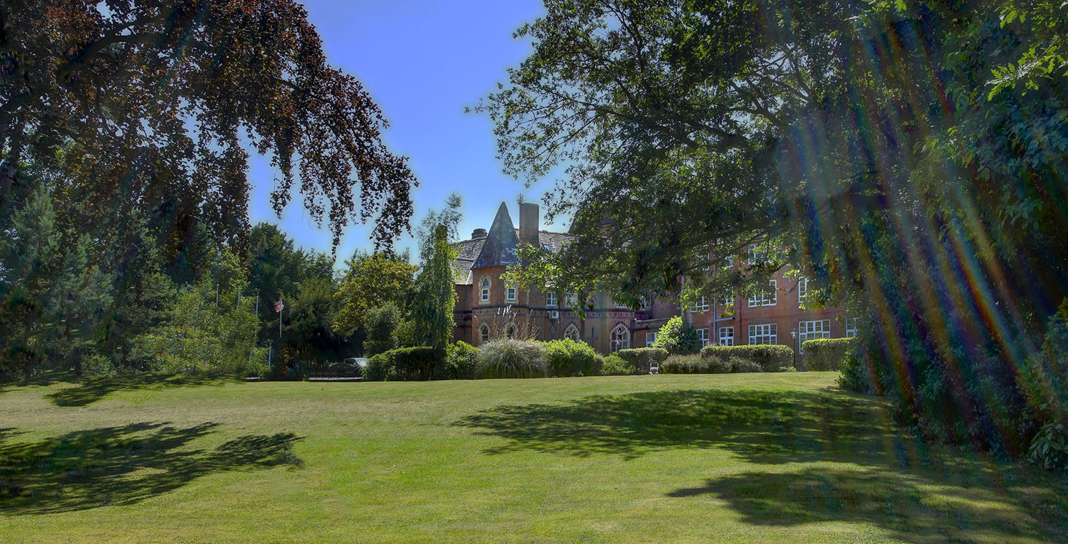
Figure 4.1a: Gothic Structure Of The Hotel
(Source: Best Western.2023)
Accommodation and Amenities
The hotel also provides standard single, double, twin, triple, and superior twin and double rooms, junior suites and deluxe suites, and superior deluxe twin and double suites. Every room has been provided with all amenities that can make the stay of the guests as comfortable as possible. There is free parking on the hotel premises and all the hotel accepts pets but on request for a certain fee (Abbots Barton Hotel. 2025).
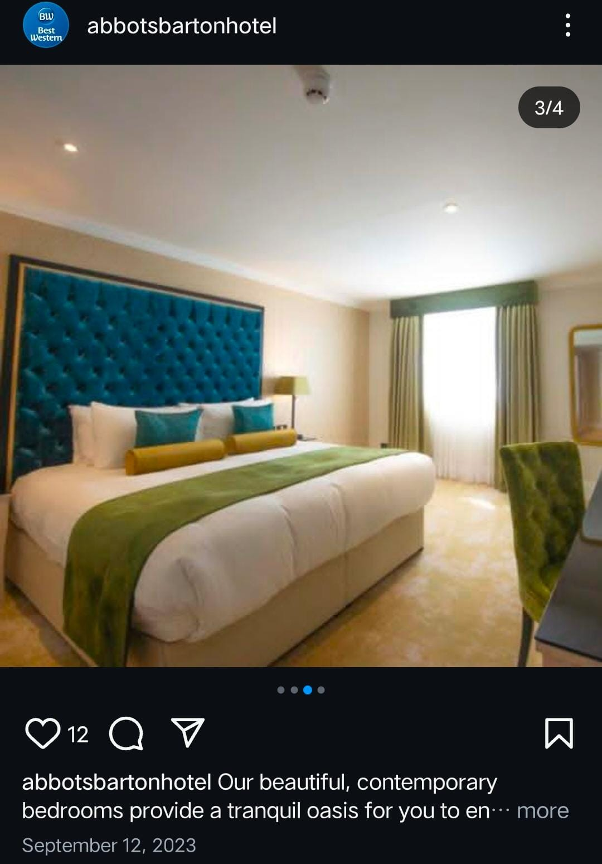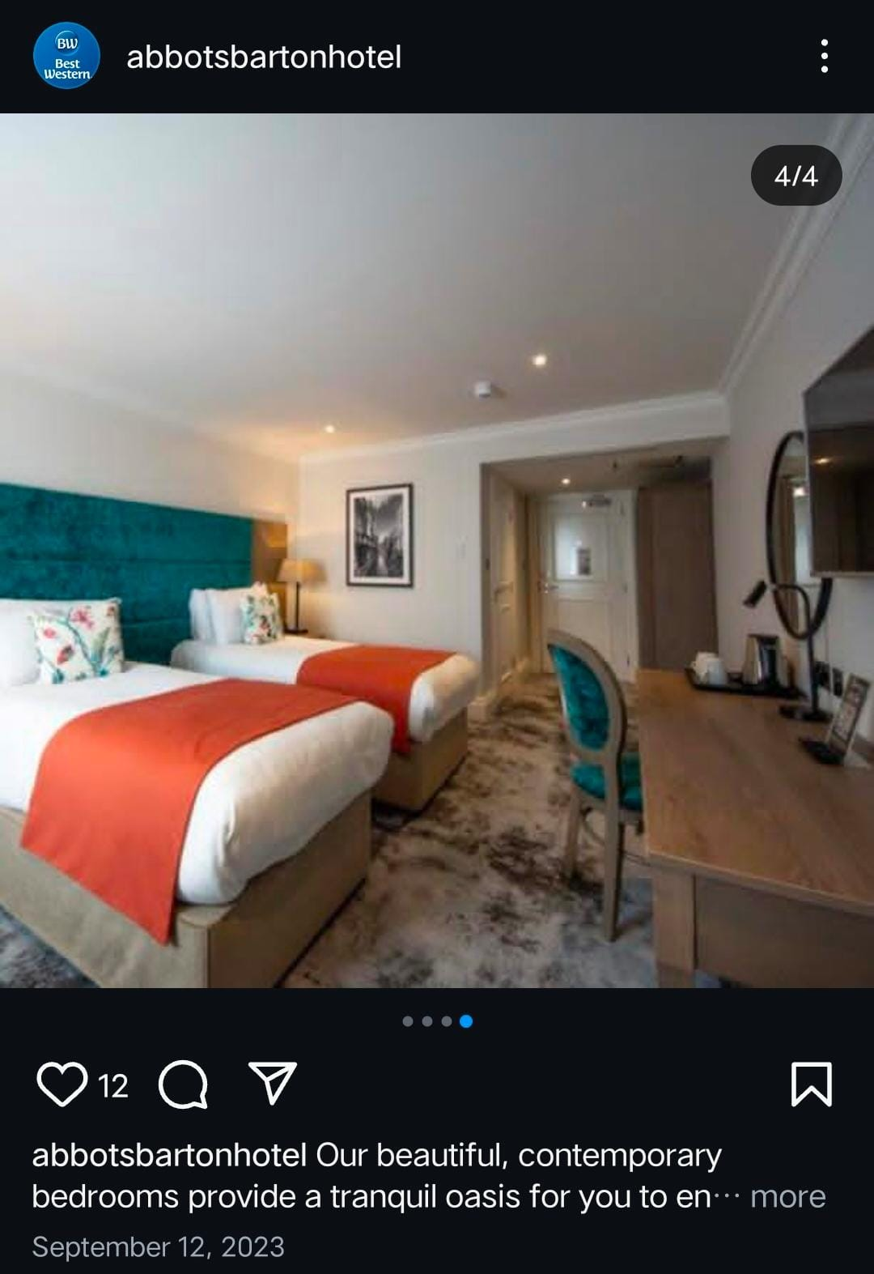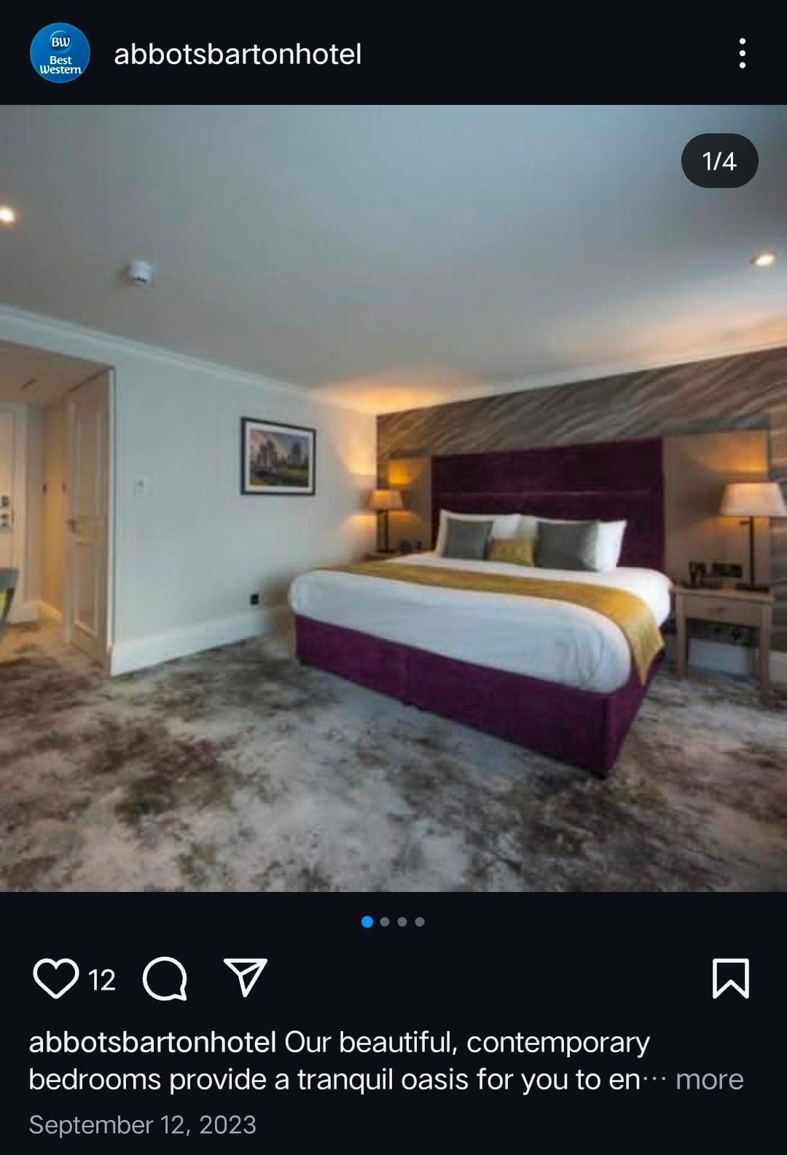
Figure 4.1b: Accomodation Facilities At Abbotts Barton Hotel
(Source: Instagram.com. 2020)

Dining Experience
Westfield Bar has been reopened, and the guests can savor different meals in the comfortable atmosphere of the newly designed bar. The bar offers appetizers, entrees, pizza, and desserts among other meals to suit the clients’ variety of tastes. Breakfast is taken in the Fountain Room which offers continental breakfast; however there is also a hot menu. What is more, the main restaurant is temporarily closed for renovations in order to improve the future guests’ experience (Abbots Barton Hotel. 2025).
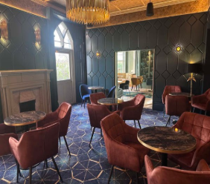
Figure 4.1c: Dining Experience At Abbots Barton Hotel
(Source: Best Western.2023)
Location and Accessibility
Located at a strategic location, the hotel is only 10 minutes’ walk away from Canterbury city centre, some of which include; Canterbury Cathedral, The Roman Museum, and Marlowe Theatre. For the further exploration, the Dover Ferry Terminal is located approximately in a twenty minutes driving distance and allows getting to the continental Europe (Abbots Barton Hotel. 2025).
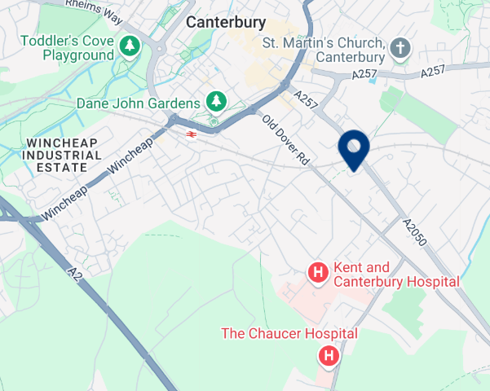
Figure 4.1d: Location
(Source: Best Western.2023)
Meetings and Events
There are good facilities for meetings, conferences and events available at the Best Western Abbots Barton Hotel with a large meeting room and grounds of two acres. The flexible venues are suitable for one on one interviews, group interviews of various sizes, and other events depending on the layout of the rooms (Abbots Barton Hotel. 2025).
Commitment to Sustainability
Despite the fact that many details of the building are conveyed in historical references, there is a strong focus on sustainable design. Some of the efforts are to buy fresh and certified ethical food from local producers and farms for the dining services, indicating the thinking of being environmentally conscious and supporting local businesses (Best Western.2023). The Best Western Abbots Barton Hotel in Canterbury is pet friendly as most of their rooms allow dogs to be taken inside for a £20 fee for each animal per night. The pets of the guests are also accommodated by offering them a comfortable bed and a bowl. However, dogs are not allowed to be in the suites and therefore guests who intend to bring them must inform the hotel earlier to make necessary arrangements (Best Western.2023).
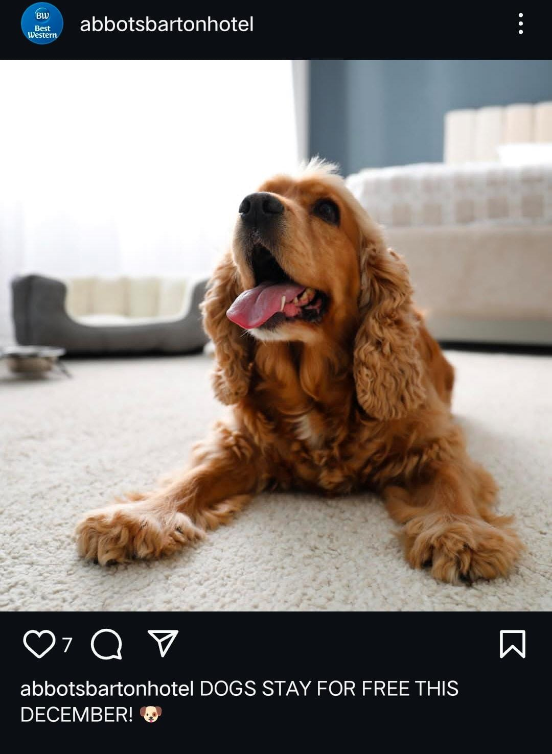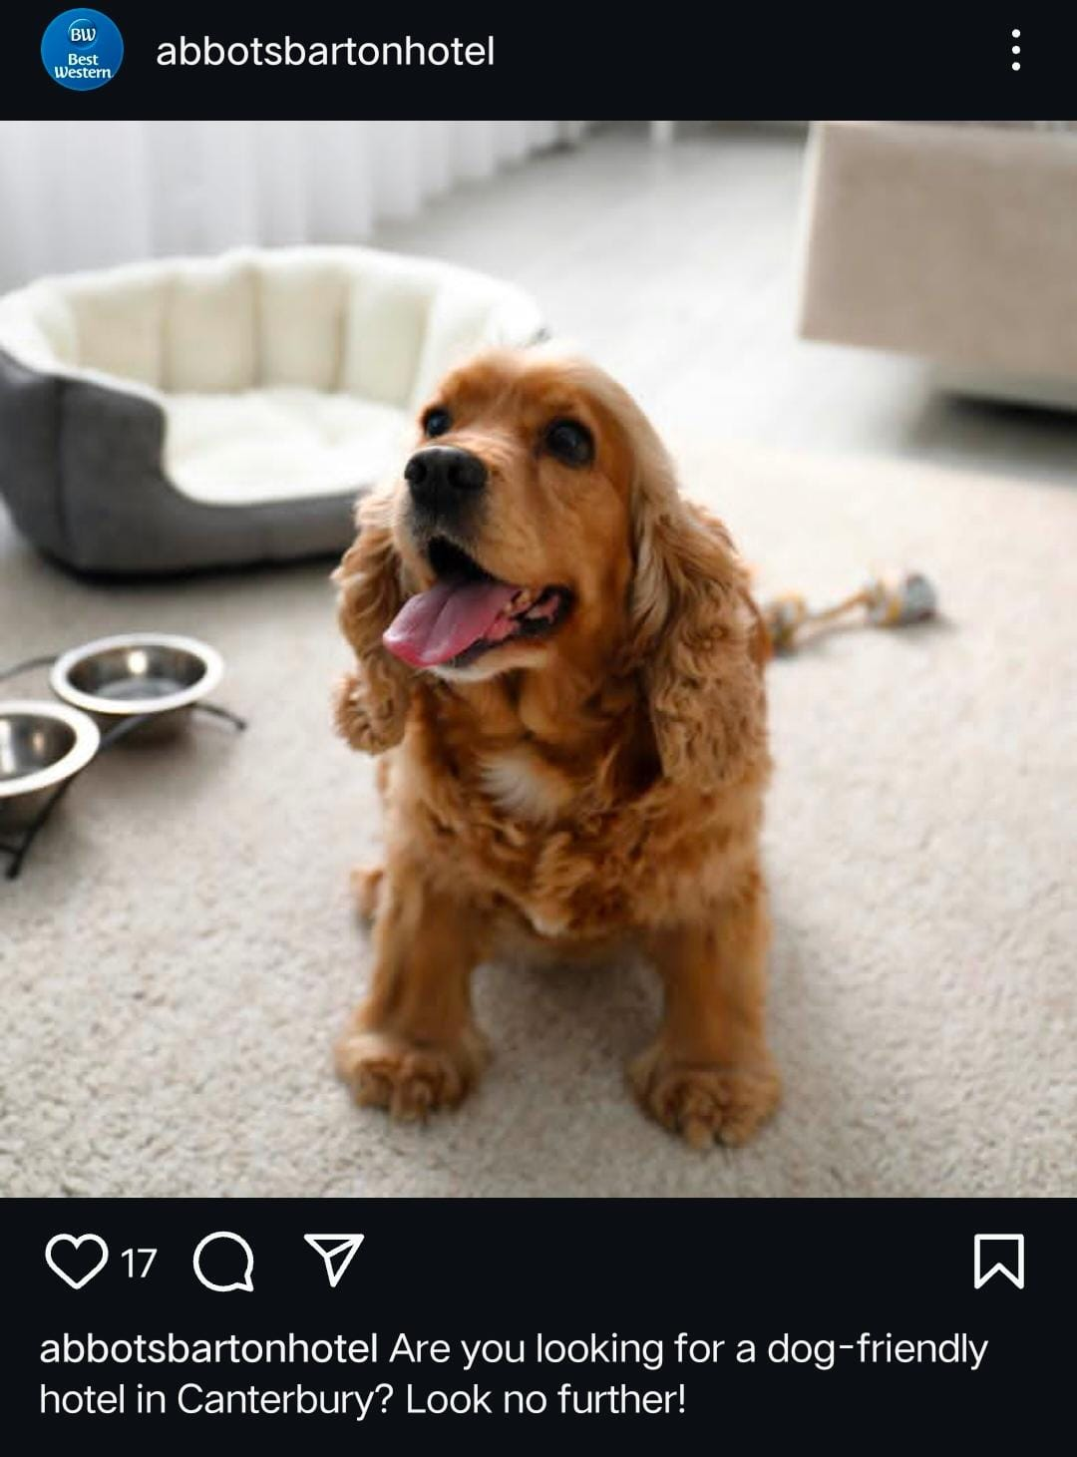
Figure 4.1e: Pet-friendliness Of The Hotel
(Source: Best Western.2023)
Offers and Loyalty Points
The Abbots Barton Hotel is affiliated to the Best Western Rewards® program, which enables participants to accrue points while using the hotel services (Abbots Barton Hotel. 2025). These points could be redeemed in the form of free nights, gift cards and many others which will help to make the guests feel more comfortable. Membership in the program is free and some of the other benefits that customers are bound to enjoy include discounts and shorter check-in times (Abbots Barton Hotel. 2025).

4.2 SWOT Analysis Of Best Western Abbots Barton Hotel
Strengths | Weaknesses
Facilities: The hotel has a Victorian Gothic design and the façade of the residence has a historic appeal, which gives the guests a romantic feel (Abbots Barton Hotel. 2025).  Accessibility to Central Business District: The hotel is situated within walking distance from Canterbury City Centre that can be easily accessed by clients within 10 minutes (Abbots Barton Hotel. 2025).  Pets: They allow pets and are friendly to clients who are carrying along their animals (Bestwestern.com.2025).  Landscape Gardens: Located in two acres of beautiful landscaped gardens giving a calm atmosphere to the guests (Abbots Barton Hotel. 2025). | Lack of some facilities: The hotel does not have certain amenities such as a swimming pool and fitness center, which may not be preferred by some clients (Bestwestern.com.2025).  Maintenance Issues: It is a very old building, so it may need much attention in terms of maintenance and upgrade.  Limited room choices: The hotel provides small classic doubles, luxury, and executive and even junior suites for accommodations but may not contain all the preferred by the guests (Abbots Barton Hotel. 2025).

Opportunities | Threats
Sustainable development: There is an opportunity of embracing green practices because it could attract an environmentally concerned traveler.  Weddings and Corporate Business: Exploiting its architectural value and the beautiful gardens for wedding occasions or for corporate business may add more to the establishment’s income.  Culinary Improvements: Increasing the number of available dishes and services, for example, introducing tea time. | Intense rivalry: There are other existing hotels in Canterbury that are already equipped with modern facilities which present a strong rivalry.  Economic fluctuations: Economic difficulties can be observed and potentially influence travel and tourism, the occupancy level.  New Trends in Travel: Such changes as shift to the use of platforms such as Airbnb to book accommodations may diminish traditional hotels.

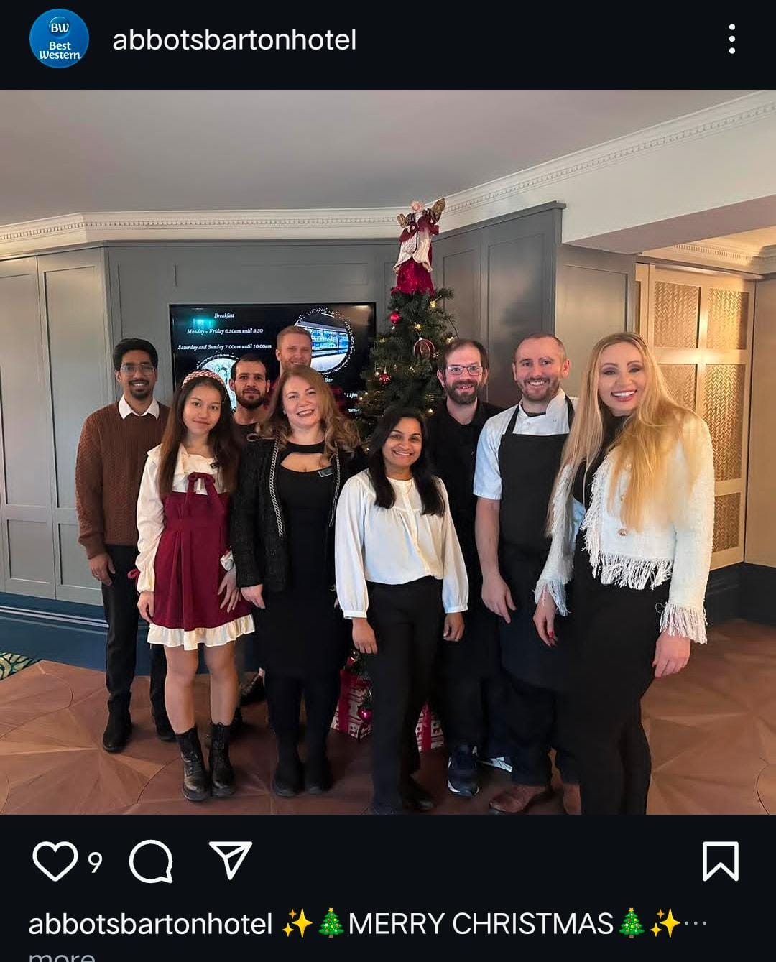
Figure 4.2: Staffs At Abbots Barton Hotel
(Source: Instagram.com. 2020)

4.3 PESTLE Analysis Of The Organisation:
Factor | Analysis
Political | The hotel industry in the UK is strictly governed and there are legal provisions regarding the rights of employees, health, safety and environmental issues. Best Western Abbots Barton Hotel operates in a legal environment, and therefore, it has to abide by laws like the modern slavery legislation as stated by Jones and Comfort (2021). Also, political instability can alter such tendencies of tourism that could affect the occupancy levels.
Economic | In 2023, UK household disposable income decreased by 2.5% to £34,500, influenced by rising prices and higher interest rates (Office For National Statistics. 2024). This decline can lead to reduced consumer spending on non-essential services, including travel and accommodation. Additionally, the UK tourism industry faced a deficit of £2.8 billion in tourism spending, attracting almost three million fewer foreign visitors annually compared to pre-pandemic levels (Walsh, 2024). These economic factors can impact hotel bookings and profitability.
Sociocultural | There are social factors that have been noted to be on the rise within societies and affecting the hotel industry these include; These values must be upheld at Best Western Abbots Barton since green tourism is increasing (Prakash et al., 2023). Furthermore, diversification of customers calls for appreciation of cultural differences and demands as a way of satisfying the customers.
Technological | New technologies affect guests in their stays, with most of the hotels adopting sophisticated check-in systems and online services. The case of Best Western Abbots Barton means that this hotel requires technology acquisition to enhance its competitiveness. Also, positive and secure measures have to be put in place since the bookings are made through the internet (Hultman et al., 2021).
Legal | Legal regulations that affect the UK hotels include data protection laws and employment regulations among others. For example, the hotel has to consider the National Minimum Wage Act and the employment rights of workers especially the migrant workers since this sector is filled with them (Ndiuini and Baum, 2021).
Environmental | This is a critical factor that has not only affected the hospitality industry but has also become a top issue of concern in the current society. A proposal that needs to be implemented by the Best Western Abbots Barton Hotel is the environmental management of energy and waste. Embracing green practices not only has an environmental impact but also meets the current trend where customers demand firms to adopt environmentally sustainable practices (Prakash et al., 2023).

4.4 Competitor Analysis
Hotel Name | Average Nightly Rate | Guest Experience Features
Best Western Abbots Barton Hotel | £100 - £130 | Victorian Gothic-style, located near the city center, offers scenic gardens, family-friendly, pet-friendly, free parking, and an on-site restaurant and bar.
Hampton by Hilton Canterbury | £90 - £120 | Modern and contemporary, located close to the city center, complimentary breakfast, fitness center, free Wi-Fi, and business facilities.
Premier Inn Canterbury | £60 - £80 | Affordable and simple, centrally located, comfortable rooms, free Wi-Fi, 24-hour reception, on-site restaurant, and a family-friendly atmosphere.
Holiday Inn Express Canterbury | £85 - £110 | Budget-friendly with modern design, free Wi-Fi, complimentary breakfast, on-site bar, business services, and close to the city center.
ABode Canterbury | £120 - £150 | Boutique hotel, high-end experience with elegant rooms, fine dining restaurant, stylish bar, central location, and personalised services for an upscale experience.

4.5 Netnography:
Best Western Abbots Barton Hotel in Canterbury has garnered positive feedback from guests, particularly highlighting its historic charm, tranquil setting, and proximity to the city center. The hotel is set amidst two acres of landscaped gardens, offering a peaceful retreat just a 10-minute walk from Canterbury Cathedral (Abbots Barton Hotel. 2025). Guests frequently commend the hotel's blend of Victorian Gothic architecture with modern amenities. Many appreciate the spacious, individually decorated rooms equipped with flat-screen TVs and modern bathrooms. The hotel's commitment to cleanliness and comfort is consistently noted (Booking.com. 2025). The on-site Westfield Bar has received praise for its modern ambiance and diverse selection of food and drinks. However, some guests have mentioned that the restaurant is currently closed for refurbishment, which may affect dining options during their stay (Abbots Barton Hotel. 2025).
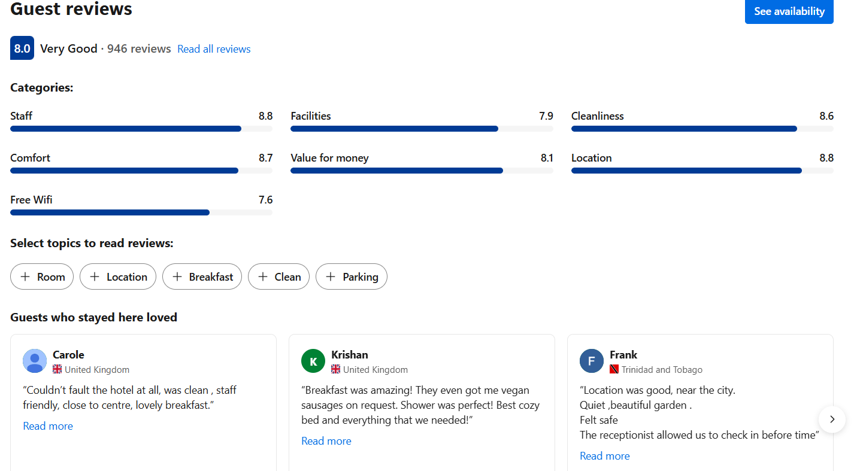
Figure 4.5: Customer Reviews Of The Hotel
(Source: Booking.com 2025).
Customer behavior indicates a preference for the hotel's central location, allowing easy access to Canterbury's attractions. The availability of free on-site parking is also a significant advantage for those traveling by car. The hotel's pet-friendly policy is appreciated by guests traveling with pets (Booking.com. 2025). While the hotel has received numerous positive reviews, some guests have noted areas for improvement. For instance, there have been mentions of noise levels in certain rooms, with management acknowledging the need for soundproofing enhancements (Tripadvisor. 2025).

4.6 Personal Account On The Experience And Observations Of Working At Best Western Abbots Barton Hotel in Canterbury
My time at Best Western Abbots Barton Hotel in Canterbury has been the most productive and fulfilling experience, particularly regarding sustainable approach to business and customer service. The corporate responsibility the hotel has towards its guests in providing a sustainable experience is one of the things I have come to like most when working at the hotel. The operations are highly focused on the environmental concerns, which are critical issues in the hospitality business nowadays.
Another measure that has been implemented in the hotel is that it is a no-smoking hotel. This goes a long way to enhance a healthy environment within the guests as well as the personnel. Another tactic for the overall sustainability plan is the non-smoking policy of the hotel to protect the guests from health risks and for a cleaner environment of the hotel. This is quite relevant knowing the increasing popularity of the concept of environment friendly hotels. The policy against smoking has been well appreciated by many guests especially those who are allergic to bad air or those who accompany children.
Besides the complete ban of smoking within the hotel premises, the hotel boasts of great achievements in the use of energy. For instance, it has ensured the use of energy efficient light and heating systems in the facility. This decision cuts down on the overall emissions of carbon, a factor that is very much in line with the sustainable development goals of the world. However, much as the hotel has made efforts to adopt energy saving measures, this practice can still be enhanced. This is particularly true in some parts of the hotel especially those whose installation was done several years ago. These places might be beautiful and rich in history but some of them can be seen to be lacking in a proper plan when it comes to sustainably developed architecture.
Another form of sustainability in the hotel is in the landscaping of the building. The landscaping also entails the use of water sparingly in the well-trimmed gardens around the property and an emphasis on growing native plants that, in addition to supporting biological diversity, do not demand many resources to be introduced into the country. The concept of the garden areas is particularly popular with visitors who want to relax in a calm zone while at the same time, the green areas are consistent with the green profile of the hotel. However, while the gardens enhance the experience of the guests, there is sometimes worry of how to maintain the gardens given that during the busy season there is a high demand for gardeners.
From the operational viewpoint, the hotel has achieved a lot in the management of wastes. This chain is actively engaged in recycling and promotes the concept among the guests of the hotel. Information regarding ways through which the guests may help in minimising the impacts of this hotel are included in literature placed in the rooms. However, there is still some inconsistency concerning the management of waste out of sight of the consumers. For instance, the segregation of wastes could be enhanced across all departments, and there could also be regular training instilled to all employees to ensure that they appreciate the need for implementing these practices.
Despite these, the hotel has a good standard of sustainable practices in their company, and there are some challenges associated with it. This area of improvement can be further focused on the communication with the guests about the hotel’s environmental policies. Some of the guests are conscious of the sustainable aspects of the hotel while others are not aware since there is little notice at the hotel re the issue or no direct communication to guests on the matter. The hotel should strive to ensure that guests understand its conservation measures such as using environmentally friendly products in the rooms, the use of water and the fact that the hotel is a smoking-free facility. It would be beneficial not only to the guests but also improve their behavior as well. In general, Best Western Abbots Barton Hotel in Canterbury is friendly to the natural environment, as it is a no-smoking hotel with energy-efficient facilities, as well as practicing waste management. Nevertheless, certain recommendations for future research could be the following: the first is the necessity to spread sustainable practices throughout all departments of the hotel; the second is the need to improve the communication with guests regarding the hotel’s sustainable activities. The hotel is in a very good position to further establish and develop a sustainable image of the hotel while at the same time improving on the quality of services and comfort of the guests.

5.0 Discussion:

5.1 Theme 1: Current state of sustainability of guest experience in the hotel industry with reference to Best Western Abbots Barton Hotel in Canterbury.
Taking into account the increased awareness of the impact of the environmental problems and the shift of consumer preferences, the concept of sustainability of the guest experience in the hotel industry is becoming crucial nowadays. The Abbots Barton Hotel in Canterbury is a hotel establishment that has embraced several sustainability measures to reduce its effects on the environment while at the same time offering the best services to its customers. However, there are still some issues that the hotel industry of the world has not been able to overcome fully in its bid to become sustainable and these are well illustrated by the Best Western Abbots Barton (Best Western, 2024). In the present context, one of the areas in which sustainability is being practiced is energy usage. The hotel has however made efforts to have efficient energy utilisation in lighting, heating and air conditioning systems. However, despite the use of these measures in conserving energy, the hotel industry continues to have an adverse effect on the environment (Jones, 2022). Some of the hotels that are not yet able to fully implement renewable energy sources include Best Western Abbots Barton in which the above challenges still remain a barrier to full sustainability. Nonetheless, the hotel has a clear demonstration of sustainable practices, but it is not practical for it to rely solely on renewable energy because of the high costs in acquiring the technology and transitioning to a new method of generating power (Miller, 2023).
Another factor that is hard to overestimate in the sphere of sustainable hospitality is water conservation. Best Western Abbots Barton has ensured that it has fixed facilities that save water and also ensures that they check for wastage often. However, due to the significant usage of water in the consumption of water for cleaning, laundry, and various other guest requirements, the efficiency of such measures can be somewhat restricted (Taylor, 2021). In this respect, the hotel is making a great improvement in the water management; nevertheless, the process of enlarging the possibilities of the water conservation could be quite problematic because of the differences in the consumers’ necessities, particularly during the periods of the high demand. There is also the use of sustainable waste disposal and management practices in the hotel. The Best Western Abbots Barton has implemented measures to adopt the concept of recycling whereby there is a limited disposal of waste to the landfills as recommended by Smith (2024). Although, the entire hospitality industry has not yet come to a solution of using single-use plastics, which is a major setback to sustainable practices. The attempt to decrease plastic waste, for instance, through refillable amenities that are offered in the hotel are commendable, however, this requires action at the industrial level to fit the magnitude of the problem (Baker, 2022). Also, the sustainability of the company in terms of guest experience does not only entail environmental stewardship but also making guests’ stay a pleasant one. At Best Western Abbots Barton, the guests are informed about sustainability practices within the facility and are urged to practice conservation measures during their stay (Best Western, 2024). However, a few obstacles are still apparent in the implementation of sustainability to the guest experience. There are some visitors who may not be very much concerned with the environment and hence the need to ensure that the measures towards environmental conservation are balanced by ensuring that all the visitors are comfortable and happy (Jones, 2022).
Best Western Abbots Barton Hotel meets the sustainability criteria for energy efficiency, water saving in the building, proper waste disposal, and information sharing regarding sustainable practices. However, some factors might act as a thorny issue where the hotel might experience difficulties in implementing sustainable practices, for example, the high cost of implementing renewable energy sources, difficulties in managing water and waste, and the constant need to engage the guests in sustainability. There has been a steady improvement in the efforts to make the guest experience sustainable in the hotel industry but the challenge still persists as it remains difficult to fully achieve a sustainable guest experience which would need a collective effort and joint initiative from the hotels (Miller, 2023).

5.2 Theme 2: Issues persisting in offering the sustainable guest experience in the hotel industry
The hotel industry has various hurdles to overcome in order to ensure that guests have a positive experience at their hotel and this also applies to Best Western Abbots Barton Hotel in Canterbury. Despite the measures that the hotel has taken in its effort to incorporate sustainability into its operations, there are several factors that still hinder effective implementation of sustainability in the hotel. Another is the cost implication of going to a fully renewable energy base and how this can be achieved in the shortest time possible. In the same respect, like any other establishments, the hotel has tried to embrace energy efficient systems although it has not been easy for them to go green due to the high costs of implementing the systems and the physical structures in place. While such investments are advantageous in the long run, they are considered as opportunities of high risk for many hotels, especially for those small hotels (Miller, 2023). Although some energy efficient features such as efficient lighting system and efficient heating system have been incorporated, it is largely inconsequential in reducing the institution’s carbon footprint bearing in mind the level of investment that would be required in renewable energy sources.
Water conservation is another concern now as it has remained a critical challenge in the past years. Some of the measures that have been adopted by Best Western Abbots Barton are the use of low-flow fixtures and other water-saving measures; this has been quite difficult to manage water usage in a hotel since guests as well as the hotel operations require a lot of water. Due to the large amount of water used in washing clothes, cleaning, and other related services, it becomes impossible to achieve water conservation. Even with the water-saving technologies in place, it is quite hard to reduce the consumption during the peak seasons (Taylor, 2021). Waste management is still a major issue in the country’s construction industry. At Best Western Abbots Barton, it has made efforts to lower waste through recycling programmes but the problem of single-use plastics still remains problematic in hospitality businesses. In order to accommodate the guests, there are decisions that lead to wastage for example on toiletries and plastics which are hard to be phased out due to their huge consumption in packaging. While there are permanent amenities and biodegradable products, the issue of disposable plastics is not solved yet (Smith, 2024). There is also the issue of meeting the expectations of the guests while at the same time ensuring that the company is sustainable. Though clients are informed about sustainability, not all of them are willing to participate in these practices. Lack of commitment to the sustainable practice is also a challenge to the consistency of the guests’ participation as most of the guests are more concerned with comfort and ease. For example, the hotel may take such measures as persuading the guests to reuse towels or adopt energy saving measures in the hotel; such measures are often ignored or opposed by the guests because they are considered inconvenient (Jones, 2022).

5.3 Theme 3: Effective strategies to improve sustainable guest experience in the hotel industry.
In order to improve the sustainable guests’ experience in the hotel industry, it is valuable to use the theoretical approach based on Social Exchange Theory (SET). As defined by SET, people’s relationships are transactional, and all the parties involved seek to gain as much as possible while losing as little as possible. As for the hospitality industry, this theory may help hotels to build long-term cooperation with their clients by providing them with various sustainable solutions that reflect their interests and needs. Another important measure is the promotion of incentives that will ensure long term sustainable behavior among its clients. It involves involving guests in environmentally conscious practices like not replacing the towels daily or not having housekeeping services daily since it will benefit both the hotel and the guests. These incentives develop a mutually beneficial relationship whereby guests feel they are receiving more value while the company achieves sustainable development.
Another important strategy that should be implemented is the reporting on sustainability initiatives. Consumers will be willing to practice sustainable actions that were proposed by the hotel if those practices are genuine and have a significant impact. It is in the best interest of the hotel to give customers details of the energy-conserving measures that it has put in place, the measures it is taking to minimise waste, and which food it sources locally and organically. This is in line with the reciprocity theory at SET as guests feel they are contributing towards a greater cause of improving the social and environmental fabric of the society. According to Taylor (2021), effective communication of sustainability strategies ensures that there is a connection between the workings of the hotel and the guests’ expectations thus increasing the level of interaction of guests with the hotel. Also, the inclusion of sustainability in the organisation’s guest offering positively affects perceived value in the hotel industry. For instance, through offering and providing environmentally friendly facilities and amenities or by providing an option of environmentally friendly means of transport the company not only increases sustainability but also enhances the guest experience. This approach ensures that all the efforts by the hotel are perceived to be part of the value being delivered to the customer hence making it a win-win situation. Smith (2024) identified perception of value as one of the crucial elements as guests correlate the green commitment by the hotel as a better quality service delivery. Lastly, collaborations with the locals for sustainable development can also be an added value for the guests. This is because involvement in sustainability initiatives such as sourcing local products or supporting local environmental causes makes guests feel like they are part of the hotel’s cause. This social exchange makes the guest to be associated with the hotel thus increasing loyalty and satisfaction through shared value (Jones, 2022).

6.0 Conclusion:
Therefore, the concept of sustainability in the hotel industries should be given priority in order to meet the increasing environmental friendly clientele as well as maintain sustainable development. The application of sustainability in hospitality services is an effective way to create a bond with the guest through Social Exchange Theory. Loyalty programmes, clear communication, incorporation of sustainability into the guest experience, and community relations are among the measures that can be effective when achieving an optimal balance between business performance and sustainability in the context of the hotel industry. There are some weaknesses such as lack of guest involvement and investment in sustainable structures, yet the advantages of using these strategies are evident. Apart from improving the image of the hotel and raising customer satisfaction, they also play a part in the matter of sustainability. Thus, sustainability will remain a critical factor of competition where guests are concerned in the future of the industry. The hotels that seek to involve guests in sustainability initiatives and make sure that the guests are aware of their environmental policies will not only succeed in creating a favorable image of the hotel but also contribute to the development of a sustainable tourism industry. Thus, the hotel industry should ensure it links the guest values with a long-term plan that would also include the well-being of the planet.

6.1 Recommendations:
Technology Integration The management of the hotel should incorporate the latest technologies that would support sustainable practices in the organisation and provide value addition to the customers. Energy-efficient lights, smart controls of the room, and water-saving systems are among some of the ways in which the hotel’s carbon footprint can be reduced while at the same time making guests’ stay more comfortable (Bharwani and Mathews, 2021). These technologies do not only help with the environment but also help the guests which fully supports the recent trend of sustainable services in the hospitality industry (Kim and Kim, 2022).
Promoting Eco-friendly Guest Activities and Amenities The Best Western Abbots Barton could enhance awareness of eco-friendly activities and services for the guests. For instance, while accommodating guests, the hotel can offer them options such as digital check-in as well as biodegradable products. Also, extending guest-friendly environmentally conscious food options like locally sourced or organic foods would be in line with the hotel’s green goals (Olorunsola et al., 2022). Customers not only desire eco-friendly products and services for themselves, but also expect the companies to provide them with options that are environment friendly (Kandampully et al., 2023)..
Sustainability-focused Loyalty Programs The hotel could incorporate sustainability as the main theme of its loyalty programs. For instance, points can be earned by guests who accept to go green practices like towel reuse, contactless registration, and green transport means. This would not only help the guests to be more conscious of their consumption and make the right decisions but also promote the sense of unity and common responsibility (Kim and Kim, 2022). It is evident from literature that the company’s sustainability-focused loyalty programs can have the potential of enhancing customer satisfaction and repeat business (Bharwani and Mathews, 2021).
Staff Training and Guest Engagement on Sustainability Increased staff awareness of sustainable practices in the hotel and how to communicate them to customers will improve the customer experience. Employees should also play a role in promoting environmental conservation by persuading the guests to embrace environmentally friendly activities for instance recycling or conserving energy. This makes the guests feel engaged in the sustainability process, and also improves the guests’ experience (Olorunsola et al., 2022). In addition, informing guests about the measures implemented by the hotel may help them identify themselves with the hotel’s practices (Kandampully et al., 2023).
Partnerships with Local Sustainable Initiatives Best Western Abbots Barton should engage in stakeholder management and ensure that it partners with other local sustainable businesses/organisations. This could be in sourcing food supplies from local farmers or using local environmentally friendly means of transport. Such partnerships would not only have a positive impact on the local economy but would also be advantageous in terms of positioning the hotel as sustainable to the eco-tourism consumer (Bharwani and Mathews, 2021). A study shows that guests have a positive perception of the hotels who engage in local sustainability activities hence, they are more loyal and recommend the hotels (Kim and Kim, 2022).

7.0 References

Abbots Barton Hotel. (2025). Abbots Barton Hotel | Hotels Near Canterbury | Best Western. [online] Available at: https://www.abbotsbartonhotel.com/ [Accessed 10 Feb. 2025].
Abbots Barton Hotel. (2025). Abbots Barton Hotel | Hotels Near Canterbury | Best Western. [online] Available at: https://www.abbotsbartonhotel.com/. [Accessed 2 Feb. 2025]
Abdou, A.H., Hassan, T.H., Salem, A.E., Albakhit, A.I., Almakhayitah, M.Y. and Salama, W., (2022). The nexus between environmentally sustainable practices, green satisfaction, and customer citizenship behavior in eco-friendly hotels: social exchange theory perspective. Sustainability, 14(19), p.12791.
Berezan, O., Millar, M. and Raab, C., (2014). Sustainable hotel practices and guest satisfaction levels. International Journal of Hospitality & Tourism Administration, 15(1), pp.1-18.
Best Western. (2023). Best Western Abbots Barton Hotel. [online] Available at: https://www.bestwestern.co.uk/hotels/best-western-abbots-barton-hotel-83796 [Accessed 2 Feb. 2025].
Bestwestern.com. (2025). Best Western Abbots Barton Hotel, Canterbury - UK. [online] Available at: https://www.bestwestern.com/en_US/book/hotels-in-canterbury/best-western-abbots-barton-hotel/propertyCode.83796.html [Accessed 3 Feb. 2025].
Collis, J & Hussey, R (2014), Business Research, A Practical Guide for Undergraduate and Post Graduate Students, Palgrave, London
Cottrell, S. (2014) Dissertations and project reports : a step by step guide. New York: Pallgrave.
Grbich C. (2006), Qualitative Data Analysis, Sage Publications Ltd.
Hultman, M., Papadopoulou, C., Oghazi, P. and Opoku, R., (2021). Branding the hotel industry: The effect of step-up versus step-down brand extensions. Journal of business research, 124, pp.560-570.
Instagram.com. (2020). BW Abbots Barton Hotel Canterbury (@abbotsbartonhotel) • Instagram photos and videos. [online] Available at: https://www.instagram.com/abbotsbartonhotel?igsh=MTltZDRyZHI5MjU5dw== [Accessed 11 Feb. 2025].
Jones, P. and Comfort, D., (2021). Modern slavery statements and leading UK hotel companies. Athens Journal of Tourism, 8(3), pp.147-162.
Khalil, N., Che Abdullah, S.N., Haron, S.N. and Hamid, M.Y., (2024). A review of green practices and initiatives from stakeholder’s perspectives towards sustainable hotel operations and performance impact. Journal of Facilities Management, 22(4), pp.653-682.
Kim, Y.J. and Kim, H.S., (2022). The impact of hotel customer experience on customer satisfaction through online reviews. Sustainability, 14(2), p.848.
Liu, H., Xiao, Q. and Wang, H., (2024). Understanding Customer Experience for Sustainable Innovation: An Integration of Conscious and Unconscious Perspectives of Theme Hotel Guests. Sustainability, 16(13), p.5274.
Marshall, C. (2015), Designing Qualitative Research, 6th Ed, Sage, London.
Merli, R., Preziosi, M., Acampora, A. and Ali, F., (2019). Why should hotels go green? Insights from guests experience in green hotels. International Journal of Hospitality Management, 81, pp.169-179.
Moise, M.S., Gil-Saura, I. and Ruiz-Molina, M.E., (2021). “Green” practices as antecedents of functional value, guest satisfaction and loyalty. Journal of Hospitality and Tourism Insights, 4(5), pp.722-738.
Moliner, M.Á., Monferrer, D., Estrada, M. and Rodríguez, R.M., (2019). Environmental sustainability and the hospitality customer experience: A study in tourist accommodation. Sustainability, 11(19), p.5279.
Nazarian, A., Zaeri, E., Foroudi, P., Afrouzi, A.R. and Atkinson, P., (2022). Cultural perceptions of ethical leadership and its effect on intention to leave in the independent hotel industry. International Journal of Contemporary Hospitality Management, 34(1), pp.430-455.
Ndiuini, A. and Baum, T., (2021). Underemployment and lived experiences of migrant workers in the hotel industry: policy and industry implications. Journal of Policy Research in Tourism, Leisure and Events, 13(1), pp.36-58.
Olya, H., Altinay, L., Farmaki, A., Kenebayeva, A. and Gursoy, D., (2021). Hotels' sustainability practices and guests' familiarity, attitudes and behaviours. In Sustainable Consumer Behaviour and the Environment (pp. 43-61). Routledge.
Prakash, S., Sharma, V.P., Singh, R. and Vijayvargy, L., (2023). Adopting green and sustainable practices in the hotel industry operations-an analysis of critical performance indicators for improved environmental quality. Management of Environmental Quality: An International Journal, 34(4), pp.1057-1076.
Robson, C. (2016), Real World Research, 2nd Ed, Blackwell: Oxford
Saunders, M., Lewis, P. and Thornhill, A. (2012) Research Methods for Business Students, FT/Prentice Hall: Harlow
Silverman, D. (2011), Qualitative Research Methods, 2nd Ed, Sage: London
Statista (2024a). Share of travelers choosing eco-friendly hotels UK 2022. [online] Statista. Available at: https://www.statista.com/statistics/1340780/travelers-choosing-ecofriendly-hotels-uk/. [Accessed 1 Feb. 2025].
Statista. (2024b). Paying more for sustainable hotels Great Britain 2024 | Statista. [online] Available at: https://www.statista.com/statistics/1482159/willingness-pay-sustainable-hotels-great-britain/. [Accessed 1 Feb. 2025].
Tan, Y. and Despotis, D., (2021). Investigation of efficiency in the UK hotel industry: A network data envelopment analysis approach. International Journal of Contemporary Hospitality Management, 33(3), pp.1080-1104.
Veal, A J (2006), Research Methods for Leisure and Tourism, 3rd Ed, Financial Times/ Prentice Hall
Yin, R. K. (2003), Case Study Research, 4th Ed, Sage: London

