C Exercises 3c – Input and Calculations (SOLUTIONS)

1. Write a program to allow the user to enter their name (first name and surname) and then print it out so that it looks something like the following (ie surname first, with a comma inbetween) Choose a suitable length for your strings so that the majority of first names and surnames can be accommodated.

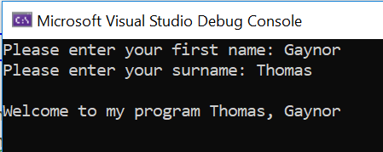

Solution:

#define _CRT_SECURE_NO_WARNINGS
#include <stdio.h>

void main()
{
char firstName[30];
char surname[30];

printf("Please enter your first name: ");
scanf("%s", &firstName);

printf("Please enter your surname: ");
scanf("%s", &surname);

printf("\nWelcome to my program %s, %s\n\n", surname, firstName);

}

2. Write a program to print out the area of a circle. The user will enter the radius of the circle. You can set π to be 3.142.
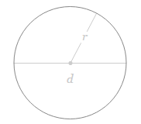
The formula is: Area = π r ²

Here is an example of output:
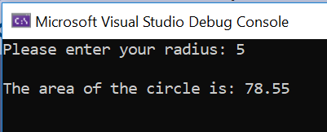

Solution:

#define _CRT_SECURE_NO_WARNINGS
#define PI 3.142
#include <stdio.h>

void main()
{
float radius, area;

printf("Please enter your radius: ");
scanf("%f", &radius);

area = PI * radius * radius;

printf("\nThe area of the circle is: %.2f\n\n", area);
}
OR
#define _CRT_SECURE_NO_WARNINGS
#define PI 3.142
#include <stdio.h>
#include <math.h>

void main()
{
float radius, area;

printf("Please enter your radius: ");
scanf("%f", &radius);

area = PI * pow(radius,2);

printf("\nThe area of the circle is: %.2f\n\n", area);

}
3. Volume of a Cylinder

Extend your previous program to find the volume of a cylinder:

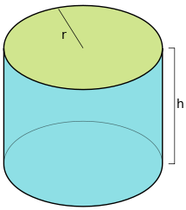

The formula is: V = π r ² h

Solution:

#define _CRT_SECURE_NO_WARNINGS
#define PI 3.142
#include <stdio.h>
#include <math.h>

void main()
{
float radius, height, volume;

printf("Please enter your radius: ");
scanf("%f", &radius);

printf("Please enter the height: ");
scanf("%f", &height);

volume = (PI * pow(radius,2)) * height;

printf("\nThe area of the circle is: %.2f\n\n", volume);

}

4. Rice Krispies

A student’s favourite food is Rice Krispies which cost £3 per box in Tesco.

There are 8 servings (bowls) of Rice Krispies per box.

The student’s maximum Rice Krispie budget is £12/week.

Using the information above, write a program to work out the following:

(Note: Think about the various stages of the program, what variables need to be set and any simple formulas you might need to write. )

- How many boxes of Rice Krispies can the student afford per week?
- How many bowls of Rice Krispies can the student eat per week based on your answer to a) ?
- How much does 1 bowl of Rice Krispies cost?
- How many bowls of Rice Krispies will the student eat during a year (based on 52 weeks and an extra bowl on Christmas Day)?

(Note: you can assume the student has a suitable supply of milk and/or sugar to accompany the Rice Krispies)

Solution:

#define _CRT_SECURE_NO_WARNINGS
#include <stdio.h>
#include <math.h>

void main()
{
float boxPrice = 3;
float servings = 8;
float budget = 12;
float oneBowl, yearBowls, weekBoxes, weekBowls;

weekBoxes = budget / boxPrice;
printf("Boxes per week: %.0f \n\n", weekBoxes);

weekBowls = weekBoxes * servings;
printf("Bowls per week: %.0f \n\n", weekBowls);

oneBowl = boxPrice / servings;
printf("Cost per bowl is: %.2fp \n\n", oneBowl);

yearBowls = (weekBoxes * servings * 52) + 1;
printf("Bowls per year: %.0f \n\n", yearBowls);
}

NOTE: If budget was £10, the programme would have to change a little to accommodate the leftover cash. Revisit your programme with a budget of £10. Remember you cannot buy 3.33 boxes from Tesco
5. Area of pyramid
The surface area of a square-based pyramid is calculated using the formula: Area =2bs + b² Here is a picture of one:

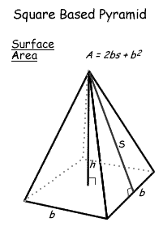
b=base s=slant height

Think about the various stages of the program. What information do you need the user to enter? Then write the program to work out the area.

Solution:

#define _CRT_SECURE_NO_WARNINGS
#include <stdio.h>

void main()
{

float base, sh, total;

printf("Enter the base: ");
scanf("%f", &base);

printf("Enter the slant height: ");
scanf("%f", &sh);

total = (2 * base * sh) + (base * base);

printf("\nThe surface area is: %.2f\n\n", total);

}

6. TV shopping

I am about to buy a new TV for £200 via online shopping

When I am checking out, I notice that it is a sale day, and the TV is eligible for 40% off.

Write a program in Python to calculate the discounted price.

Solution:

#define _CRT_SECURE_NO_WARNINGS
#include <stdio.h>

void main()
{
float myTV, coupon, discountPrice;

myTV = 200;
coupon = 0.40;
discountPrice = myTV * (1 - coupon);

printf("The discounted price is: %.2f \n\n", discountPrice);

}

7. Overtime

I get paid £8.72/hour in my job as an admin assistant. I normally work 35 hours a week, but this week I did 5½ hours of overtime (at the same rate of pay).

Using a Python program, calculate:

a) how much I get paid in a normal week of 35 hours
b) how much I will be paid this week (including overtime)

Solution:

#define _CRT_SECURE_NO_WARNINGS
#include <stdio.h>

void main()
{
float hourWage = 8.72, baseWage, thisWeek, overtime=5.5;

baseWage = hourWage * 35;

printf("Normal week's pay: \x9c%.2f \n\n", baseWage);

thisWeek = baseWage + (overtime * hourWage);

printf("This week's pay: \x9c%.2f \n\n", thisWeek);

}
c) Extend your programme to allow the user to enter the overtime they have done this week (on top of their basic 35 hours) and calculate their pay.

Solution:

#define _CRT_SECURE_NO_WARNINGS
#include <stdio.h>

void main()
{
float hourWage = 8.72, baseWage, thisWeek, overtime;

baseWage = hourWage * 35;

printf("Normal week's pay: \x9c%.2f \n\n", baseWage);

printf("How much overtime? ");
scanf("%f", &overtime);

thisWeek = baseWage + (overtime * hourWage);

printf("\nThis week's pay: \x9c%.2f \n\n", thisWeek);

}

8. Lightspeed calculations (note: no input from user – hard-coded values)

Light travels 186000 miles/second

Earth is (on average) 93 million miles from the Sun.

Jupiter is 5.2 times further from the Sun than Earth

Neptune is 30.1 times further from the Sun than Earth

Given the above information, write a program to calculate the following:

a) how long does light from the Sun take to reach Earth in seconds? and in minutes?
b) how long does light from the Sun take to reach Jupiter?
c) how long does light from the Sun take to reach Neptune?



Solution:

#define _CRT_SECURE_NO_WARNINGS
#define LIGHTSPEED 186000
#include <stdio.h>

void main()
{
float earthDistance = 93000000;
float earthLightSec, earthLightMin, jupiterLightMin, neptuneLightMin;

earthLightSec = earthDistance / LIGHTSPEED; // calculate distance in seconds

earthLightMin = earthLightSec / 60; // calculate distance in minutes

printf("Sun to Earth %.2f (seconds)\n", earthLightSec);
printf("Sun to Earth %.2f (minutes)\n", earthLightMin);

jupiterLightMin = earthLightMin * 5.2;
printf("Sun to Jupiter %.2f (minutes)\n", jupiterLightMin);

neptuneLightMin = earthLightMin * 30.1;
printf("Sun to Neptune %.2f (minutes)\n\n", neptuneLightMin);

}

