St Winefride’s well at Holywell
St Winefride’s Well (Ffynnon Wenffrewi) is located below the town of Holywell, Flintshire in Wales, on the side of a steep hill and was originally formed from a mountain spring. The shrine has been welcoming visitors for over thirteen hundred years, thus leading the town to take its name from the holy well. The legend of Winefride’s well is set in the fifth century C.E. and the movement of Christian hermits into the region. However, the earliest recording of the legend is from the 12th century, at which point the well became popular as a Christian holy well and was regularly used for its healing waters.
What is a Holy Well?
A holy well is a naturally occurring spring or pool of water revered by Christians and spiritual people. Many holy wells originated as sacred springs or pools and were considered places of healing or ritual pre-dating Christianity. As Christianity spread across Britain, the beliefs and stories surrounding the springs began to change, with most of them being known as holy wells as early as the 7th-9th centuries.
The water of a holy well is considered to have miraculous healing properties. Most holy wells are named after a Christian saint that reportedly made the waters begin to flow by their action; for example, the place where the saint sat down or where their head landed if they were martyred and beheaded, (as many of the early Christian saints were).
There are many famous Holy wells in the United Kingdom, with Saint Winefride’s possibly being the most well-known. Some other examples include St. Ludgvan’s Well in Cornwall, which sprung water when the Saint prayed on the spot; Saint Madron’s Well in Cornwall, even though there is no record of this saint ever existing; St. Kenelm’s Well in Clent Hills, West Midlands that miraculously appeared on the spot where King Kenelm was killed; St. Milburga’s Well in Shropshire popped up when St. Milburga suffered a horse accident, she injured her head and asked her horse to break open the ground with his hoof to produce healing waters for her head; Gwynllyw’s Well in Glamorgan Wales sprung forth when the Saint pushed his staff into the ground … this list goes on and on.
The healing properties of the water depend upon which saint the well is linked to, as many saints were considered to have specific miraculous healing abilities. Over time holy wells became stopping places for pilgrims and places of ritual and worship.

St Winefride’s Legend

The details of the legend vary depending on the version, but the main points of the story are sturdy.
St Winefride’s legend states that young Winefride was the daughter of a wealthy Welsh landowner Tewyth and his wife Gwenlo. St Beuno was either her uncle or their well-trusted preacher (or both). Winefride was a graceful beauty who devoted her life and learning to God and the church.
Around the year 630, a local prince, Caradog from Hawarden, was out hunting a stag. Feeling overcome with thirst, he stopped at Winefride’s home to ask for a drink of water. Being the kind and God-fearing girl that she was, she helped the stranger and fetched him a drink. Prince Caradog was incorrigible and decided then and there that he must have this beautiful kind girl at once. He confessed his undying love and desire to her in an attempt to seduce her whilst her parents were at church; he wanted her to be his then and there and would not take no for an answer. She was, however, devout to God and had promised she would give herself to no other man. Her rejection enraged Prince Caradog who was used to getting his own way. He threw a mighty tantrum and stamped his booted foot on her threshold. ‘If I can’t have you, then nobody can,’ he shouted, and at that, he withdrew his long sword and swung it above his head in a threatening manner.
On witnessing his furious reaction, Winefride ran in terror from the prince. It was a bit drizzly and grey outside, and she had no shoes on, but she didn’t care. She ran those little bare feet through the wet gorse and moss all the way over the hill to her uncle Beuno’s church. But her pursuer caught up with her at the entrance. When he reached her on the steps of the church, he beheaded her with one swipe of his sword. Thus, martyring her as a devout Christian who gave her life for the love of God. When her head fell from her shoulders, it bounced and rolled down the hill and landed in a soft hollow. In that spot, the moss turned red, and the aroma of violets filled the air. Immediately, a spring of clear water bubbled up from the ground; thus, St Winefride’s holy well was created.
On witnessing Winefride’s martyrdom, Prince Caradog sunk into the sodden earth and was never seen again. When St Beuno found her body on the church threshold, he hunted for the head and found it down the hill submerged in clear sparkling water. He then carried it back and reunited it with her body. Cradling her limp form and decapitated head, he entered the church, where he lay her down. He then prayed over her corpse until life re-entered, and a thin silver scar formed around her neck. The resurrected Winefride, then became a nun and stayed in Holywell until her uncle Beuno left the parish. She then went to the Monastery of Clynnog Fawr and joined a community at Gwtherin, where she eventually became the Abbess. She lived on for another 22 years.

The History of St. Winefride’s Well
The spring has since become famous for its apparent healing waters and has been a pilgrim site for centuries. Relics believed to belong to St Winefride were placed in the church at Shrewsbury. Since the Middle Ages, Pilgrims would go to Shrewsbury church to visit the relics and then go to Holywell to visit the well. Along the way they would stop and visit stones that were reportedly scattered with her blood.
It is believed that the beautiful late perpendicular architecture that surrounds the holy waters was commissioned in the 1500s by Henry VII’s mother. There is no way to be certain of this, but her coat of arms is displayed among those of other noble families upon the structure. This prestigious patronage is believed to have enabled the building of such a large and intricate shrine.
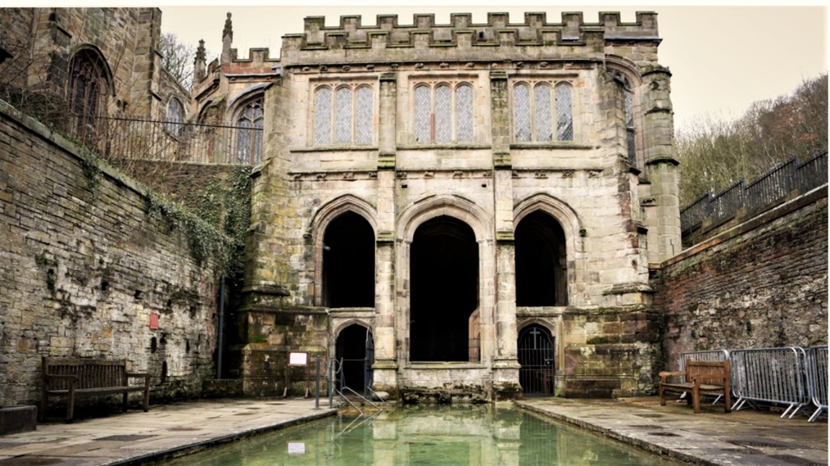

In 1540 King Henry VIII was moving against the monasteries and pilgrimage sites. During this destructive rampage, he attempted to end the cult of Winefride, destroyed her relics, and lost the blood-split stones. The only surviving relic was a finger believed to be from the hand of Winefride herself. The finger was taken to Rome and hidden until 1852, when it was finally returned to England. Half of the finger was given to the well site and the other half to Shrewsbury church. And so, the pilgrimage of Winefride continued.
After Catholicism was replaced by the Church of England as the official state religion and Catholic practices were outlawed, Catholic pilgrims continued to visit the well and talk of its healing miracles. In the middle of the 19th century, the church at Holywell was once again given legal status, and the pilgrimages continued in a more official sense.
Saint Winefride and her holy spring (no date) OrthoChristian.Com. Available at: https://orthochristian.com/42777.html#:~:text=But%20it%20was%20during%20the%20reign%20of%20the,under%20the%20patronage%20of%20Henry%27s%20mother%2C%20Margaret%20Beaufort. (Accessed: April 19, 2023).

St Winefride’s Well Today
The shrine that stands in Holywell today is considered one of the finest medieval holy wells still standing in Britain.
The well and shrine are still popular pilgrimage sites for both the Anglicans and the Catholics today. In the church across from the well, you can visit and receive blessings of Winefride’s finger from the catholic priest.
Pilgrims are still recounting healing miracles from the well as they have been for centuries.
The well is now a grade I listed building and scheduled ancient monument. St Winefride's well is believed to be connected to St Mary's well and chapel in Cefn Meiriadog, Denbighshire. It is one of the few locations mentioned by name in the anonymous medieval alliterative poem Sir Gawain and the Green Knight.

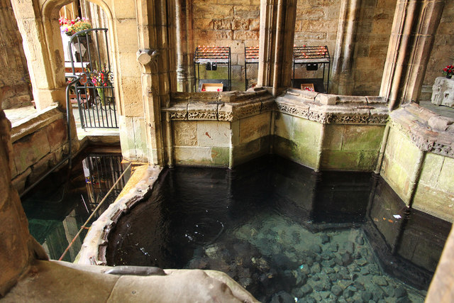
The Site
At the site you can visit an interpretative exhibition displaying the detailed story of Winefride and her shrine. The former custodian house is Victorian in origin and houses a museum of the pilgrimage.
The Sanctuary
The sanctuary contains a small chapel, crypt, and outer pool. This is a space to be mindful and quiet. A sacred place of contemplation, prayer, tranquillity, and healing.
The crypt contains the source of the healing waters, the well. The spring emerges into the well in the lower open crypt and flows out into the large-open pool, where you can bathe in the therapeutic water.
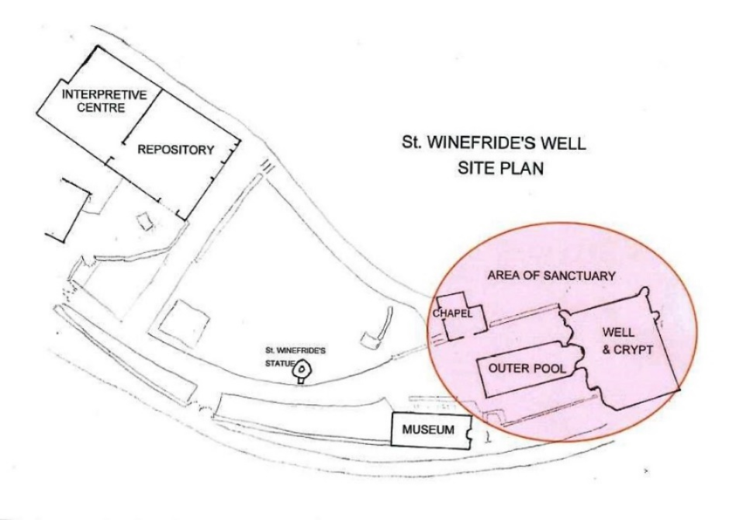

The Chapel
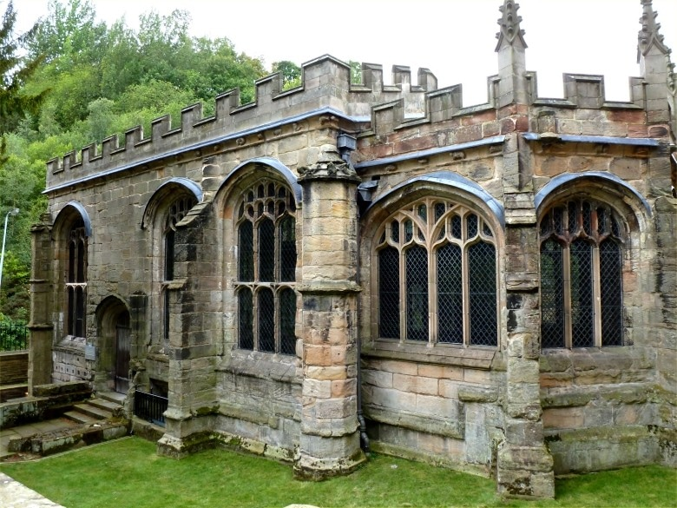

St. Winefride’s Chapel is in the ownership of the Church in Wales.

Royal Pilgrims & Visitors to St Winefride's Well

1189 Richard I Richard I, the Lionheart, made a pilgrimage to the Well.
1416 Henry V Following his victory at Agincourt, Henry V paid a thanksgiving visit to
​ the Well: 'The King, with great reverence, went on foot on pilgrimage
​ from Shrewsbury to St Winefride's Well in North Wales (Adam of Usk,
​ "Chronicle".)
1461 Edward IV According to the Welsh poet Tudor Aled, Edward IV came
on pilgrimage, when he placed a pinch of earth taken from beside the
well upon his crown.
1686 James II and Queen Mary Beatrice
On 29th August James II and Queen Mary Beatrice came on pilgrimage
​ to the Well, to pray for an heir; according to Thomas Pennant (Whitford
​ & Holywell, 1796, 230) the Jesuits then in charge of the Well presented
​ the King with a present of the very shift in which his Great Grand
Mother Mary Stuart lost her head.

1828 Princess Victoria and King Leopold of Belgium
Princess Victoria, staying in Holywell, with her uncle King Leopold of
Belgium, visited the Well.

2005 HRH The Duchess of Gloucester
14 October: visit of HRH The Duchess of Gloucester to St Winefride's
​ Well and the Museum.

2021 HRH The Prince of Wales, Prince Charles
​

Other Wells and Churches Dedicated to St Winefride.
St. Winefride also has a well in the hamlet of Woolston near Oswestry in Shropshire named after her. The legend says that whilst her body was on its journey to Shrewsbury Abbey, it was laid to rest in Woolston for a night, and where she lay, a spring sprang up from the ground. The water is said to heal broken bones, wounds, and bruises. The well is situated within a 15th-century cottage. The cottage is looked after by the Landmark Trust. The water follows a path through stone gulley’s and eventually into a pond that leads to a stream.
The laying down of Winefride's body caused another spring to bubble up at Holywell Farm, between Tattenhall and Clutton, Cheshire. The farm is no longer in use, but the spring supplies two houses with water.
There is another spring in Bath on Lansdowne Hill called Winefride’s Spring, the waters of which are said to help women conceive a child. There is, however, no known connection to Saint Winefride.

says:, A.N. and Says:, T. (2021) Holy Wells, The Naiads Well. Available at: https://naiads.org/holy-wells/ (Accessed: April 19, 2023).
St Winefride &amp; The Well (no date) St Winefride's Well. Available at: http://www.stwinefrideswell.org.uk/st-winefride--the-well.html (Accessed: April 19, 2023).
Saint Winefride and her holy spring (no date) OrthoChristian.Com. Available at: https://orthochristian.com/42777.html#:~:text=But%20it%20was%20during%20the%20reign%20of%20the,under%20the%20patronage%20of%20Henry%27s%20mother%2C%20Margaret%20Beaufort. (Accessed: April 19, 2023).
http://www.stwinefrideswell.org.uk/royal-pilgrims.html

