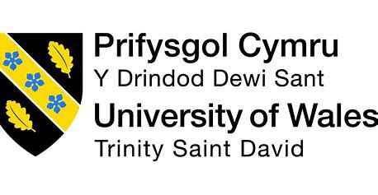

BACHELOR OF ARTS
BUSINESS MANAGEMENT

INTRODUCING THE MODERN
WORKPLACE
(LCBB4003)

LECTURER
Dr. DUDLEY OFORI

Reflective Report

DIANA VERONICA NEGRU
2233646

Table of Contents
Introduction 3
Gibb’s Reflective Model 4
Description 4
Feelings 5
Evaluation 5
Analysis 6
Conclusion 7
Action Plan 7
References 8

Introduction
In the journey of working with group, I thought myself very innovative to learn different perspectives from them, to learn about the skills, to learn about the personality. I believe that collaborative experience can be understood by the reflective model so I will now share my teamwork experience that helped me to ensure the personal and professional group and I will take help from Gibb’s model in order to articulate the sources into reality. (Gibbs, Brigden and Hellenberg, 2020).

Gibb’s Reflective Model
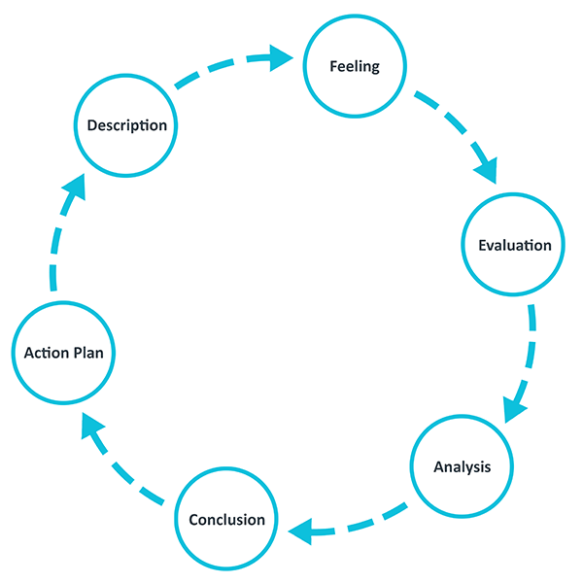
Figure 1: Reflective Gibb’s Model (Gibbs, Brigden and Hellenberg, 2020)

Description
Our group is formed with individual who have proper background also expertise level that help us to make a better presentation easily. The diversity within our group helped us a lot to face every dynamic environment where ideas are generated by someone and creativity level was too much (Pianpeng and Koraneekij, 2016). I had to handle different challenges but by collective behaviour and by the process of synergy, we were enough capable to make proper collaborative methods. In case of the maintenance of group presentation, we used to sit together in order to engage as within teamwork with ideas where identified and creativity level where achieved by the collaboration from the teammates. When I have given that lecture to my team member, they used to learn that properly and they understand what should be done by them in order to achieve success in the dynamic environment. This is how, the background also the expertise level can reach to unique set of skills to be creative enough and to achieve the collaborative success properly and to embrace the synergy properly in every presentation or in group task.

Feelings
In the very beginning, I was the leader so I had that different level of excitement but when I have understood about the diverse personalities also about diversify viewpoint, I was capable enough to understand the discussion level in order to remove that occasional conflict. As my team member were enough intelligent but some of them were frustrated due to their unsatisfied performance and some conflicts used to appear between them. Also, some has given better presentation in every teamwork so I can fit between the satisfied group and unsatisfied group there. I had to maintain a strong connection within the team in order to make my team enough capable to face any challenges with collaboration. I found that, the diversify personalities, the diversified learning experience has given a journey of interpersonal development and ultimately the satisfaction level of everyone has a rising and a strong connection within the team has been settle down by which emotional intelligence and adaptability is being developed and team can be managed by me easily compared to the previous time.

Evaluation
Throughout the interaction period, I have realised the importance of active listening also to become empathetic enough in case of doing communication. When I was a leader, my task was to understand the strength of each team member in order to play a collective group performance. So, I have to be capable of listening everything from my team also I had to do empathetic communication by which team member will have enough trust on me and they will share their problem, their opportunities with me. I have learned a lot about appreciation of different opinions. Also, I have learned about the opportunities to make constructive feedback. I have recognised the impact of word also action by which emphasise over the positive encouragement was done by me. So, during the team learning, I have played a better role as a team leader by which the collective potential level was in reached and that has lead to the exercise of better team morale and better team success.

Analysis
Analyses of the teamwork helps to understand the dynamic situation of the team and by which the goal can be achieved by shared performance. For me the shared objective of the team was to deliver a successful presentation, to do better task by continuation of the group mate. I found that whether the team is big or small doesn’t matter rather unity matters and each members contribution matter for getting team success. I believe that understanding the strength also weakness of each team can help to assign task effectively and to ensure a balanced workload and to utilise the skill properly. I found that, when the understanding of team dynamism was done by me where my duty was capable enough to do proper research and to study different material also, my other colleague it was better enough to make a PowerPoint presentation also, another was very capable to make a necessary edit so based on their continuous effort, I was capable enough to done with a better working layout every-time.

Conclusion
In the conclusion, the collaborative experience to work with team member is unique enough which has given me valuable insight and I have learned about the synergy, mutual respect, about active communication also about being empathetic. So, I have learned a leadership skill as I have given the instruction to my team member and I was a leader in my team and I have attained different success by fostering a positive and inclusive atmosphere. For me, collective goals attainment, better handling of future challenges is possible to achieve the collaborative success for the personal as well as for professional growth. I felt that, every learning, every interaction also every challenges was faced by me by the help of my team. And this is how, continuous learning and resilience period of mine was increased and by that my future success can be assured that will foster my performance.

Action Plan
Throughout this reflection journey, I have learned many things and found some capabilities to be improved. I need to improve on my researching skill which will help me in my near future. The researching skill need to be improved within the next 45 days. I will get the help from my supervisor, seniors and experts to improve myself.

References
Bhattarai, A. (2020). Action Research: A Reflective Cycle. Journal of NELTA, 10(1).
Ellison, C.M. (2018). Reflective make‐and‐take: a talent quest reflective practice teacher model. Reflective Practice, 9(2), pp.185–195.
Ghaye, T. (2020). Is reflective practice ethical? (The case of the reflective portfolio). Reflective Practice, 8(2), pp.151–162.
Gibbs, T., Brigden, D. and Hellenberg, D. (2020). Encouraging reflective practice. South African Family Practice, 47(7), pp.5–7. Available at: https://doi.org/10.1080/20786204.2005.10873254. Accessed (October 25, 2023).
Pianpeng, T. and Koraneekij, P. (2016). Development of a Model of Reflection Using Video Based on Gibbs’s Cycle in Electronic Portfolio to Enhance Level of Reflective Thinking of Teacher Students. International Journal of Social Science and Humanity, [online] 6(1), pp.26–31. Available at: https://doi.org/10.7763/ijssh.2016.v6.612. Accessed (October 30, 2023).
Potter, C. (2022). Leadership Development: an Applied Comparison of Gibbs’ Reflective Cycle and Scharmer’s Theory U. Industrial and Commercial Training, 47(6), pp.336–342.
Shaw, R. (2013). A model of the transformative journey into reflexivity: an exploration into students’ experiences of critical reflection. Reflective Practice, 14(3), pp.319–335. Available at: https://doi.org/10.1080/14623943.2013.767229. Accessed (November 1st, 2023).
Wareing, M. (2017). Me, my, more, must: a values-based model of reflection. Reflective Practice, 18(2), pp.268–279. Available at: https://doi.org/10.1080/14623943.2016.1269002. Accessed (November 7th, 2023).
Wikström, B.-M. (2021). A visual art museum in Sweden as pedagogical scenery: Gibbs’ reflective cycle guiding student nurses in the reflective process. Open Journal of Nursing, [online] 02(02), pp.130–137. Available at: https://www.scirp.org/html/16-1440037_20458.htm. Accessed (November 13, 2023).

