Business, culture and change in context
Examine two key external influences impacting or likely to impact the activities of the organisation that you work for (or an organisation with which you are familiar) (AC 1.1)
Bluestone Wales is a place where your family can relax and feel at home, whilst enjoying themselves and having fun. They have a range of activities to do and different types of lodges to stay in. It is classed as a UK ‘staycation’ targeted for under 5’s and its main competitor is Centre Parcs.
A PESTLE analysis studies the key external factors (Political, Economic, Sociological, Technological, Legal and Environmental) that influence an organisation. It can be used in a range of different scenarios, and can guide people, professionals and senior managers in strategic decision making (CIPD, 2024).
Taking the PESTLE analysis into account, one external influence on Bluestone would be Economic. Bluestone had a booming few years throughout COVID as tourists could not travel abroad so they chose to visit UK staycations. This saw the revenue increase by thousands and the lodges were almost always fully booked. Nearly five years on post COVID and with tourists being able to travel abroad again, this has seen a change in the booking numbers and lodging capacity at Bluestone. Understanding the struggles Bluestone are up against as it is a tough market to compete with going to the sunshine, for almost the same price. Bluestone have had to increase their prices, to reflect the short fall in bookings.
Another external influence to impact Bluestone would be Environmental. Bluestone pride themselves on being sustainable and making a difference to itself and the community around them. Bluestone understands the importance of CSR (Corporate Social Responsibility) and how they need to conduct their business. Factors include climate change, government environmental policies and their carbon footprint. Some of Bluestone’s repeat customers come from their love of sustainability and many enjoy the differences Bluestone are making to the community, so it is important that they uphold this reputation to keep retention in their customers. For example, all rainwater is collected from the Serendome and around the park, filtered and used to water the plants around the resort.
Discuss the main business goal of the organisation that you work for (or an organisation with which you are familiar) and why it is important for that organisation to plan how they achieve the goal. (AC 1.2)
‘Put quite simply, our purpose is to make people happy!’ (Bluestonewales.com, 2024) Bluestone have four main values which they live and breathe:
- Free Range – the freedom to explore and enjoy
- Sense of Place – Pembrokeshire is a playground, and they encourage people to explore (something their main competitor Centre Parcs does not have is coastlines)
- Differentiated – Bluestone is unique and filled with charm
- Sense of Person – Bluestone always strives to make others feel welcome.
It is important for Bluestone to plan how they will achieve the above because they need to ensure they are attracting the right people. It is important that they employ the right people to help them achieve this goal. Bluestone’s marketing department targets a variety of audiences such as families with under 5’s, grandparents and anyone with children. Unless this is done correctly, due to the current climate, customers may choose to go abroad – so this step is very important.
Another important reason for Bluestone to plan how they will achieve their main business goal is because of competition. With Centre Parcs being one end of the M4 and Bluestone being the other, it is important that planning to reach the business goals (and going above and beyond) so that customers choose to spend their time and money at Bluestone rather than a competitor. It is important that whilst Bluestone continue trying to reach their goal, they also always look for ways to improve and be better/different.
Discuss the products and/or services of the oragnisation that you work for (or an organisation with which you are familiar) and discuss the organisations main customers. (AC 1.3)
Bluestone’s main product is selling family UK staycation breaks. During the break, they have many different products such as eateries, activities, shows and upgrading lodges which gives them the chance to be able to upsell once their customers have booked.
Bluestone’s main customers are families. They specifically target families with children under the age of five and grandparents. They provide plenty of family fun including the use of the Blue Lagoon, family shows, wildlife and nature activities and they also have a spa (to cater for the adults).
Bluestone also provides several smaller lodges to be able to cater to couples breaks.
‘Above all, we are a people – centric business and are so passionate about delivering the best experiential escapes possible’ (Bluestonewales.com, 2024).
Bluestone understands their customers well and this shows in how many customers visit repeatedly. Bluestone customers are loyal and return back due to the experience they are given by not only the place itself, but also the staff service.
Review how file sharing technology and video conferencing can be used to improve working practices and collaboration within the people profession in your organisation (or an organisation with which you are familiar.) (AC 1.4)
File sharing technologies help provide digital tools and platforms that allow users to share access to one another and collaborate on documents and digital files. These may include systems such as Google Drive, Microsoft Teams, iCloud, Dropbox, WeTransfer and Microsoft OneDrive. Within the people profession at Bluestone, it is beneficial to use Microsoft Teams when working as it was an easy, effective way to communicate with my peers, especially within the people profession. It was also an easy access way to hold disciplinary meetings where required – especially if this member of staff worked from home. This helped improve collaboration as from my experience, it was an easier way to get staff together to cascade this. Rather than finding a suitable time and date for a meeting, we found that Microsoft Teams was the better tool to use.
Bluestone also were heavy users of an app called Engage where employees would receive communication from the CEO, Human Resources and different departments. Bluestone found this app beneficial as they had so many members of staff. It was a great tool to use for informal messages such as gentle reminders about uniform standards, name badges and employee appreciation days such a Bluestone treating all staff to ice-cream on hot days.
Video conferencing is not going anywhere. It is deeply woven into our modern work cultures and operations. Companies that fully embrace this communication channel, mastering all its opportunities, will hold a strong competitive advantage over those that are slower to adapt. (Samba, 2024)
Bluestone also use SurveyMonkey which is a great tool for employees to feedback any issues or review changes Bluestone create. They often do this, and it is a good way to gather quick feedback due to the volume of staff (over 800). Employee voice is important at Bluestone so regular check ins are important to foster a positive culture.
Define organisational culture and explain why it is important to foster an appropriate and effective workplace culture in your organisation (or an organisation with which you are familiar). (AC 2.1)
Organisational culture is an important aspect of organisational life and a term that has become a mainstay among business leaders. The work of HR, L&D and OD influences and is influenced by organisational culture because every organisation is made up of human relationships and human interactions (Young, 2023).
Having a great organisational culture means there are lots of positive traits leading to improved performance. On the flip side, with a dysfunctional company culture, there are qualities hindering success (Woffindin, 2022).
The main reason to foster an appropriate and effective workplace culture is for retention. If you have a positive workplace culture, people are more likely to be happy and stay in their role.
With Bluestone, we had a few members of staff who would work remotely so it was important from a HR perspective to always ensure the workplace culture was transferred (file sharing and video conferencing also comes into play here.)
We also know that replacing talent comes at a cost, so it is important that workplace culture is embedded from the beginning of the employee lifecycle, so employees understand what is expected of them from the start of their employment.
Within Bluestone we found there were many ‘sub-cultures’ as the resort is so big. It was important to be able to manage these sub-cultures correctly, ensuring that employees did not pick up bad habits or were lead astray. Bluestone often had ‘brand-champions’ where employees were picked out of sub-cultures to help people professionals and managers by setting good examples.
Explain how culture is part of a whole system and explain how people professionals’ work and actions could impact elsewhere in your organisation (or an organisation with which you are familiar) (AC 2.2)
When examining the Burke-Liwin Model of Organisational Change, we can see that culture becomes part of a whole system. It argues that all the factors are integrated and therefore, change will eventually affect all other factors (a whole system).
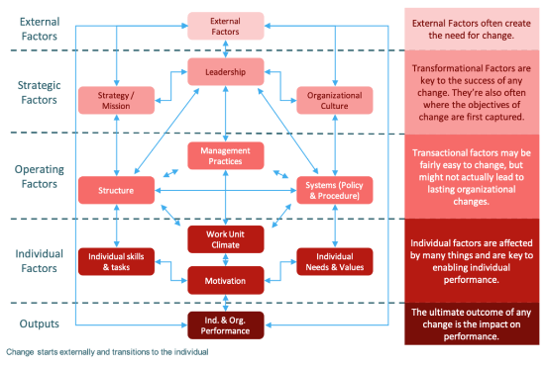

(World of Work, No Date).

It should also be mentioned that the actions of people professionals’ impact various aspects of an organisation. For example, at Bluestone, we would be responsible for recruiting and sourcing talented employees to make a difference to families choosing to spend their money and stay with us. Without this aspect, the customers may not have the best experience and may then choose to next time, spend their money and go abroad. Also, by implementing effective recruitment and retention measures, people professionals ensure that organisations (such as Bluestone) have the right workforce at the right time, which will essentially enhance efficiency.
Explain why it is important that organisational change driven by economic downturn and challenging trading conditions is planned, and effectively managed in your organisation (or an organisation with which you are familiar). (AC 3.1)
Change is always inevitable in any organisation that is evolving. Change helps organisations to succeed and grow. Planning and managing change led by people professionals is important for the organisation as it relates back to retention and effective work. Some employees embrace change, and others find it difficult to get on board with.
When looking at The Change Curve by Kubler-Ross, we can see that when dealing with change, we go through a ‘grieving’ process throughout the different stages. The different stages include:
- Shock – usually short lived, however this can slow down productivity whilst employees take time to take information in. Employees will seek further reassurance once the shock has settled into the system.
- Denial - there is likely to be a feeling that nothing is going to change/happen within the business. Employees tend to carry on as if nothing has happened and wait to hear news. They may deny receiving any communication.
- Frustration – after the feelings of shock and denial leave, the frustration kicks in whilst employees fear for their future and the change that is upcoming.
- Depression – Depression follows from feeling frustrated, starting to accept the reality and feeling low. It is possible that work reflects these feelings and employees will more so seek support from employers.
- Experiment – if employees feel supported, they consider experimenting as the harsh reality is, there is no other choice unless they plan on leaving the business. There are slow signs of recovery if employees agree to experiment with the change.
- Decision – employees learn how to work in a new situation with change and feel more positive.
- Integration – once change has been integrated, it is important to review this often, check in with employees and take feedback onboard. This can be done via surveys, polls, and performance reviews.
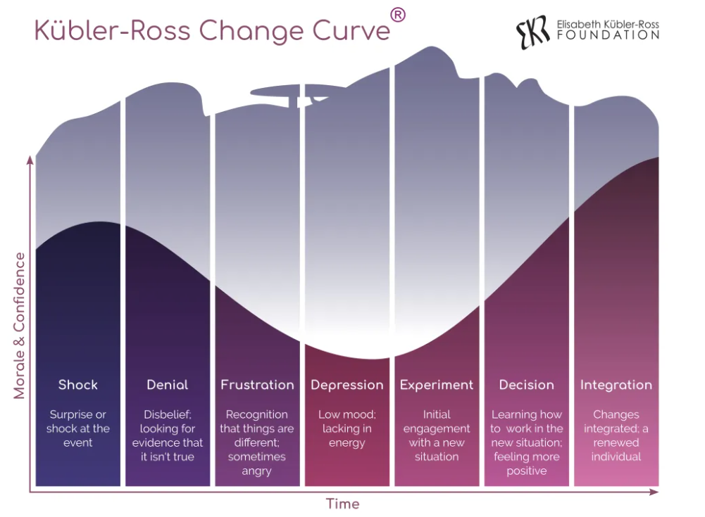

Kulber-Ross Change of Curve Image above (Ross, n.d.)
Managing change in the workplace is extremely important for various reasons. It helps reduce resistance to change among individuals within the workplace and helps identify risks and barriers. Change management helps identify those who are responsible for cascading change and implementing it in the correct way to ensure it progresses to plan. It is important to note that not rolling out change correctly, can have a snowball effect on the organisation if the individuals are not on board.
Explain the importance and role that could be played by people professionals in your organisation (or an organisation with which you are familiar) within change driven by economic downturn. (AC 3.2)
People professionals act as change champions when managing change driven by economic downturn. It is therefore important that people practitioners remain constantly aware of the economic environment and look ‘upwards and outwards’ from their organisation (CIPD, 2020).
In relation to Bluestone and the economic downturn, looking back at COVID, it was our duty to ensure that we had used the correct tools and measure to ‘furlough’ the correct employees and save costs where we could as the business was not making any profit. Again, the use of technology was important as in a time where we had to keep our distance and isolate, we got quickly introduced to video conferencing.
It is also important to note that people professionals have a duty of care to employees when dealing with change and supporting them through the process is vital. This may mean implementing flexible working arrangements (people professionals can help reduce employee stress by offering flexible work arrangements). People professionals also need to be on hand and ready to answer any questions in relation to change and initially, change can bring a lot of uncertainty.
Discuss how organisational change, driven by economic downturn, could impact people in your organisation (or an organisation with which you are familiar) in different ways. (AC 3.3)
Organisational change often takes place in the workplace which includes changing policies, inflation changes, cost of products increasing and so much more. Organisational change can result in redundancy due to not being able to pay staff. We saw this happen in Bluestone through COVID and the change in job titles due to not companies/Bluestone not being able to afford to pay staff. When reviewing redundancies, we must be careful of employee’s mental health as some people do have a genuine care for their job. We must ensure we are supporting these people with regular check ins.
Becoming redundant could cause severe stress and uncertainty for their future. Living in Pembrokeshire, there are not many job opportunities so employees may find it difficult to seek further employment. In addition, economic downturn could also decrease employee engagement as workload may decrease. This is because employees could feel undervalued and overworked by the business. Most of the time Bluestone have a good reputation for employee engagement, and they do their best to look after their staff. Again, there could be a snow-ball effect on engagement if employees are made redundant.
However, if managed correctly, people professionals can turn these challenges into opportunities and can look to foster a culture of resilience and adaptability by involving employees in any change process that is happening throughout. Buying into employees is just as important and employees buying into the business. This can effectively, strengthen the company’s capacity to manage future changes.
Whether it involves a shift in strategy, restructuring, or adopting new technologies, oganisational changes can create uncertainty and tension among employees. If managed effectively, this can increase morale, reduce productivity and increase turnover (Consultants, 2023).

Reference list
Bluestonewales.com (2024) Our Values | Careers | Bluestone. Available at: https://careers.bluestonewales.com/our-values. (Accessed: 24 October 2024).
Bluestonewales.com. (2024). Sense of Person | Careers | Bluestone. [online] Available at: https://careers.bluestonewales.com/our-values/sense-of-person (Accessed 23 Oct. 2024).
CIPD (2020) Economic transformation remains the biggest driver of change in organisations. Available at: https://www.cipd.org/uk/views-and-insights/thought-leadership/people-profession/economic-transformation-driver-change-organisations/. (Accessed: 24 October 2024).
CIPD (2024) PESTLE Analysis. CIPD. Available at: https://www.cipd.org/uk/knowledge/factsheets/pestle-analysis-factsheet/. (Accessed: 24 October 2024).
Consultants, I.R.I. (2023) The Human Side of Change: Impacts on People and Organizations. Available at: https://projectionsinc.com/the-human-side-of-change/. (Accessed: 24 October 2024).
Ross, K. (n.d.). Kubler-Ross Change Curve. Available at: https://www.ekrfoundation.org/5-stages-of-grief/change-curve/ (Accessed Oct. 23AD).
Samba, D. (2024) The Impact of Video Conferencing on Corporate Culture and Engagement. Digitalsamba.com. Available at: https://www.digitalsamba.com/blog/the-impact-of-video-conferencing-on-corporate-culture-and-employee-engagement. (Accessed: 24 October 2024).
Woffindin, L. (2022). What is Organisational Culture? CPD Online College. Available at: https://cpdonline.co.uk/knowledge-base/business/organisational-culture/. (Accessed: 24 October 2024).
World of Work (No Date). The Burke-Litwin Organizational Change Framework: A Simple Summary. Available at: https://worldofwork.io/2019/07/the-burke-litwin-organizational-change-framework/ (Accessed: 24 October 2024).
Young, J. (2023). Organisational climate and culture. CIPD. Available at: https://www.cipd.org/uk/knowledge/factsheets/organisation-culture-change-factsheet/. (Accessed: 24 October 2024).

