University of Wales Trinity Saint David
Wales Institute of Science &Art

Suspension Kinematics Formula Ford Van Diemen
Motorsport Technology (ACHA4012)

Owain Wilcox (2003601)
November 2021
Contents
1 Introduction 1
2 Laboratory Sessions 2
2.1 Equipment 2
2.2 Methodology 2
2.3 Results 5
3 WinGeo Kinematic Simulation 9
3.1 Methodology 9
3.2 Results 9
3.3 RC Migration 13
4 Suspension Calculation 14
4.1 Calculations 14
4.2 Discussion 15
5 Validation 16
6 Conclusion 17
7 References 18

Figure 1: Damper Adjustment and Height Gauge 2
Figure 2: DTI and Camber Gauges 3
Figure 3: Measuring Wheel Unsprung Mass 3
Figure 4: Tyre Deflection test with DTI 4
Figure 5: Spring Compression test 4
Figure 6: Changes in Camber and Toe vs Chassis Height 6
Figure 7: Change in Spring Length vs Wheel Deflection 7
Figure 8: Spring Deflection vs Force 7
Figure 9: Tyre deflection vs Force 8
Figure 10: Measured vs Simulation Camber and Toe against Chassis Height 11
Figure 11: Change in Spring Length vs Wheel Deflection 11
Figure 12: WinGeo Camber & Toe vs Roll 12
Figure 13: Roll Centre Migration 13

Table 1: Alignment, Height and Mass Data 5
Table 2: Spring Deflection Data 5
Table 3: Tyre Deflection Data 5
Table 4: WinGeo Ride Height Data 9
Table 5: WinGeo Roll Data 10

Equation 1: Wheel Rate Equation 16
Equation 2: Sprung Mass Natural Frequency Equation 16
Equation 3: Un-sprung Mass Natural Frequency Equation 16

Introduction

This report analyses the front suspension characteristics of a Van Diemen single seater race car. This vehicle is a naturally aspirated, 2000cc open wheel racer harnessing around 153hp. The car utilises a double wishbone and pushrod front suspension setup. The pushrod connects to a rocker which in turn feeds to inboard Penske double adjustable dampers (Race-Cars.com).

The report analyses data from workshop laboratory sessions and compares them to WinGeo Simulated data to evaluate correlations between the collected data samples.

Laboratory Sessions

Equipment

This section evaluates the accuracy and sustainability of the equipment used for the data capturing. This equipment composes of a vernier gauge, DTI’s measuring thousands of an inch, corner weight scales, height gauge, camber gauge and hydraulic presses to measure spring and tyre stiffnesses. These are highly sensitive and accurate pieces of equipment however a digital vernier gauge would have been more accurate than an analog version and the hydraulic presses needed new valves to sustain pressure in the system to improve the data quality.

Methodology

The initial task was to record data for varying measurements of chassis height. To begin with the wheel was set to +25mm making sure the height gauge was zeroed at this point along with DTI A and B. The measurements, including camber, were then recorded under wheel position 0.00mm. Proceeding this, the damper nut was tightened 2 full revolutions and all data values were observed and recorded for each position. This was repeated until the wheel position reached approximately 50mm from its origin. Figures 1 and 2 display the experiment setup.
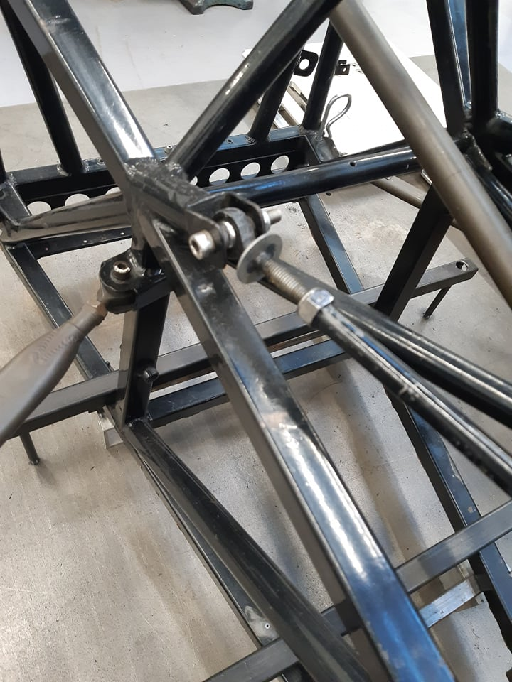
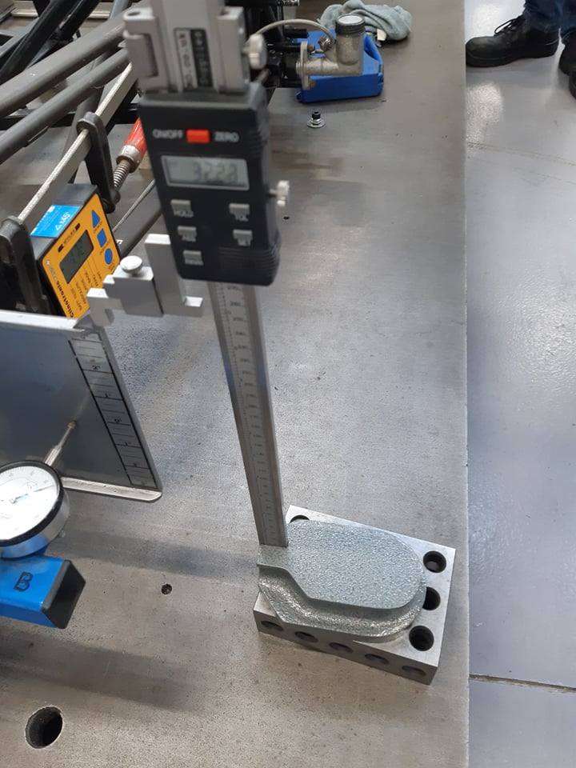
Figure 1: Damper Adjustment and Height Gauge
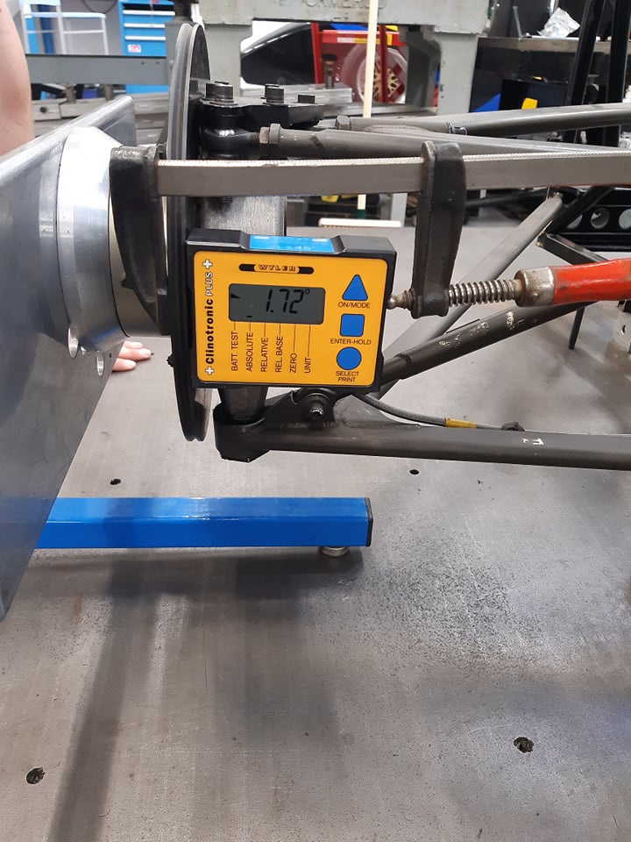
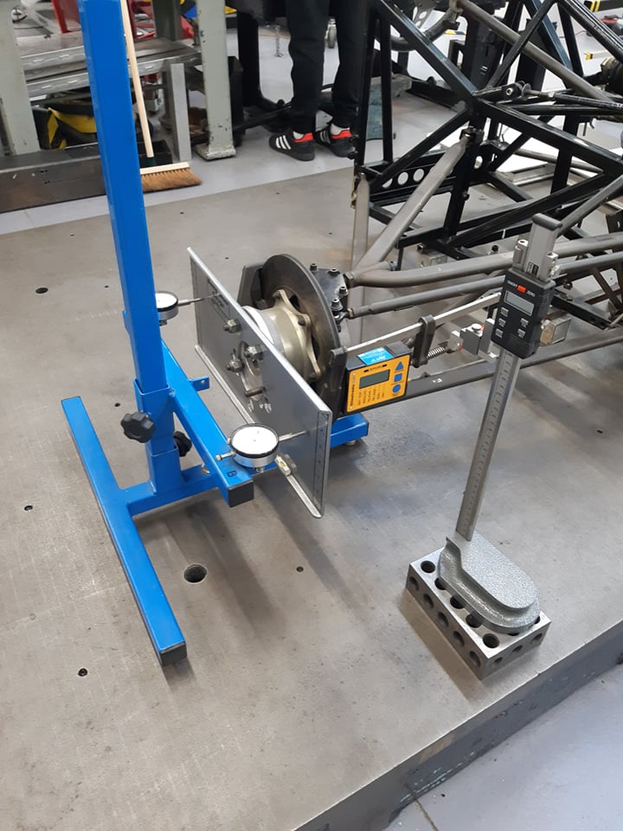
Figure 2: DTI and Camber Gauges

After collecting the alignment data, the wheel was weighed both on and off the car to provide data for the sprung and unsprung masses. Figure 3 highlights the procedure to measure the wheel off the car.
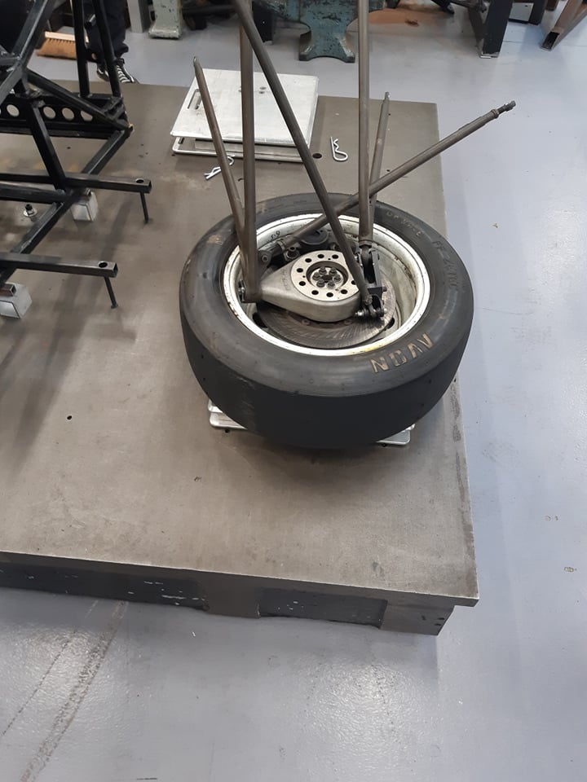

Figure 3: Measuring Wheel Unsprung Mass
The Tyre was then attached to a hydraulic press, a corner weight scale, and a DTI to measure the tyre deflection through various applied forces. The press was then initiated for 2 full revolutions of the DTI and the measurements recorded. This was repeated 7 times for a total of 14mm from origin. The test procedure is displayed in figure 4.
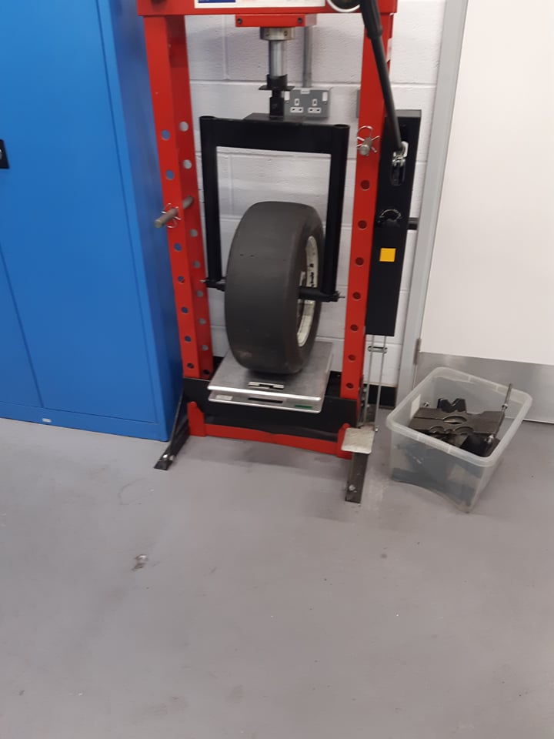
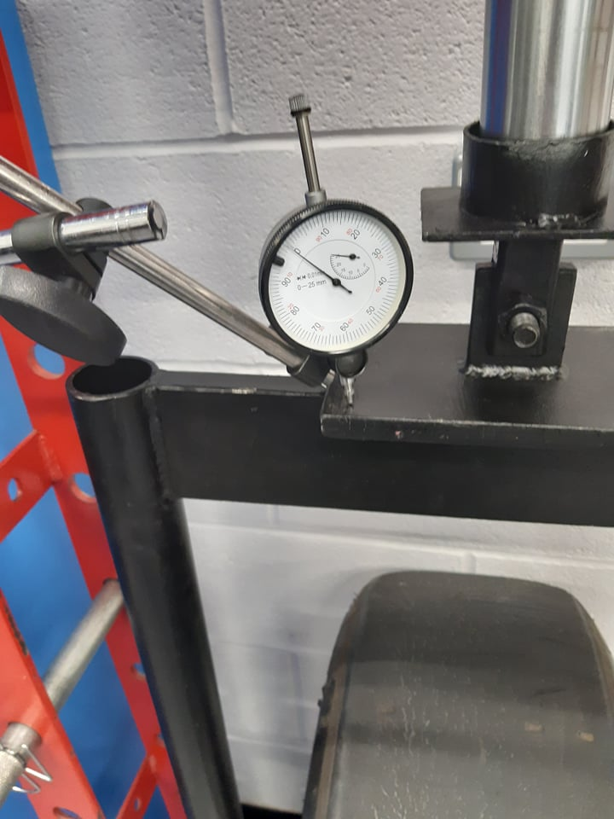

Figure 4: Tyre Deflection test with DTI

Finally, the spring was inserted into a hydraulic press as seen in figure 5. The press was set to rest on top of the spring where the DTI was then zeroed. From here the spring was then compressed in 0.1 inch increments up to 1 inch, procuring measurements from the laptop at each interval.
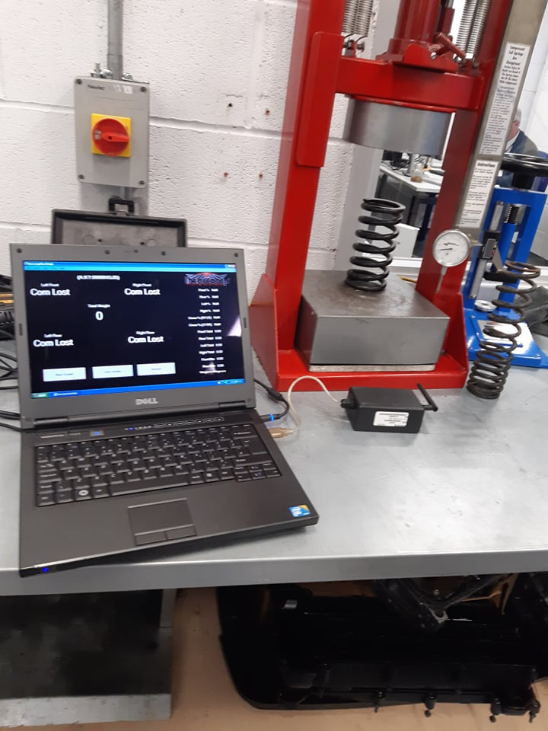
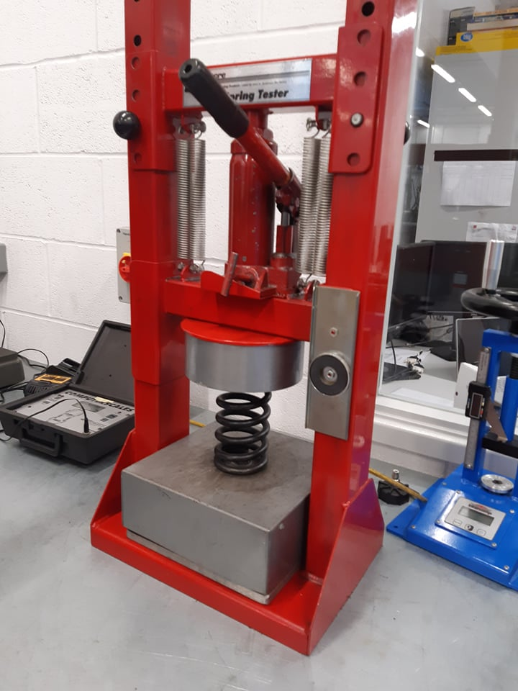

Figure 5: Spring Compression test

Results

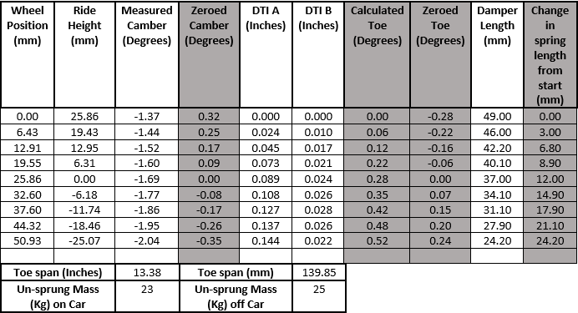
This section depicts the results. Table 1 represents the alignment and ride height segment, tables 2 and 3 show the suspension and tyre segments respectively. All white cells represent collected data whereas grey displays calculated data.
Table 1: Alignment, Height and Mass Data
Table 2: Spring Deflection Data
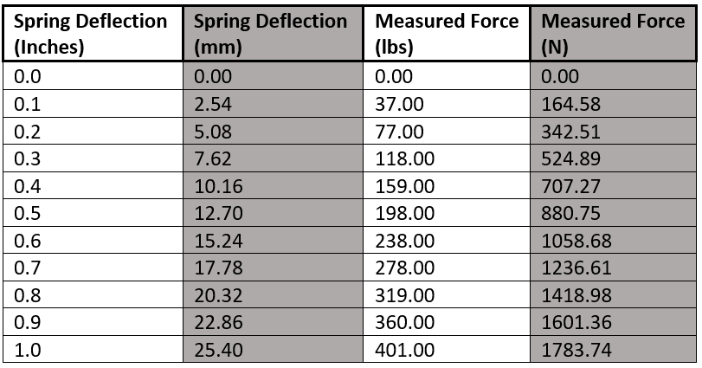

Table 3: Tyre Deflection Data

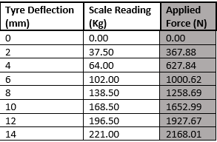

The spring rating for this vehicle is 400lbs/inch which is shown in table 2. May it be noted that the Tyre Deflection data in table 3 was collected when the tyre was at a pressure of 10psi.

To aid the data interpretation, multiple graphs were generated for the above tables. Figures 6 uses the data from table 1 to display the change in Camber and Toe against Chassis height.
Figure 6: Changes in Camber and Toe vs Chassis Height

Figure 6 represents the alignment of the vehicle as it undergoes various stages of heave. Regarding the Camber, it has the greatest negative value when the chassis is at its lowest point (bump), and the greatest positive value when the chassis is raised in relation to the wheels (Rebound).

The opposite can be said for the Toe, which has the greatest positive value (Toe-in) when the chassis is at its lowest point. Both graphs have a linear trend against their respective chassis heights, however Toe and Camber share an inversely proportional relation to each other.

Figure 7 uses data from table 1 to display the spring length from the origin against the wheel deflection from the origin. This graph has a near perfect linear relation however one value has a noticeable deviation from the line of best fit. As all other points sit upon this line it is fair to say that the anomaly is down to human error when taking the data results.
Figure 7: Change in Spring Length vs Wheel Deflection

The Motion Ratio can be calculated if the distance the spring has moved is divided by the distance the wheel has moved. This is, in effect, the gradient of figure 7. Therefore, the measured data from this vehicle calculates a Motion Ration of 0.4726.

Figure 8: Spring Deflection vs Force

Figure 8 shows the spring deflection against the applied force. This again is a linear relation which implies that the spring force will increase in equal increments proportional to the springs travel. The spring rate can be calculated by dividing the spring force by the spring deflection, which corresponds to the gradient of the graph as seen in figure 8. This value, however, is not in standard SI units. Multiplying by 1000 provides the correct units of measurement and produces a spring rate of 70,401 N/m.

Finally, Figure 9 graphically represents tyre deflection vs force. This is another linear relation which shows the proportional increase between force and deflection. The gradient of this graph presents the trye stiffness which calculates as 157,190N/m once converted to standard SI units.
Figure 9: Tyre deflection vs Force

WinGeo Kinematic Simulation

Methodology

WinGeo is a simulation program that allows the user to digitally duplicate a vehicle’s suspension system. The user can then input variables to assess how that suspension system will react. The simulation then calculates a multitude of data values for each increment of variable change. In this instant, ride height, roll and steering angles were altered, and the simulated data sets were recorded.

Results

Table 4 portrays the data when ride height was altered by 5mm increments between -25mm and +25mm. Table 5 shows the data when the roll was altered by 0.1-degree increments between 0 and 2 degrees.

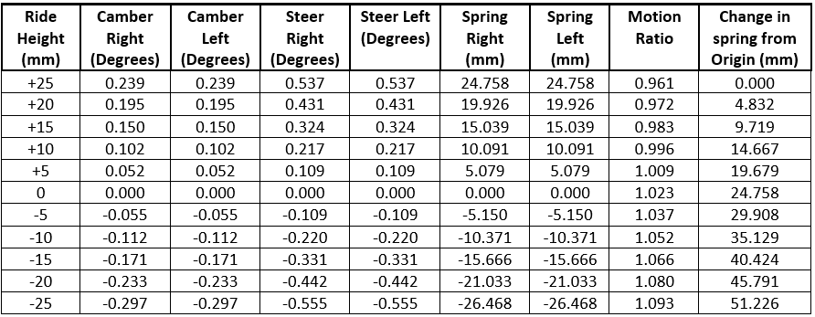
Table 4: WinGeo Ride Height Data

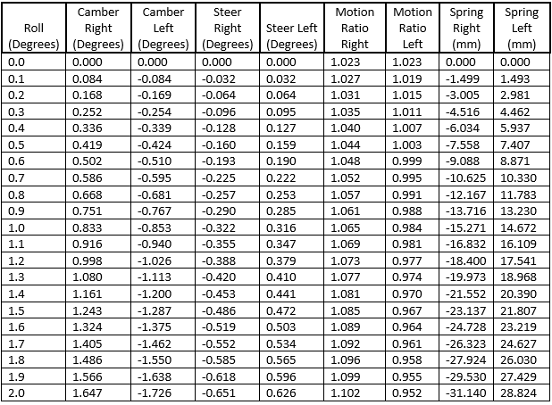
Table 5: WinGeo Roll Data

Graphs were produced to better display this data. The WinGeo data was overlayed onto the measured data graphs displayed in Figures 6-9 to compare the simulated results against the laboratory results.

Figure 10 compares the measured data vs the simulated data for the Camber and Toe against Chassis Height. Both sets of data are linear however there are some discrepancies between the gradients. The WinGeo camber has a lesser gradient than the measured data whereas the WinGeo Toe has a steeper gradient than that measured.
Figure 11 shows the change in spring length in relation to wheel deflection. This is again another positive linear relation however the gradient is remarkably different form the measured data with a motion ratio of 1.0241.
Figure 10: Measured vs Simulation Camber and Toe against Chassis Height

Figure 11: Change in Spring Length vs Wheel Deflection
Figure 12 presents Table 5’s data showing the simulated camber and toe against degrees of roll for each side of the car. Both Toe and Camber share an inversely proportional relationship to the other wheel on the car, meaning that when the vehicle is under a state of roll, one wheel will have negative camber, the other positive.
Figure 12: WinGeo Camber & Toe vs Roll

RC Migration

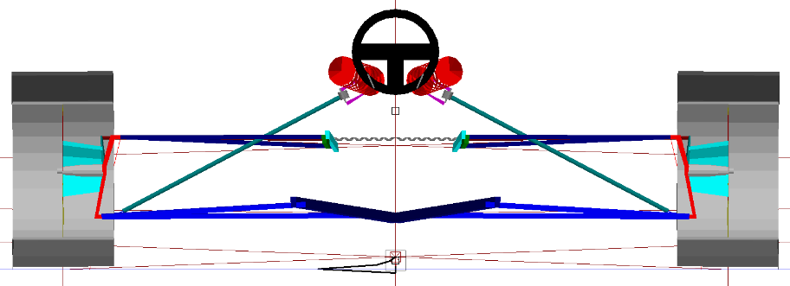
This section focuses on the roll centre migration (RCM) when a real-world scenario is applied to the WinGeo simulation. The roll centre is the theoretical point that the suspension is considered to act around in the transverse and vertical axis. Figure 10 portrays the RCM under different circumstances: full braking, half braking with half steering, full lock, half acceleration with half steering and finally full acceleration.
Figure 13: Roll Centre Migration

RCM is a key factor in vehicle handling as it dictates the vehicles safety and handling during cornering. Rolling occurs when the RCM is below the vehicles Centre of Gravity (CoG). Increasing the distance between the RCM and CoG allows for optimisation of camber which improves straight line handling and ride comfort, however, produces more roll in corners, reducing handling and safety. Reducing the RCM to CoG distance increases the resistance to roll, providing better cornering. This comes at the cost of increasing camber changes, straight-line stability, and comfort (Lee, 2001).

Suspension Calculation

This section focuses on calculating various suspension attributes based off the collected data in table 1. The attributes mentioned are the wheel rate, suspension ride frequency and un-sprung mass natural frequency.

Calculations

To calculate the Wheel rate the equation, $Kw=Ks×MR^{2}$ is used where Kw is the wheel rate, Ks is the spring rate and MR is the motion ratio.
Therefore, $Kw=70401 ×{0.4726}^{2}$ = 15,724.12 N/m.
Equation 1: Wheel Rate Equation

Calculating the natural frequency of the sprung mass is given via the formula, $f=\frac{1}{2π} ×\frac{\sqrt{Kw}}{Ms}$ where Ms is the sprung mass of the suspension (115Kg).
Therefore, $f=\frac{1}{2π} ×\sqrt{\frac{15724.12}{115}}$ = 1.861034 Hz.
Equation 2: Sprung Mass Natural Frequency Equation

Finally, calculating the natural frequency of the un-sprung mass is given via the equation,
$fus=\frac{1}{2π} ×\sqrt{\frac{Kw+Kt}{Mus}}$ where Kt is the tyre stiffness and Mus is the measured un-sprung mass on the car data as seen in table 1.
Therefore, $fus=\frac{1}{2π} ×\sqrt{\frac{15724.12+157190}{23}}$ = 13.79976 Hz.
Equation 3: Un-sprung Mass Natural Frequency Equation

Discussion

The natural sprung frequency for OEM passenger cars is around 0.5-1hz as this frequency is superior for ride comfort. The Van Diemen, however, has a natural sprung frequency of 1.8 Hz due to the car utilising stiffer suspension, bushes and incorporating mild aerodynamics. These factors compromise driver comfort for track performance.

Validation

This section analyses the measured data vs the WinGeo data. As forementioned, there are various discrepancies between the two data sets. The greatest difference is the motion ratio value. The measured data outputted a value of 0.4 whereas WinGeo produced a value greater than 1. As the measured data had consecutive linear results then it suggests that the simulated data isn’t reliable. A possible reason for this is that the simulation had to be created and designed in WinGeo, a small calculation error in a component’s position or dimensions could alter the readings. For example, if the suspension rocker ratio was incorrect then it would offset the data values.

Another factor to consider are the Instant Centres (IC) of the suspension arms. The IC is the imaginary point the upper and lower control arms intersect and is considered the point in which the lower arm pivots around. It affects the radius of arc the wheel moves through, the longer the IC, the larger the arc and therefore the lower the magnitude of alignment changes during bump and rebound.

Due to this, it is acceptable to hypothesise that the IC’s between the measured and WinGeo data are different. As the WinGeo Camber in figure 10 has a lesser gradient than that of the measured, it could be the result of a larger IC in the simulation due to incorrect mounting points of the upper and lower arms.

Conclusion

To conclude, this report has evaluated the suspension characteristics of the Van Diemen formula car. An outline of the experimental procedures has been provided and a comparison between the measured and simulated data has been given. Graphical data has been presented and evaluated and validation of possible discrepancies between the data sets has been hypothesised.

References

Lee, U. and Han, C., 2001. A suspension system with a variable roll centre for the improvement of vehicle handling characteristics. Journal of Automobile Engineering, [online] 215(6), pp.677-678. Available at: <https://journals.sagepub.com/doi/10.1243/0954407011528266> [Accessed 25 November 2021].

Race-cars.com. n.d. 1993 Van Diemen RF93. [online] Available at: <http://www.race-cars.com/carsales/vandiemn/1508364016/1508364016ss.htm> [Accessed 15 November 2021].

