

HOW CAN THE POLICE IMPROVE EFFECTIVENESS AT TACKLING FRAUD AND DOES SOCIOLOGICAL THEORY ASSIST IN ASSESSING THIS?

Student Name: Kian Board

Student Number: 2134510

Subject: BSc (Hons) Professional Police Practice

Acknowledgements:

I would like to thank my friends, family, colleagues and my partner for the support and assistance you all provided throughout this dissertation process.
Without your needed guidance, this project would not be where it is now.

Declaration:

- Declaration - This work has not previously been accepted in substance for any degree and is not being concurrently submitted in candidature for any degree.
Signed: Date: 16/03/2025
- Statement 1 - This dissertation is being submitted in partial fulfilment of the requirements for the degree of BSc.
Signed: Date: 16/03/2025
- Statement 2 - This dissertation is the result of my own independent work/investigation, except where otherwise stated. Other sources are acknowledged by footnotes giving explicit references. A bibliography is appended.
Signed: Date: 16/03/2025
- Statement 3 - I hereby give consent for my dissertation, if accepted, to be available for photocopying and for interlibrary loan, and for the title and summary to be made available to outside organisations.
Signed: Date: 16/03/2025
- Statement 4 - I hereby give consent for my dissertation, if accepted, to be available on the university’s IT system to those who have consent to use the system.
Signed: Date: 16/03/2025
Abstract:

This dissertation is aimed at providing working strategies on improving police response to Fraud and if Sociological theory assists in creating strategies.
The two theories that are the focal points of sociological research are Consensus and Conflict Theories.

Consensus Theory is a collective of sub-theories, and popular ideologies such as Functionalism and Interactionism which present the theory that society is joined through cohesion, and togetherness. In the perspective of policing, the public interact with the police through engagement and that the police are “one from the community.”

Conflict Theory is the opposite of the aforementioned. It is a collection of sub-theories such as Marxism and Feminism. Comparatively, it focuses on the conflicts in society and present the idea that society clashes to create rules and laws. In the context of policing, they state that the police only interact with the public through conflict such as responding to crime and that laws/the police are a conflict themselves against the public.

Using both conflict and consensus theory alongside independent research, the researcher will be collating all gathered evidence to conclude working strategies to improve police response to fraud.

Table of Contents:

Chapter One – Introduction
1.1 - Background
1.2 – Research Objectives
1.3 – Introduction to Literature
1.4 – Introduction to Research Method
1.5 – Sampling Framework
1.6 – Ethical Issues

Chapter Two – Literature Review
2.1 – Introduction
2.2 – Conflict Theory
2.2.1 – Marxism and Classist ideologies
2.2.2 – Selective Law Enforcement
2.2.3 – Analysis of Conflict Theory
2.3 – Consensus Theory
2.3.1 – Peelian Principles and Public Confidence
2.3.2 – Legitimacy of the Police
2.3.3 – Interactionism
2.4 – Analysis, Review and Conclusion of Literature

Chapter Three – Methodology
3.1 – Introduction
3.2 – Research Strategy
3.3 – Data Collection
3.4 – Limitations and Problems
3.5 – Methods of Use
Chapter Four – Analysis of Results:
4.1 – Introduction
4.2 – Research Findings

Chapter Five – Findings and Conclusions
5.1 – Introduction
5.2 – Findings and Subsequent Conclusions
5.2.1 – External Influence
5.2.2 – Conflict Reflecting the Public’s Opinion
5.3.3 – Representation of Public in Research

5.3 – Strategies for Improving Police Effectiveness

Chapter Six – Limitations and Recommendations
6.1 – Introduction
6.2 – Limitation of Research Choice
6.3 – Limitation of Questionnaire
6.4 – Limitation of Timing and External Factors

Chapter Seven – Bibliography
7.1 – Bibliography

Chapter Eight – Appendix
8.1 - Appendix

Chapter One – Introduction:
  - Background:
The researcher has chosen to focus their dissertation on the effectiveness of policing fraud and how it can be improved via the analysis of consensus and conflict theory and also public perceptions. They have chosen to do this as they believe with events ongoing within the UK, Policing in the UK is being questioned as to their response to online crime namely fraud. Further, Policing has been questioned as to whether it is effective even when changes are made.
Fraud is defined as “Wrongful deception with the intent to gain personally or financially” (Legal Dictionary, 2014). This definition will set the basis for how fraud will be analysed throughout the dissertation process.
Scanning literature, there are ample studies relating to the effectiveness of policing. Firstly, theories show how policing could be a hindrance due to the ‘Policing Culture’ (Campeau, 2015) as well as how the police use “Selective Law Enforcement” which targets working class populations and its effect on their opinions on the police (Feria, Tax Fraud and Selective Law Enforcement, 2020)
Articles from BBC News also demonstrate how the Inspectorate of Constabulary believes the trust in police is “hanging by a thread” after a review of reports from the public (Levi Jouavel, 2023).
Effectiveness is defined as “​the fact of producing the result that is wanted or intended” (Collins Dictionaries, 2023). This will be measured by analysing the amount of police recorded fraud between 2016 to 2024 in relation to fraud offences in South Wales Police. This will identify if the police response to fraud is effective and deterring future crime from occurring and analysing if it is increasing/decreasing and suggest change on the basis of research to ascertain if sociological research may assist in providing strategies of improvement.

  - Research Objectives:

1. Evaluate the public’s perception on conflict and consensus sociological theory to utilise in gathering strategies on improving police effectiveness.

Hypothesis:
- The researcher believes that evaluating the public’s perceptions on conflict and consensus theorems will allow them to create working strategies on improving effectiveness in fraud response through evaluation of the perceptions gathered.

2. Analyse independent conflict and consensus sociological theories in order to create working strategies on improving the effectiveness of the police.

Hypothesis:
- The researcher hypothesises that through a review of conflict and consensus theory literature, it will present a basis for strategy creation to improve the effectiveness of fraud response. The researcher will be applying several aspects of both consensus and conflict theories in order to understand if sociological theory will assist in strategy creation.

3. Analyse a variety of perceptions both internally and externally to the police to perceive positive or negative bias created via institutionalisation.

Hypothesis:
- The researcher speculates that there will be bias from participants within the police due to the exposure they have to incidents which they have attended which creates a wider knowledge of the policing role comparatively to the general public who may not have had any experience with the police at all. The researcher aims to gather both perceptions to analyse this bias to see if it has an effect on the respondent’s answers to the research questions.

4. Measure effectiveness through the mean of analysing successful prosecutions for fraud related crime

Hypothesis:
- the researcher will be conducting research into successful prosecutions for fraud related crime and use this as a means to measure police effectiveness at dealing with this crime. The researcher hypothesises that the percentage of successful prosecutions will be decreasing.

  - – Introduction to Literature:

Throughout this dissertation, the researcher will be referring to several pieces of literature.
As stated in their introduction, the researcher will implement literature in the form of media articles, sociological theories, and studies as well as reports focused upon aspects of the public’s perception on effective fraud response.
From looking at research, the researcher understands the broadness of research available and has therefore focused their literature to two sociological theories which encompasses sub-theories in order to gather opposing viewpoints to better ascertain if sociological perspectives can be used in strategy creation for improving effectiveness.
It is to be understood if sociological perspectives can be used in creating practical strategies for the police to implement when tackling. Both theories within this dissertation will be analysed by the researcher and assessed whether they provide valid evidence useful in creating working strategies.
Finally, the reports focused on public perception is vast and there are many reports that focus on topic areas to evaluate the public’s perception of policing effectiveness. Firstly, there are reports which are simplified into yes/no answers which is broadcasted to many participants. The researcher understands there is few reports which are individually focused which allows participants to clarify answers and justify their viewpoints.
The researcher’s aim is to have smaller amounts of data compared to the large government reports but have the answers given to be thorough with reasonings.
  - – Introduction to Research Method:
As stated above, the researcher’s method will gather the viewpoints of the public both internally and externally of the police to understand how they believe policing could be more effective and to analyse any institutional bias.
They believe a questionnaire will best suit this need. They have considered a more focused method of interviews; however, they do not believe this method is suitable as they still need to gather a sizable group of data to corroborate the ideas of the public and to analyse trends.
Questionnaires allow the researcher to ask open questions which in turn, gives the participants opportunity to detail their reasonings why they have specific viewpoints on police effectiveness. Utilising a questionnaire also allows them to broadcast their research to a vast majority of persons from a localised area which will then gather a view on police effectiveness.
  - – Sampling Framework:
The researcher’s sample framework will consist of members of the public as well as persons working within the police. Their intention is to use the public as a means to gather the majority view and how they can develop a strategy to suggest more effective policing. The questionnaire will be shared via electronic means. The researcher hopes to gather as many viewpoints as possible and aim for a sample size of 20-80 persons. Although a small sample size, it will gather viewpoints from several areas which allows them to gather broader viewpoints.
The researcher will also gather viewpoints from within South Wales Police as they believe it will be useful in gathering the opinions of those exposed to the duties of the police and may also be institutionalised which can be analysed if it has an effect on their responses. The researcher believes there may be bias when evaluating the effectiveness of police from viewpoints of internal respondents due to institutionalisation however, as stated, this will be analysed and factored into the conclusion of creating working strategies to improve effectiveness.

  - – Ethical Issues:
The research may generate ethical issues where participants may wish to retract their input on the questionnaire. The researcher ensures they are aware of this before starting the questionnaire. Further, their sample size consists of few members of the public and persons in the police. This will generate bias based on area and also persons from within the police therefore, their questionnaire may not be representative of the views on police nationally.

Chapter Two – Literature Review:

2.1 - Introduction:

In literature and writing, Consensus vs Conflict theories debate their theorems on how the public view the police. The below writing highlights how these theories are evidenced in opinions broadcasted and shared in different versions of media and reports which will be utilised in creating working strategies on how to improve the effectiveness of response to fraudulent crimes.

2.2 - Conflict:

Initially, Conflict theory has not been defined by one sociologist but many from several theories. It can be surmised as an amalgamation of theories that are based upon the ideology that individuals and groups of society connect via conflict rather than agreement. These theories which include heavy influences of Marxism, focus on social disagreements such as social class, gender, and race as reasons of conflict in society.

2.2.1 - Marxism
Within Marxism, there are two focal points of which writers have theorised how the public view the police and their response to fraud. These being “Selective Law Enforcement” and “The State and Law Making.”
In his 2001 book “The Rich get Richer, and the Poor get Prison”, Jeffrey Reiman theorises that crimes committed by the upper class are accepted and unlikely to be treated as a criminal offence (Jeffrey Reiman, 2016). This idea presents the theory that police and state are “selective” in their prosecution and pursuit of crimes against those in the upper class and the crimes they are likely to commit. These being established as “complex crimes easily undetectable but the common man” such as fraud in original Marxism writing by Karl Marx (Karl Marx, 2015). Reiman focuses his work upon crimes committed within the workplace that exploit rules, and these go unpunished comparatively to crimes such as assault, theft, and burglary. This includes the ignorance of health and safety laws whereby corporations are unpunished for the nescience of these laws as well as the exploitation of tax laws such as offshore accounting to avoid taxes in place that the corporation must pay.
A recent study based on tax fraud that highlights selective law enforcement shows that although there have been a recent influx of “measures” in the last decade to combat tax fraud, these measures are focused on enforcement of revenue gain rather than the combating of the fraud itself (Feria, Tax Fraud and Selective Law Enforcement, 2020). This study highlighted and argued that the state creates enforcement measures that reimburses revenue rather than measures that will help prevent tax fraud and create laws that make it more adverse to achieve tax fraud. Feria’s study emphasises the ideology that Reiman and Karl Marx present of “Selective Law Enforcement” and “The State and Law Making” by evidencing that the state does not create laws that help prevent fraud rather than seek recompense for it and thus creating a cycle of keeping the upper class in power through monetary value.

2.2.2 - Selective Law Enforcement
Further to these two theorems, William Chambliss conducted a study in 1978 within Seattle that focuses upon Selective Law Enforcement. Chambliss’ report showed that 70% of arrests were for public drunkenness whilst white collar crimes involving lead politicians, official state heads and other important upper-class individuals were all but ignored. Some of these crimes he identified from official statistics and reports were in relation to organised crime prostitution that effected the community at large; in particular that of the lower class. (Chambliss, On the Take: From Petty Crooks to Presidents, 1978). Chambliss’ report, which contains credible evidence from official police reports of Seattle further underlines the issue of Selective Law Enforcement as the police and state created those reports themselves. Chambliss’ report and theorem of Selective Law Enforcement is further substantiated by a report from Richard Murphey in 2011 where, as a tax researcher, has found that in 2011 the outstanding debt estimated from tax evasion, fraud and eversion amounted to £120 billion whereas benefit fraud only amounted to £1.1 billion (Murphey, The Courageous State: Rethinking Economics, Society and the Role of Government, 2011). This report demonstrates Chambliss’ idea of Selective Law Enforcement whereby white-collar crime of tax evasion and tax fraud amount to a substantial amount more than benefit fraud. Marxism would argue that this is due to the media portraying the idea of benefit fraud being more prevalent than tax evasion and the media being controlled by the elite and upper classes. This is one of the main concepts of Marxism known as Instrumentalist Theory but applied to the form of media and its effects on public perception (Thompson, 2022) Despite the media stating so, the credible report from Murphey who took statistics from state findings portrays the opposite opinion with factual evidence that white collar crime causes more financial damage to society than benefit fraud from those in the lower class. Marxism would argue that this is a form of control over the lower class.
Despite evidence stating so, the public deemed benefit fraud to be of concern as per a report from UK Government Social Research. The research report conducted in 2023 showed that “62% of respondents saw fraud and error in the system as a big problem; 39% thought it was on the increase (compared to 5% who thought it was decreasing); and around a third (31%) believed “most” incorrect benefit claims are a result of dishonesty” (UK Governement Social Research, 2023). This report showing the public’s perception in correlation with the report conducted by Murphey and Chambliss’ theory, it can be perceived that the public’s perception on benefit fraud is stained by the media’s portrayal that it is of concern despite the evidence from Murphey’s research showing otherwise. This concept of Instrumental Theory being applied to the use of media and its effect on public perception further validates Chambliss’ theory. An overall thesis concluding that despite evidence, the public’s opinion on policing action and accountability may not be reliable compared to the reality of what police are counteracting and responding to.

2.2.3 - Analysis of Conflict Theory
Analysing the research above, it is evident that alongside Feria’s report, the ideology of “The State and Law Making” is prevalent to today’s society as it demonstrates the state’s laws focus on reparation of fraud through monetary gain rather than the prevention of tax fraud which in turn, effects only those paying tax which are predominantly lower to middle classes. Further to this, Feria’s study is credible due to its use of current laws that are still present in modern society. The theory of Selective Law Enforcement is also evidenced in an IPSOS study into the public perception of fraud response. 4,709 British adults were interviewed on their perceptions of response and within the interview, they were asked “In the past 12 months how effective, if at all, do you think the police in your local area have been at each of the following?”. The result of the question posed that the public believe that their local police are least effective at tackling online crime such as fraud and protecting those who are online comparatively to those who are at greatest risk (IPSOS, 2020). This study further accentuates that the public perceive the police to be inept at tackling fraud. Combined with the beforementioned theories, it could be perceived that the police choose to tackle fraud inefficiently due to the monetary value it brings the state and that it does not affect those who are in power or the elite of society.
On the other hand, it is argued that the originality of the theory from Marx and Reiman is outdated due to the original theories being published some hundred years before. A further criticism of the above is that the culmination of Richard Murphey, Chambliss and the research study from UK Government again does not demonstrate evidence that the media influences the public’s opinion that benefit fraud is more prevalent than white collar fraud. No evidence suggests the media is at hand of influencing the public and only theorises that it is used to control lower class opinions. Consensus theorists would argue that the media is used to inform society of the most prevalent issues it faces and creates cohesion in society by uniting social groups against the issue (Parsons, 1964).

2.3 - Consensus:

Consensus theory has strong ties to the unity and togetherness of society and in turn between public and police. Consensus theory comprises of mainly functionalist theorists who believe the relationship between public, and police is harmonious and that the police is comprised of persons to and from the community it serves and representative of the local social groups (Durkheim, 1938). Police are seen as a welcome presence in the community, and it is a value that is needed within society especially when countering fraud where it is argued that reducing crime particularly fraud is done by reducing the opportunity for it and therefore, having positive police presence to educate vulnerable members of society and showing presence online (Clarke, 2010).

2.3.1 - Peelian Principles and Public Confidence
The view on police, punishment and the state are viewed mostly in a positive light in consensus theory. As stated above, it is a bond between community and police whereby police work on a “Policing by consent” theory. This theory developed by Robert Peel was contained in his “Peelian Principles” issued to the Metropolitan Police in 1829 whereby the 9 principles he stated confirmed police will work by the consent of the public and this is where their power derives, not by the power gave from the state (GOV.UK, 2012).
With this basis, Consensus theory derives a form of cohesion and the necessity of crime within society. Focusing on the legitimacy and why the public conform to authority, it is stated that the legitimacy of policing fraud does not come from the effectiveness of dealing with fraud but from the fairness of dealing with it. The public were observed to be more concerned with the fairness of prosecution and treatment of victim rather than the effectiveness of dealing with the matter (Fielding, Concepts and Theory of Community Policing, 2005). A report conducted by the Ministry of Justice shows public confidence in police in 2013/14 which showed that public confidence was high and believed that fairness was at the forefront of their opinion. This trend was increasing and continues to increase due to the policies applied by police to make responding fairer (Jansson, 2015). Despite research stating the public are more concerned about fairness in prosecution, it does not assist the researcher in understanding the effectiveness of policing fraud. The above study does, however, recognise that the public are not concerned with how effective the police are, so long as they are treated fairly when they are a victim of fraud.

2.3.2 - Legitimacy of the Police
consensus theorists further argue that the public only comply with the law due to the legitimacy of the criminal justice system (Brogden & Nijhar, 2005). It is stated that the police and criminal justice system present punishment to reinforce the norms and expectations from persons in society. These punishments and consequences, provide the legitimacy of the criminal justice system which in turn creates conformity to law in society. The public then, view the police and criminal justice system as legitimate due to the consequences they know will be applied should they deviate from social norms. This theory is evidenced in a report on Public Opinion and Understanding of Sentence from UK Parliament whereby it evidenced that of the applicants to the study, 52% felt confident in the consequences and punishments provided in sentencing and 54% thought it was fair. Further applying Fielding’s theory to the study coincided with the theory of legitimacy from Brogden & Nijhar it is evident that the report demonstrates that the legitimacy of the criminal justice system and police stems from the fairness and treatment of the public rather than its effectiveness. Despite the legitimacy being reinforced from fair prosecution, it does not account for why fraudulent incidents continue to occur. The combined theories do not account for why fraud continues to account for one third of crime overall despite the “high legitimacy” of the police (The Police Foundation, 2018).

2.3.3 - Interactionism:
Interactionism is also key when analysing Consensus theory and the public perception on fraud response. Interactionism is defined as “a micro-sociological perspective that argues that meaning is a product of interactions or repeated interactions between individuals and social groups” (Mead, 1934). This theory concurs with functionalist theory as it argues that positive interactions between public and police creates legitimacy however, Interactionist theorists look at these interactions on a micro scale rather than society as a whole.
When evaluating the public’s perception on response to fraud, it is seen that positive and negative interactions with police effect the overall confidence and trust in police (Miller & D'Souza, 2016). This journal article which looked at searches conducted by police found that those who had a negative interaction with police were associated with negative opinions of the police and had a higher influence on those who broadcasted positive interactions with police to the public. On a micro scale, it was found that those who did have a positive experience with police were likely to engage more frequently with police and be more aware of crime comparatively to those who had a negative view to be ignorant of crime occurring. Peyton supports this by showing that the public’s perception is vital for the effective function of the police and is driven by the perceptions of the public to function as a social institution and individual officers (Peyton et al, 2019). Assessing both theories, it is seen that in order to achieve confidence and legitimacy in police, a positive interaction is required in order for that interaction to be broadcast to the wider public to reinforce a positive overall opinion on the police and their response to fraud. In relation to the functionalist theorists, this positive interaction then creates police legitimacy as persons with a positive opinion on police are more likely to engage, report and assist in the action against fraudulent crime in society and reinforcing the norms and values agreed upon by the public. Further, the UK Parliament report highlights that interactions with police are marjorely positive due to the percentages showing confidence and trust in police and the fairness of treatment. This evidence shows that overall, interactions with police are positive and help build trust and legitimacy for the police which in turn benefits police further due to the public engaging by reporting more fraud, assisting police during investigations and taking a proactive role in the prevention and intervention of fraud.

2.4 - Analysis, Review and Conclusion:

Reviewing the literature stated above, the researcher understands the difficulty in applying sociological theory to practical strategy.
Initially, conflict and consensus perspectives counteract one anothers opinions as conflict states that the relationship between police and public is built on conflicting opinions whereby consensus argues that it is harmonious. Evidence above shows that despite conflicting theories, the UK parliament report shows a majority of public are trusting and confident in police response to fraud due to the fairness it provides. However, Conflict theories would argue that the public’s perception is misconstrued due to the publication of material that sways the public away from white collar crimes such as fraud being committed which help legitimise the elite in power as per Instrumental Theory.
When asssessing the above literature it is understood that no macro perspective has the answer to whether the public has a positive or negative opinion on police response to fraudulent crime. It is agreed upon that the relationship between police and public is complex and can be analysed both on macro and micro scales giving both varying results as presented above.

It is agreed upon that without trust and confidence in the police, they are limited in their ability to act and prevent crime such as fraud (Rosenbaum, 2005). Whether it is conflict who argues that reform is needed within police to take power away from the elite or whether it is consensus theorem who believe the police function the way it does to reinforce social norms agreed upon by the public, both macro perspectives agree that without the trust and confidence of the public, the police would have no power to perform as a social institution and be effective at tackling fraud.
With evidence from reports, studies and findings conducted by official state reports, the police and individual theorists, the large amount of findings present the evidence that public confidence in police is in the majority.
Despite researching into both theorems, it can now be determined that due to the disparity between both theories and that sociological theory is based upon abstract ideologies and not on factual evidence, that sociological theory will not be beneficial in comprising a working strategy to improve police effectiveness at responding to fraud.
If a working strategy was used on the basis of sociological theory, it may include the police/crown prosecution service removing background factors from sentencing in order to create fairness between class divide criminals as well as the police changing their approach and response to fraud whereby positive interactions are created and further bolstering the respect and trust in the police and further legitimising their authority when responding to fraudulent crime.

Chapter Three – Methodology:

3.1 - Introduction:
In this section the researcher discusses the method in which they will conduct their research surrounding the topic of how conflict and consensus theory as well as the public’s perception on fraud response can be applied to improve the police’s effectiveness at managing fraud. This topic delves into how theories of sociology; namely conflict and consensus, and the public’s perceptions on the police can be collated to create a strategy to improve effectiveness to fraud.
The objective of their research is to gather data employing a quantitative method which will highlight perception trends and patterns whilst corroborating them with the specific theories of conflict and consensus. For example, several questions involved in the questionnaire will ask how much the participant agrees with a statement which stems from a sociological theory on policing.
There are multiple reasonings as to why the researcher wishes to undertake this research. Firstly, there are several gaps in their research which do not portray sub-theoretical viewpoints which may be prominent in the public’s perception on policing fraud effectively. For example, feminist theorist Emma Cunningham presents a book upon the representation of women within the police and their effectiveness within the force comparatively between men (Cunningham, 2021).
3.2 - Research Strategy:
For the researcher, they will be undertaking quantitative methods of research in order to facilitate gaining a large response with more data whilst also targeting key questions to gather the opinions of the public. They chose to do this so that they can have a large sample for those involved in their questionnaire where they are able to analyse trends, patterns, and themes from the result.
Sample size is defined as “...the number of observations or individuals included in a study or experiment. It is the number of individuals, items, or data points selected from a larger population to represent it statistically” (Staff, 2024). For the researcher’s quantitative method through the means of a questionnaire, they aim to gather a sample size of approximately fifty participants. Participants will range from internal and external from the police. They have chosen to do this, as their sample from within the police is easily obtainable and likely to receive higher amounts of responses thus boosting the number of results. They will manage persons already willing to participate such as colleagues and/or friends due to ease of access to participants. Ensuring they have guaranteed responses from trusted persons makes for efficient research, however, creates bias which is a distortion in results formed from influence within research (Polit & Beck, 2014). Despite the presence of bias and its effect on their results, both the researcher’s methods will therefore use opportunistic sampling which is defined as a method in which “participants are chosen based on their ease of availability and proximity to the researcher, rather than using random or systematic criteria” (McLeod, 2023). They have chosen this due to the ease of access to results based around time. They will not have time to balance full time work, personal life and undertaking vigorous research methods which will consume much time for the brief time they have to conduct and review results.
3.3 - Data collection:
Data is defined as “information, especially facts or numbers, collected to be examined and considered and used to help decision-making” (McIntosh, 2017). After collecting data via their research method, the researcher will look to analyse the results to identify trends, patterns and themes within the data and corroborate it to corresponding sociological theories and ideas to then create sustainable, achievable, and efficient strategies to improve police effectiveness.
With quantitative data, they will look to review the number of responses based on numerical data and which number favours certain statements/ideas presented in the questionnaire. This will involve the production of graphs to present the data in an easily identifiable format which will present the trends needed to analyse any institutionalisation in results and develop the best working strategy. For example, an agree/disagree question may have a split response of 60/40% respectively which is easily displayed in a graph showing the 60% agree with the presented statement.
Comparatively, if the researcher were to undertake qualitative data, they would compare this with the questionnaire results and try to target specific questions which would have a disparity in results or a clearer majority for one statement. This would allow them to dive into the “how’s?” and “why’s?” of the question and it may have presented more critical results as to why the public may present that specific viewpoint. Combining both research methods would’ve allowed the researcher to collect large amounts of data whilst also critically analysing the data however, they are unable to conduct both due to the time constraints to themselves whilst working full time and managing expectations within work as well as realistic and achievable research for this project.
3.4 - Limitations and Problems:
As briefly discussed above, there is guaranteed to be bias within the research. Due to using opportunistic sampling, it is likely the researcher’s sample will contain persons from within the police and friends. This creates bias as they are only sampling a niche part of the population which will have a shared opinion compared to using stratified sampling to get an even distribution of persons within the population. Despite the presence of bias, it will be beneficial to the researcher who can identify patterns of this bias and understand whether it is because of institutionalisation factors which has impacted and created this bias. The bias can then be factored into the concluded working strategy to improve police effectiveness.
Further, using opportunistic sampling limits the number of responses the researcher will be able to gather. Despite broadcasting their questionnaire through channels such as internal emails, word of mouth etc. it is likely they will receive less than 50 responses. Comparatively, if the researcher were to have more time and funding, stratified sampling which is the use of carefully selected populations based on criteria, they would be able to have a representative sample of the population and of a larger quantity which will present more data. Analysing those results would yield representative trends of the overall public population.
There are also several limitations with the creation tool used to create the questionnaire. One of those being the limitations in creativity with the creation tool SurveyMonkey which has locked features behind a paid subscription. This limited the researcher’s ability to create open questions whereby they could not use text boxes for responses which would have allowed respondents to answer freely and had to use the free tools which comprised of agree, yes/no and tick box answers. Further, the online tool limited the researcher as it only allowed the questionnaire to ask ten questions and locked further behind a paid subscription, further limiting the data able to be gathered.
3.5 - Methods of Use:
Finally, the method the researcher will be utilising will be a questionnaire. As briefly discussed, the questionnaire will present quantitative data in the form of ten questions due to the limitations of free online questionnaire creation tools. Despite the limitations, they will aim to choose carefully worded questions in order to target key sociological points from both consensus and conflict policing to identify trends to assist in creating a working strategy for improved effectiveness of the police.

Chapter Four – Analysis of Results:
4.1 – Introduction:
Completing the research via quantitative means has allowed the researcher to gather a collection of results from the public as well as internally via the police in order to gain their perspectives on consensus and conflict perspective theory viewpoints.
Before starting this task, they completed four objectives of their research which were the focal point as to why they are conducting this research and created their questionnaire based on the objectives and hypothesis of these. The researcher’s objectives and hypothesis were:
“Evaluate the public’s perception on conflict and consensus sociological theory to utilise in gathering strategies on improving police effectiveness.

Hypothesis:
- The researcher believes that evaluating the public’s perceptions and opinions on conflict and consensus theorems will allow them to create working strategies on improving effectiveness in police through thorough evaluation of the perceptions gathered.

2. Analyse independent conflict and consensus sociological theories in order to create working strategies on improving the effectiveness of the police.

Hypothesis:
- The researcher hypothesises that through a review of conflict and consensus sociological theory literature that it will present a basis for strategy creation to improve the effectiveness of the police. The researcher will be utilising several aspects of both consensus and conflict theories in order to create suggestive strategies on how to improve effectiveness in policing.

3. Analyse a variety of perceptions both internally and externally to the police to perceive positive or negative bias created via institutionalisation.

Hypothesis:
- The researcher speculates that there will be bias from participants within the police due to the exposure they have to certain jobs and incidents which they will attend which creates a wider knowledge of the policing role comparatively to the general public who may not have had any experience with the police at all. The researcher aims to gather both perceptions to analyse this bias to see if it has an effect on the respondent’s answers to the research questions.

4. Measure effectiveness through the mean of analysing successful prosecutions for fraud related crime

Hypothesis:
- the researcher will be conducting research into successful prosecutions for fraud related crime and use this as a means to measure police effectiveness at dealing with this crime. The researcher hypothesises that the percentage of successful prosecutions will be decreasing.

The questionnaire was created utilising a free online tool which had limitations to its usage. Unfortunately, it only allowed for the use of ten questions to be asked in the survey and also limited the type of questions the researcher could ask. For example, it did not allow them to create questions which could provide an open answer which participants could answer in a text box to give a more qualitative answer. This limited the questions they were able to ask.

4.2 - Research Findings:
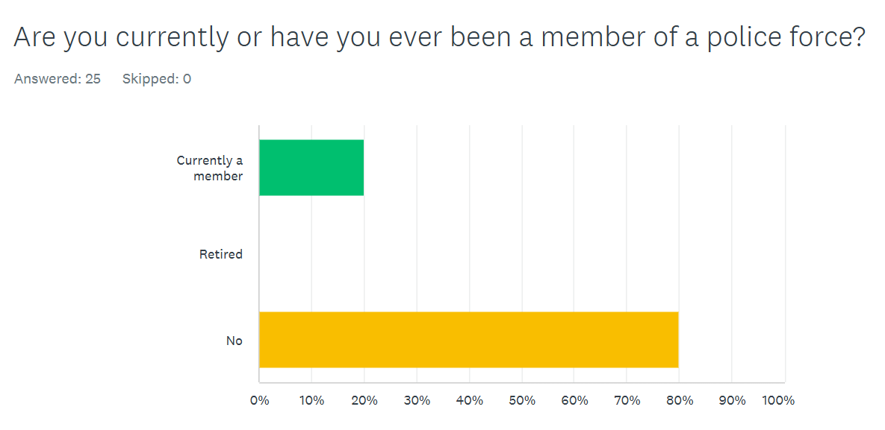
As shown below, the majority of the researcher’s participants were external to the police and from the public. This will allow them to factor in institutionalised bias from those respondents internal to the police but have a majority of respondents without bias fixated to their answers.

This question contains both key factors from both theories such as conflicts “connecting via conflict and response” comparatively to consensus’ theory focal point of the police connecting via community and consensus with one another. As seen below, 88% of respondents agree that the police connect with the public more via conflict and response to incidents rather than community engagement.
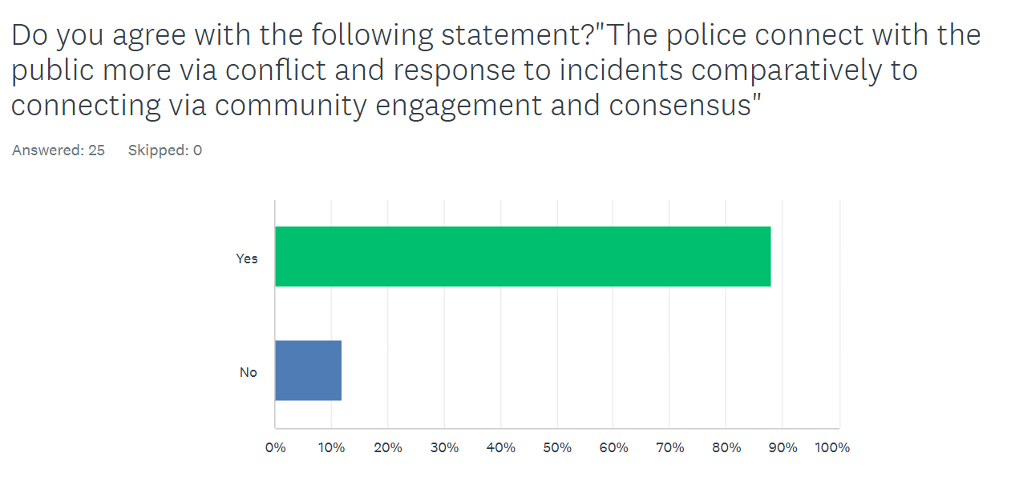
Following the previous question, this question was focused on the 2011 study from Richard Murphey (Murphey, The Courageous State: Rethinking Economics, Society, and the Role of Government, 2011) relating to tax fraud and its main contributor. The below graph demonstrates that the public’s opinion on tax fraud is fixated on benefit fraud and tax eversion. Despite 72% of respondents being split evenly between tax eversion ad benefit fraud, this graph highlights the trend that benefit fraud is broadcasted more as a predominant issue by media and government and therefore, evidencing Murphey’s and William Chambliss’ (Chambliss, On the Take: From Petty Crooks to Presidents, 1978) viewpoint in conflict theory that there is “Selective Law Enforcement” and the Marxist Instrumental Theory in relation to media promoting lower class crime to enforce class divide.
In relation to institutionalisation, four out of the five respondents internal to the police answered benefit fraud to the below question. This concludes that despite exposure to similar incidents, it can be perceived that it has not had an effect on the believed main cause of fraud debt. Marxists would argue this is due to instrumental theory and the media’s effect at influencing the population as a means of controlling class divide.
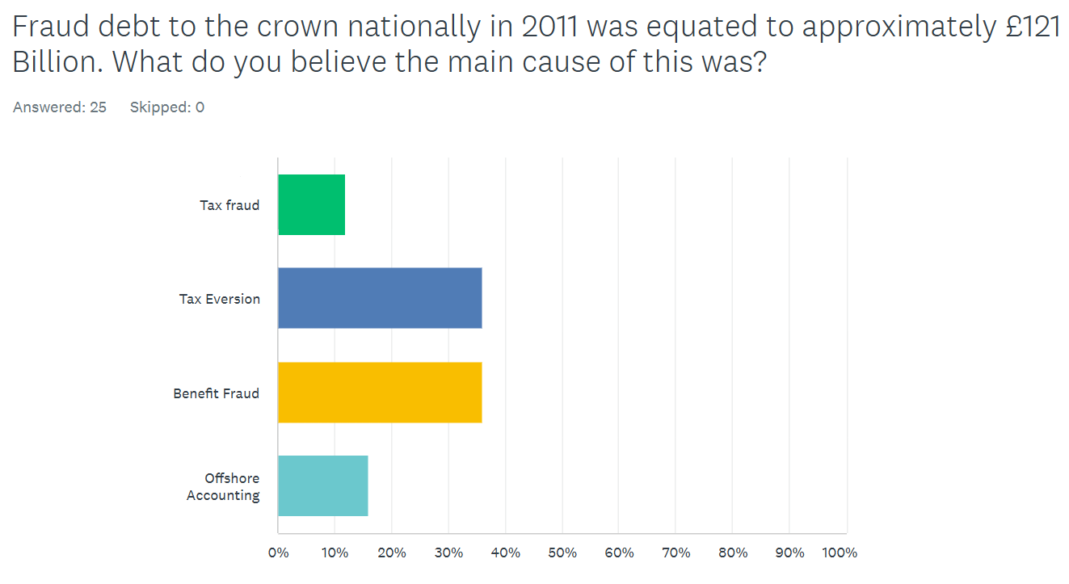

The fourth question was formed from the IPSOS study of 4709 persons in Britain about the police’ effectiveness at tackling online crime such as fraud, hacking, and sextortion. Despite one respondent skipping the answer, 70% of respondents believe the police being inept at dealing with this crime and do not feel safe from it. This further bolsters the viewpoint conflict theorists are presenting of Selective Law Enforcement.
All respondents currently a member of the police force also agreed that the police are inept at tackling these types of crimes. This evidences that officers being exposed to these types of incidents do also corroborate the general public’s opinions and the hypothesised bias does not take effect in relation to this matter.
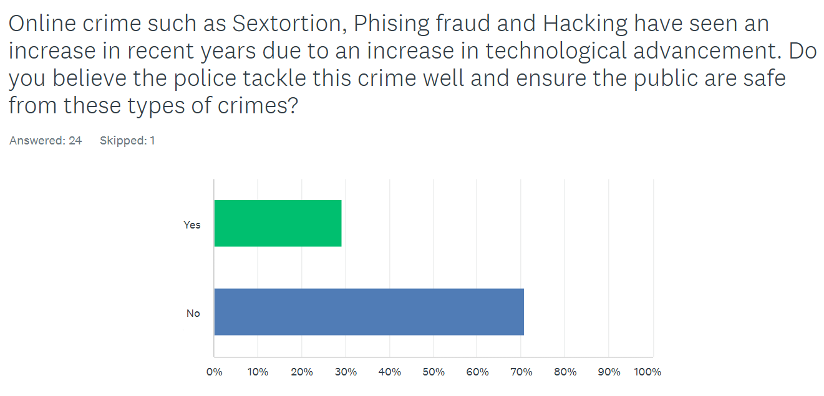
Sixty-four percent of respondents agreed with the below question of policing and prosecution being classist. This highlights the conflict (Marxist) theory point of bias law enforcement based on the factor of class and further the public’s agreement with conflict theorists.
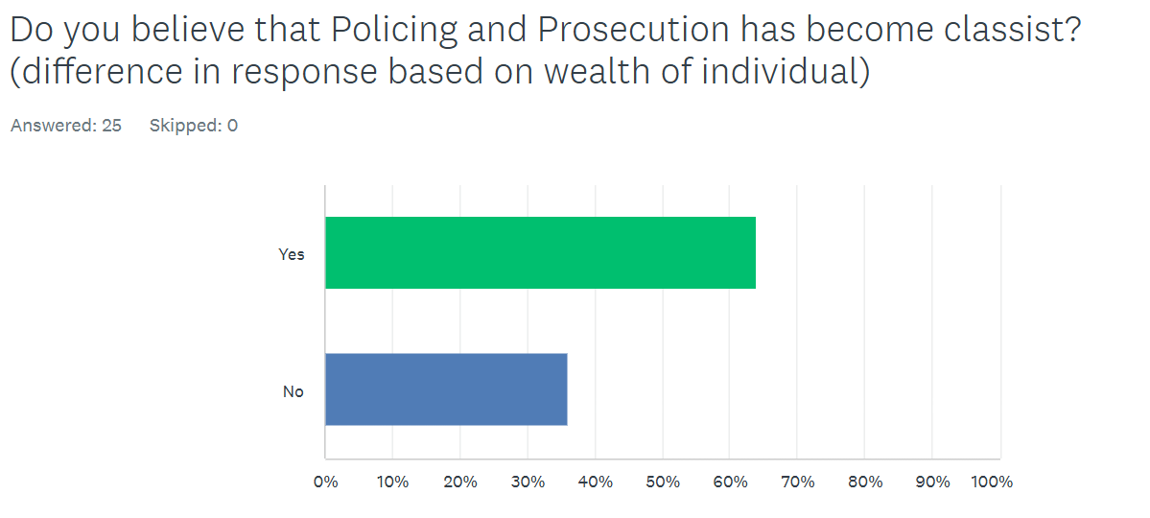
The questions from here focused on consensus theory viewpoints in order to ask an even number of questions on both theories. The below question shows that a policing presence is welcomed in the community with 72% of respondents evidencing an agreement with this consensus theory viewpoint.
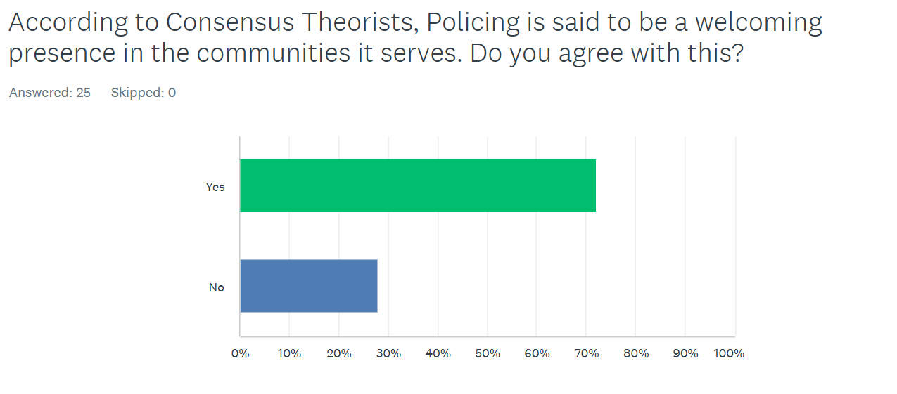
With consensus theorists arguing from the Peelian principles which state that the police’s legitimacy comes from consent from the public. Utilising the report from Fielding (Fielding, Concepts and Theory of Community Policing, 2005) which stated that the public were more concerned with fairness in law enforcement comparatively to effectiveness, the researcher wished to evidence this in their own research to see if the public’s opinion is truly reflected in this. As below, the results are almost a 50/50 split with an exceedingly small majority for fairness. These results do disprove Fielding’s report slightly, as it shows that it is not a stark majority of the public who agree with the sentiment that fairness is more important than effectiveness.
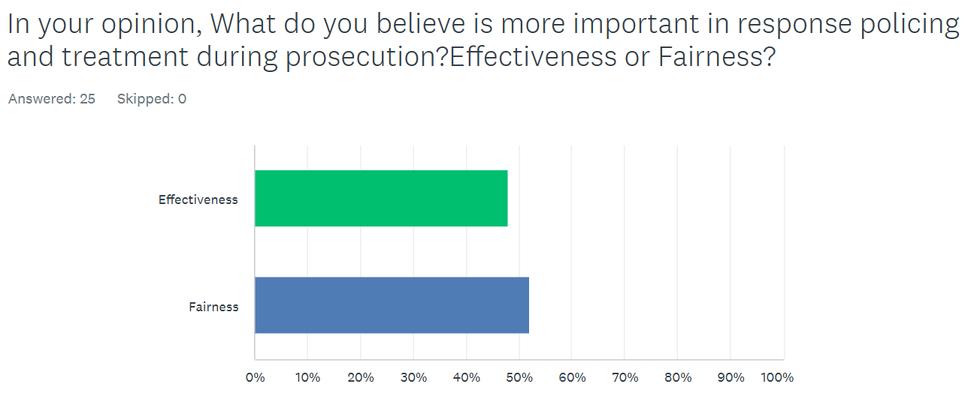
The following question was aimed to gather initial opinions and opinions heard of the police and their ranking of positive or negative. This graph presents the mixture of results gathered from this question with the majority of participants stating it was both “Somewhat Positive” and “Somewhat Negative.” This was to highlight the correlation in consensus theorist viewpoints that the public’s opinion on the police effect the function of the police as theorised by Peyton (Peyton, 2019). This graph, therefore, shows according to Peyton’s theory that the police is therefore ineffective because the opinions of the police are mostly “somewhat negative” to “very negative.”

Following the previous question, Peyton’s Theory (Peyton, 2019) was also asked in this question and whether the public agreed with the below statement. As such, the public disagreed with the theory presented by Peyton with a majority of respondents (44%) stating they disagreed or strongly disagreed with the statement made by Peyton. This could theorise that the majority of respondents are in agreeance with conflict theory sentiments and ideologies.
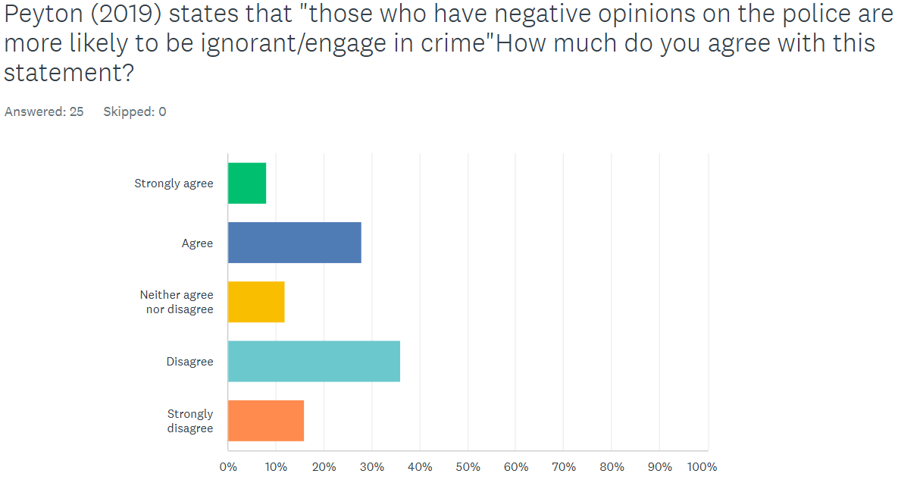
The final question in the survey was to ask whether they agreed with conflict or consensus theory or if they agreed with both. A small text box was used as an “other” box so the respondents could justify their answers. The overarching themes of conflict and consensus were included in the question. The majority of respondents have therefore answered they agreed with Conflict theory more (52%).
Similarly, three respondents stated they agreed with both for several reasons. One respondent believed that society began as a consensus and community, however, has overtime developed to be more conflicting. A second respondent stated that “Law/rules are predominantly made for and by the upper-class white male” but also believe that societal changing events such as the suffragettes and the case of Stephen Lawrence push for societal change.” It can therefore be derived that from this respondent’s answer that they believe consensus and societal change comes from events and protests from the majority whilst also agreeing with sentiments from Marxist and feminist theories that class and gender are predominant factors of unfair law enforcement. This respondent was also not a member of a police force and therefore, has no known bias attached to their answer.

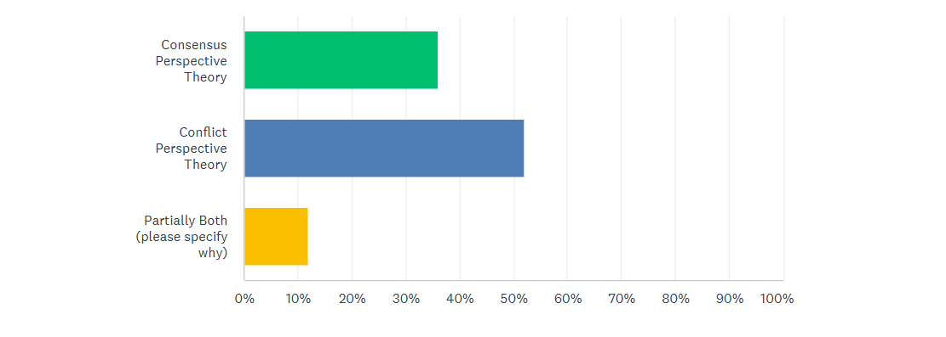

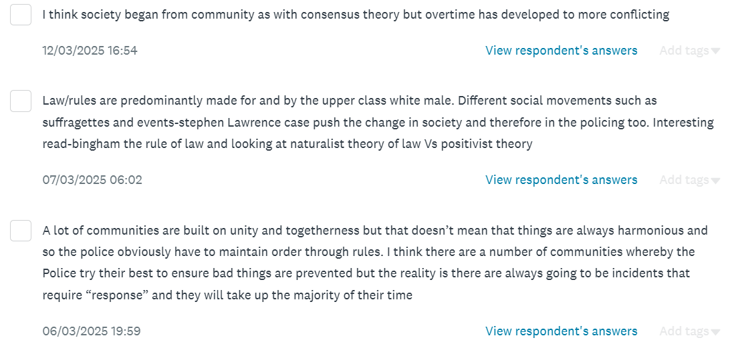

Throughout the questionnaire, the five respondents who were currently serving members of the police were analysed to assess whether any institutionalisation effected their results in responses. It can be determined that the majority of the internal respondents followed the trends identified by the external respondents. This can therefore be determined that despite exposure to incidents and working with crime every day, becoming institutionalised does not affect or change the respondents’ answers from those who have not been exposed to policing duties. In the development of their working strategy, the researcher has therefore concluded that the internal respondents’ answers will factored into the strategy exactly the same as external respondents’ answers.

Measurement of Effectiveness Between 2016-2024:
As discussed in the introduction, the researcher has inspected data provided by official statistics to the exact number of police recorded fraud incidents in the UK between the years of 2016 to 2024 for South Wales Police. This data is comprised of fraud statistics gathered by the Office of National Statistics whereby the data annually begins in April and ending in March the following year. The total fraud statistics are consistent of several fraudulent offences such as fraud by false representation, fraud by abuse of position and fraud by failure to disclose information as well as several other niche fraud offences. The below graph has been collected to display the data between 2016-2024 for South Wales Police

Data collected from Home Office - (Home Office, 2025)
It is clear that despite a spike in decreasing between 2019/20 and 2021/22, recorded fraud in South Wales Police has been increasing gradually since 2016 to 2024/25. This evidences that the effectiveness of police as defined prior is decreasing as the number of recorded incidents is on the rise. It is therefore evident that the researcher’s requirement for implementing strategies to improve the effectiveness of police response to fraud is clear. The above results will be used when suggesting strategies for improving police effectiveness and response to fraudulent crime.

Chapter Five – Findings and Conclusions:
5.1 - Introduction:
The literature and qualitative research have allowed the researcher to conduct analysis and accumulate findings and trends to conclude.
Firstly, their literature review was conducted to compile selected literature in which highlights key points presented by both consensus and conflict theory. As with their review of the literature, there were endless research opportunities due to the amount of previous theorist presentations, reports, and other findings from other researchers in which they could collect to form an overarching picture. With the focus of their research being response effectiveness to fraud and the measurement of effectiveness through recorded fraud crime to police, the below conclusions have been collected.
5.2 - Findings and Subsequent Conclusions:
5.2.1 - External influence:
The researcher selected carefully worded questions within their questionnaire in which they conducted analysis on. In particular, question three evidences the presence of external influence due to the majority of respondents being external to the police and having no exposure to policing duties. This has led to the researcher’s conclusion that the public’s perception of policing effectiveness can therefore be derived from external influence on their opinion. The literature collected relating to conflict theory in this dissertation was focused on the media’s influence on the public’s perception of policing effectiveness. For example, research showed that Chambliss’ ideology of selective law enforcement could be evidenced in their research where a majority of respondents thought benefit fraud was the biggest factor for fraud debt in 2011. The researcher can conclude that their respondents have had an external influence such as media, government propaganda or their own research that has impacted their decision to think that benefit fraud is the majority cause which in turn, validates the presence of the Marxist Instrumental Theory and external bias within the research.
5.2.2 – Institutionalisation not being an impactful factor:
Despite being hypothesised to impact the answers provided by internal respondents, the researcher has identified through analysis of the results provided by the internal respondents, that their answers do not differ from those of the external respondents. Those exposed to duties as part of their job are likely to be institutionalised due to repetition of norms and values (Cooper, 2008) therefore, it can be concluded that despite institutionalisation being present, it has not affected the results gathered by the internal respondents as they have collectively followed the trend and majority answer of those external to the police. As stated in the aims and objectives, the researcher wished to perceive any positive or negative bias from institutionalisation however, the bias does not play an impactful role in the determination of a working strategy as the internal respondent’s answers collate with external respondents. The researcher therefore decided that institutionalisation will not be factored in when creating strategies for improving police effectiveness.
5.2.3 – Sociological Theory Cannot be Used in Practical Strategy Creation:
After collating the literature gathered, the researcher had concluded that sociological theory cannot be utilised in the creation of practical strategies for multiple factors. Firstly, Sociological theory, although evidenced in a multitude of reports and official statistics, are created from vague and ambiguous ideologies with no original basis for the theory. Further to this, the researcher understands that the sociological literature provides insight as to why the public have confidence in the police but does not provide evidence as to how the police are effective at managing fraud at present or could manage it in future. It is now understood that sociological theory operates on an elevated level of abstraction and ideology that it cannot be used in pragmatic approaches to improving effectiveness at tackling fraud.
Reviewing this after conducting the research, the researcher would in future provide further focus into fraud specific cases and research into sociological theory so that it is more relevant to the chosen topic subject. In conclusion, sociological theory cannot be used in the creation of working practical strategies at improving the police response to fraud and improving its effectiveness at tackling it.

5.3 – Strategies to Improve Police Effectiveness to Managing Fraud:
With the aim and objectives of the dissertation in mind, the researcher has collated the research they have conducted and noted the shortfalls in policing effectiveness and has concluded three working strategies to improve policing effectiveness based on literature and research from this dissertation.
- Improved Training Standards

Despite having high entry requirements and rule adherence it is clear from research review that further training is required to improve the standards of response to fraud where there have been failures or shortcomings.
It can be evidenced in the IPSOS study as part of the literature review that the public feel unsafe when faced with online crime fraud. Furthermore, the effectiveness of police responding to fraud has been evidenced to be decreasing on the basis that police recorded fraud has increased and the deterrence of fraud has not been effective. In 2024/25, the number of recorded fraud incidents amounted to 6, the highest recorded number between 2016-2024/25 and also further that fraud debt to victims including the state has now amounted to over £2.3 billion (Sims, 2025).
With this in mind, a working strategy can be created to improve not only the standard of training when faced with fraud, but also interactionist based training to improve the police’s interactions with the general public. If standards and norms of training are improved in these areas, then the public will have increased confidence in the police due to positive interactions, feel safer when faced with online crime such as fraud which overall increases the confidence and perception of the public who will be more likely to assist police, report crime and further legitimises the police’s authority, respect and effectiveness.
A simple way of improving the interaction between public and police is effective advice from community officers who can pass on safeguarding advice to vulnerable members of the public who may be at increased risk to fraud and ensure that fraudulent crime is prevented by means of removing opportunities for perpetrators (Clarke, 2010).

- Dedicated Fraud Management Teams

A suggestion with managing fraud related incidents and lack of training would be to have a dedicated fraud management team who manage the investigations of all recorded fraud crime. The police federation reported that a main reason for failed investigations is due to officer burn out and fatigue due to high workload amounts and declining mental health (Police Federation, 2024). The implementation of a dedicated workforce that manages solely fraud related incidents reduces complex fraud cases off response officers who manage high stress incidents on top of a toppling workload and therefore, improves the quality, efficiency, and effectiveness of the investigation into fraud due to suitably qualified officers leading the investigation.

- Fraud offenders being considered “Serious Offenders” to increase prevention tactics

As per the HMCIFRS inspectorate report into the response to fraud (HMICFRS, 2023), they have presented the strategy of increasing fraud offenders to be considered amongst those considered for serious organised crime ‘prevention tactics’. This will allow the police to authorise and use high level prevention tactics such as phone downloading, tracing of fraudulent data via patterns of behaviour and repeat suspect offending. If further tactics can be utilised via authorisation and legislation then more action can be used legally to prevent fraud from re-occurring, reduce and deter further fraud from taking place and to improve the standard of safeguarding for victims and potentially vulnerable persons to fraud.
A decrease in police recorded fraud crime will therefore be measured as the police acting in a more effective manner and increasing their effectiveness at managing, dealing, and preventing fraud from occurring.

Chapter Six – Limitations and Recommendations:
6.1 - Introduction
This dissertation has provided insight into the public’s perception, conflict, and consensus/conflict theory and how it can be used to improve the police’s effectiveness when responding to fraud. Despite this, there were limitations to the researcher’s presentation and research, and therefore recommendations for future research have been listed below.
6.2 - Limitation of Research Choice
Their research was limited by only using quantitative research methods which means the researcher did not get in-depth answers as to why respondents selected their answers. The limitation that stopped them from undertaking this research was that they did not have the time to undertake this research due to time constraints with full time work and personal life and if they were to re-do the research, wish to conduct it to gather qualitative data for further analysis.
6.3 - Limitation of Questionnaire
The questionnaire used to conduct their research was limited to ten questions due to it being a free online tool. In future research, the researcher wishes to use funding to expand the possibilities of their research with additional questions targeted at key points in their literature review and broadcast their research further with a larger sample size and paid broadcasting. This would add to the number of participants which would allow the researcher to have more data to analyse as well as having better generalisation and relatability for their research. Further limitations of the questionnaire included the wording of several questions, and the researcher believes that the questionnaire did not target the topic of fraud enough to gather the data required for in depth analysis of the police’s effectiveness at responding to fraud.
6.4 - Limitation of Timing and External Factors
Finally, the researcher’s dissertation and research were drastically hindered by their time and ability to complete the project in time due to personal factors such as full-time work and personal life which have impacted their ability to complete this project in a timely manner. If they were to undertake this project again, they would try to factor in the limitations of work life and try to the research.

Chapter Seven - Bibliography:

Bibliography:
Brogden, M., & Nijhar, P. (2005). Community Policing. London: Willan.
Campeau, H. (2015). 'Police Culture’ at Work: Making Sense of Police Oversight. The British Journal of Criminology Volume 55, 669-687.
Chambliss, W. (1978). On the Take: From Petty Crooks to Presidents. Bloomington, Indiana: Indiana University Press.
Chambliss, W. (1978). On the Take: From Petty Crooks to Presidents. Bloomington, Indiana: Indiana University Press.
Clarke, R. V. (2010). Situational Crime Prevention. Encyclopedia of Criminological Theory, 160-166.
Collins Dictionaries. (2023). Collins English Dictionary. Glasgow: HarperCollins Publishers.
Cooper, D. E. (2008). Examining ‘Institutionalization’: A Critical Theoretic Perspective. In C. O. Royston Greenwood, Handbook of Organizational Instituionalism (pp. 673-701). London: Sage.
Cunningham, E. (2021). Women in Policing: Feminist Perspectives on Theory and Practice. London: Routledge.
Durkheim, E. (1938). The Rules of Sociological Method. Chicago: Chicago University Press.
Feria, R. D. (2020). Tax Fraud and Selective Law Enforcement. Journal of Law and Society Volume 47, 240-270.
Feria, R. D. (2020). Tax Fraud and Selective Law Enforcement. Journal of Law and Society, 240-270.
Fielding, N. (2005). Concepts and Theory of Community Policing. The Howard Journal of Criminal Justice Vol 44 Is 5, 460-472.
Fielding, N. (2005). Concepts and Theory of Community Policing. The Howard Journal of Criminal Justice Vol 44 Is 5, 460-472.
GOV.UK. (2012, December 10th). Definition of policing by consent. Retrieved from GOV.UK: https://www.gov.uk/government/publications/policing-by-consent/definition-of-policing-by-consent
HMICFRS. (2023). Fraud: Time to Choose – An inspection of the police response to fraud. LONDON: HMICFRS.
Home Office. (2025). Police recorded crime Police Force Area Open Data tables, from year ending March 2013 to year ending December 2024. Croyden: Home Office Crime Analysis Unit.
IPSOS. (2020). Public perceptions . London: IPSOS.
Jansson, K. (2015). Public confidence in the Criminal Justice System - Findings from the Crime Survey for England and Wales 2013/14. London: Ministry of Justice.
Jeffrey Reiman, P. L. (2016). The Rich Get Richer and The Poor Get Prison (11th edition). New York: Routledge.
Karl Marx, F. E. (2015). The Communist Manifesto. London: Penguin Books.
Legal Dictionary. (2014, December 1st). Fraud. Retrieved from Legal Dictionary: https://legaldictionary.net/fraud/#ftoc-heading-1
Levi Jouavel, C. B. (2023, June 9). Trust in police hanging by a thread, inspectorate says. Retrieved from BBC News: https://www.bbc.co.uk/news/uk-65845463
McIntosh, C. (2017). Cambridge Advanced Learner's Dictionary & Thesaurus 4th Edition. Cambridge: Cambridge University Press.
McLeod, S. (2023, September 26). Sampling Methods In Research: Types, Techniques, & Examples. Retrieved from SimplyPsychology: https://www.simplypsychology.org/sampling.html#Opportunity-Sampling
Mead, G. H. (1934). Mind, Self, Society. Chicago: University of Chicago Press.
Miller, J., & D'Souza. (2016). Indirect effects of police searches on community attitudes to the police: resentment or reassurance? The British Journal of Criminology, 56(3), 456-478.
Murphey, R. (2011). The Courageous State: Rethinking Economics, Society and the Role of Government. Cambridge: Searching Finance Ltd.
Murphey, R. (2011). The Courageous State: Rethinking Economics, Society, and the Role of Government. Cambridge: Searching Finance Ltd.
Pamela Hanway, O. H. (2023, August 28). Public perceptions of policing: A review of research and literature. Retrieved from Gov.UK: https://www.gov.uk/government/publications/public-perceptions-of-policing-a-review-of-research-and-literature/public-perceptions-of-policing-a-review-of-research-and-literature
Parsons, T. (1964). Social Structure and Personality. Ann Arbor, Michigan: Free Press.
Peyton, K. (2019). A field experiment on community policing and police legitimacy. Proceedings of the National Academy of Sciences, 116(40), 19894-19898.
Police Federation. (2024, January 11). Challenges faced by police demand urgent attention and reform. Retrieved from Police Federation: https://www.polfed.org/news/latest-news/2024/challenges-faced-by-police-demand-urgent-attention-and-reform/#:~:text=Shift%20work%2C%20workload%2C%20and%20hindrance%20stressors%20are%20also,with%2028.9%20per%20cent%20experiencing%20very%20high%20fatigue.
Polit, D., & Beck, C. (2014). Essentials of nursing research: Appraising evidence for nursing practice. Philadelphia: Wolters Kluwer/Lippincott/Williams & Wilkins Health.
Rosenbaum. (2005). Attitudes toward the police: The effects of direct and vicarious experience. Police Quarterly, 8(3), 343-365.
Sims, E. (2025, April 28). Fraud loss reaches £2.3bn as fraudsters become increasingly sophisticated. Retrieved from RSM: https://www.rsmuk.com/news/fraud-loss-reaches-2-point-3-billion-fraudsters-become-increasingly-sophisticated
Staff, C. (2024, November 21). What is Sample Size? Retrieved from Coursera: https://www.coursera.org/articles/what-is-sample-size
The Police Foundation. (2018, December 3rd). Police Foundation. Retrieved from Fraud is not prioritised by the police, report finds: https://www.police-foundation.org.uk/news/policing-fraud/
Thompson, K. (2022, November 24). The Marxist Instrumentalist Theory of Media. Retrieved from Revise Sociology: https://revisesociology.com/2019/08/02/marxist-instrumentalist-theory-media/
UK Governement Social Research. (2023). Survey of public perceptions of fraud, error and debt. London: Department of Work and Pensions.

Chapter Eight – Appendix:

Questionnaire Graphs:
The below are the graphs generated from all ten questions used in the questionnaire.
The questionnaire was created on website SurveyMonkey:
https://www.surveymonkey.com/home/
Link to Questionnaire created - https://www.surveymonkey.com/r/9SBK9DV

Figure 1:
Figure 2:

Figure 3:

Figure 4:

Figure 5:

Figure 6:

Figure 7:

Figure 8:

Figure 9:
Figure 10:
Figure 11:

Total Word Count:
8800 Words

