BEng ELECTRONICS AND ELECTRICAL ENGINEERING

POWER ELECTRONICS AND DRIVES
ASSIGNMENT

SAMIH ALTIGANY

Table of Contents
1 Introduction 5
2 Task one 5
3 Background literature 5
3.1 The motors 5
3.2 DC motors 6
3.2.1 DC shunt motors 6
3.2.2 Separately excited motor 7
3.2.3 DC series motor 7
3.2.4 PMDC motor 7
3.2.5 DC compound motor 7
3.3 AC motors 7
3.3.1 Synchronous motor 7
3.3.2 Induction motor 7
3.4 Special purpose motors 8
3.4.1 Stepper motor 8
3.4.2 The brushless DC motors 8
3.4.3 Hysteresis motor 8
3.4.4 Reluctance motor 8
3.4.5 Universal motor 8
3.5 The motor drives 8
3.6 Types of motor drives 8
3.6.1 DC drive 8
3.6.2 AC drive 8
3.6.3 Stepper drive 9
3.7 Motors use AC drives 9
3.8 Motors use DC drives 9
3.9 Types of AC drives 9
3.9.1 The current source inverter CSI 9
3.9.2 The voltage source inverter VSI 10
3.9.3 Pulse width modulation PWM drive 10
3.10 Types of DC drives 11
3.10.1 Non-regenerative DC drive 11
3.10.2 Regenerative DC drive 11
4 Selecting drives for a variety of induction motors 11
4.1 Motor drives families from ABB 12
ACS880 12
4.2 The selected drives for motor A 500KW, 400V, 1250A 14
4.3 The selected drives for motor B 80KW, 400V, 200A 14
4.4 The selected drives for motor C 10KW, 400V, 25A 14
4.5 The selected drives for motor D 5KW, 400V, 12.5A 14
4.6 The selected drive for motor E 1KW, 230V, 4.34A 15
4.7 Conclusion 15
5 Task two 16
5.1 Background literature 16
5.1.1 The variable frequency drives VFDs 16
5.1.2 The rectifier 16
5.1.3 The DC bus 16
5.1.4 The inverter 17
5.1.5 The control circuits 17
5.2 Mitigation of harmonic noise through careful rectification design 17
5.2.1 Rectifier design 18
5.3 The effect of harmonics on power and power factor 22
5.3.1 The linear load 23
5.3.2 Non-linear load 24
5.3.3 The power factor in sinusoidal situations 24
5.3.4 The power factor in non-sinusoidal situation 26
5.3.5 Comparison between the impact of THD on sinusoidal and non-sinusoidal systems 27
5.4 Conclusion 28
6 References 29

Table of figures
Figure 1: Graph shows the different types of motors 6
Figure 2: graph shows photos for the different types of motors 7
Figure 3: graph shows the separately excited motor 8
Figure 4: graph shows the market share of the AC drive vendors 13
Figure 5: graph show the components of the VFD 17
Figure 6: The three-phase rectifier outputs 19
Figure 7: the design of the 6-pulse rectifier 20
Figure 8: the simulation of the inputs and output of the 6-pulse rectifier 20
Figure 9: Fourier analysis showing the harmonics of the output of the 6-pulse rectifier 21
Figure 10:the design of the 12-pulse rectifier 21
Figure 11: the simulation of the inputs and output of the 12-pulse rectifier 22
Figure 12: Fourier analysis showing the harmonics of the output of the 12-pulse rectifier 23
Figure 13:Harmonics of a complex wave 24
Figure 14:Resistor and capacitor load with sinusoidal current draw 24
Figure 15: Non-linear load of 6-pulse rectifier and its distorted current drawn 25
Figure 16: Power system with linear load 26
Figure 17: Effect of displacement power factor on power losses 26
Figure 18: Maximum true power factor versus THD 28
Figure 19: Power system with non-linear load 28
Figure 20: Effect of displacement power factor on non-sinusoidal system losses 29

Introduction
This report is divided into two sections, the first section discusses the process of choosing a suitable technology of motor drive system for a variety of motors in different sizes used for different applications in a factory, putting in consideration the use of a common DC bus, starters, protection, cost, flexibility of control systems and information gathering ability.
While the second section of this report illustrated the use of diodes, thyristors (SCRs) and IGBTs for rectification of the incoming mains in terms of variable frequency drives. In addition, it discusses how the harmonic noise can be minimised through careful rectifier design and how the harmonics affects the power factor.

Task one

Background literature

The motors
Motors are electrical devices convert the electrical energy into mechanical energy and that through the interaction between the magnetic field and the electric current in the windings which generates force in the form of shaft rotation. [1]
Motors have an essential role in the industry, and are used in many applications as they have many types classified into AC motors, DC motors and special purpose motors as shown on the graph below 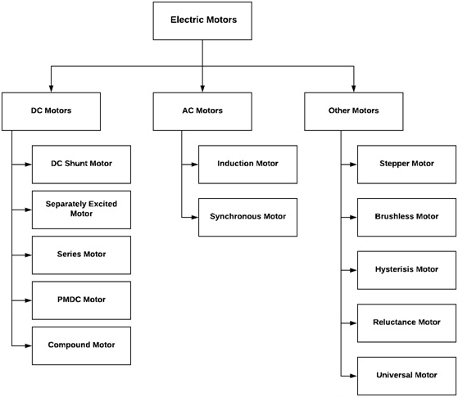
Figure 1: Graph shows the different types of motors
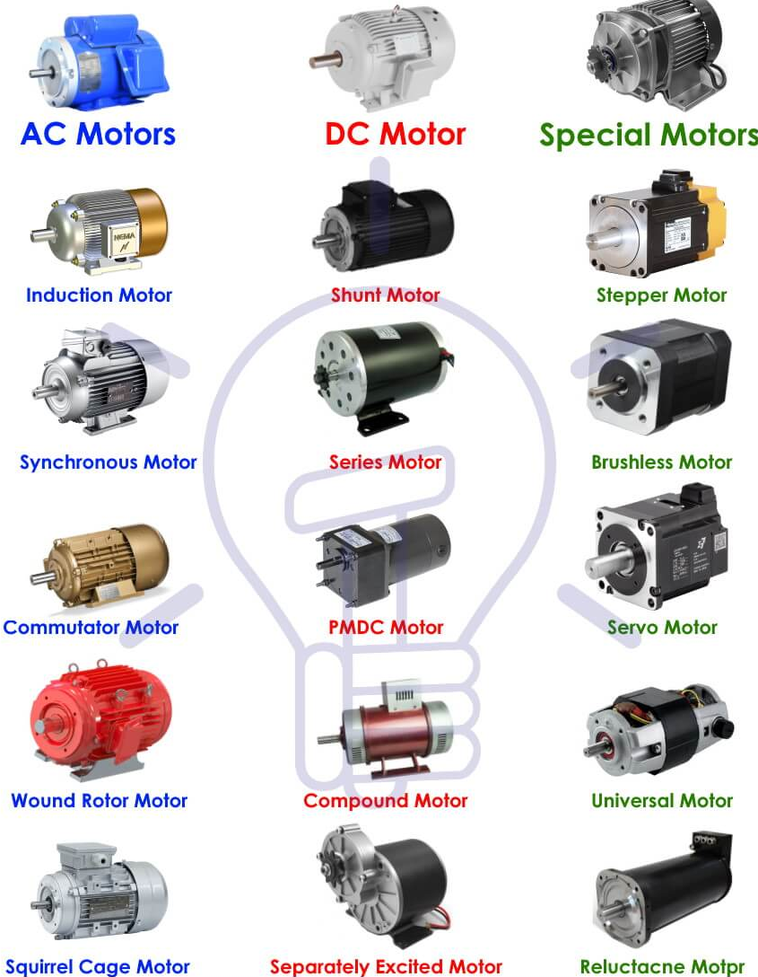
Figure 2: graph shows photos for the different types of motors

DC motors

DC shunt motors
DC shunt motor is the type of DC motors have shunt circuit which is a parallel circuit where the armature and the field windings are connected in parallel, which enables the motor to maintain a constant speed regardless of the load on the motor. [2]

Separately excited motor
The separately excited DC motor is the type of DC motor which the supply is given separately to the field and armature windings as shown below. [3]
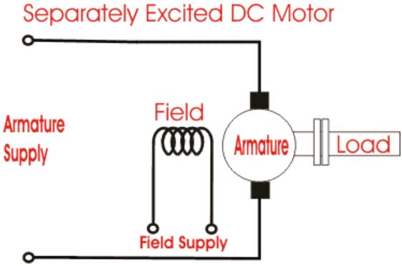
Figure 3: graph shows the separately excited motor

DC series motor
The DC series DC motor is the type of motor where the field coil is connected in series to the armature windings and therefore, higher current passes through it. [4]

PMDC motor
The permanent magnet DC motor is the type of DC motor has permanent magnet included in order to generate magnetic field for the electric motor operation. [5]

DC compound motor
The DC compound motor is the type of DC motor which is hybrid of DC series and shunt motors where the stator and the rotor are connected to each other through shunt windings which are designed of copper wires. [6]

AC motors

Synchronous motor
The synchronous motor is a type of AC motors which the rotation of the shaft is synchronized with the frequency of the supply current where the integral number of AC cycles is equal to the rotation period. [7]

Induction motor
The induction motor which is known as the asynchronous motor, uses electromagnetic induction in order to change the energy from electrical to mechanical, and it has two types based on the rotor construction which are the squirrel cage and the phase wound. [8]

Special purpose motors

Stepper motor
Stepper motor is a two-phase brushless DC motor where each full rotation is divided into a number of equal 200 steps per revolution of 1.8$°$ each, which enables the stepper motor to have a quick response and precise positioning and a incredible torque holding at any step. [9]

The brushless DC motors
The brushless DC motor is known in manes names such as the electronically commutated motor ECM or the synchronous motor as it uses direct current electric power supply and electronic closed loop controller in order to produce magnetic field by switching DC current to the motor windings and adjusting the phase and the pulses to control the speed and the torque of the motor. [10]

Hysteresis motor
The hysteresis motor is a synchronous motor which has a uniform air gab and no DC excitation where the torque is generated by eddy current induced. This motor can run on single phase and three-phase supply. [11]

Reluctance motor
The reluctance motor is a single-phase synchronous motor, it has a similar design to the induction motor. The motor is similar to squirrel cage type and the stator has auxiliary and main windings.

Universal motor
The universal motor runs on a single-phase AC supply or DC supply. These motors run on high speed above 3500 RPM therefore, it has a series of wound and the armature and the windings are connected in series to generate a high starting torque. [12]

The motor drives
The motor drives are electronic devices designed to control the motor by controlling and modifying the torque, position output and the speed to get the needed output.

Types of motor drives
There are many types of motor drives differ according to the type of the motor, but the main four types are stepper, AC, DC, and servo and each of them has input power type designed to match the output function of the application.

DC drive
The DC drive is an interface power module between a DC motor and a controller, performs by converting the alternating current AC into direct current DC.
There are different types of DC drives differ according to their output which are the half-bridge DC output which uses SCRs silicon-controlled rectifiers by using a single-phase AC input to generate half-cycle DC output. The other type is the full-bridge where six SCRs are used to utilize a full-bridge with a three-phase AC input.

AC drive
The AC drive works in a similar way to the DC drive by converting the AC input into DC output, but then it has another stage where this DC output will be converted back into AC again. Therefore, the AC drive is an interface between an AC motor and a controller works as amplifier or frequency inverter which makes the voltage compatible with the motor and regulating the torque and output speed. [13]

Stepper drive
Stepper motor derive or also known as step amplifier and pulse drive as it modifies the alternating current or the direct current into stepped current output. As the output of the stepper motor is not continuous, then the input power needs to be controlled in order to the poles to be either energized or de-energised. [14]

Motors use AC drives
- Synchronous motor
The synchronous motor maintains a constant speed even in full load, and it is used in machines and devices that require high accuracy such as metering pumps, timers, clocks and robots.
- Induction motors
The induction motors are known for their variable speed control and their significant power generation. These motors are used in household appliances, vehicles and industrial machines.
- Sensor less vector drives
- Servo motor
Servo motors are used in robotics, industrial production, elevators and construction manufacturing industries.

Motors use DC drives
- Linear motors
These motors are used in applications where precise speed control is important such as in looms, sliding doors, baggage handling machines and roller coasters.
- Brushed motors
These motors are used in applications like in battery powered pumps, X-ray equipment’s and welding equipment’s.
- Brushless motors
These motors are known for their efficiency and durability therefore, they are used where motors extended running period is likely to happen such as in hard drive disk, washing machines, computer fans and air conditioners.

Types of AC drives
The AC drive or the variable frequency drive VFD has three different designs which are the current source inverter CSI, the voltage source inverter VSI, and the pulse width modulation PWM.

The current source inverter CSI
The current source CSI converts the incoming AC voltage and varies its frequency and supplied to the AC induction motor. The convertor uses silicon-controlled rectifiers SCRs, gated commutated thyristors GCTs or symmetrical gated commutated thyristors SGCTs in order to convert the AC voltage into DC voltage. And the DC link uses conductors to reduce the current ripple. [15]
Advantages of the current source inverter CSI
- It has a regenerative power capability.
- It is reliable as it has current limiting operation.
- It has a simple circuit design.
- It has a clean current wave form.
Disadvantages of the current source inverter CSI
- When the PWM output is lower than 6HZ, the motor cogs.
- Expensive and the large size of the inductor.
- Large harmonic power.
- It is dependent on the motor load.
- It has low input power factor.

The voltage source inverter VSI
The convertor has a similar design to the CSI but it uses a diode bridge rectifier in order to convert the AC voltage into DC voltage, and the DC link uses capacitors to reduce the current ripple. [16]
Advantages of the voltage source invertor VSI
- It has a simple circuit design.
- Multiple motors can be used.
- It is not dependent on the load.
Disadvantages of the voltage source invertor VSI
- It generates high harmonic power fed back to the source.
- When the PMW is lower than 6HZ, the motor cogs.
- It has non-regenerative operation.
- It has low power factor.

Pulse width modulation PWM drive
It is used for the motors between 0.5HP and 500HP range, and has input voltage of either 230V or 460V in three-phase operation with output frequency range of 2-400HZ.
The convertor design is similar to the VSI where diode bridge rectifier is used to convert the AC voltage into DC voltage, while in the DC link capacitors are used to reduce the ripple.
In case of the six-step invertor, high power IGBTs are used to turn on and off in order to regulate the frequency and the voltage. The transistors are connected to a microprocessor to control the opening and closing sequence which produces a wave similar to the sine wave. [17]
Advantages of the pulse width modulation PWM drive
- No motor cogging.
- It has efficiency in range of 92% to 96%.
- It has a good power factor.
- Multiple motors can be used.
Disadvantages of the pulse width modulation PWM drive
- It has non-regenerative operation.
- Motor heating due to the high frequency switching.

Types of DC drives

Non-regenerative DC drive
This drive is known as the single quadrant drive as it rotates only in one direction and it does not inherent braking ability as the motor stops only by terminating the power.

Regenerative DC drive
This is a four-quadrant drive controls the speed, torque and direction of the motor by converting the mechanical energy into electrical energy. [18]

Selecting drives for a variety of induction motors
In a scenario of a factory refitting motor drive systems for five different types of induction motors as shown in the table below, it is required to specify a suitable technology for the motor drive systems putting in consideration the usage of a common DC bus, protection, control system flexibility and information gathering ability.
 | Motor A | Motor B | Motor C | Motor D | Motor E
Power | 500 kW | 80 kW | 10 kW | 5 kW | 1 kW
Phases | 3 | 3 | 3 | 3 | 1
Voltage | 400 | 400 | 400 | 400 | 230
Current | 1250 | 200 | 25 | 12.5 | 4.34
Motor reversibility | Yes | Yes | No | Yes | No
Variable speed | Yes | Yes | Yes | No | No
Quantity Installed | 5 | 10 | 23 | 17 | 127
Example Application | Rolling Mill | Gantry Crane | Conveyor | Cutting machine | Pumps / Fans

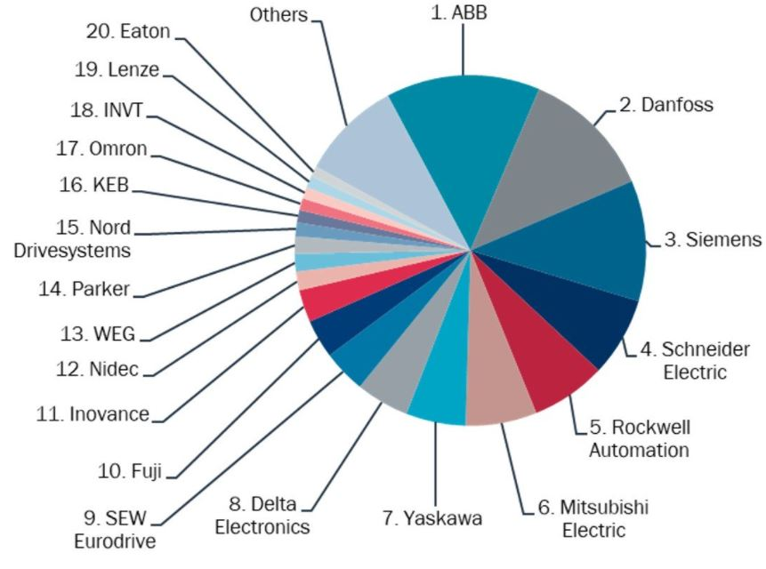
Figure 4: graph shows the market share of the AC drive vendors
The graph above shows the market shares of the AC drive vendors in the world, therefore, taking ABB as an example, it has a variety of motor drives families with different sizes and different power ranges.
Most of ABB motor drives families share the same features such as protection with different IP rates, the flexibility of control, and the information gathering, but the dividing feature is using a common DC bus as not all of the families support the feature of sharing a common DC bus such as ACS580 motor drive family. The table below shows three of the families which support the feature of sharing a common DC bus and details the rest of their features.

Motor drives families from ABB
 | Motor A, B, C and D |  | Motor E
Family name | ACS880 | ACS850 | ACS380
Power range | 0.55 to 6000 KW | 0.37 to 560KW | 0.37 to 22 KW
Protection | IP22 | IP20 | IP20
Phase | 3-phase | 3-phase | 1-phase  3-phase
Voltage | 208 to 690V | 200 to 500V | 200 to 240V  200 to 480V
Frequency | 50 / 60 HZ | 50/60 HZ | 50/60HZ
Power factor | 0.98
Efficiency | 98%
Ambient temperature | -15$℃$ to +40$℃$ | -10$℃$ to +55$℃$ | -10$℃$ to +50$℃$
Altitude | 0 to 1000 m | 0 to 4000 m | 0 to 4000 m
Features | - It has built in safe torque off (STO) safety feature.  - It has ultra-low harmonics generation.  - It has high performance technology called direct torque control DTC enables it of better accuracy and performance.  - It is compatible with a wide range of fieldbus protocols.  - It has built in Modbus RTU protocol interface feature.  - It supports a common DC bus.  - It is compatible with all major automation networks, has mobile connectivity and has remote monitoring feature.  - It has built in EMC filter, electromagnetic compatibility.  - It has built in brake chopper as standard. | - It has high performance technology called direct torque control DTC enables it of better accuracy and performance.  - It supports a common DC bus.  - It has remote monitoring tool gives access to the drive through the internet and Ethernet network.  - It is compatible with a wide range of fieldbus protocols.  - It has a USB port and WLAN/3G. | - It has built in brake chopper as standard.  - It has built in safe torque off (STO) safety feature.  - It has built in Modbus RTU protocol interface feature.  - It supports a common DC bus.  - It is compatible with a wide range of fieldbus protocols.  - It has built in EMC filter, electromagnetic compatibility.
[19]

The selected drives for motor A 500KW, 400V, 1250A
 | ACS880 family | ACS850 family
 | 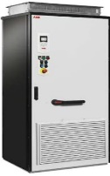 | 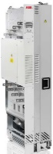
Model number | ACS880-07-1760A-3 | ACS850-04-875A-5
Voltage | 380 to 415V | 400V
Power | 710KW | 500KW
current | 1316A | 1250A
Phase | 3-phase | 3-phase

The selected drives for motor B 80KW, 400V, 200A
 | ACS880 family | ACS850 family
 | 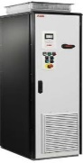 | 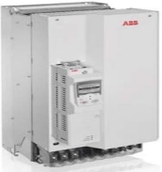
Model number | ACS880-01-246A-3 | ACS850-04-035A-5
Voltage | 380 to 415V | 400V
Power | 110KW | 110KW
Current | 206A | 215A
Phase | 3-phase | 3-phase

The selected drives for motor C 10KW, 400V, 25A
 | ACS880 family | ACS850 family
 | 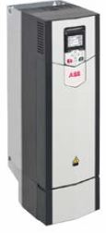 | 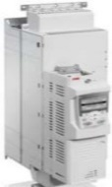
Model number | ACS880-01-032A-3 | ACS850-04-035A-5
Voltage | 380 to 415V | 400V
Power | 11KW | 15KW
Current | 25A | 29A
Phase | 3-phase | 3-phase

The selected drives for motor D 5KW, 400V, 12.5A
 | ACS880 family | ACS850 family
 |  | 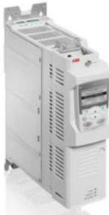
Model number | ACS880-01-017A-3 | ACS850-04-018A-5
Voltage | 380 to 415V | 400V
Power | 5.5KW | 7.5KW
Current | 12.6A | 14A
Phase | 3-phase | 3-phase

The selected drive for motor E 1KW, 230V, 4.34A
 | ACS380 family
 | 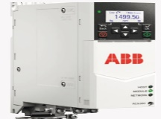
Model number | ACS380-040x-07A8-1
Voltage | 200 to 230V
Power | 1.1KW
Current | 6.9A
Phase | 1-phase

Conclusion
The drives for motor A, B, C and D can be selected either from ACS880 family or from ACS850 family while the drive for motor E can be selected only from ACS380 family, as all these three motor drive families share the same in term of the same DC bus, fieldbus and other features. Therefore, the options are:
- The first option is selecting the drive for motor A, B, C and D from ACS880 family and the drive for motor E which is from ACS830 family.
- The second option is selecting the drives for motor A, B, C and D from ACS850 family and the drive for motor E from ACS830 family.

Task two

Background literature

The variable frequency drives VFDs
Controlling AC motors is normally achieved by either of two ways, controlling the voltage or the frequency. Due to the constant flux density, controlling the motor through the frequency is better than the voltage, and the VFD is the device which apply this concept by converting the fixed frequency into variable frequency output to control the AC motor.
The main components of the variable frequency drive are the rectifier, the DC bus, the inverter and the controlling circuit as shown in the graph below
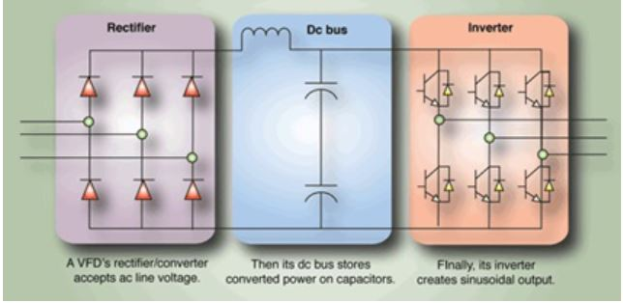
Figure 5: graph show the components of the VFD

The rectifier
It is the first stage of the variable frequency drive where it receives the main AC supply and converts it into DC using diodes, IGBTs or thyristors. and it can be unidirectional or bidirectional matching the application it is used for such as the four-quadrant operation of the motor.
The use of diodes results in uncontrolled converted DC power output while using thyristors results in a controlled converted DC power varied gate control, in order to convert a three-phase AC to DC, it requires a minimum of six diodes in the design of the rectifier which is considered as a six-pulse rectifier.

The DC bus
This section of the drive consists of capacitors and inductors and the DC power produced by the rectifier is passed through it in order to smooth the ripples and store the DC power.

The inverter
This section controls the speed of the induction motor by using modulation techniques such as pulse width modulation with the help of electronic switching devices such as transistors, thyristors and IGBTs to receive the DC power and convert it to modulated AC power.

The control circuits
It is a microprocessor controls the various functions in the drive and receiving the motor’s feedback and accordingly adjust the and regulate the ratio of the voltage to frequency to control the speed of the motor. [20]

Mitigation of harmonic noise through careful rectification design
Limiting the harmonic generated by non-linear loads require using some mitigation techniques such as active filters, passive filters and phase shifting.
The three-phase bridge rectifier, which is normally used for high power applications as it has the highest transformer utilization for a three-phase system, the phase shifting technique or as called pulse multiplication technique and the drives using this technique is named on it according to the number of pulses it contains such as 6-pulse drive, 12-pulse drive, 18-pulse drive and 24-pulse drive.
The single base unit of the 3-phase rectifier is called 6-pulse rectifier. Therefore, a 12-pulse rectifier is built of 2x6-pulse rectifier and contains two rectifier bridges, and in the same way the 18-pulse rectifier is built of 3x6-pulse rectifier and has three rectifier bridges.
The phase shift angle is determined by dividing 60$°$ by the number of bridges of the rectifier. Therefore, 12-pulse rectifier has a phase shift of 60$°$/2 which is 30$°$, and the 18-pulse rectifier has a phase shift of 60$°$/3 which is 20$°$. [21]
The graph below shows a three-phase bridge rectifier, the diodes are numbered according to the conduction sequence which is (1,2 – 2,3 – 3,4 – 4,5 – 5,6 and 6,1), and the conduction angle of each diode is 2π/3 which 120. [22]
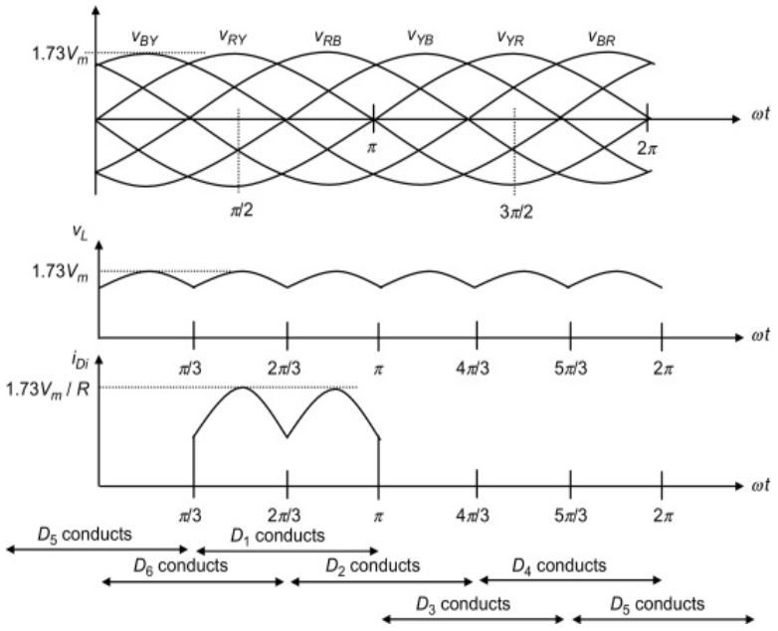
Figure 6: The three-phase rectifier outputs
Therefore, a 12-pulse rectifier which consists of 2x6-pulse rectifier, reduces the harmonics considerably as the AC power supply is split into two separate three-phase supplies the been passed through 2x6-pulse rectifier, then the amplitude of the output DC is split to half and the its frequency increased as the conduction angle of the diode become smaller which is 2π/6 which 60, and therefore, the 18-pulse rectifier and the 24-pulse rectifier has diode conduction angle of 30 and 15 consequently which means higher DC out frequency and lower amplitude.

Rectifier design

Six-pulse rectifier
On the graph below is a circuit for a 6-pulse rectifier built on proteus which consists of 6 diodes, a capacitor and a load. The sine waves represent the AC power supply.
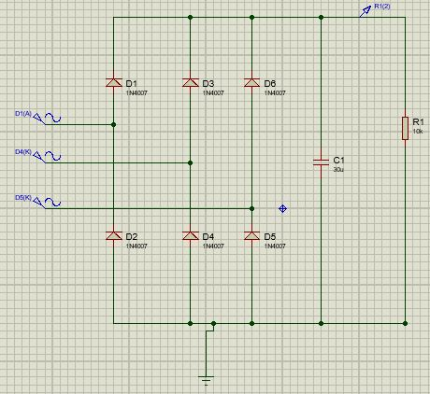
Figure 7: the design of the 6-pulse rectifier
And the analogue simulation below shows the input waves and the DC ripple output and how the rectifier converted the AC input into DC output.

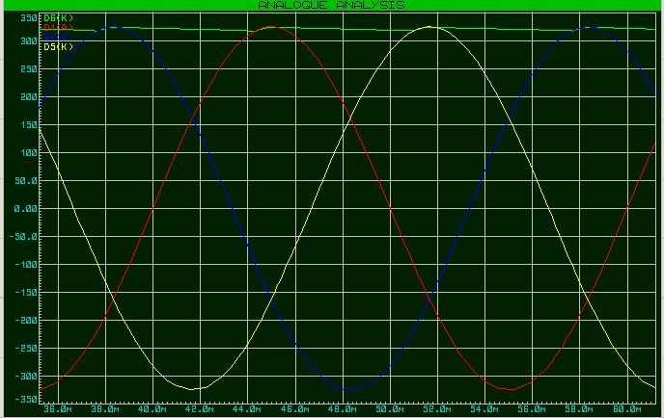
Figure 8: the simulation of the inputs and output of the 6-pulse rectifier

Fourier analysis below show that the DC output is not a perfect straight line but instead it is a wave and the graph show the harmonics forming that wave. The first harmonic is at 150Hz which is the ripple DC output, and the other harmonics are on (300Hz, 450Hz, 600Hz, 700Hz, 750Hz, 850Hz, 900Hz and 1000Hz).
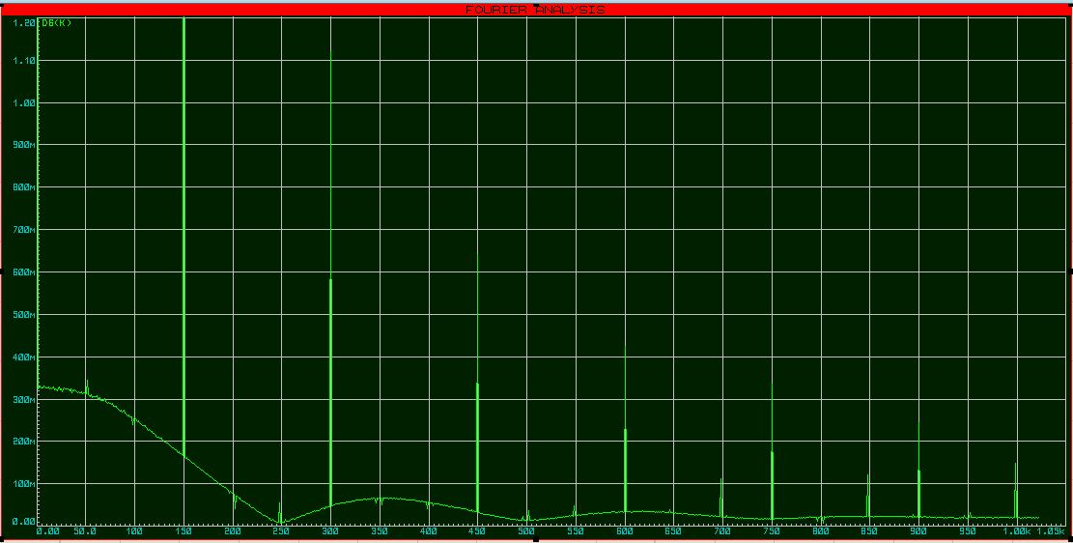
Figure 9: Fourier analysis showing the harmonics of the output of the 6-pulse rectifier

12-pulse rectifier
On the graph below is a circuit for a 12-pulse rectifier built on proteus which consists of 12 diodes, a capacitor and a load. The sine waves represent the AC power supply.

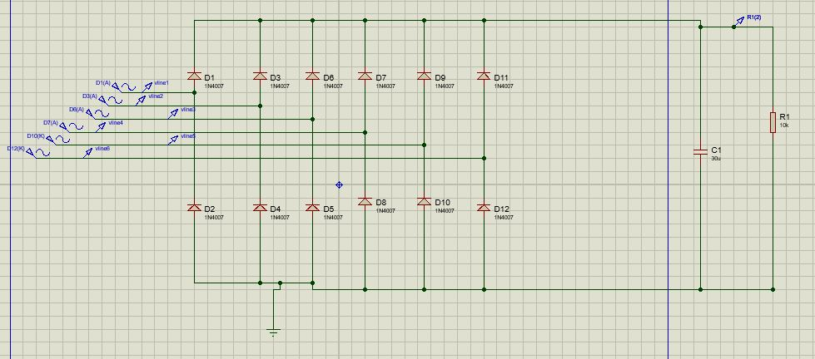
Figure 10:the design of the 12-pulse rectifier

And the analogue simulation below shows the 12 input AC waves and the DC ripple output and how the rectifier converted the AC input into DC output.

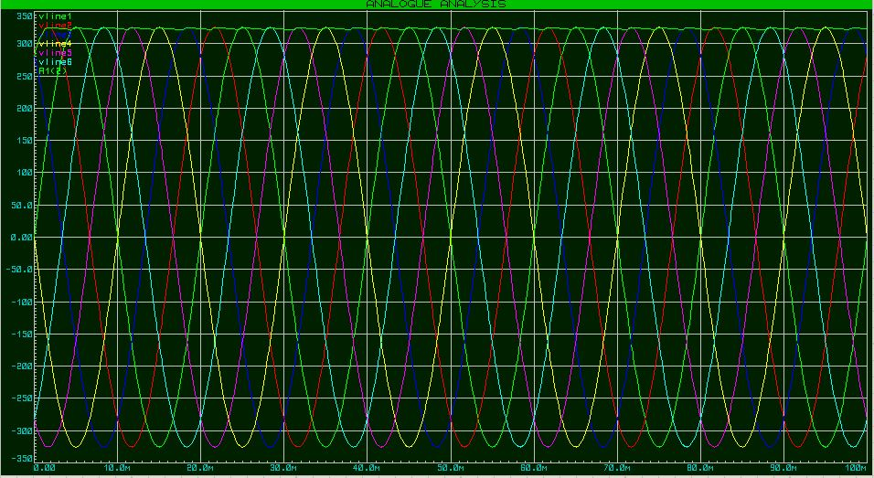
Figure 11: the simulation of the inputs and output of the 12-pulse rectifier

The 12-pulse rectifier which consists of 2x6-pulse rectifier, reduces the harmonics considerably as the AC power supply is split into two separate three-phase supplies the been passed through 2x6-pulse rectifier, then the amplitude of the output DC is split to half and the its frequency increased as the conduction angle of the diode become smaller which is 2π/6 which 60$°$
Fourier analysis below show that the DC output is not a perfect straight line but instead it is a wave and the graph show the harmonics forming that wave. The first harmonic is at 300Hz which is the ripple DC output, and the other harmonics are on (350Hz, 550Hz, 600Hz, 850Hz and 900Hz).
The number and amplitude of the harmonics on the 12-pulse rectifier are much less and has smaller amplitude which contribute in smoothing the ripple DC output.
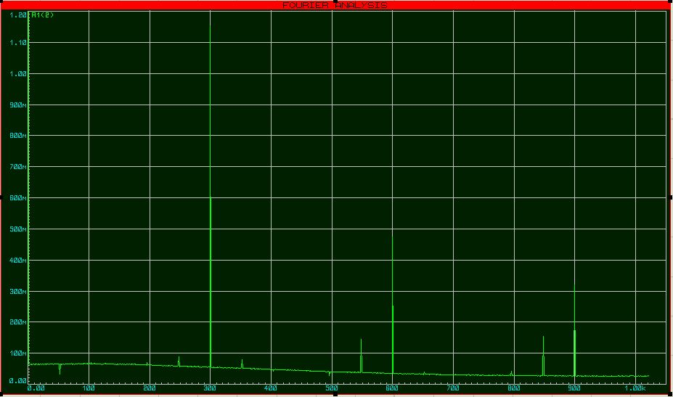
Figure 12: Fourier analysis showing the harmonics of the output of the 12-pulse rectifier

The effect of harmonics on power and power factor
Harmonics are a form of electrical pollution which cannot be used by the devices on the network created by non-linear loads, which the sum of them causes problems if it exceeded a certain limit such as overheating the cables, noise in the motors and torque oscillations and mechanical resonance. The frequency of the harmonic current is a multiple of the fundamentals frequencies of the waves forming it, for example 180Hz current on a 60Hz network is the 3rd harmonic as shown below. [23]
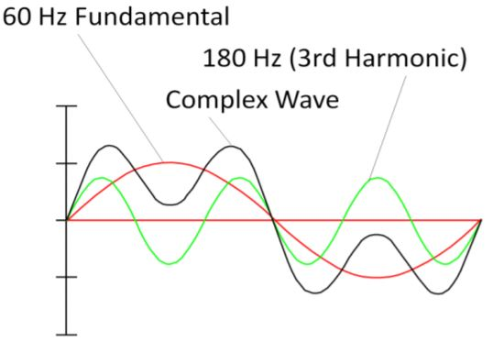
Figure 13:Harmonics of a complex wave

The linear load
The linear load is where the impedance remains constant during the alternating current wave length and this by drawing instantaneous proportional current to the applied voltage, and the current draw of this load is sinusoidal wave.
There several types of linear loads such as resistive “electrical heater”, capacitive “capacitors”, and inductive “motor” or a combination of them. The graph below shows linear loads and their output wave. [24]
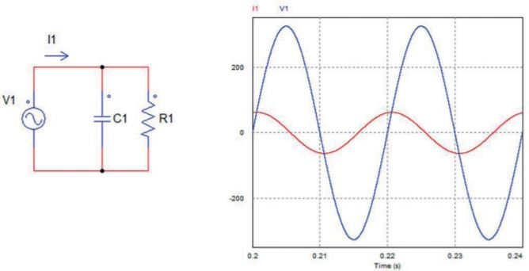
Figure 14:Resistor and capacitor load with sinusoidal current draw

Non-linear load
This type of load its impedance changes with the instantaneous applied voltage which means the current drawn is not in constant relationship to the applied voltage during the voltage wave length time, which means the current draw of this load is a non-sinusoidal wave which is not linear. A simple example of a non-linear load is a diode rectifier as shown in the graph below. [25]
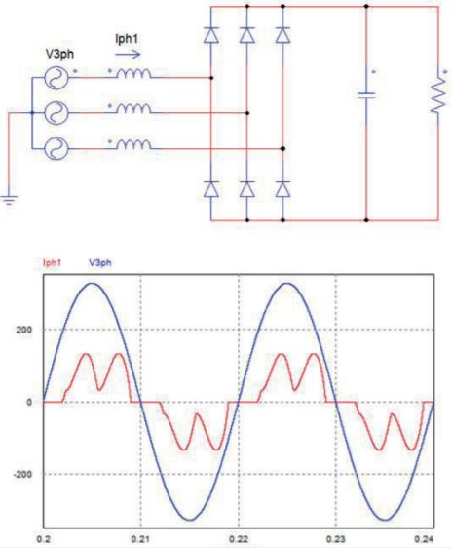
Figure 15: Non-linear load of 6-pulse rectifier and its distorted current drawn

The power factor in sinusoidal situations
The power factor quantifies the utilization efficiency of the motor for the current of the AC system. In the figure below the linear load is connected to the AC power source in an ideal sinusoidal situation where there the AC power wave does not have harmonics:
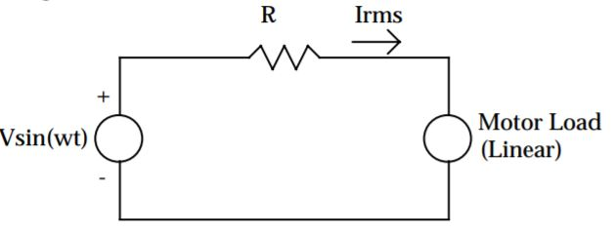
Figure 16: Power system with linear load

V(t)= $V1sin{(wt+∂1)}$ and i(t)= $I1sin{(wt+Ɵ1)}$
V1 and I1 are the voltage and current peak values while $∂1$ and $Ɵ1$ are the phase angles. Therefore, the true power factor equals to the displacement power factor which is the ratio of the average power to the apparent power
Pf true = Pf dis = ${Pavg}/S$ = $\cos{∂1-Ɵ1}$
In the sinusoidal case, the unity power factor occurs when the reactive power is zero while low power factor occurs when the reactive power is high. In this case where the load is linear, the power factor is corrected by adding capacitors to the system.
The graph below shows the effect of the displacement power factor on the losses of power delivered to the motor. The losses are expressed in per unit of nominal sinusoidal case where pf true=pf disp=1. [26]
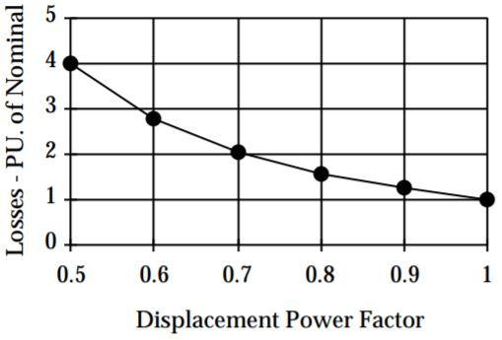
Figure 17: Effect of displacement power factor on power losses

The power factor in non-sinusoidal situation
This is the case where the voltage and current of the AC power include harmonics caused by the system nonlinearity. On a steady state, the voltages and currents and their rms values are represented by using Fourier series as follows:
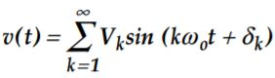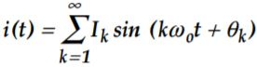
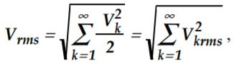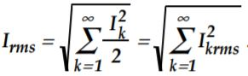

Therefore, the harmonics affect the average power on each harmonic which in return affect and contribute to the average power of the fundamental harmonic as in the equation below. [27]
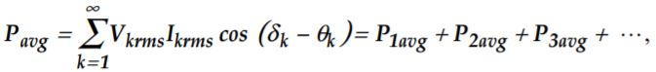
The harmonic levels are measured by using the total harmonic distortion or the distortion factor which is the percentage ratio of the rms of the harmonics above the fundamental, to the value of the fundamental as in the equations below showing the distortion in the voltage and the current. [28]
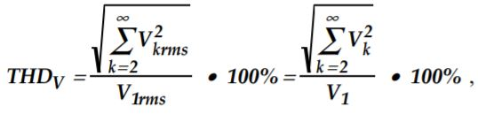
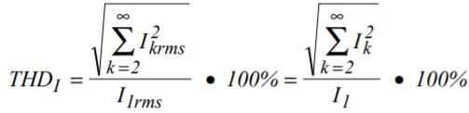
Therefore, after applying long mathematical calculations, it yields an equation to calculate the power factor in non-sinusoidal situations with non-linear load as follows.
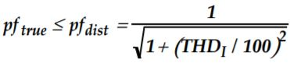

The figure below shows the inverse relationship between the maximum true power factor (Pftrue) and the total harmonic distortion THD, where the more the total harmonic distortion TDH increases the more the true power factor (Pf true) decreases. [29]
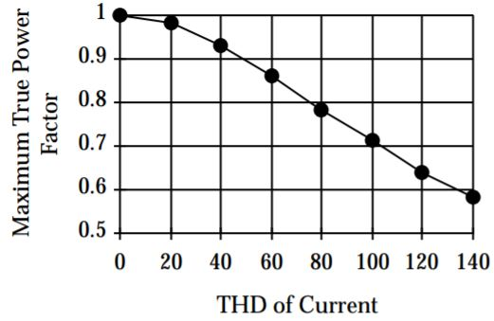
Figure 18: Maximum true power factor versus THD

Comparison between the impact of THD on sinusoidal and non-sinusoidal systems
The graph below represents power system with non-linear load,
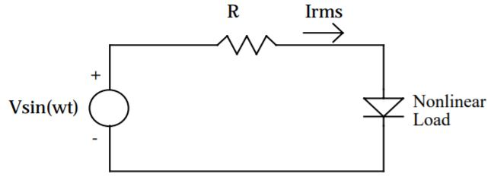
Figure 19: Power system with non-linear load
Assuming that the average power of the fundamental (Pavg)is constant, and by varying the displacement power factor, it is clear that the total harmonic distortion THD has a great impact on both sinusoidal and non-sinusoidal system efficiency. But the impact on the non-sinusoidal system is much higher than on the sinusoidal system as plotted on the graph below. [30]
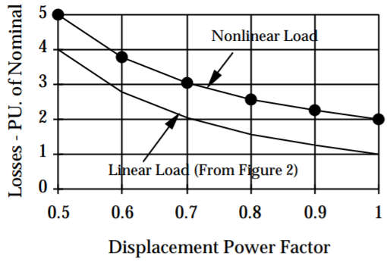
Figure 20: Effect of displacement power factor on non-sinusoidal system losses

Conclusion
- In order to mitigate the harmonics using bridge rectifier, the higher pulses rectifiers such as 12-pulse rectifier are better in mitigating the harmonics and their output DC ripple is smoother and has a smaller number of harmonics with less amplitude and higher frequency.
- The harmonics, the power and the power factor are all concepts tied to each other and depend on each other, as the more harmonics the fundamental wave has, the more total harmonic distortion THD it has and consequently less power factor and less power.

References

[1] | [Online]. Available: https://en.wikipedia.org/wiki/Electric_motor#:~:text=An%20electric%20motor%20is%20an,applied%20on%20the%20motor's%20shaft.. [Accessed 26th April 2021].
[2] | [Online]. Available: https://www.motioncontroltips.com/faq-what-are-dc-shunt-motors-and-where-are-they-used/. [Accessed 26th April 2021].
[3] | [Online]. Available: https://www.electrical4u.com/types-of-dc-motor-separately-excited-shunt-series-compound-dc-motor/. [Accessed 26th April 2021].
[4] | [Online]. Available: https://www.linquip.com/blog/series-dc-motors/#:~:text=Series%20DC%20motors%20are%20a,one%20based%20on%20electromagnetic%20law.. [Accessed 26th April 2021].
[5] | [Online]. Available: https://www.elprocus.com/different-types-of-electric-motors/. [Accessed 26th April 2021].
[6] | [Online]. Available: https://www.elprocus.com/different-types-of-electric-motors/. [Accessed 26th April 2021].
[7] | [Online]. Available: https://en.wikipedia.org/wiki/Synchronous_motor. [Accessed 26th April 2021].
[8] | [Online]. Available: https://www.elprocus.com/different-types-of-electric-motors/. [Accessed 26th April 2021].
[9] | [Online]. Available: https://www.kollmorgen.com/en-us/products/motors/stepper/?utm_source=google&utm_medium=cpc&utm_campaign=UK-stepper-motors&gclid=Cj0KCQjwyZmEBhCpARIsALIzmnLzueWeTolDOEwhwiKvg816IuRf-1HwJ2sfvC5ppYwNMh5FtAeXTIoaAsQzEALw_wcB. [Accessed 26th April 2021].
[10] | [Online]. Available: https://en.wikipedia.org/wiki/Brushless_DC_electric_motor. [Accessed 26th April 2021].
[11] | [Online]. Available: https://circuitglobe.com/hysteresis-motor.html#:~:text=A%20Hysteresis%20Motor%20is%20a,flux%20of%20the%20stator%20windings.. [Accessed 26th April 2021].
[12] | [Online]. Available: https://www.elprocus.com/different-types-of-electric-motors/. [Accessed 26th April 2021].
[13] | [Online]. Available: https://gesrepair.com/motor-drive-types/. [Accessed 26th April 2021].
[14] | [Online]. Available: https://gesrepair.com/motor-drive-types/. [Accessed 27th April 2021].
[15] | [Online]. Available: https://www.anaheimautomation.com/manuals/forms/ac-motor-guide.php. [Accessed 27th April 2021].
[16] | [Online]. Available: https://www.anaheimautomation.com/manuals/forms/ac-motor-guide.php. [Accessed 27th April 2021].
[17] | [Online]. Available: https://www.anaheimautomation.com/manuals/forms/ac-motor-guide.php. [Accessed 27th April 2021].
[18] | [Online]. Available: https://circuitglobe.com/dc-motor-drives.html. [Accessed 27th April 2021].
[19] | [Online]. Available: https://selector.drivesmotors.abb.com/recommended-drives. [Accessed 1st May 2021].
[20] | [Online]. Available: https://www.elprocus.com/brief-explaination-about-working-of-vfds/. [Accessed 3rd May 2021].
[21] | [Online]. Available: https://digitalcommons.du.edu/cgi/viewcontent.cgi?article=1527&context=etd. [Accessed 3rd May 2021].
[22] | [Online]. Available: https://www.sciencedirect.com/topics/engineering/three-phase-bridge-rectifier. [Accessed 3rd May 2021].
[23] | [Online]. Available: https://library.e.abb.com/public/afa9690deb15a092c125744f003cb018/TD2_Reducing_harmonics_EN_revD_LR.pdf. [Accessed 3rd May 2021].
[24] | [Online]. Available: https://www.salicru.com/files/pagina/72/278/jn004a01_whitepaper-armonics_(1).pdf. [Accessed 3rd May 2021].
[25] | [Online]. Available: https://www.salicru.com/files/pagina/72/278/jn004a01_whitepaper-armonics_(1).pdf. [Accessed 3rd May 2021].
[26] | [Online]. Available: https://www.maintenance.org/fileSendAction/fcType/0/fcOid/399590942964674223/filePointer/399590942964873514/fodoid/399590942964873512/POWERFAC.pdf. [Accessed 3rd May 2021].
[27] | [Online]. Available: https://www.maintenance.org/fileSendAction/fcType/0/fcOid/399590942964674223/filePointer/399590942964873514/fodoid/399590942964873512/POWERFAC.pdf. [Accessed 3rd May 2021].
[28] | [Online]. Available: https://www.maintenance.org/fileSendAction/fcType/0/fcOid/399590942964674223/filePointer/399590942964873514/fodoid/399590942964873512/POWERFAC.pdf. [Accessed 3rd May 2021].
[29] | [Online]. Available: https://www.maintenance.org/fileSendAction/fcType/0/fcOid/399590942964674223/filePointer/399590942964873514/fodoid/399590942964873512/POWERFAC.pdf. [Accessed 3rd May 2021].
[30] | [Online]. Available: https://www.maintenance.org/fileSendAction/fcType/0/fcOid/399590942964674223/filePointer/399590942964873514/fodoid/399590942964873512/POWERFAC.pdf. [Accessed 3rd May 2021].

