

Component 2 Assignment (Report)
CHANGEMAKERS: CREATIVITY AND VALUE CREATION PROFESSIONS (BMHP5014)
Student name: Laura Gando
Student number: 2428547
Lecturer’s name: Laila Surani

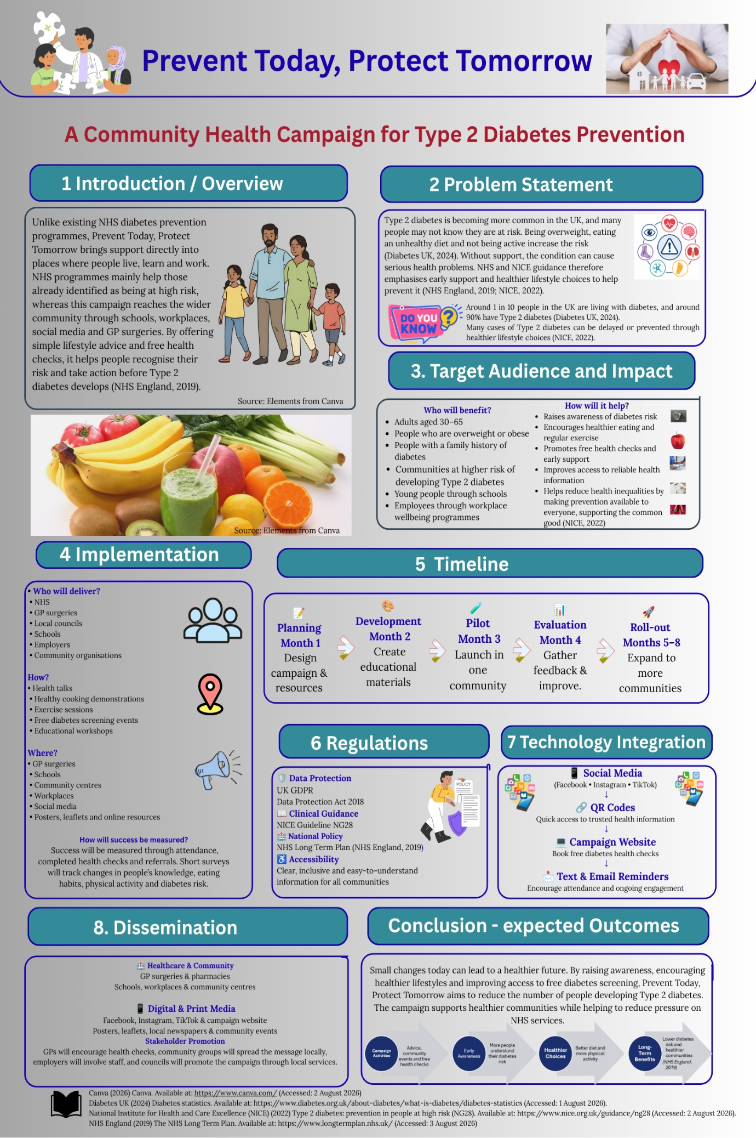

Prevent Today. Protect Tomorrow

Introduction
Type 2 diabetes mellitus (T2DM) is one of the most rapidly expanding long-term health disorders in the UK and continues to place increasing demand on individuals, families and health care providers. Many instances of T2DM are avoidable, and the incidence continues to grow, driven by modifiable risk factors such as obesity, poor nutrition and physical inactivity (Diabetes UK, 2024; NICE, 2022). Many people do not realise they are at risk until difficulties arise that require early management and greater public awareness.
Prevent Today, Protect Tomorrow is a community-based health promotion campaign to reduce the occurrence of Type 2 diabetes by supporting healthy lifestyle choices via education, free diabetes screening and community engagement. The campaign, with the backing of the NHS, doctors’ surgeries, schools, workplaces and local organisations, shows lifestyle changes may help prevent type 2 diabetes, with support made more available through online tools as well as face-to-face events. The programme builds on existing work to prevent diabetes and targets those at higher risk to minimise health inequalities and encourage earlier treatment and support the NHS’s focus on prevention.

Background
Type 2 diabetes is a serious public health problem, affecting about one in ten individuals in the UK, with roughly 90% of cases being Type 2 diabetes (Diabetes UK, 2024). Genetic factors and rising age are involved, but lifestyle factors such as obesity, poor diets and physical inactivity are the primary drivers of the disorder (NICE, 2022). Without effective prevention, the number of people living with T2DM is expected to continue to climb, putting further pressure on already stressed health and social care resources.
The result of Type 2 diabetes goes beyond increased blood sugar levels. Poorly managed diabetes is a major risk factor for cardiovascular disease, stroke, chronic kidney disease and vision loss, leading to worse quality of life and greater health care expenses (NICE, 2022). These largely preventable consequences emphasise the necessity of identifying at-risk individuals before the problem occurs.
There is substantial evidence that lifestyle change is an effective method for the prevention of Type 2 diabetes. Diet changes, physical activity and modest weight loss have been shown to dramatically lower the prevalence of type 2 diabetes in those with impaired glucose tolerance (Tuomilehto et al., 2001), as evidenced in the Finnish Diabetes Prevention Study. Likewise, the Diabetes Prevention Program demonstrated a 58% reduction in diabetes risk among high-risk individuals after rigorous lifestyle therapies (Knowler et al., 2002). These results continue to support the existing NICE recommendation, which recommends a comprehensive lifestyle intervention for people at higher risk of developing the disease.
There are evidence-based prevention measures, but participation is inconsistent. Many programmes are founded on referrals from primary care or on people actively seeking help. This may put people with reduced health literacy, restricted access to healthcare or other social and economic requirements at a disadvantage. Thus, community-based approaches that provide accessible information, opportunistic screening, and ongoing support may help overcome these barriers by engaging patients in their environments before they develop diabetes.

Innovation Summary
Prevent Today. Protect Tomorrow is a community-based health promotion initiative to prevent Type 2 diabetes via health education, early screening and individualised lifestyle support. This is unlike many traditional health campaigns that rely heavily on internet resources or recommendations from healthcare specialists. This project brings prevention right into the community settings where people live, work and socialise. Activities will be delivered in GP practices, pharmacies, schools, workplaces, leisure facilities and community hubs to help make support more visible and accessible to those who would not otherwise seek healthcare services.
The campaign is not to push individuals to make immediate or severe changes in their conduct but to make small, attainable improvements to their lifestyle. Educational seminars will provide practical knowledge on healthy diet, physical exercise, weight management and risk factors for diabetes. These sessions will be complemented by healthy cooking demonstrations, fitness activities led by a guide and free diabetes risk assessments by healthcare specialists and trained community volunteers. Those identified as being at high risk will be referred to their GP or the NHS Diabetes Prevention Programme (NHS DPP) for ongoing clinical support. The integrated approach ensures the campaign is complementary to existing NHS services, not duplicative.
Digital technology will also play a key role in increasing accessibility and keeping participants engaged. We will provide evidence-based health information, healthy recipes, fitness ideas and participant success stories on social media platforms, including Facebook, Instagram and TikTok. QR tags on campaign materials will send customers to the campaign website where they can take a diabetes risk assessment, book screening appointments and learn about local community events. Text message and email reminders will encourage attendance at sessions and help maintain positive lifestyle behaviours after participation. The campaign employs a combination of online communication and in-person events to expand its reach and maintain regular contact with participants.
The NHS Diabetes Prevention Programme has been successful in lowering the risk of developing diabetes, but its performance is very dependent on referrals from primary care and attendance at organised training sessions. This might suggest that people who utilise healthcare services less regularly, have lower health literacy or suffer social and economic difficulties are less likely to participate. This is particularly relevant in deprived areas and some ethnic minority groups where Type 2 diabetes is disproportionately more frequent (NICE, 2022). Prevent Today, Protect Tomorrow aims to reduce these barriers and reach people sooner, before they acquire diabetes, by providing education and screening in trusted community settings. This program is largely a complementary strategy, increasing accessibility to augment existing services rather than replacing present NHS provision.
The programme is based on substantial evidence that demonstrates lifestyle changes are particularly useful in preventing type 2 diabetes. The Diabetes Prevention Program has demonstrated that moderate weight loss, improved nutrition and increased physical activity reduced the prevalence of type 2 diabetes by about 58% in those at high risk (Knowler et al., 2002). In the Finnish Diabetes Prevention Study, it was also shown that significant delay or prevention of the disease is possible with long-term modifications in diet and physical activity (Tuomilehto et al., 2001). But for research findings to lead to meaningful behaviour change, interventions must be accessible and acceptable to local communities. Interventions must be acceptable and accessible to local communities if they are to effect meaningful behaviour change. Prevent Today, Protect Tomorrow connects clinical advice with daily practice by combining research-based education, community involvement, on-the-spot screening, and continuous support to help people make smart health choices and support the long-term viability of NHS services.

The programme’s effectiveness depends on its impact on health and social care, as well as its execution and assessment.
Protect Today, Prevent Tomorrow aims to raise awareness of type 2 diabetes and support those at high risk, including adults between the ages of 30 and 65; people with obesity or a family history of diabetes; and South Asian and Black African or Black Caribbean communities, who are more likely to be affected by the disease (NICE, 2022). Detecting and assisting people to make lifestyle changes early can reduce the prevalence of diabetes and its associated issues, helping to alleviate the long-term pressure on NHS resources.
The campaign will be a six-month experiment in one integrated care system (ICS). The delivery will involve a multidisciplinary team, including a project coordinator, a diabetes specialist nurse, a dietitian, a health care assistant and trained community volunteers working with GP practices, pharmacies and local groups. Estimated costs of £20,000-£30,000 would cover staff, screening equipment, training resources and assessment of the initiative. It will need an upfront expenditure, but prevention is likely to be more cost-effective than treatment of long-term diabetes issues.
There might be some issues with the attempt. Maintaining engagement among participants beyond the first events is a challenge; however, SMS reminders for follow-up, support groups within the community and monthly seminars would promote lasting habit modification. We would also keep print materials and in-person support, as digital resources can be exclusionary if people have limited computer skills or internet access. Culturally relevant campaign resources, translated as needed, and available in trusted community settings, would decrease health inequalities. We will use culturally relevant marketing tools, translating them as necessary, and distribute them through trusted community venues.
Measurable outcomes to evaluate the pilot would include an increase in the number of people attending diabetes screening, referrals to the NHS Diabetes Prevention Programme, increases in participants’ awareness of diabetes prevention and self-reported changes to diet and physical activity. Input from participants and staff evaluations would be gathered to identify strengths, barriers and opportunities for advancement ahead of wider deployment.

Public and Stakeholder Engagement
Prevent Today, Protect Tomorrow Success requires the engagement of healthcare professionals, community groups and the public. A co-production approach will be used to engage community people in the conception and delivery of the campaign so that activities are relevant, culturally appropriate and responsive to local needs. Evidence suggests that involvement of the community in health promotion can lead to better trust, engagement and longer-term participation (NICE, 2022).
Healthcare professionals, including GPs, practice nurses, dietitians and chemists, will be helping with screening for diabetes, providing educational sessions and referring patients at high risk to appropriate NHS services. Local authorities, corporations, schools and volunteers, including Diabetes UK, will support the initiative, offer venues and help to promote events and reach neglected populations. Participants will also be encouraged to share their experiences with community champions who have successfully adopted healthier lives, are genuine role models and help to motivate them.

Conclusion
Early intervention and healthy lifestyle choices can prevent many instances of Type 2 diabetes, a significant public health concern. Early intervention and positive lifestyle choices can lead to better health outcomes. Avert Today, Safeguard Tomorrow will enhance existing NHS diabetes prevention efforts, including information dissemination, complimentary screenings, and lifestyle assistance within community environments, while also facilitating access to preventative measures for individuals who often do not use healthcare services.
The campaign will collaborate with health professionals, local authorities, employers and community organisations to raise awareness, promote better behaviours and eliminate health inequities. To work, it will need constant buy-in, sufficient financing and periodic review, but a trial programme will help show its worth before it’s deployed more broadly.
If effective, the programme might lead to increased adoption of diabetes screening, improved awareness of diabetes prevention and beneficial changes in diet and physical activity. In the long term, investing in community-based prevention results in improved health outcomes, reduced future demand on NHS services and healthier, more resilient communities.

References
Diabetes UK (2024) Diabetes statistics. Available at: https://www.diabetes.org.uk/about-diabetes/what-is-diabetes/diabetes-statistics (Accessed: 2 August 2026).
Equality Act 2010. c.15. London: The Stationery Office. Available at: https://www.legislation.gov.uk/ukpga/2010/15/contents (Accessed: 29 July 2026).
Knowler, W.C., Barrett-Connor, E., Fowler, S.E., Hamman, R.F., Lachin, J.M., Walker, E.A. and Nathan, D.M. (2002) 'Reduction in the incidence of type 2 diabetes with lifestyle intervention or metformin', The New England Journal of Medicine, 346(6), pp. 393–403. Available at: https://doi.org/10.1056/NEJMoa012512 (Accessed: 5 August 2026).
National Institute for Health and Care Excellence (NICE) (2022) Type 2 diabetes: prevention in people at high risk (NG28). Available at: https://www.nice.org.uk/guidance/ng28 (Accessed: 5 August 2026).
NHS England (2019) The NHS Long Term Plan. Available at: https://www.longtermplan.nhs.uk/ (Accessed: 2 August 2026).
NHS England (2024) Healthier You: NHS Diabetes Prevention Programme. Available at: https://www.england.nhs.uk/diabetes/treatment-care/healthier-you/ (Accessed: 6 August 2026).
Office for Health Improvement and Disparities (2023) Health Profile for England 2023. Available at: https://www.gov.uk/government/publications/health-profile-for-england (Accessed: 6 August 2026).
Tuomilehto, J., Lindström, J., Eriksson, J.G., Valle, T.T., Hämäläinen, H., Ilanne-Parikka, P., Keinänen-Kiukaanniemi, S., Laakso, M., Louheranta, A., Rastas, M., Salminen, V., Uusitupa, M. and Finnish Diabetes Prevention Study Group (2001) 'Prevention of type 2 diabetes mellitus by changes in lifestyle among subjects with impaired glucose tolerance', The New England Journal of Medicine, 344(18), pp. 1343–1350. Available at: https://doi.org/10.1056/NEJM200105033441801 (Accessed: 2 August 2026).
UK Government (2018) Data Protection Act 2018. Available at: https://www.legislation.gov.uk/ukpga/2018/12/contents (Accessed: 29 July 2026).

