The connection between sensation chasing and dangerous conduct has been seen since the 1970s. Amid the late 1980s and mid 1990s, street wellbeing scientists have analyzed the connection between sensation seekingand riskydriving (e.g. drivingwhile disabled, speeding,following too nearly), and also its outcomes (e.g. impacts, infringement). There is additionally developing proof that sensation looking for may likewise direct the way in which drivers react to different factors, for example, liquor disability and saw chance. This paper audits and integrates the writing on sensation looking for as a direct inﬂuencer of unsafe driving and its outcomes and as an arbitrator of the inﬂuence of different components. By far most of the 40 contemplates looked into demonstrated positive connections between sensation chasing (SS) and unsafe driving, with relationships in the 0.30– 0.40 territory, contingent upon sexual orientation and the measure of dangerous driving and SS utilized. Of those investigations that have taken a gander at the subscales of Zuckerman's Sensation Seeking Scale, Thrill and Adventure Seeking seems to have the most grounded relationship to unsafe driving. The natural bases of SS is talked about similar to the suggestions for crash avoidance measures. Brian A Jonah

Introduction

Sensation seeking ‘is a trait defined by the seeking of varied, novel, complex and intense
sensations and experiences and the willingness to take psychical, social, legal, and financial risks for the sake of such experiences ‘Zuckerman (1994)
The four components when it comes to sensation seeking according to Marvin Zuckerman is Thrill, speed, adventure and danger. You would be more likely to seek adventure that an older generation person. Gender differences factor when SS (sensation seeking) in a high quantity man would score high in adventure
seeking where a female would score high on experience seeking. Behavioural differences people high in sensation seeking are more outgoing and thus adventurous (mountain climbing, scuba diving, racing etc) where as those low scoring low on sensation seeking do not have the tendency’s to enjoy such activities.
High scores when sensation seeking is open to express emotions, assertive when relating to others
And are confirmed to be risk takers. They act on their own dependency for own need and desire,
Where as the low sensation seekers do the opposite.
High sensation seekers have more needs for stimulating and varied experiences.
The two studies taken place being Stepherson,M.T., Hoyle, R.H., Slater, M.D.,& Palmgreen,P (2003) a Brief measure of sensation seeking, and Ivers,R.,Senserrick,T., Boufous,S., Stevenson, M., Chen, H-Y.,woodward M., …& Norton,R.(2009) risky driving behaviour
The main aim of the study was to collect information and contrast if there is any relationship
Between the level of sensation seeking and the likelihood for increasing risky driving behaviour
In the study’s that have taken place the hypothesis would be the results would show a positive
Connection to sensation seeking v risky driving behaviour

During the study twenty-one females and five males participated twenty four out of twenty six held a full licence with the age ranging from eighteen too sixty average age of participants taking place being 27.58
Both studies where done online BSSS and RDB where used to measure the results of each questionnaire
Consent forms where issued for each participant to continue with the study stating it was confidential. Appendix 1. In the first study you would have to respond to the statement about the participants general feelings towards each one using the rating scales one being strongly disagree five being strongly agree appendix 2. Within the second study there were fourteen questions in which participants were asked to answer honestly on a scale of one to four one being never and four being very often appendix 3.
The studies showed a weak/ no correlation between the two varieties compare previous studies that have taken place Appendix 4-11

References
Hartman, M.L. and Rawson, H.E. (1992): Diﬀerences correlates of sensation seeking in male and female athletes and non-athletes. Personality and Individual H.D.Utzelmann, G. Diﬀerences 13, 805–812.
Jonah, B.A. and Wilson, R.J. (1986) Impaired drivers who: a review and theoretical formulation.. impaired drivers? SAE Technical Paper Series, No. 860195, pp. 83–93

Eysenck, H.J. (1983) A biometrical- genetic analysis of impulsive and sensation seeking behaviour. In biological base of sensation seeking, impulsivity and anxiety,ed M. Zuckerman pp1-35

Appendices
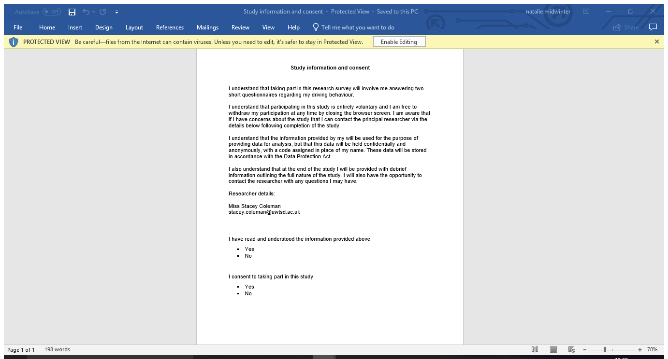

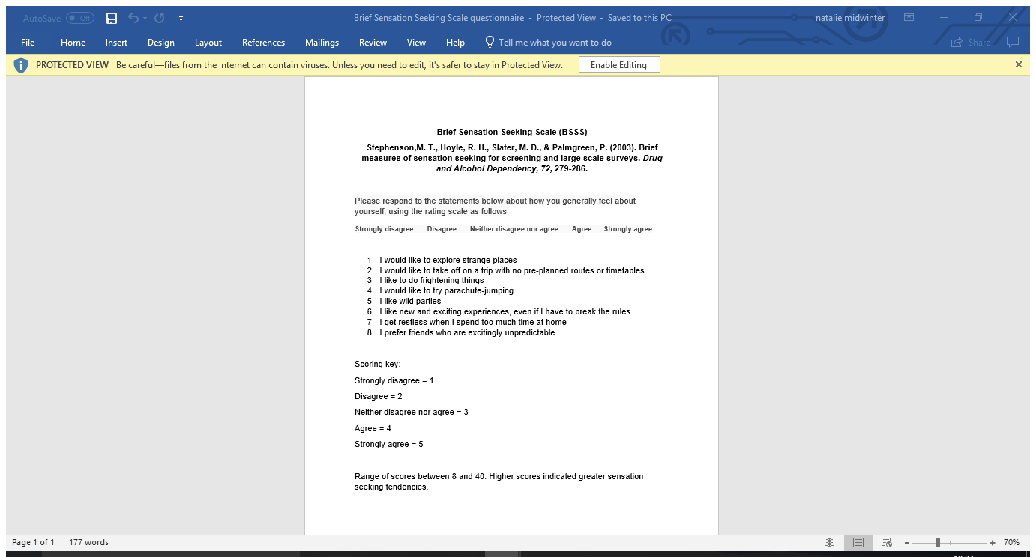

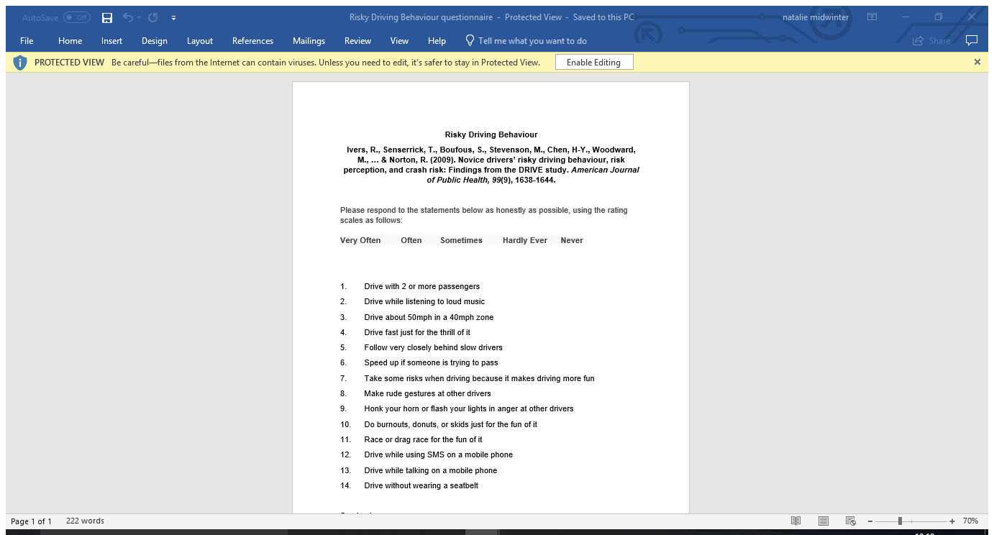
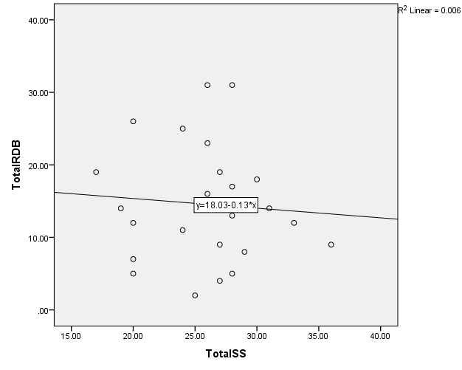

Statistics
 |  | TotalRDB | TotalSS
N | Valid | 26 | 26
N | Missing | 0 | 0

Descriptive Statistics
 | N | Minimum | Maximum | Mean | Std. Deviation
TotalRDB | 26 | 2.00 | 31.00 | 14.5769 | 7.88504
TotalSS | 26 | 17.00 | 36.00 | 25.8846 | 4.49290
Valid N (listwise) | 26

Correlations
 |  | TotalRDB | TotalSS
TotalRDB | Pearson Correlation | 1 | -.076
TotalRDB | Sig. (2-tailed) |  | .712
TotalRDB | N | 26 | 26
TotalSS | Pearson Correlation | -.076 | 1
TotalSS | Sig. (2-tailed) | .712
TotalSS | N | 26 | 26

Descriptive Statistics
 | N | Minimum | Maximum | Mean | Std. Deviation
Age | 26 | 18.00 | 60.00 | 27.5769 | 11.13256
Gender | 26 | 1.00 | 2.00 | 1.8077 | .40192
Valid N (listwise) | 26

Gender
 |  | Frequency | Percent | Valid Percent | Cumulative Percent
Valid | 1.00 | 5 | 19.2 | 19.2 | 19.2
Valid | 2.00 | 21 | 80.8 | 80.8 | 100.0
Valid | Total | 26 | 100.0 | 100.0

