

Community Engagement -Essay

Baciu Severina 2022009
Community Engagement
LCBB4002
Tutor: Dale Clarke

Table of Contents
Table of Figures 1
Introduction 2
About Novavax 2
Key people at Novavax.Inc 3
Value and development 4
Swot analysis Novavax Inc 4
Internal factors 5
External factors 5
Pestel analysis for Novavax Inc. 6
Data collection 8
Conclusion: 8
References: 9
Appendixes 11

Table of Figures
- Figure 1. Novavax Covid-19 candidate vaccine………………………………………….1
- Figure 2. Vaccine trials phases…………………………………………………………….2
- Figure 3. Novavax careers accomplishments…………………………………………….3
- Figure 4. Appendix C from Agreement Novavax-Serum Institute………………………8

Introduction
In late December 2019, the world has found from China that a new dangerous and highly transmittable disease is breaking out of control. In January 2020 WHO declared concerns about the new virus named Covid-19 which has variable symptoms from light to life-threatening.
At the same time few vaccine development companies have started to work on Covid -19 vaccine. The newest biotechnologies in creating the vaccine have taken the lead.
In particular, Novavax, Inc. which is dedicated to the research, development, and marketing of vaccinations for the prevention of infectious illnesses.

About Novavax
Novavax company was founded in 1987 and its main activities are in pharmaceutical sector. The company is publicity listed on U.S market by ticket NVAX.
Novavax announced in late January 2020 that they are working on vaccine “engineered from the COVID-19 genetic sequence” (Novavax, 2020). (Figure 1)
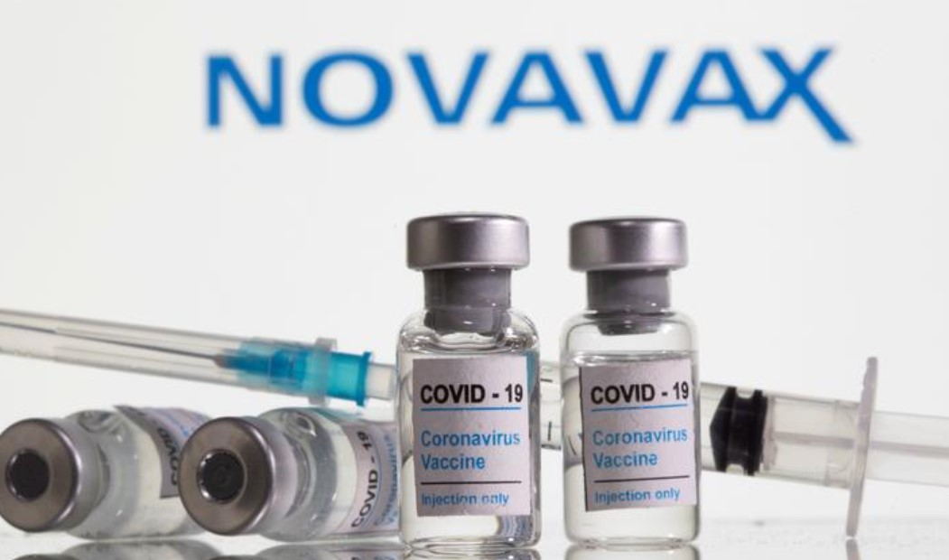
Figure 1. Novavax Covid-19 candidate vaccine (REUTERS/Dado Ruvic/Illustration)
In July,2020, Novavax has been selected by the U.S government for delivering millions of covid-19 doses in an operation called “Warp Speed” (Novavax, 2020). Its clinical trial for vaccine is still undergoing on four continents and the vaccine is in the last phase 3 with a successful precedent trial.” Novavax intends to seek vaccine approval in the United States, Europe, and other countries by the end of September 2021, with the objective of manufacturing 100 million doses per month by then.” (AP NEWS, 2021). Novavax has found support from U.K government where they are conducting trials on European citizens in the UK and according to the company “there were no cases of severe illness or death among those who received the vaccine, indicating that it may be able to prevent the worst effects of new variants that have emerged.” (O’Donnell, 2021)
“Our devotion to our goal requires us to focus our efforts on developing a vaccine that can assist global health authorities in addressing, controlling, and potentially eradicating SARS-CoV-2, the virus responsible for COVID-19. With NVX-CoV2373, we hope to complete our objective.” (Novavax, 2021)
Apart from coronavirus clinical trials, Novavax is engaged in development of life salving vaccines as:” seasonal flu, respiratory syncytial virus, Ebola, and Middle East respiratory syndrome vaccinations.” (Novavax, 2020) (figure 2).

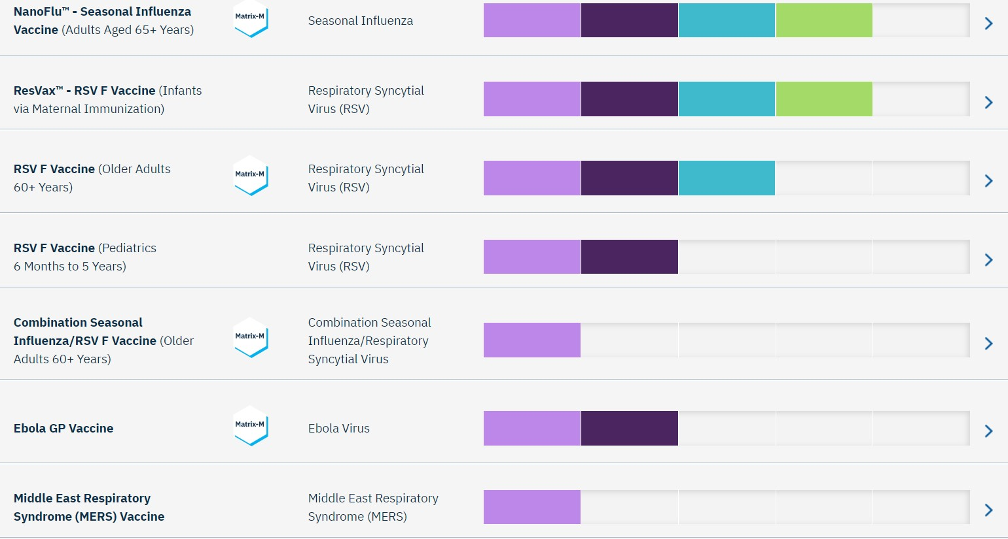
Figure 2. Vaccine trials phases (Novavax, 2020)

Key people at Novavax.Inc
“Our team is made up of drug development specialists who comprehend science, technology, medicine, and their worldwide context. Our highly skilled staff is dedicated to reducing the global burden of infectious illness.” (Novavax, 2021)
As most of the companies are driven to success by their leader CEO, Novavax has in top Mr. Stanley C.Erck who is the CEO and President of the company. In 2011 he was elected to become the company’s president by board of directors for his value and management experience “We believe Mr. Erck is well-suited to serve on our Board based to his leadership expertise in the biotechnology sector, having served as CEO of multiple firms, and his significant experience acting on the boards of other companies.” (NVAX, 2011).
Totally, in 2021, Novavax board of directors is composed from six important persons, and all are “well-suited to serve on our Board due to his/her significant business experience and scientific background.” (Novavax, 2021)

Value and development
For late 2020, and yearly 2021 the company received the best top ratings for the job places which it provides.
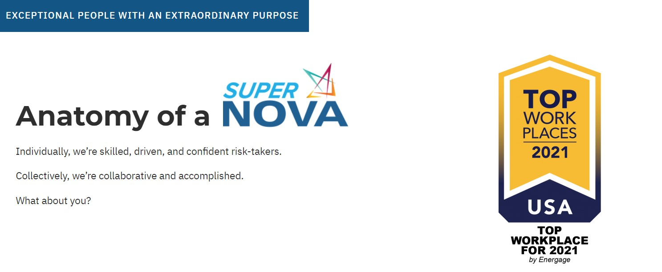
Figure 3. Novavax careers accomplishments (Novavax, 2021)
The company is promoting “health and wellness “(Novavax, 2021) when new specialists are joining Novavax. SuperNova’s recruitment department is admitting that “We appreciate balance, promote growth, and realise that you are our most valuable asset.” (Novavax/careers, 2021). In fact, joining a team as Novavax in world changing circumstances gives the opportunity to change the world itself and grow, succeed while helping an entire nation, world.

Swot analysis Novavax Inc
This is a comprehensive examination of the company's strengths, weaknesses, opportunities, and threats. Internal environmental research can assist a company in identifying its key strengths and shortcomings.
“The pipeline portfolio, shifting demographics, and rising healthcare costs in the United States might all provide possibilities for the firm.” (GlobalData, 2021). However, the firm may face challenges from large companies, unclear R&D outcomes, and reliance on third-party distributors.
Novavax Inc can react and regulate its internal variables (strengths and weaknesses), but it cannot handle external elements (opportunities and threats):

Internal factors
- Leadership abilities – the company’s high performance is attributed to a professional leadership team “Leadership is a skill that must be regularly developed and improved.” (Northeastern University Graduate Programs, 2019). Novavax’s leadership is composed from directors with huge experience in management and business. Many of them are in board of directors of different companies which allows Novavax to partner more easily with institutional or private company.
- Cash flow - The firm's strong financial position and health may allow it to make more investments.
- intellectual property rights – Novavax possess various intellectual property rights that make its product offers distinctive and exclusive, making it difficult for competitors to copy.
- geographic presence - One of the organization's key strengths might be its regional presence in several locations. It establishes the reach of the firm to the potential customers and guarantees simple accessibility.
- locational benefits - The locational advantage may boost the firm's competitive posture in a variety of ways, including cheaper costs, greater accessibility, and higher brand recognition.
- Environmentally problems - Environmentalists may criticise the organisation for its inadequate waste management methods and failure to integrate sustainability into commercial operations.

External factors
- Customers' shifting choices and interests - Customers' preferences for innovative and inventive products/services may emerge as a consequence of shifting tastes. As example, competitors of Novavax are already approved in many countries and their vaccine candidate are publicly available for any customer.
- competitive trends – fair competition between products with better percentage of commercialization.
- inflation - Inflation raises manufacturing costs and has an impact on corporate profitability.
- population expansion are all factors to consider - Process of globalization forces organisations to make every effort and engage with cultural variety, which can be harmful if the organisation lacks cultural awareness.

Pestel analysis for Novavax Inc.
Pestel is a tool for analysing a company in a macro-environment view.
Other than competitive factors, PESTEL research gives considerable insight regarding the operating problems Novavax, Inc. will encounter in the prevailing macro environment. For example, changes which can occur in macroenvironment and affect growth companies like Novavax in biotechnology sector.
The political aspect which is impacting Novavax’s operations is an important factor as “Novavax, Inc. operates in more than a dozen nations in the field of biotechnology, exposing itself to a variety of political environment and political system risks” (Fern Fort University, 2020).
Before entering a new market Novavax’s experts are analysing al political factors which may interfere with their biotechnology advancement. For example, the UK government is a political partner of Novavax which is a catalyst for their success in eurozone, particularly the UK “Novavax and UK government to collaborate on Phase 3 clinical trial in UK commencing in the third quarter of this year” (ir.novavax.com, 2021). “We are honoured to partner with the UK government to deliver a vaccine that could provide vital protection in the fight against the global health crisis,” said Stanley C. Erck. The Novavax is seen as a successful developer of coronavirus vaccine and a dozen of countries are striving to collaborate and purchase million of Novavax’s vaccine dozes. Also, the sales team are conducting all legal aspect for selling their product in each country taking in consideration wage legislation, safety regulations and price legislations in healthcare system of each country.
Being a biotechnology company Novavax’s team is considering in their analysis next economic factors:
- What type of economic system exists and how stable it is- as example the U.S government has signed an agreement for $1.6 billion with Novavax to ensure that their covid vaccine doses are on the way and being an economic power U.S is posed to buy more doses if necessary and that beneficial for Novavax’s balance sheet.
- Comparative advantages of the host country and the healthcare sector in that nation- again as example is being given The UK country with their NHS system well organised and capacity to qualitative distribution of their vaccine which necessity special stocking condition as low as -15C.
- And other economic factors specifics for each country – examples, Rate of economic growth, expenditure discretionary income, the rate of unemployment, the rate of inflation, rates of interest etc.
“The culture and manner of doing things in society have an influence on the culture of an organisation in an environment.” (Fern Fort University, 2020). The population's shared ideas and attitudes play a significant part in how marketers at Novavax, Inc. identify the clients of a given market and develop the marketing strategy for Biotechnology customers of a given market. The attitude of people regarding the disease is different that’s why trained marketers are conducting social factors analysis in the country where they will sell their products. As important social factors are:
- Education level and education standard in the Novavax, Inc. industry
- The arts and culture (gender roles, social conventions etc.)
- The entrepreneurial spirit and the wider character of society -promote entrepreneurship, while others do not.
- Perceptions (health, environmental consciousness, etc.)
In the technology sector Novavax is well ahead of many traditional competitors and when signing new distribution agreements, they take in consideration next factors:
- The influence of technology on product offerings
- The impact on the cost structure of the biotechnology sector
- The effect on the value chain structure in the healthcare industry
Weather and climate concerns are studied by the Novavax’s experts as their conceptual trial vaccines heavily rely on climate data and environment analysis are very important for the company. For example, the shipping and storage temperature for Novavax covid vaccine explained by Edna Kaplan “We expect the product to be viable a minimum of six months at 2º to 8º C, and at least 24 hours at room temperature,” (Philippidis, 2020).
Legal specification for the Novavax supply and licence agreements are specified on sec agreements and individually with each costumer of Novavax. Example, the agreement with “Serum Institute of India Private Limited dated,30 July 2020.” (Sec.gov, 2020) This agreement contains fourteen articles between companies and appendixes (figure 4)
Figure 4. Appendix C from Agreement Novavax-Serum Institute

Data collection
The goal of each study determines whether primary or secondary data will be gathered. For example, Novavax data for the analysis has been obtained from credible sources as well from annual reports with actual primary research. Novavax collected and demonstrated all its vaccine trials through primary research and detailed reports. This study reflects secondary research demonstration for all contents from data collected previously by experts in data collection.

Conclusion:
Coronavirus pandemic changed the global shape of the economy. Some biotech companies failed in development of a vaccine against disease, some succeeded. Novavax name was unknown until they proved that their Covid-19 vaccine is effective and easy modifiable to any emerging variant of coronavirus. Now, the company expect authorization from US, India and other countries for their vaccine shot. This study was completed based on secondary data research. Pestel and Swot analysis for Novavax Inc demonstrated that the company is ready for any micro or macro changes. The company has strong financial position and health to improve their pipeline which will boost their revenues. Leadership is professional, educated and experts in their fields. Marketers are working in different countries improving their political and private partners. Overall, Novavax Inc become successful company because of the coronavirus outbreak, and they gained advantages from this boosting revenues, improve pipeline, conduct trials of their product in different countries which potentially will save peoples lives and will substantially reduce coronavirus crisis to the levels before pandemic.

References:
AP NEWS. (2021). U.S. News. [online] Available at: https://apnews.com/hub/us-news [Accessed 22 Jun. 2021].
Fern Fort University. (2020). Novavax, Inc. PESTEL / PEST & Environment Analysis[Strategy]. [online] Available at: http://fernfortuniversity.com/term-papers/pestel/nyse4/1942-novavax--inc-.php [Accessed 23 Jun. 2021].
GlobalData. (2021). Company Profile - Swot Analysis. [online] Available at: https://www.globaldata.com/company-profile/novavax-inc/swot-analysis/ [Accessed 23 Jun. 2021].
Ir.novavax.com. (2021). Novavax and UK Government Announce Collaboration and Purchase Agreement for Novavax’ COVID-19 Vaccine Candidate | Novavax Inc. - IR Site. [online] Available at: https://ir.novavax.com/news-releases/news-release-details/novavax-and-uk-government-announce-collaboration-and-purchase [Accessed 23 Jun. 2021].
Northeastern University Graduate Programs. (2019). 5 Essential Leadership Skills for the Workplace of Tomorrow. [online] Available at: https://www.northeastern.edu/graduate/blog/essential-leadership-skills-for-tomorrow/ [Accessed 23 Jun. 2021].
Novavax. (2020). Pipeline is robust at Novavax. [online] Available at: https://www.novavax.com/our-pipeline#nvx-cov2373 [Accessed 21 Jun. 2021].
Novavax. (2021a). Careers at Novavax. [online] Available at: https://www.novavax.com/careers [Accessed 22 Jun. 2021].
Novavax. (2021b). Who is Novavax? [online] Available at: https://www.novavax.com/about-us#our-team [Accessed 22 Jun. 2021].
O’Donnell, D.N., Carl (2021). Novavax vaccine 96% effective against original coronavirus, 86% vs British variant in UK trial. Reuters. [online] 11 Mar. Available at: https://www.reuters.com/article/uk-health-coronavirus-vaccines-novavax-idUSKBN2B32ZI [Accessed 22 Jun. 2021].
Philippidis, A. (2020). The Cold Truth about COVID-19 Vaccines. [online] GEN - Genetic Engineering and Biotechnology News. Available at: https://www.genengnews.com/news/the-cold-truth-about-covid-19-vaccines/ [Accessed 23 Jun. 2021].
Sec.gov. (2020). secnvax agreement. [online] Available at: https://www.sec.gov/Archives/edgar/data/1000694/000155837020013462/nvax-20200930xex10d4.htm [Accessed 23 Jun. 2021].
Thomas, K. (2020). U.S. Will Pay $1.6 Billion to Novavax for Coronavirus Vaccine. The New York Times. [online] 7 Jul. Available at: https://www.nytimes.com/2020/07/07/health/novavax-coronavirus-vaccine-warp-speed.html [Accessed 22 Jun. 2021].
www.wsj.com. (2021). NVAX | Novavax Inc. Company Profile & Executives - WSJ. [online] Available at: https://www.wsj.com/market-data/quotes/NVAX/company-people#:~:text=Description%20Novavax%20Inc. [Accessed 21 Jun. 2021].

Appendixes
Appendix A:

SWOT analysis template
NOVAVAX
Strengths  - Novavax Inc has a diverse workforce of staff from diverse geographic territory, ethnographic, social, and educational backgrounds who support the organization by introducing innovative ideas and ways of doing things.  - Has developed ability and succeeding in new markets and earn additional income for company.  - Its goods have retained their quality through the years and are still respected by clients, who regard them as good value for the money they spend.  -Novavax, Inc. provides great free cash flows, which give the firm with resources to develop into start-ups.  - Novavax Inc offers a diverse product portfolio that includes goods in a variety of sectors. It features a lot of distinct product offers those rivals do not have. | Weaknesses  -Low current ratio: The company's current ratio, which measures its capacity to satisfy short-term financial obligations. This might suggest that the corporation will be affected by cash issues in the future.  -Should spend more money in new and innovative technologies.  - A major amount of Novavax Inc's property is rented rather than acquired. It needs to pay a lot of rent on these, which adds to its another expenses.  -Compared to opponents, Novavax Inc has a higher employee turnover rate. They need spend new money for training new people.  -Research data base -operate with an old information, it is not actually any more.
Opportunities  -Constant free cash flow - give chance to company will invest in new technology as well as new product areas.  - Tax policy: Novavax Inc benefits from the government's lowering in tax rates since a lower amount is expensed as a tax.  - The corporation has invested a significant amount of money on the social media and online market during the last few years- knowing its customer needs better and serving using big data analytics. | Threats  -Inflation- raises manufacturing costs and has a negative impact on corporate profitability.  -High number of competitors in the pharmaceutical market - has an effect on the organization's ability to maintain and grow its client ground.  - Due to a skilled duty deficit in the industry, this might be difficult for an organization to recruit employees with the appropriate skills and experience.

Appendix B: Long PESTEL Analysis
 | Political | Economical | Societal | Technological | Legal | Environmental
Local | Mandatory employee benefit | Skill level of workforce in drug producers | Demographics and skill level of the population |  | Laws governing intellectual property and other aspects of data protection. | Climate change may have a substantial influence the capacity to manage the transport in both way  : resources and completed goods.
National | Tax rates and incentives | Labor costs and productivity in the economic sector. | Develop a social structure,like a hierarchical system. | Technology's influence at product offering | After observing the appalling circumstances that people were compelled to work in during and immediately after the industrial revolution, health and safety rules were enacted. | Companies that generate enormous volumes of trash may be compelled by law to regulate their environmental practises.
Global | Trade regulations & tariffs related to Healthcare. | what kind an economic structure exists, and how balanced it is. | Different culture. | The effect on the value chain structure in the healthcare industry. | Implementing correct rules may be costly, but it is necessary not just to comply with the law, but also to fulfil one's personal sense of ethical and social duty to other human beings. | While relying on renewable energy in any percentage may be costly, it frequently obtains support not only from the government but also from its consumer base.

Appendix C: Gantt Chart


