
Organisational Consultancy

February 2019

MODULE NAME: Organisational Consultancy
NAME: CAMERON CARLSON
STUDENT NUMBER: 1701627
MODULE CODE: M6X01422

How to improve the sustainability of House of Fraser by using ecofriendly options.

Table of Contents
1.0 Project Justification 4
1.1 Aims and objectives 4
1.2 Rational 5
2.0 Business case and Project Approach 6
3.0 Research Methodology 8
Secondary Research 8
Primary Research 9
4.0 Project plan 10
Bibliography 11

Project Justification
This project is going to look at how House of Fraser can become a more sustainable retailing store and consult on how being a more sustainable company will lead to more profits and an increase in new customers. House of Fraser are a large retailing company that sells various different products ranging from clothing to household items.

Aims and objectives

The aim of this project is to look at how House of Fraser can make their company more sustainable. Currently they are suffering a lot within the company due to customers discovering that they were back to selling fur products in the November of 2017 (BBC, 2019). Maintaining a sustainable company can provide numerous benefits to sales, reputation and popularity. After examining the company, it can be seen that they’re not engaging with the public as much as they should and that certain sustainable ideas need to be implemented to try and regain some of the customers that have been lost.
Various articles have been written regarding the new owner of House of Fraser,
“Mike Ashley has been hit by a tsunami of public protest, with thousands of messages from shoppers shocked and appalled to see this respected high street store turned into a House of Horrors” (INDEPENDENT, 2019).
The objective of the project is to help change titles like this to a more positive title, rebuilding House Of Frasers image will be down to the sustainability of the business, they currently have numerous stores closing all over the UK due to them not using sustainable materials when manufacturing the products.

Rational
This project is vital in trying to improve the sustainability of House of Fraser, this is a major reason why people have chosen to not shop here, which then causes a domino effect meaning that the house of Fraser stores isn’t making enough profit to keep them open. House of Fraser has had to try and rebuild their image after this incident.
“Mike Ashely is preparing to invest millions of pounds in turning up to seven of House of Fraser’s 50-plus stores into a new luxury mini-chain to be called Frasers” (The Guardian, 2019). Mike Ashley is planning on rebranding house of Fraser, this is to help rebuild the image of the company, he is showing that it doesn’t matter how much it’ll cost he’s willing to try and save the organisation. Being such a large company, it means they’re in the public eye constantly, therefore any change being made is instantly viewed by the public. By making some changes to make the company more sustainable will have a positive effect in the public’s eye, this could then potentially see a rise in profits and social standpoint. In 2017 House of Fraser opened up a new 140-million-pound store in Northamptonshire with a ‘living wall’, the wall was made up of various different plants. The reason for this was to help improve the air quality in the store. The store itself one a BREEAM certificate, these certificates are given to stores for their sustainable design and features “BREEAM is the world’s leading sustainability assessment method for master planning projects, infrastructure and buildings” (Breeam, 1990). This outlines that they’re trying to become more sustainable with the buildings themselves, as it stands this is their only “Sustainable” store. If they were to choose more sustainable materials for clothing, they could see an increase in quality but also see an increase in the costs of the materials.

Business case and Project Approach

House of Fraser is a global company, their headquarters are located in London. They have one other major office located in Abu Dhabi, they sell various big branded items online and in store such as:
- Polo Ralph Lauren – Shirts, T-shirts, Underwear, Loungewear.
- Calvin Klein – Underwear, Shirts, Jeans.
- Levi’s – Jeans, T-shirts, Hoodies.
- Tommy Hilfiger – Jumpers, Hoodies, T-shirts.
(House Of Fraser, 2020)
In 1849 two men by the names of Hugh Fraser and James Arthur came together to open up the first House of Fraser store located in Glasgow. (HOUSE OF FRASER, 2020).
Below is a basic diagram of what the PEST analysis is broken down into the separate sections:

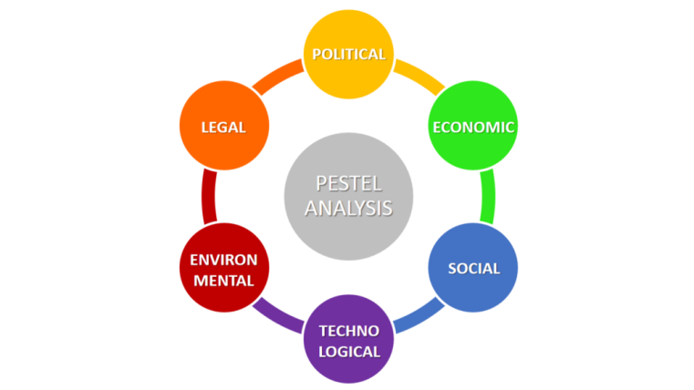
(Business-to-you, 2016)
“The PESTLE Analysis is used as a tool of situational analysis for business evaluation purposes and is one of the most used models in the evaluation of the external business environment that is highly dynamic” (Perera, 2017). A PESTLE analysis is broken down into six separate sections that all have their own important part within the analysis, companies will perform these sorts of analyses to ensure they’re performing at the highest standard or they can see where they need to improve and focus their attention on.
PESTLE Analysis of House of Fraser:
Political: This would link in with any new trading laws or any certain laws regarding GDPR, the government will affect this the most
Economic: Examples of this could be what the stores are doing to the local economy, it could be bringing people to the town centres or wherever the store is located. Also, House of Fraser would have to look at the demographic that they are marketing and seeing how much disposable income they have.
Social: Age, attitudes, social trends and social standpoint. These are just some of the many things that can potentially effect house of fraser
Technological: These factors come together to affect the business internally, it will be revolved around how easy the technology is and how efficient they are.
Environmental: This will come down to the sustainability of the business, we already know that they are lacking ideas, with regards to aiding the environment
Legal: These could be consumer protection, employment laws and health and safety of the workplace.
This analysis suits best for house of Fraser because these are the main points they will need to look at when trying to become eco-friendlier and working towards being a more sustainable company. Each of the components come together to help create a successful business. “reassessment of the issues resulted in evolution of green or environmental issues in marketing strategy and now the sustainability in marketing strategy has become the focus of attention of the researchers” (Kumar, et al., 2012). Now researchers are focusing more and more on becoming greener with their marketing, this is due to laws changing on environmental factors.

Research Methodology

“A concept that is used to describe community and economic development in terms of meeting the needs of the present without compromising the ability of future generations to meet their needs” (Park, 2007). To ensure that the company is sustainable they will need to look at what other companies do to ensure they are sustainable. An example of an eco-friendly sustainable company is IKEA, “We’re promoting responsible forestry methods. We do this to influence the industry and also to contribute to the important work of ending deforestation” (IKEA, 2017). This is outlining that one of their most important materials is taken from sustainable forests, this is helping the environment, whilst maintaining an eco-friendly outlook. If a company that relies on specific materials can find a more sustainable resource, then house of fraser potentially could look to do the same with regards to their clothing items. Primary and secondary research will need to be performed to gain more of an understanding on what House of fraser can do going forward in the future.

Secondary Research

“Research using information that has already been compiled and formatted” (Oxford , 2011). Secondary research is to use existing information or data to complete the current task that’s been set out. By using secondary research, you can look at pre-existing data and see if there’s any correlation with the issues that the company are facing at the present time. The secondary research that will be undertaken on House of fraser will be to look at how they are sustainable and if they have any plans to improve their sustainability. The consult will look into their sustainability polices and see what they do to try and be sustainable, the consultant will have to take to their website to try and find any sort of information surrounding sustainability. The consultant could also compare what other successful companies are doing to try and become more sustainable, the consultant could then use these as potential examples and recommendations for House of fraser.

Primary Research

Below is an image that has been broken down to outline each stage of collecting the data and how to collect.

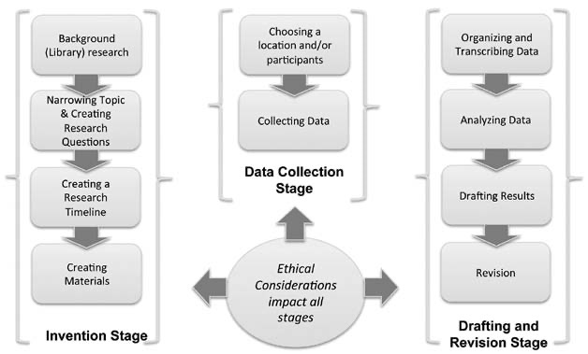
(Charlton, 2010)
There are three main stages of primary research and the ethics that need to be considered when collecting the information. Firstly, there is the invention stage, this is down to researching the issue, creating a timeline for the research and then the creation of materials. All of these factors combined together help to create questionnaires or feedback forms. Feedback forms and questionnaires link in with the data collection stage, this would be going out and interviewing people specific questions, in house of fraser case they could send out feedback forms to gain a basic understanding of what their customers want from the company itself. After gaining all the information from forms and the customers, house of fraser can move on to the final stage. Drafting and Revision stage, this is the stage where companies will look at all the information collected and then turn it into data that the company can use. Performing the questionnaires for house of fraser will be very beneficial and should see an insight into what customers true feelings are towards house of fraser, to help create a relevant questionnaire the consultant will look into various secondary researcher surrounding the topics of, retail stores and retail parks.

Project plan
This project is hopefully going to provide House of fraser with a better understanding as where they are going wrong and what they could do to change the pre-existing opinions of them. Firstly, the consultant will perform some secondary research to help create a questionnaire that will work to getting the primary data the consultant need. The consultant will look at any relevant literature surrounding the environment, sustainability and any companies that are succeeding with being a green company. On the 9th of March the questionnaire for house of fraser will be distributed to the public to start collecting primary data surrounding people thoughts and opinions on the retailer. Once a substantial amount of data has been collected, it will then be broken down and analysed thoroughly. From the data collected house of fraser will then be able to create and action plan to solve and issues that have been found whilst performing the questionnaires. The report will contain a PESTLE analysis of house of fraser, after performing an in-depth PESTLE analysis it should be clear what changes need to be made to progress in the future. It can then help to create new ideas and address some underlying issues. The consultant should address to house of fraser that it would be a good idea for them to include some sustainability policies online, as it stands house of fraser do not have any sort of sustainability policies on their website. The project will use any relevant theories or literature to help complete the task they have been set out. A recommendation for house of fraser would be to promote more green ideas, this would then help to change previous impressions people may have of the company.

Bibliography
BBC, 2019. BBC News. [Online]
Available at: https://www.bbc.co.uk/news/business-50807872
[Accessed 26 February 2020].
Breeam, 1990. Breeam. [Online]
Available at: https://www.breeam.com
[Accessed 26 February 2020].
Business-to-you, 2016. Scanning the Environment: PESTEL Analysis. [Online]
Available at: https://www.business-to-you.com/scanning-the-environment-pestel-analysis/
[Accessed 27 February 2020].
Charlton, C., 2010. Writing spaces : Readings on writing, Volume 1. In: C. Lowe & P. Zemliansky, eds. Introduction to primary research: observations, surveys and interviews. Indiana: Parlor Press, pp. 157-158.
House Of Fraser, 2020. House Of Fraser. [Online]
Available at: https://www.houseoffraser.co.uk
[Accessed 26 February 2020].
HOUSE OF FRASER, 2020. HOUSE OF FRASER. [Online]
Available at: https://www.houseoffraser.co.uk/company-information/our-history
[Accessed 26 February 2020].
IKEA, 2017. IKEA. [Online]
Available at: https://www.ikea.com/gb/en/this-is-ikea/about-us/wood-a-material-with-many-qualities-pubd4deffde
[Accessed 27 February 2020].
INDEPENDENT, 2019. IDEPENDENT. [Online]
Available at: https://www.independent.co.uk/news/business/news/house-of-fraser-removes-fur-mike-ashley-a9214421.html
[Accessed 26 February 2020].
Kumar, V., Rahman, Z., Kazmi, A. A. & Goyal, P., 2012. Procedia - Social and Behavioral Sciences. Evolition of Sustainability as Marketing Strategy: Beginning of New Era, 37(1), pp. 482-489.
Oxford , 2011. A Dictionary of Marketing. In: 3, ed. Secondary Research. Oxford: Oxford University Press, pp. 80-81.
Park, C., 2007. Sustainability. In: 1, ed. A dictionary of environment and conservation. Oxford: Oxford University Press, pp. 1-455.
Perera, R., 2017. The PESTLE Analysis. In: 1.0, ed. The PESTLE Analysis. London: Nerdynaut, pp. 0-1.
Sammut-Bonnici, T. & Galea, D., 2015. Strategic Management. PEST analysis, 12(1), pp. 0-1.
Slide Ocean, 2020. PEST Analysis Diagram. [Online]
Available at: https://www.slideocean.com/downloads/pest-analysis-diagram-powerpoint-template/
[Accessed 27 Feburary 2020].
The Guardian, 2019. The Guardian. [Online]
Available at: https://www.theguardian.com/business/2019/may/08/house-of-fraser-up-to-seven-stores-to-become-luxury-mini-chains
[Accessed 26 February 2020].

