
Name: Carl Bailey
Course name: Cert HE Computing skills for the workplace
Module name: Software solutions for business
Student number: 2325942
Module code: ACCA4026
Lecturer's name: Osman Elgawi
Submission date: 25th March 2026
University name: University of Wales Trinity Saint David
Campus: Birmingham Quay Place

Table of contents
Contents
Introduction 4
Task 1. e-Commerce Website builders/software solutions 5
Introduction to e-commerce web builders 5
Shopify 5
Wix 5
Task 2. Mind-map of contemporary software applications 6
A) Explain mind mapping 6
b) Create Mind mapping 7
Task 3. Office Applications for creating, storing, presenting, and analysing information/data 8
Introduction to office applications 8
Microsoft word 8
Microsoft excel 9
Microsoft access 9
Task 4 Communication and Collaboration applications 10
References 11

Introduction

Task 1. e-Commerce Website builders/software solutions

Introduction to e-commerce web builders

Shopify
Shopify is a well known e-commerce website builder and is widely regarded as the best all round platform for building websites it combines powerful selling tools with ease of access. Shopify offers a number of effective tools that make website building easier including built in payment processing with collaboration’s with apps like pay pal and also giving users access to over 8000 apps.[1] Shopify allows people to set up their own online stores to sell products Shopify is a subscription based service that was founded in 2006 and has become popular with over five million businesses worldwide. Shopify is designed to be used by a wide range of customers from large companies to small start up businesses giving access to a wide range of tools that make the e-commerce process simple for new users.[2] shopify is widely regarded as one of the most functional dedicated e-commerce platforms offering a wide range of extensive tools that are made for selling both physical and digital goods across online and in person channels.[3] shopify infrastructure is designed to retail online with a strong emphasis on reliability, scalable performance and conversion optimised store fronts. Shopify has some key characteristics which include a structured theme system, strong scalability which makes it suitable for small shops and enterprise-level brands.

Wix
Wix’s e-commerce platform is recognised as a beginner friendly website builder that offers a solid set of online tools world wide reviews position wix as a strong option for small to medium sized businesses that want to maintain creative control while being simple to use.[3] although wix is a website first platform it incorporates e-commerce functionality wix is well know for its drag and drop editor which is highly flexible and allows users to create visually distinctive websites without high technical skills some consider wix’s e-commerce tools are less advanced than shopify e-commerce functions. Wix’s has integrated business tools like payment, shipping, analytics and product listings. within the wix’s platform there is hosting, site management and security which helps in reducing technical overheads.[4] The core features within the wix’s platform are storefront builder which provides templates, drag-and-drop editing and mobile optimisation product management which helps to track inventory both physical and digital goods while also managing different variants. Wix also runs multiple payment gateways helps manage taxes and processes coupons. Automation of shipping and carrier integration’s helps with shipping and fulfilment obligations. Wix’s operates a number of marketing tools like email campaigns, social integrations and Seo tools these features used together provide support for day-to-day online retail operations.

Task 2. Mind-map of contemporary software applications

A)Explain mind mapping
Mind mapping is a visual technique that is used to organise information by using a central idea/issue at the centre of a page then branches are created to explain themes connected to the centre each theme which is described as a branch can expand in to a different sub branches providing more detailed information. Mind maps are designed to mimic how the brain naturally processes and combines ideas making mind mapping an effective tool for both analytical and creative thinking.[6] There are many benefits of mind mapping it helps professional’s and academics think more creatively while exploring alternative solutions making it easier to spark new ideas.[7] Mind mapping significantly enhances memory and comprehension by linking freshly gained information to existing knowledge through a visually striking layout allowing people to more effectively retain information.[7} mind mapping has an added benefit of improving communication and collaboration within teams by interpreting information in a universal way so everyone soaks up information in the same way enabling teams to share ideas and build shared knowledge structures making team projects more effective.[8]

B) Create Mind mapping 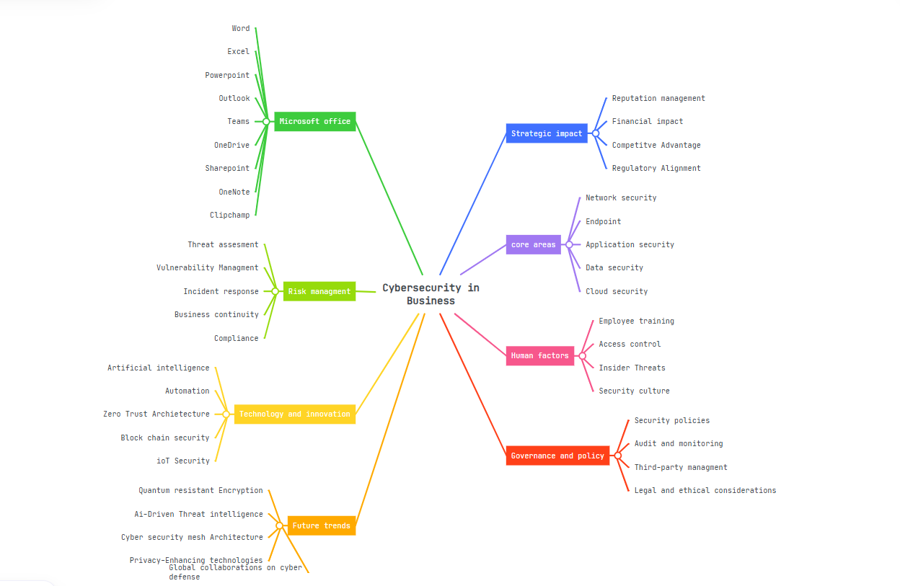
Figure 1 mind map of contemporary business

Task 3. Office Applications for creating, storing, presenting, and analysing information/data

Introduction to office applications

In today's world modern businesses rely heavily on digital tools that support communication, analysis, data management and presentation. Some of the most commonly used tools are Microsoft Office applications. These applications have become the industry standard within multiple sectors, including finance, retail, and government. Four of the Microsoft office applications most used are Microsoft Word, Microsoft PowerPoint, Microsoft excel and Microsoft access all these applications offer unique features that support productivity and decision making. Although these applications have many benefits they also come with certain limitations that people and businesses must understand to use them effectively.

Microsoft word
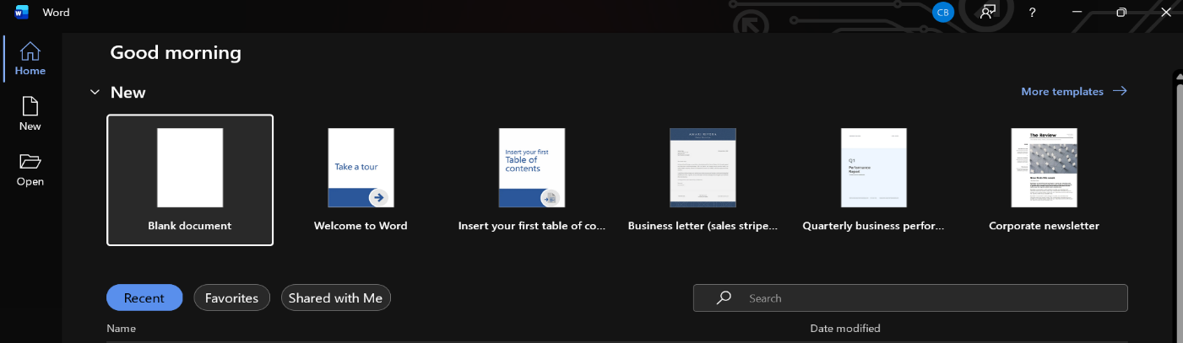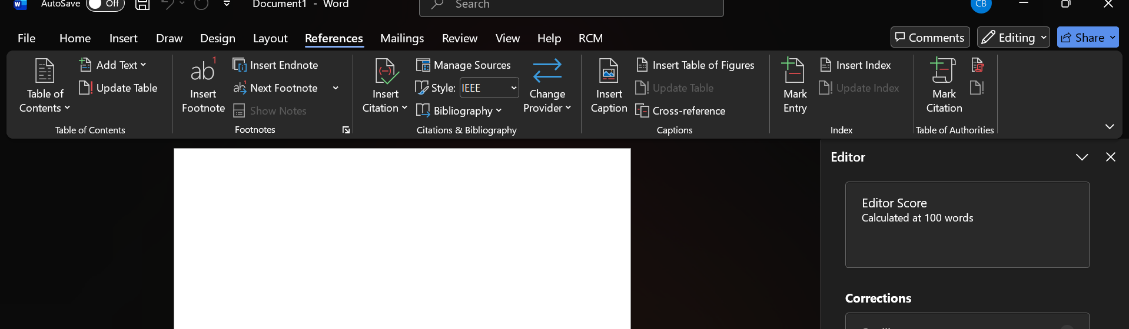
First when entering Microsoft word you must open a blank document then this will take you to a blank page that you can enter text/information into.
Microsoft Word is arguably the most common word processing application used worldwide it is designed for ease of access by given users access to features like creating, editing, formatting and sharing text based documents making it an essential tool within a business environment for producing documents related to the business.[9] the major features within the Microsoft word application are advanced formatting tools which are used for layouts, fonts, paragraphs and styles templates for business letters, resumes, forms and reports reviewing tools like track changes, version history and comments which help and support collaborative editing Microsoft word also contains features like smart art, tables and charts which allows users to add and improve visual elements within documents mail merge has features that enable personalised letters and labels while allowing users to use data and information from other Microsoft office applications like Microsoft excel and Microsoft access he last major feature in Microsoft word that I want to discuss is cloud integration which allows users to use Microsoft word in conjunction with applications like SharePoint and OneDrive.[9] Although there are many strong features within the Microsoft Word application there are benefits and limitations involved in using the Microsoft Word application. Microsoft word offers a number of benefits that make it essential within a business these include its intuitive interface that allows users ease of access to create professional documents with minimal training Microsoft word supports text, tables, hyperlinks, images and embedding objects which showcases the applications versatility. Microsoft word has functions that make it easier to save documents in multiple formats including pdf files which are widly used within a business setting. Despite Microsoft word having numerous benefits it also has its limitations. Microsoft word lacks the computational power of excel which limits its uses within a business environment. Microsoft word is made mainly a word processing application where as Microsoft excel is built on a high performance calculation engine and is designed for more complex requirements like data analysis, formulas and functions, pivot tables and charts along with its automation feature excel is more suited to large data sheets and complex calculations.[10]

Microsoft excel
Microsoft excel is a spreadsheet based application that is used for data analysis, complex calculations and visualization. Microsoft Excel was first released in 1985 and has become arguably the most widely used applications for numerical computation and data organisation It is one of the most common applications used within Microsoft office in business, finance, research and education. Microsoft excels power comes from its functions library, calculations library and the ability to organise and manage complex data sets.[11] The key features of Microsoft excel are the ability to enter data and excel helps to organize the data that has been entered into the system. Microsoft excel has the ability to also put data into graphs and charts that makes data sets more visually appealing and easier to read while having the ability to perform mathematical and statistical calculations. One of Microsoft excels most useful features is the ability to manage data (data analysis) by sorting, filtering and using pivot tables.[11] Microsoft excel has over 400 built in functions within multiple categories these include, math and trigonometry, engineering, text, financial, statistical, lookup and reference and logical making excels calculation engine its defining strength. These functions enable users to anything from simple calculations to complex financial modelling and statistical analysis.[12] Microsoft excel has gone through continuous development incorporating innovations like Enhanced charting, improved collaboration tools, multi-sheet workbooks and integration with cloud services.[13] Despite its strength’s Microsoft excel has limitations excel is not optimised for major data sets (millions of rows) where specialised analytic platforms and data systems are better suited to handle extremely large data sets[14] In summary Microsoft excel is a powerful, versatile and enduring tool for analysis and data management. Excels combination of computational power, automation and visualisation capabilities has made excel and invaluable and indispensable application across industries worldwide with continues enhancements and the ability to integrate with cloud based technologies excel has consistently been a staple within modern digital work

Microsoft powerpoint

Microsoft access

Task 4 Communication and Collaboration applications

References
- D. Winter, “What is Shopify and How Does it Work? (2022),” Shopify, Oct. 06, 2023. https://www.shopify.com/uk/blog/what-is-shopify
- “What is Shopify and How Does It Work? (2025 Guide),” Site Invention, Feb. 17, 2025. https://siteinvention.com/what-is-shopify-and-how-does-it-work/ (accessed Feb. 03, 2026)
- PCMag UK. (2026). Shopify vs. Wix Stores: I Tested Both E-Commerce Platforms and Found a Clear Champ. [online] Available at: https://uk.pcmag.com/e-commerce-software/163283/shopify-vs-wix-stores-i-tested-both-e-commerce-platforms-and-found-a-clear-champ [Accessed 2 Mar. 2026].
- “Wix Review: Pros & Cons and Features (2026 Updated),” LitCommerce, Dec. 25, 2025. https://litcommerce.com/blog/wix-review/?utm_source=copilot.com (accessed Mar. 03, 2026).
- “Wix Ecommerce,” Gartner.com, 2026. https://www.gartner.com/reviews/product/wix-ecommerce?utm_source=copilot.com (accessed Mar. 03, 2026).
- TheKnowledgeAcademy, “12 Benefits of Mind Mapping That You Must Know,” Theknowledgeacademy.com, 2024. https://www.theknowledgeacademy.com/blog/benefits-of-mind-mapping/
- S. Peek, “How Mind Mapping Can Help Entrepreneurs,” business.com, Apr. 03, 2023. https://www.business.com/articles/benefits-of-mind-mapping-for-professionals/
- “4 Useful Applications Of Mind Mapping In Business,” eLearning Industry, Oct. 12, 2017. https://elearningindustry.com/mind-mapping-in-business-4-useful-applications
- A. Jalil, F. Rosa, Rheinald Affandi, A. Aziz, N. Hadi, and Atok Ainur Ridho, “Literature Review: Exploration of Features Microsoft Word,” International Applied Science, vol. 3, no. 1, pp. 28–32, 2024, doi: https://doi.org/10.32528/ias.v3i1.474.
- FastExcel, “Excel performance - Tips for optimizing performance obstructions,” Microsoft.com, Mar. 30, 2022. https://learn.microsoft.com/en-us/office/vba/excel/concepts/excel-performance/excel-tips-for-optimizing-performance-obstructions
- alan.dotchin, “Microsoft Excel: A Comprehensive Overview – The Code Academy,” Thecodeacademy.co.uk, Oct. 06, 2024. https://thecodeacademy.co.uk/docs/microsoft-365/microsoft-excel/microsoft-excel-a-comprehensive-overview/ (accessed Mar. 16, 2026).
- “Excel functions (by category),” support.microsoft.com. https://support.microsoft.com/en-us/office/excel-functions-by-category-5f91f4e9-7b42-46d2-9bd1-63f26a86c0eb
- “History of Microsoft Excel - With Timeline,” Spreadsheet Planet, Nov. 23, 2023. https://spreadsheetplanet.com/excel/history/
- “Microsoft Excel | Research Starters | EBSCO Research,” EBSCO, 2024. https://www.ebsco.com/research-starters/computer-science/microsoft-excel

