Effective Teamworking for business success.

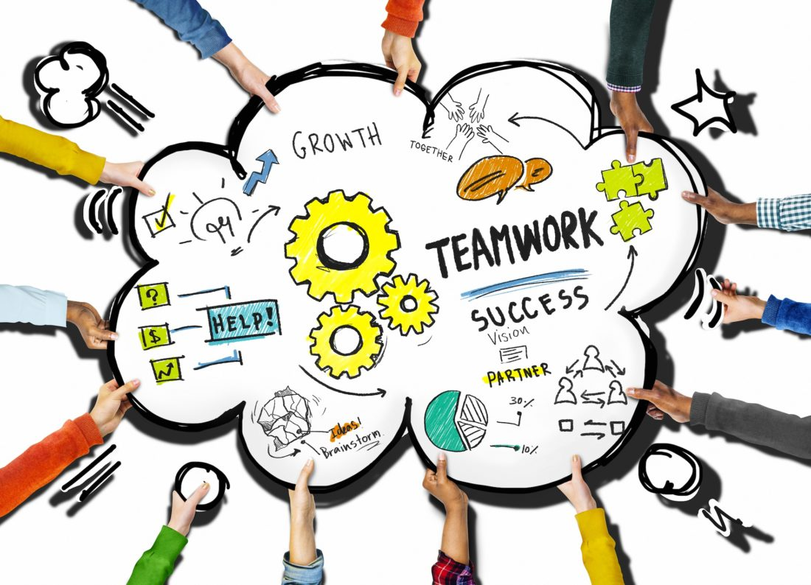

Student name: Flavius- Daniel Pruna
Tutor name: Akash Puranik
Student Id: 2129728
Word count: 2000
Module code and name: BMSW4002 Effective Team Working and Communication

Table of content:
Introduction 3
How to develop an effective team and what team development stages model can be used? 4
What team roles are needed to create an effective team? 7
What are the benefits of teamwork? 8
What are the barriers to effective teamwork identified in this scenario? 9
Conclusion 10
References 11

Introduction
This assignment will be based on a case study project that has been assigned to us by our tutor. In this case study we are presented with a new opportunity for the largest e-commerce Amazon who are trying to expand by opening three large warehouses across Europe a very ambitious and large project. Furthermore, within this assignment we will focus on the importance of effective teamwork and how it can be attained as well as the barriers that might create inconvenience or difficulties for the development of an effective team. Moreover, models and theories such as: Tuckman and Belbin will be used in order to get a better understanding of how different team roles can influence the evolution and formation of a team as well as the stages a team needs to go through in order to form.

How to develop an effective team and what team development stages model can be used?
Teamwork is defined as being a process of working collectively with a group of people in order to achieve a goal as discussed by O'Neill and Salas, (2018). Moreover, teamwork means that the persons will seek to cooperate by using their own skills and give positive feedback, despite any conflicts that may appear between individuals (Conti and Kleiner, 1997). Contrary to that, teamwork is often a crucial part of a company and if the people are doing their job properly, effectively, and work together to achieve the tasks this will lead to the company improvement (Salas, Shuffler, Thayer, Bedwell and Lazzara, 2015).
Teamwork is crucial at the workplace because problems can be solved easily, increases productivity, grows potential for innovation, the team can take smarter risks which will help to develop their confidence meaning there will be less mistakes and issues to be repaired allowing them more time to focus on achieving their goals and to perform at their maximum potential (Irina, 2016).
Tuckman’s Model (1965)
Bruce Tuckman (1965) defined his model as a way in which a team faces an assignment or a task from the start of being a team throughout the entire process of completing the task. Tuckman’s model has five important steps through which a team needs to go, and the five levels are: Forming, Storming, Norming, Performing and Adjourning.
The first phase of the model which a team needs to across is Forming. In this phase the team is already assembled, and the task is assigned to them. Now the team members incline to “test the waters” in this way they can decide what rules they need to follow, and where are the boundaries of their relationship as a team. Also in the meantime, they are planning and searching for information. In the case study we can see that Tom Jackson created a squad and he needs to split the tasks and duties for all the members of the squad in order to reach the ambitious goal that Amazon set for this project which is to open three large warehouses across great cities of Europe: Berlin, London and Paris. This plan also aims to foster fast and reliable dispatch services covering Europe.

Furthermore, we have the second stage of Tuckman’s model which the squad needs to face and that is Storming. This stage is very decisive for the team because if it is poorly managed by the leader, the squad can be compromised and even destroyed since in this phase the members of the team start to address suggesting ideas for the task. Moreover, in this phase the relationships between people are made or broken and the risk of not managing this phase is that you can remain stuck. In the case study, the team lead by Tom is not fully committed to the task because two of the squad members, Mihaela and Spencer, are not dedicated in achieving the squad's target or help them in any way since they are more interested in what they will gain or obtain from the project. So just by looking in the Amazon case we can see that the team is stuck between the Forming and Storming phases.
Moreover, we have the third phase of the model and that is Norming. On this state the conflicts between the squad members are settled, the trust develops and there are close relationships into team. Now the ideas are shared and listen by all the members without arguments, and the team makes progress on their task. In the meantime, the team leader is sharing the leadership roles, observes the progress of the team, and he encourages efforts. Tom didn't manage to bring the team in this stage because of his lack of communication, lack of interaction, lack of commitment and lack of leadership.
The fourth stage that follows in line is Performing. Now the team has united their forces, knowledge and ideas all together in order to achieve the common goal that they have and finish the task successfully. Moreover, now the structure of the team is now accepted and practical which helps the team to solve any problems that they encounter, the solutions for the task are implemented and found by them more easily. Just by watching in the case study we can see that the team leader, which is Tom, needs to promote clear communication, he needs to have regular team meetings face to face, he also needs to make a plan that increases productivity and is demand from him to lead by example.
In addition, the last phase of Tuckman’s model is Adjourning. This is the final stage which the team across together, now the work is done and they achieved the common goal and finished the task effectively and successfully. Now the team members review haply the whole process from the beginning to end of the project and how they completed their assigned tasks. Meanwhile, the Team Captain, grants each person from the squad contribution, he gives rewards and values all the squad members and finally he capitalises on the relationship built and takes it to a new task.

Figure 1
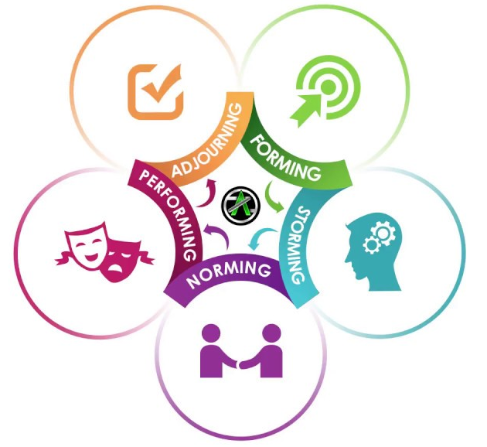
Source:

What team roles are needed to create an effective team?
Roles within a team can vary do to the fact each team member has a unique skill set meaning that along the way their strengths have been sharpened through hard work and life experiences and their weaknesses have been carefully monitored in order to ensure that their efforts are not defined by it. Creating an effective team can be challenging and it is not dependent just on the roles everyone has within the team, it is also based on their personality, life goals, determination behaviour, as well as the person who leads them. For example, when we look at the individuals that have been selected to work on the Amazon project, we determine that they lack professionalism and behave immaturely which is not appropriate and it will affect the progress of the project negatively. Also, their leader Tom seems overwhelmed and unprepared by this newly assigned responsibility this has led to a very chaotic environment which only worsens the team members behaviour and attitude towards this project.
Contrary to that, having a good team leader is essential in creating an effective team because if he or she can understand their teammates strengths and weaknesses they can use that to the team advantage making it more effective and efficient. For example, in the case study, the Amazon team wasn’t successful because of bad leadership, lack of communication and lack of commitment that came from Tom. In other words, their leader was not able to either lead or motivate his colleagues making him unsuited for the role which has affected the team performance negatively.
Belbin Team Roles Model:
Dr Meredith Belbin defined a “Team Role” as being one of nine groups of behavioural characteristics which are effective in order to facilitate the team’s progress. The nine Belbin Team Roles are: Shaper, Implementer, Completer Finisher, Resource Investigator, Team worker, Co-ordinator, Plant, Monitor Evaluator and Specialist. Each role is very important in a team and if you put the appropriate roles in it, the team will successfully achieve its tasks.
They and the task will be successful that is what Belbin’s Model stands for. In the case study we can see that the squad really needs a Shaper, who can take the lead, delegate the tasks to every person, someone who needs to be impulsive and determined in order to make the team finish their tasks without delay. They also need a Completer Finisher who’s only purpose is to foresee what could go wrong. Also, he is observant and focused on checking all the details of the task as well as ensuring it will be completed on time. Furthermore, they could benefit from the role of a Team Worker who is considered to be the glue of the team because they are likeable, popular, friendly and loyal. Their role is focused on providing ideas and avoiding conflicts with the other teammates. Moreover, a Resource Investigator would be a good asset for the team because he has bonds with important people from the exterior and through that he helps the team by bringing ideas from outside the group, he is sociable, enthusiastic, positive but the bad side of him is that he loses his interest after the start of the task. In addition, the team needs a Monitor Evaluator because all the ideas that come from all the colleagues goes through him, and he decides which one is good or bad. He is more of a critic than a creator but only if he or she sees a fault in the argument.

What are the benefits of teamwork?
Nowadays business organizations worldwide have acknowledged that the key to successfully achieve projects is through the development of teams as stated by Tripathy, (2018). Contrary to that we need to understand that a team is not a group; because if we investigate closely, we will find that a group is just a gathering of people, but a team is made of a group of talented individuals with unique skill sets and abilities united by a common goal. Moreover, teamwork provides an opening for both personal and professional growth, profits maximisation etc. (Salas, Shuffler, Thayer, Bedwell, and Lazzara, 2015). Furthermore, effective teamwork leads to efficient communication that prevents project delays resulting in a higher quality output from the employees. In other words, open -minded individuals often come together to share their ideas, suggestions and concerns when working together this leads in better brainstorming as well as continuous improvement of organisations meaning that they will always have an advantage over their competitors as argued by Gallie, Zhou, Felstead and Green, (2012). Tripathy, (2018) also concluded that teamwork creates a strong bond between individuals if they enjoy working together also, once trust is established teammates to open up and encourage each other.

What are the barriers to effective teamwork identified in this scenario?
Firstly, one of the barriers that came to attention was the ineffective communication between team members which led to a lot of conflict, confusion, waste of time and this has affected the team performance and delayed the progress of the project. For example, when people focus more on the reward offered once the project has been achieved this will impact everyone's work and in this case study, we can see that Spencer and Mihaela were more focussed on what could they gain once the project was finished then actually do the tasks that were assigned to them. Because of this
Secondly the lack of leadership from Tom`s behalf plays a major role in this case study, because of his inexperience the whole team is suffering which could led to the failure of the project. For example, Tom is not confident enough to take charge and delegate tasks to his teammates; he seems hesitant in his approach and unsure of how to coordinate and motivate his staff and this was not missed by the other employees who are more interested in keeping the conflict going then putting their differences aside and creating a plan that will benefit everyone and led to the achievement of this project.
Lastly, we will discuss the lack of commitment which has led to a lot of conflict and misunderstandings among the team members making it almost impossible for the project to be successful. Their attitude and behaviour are a major factor in the evolution and progress of this new project and at the moment we can determine that none of them are interested or committed to doing the work that is required in order to make it successful and because of this the conflict among them seems to only aggravate which continues to delay the project.

Conclusion

In conclusion, in order to have an effective and successful team Tom Jackson has to cross all the stages of team development from the Tuckman Model which are mandatory and essential for a group of persons to become a team. Moreover, after the formation of the team physical contact is very important so most meetings should be face to face in order for the team to get to know each other as well as give them a chance to assess everyone’s strengths and weaknesses so that when the roles are assigned each team member will be able to fulfil their duties.

References
Belbin, M., (2004). Belbin team roles. Book Belbin Team Roles.
Conti, B. and Kleiner, B.H., (1997). How to increase teamwork in organizations. Training for quality.
Fapohunda, T.M., (2013). Towards effective team building in the workplace. International journal of education and research, 1(4), pp.1-12.
Fisher, S.G., Hunter, T.A. and Macrosson, W.D.K., (1998). The structure of Belbin's team roles. Journal of occupational and organizational psychology, 71(3), pp.283-288.
Frances, M., (2008). Stages of group development–a PCP approach. Personal Construct Theory & Practice, 5, pp.10-18.
Gallie, D., Zhou, Y., Felstead, A. and Green, F., (2012). Teamwork, skill development and employee welfare. British Journal of Industrial Relations, 50(1), pp.23-46.
Irina, E.R., (2016). IMPORTANCE OF TEAMWORK IN ORGANIZATIONS. Defense Resources Management in the 21st Century.
Kumari, K., Usmani, S. and Hussain, J., (2014). Responsible leadership and intellectual capital: The mediating effects of effective teamwork. Journal of Economics, Business and Management, 3(2), pp.176-182.
O'Neill, T.A. and Salas, E., (2018). Creating high performance teamwork in organizations. Human resource management review, 28(4), pp.325-331.
Runkel, P.J., Lawrence, M., Oldfield, S., Rider, M. and Clark, C., (1971). Stages of group development: An empirical test of Tuckman's hypothesis. The Journal of Applied Behavioral Science, 7(2), pp.180-193.
Salas, E., Shuffler, M.L., Thayer, A.L., Bedwell, W.L. and Lazzara, E.H., (2015). Understanding and improving teamwork in organizations: A scientifically based practical guide. Human resource management, 54(4), pp.599-622.
Salas, E., Shuffler, M.L., Thayer, A.L., Bedwell, W.L. and Lazzara, E.H., (2015). Understanding and improving teamwork in organizations: A scientifically based practical guide. Human resource management, 54(4), pp.599-622.
Tripathy, M., (2018). Building quality teamwork to achieve excellence in business organizations. International research journal of management, IT and social sciences, 5(3), pp.1-7.
Tuckman, B.W. and Jensen, M.A.C., (1977). Stages of small-group development revisited. Group & organization studies, 2(4), pp.419-427.
West, M.A., (2012). Effective teamwork: Practical lessons from organizational research. John Wiley & Sons.

