Commentary on ‘St John’s vision of the apocalypse’
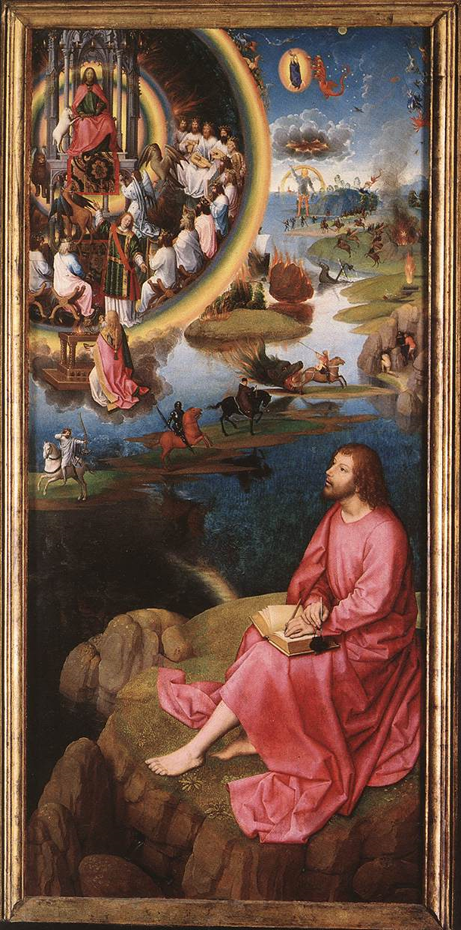
St John’s vision of the Apocalypse is one of five paintings, known as the St John Altarpiece, this image itself sits on the right hand side of three of these images, with two being on the back, and at 1.76 metres by 0.78 metres for this panel alone (HansMemling.org, 2002-2017), you can tell that it is a large, imposing piece of work. Of course being an altarpiece, it is this size so that it draws attention to itself. The size of this painting is also important as it has a far more dramatic effect than it would have if it were a smaller piece; its enables us to see the scenes that are taking place within the image as they are shown to be important, especially because so much is happening.
The image shows St John’s vision of the apocalypse; we watch with him as the events of the apocalypse “unfold in a series of events at sea, on land, and in the air” (Ridderbos, 2005, 140). St John is in the foreground of this painting, and is clothed in a bright red/pink colour so that your eyes are immediately drawn to him, this suggests that he is the most important person in this image, despite the fact that God appears in it, for God appears to be small and tucked away into a corner. However, St John, who is on land, is looking up at God, in the sky, surrounded by his angels and elders, for it is them who are casting this apocalypse onto Earth, and so if we follow his eye-line we could propose that perhaps God is in fact the most important person in the image, as everything that is happening is happening because of him. This is because the way God is depicted also seems to draw in the viewer’s eye, for all those that surround him are looking to him, he is encircled by his angels and elders, and is shown to be elevated above them.
Riding across the land in this image are the four horsemen of the apocalypse, the pale horse of Death is emerging from what appears to be the mouth of hell, perhaps to show that this is the most dangerous horseman. The four horsemen are almost universally agreed upon to be Conquest, or Pestilence (Flegg, 1999, 90), as well as Famine, War and of course, Death. This image was painted by Hans Memling over a hundred years after the Black Death first spread throughout Europe, and was initially painted to hang in a hospital. There are several interpretations as to why it was painted for a hospital, one could suggest that it was intended to be a sign of hope, while some could infer that it acts as a warning, and finally, it could simply be dedicated in memory of the Black Death.
In the background of the image there are several fires raging on land, and they seem to form a curve round the side of the painting to where a giant man appears to be climbing out of the sea and onto land, with a rainbow towering behind him. Above this man are what appear to be storm clouds, however, instead of rain coming out, we see fire coming out of darkness; this darkness is perhaps supposed to symbolise nothingness, humanity’s fear of an existing emptiness. Above this we see what appears to be a demon attacking a woman who is surrounded by a bright orange circle of light, it is possible that she may be a Saint, or is a person who is protected by God, however I believe this is unclear. Behind St John himself, the image shows a few people attempting to hide from the four horsemen in caves, however they appear to be unsuccessful, I believe that this in intended to be symbolic, meaning that no one can hide from God, or that no one can escape their fate.
The most interesting part of this painting, in my opinion, is how separated God and his followers are from the action, they appear to be in what may be Heaven, surrounded by a glowing circle that may be a rainbow that is acting as a barrier. They are completely cut off from the rest of the goings on within the painting, showing that while they are the reason behind the destruction and mayhem being caused, they are unwilling to actually get closer or experience it themselves.
I believe that, to a religious person, this would be a highly sacred image, one that combines God, his followers, and the threat of the Apocalypse. To view it, in its original height and width would surely be astounding for someone looking up at it. However, I feel that without its original other paintings to accompany it, you cannot truly understand this piece of artwork, as it is incomplete. If it were next to its accompanying pieces then there may be similarities or/and differences that are easier to spot, and that make this image more meaningful. Yet there may be another way to look at it. When it is with its other paintings it is merely a side piece, and, while magnificent, it is not the central piece and so will not draw people’s attention first. And so it can be said that by viewing it by itself, without the distraction of the other works, you can only then truly see what makes this piece of art so special, as there is nothing else that can draw your eye away from it.
To summarize, this painting of St John’s vision of the apocalypse shows St John recording what he can see, while looking up at God and the people surrounding him. It shows destruction of land, sea, and sky, with people cowering and hiding in fear while the four horsemen of the apocalypse ride out in a diagonal line across the centre of the painting, their placement here maybe signifying their importance. The use of colour, light and religious symbolism features heavily and creates a dramatic scene that, if stood above an Alter, would be imposing to anyone. I was unable to find any previous commentaries on this image despite vigorous searching and so it was a fun experience to be able to give an honest personal critical view.
Bibliography
- Flegg, C. 1999. An Introduction to Reading the Apocalypse. USA, St Vladimir’s Seminary Press.
- HansMemling.org, 2002-2017. St John Altarpiece (detail). HansMemling.org: The complete works. Available from http://www.hansmemling.org/St-John-Altarpiece-Detail-5.html. Accessed on [04/11/17].
- Ridderbos, B. 2005. Early Netherlandish Paintings: Rediscovery, Reception and Research. Holland, Amsterdam University Press.

