University of Wales Trinity Saint David
London Campus
Module Name: Introduction to Web and Database Concepts
Assignment Title: HTML & CSS Web Development
Module Code: ACCA 4023
Student Name: Alok Dhariwal
Student ID: 2512876
Group: 2
Lecturer’s Name: Anum Paracha
Table of Contents
Introduction 3
Requirements 3
Implementation 4
Validation 7
Evaluation 8
Usability, Accessibility and Search Engine Optimisation 8
Usability 8
Accessibility 8
Search Engine Optimisation (SEO) 9
Your Website Evaluation 10
Usefulness (Usability and Utility) 10
Search Engine Optimisation (SEO) 10
Accessibility (WCAG 2.1) 10
Website Comparison 11
Comparison of Two Websites: BBC vs GOV.UK 11
Websites: 11
Usability 11
Accessibility 11
SEO 12
Mobile Friendliness 12
Conclusion 12
References 12
Appendices 13
Appendices 13

Introduction
This report describes the tale of how the responsive website Nayi Zindagi—Fitness & Wellbeing was designed, created, and tested. The purpose of the website is to assist individuals live a healthy life by giving them simple ideas on how to keep fit and healthy.

The pages on the website are very connected to each other. There are pages for the home site, the about page, the programs page, the wellness advice page, and the page where you can get in touch with us. It was developed with HTML and CSS, which are standard web standards, thus it works on all sorts of displays and devices.

The report tells about what the site needs, how it will be made, and how it will be checked. It also covers about key areas of making websites, such SEO.

Requirements
The name of the website made for this assignment is Nayi Zindagi—Fitness and Wellbeing. The main goal of the website is to encourage healthy living by giving people easy-to-understand information about fitness, lifestyle changes, and general health.

The website is for a wide range of people, including beginners who want to get healthier, people who want to start working out, and people who want useful advice on how to live a balanced life. The content is simple and easy to understand so that people with different levels of knowledge can use it.

There are five main pages on the website: Home, About, Programs, Wellness Tips, and Contact. There is a reason for each page. The home page shows off the website and its most important features. The About page tells you more about the website and what it's for. The Programmes page lists the different wellness programs that users can choose from. The Wellness Tips page has easy-to-follow advice on how to live a healthy life. Users can fill out a form on the Contact page to get in touch.

The design is all about being clear, consistent, and easy to use. A user-friendly experience has been made possible by a clean layout, easy-to-read text, and a colour scheme that stays the same throughout. It is also possible to access the website on both desktop and mobile devices because it is responsive.

Implementation
HTML was used to build the website's structure, while CSS was used to style it. To make sure that all users had the same experience, all pages had the same header and footer. There were links to help people get about the site easily.

CSS Grid and responsive design are used in the design to make sure the website works on all screen sizes. There were pictures on every page to make them look better and keep people interested. All pictures have alternative text (alt attributes) to make them easier to see.

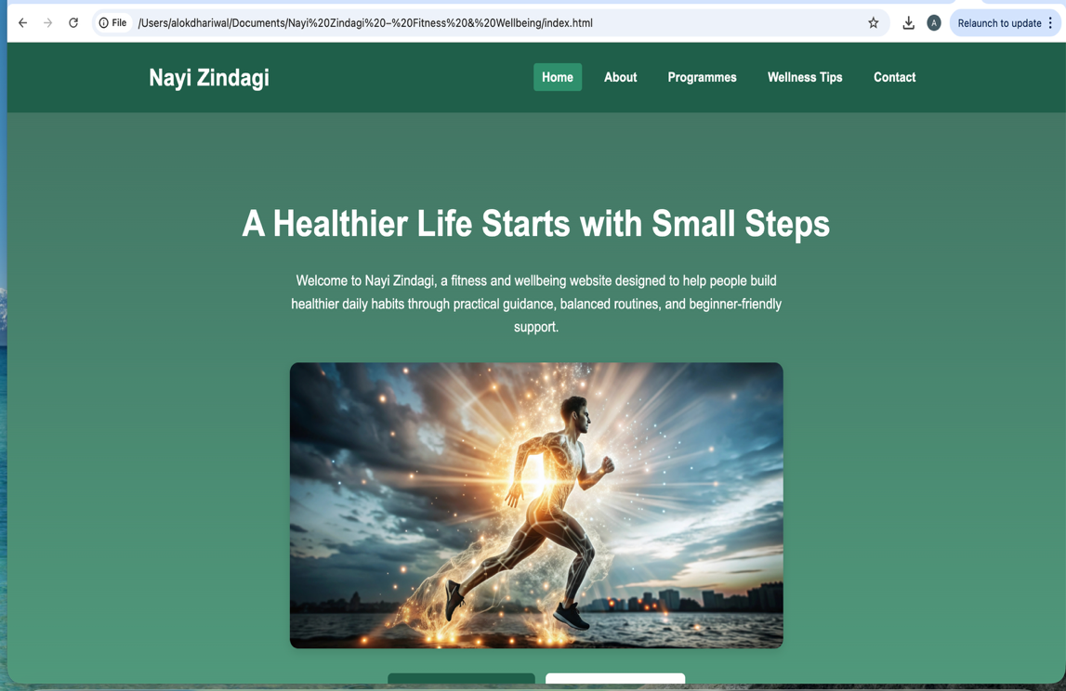
Figure 1: Home page.

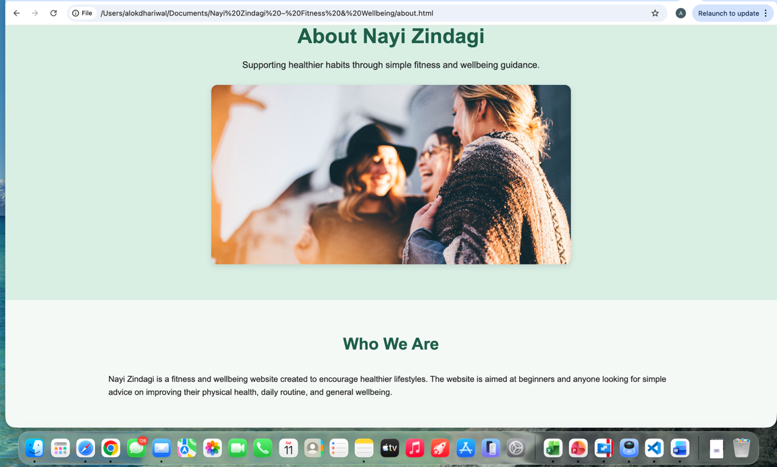
Figure 2: About page

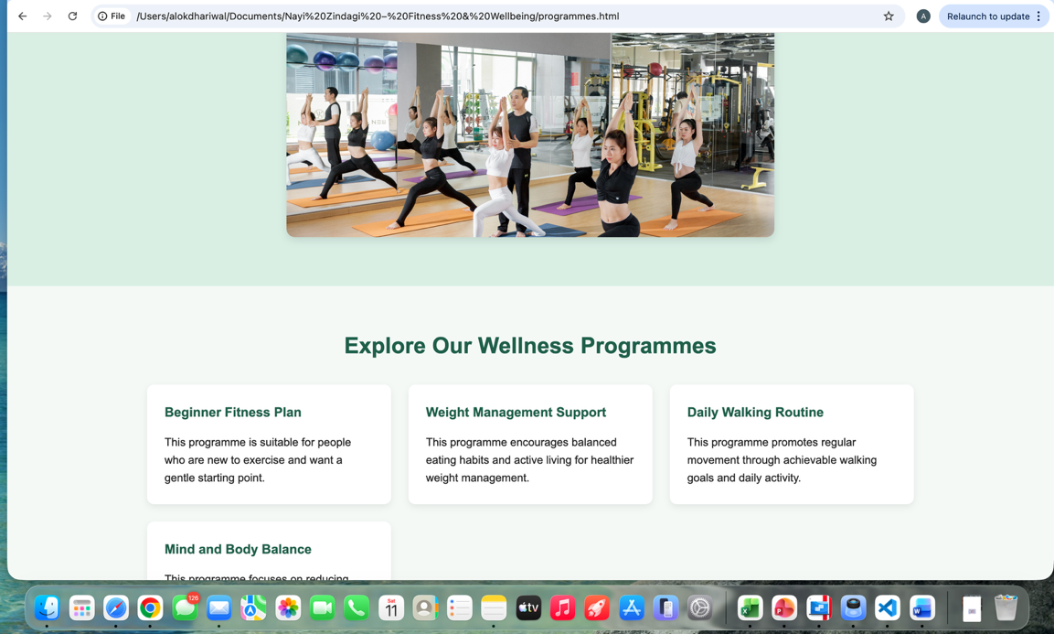
Figure 3: Programmes page showing different wellbeing programmes in a card layout.

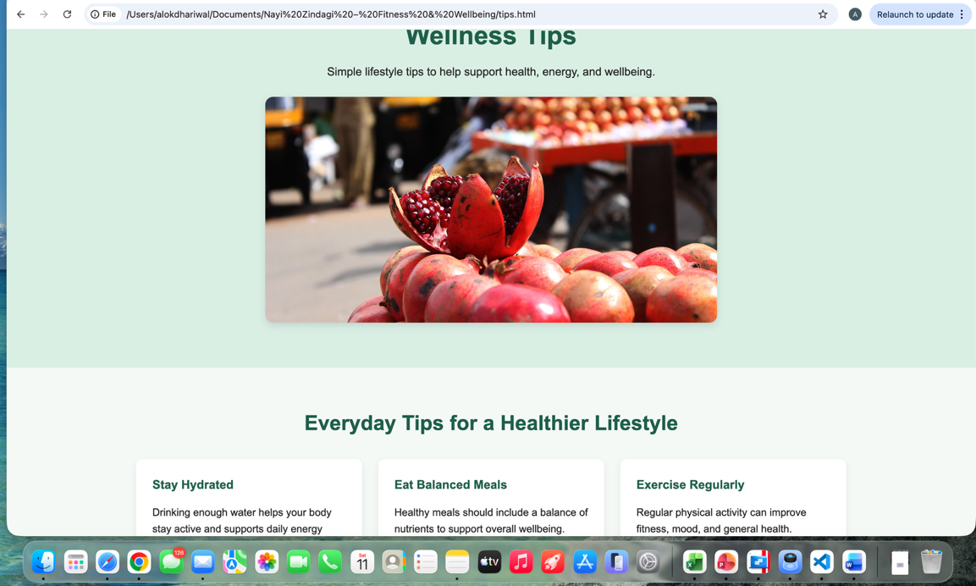
Figure 4: Wellness tips page providing simple health-related advice.

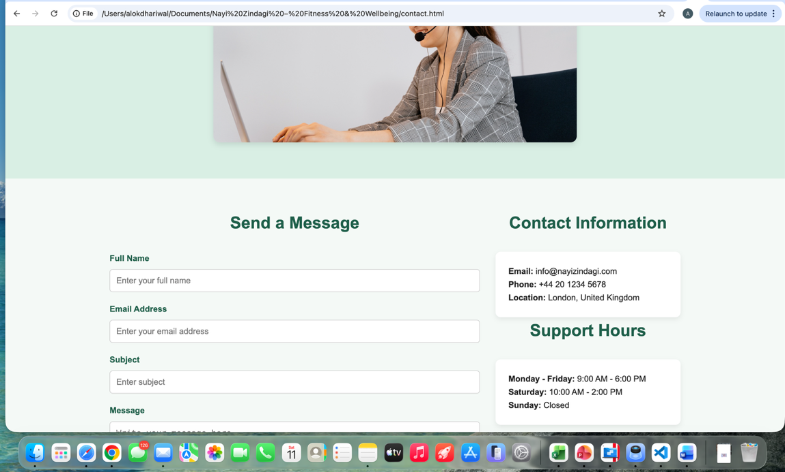
Figure 5: Contact page including a user input form and contact details.

Validation
The HTML and CSS code were validated using the W3C Markup Validation Service and the W3C CSS Validation Service. As required, only the home page (index.html) and the main stylesheet (style.css) were validated.

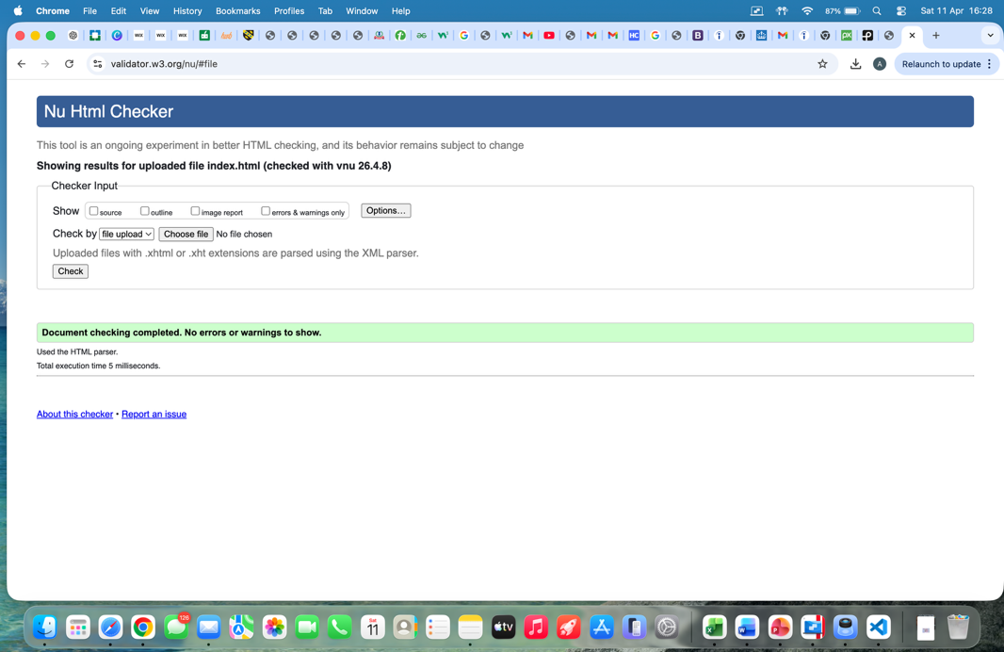
Figure 6: HTML validation results of the home page (index.html).

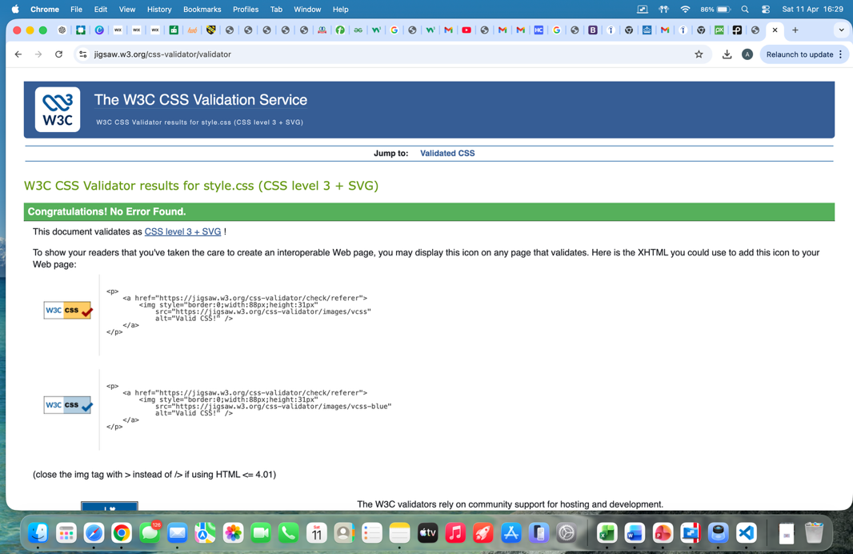
Figure 7: CSS validation results of the stylesheet (style.css).
The validation results confirmed that the code follows standard web development practices. Minor warnings, where present, were reviewed and corrected where possible to improve code quality and ensure compatibility across different browsers.

Evaluation

Usability, Accessibility and Search Engine Optimisation

Usability
Usability is about how easy and quick it is for people to use a website. A website that is easy to use lets people rapidly access information, move around effortlessly, and finish tasks without becoming lost. Layout, navigation, readability, and responsiveness are all important parts of usability.

Jakob Nielsen's (1994) research shows that consumers want simple and consistent interfaces where navigation is easy to guess and content is easy to scan. The study underscores that usability enhances user happiness and diminishes errors.

This website is easy to use because it includes a clear navigation menu at the top of every page, a consistent layout across all pages, and fonts that are easy to read. Using divisions and card layouts also makes it easier for consumers to absorb the text quickly.

Accessibility
Accessible websites are for people with different abilities, like those who are blind, deaf, or have a physical disability. WCAG 2.1 says that four basic things must be true: they must be perceivable, operable, comprehensible, and strong.

Lazar et al. (2017) found that many websites don't follow accessibility rules, which makes it harder for people with disabilities to use them. The research demonstrates the significance of possessing the appropriate HTML structure, incorporating alt text for images, and ensuring adequate colour contrast.

Adding alt language to all images, using clear headings, and making sure the colours are easy to see have all made this website easier for people with disabilities to use. The layout also responds to different devices, which makes it easier to use.

Search Engine Optimisation (SEO)
Search Engine Optimisation (SEO) is a set of methods that make a website easier to find on search engines like Google. Good SEO makes it easier for people to locate websites by helping them show up higher in search results.

Beel et al. (2010) found that using meta tags, meaningful titles, and structured headings made search engines much easier to find. The study shows that on-page SEO is quite important for getting people to visit your site.

Using meaningful page names, meta descriptions, a good heading structure (H1, H2), and alternative text for images are all SEO methods used on this website. These things help search engines figure out what the website is about.

Your Website Evaluation

Usefulness (Usability and Utility)
The site is helpful since it gives easy-to-understand and useful information about health and fitness. The layout is neat and simple to use, making it easy for people to move from one page to another. Using pictures and distinct sections makes the experience better for everyone.
The website could be better, though, if it included more interactive elements like forms for user comments, progress monitoring, or more multimedia content. This would make the site more useful and keep users interested.

Search Engine Optimisation (SEO)
Several on-page SEO techniques have been applied in the website. These include:
- Use of descriptive page titles
- Meta description tags in each page
- Proper use of heading tags (H1, H2, H3)
- Use of alt text for images
- Clean and readable URL structure
These techniques help improve the visibility of the website in search engines and make the content easier to understand.

Accessibility (WCAG 2.1)
The website has been developed with reference to WCAG 2.1 principles:
- Perceivable: Images include alt text so that screen readers can interpret them
- Operable: Navigation is simple and works across devices
- Understandable: Content is written in clear and simple language
- Robust: The website uses standard HTML and CSS, making it compatible with different browsers
While the website meets basic accessibility requirements, further improvements could include adding keyboard navigation support and ARIA labels.

Website Comparison

Comparison of Two Websites: BBC vs GOV.UK

Websites:
- BBC
- GOV.UK

Usability
The BBC website provides a visually rich experience with images, videos, and multiple content sections. However, it can sometimes feel cluttered due to the large amount of information.
In contrast, GOV.UK uses a very simple and minimal design. The layout is clean, with clear headings and straightforward navigation, making it easier for users to find information quickly.

Accessibility
GOV.UK is designed with strong accessibility principles, following WCAG guidelines closely. It uses high contrast colours, simple language, and clear structure.
The BBC website is also accessible but focuses more on media content, which can sometimes make accessibility more complex.

SEO
Both websites use strong SEO practices, including proper headings, meta tags, and structured content. However, the BBC benefits from high traffic and content updates, which improves its search ranking.

Mobile Friendliness
Both websites are responsive and work well on mobile devices. GOV.UK maintains simplicity across all devices, while the BBC adapts its layout to display multimedia content effectively.

Conclusion
Overall, GOV.UK performs better in terms of usability and accessibility due to its simple and user-focused design. The BBC website, while visually engaging, can sometimes be more complex to navigate.

References
[1] J. Nielsen, Usability Engineering, Academic Press, 1994.
[2] J. Lazar, D. Goldstein and A. Taylor, Ensuring Digital Accessibility, Morgan Kaufmann, 2017.
[3] J. Beel, B. Gipp and E. Wilde, “Academic search engine optimization,” Journal of Scholarly Publishing, 2010.

Appendices

Appendices
All HTML and CSS code used to develop the website are included in this section.

index.html
<!DOCTYPE html>
<html lang="en">
<head>
<meta charset="UTF-8">
<meta name="viewport" content="width=device-width, initial-scale=1.0">
<title>Home | Nayi Zindagi</title>
<meta name="description" content="Nayi Zindagi is a fitness and wellbeing website promoting healthy habits, balanced living, and simple wellness guidance for beginners.">
<link rel="stylesheet" href="css/style.css">
</head>
<body>

<header class="site-header">
<div class="container">
<div class="header-content">
<h1 class="logo">Nayi Zindagi</h1>
<nav class="site-nav">
<ul>
<li><a href="index.html" class="active">Home</a></li>
<li><a href="about.html">About</a></li>
<li><a href="programmes.html">Programmes</a></li>
<li><a href="tips.html">Wellness Tips</a></li>
<li><a href="contact.html">Contact</a></li>
</ul>
</nav>
</div>
</div>
</header>

<main>
<section class="hero">
<div class="container">
<div class="hero-content">
<h2>A Healthier Life Starts with Small Steps</h2>
<p>
Welcome to Nayi Zindagi, a fitness and wellbeing website designed to help people
build healthier daily habits through practical guidance, balanced routines, and
beginner-friendly support.
</p>
<img src="images/hero.jpg" alt="Healthy lifestyle and fitness" class="page-image">
<div class="hero-buttons">
<a href="programmes.html" class="btn">Explore Programmes</a>
<a href="tips.html" class="btn btn-secondary">Read Wellness Tips</a>
</div>
</div>
</div>
</section>

<section class="features section">
<div class="container">
<h2 class="section-title">Why Choose Nayi Zindagi?</h2>
<div class="card-grid">
<article class="card">
<h3>Beginner-Friendly</h3>
<p>
The website is designed for people who are just starting their health and fitness journey.
</p>
</article>
<article class="card">
<h3>Balanced Wellbeing</h3>
<p>
It focuses on physical health, healthy habits, and mental wellbeing together.
</p>
</article>
<article class="card">
<h3>Practical Advice</h3>
<p>
Users can access simple and realistic tips that can be followed in everyday life.
</p>
</article>
</div>
</div>
</section>

<section class="programmes-preview section alt-bg">
<div class="container">
<h2 class="section-title">Featured Programmes</h2>
<div class="card-grid">
<article class="card">
<h3>Beginner Fitness Plan</h3>
<p>
A simple starting point for people who want to become more active and improve fitness.
</p>
<a href="programmes.html" class="text-link">Read More</a>
</article>
<article class="card">
<h3>Weight Management Support</h3>
<p>
Practical guidance for building a healthier routine and managing weight in a balanced way.
</p>
<a href="programmes.html" class="text-link">Read More</a>
</article>
<article class="card">
<h3>Daily Walking Routine</h3>
<p>
A gentle plan that encourages regular movement and supports an active lifestyle.
</p>
<a href="programmes.html" class="text-link">Read More</a>
</article>
</div>
</div>
</section>

<section class="tips-preview section">
<div class="container">
<h2 class="section-title">Healthy Daily Habits</h2>
<div class="card-grid">
<article class="card">
<h3>Stay Hydrated</h3>
<p>Drinking enough water during the day helps the body function effectively.</p>
</article>
<article class="card">
<h3>Move Regularly</h3>
<p>Even light movement can improve health, mood, and energy levels.</p>
</article>
<article class="card">
<h3>Sleep Well</h3>
<p>Good sleep is important for recovery, focus, and overall wellbeing.</p>
</article>
</div>
</div>
</section>

<section class="cta section">
<div class="container">
<h2>Start Your Wellness Journey Today</h2>
<p>
Explore our programmes and wellness tips to begin making positive changes in your lifestyle.
</p>
<a href="contact.html" class="btn">Contact Us</a>
</div>
</section>
</main>

<footer class="site-footer">
<div class="container">
<p>&copy; 2026 Nayi Zindagi by Alok Dhariwal. All rights reserved.</p>
<p>Fitness and wellbeing support for a healthier lifestyle.</p>
</div>
</footer>

</body>
</html>

about.html
<!DOCTYPE html>
<html lang="en">
<head>
<meta charset="UTF-8">
<meta name="viewport" content="width=device-width, initial-scale=1.0">
<title>About | Nayi Zindagi</title>
<meta name="description" content="Learn about Nayi Zindagi, a fitness and wellbeing website created to promote healthy living, balanced habits, and practical wellness advice.">
<link rel="stylesheet" href="css/style.css">
</head>
<body>

<header class="site-header">
<div class="container">
<div class="header-content">
<h1 class="logo">Nayi Zindagi</h1>
<nav class="site-nav">
<ul>
<li><a href="index.html">Home</a></li>
<li><a href="about.html" class="active">About</a></li>
<li><a href="programmes.html">Programmes</a></li>
<li><a href="tips.html">Wellness Tips</a></li>
<li><a href="contact.html">Contact</a></li>
</ul>
</nav>
</div>
</div>
</header>

<main>
<section class="page-banner">
<div class="container">
<h2>About Nayi Zindagi</h2>
<p>Supporting healthier habits through simple fitness and wellbeing guidance.</p>
<img src="images/about.jpg" alt="People following a healthy lifestyle" class="page-image">
</div>
</section>

<section class="section">
<div class="container">
<h2 class="section-title">Who We Are</h2>
<p>
Nayi Zindagi is a fitness and wellbeing website created to encourage healthier lifestyles.
The website is aimed at beginners and anyone looking for simple advice on improving their
physical health, daily routine, and general wellbeing.
</p>
</div>
</section>

<section class="section alt-bg">
<div class="container">
<h2 class="section-title">Our Mission</h2>
<p>
Our mission is to make health and wellbeing more accessible by providing easy-to-understand
information, practical tips, and supportive guidance that people can use in their everyday lives.
</p>
</div>
</section>

<section class="section">
<div class="container">
<h2 class="section-title">Our Vision</h2>
<p>
Our vision is to help individuals build long-term healthy habits that support a balanced
lifestyle. We believe that small positive actions can lead to meaningful change over time.
</p>
</div>
</section>

<section class="section alt-bg">
<div class="container">
<h2 class="section-title">Why Healthy Living Matters</h2>
<div class="card-grid">
<article class="card">
<h3>Improved Energy</h3>
<p>Healthy routines can increase daily energy and reduce tiredness.</p>
</article>
<article class="card">
<h3>Better Mood</h3>
<p>Regular exercise and self-care can support emotional wellbeing and reduce stress.</p>
</article>
<article class="card">
<h3>Long-Term Benefits</h3>
<p>Consistent healthy habits can improve physical health and quality of life over time.</p>
</article>
</div>
</div>
</section>
</main>

<footer class="site-footer">
<div class="container">
<p>&copy; 2026 Nayi Zindagi by Alok Dhariwal. All rights reserved.</p>
<p>Fitness and wellbeing support for a healthier lifestyle.</p>
</div>
</footer>

</body>
</html>

programmes.html
<!DOCTYPE html>
<html lang="en">
<head>
<meta charset="UTF-8">
<meta name="viewport" content="width=device-width, initial-scale=1.0">
<title>Programmes | Nayi Zindagi</title>
<meta name="description" content="Explore simple fitness and wellbeing programmes including beginner fitness, weight management, walking routines, and mind-body balance.">
<link rel="stylesheet" href="css/style.css">
</head>
<body>

<header class="site-header">
<div class="container">
<div class="header-content">
<h1 class="logo">Nayi Zindagi</h1>
<nav class="site-nav">
<ul>
<li><a href="index.html">Home</a></li>
<li><a href="about.html">About</a></li>
<li><a href="programmes.html" class="active">Programmes</a></li>
<li><a href="tips.html">Wellness Tips</a></li>
<li><a href="contact.html">Contact</a></li>
</ul>
</nav>
</div>
</div>
</header>

<main>
<section class="page-banner">
<div class="container">
<h2>Our Programmes</h2>
<p>Simple and practical support for healthier living and long-term wellbeing.</p>
<img src="images/programmes.jpg" alt="Fitness and wellbeing programme activities" class="page-image">
</div>
</section>

<section class="section">
<div class="container">
<h2 class="section-title">Explore Our Wellness Programmes</h2>
<div class="card-grid">
<article class="card">
<h3>Beginner Fitness Plan</h3>
<p>
This programme is suitable for people who are new to exercise and want a gentle starting point.
</p>
</article>
<article class="card">
<h3>Weight Management Support</h3>
<p>
This programme encourages balanced eating habits and active living for healthier weight management.
</p>
</article>
<article class="card">
<h3>Daily Walking Routine</h3>
<p>
This programme promotes regular movement through achievable walking goals and daily activity.
</p>
</article>
<article class="card">
<h3>Mind and Body Balance</h3>
<p>
This programme focuses on reducing stress, improving routine, and supporting overall wellbeing.
</p>
</article>
</div>
</div>
</section>

<section class="section alt-bg">
<div class="container">
<h2 class="section-title">Benefits of Our Programmes</h2>
<div class="card-grid">
<article class="card">
<h3>Easy to Follow</h3>
<p>The guidance is simple, clear, and suitable for beginners.</p>
</article>
<article class="card">
<h3>Flexible</h3>
<p>Users can fit the ideas into their own routine and lifestyle.</p>
</article>
<article class="card">
<h3>Supportive</h3>
<p>The focus is on gradual progress and realistic healthy changes.</p>
</article>
</div>
</div>
</section>

<section class="cta section">
<div class="container">
<h2>Ready to Take the First Step?</h2>
<p>
Contact us today to learn more about our wellbeing programmes and support options.
</p>
<a href="contact.html" class="btn">Get in Touch</a>
</div>
</section>
</main>

<footer class="site-footer">
<div class="container">
<p>&copy; 2026 Nayi Zindagi Alok Dhariwal. All rights reserved.</p>
<p>Fitness and wellbeing support for a healthier lifestyle.</p>
</div>
</footer>

</body>
</html>

tips.html
<!DOCTYPE html>
<html lang="en">
<head>
<meta charset="UTF-8">
<meta name="viewport" content="width=device-width, initial-scale=1.0">
<title>Wellness Tips | Nayi Zindagi</title>
<meta name="description" content="Read simple wellness tips on hydration, balanced meals, sleep, exercise, stress management, and staying motivated.">
<link rel="stylesheet" href="css/style.css">
</head>
<body>

<header class="site-header">
<div class="container">
<div class="header-content">
<h1 class="logo">Nayi Zindagi</h1>
<nav class="site-nav">
<ul>
<li><a href="index.html">Home</a></li>
<li><a href="about.html">About</a></li>
<li><a href="programmes.html">Programmes</a></li>
<li><a href="tips.html" class="active">Wellness Tips</a></li>
<li><a href="contact.html">Contact</a></li>
</ul>
</nav>
</div>
</div>
</header>

<main>
<section class="page-banner">
<div class="container">
<h2>Wellness Tips</h2>
<p>Simple lifestyle tips to help support health, energy, and wellbeing.</p>
<img src="images/tips.jpg" alt="Healthy food and daily wellness habits" class="page-image">
</div>
</section>

<section class="section">
<div class="container">
<h2 class="section-title">Everyday Tips for a Healthier Lifestyle</h2>
<div class="card-grid">
<article class="card">
<h3>Stay Hydrated</h3>
<p>Drinking enough water helps your body stay active and supports daily energy levels.</p>
</article>
<article class="card">
<h3>Eat Balanced Meals</h3>
<p>Healthy meals should include a balance of nutrients to support overall wellbeing.</p>
</article>
<article class="card">
<h3>Exercise Regularly</h3>
<p>Regular physical activity can improve fitness, mood, and general health.</p>
</article>
<article class="card">
<h3>Get Enough Sleep</h3>
<p>Sleep is important for rest, recovery, concentration, and emotional wellbeing.</p>
</article>
<article class="card">
<h3>Manage Stress</h3>
<p>Relaxation, breathing exercises, and a good routine can help reduce stress.</p>
</article>
<article class="card">
<h3>Stay Motivated</h3>
<p>Setting small goals and celebrating progress can help maintain healthy habits.</p>
</article>
</div>
</div>
</section>

<section class="cta section alt-bg">
<div class="container">
<h2>Small Healthy Choices Make a Big Difference</h2>
<p>
Focus on steady progress and realistic habits that fit into everyday life.
</p>
</div>
</section>
</main>

<footer class="site-footer">
<div class="container">
<p>&copy; 2026 Nayi Zindagi by Alok Dhariwal. All rights reserved.</p>
<p>Fitness and wellbeing support for a healthier lifestyle.</p>
</div>
</footer>

</body>
</html>

contact.html
<!DOCTYPE html>
<html lang="en">
<head>
<meta charset="UTF-8">
<meta name="viewport" content="width=device-width, initial-scale=1.0">
<title>Contact | Nayi Zindagi</title>
<meta name="description" content="Contact Nayi Zindagi for more information about our fitness and wellbeing website, programmes, and healthy lifestyle guidance.">
<link rel="stylesheet" href="css/style.css">
</head>
<body>

<header class="site-header">
<div class="container">
<div class="header-content">
<h1 class="logo">Nayi Zindagi</h1>
<nav class="site-nav">
<ul>
<li><a href="index.html">Home</a></li>
<li><a href="about.html">About</a></li>
<li><a href="programmes.html">Programmes</a></li>
<li><a href="tips.html">Wellness Tips</a></li>
<li><a href="contact.html" class="active">Contact</a></li>
</ul>
</nav>
</div>
</div>
</header>

<main>
<section class="page-banner">
<div class="container">
<h2>Contact Us</h2>
<p>We would be happy to hear from you and answer your questions.</p>
<img src="images/contact.jpg" alt="Contact and support for wellbeing website" class="page-image">
</div>
</section>

<section class="section">
<div class="container">
<div class="contact-grid">
<div class="contact-form-area">
<h2 class="section-title">Send a Message</h2>
<form action="#" method="post" class="contact-form">
<label for="name">Full Name</label>
<input type="text" id="name" name="name" placeholder="Enter your full name">

<label for="email">Email Address</label>
<input type="email" id="email" name="email" placeholder="Enter your email address">

<label for="subject">Subject</label>
<input type="text" id="subject" name="subject" placeholder="Enter subject">

<label for="message">Message</label>
<textarea id="message" name="message" rows="6" placeholder="Write your message here"></textarea>

<button type="submit" class="btn">Send Message</button>
</form>
</div>

<div class="contact-info-area">
<h2 class="section-title">Contact Information</h2>
<div class="card">
<p><strong>Email:</strong> info@nayizindagi.com</p>
<p><strong>Phone:</strong> +44 20 1234 5678</p>
<p><strong>Location:</strong> London, United Kingdom</p>
</div>

<h2 class="section-title">Support Hours</h2>
<div class="card">
<p><strong>Monday - Friday:</strong> 9:00 AM - 6:00 PM</p>
<p><strong>Saturday:</strong> 10:00 AM - 2:00 PM</p>
<p><strong>Sunday:</strong> Closed</p>
</div>
</div>
</div>
</div>
</section>
</main>

<footer class="site-footer">
<div class="container">
<p>&copy; 2026 Nayi Zindagi Alok Dhariwal. All rights reserved.</p>
<p>Fitness and wellbeing support for a healthier lifestyle.</p>
</div>
</footer>

</body>
</html>

style.css

* {
margin: 0;
padding: 0;
box-sizing: border-box;
}

body {
font-family: Arial, Helvetica, sans-serif;
line-height: 1.6;
background-color: #f4f9f6;
color: #222222;
}

img {
max-width: 100%;
display: block;
}

a {
text-decoration: none;
}

ul {
list-style: none;
}

.container {
width: 90%;
max-width: 1100px;
margin: 0 auto;
}

.section {
padding: 60px 0;
}

.alt-bg {
background-color: #e9f4ee;
}

.section-title {
text-align: center;
font-size: 2rem;
margin-bottom: 30px;
color: #1f5f4a;
}

.site-header {
background-color: #1f5f4a;
color: #ffffff;
padding: 20px 0;
}

.header-content {
display: flex;
justify-content: space-between;
align-items: center;
gap: 20px;
flex-wrap: wrap;
}

.logo {
font-size: 1.8rem;
}

.site-nav ul {
display: flex;
gap: 20px;
flex-wrap: wrap;
}

.site-nav a {
color: #ffffff;
font-weight: bold;
padding: 8px 12px;
border-radius: 4px;
}

.site-nav a:hover,
.site-nav a.active {
background-color: #2f8f6b;
}

.hero {
background: linear-gradient(rgba(31, 95, 74, 0.85), rgba(47, 143, 107, 0.85));
color: #ffffff;
text-align: center;
padding: 100px 0;
}

.hero h2 {
font-size: 2.8rem;
margin-bottom: 20px;
}

.hero p {
max-width: 750px;
margin: 0 auto 30px;
font-size: 1.1rem;
}

.page-image {
width: 100%;
max-width: 700px;
height: 350px;
object-fit: cover;
display: block;
margin: 25px auto 0;
border-radius: 12px;
box-shadow: 0 4px 12px rgba(0, 0, 0, 0.12);
}

.hero-buttons {
display: flex;
justify-content: center;
gap: 15px;
flex-wrap: wrap;
margin-top: 30px;
}

.page-banner {
background-color: #d9eee4;
text-align: center;
padding: 70px 0;
}

.page-banner h2 {
font-size: 2.5rem;
color: #1f5f4a;
margin-bottom: 10px;
}

.page-banner p {
font-size: 1.1rem;
}

.btn {
display: inline-block;
background-color: #1f5f4a;
color: #ffffff;
padding: 12px 24px;
border-radius: 6px;
font-weight: bold;
transition: background-color 0.3s ease;
border: none;
cursor: pointer;
}

.btn:hover {
background-color: #2f8f6b;
}

.btn-secondary {
background-color: #ffffff;
color: #1f5f4a;
}

.btn-secondary:hover {
background-color: #dff0e8;
}

.text-link {
display: inline-block;
margin-top: 10px;
color: #1f5f4a;
font-weight: bold;
}

.text-link:hover {
text-decoration: underline;
}

.card-grid {
display: grid;
grid-template-columns: repeat(3, 1fr);
gap: 25px;
}

.card {
background-color: #ffffff;
padding: 25px;
border-radius: 10px;
box-shadow: 0 4px 10px rgba(0, 0, 0, 0.08);
}

.card h3 {
margin-bottom: 15px;
color: #1f5f4a;
}

.cta {
text-align: center;
background-color: #1f5f4a;
color: #ffffff;
}

.cta h2 {
font-size: 2.2rem;
margin-bottom: 15px;
}

.cta p {
max-width: 700px;
margin: 0 auto 25px;
}

.contact-grid {
display: grid;
grid-template-columns: 2fr 1fr;
gap: 30px;
}

.contact-form label {
display: block;
margin-bottom: 8px;
font-weight: bold;
color: #1f5f4a;
}

.contact-form input,
.contact-form textarea {
width: 100%;
padding: 12px;
margin-bottom: 20px;
border: 1px solid #cccccc;
border-radius: 6px;
font-size: 1rem;
}

.site-footer {
background-color: #143d31;
color: #ffffff;
text-align: center;
padding: 25px 0;
}

.site-footer p {
margin: 5px 0;
}

@media (max-width: 900px) {
.card-grid {
grid-template-columns: repeat(2, 1fr);
}

.contact-grid {
grid-template-columns: 1fr;
}

.hero h2 {
font-size: 2.3rem;
}

.page-image {
height: 280px;
}
}

@media (max-width: 600px) {
.header-content {
flex-direction: column;
align-items: flex-start;
}

.site-nav ul {
flex-direction: column;
gap: 10px;
}

.card-grid {
grid-template-columns: 1fr;
}

.hero {
padding: 70px 0;
}

.hero h2 {
font-size: 2rem;
}

.page-banner h2 {
font-size: 2rem;
}

.section-title {
font-size: 1.7rem;
}

.page-image {
height: 220px;
}
}

.card:hover {
transform: translateY(-5px);
transition: 0.3s;
}

