Marketing Fundamentals
Student Id: 2021614
Student Name: Andrei Nalivaico

Table of Contents
1. Introduction 3
2. Sainsbury's launches New Vegetarian Patisserie collection at stores across the U.K 3
3. Sainsbury's is launching new plant-based items to its vegetarian as well as vegan collections 5
4. Product quality of such vegan items attract a huge number of customers 7
5. The non-veg alternatives are very affordable in cost 7
6. Throughout the UK all stores of Sainsbury distributes such vegetarian items 8
7. Promotional activities for these vegan items 8
8. Children to aged people all of the citizens eat such vegan items 9
9. Reason behind choosing these items 9
10. Conclusion 10
Reference 11
Books and Journals 11
Website 11

1. Introduction
Every company needs to fulfil its customers' demands and requirements. Customers are vital for an organization’s success. Hence, an organization takes any initiatives for their organizational development they need to take care of their customers. The marketing mix strategy is very important for organizational success. Different types of products and services can influence customers’ purchasing behavior as well as organizational success. The well-known company Sainsbury’s in the UK took the initiative to launch plant-based bakery items and meat-free vegan alternatives to attract new customers. These items can attract a huge number of customers.

2. Sainsbury's launches New Vegetarian Patisserie collection at stores across the U.K
As per Vegan Life Magazine. (2021), delightful Chocolate Brownie Cakes, Walnut Mini Loaf, Banana Salted Caramel Loaf, and Super Strawberries Mini Loaf are among the flavors available in Sainsbury's new plant-based bakery cakes. Vegan Food UK announced the news initially on their Instagram profile.

Figure 1: Sainsbury plant-based bakery items
(Source: Greenqueen.com, 2021)
Whereas the grocery behemoth has yet to verify the detailed information of the launch to PBN, including whether additional vegan patisserie goods would be offered to hungry vegetarians, the company has been slowly increasing its plant-based options in coming years to stay up with customer demands. Sainsbury's has started releasing all its plant-based items in addition to offering vegan brands including Alpro, Plant Pioneers, Oumph!, and others. The store was designated including some of the top large food companies for creating teams working to develop and offer new vegan items such as prepared foods and meat as well as milk substitutes.

3. Sainsbury's is launching new plant-based items to its vegetarian as well as vegan collections
The shop, which was voted best Supermarket for Vegan Food inside the Vegan Food UK poll, is keeping its title, with the new acquisitions boosting its plant-based offering to over 100 items. It's Sainsbury's fourth vegetarian enlargement since launching their next-generation plant-based line in January of last year, and it's chock-full of tasty, healthy, and good-value items (Sainsbury, 2020). The recent additions are in relation to Sainsbury's continued growth for plant-based products, which has seen an 82 % rise in customers seeking vegan items available as well as a 45% enhancement in plant-based sales revenue year over year. These tempting new plant-based substitutes, which range from smokey jackfruit cheeseburgers to vegan chorizo-style shroomdogs, promise to redefine that face of vegetarian dishes and please vegans, vegetarians, non-vegans, and meat substitutes alike (Green queen 2021). The newest meat-free options are especially beneficial for individuals who don't want to lose out on things they used to like, as well as those who want to experience all of the texture and taste of meat in such a plant-based, animal abuse version. Sainsbury's is expanding its frozen food assortment, in addition to launching a new refrigerated variety. Sophie's Kitchen GARDEIN and Lazy Vegan are among the leading plant-based cuisine brands featured in the collection (Sainsbury, 2020).
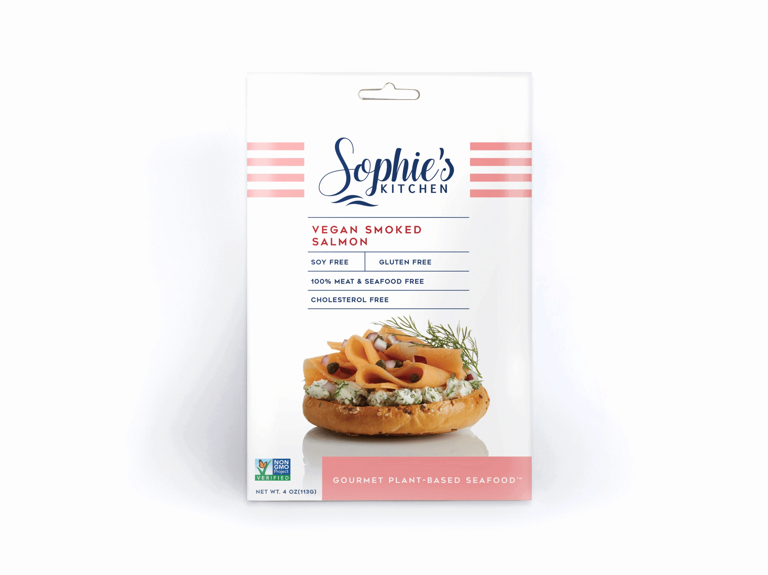
Figure 2: Vegan item of Sainsbury
(Source: Veganlifemag.com, 2021)
Sainsbury's has also been introducing a line of plant-based pizzas that are guaranteed to be a hit. Three vegetarian pizzas are also included in the Love Your Veg! pizza line, each of which counts as one of the 5 a day that is high in fiber as well as protein. Customers may pick from a variety of toppings, including spicy masala chickpeas and barbecued butternut along with charred broccoli (Sainsbury, 2020). With over 7 million vegans inside the UK and the exponential development of the vegetarian or vegan lifestyle, Rachael Matthews, product developer for Sainsbury's Plant-based, says that Britain has clearly got the appetite for meat substitutes at their mealtimes. According to Veganlifemag.com, (2021) their new line of plant-based goods offers creative and very delectable alternatives, ranging from delicious jackfruit quarter pounders to flaky fishless fillets, to make strict vegetarian cooking a breeze.

4. Product quality of such vegan items attract a huge number of customers
According to Mba Skool (2020), within its marketing mix product strategy, Sainsbury's offers a wide range of vegan foods to its consumers. It is responsible for creating new items and expanding the present product line, in addition to concentrating on innovation and quality control. Sainsbury's offers these meat-free foods in two formats: supermarkets and local convenience stores. These products are based on very creative ideas. Nowadays a huge number of individuals, especially aged people throughout the UK, prefer to take vegetarian items instead of animal protein. As these products are very suitable for those people. Soy, beans, mung beans, mushrooms, peas and corn gluten are now the most frequent plant-based meat replacements. According to Mba Skool (2020), these Plant-based non-veg alternatives are healthier than traditional meat because they are cholesterol-free and carry very low calories. They are created from plants as well as processed to feel, taste, and look like genuine meat. Coconut oil, as well as beet juices, are among the ingredients of plant-based non-veg alternatives.

5. The non-veg alternatives are very affordable in cost
Sainsbury's pricing plan is focused on giving consumers value for money, which ensures that the quality of products as well as services is maintained, resulting in customer engagement. It uses competitive pricing rather than price lowering because the latter merely delivers a short-term advantage in market dominance. Sainsbury's employs a pricing discrimination strategy that is tailored to the product's placement, resulting in a higher cost as it puts itself within the strong valuation. According to Mba Skool (2020), Sainsbury’s fixed possible lower cost of these vegetarian items which are alternatives of the meat and dairy products. These vegan items are comparatively lower in price than non-veg items. The taste of these vegetarian items is more similar to the non-veg items. As these items are purchasable for each lower to higher income family hence every individual can try it for eating as an alternative to animal protein. Those who cannot afford the non-veg items from this supermarket can purchase this vegetarian item from the store as well as through the online channel of Sainsbury. According to Mba Skool (2020), Sainsbury gives offers for their customers while they are purchasing such products from their stores or online platform. They give 20% off for their products.

6. Throughout the UK all stores of Sainsbury distributes such vegetarian items
There are 1411 grocery stores among them 813 convenience stores and the rest are supermarkets of Sainsbury’s located throughout the UK. Among them, most of the stores provide their services 24x7 every month and the rest are also providing their services till midnight. All of these stores provide vegan and alternative meat items. Hence, the customers can purchase their necessary vegan items from the convenience store or from the supermarket of Sainsbury. The organization also provides their services through their online delivery facilities (Smith, 2020). Customers who want to purchase materials from their homes purchase such vegan items by ordering their necessary items through using Sainsbury’s official website. As Sainsbury’s has numerous stores throughout the UK, customers from all corners of this nation have an opportunity to purchase their needed vegan items. There are a variety of vegan items provided by all of these stores hence customers can easily choose their preferable vegan items from those varieties of items (Judge, et al. 2021).

7. Promotional activities for these vegan items
Sainsbury's makes effective use of ATL as well as BTL promotional methods to attract customers and strengthen its brand. The company deals with celebrities to promote its items. The contract with celebrities like David Beckham for promoting their food items. The company uses social media marketing for their promotional activity (Osei-Kwasi, et al. 2021). As citizens of the UK recently use different social media platforms for their daily life communication. Hence, Sainsbury’s activities for promoting their vegan items offerings, categories, qualities through their channels. According to Mba Skool (2020), Sainsbury use’s Instagram profile for providing information about their vegan as well as alternative meat items for their potential customers. The company also takes the initiative of promoting through tv advertisements and also posters as well as leaflets.

8. Children to aged people all of the citizens eat such vegan items
According to Armstrong, et al. (2021), children need nutritious elements for their growth and development hence such food items can be used for children's growth. The vegan item has no side effects as it is created by using natural resources. Citizens who prefer to eat veg items, or the person who is known as vegetarian, would be the target audience of such vegan food items. According to Armstrong, et al. (2021), the person who is unable to digest dairy items, as well as non-veg or meat products, can try such alternative products. The aged people also can try these alternative food items as it is essential for fulfilling their regular nutritional supplements. These alternative meat items are beneficial to individuals' health and wellbeing.

9. Reason behind choosing these items
Substitute meats are increasing in popularity among consumers for a variety of reasons. Many of these are soy or gluten-based, and they are just as protein-dense as meat-based alternatives. As per Parra-Fernández, et al. (2020), when they have been part of the primary source of food in a number of UK nations, particularly in those with largely vegetarian cultures. Plant-based meats are purchased by the great majority of individuals for health reasons. A rising amount of evidence has connected red meat intake to diseases including cardiovascular disease, cancer, as well as diabetes in recent times. As per Gallagher, et al. (2020), it has been discovered that processed meat, in particular, is hazardous to human health. Ordinary individuals may reduce their weekly meat intake by introducing plant-based foods into their diet, increasing their general health and life. As per Gallagher, et al. (2020), as meat production leads to deforestation hence it hampers the environmental condition. Hence nowadays it is required to save our environment’s animal resources by using or adopting the vegan items provided by Sainsbury's which are alternatives to meat products or animal protein.

10. Conclusion
The marketing mix strategies and target audience or segmentation of any product launch is the most crucial step for any business success. Sainsbury’s also follows the basic strategies whenever they are focusing on lunch and provide their vegan or food items for vegetarians as well as others. As such items consist of nutritional elements, each and everybody can use this food product as an alternative to meat or dairy products.

Reference

Books and Journals
Armstrong, B., Reynolds, C., Martins, C.A., Frankowska, A., Levy, R.B., Rauber, F., Osei-Kwasi, H.A., Vega, M., Cediel, G., Schmidt, X. and Kluczkovski, A., 2021. Food insecurity, food waste, food behaviours and cooking confidence of UK citizens at the start of the COVID-19 lockdown. British Food Journal.
Gallagher, C.T., Hanley, P. and Lane, K.E., 2021. Pattern analysis of vegan eating reveals healthy and unhealthy patterns within the vegan diet. Public Health Nutrition, pp.1-11.
Judge, M., Fernando, J.W. and Begeny, C.T., 2021. Dietary behaviour as a form of collective action: A social identity model of vegan activism. Appetite, 168, p.105730.
Parra-Fernández, M.L., Manzaneque-Cañadillas, M., Onieva-Zafra, M.D., Fernández-Martínez, E., Fernández-Muñoz, J.J., Prado-Laguna, M.D.C. and Brytek-Matera, A., 2020. Pathological Preoccupation with Healthy Eating (Orthorexia Nervosa) in a Spanish Sample with Vegetarian, Vegan, and Non-Vegetarian Dietary Patterns. Nutrients, 12(12), p.3907.

Website
Green queen (2021) Sainsbury’s plant based pastries [online] Available from: https://www.greenqueen.com.hk/tag/sainsburys-plant-based-pastries/ [Accessed 15 November 2021]
Mba Skool (2020) Sainsbury’s Marketing Mix [online] Available from: https://www.mbaskool.com/marketing-mix/services/16809-sainsburys.html [Accessed 15 November 2021]
Sainsbury (2020) Sainsbury’s Grocery website [online] Available from: https://www.sainsburys.co.uk/shop/gb/groceries [Accessed 15 November 2021]
Smith, P. (2020) Marketing process for vegan foods [online] Available from: https://www.veganfoodandliving.com/vegan-business/marketing-a-vegan-brand-to-non-vegans/ [Accessed 15 November 2021]
Vegan Life Magazine. (2021). More products added to Sainsbury’s expansive vegan range | Vegan Life Magazine. [online] Available from: https://www.veganlifemag.com/more-products-added-to-sainsburys-expansive-vegan-range/ [Accessed 15 November 2021].

