LUX* RESORTS & HOTELS

LEADERSHIP IN HOSPITALITY
Certificate of Higher Education in Professional Practice

MODULE CODE: DSAW4077

MODULE TITLE: Preparing for work –based learning
STUDENT NUMBER: 1715706
NAME: KASSEEAH Mooneshwarnath Sharma

CONTENT

Reflective Essay (Page 2 – 6)

APPENDIX:
Annotated CV (Page 7 – 11)
Annotated Job Description (Page 12 – 14)
Personal Development Plan (Page 15)
Training Needs Analysis (Page 16)

REFLECTIVE ESSAY

REFLECTIVE ESSAY

Mooneshwarnath Sharma KASSEEAH
Reservations Manager
LUX* Le Morne
I joined the hospitality in 2004 as a Night Auditor for more than two years. I show all my interest and I climbed the first step to success in February 2007 from a night auditor to Receptionist. Being well motivated and ambitious I climbed the second step in May 2011 for the post of Front Office Supervisor. With all my hard work and motivation, that’s does not take me too long to achieve the position of the Assistant Front Office Manager. Recently (July 2018) I have been promoted to Reservations Manager of LUX* Le Morne for having all the skills of upselling and selling room nights.
I, Mooneshwarnath Sharma Kasseeah reservations manager of LUX* Le Morne thank the management for giving me the opportunity for my development in my career by the enrolment with the University of Wales. I had a one to one meeting with Mrs. Tessa which was very helpful and sharing the 360-Degree Survey Results feedback. I have completed the learning styles questionnaires of Vark, Honey and Mumford, from this exercise I realize that I am a Pragmatist. This exercise was very useful and as from now I know that how and what type of learning suits me. The learning styles that I would like to apply is the one of Kolb’s experiential learning style. Taking into account Kolb’s learning point, “assimilating”, I have understood the information and transform it into a logical format. I affirm that I am more interested in ideas and putting into practice these ideas. The next Kolb’s learning style is “Converging”, I can solve the issues at finding the practical uses for ideas and theories. I can solve problems and make decisions by finding solutions to questions and problems. Another Kolb’s learning style is “accommodating”, I am attracted to new experience and challenges and to make the planning. I will sometimes have the intention to rely on others for information than working on my SWOT analysis.
Reservation is a vital word in the world of hospitality. You need to make reservation wherever you go for holiday, meetings, conference, flights. In the field of hospitality, reservation of room which is the most important thing that we have. We would like to have proper information to spend a good and relaxing holiday to satisfy our family, wife, girlfriend or partner. There are many challenges nowadays in the market of reservation, such as online booking, travel agencies and trip advisor. A direct reservation is the best way you can plan your holiday; you will be in direct contact with the resort you want to book. A direct reservation allows you to have all the proper information and help you to make a better planning for your holiday. You will not have any bad surprise when you arrive to your hotel. However, the reservation manager and its team is the link between the guest and the resort. The reservation manager works closer to the Room Division Manager in most of the hotels. The reservation manager will be creating rate plans for the property in the collaboration with the Revenue and Pricing Manager to boost the occupancy and average room rate. The reservation manager will liaise with the room division manager to ensure that the daily is maximized. The room division manager will monitor the sales and the room availability. Depending the availability of the room and the occupancy the Reservation Manager decides to launch some offers to the residents. In some cases, we launch special promotion in the Reunion island market to boost the sales. The tracking and the occupancy together with the market also should be taken into consideration.
Nowadays stress is becoming a major issue in the world. This affects everyone with the rapid evolution and changes. There are many causes of stress, many things can trigger the stress reaction, including the dangers, threats, news, illness and a significant change in someone life. Stress is listed as one of the major flails of the 21st century. Its impact can be major and can incur major costs. It is proven that hotel employees tend to be more stressed than others. Stress leads to absenteeism. As from figures gathered from HR, several cases related to stress have been reported over the year, thus resulting in loss of man days every year. You will agree that the mind of a person who is stressed will most likely be absent minded, in deep thought, unhappy, sad and this will have an impact on the person’s work and personal life. Stress in the hotel industry is linked to workload, pressure and job dissatisfaction.
I need to work on the stress management as I have to cope with the workload and juggle with many tasks. Initially, there is a lot of demand from the guests for direct reservation with the hotel and at the same time I have to manage the team for a smooth-going operation. There are a lots of queries, such as room location, rates, size, twin bed, room categories, meal plan, offers and food preferences. Guests compare the prices to the ones of the agencies, online booking engines and direct booking via the hotel. The competition is very tough and we have to compete in order to run a good business. Being on a commission scheme, I need to generate sales throughout the month, in order to be able to reach a certain commission amount at the end of the month. There are many kinds of guests on the market with different types of requests and my job is to tailor-make their holiday and cater for their needs. The main purpose of the stay remains the main question for them. Also, what is included and what is not included is a big question in their mind. The Reservation Manager facilitates the task for the guest by providing them the right advice and help. For example, a honeymoon couple that wants to book a room, wants also to have more information about which room category or offer to take. The Reservation Manager acts as an important link to facilitate them with all these information, as well as to even organize surprises for their companions. There are many requests for food preferences, transfers, sight-seeing, room location on ground floor or first floor. The processing of the booking confirmation, the proposals and the team management. All this at times causes stress and impacts on my morale. To fight this stress, I will have coaching session with the gym/yoga instructor, as well as a one to one coaching with the Room Division Manager for a proper planning, to be able to juggle with many tasks, prioritize efficiently and handle my workload. This will also help me to have more time and be more productive. The more time I have, the more I can decide how to tackle the competitors. The Reservation Manager can delegate some task to a member of the front office team, like one person can be responsible for sending proposals and another to look after the confirmation letter. The team can have two persons for the processing of the booking and making follow up for the payment. One team member can follow for the transfer and liaise with the concierge for the excursions and planning the excursion program.

Finance is another important aspect in every business and mainly for the hospitality industry. The word finance which means money, cash, bank transactions, profits and loss. Budget, the direct connection in finance. Without a budget you cannot have the right track of the business. This manages the revenue and the expenses of the company. The finance department manages reports, financial statement, the preparation of accurate business forecast, the strategic billings and pricing, cost control, the capital expenditures, developing and financing strategies for the benefit of the company. The Reservation Manager work in accordance with the budgeted average room rate for the upselling of the available rooms in a profitable manner. The room rates are finalized by the Revenue and pricing manager and the Reservation Manager. The Reservation Manager and the team work towards the meeting of the budget every month. To be always on the right track and making the company the best profit making company, a good knowledge of finance is very important. I will have a weekly financial classroom learning with the financial controller and the accountant. This coaching will be very beneficial for me and this will help me to understand the finance aspect for the room revenue. The billing procedures can be controlled by one person and all payment for the room accommodations. The proper records for the room accommodation payment and the extras can be monitored for a long term follow up. After the follow up a package can be prepared and launch. This will keep the business in an updated track and money will be coming into the business.
Moreover, group reservations is a big sort of revenue making option in regards to individual reservation. To work with group reservation, the revenue is achieved more rapidly than one by one booking. Sometime the group booking is not an advantage as the revenue is not as beneficial as it should be, as the rate is lower than the single booking. For group reservations, the rates are low but the quantity of rooms are bigger. Looking for the big volume of rooms, in terms of some season we should take the groups to have a better revenue to meet our budget. The reservation manager must know the occupancy trend in accordance to the season, then group’s reservation and individual booking can be taken accordingly to manage the financial management. I will work with the Sales and Marketing manager to better understand the process of group reservation. A weekly coaching session for a duration of nine months will be organized. After nine months, I will be able to manage group reservation in the hotel directly. I will be fully able to block the rooms and work on block reservation. The rate grid, which is difficult for me to read now, after the coaching will look very familiar. The business will be more effective and beneficial. The group reservation booking process will be handled by me, as I will be more comfortable with the software. I will be able to process the rate and split the group booking on system. As part of the group booking process, there are major points which I need to work on and skills to acquire. New leads are a challenge for me. In terms of generating new leads, I will need to work more on getting new leads though various methods. At LUX* Le Morne the method we use to generate sales is by using an existing database, by contacting the previous guests to generate sales and so far it has been successful, however with fierce competition, we will need to find other leads and ways to be more efficient. LUX also uses its platform of ‘KOZE LUX’ (KOZE LUX is the online booking engine for resident guest only) to attract customers. The new trend these days is ‘roadshows’, maybe I could be part of the sales and marketing team to acquire the required skills and know how to target other markets. In the 21st century, social media is also booming. As a reservations manager I have not yet started making use of these tools to sell room nights and to attract customers.

Market analysis is also primarily important for my role. I need to understand more other segments of the market to develop more leads. The way I plan to learn more about market analysis is to spend time with the sales team based at LUX itself and the Mauritius hotel association to know better how to address the nationalities, language and country guests are coming from. I need to expand my skills and open up to new markets. New airlines, such as Turkish airline is coming to Mauritius as well as Russian airlines. I will need to be able to attract guests from these markets. New offers need to be created and interesting packages with excursions and tours to be introduced. This will help to have these guests from these markets.
Innovation is another important tool that makes the company differs from the others. Good creation is the better solution to meet the new requirements or existing market needs. There is no need for a company to be small or big, national or international chain, the call to action is the same. But, what does this mean, and what do businesses in the hospitality need to know to survive? We need to be different from the others, build a brand that our guest will like and have trust. The direct reservation or booking, help the company to avoid the “agents and agencies” for a better service, turnover, right and precise information before and after the stay. We at LUX* Resorts and Hotels, we treat our guest feedback as diamonds. We have to be on the same wavelength of our guest, we have to be accountable for the satisfaction of our guest, the profit increase and the works also to be done in a good and pleasant manner. Innovating in the digital age for the hospitality industry is about embracing a mindset that weaves together cutting-edge technology, marketing system, and consistent branding. It’s has about upgrading the old methods and more about integration and connectivity.
Finally, I will introduce two new packages in six months’ time for the reservation to meet the budget, organization of group booking and to facilitate individual reservation. This learning will help me to manage my stress and to juggle with many tasks. This distance learning with the University of Wales Trinity Saint David is very useful and is helping me a lot on my daily tasks, new challenges and the advancement in terms of bringing more room nights for LUX* Le Morne resort.

ANNOTATED CV

Mooneshwarnath Sharma KASSEEAH
Royal Road, Chamouny, Mauritius. 61301
00230 59191957
Moonesh.kasseeah@luxlemorne.com

PROFILE
I am currently Reservations Manager at LUX* Le Morne. I have three months experience as a Reservation Manager and was handling direct booking as from September 2014. I was Assistant Front Office Manager for the past four years. Three years in the position of Night Auditor, four years as Receptionist and Front Office Supervisor for three years.

EXPERIENCE:
- LUX* Resorts and Hotels Group (LUX* Le Morne), June 2004 to now.
Reservations Manager, (July 2018 to Now)
Sales techniques- Working in collaboration with the sales and marketing Team for developing sales plans
Budget management- To handle the Reservation department to meet the budget
Customer service- Make proper follow up for potential guests
Generating revenue- Keeping records of revenue variances, and work on plans to maximize revenue.
Accounts development- helping the sales consultant in keeping good account
New leads- Seek new market to increase revenue.
Market analysis- Understand the competition on the sales market and search for new openings
Team development- develop the Team to ensure good Customer service.
Job shadowing- Work closely in collaboration with the central reservations department to have more experience
Cross exposure- Have had 32 hours of cross exposure to the new hotel software for sales management and the pricing unit/accounts

Assistant Front Office Manager, (February 2014 – June 2018)
Customer service- Guest Survey (Feedback from the guest, Trip Advisor and Facebook Review).
Financial Performance- (Up selling of room categories, Room Revenue, Meal plan upselling).
Taking Initiative, Solving problems, To train the staff, cross exposure
Staff management-Managing and motivating the Front Office team in order to provide a LUX* Shinning Service.
Guest relations- Welcoming the guests and repeaters through his/her friendly manner and develop high quality relationships with guests throughout their stay.
Guest complaints- Handle the guest complaints or other issues that cannot be settled directly by team members and provides a fast solution.
Arrival and departure- Supervising the guest arrivals and departures with the front office team and duty managers.
Pre arrival allocation- Checking of the arrival list for all arrivals, VIP, Repeaters for their preferences, specials and requirements.
Recruitment- Interview for best candidates for the available job.
Team training- Training for all the new comers and update the team for the changes.
Grooming- Ensure the team grooming as according to the standard (uniforms, personal hygiene etc.), and they are punctual.
Hygiene- To check and ensure that the front office and back office, concierge and porter’s desk remains clean and tidy every time.
Product knowledge and training- Ensuring all the team members have current knowledge of hotel products and events.

Achievement from Assistant Front Office Manager to Reservations Manager.

Front Office Supervisor, (May 2011 – January 2014)
Customer service- Knowing and delivering outstanding customer service.
Grooming, attitude and behavior- Maintaining a friendly and team member always with a smile and courteous all the times.
Guest relations- Answer to telephone and in-person inquiries regarding reservations, hotel information and guest requirement.
Upselling- Use the best-selling techniques to sell rooms and meal plan, increasing the occupancy and revenue.
Staff rotation- Ensure the daily shift to ensure all team members adhere to standard operating procedures.
Staff supervision- To resolve problems, train the staff and coaching the staff for the front desk.
Complaint resolution- Solving the guest issues, complaints, problems in a quick, efficient manner to maintain a high level of good quality of service.
Company policy- Respect the company policy, for the credit limit to avoid surprises upon check out.
Reservation- Allocation of room in regards to the guest preferences and requests.
Inter team relationship- Keep good relationships and liaise with all other department's mainly the reservations, food and beverages and housekeeping etc.
Billing- Docket and billing check one day prior to departure.
Management of team and of operations- Take the entire responsibility of the Front Office in the absence of the Front office manager
Lead by example- Being a role model, sharing your experience and continually inspiring the front office team.

Achievement from Front Office Supervisor to Assistant Front Office Manager.

Receptionist, (February 2007 – April 2011)
Customer service- Greeting and welcoming the guests as soon as they arrive at the resort
Guest relations- Conduct visit which is plan or unexpected
Reception cover- Receiving and transferring of internal and external calls
Guest service- To provide proper information to the guest and outsiders
Supplies order- Make requisition and balancing of stock
Plannification- Updating the calendars and the meeting schedule.
Conciergerie- Organizing the transfers, excursions and activities.
Cost management- Keeping and updating records of front office expenses and costs

Achievement from Receptionist to Front Office Supervisor.

Night Auditor, (October 2004 – January 2007)

Guest relations- Greeting the guests upon arrival, assist them for the check in process.
Auditing- Balancing and auditing all the transaction carried throughout the day by the reception, food and beverages outlets and shop.
Guest service- Manage early departures and guest wake up call.
Plannification and verification-Verification of the end of day work which has been performed by all the departments.
Customer care and reception cover- Answering telephone calls and handle guest for their request.
Running night audit- Running of the night audit after all the verifications of the transactions.
Pre check out verification- Cross check all the guest billing for next day checkouts.
Verification of reception float- Balancing the cash float and the credit cards and keep proper records.
Achievement from Night Auditor to Receptionist.

- Shibani Textiles Limited

Storekeeper

Stock control- Responsible for receiving, arranging, and presentation of materials.
Record- Recording, issuing and purchasing requisition follow up.
Supplier contact- Correspondence with supplies via email, phone and fax. Sourcing for new suppliers and samples for new development.
Delivery- Ensuring the record are kept accordingly and to ensure the deliveries schedule are respected.

- Novel Garments (MTS) Limited

Marker room clerk (February 2000-March 2004)

Planning- To update the production schedule, liaise with the cutting and store department.
Record keeping- Keep proper records of new production orders with merchandisers issue to marker room.
Productivity- Check mail and to set the order that is in priority and to prepare the cut plan of the markers to achieve maximum efficiency.
Communication- To inform the washing and finishing department accordingly.

- Jaddoo & Company Limited

Shop Assistant Manager (October 1997 – January 2000)

Implementation- Responsible to implement new displays for the shop, so as to promote the turnover of the company.
Analysis- Make the records of the sales and balance the account at the end of the day.

EDUCATION:
Cambridge General School Certificate of Education “O” Level
London General Certificate of Education “O” Level
Leadership Training for Managers (Dale Carnegie Training)

SKILLS:
Computer proficiency programme.
OTHER ACHIEVEMENT:
Certificate of achievement in Basic and Advance Electronics.
Chinese Course Beginner Level (Formaclic).
Call and Analysis Management training (LUX* Training Academy).
Emergency and Domestic First Aid (Fellowship / IAPS)
Certificat de Reconnaissance (VATEL)
Leadership 2.0 – Redefining Leadership (Whitefield Business School, Mr. Robin Sharma)

LANGUAGES:
English & French
Reading-Perfect command
Speaking-Perfect command
Writing-Perfect command

ANNOTATED JOB DESCRIPTION

RESERVATIONS MANAGER

Job Description: Reservations Manager
Accountable to: Room Division Manager
Responsible for: To improve the revenue and ensure that all the booking is well processed. Follow up for the proposal / confirmation and act as a direct link between the guest and the resort. Keeping all the records and manage all direct bookings to ensure all the rooms are sold accordingly in respect with the occupancy and forecast.
Base of work: The base of work will be the LUX* Le Morne hotel located in Le Morne, south west of Mauritius. You will have to build strong relationship with guest, agents and team members in order to gain full understanding of their needs to promote sales.

VISION AND VALUES

Vision
Making LUX* Le Morne the best property in generating the best sales and occupancy in the LUX* group.

Values
Respect – We respect our guest, team member, superiors and have a no blame culture.
Innovation – Create new ideas, packages and offers.
High standards – We are always ready to make each moment matter for our guest and in delivering the right service at the right time.
Building relationship – Loyalty program. (Special amenities, discount, special rate)

OVERALL PURPOSE OF THE ROLE
The purpose of this role is to assist LUX* Le Morne in the delivery of its vision and values through the achievement of being the best hotel in the group. This will be by offering a unique and exceptional service. I will help the team in exceeding the guest expectations and this will be the main factor for our guest to return in our resort for their next stay.

RESPONSIBILITIES
Work with the Sales and Marketing teams to develop a strategic sales plan. Creating a proactive and dynamic approach to secure every single reservation and upselling. Seeking for opportunities, actively, to increase revenue.

NEW DEVELOPMENTS
Cross exposure training with the Central Reservation Office and Revenue department.
Create new packages to meet guest request or exceed their expectation.
Understand the proper functions of the Online booking engine.
Manage overbookings.

RESERVATIONS IMPROVEMENT
To ensure all the request are responded within 12 hours.
Focus on more direct booking than online and tour operators.
To organize the whole stay of the guest and create a bond before the arrival.

CONTINUOUS IMPROVEMENT
Accept and open to new ways of doing things by creating new offers to resist against competitors.
Seeking news ways to improve the reservation technics.
Good customer service and relationship.
Flexible to changes and exceptions on certain aspects.

CUSTOMER SERVICE
Good relationship with the guest before, during and after their stay.
Respond to every single request as quick as possible.
Present the unique selling points and reasons to go to the guest, this attract them to confirm their reservation.
Promote and maintain high standards of customer service.

TRAINING & DEVELOPMENT
Attend Front Office and Central Reservation meetings and other Revenue meeting as required
Cross exposure with Central Reservation Office and Revenue for better understanding of the forecast.
On the job training, professional studies and distance learning styles are recognized and taken into account.
EQUAL OPPORTUNITIES
To treat everyone in a fair and non-discriminatory way.
ORGANIGRAM
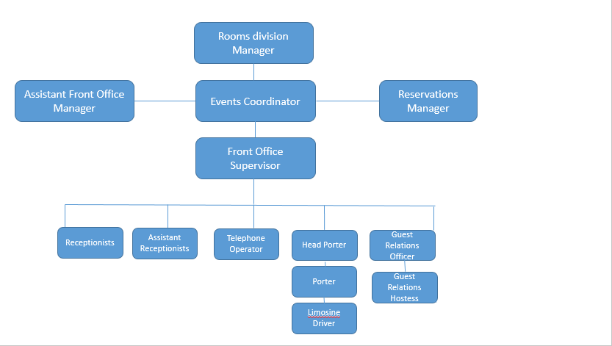

PERSONAL DEVELOPMENT PLAN

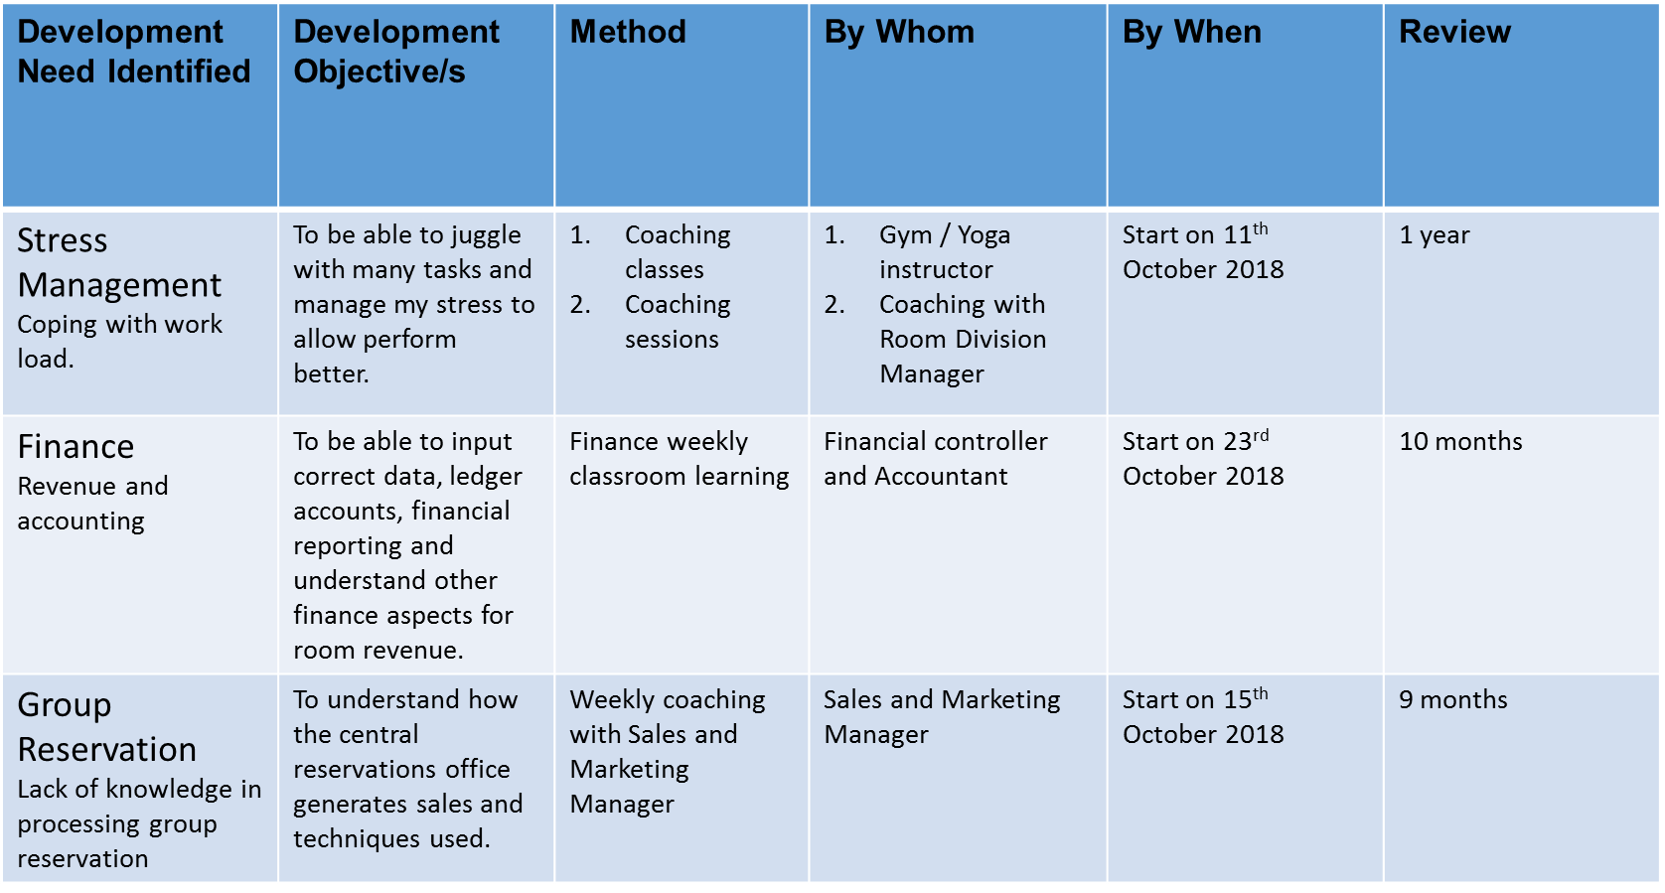
Personal Development Plan

TRAINING NEEDS ANALYSIS

SWOT ANALYSIS
STRENGHT | WEAKNESS
-Guest services (Assisting the guest before arrival, during stay and after check out)  -Promoting sales and upselling (Make extra revenue by selling high categories of room and meal plans)  -Handling guest complaints (Help in solving the issues of the guest)  -Handling overbooking (To tackle the overbooking and relocate guest from one resort to another)  -Individual Reservations (To handle direct individual booking)  -Team management (To manage the team in a productive way ) | -Stress management (coping with load of work)  -Revenue and accounting (understand room revenue)  -Handling group reservations (to handle group booking and to process on system)
OPPORTUNITY | THREATS
-Training with Central Reservation Office (Reservation procedures and rates)  -Cross Exposure in other departments (To know the process of every department)  -Internship in another group & hotel visit (To experience new ideas)  -Distance learning (Help to motivate and learn new techniques to improve ourselves)  -Unique selling points (To know the unique selling points for more upselling) | -Agent and Tour operators (They provide Flight and Insurance facilities)  -Online booking on other search engines (Rates comparisons)  -Competition in hospitality (Offers and added values for guest)  -Reviews (Trip Advisor reviews)  -Social Media (Facebook and chats)

