A portfolio which presents evidence of the way in which you will have developed your Welsh Language skills during the year.

Welsh Language sessions
For this section of the portfolio, I aim to demonstrate my engagement within learning Welsh language through lessons provided by the University. I attended six lessons based in University, and two virtual lessons provided online during the virus pandemic. These lessons helped me to enhance my Welsh skills and I have learnt some important skills and techniques in Welsh to use in the classroom, such as, how to use a language mat to drive Welsh discussion and learning to pronounce traditional numbers which helps me to remember how to write the date in Welsh. Evidence of continuing learning online can be seen below where I emailed my notes and activities to my Welsh lecturer Nia Evans, who kindly made some corrections and praised me for my efforts.
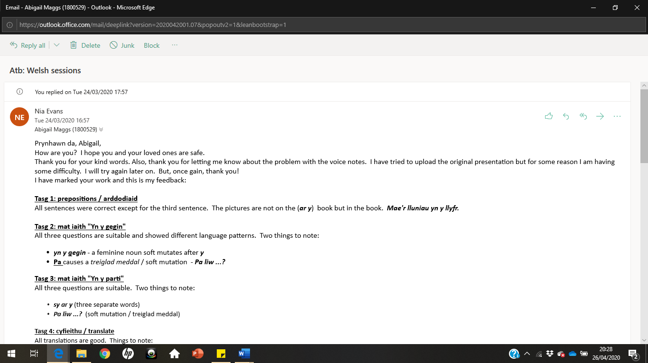
Evidence of online learning (1)

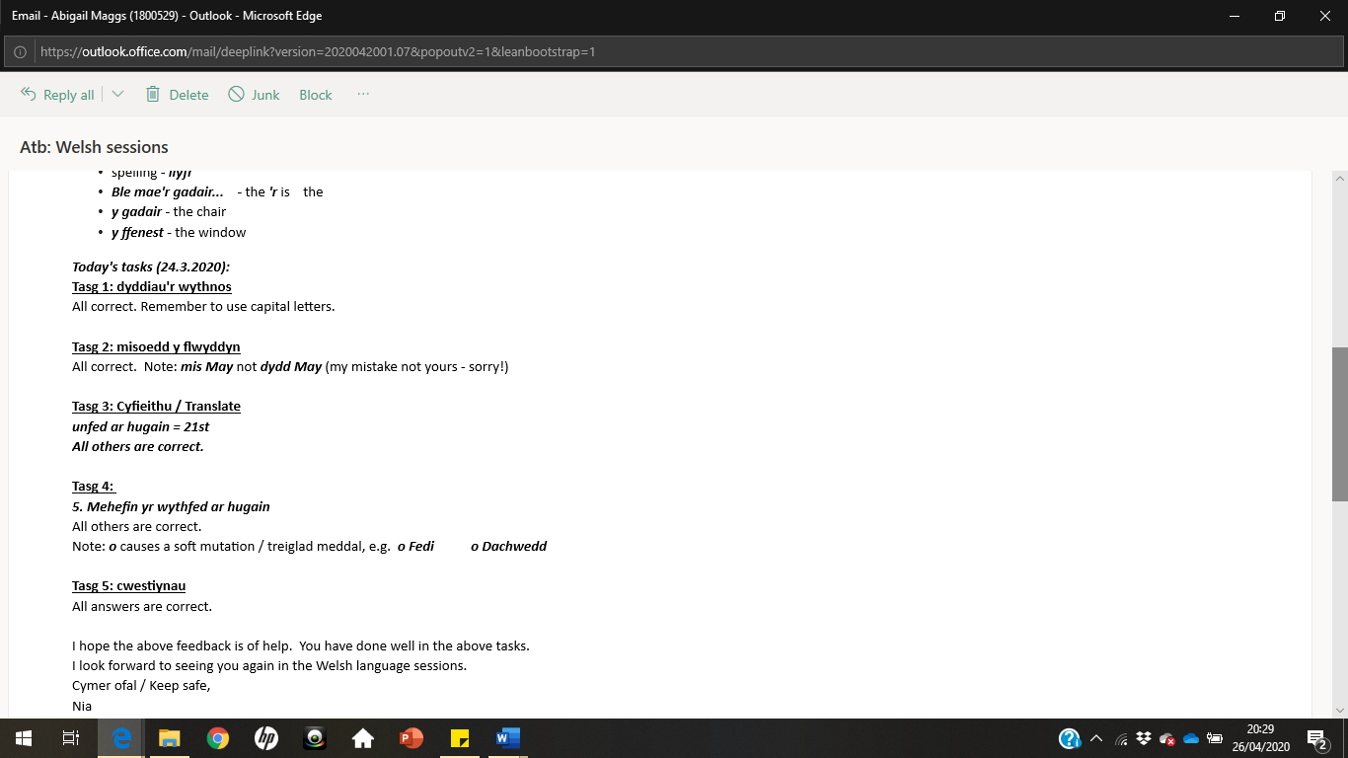
Evidence of online learning (2)

Incidental Welsh planning sheet
During my first week of Professional Teaching Experience (PTE) 2, I was assigned the personal target to include more incidental Welsh within my lessons. To make sure I was including more incidental Welsh, I created a Promoting Welsh planning sheet which listed the incidental Welsh that I had planned to implement every week with a checklist to assess and encourage my performance. I made sure to check this before every lesson and therefore was aware of my level of Welsh being used in the classroom. Evidence of this planning sheet can be seen here: https://uowtsd-my.sharepoint.com/:w:/g/personal/1800529_student_uwtsd_ac_uk/EXG5KG6yX2FIol_c8WTlyfkB5FoAyfZo-yHrD578IGeBcg?e=c9QEB6

Evidence based on one Welsh lesson (6.2.20)

To further evidence my Welsh language development, I have recorded a short video clip on a Welsh lesson delivered during PTE 2. This section of the portfolio includes a lesson plan, a rationale, and a self-evaluation along with appendices of the worksheet assigned and evidence of correction of learner’s work.

Hyperlink to video: https://uowtsd-my.sharepoint.com/:v:/g/personal/1800529_student_uwtsd_ac_uk/ESZcrvtlq4lFmfEV9gvxORIBCD7IS2hZhD2A4nYVps_5Aw?e=AriNjS

Lesson plan:
Student-teacher | Abigail Maggs | Class: | Year 3 (26)
AoLE or Subject | Welsh | Date: | 6.2.20
Lesson Focus: | Emosiwn a Teimladau- Pam
Meaningful links to Curriculum | Welsh Second Language Programme of Study (2016)  Speaking  - Explain information and ideas using relevant vocabulary  - Organise what they should say so that listeners can understand  - Speak clearly varying expression to help listeners  - Contribute to group discussion, sharing ideas and information  - Use talk purposefully to complete a task in large numbers.  Reading  - Use visual clues, e.g. illustration, photographs, diagrams and charts, to enhance understanding.  Writing  - Include relevant details, information or observations in their writing.  - Use connectives for causation and consequence, e.g. achos
Meaningful links to:  Cross Curricular Responsibilities | Literacy (LNF)  - Welsh-medium statement: use some mutations that have been practised orally, e.g. y bêl, fy mag, i'r dref.
Personal Targets (Linked to QTS and identified in weekly review)
Implement an AfL strategy during a lesson to recognise which students need more support and support these until the end of the lesson.
Links to QTS: The range of purposes and practises for assessment is understood and articulated.

Learning Objectives (focus on Learning- use accessible vocabulary):
The pupils will learn to: Describe how we are feeling and why in Welsh.

Success Criteria (clearly linked to each Learning Objective and related to the process and/or product of learning) | Assessment of Pupils’ Learning  Evidence  (What have the learners to say/write/do/produce – to demonstrate learning)
I must explain how I am feeling in Welsh.  I should extend my answers where possible.  I could check the Welsh Vocab wall for help. | I will know if the children have understood the lesson focus if they can confidently complete the activity worksheet and if they label their understanding as green/yellow on the AfL RAG rating system.

Time | Activities/Methodology/Key Concepts  (Teacher’s Role – including key teaching points, differentiation strategies and key questions) | Pupil Tasks  (Pupils’ role –including differentiation, engagement in formative assessment and homework) | Resources  (Including Health and Safety requirement)
Opening phase (with links to prior learning) | *Children sat on carpet.  Explain to children that today we are improving our Welsh skills and aim to learn a new skill.  Ask children: Beth ydy emowsiwn?  Beth ydy teimladau?  RECAP: Sut wyt ti’n teimlo? Reveal to the children all the different emotions, use “repeat after me”.  Once the children are used to them, explain that today we are expanding our sentences by explaining why.  Remind children about using achos to extend our answers and reveal new sentence pattern.  Dw i’n hapus achos dw i mynd i’r sinema  Go through possible answers. Ask random children, | Children recap prior learning.  Children practise the emotions in Welsh by drilling and using facial expressions if they wanted to. | PowerPoint
Teaching & Core Learning | Activity sheet is a table labelled “Enw”, “Sut wyt ti’n Teimlo?” and “Pam?”. The children are to go around the class and fill out the table listening to each other and communicating only in Welsh. | There is no differentiation for this task. Children are not to ask children on their table they are to move around the classroom.  *AfL check mid-lesson.  GWYRDD (Dwi’n hyderus)  OREN (Dwi’n hanner a hanner)  COCH (Dw i ddim yn siwr)  Ask children to put their initials on the colour (lliw) that best represents their understanding of today’s lesson. | Activity worksheet (See Appendix 1)  AfL scale
Plenary | Children play a game of Bang bang. Divide the class into 2 teams- each team needs a team name.  One opponent from each team plays for a point for their team, if they can say the sentence in Welsh.  E.g. I am happy because I am going to the shop. | Children compete for a point for their team by shouting out the called sentence followed by “BANG BANG”. | Whiteboard  Classroom split into 2 teams.

Rationale
The Welsh lesson that was delivered follows the Year Three Welsh topic “Fi a fy ffrindiau”. It is based on ‘Cam 2’ where children are expected to expand on their answers when asked “Sut wyt ti’n teimlo?” by explaining why and exercising ‘achos’, for example “Dw i’n dda iawn diolch achos dw i’n mynd i’r parc”.

With reference to the new curriculum, the children will be making progress in their ability to “explain information and ideas by using relevant vocabulary” and “listen carefully and make connections between what they are learning and what they already know” (Welsh Government, 2015, p.4). By introducing a new sentence pattern allowing them to explain why and expand on previous Welsh sentence patterns, can help make connections between their prior and current knowledge. This constructivist approach is supported by Piaget as he put forward the idea that “knowledge is constructed from the learner’s previous knowledge, regardless of how one is taught” (How children learn, 2014, p.47)

The worksheet for the lesson is quite simple so that the children can become comfortable with speaking and writing the new sentence pattern. The task is to be completed with other children in the class by noting down their name, how they’re feeling and why (See Appendix 1). The new sentence pattern and options were also kept on the classroom whiteboard during the lesson so that the children can use it to help them, along with the classroom Welsh wall. This addresses the skill to be able to “explain information and ideas using supportive resources” (Welsh Government, 2016, p.3).

According to the Welsh theme that the Year Three class are working through, the next steps (Cam 3) is to expand the sentences further by describing when and with who, using “gyda” and “am”.

Self- Evaluation

For this section of the portfolio, I aim to reflect and discuss my feelings on both my performance as a teacher developing the learners Welsh through the attached lesson as well as explaining what I have done to develop my own Welsh language skills. Reflective practise is vital within the teaching industry. This is evident within the Qualified Teacher Status (QTS) standards under Professional Learning where teachers are expected to take responsibility for their continuing professional development by reflecting on their practise (Welsh Government, 2020). I am going to be following the Assistant Reflective Conclusion (ARC) model of reflection.

Feelings

I felt confident with my level of Welsh before PTE due to my efforts in continually enhancing my Welsh language skills by seeking help and advice from Welsh university lecturers. These lessons gave me ideas of what sort of activities I could include in my planned Welsh lessons and how best I could develop the children’s Welsh skills.

I was nervous when initially set with the task of delivering a new sentence pattern in Welsh. This was because I had not taught a Welsh lesson in my Year Three class prior to this and I was unsure of the class’s Welsh capability.

I wanted to make sure that the lesson was set out effectively including a starter, main activity and plenary so that the children could enhance their Welsh skills in different ways. My weekly personal target was “to implement an AfL strategy during a lesson to recognise which students need more support” (See lesson plan). This was addressed by demonstrating traffic lights which included the Welsh phrases “Dw i’n hyderus” (green), “Dw i hanner a hanner” (amber) and “Dw i ddim yn siwr” (red) where the children were expected to write their names on the colour representing their understanding of the lesson. Overall, I am happy with how the lesson went and believe that the children successfully enhanced their Welsh skills.

Remember and Understand

An aspect of the lesson that I think drove the overall learning was that it was a practical lesson. During the introduction, the children got to stand up and sing Head, Shoulders, Knees and Toes. Jernigan (2015) describes how singing songs can increase the level of learning and progression in a language due to memorable rhythm and rhyming that helps you remember pronunciation and vocabulary. The main activity itself was also a move around activity where the children could interact with other children in the classroom rather than just with those on their table. Choosing to learn cooperatively links to Vygotsky’s ZPD theory where he states that children learn best with a more knowledgeable other (How Children Learn 2014). Therefore, tracking what a child can do within a social setting will help both the children and the teacher to distinguish what they could and could not do if they were to work individually.

Another aspect of the lesson that I think went well was the level of contribution. As you can see in the video, a lot of the children are constantly contributing to group discussion and seem eager to express their views in Welsh. This shows that the children are engaged and may be enjoying the lesson.

However, after reflecting on my lesson and watching back the video clip, it became clear that the same children are consistently putting their hands up and as a result I am choosing the same children to answer a question. This disappointing element was also evident from the teacher who was observing the lesson (See appendix 3). Wiliam (2011) states that when carrying out this error, we are in danger of making assessment need decisions based on the responses of a few confident children.

Timing was also an issue. After marking the produced work (See Appendix 3) it is clear that the children did not interact nor ask as many questions with each other as I had expected. This was disappointing as I had left enough room on the worksheet for the responses of nine children.

Evaluate and Analyse

Before delivering the lesson, I practised the PowerPoint presentation at home and carefully thought of incidental Welsh that I could use during the lesson. In preparation and throughout PTE, I read the book ‘Developing Incidental Welsh in primary schools (Welsh Joint Education Committee, 1998) to help improve my Welsh pronunciation and to add more key vocabulary into my lesson plan. In addition to this, I also filled out a ‘Promoting Welsh planning sheet’ given by the University every week where I increased the amount of incidental Welsh I would plan to use in the upcoming weeks. I think that I was prepared enough as I did not struggle for conversation at any point during the lesson.

The lesson helped me to develop my confidence skills, especially being a second-language Welsh practitioner. I felt pressured to make sure that I pronounced everything correctly and most importantly, that the children understood and learnt something new. As a teacher and role model, it was important for me to practise my Welsh pronunciation skills so that I was clear in delivering the lesson to the children. I often do this by having regular conversations in Welsh at home with my father who is fluent Welsh speaking and by making use of the app ‘DUOLINGO’ which allows me to listen and record Welsh words. After delivering this lesson and making efforts to improve my Welsh skills, I feel more confident now to deliver new Welsh patterns and sentences to children.

To ensure effective teaching and learning in the future, I will make sure to plan Welsh lessons to be both fun and practical. From the attached lesson, I think that the children enjoyed walking around the classroom rather than the traditional sat at desk learning.

Furthermore, I think that drilling the emotions during the introduction is an effective way of teaching and activates the children’s prior learning while learning new things. This behaviourist approach links to Pavlov’s theory of classical conditioning which has been proved to be a “successful treatment in modifying behaviours” (Pound, 2014).

Conclusions and Actions

To ensure that all children contribute in my lessons, I will adapt a ‘No hands up’ approach. This AfL strategy allows the teacher to randomly select a child in the class to answer a question. The teacher observing my lesson suggested in my learning journal that I could use lollipop sticks to tackle this issue (See appendix 3). By doing this, learners are therefore expected to contribute, and all answers are valued whether right or wrong. Wiliam describes how “when teachers allow students to participate or not, they are actually making the achievement gap worse” (Williams, 2011, p.31). This is visible within the video during the introduction as there are children sat at the back on the carpet, possibly avoiding contribution. The randomiser tool could have been used to its advantage here by involving these children and also allowing me to assess their understanding.

In relation to timing of the lesson, I could have differentiated the activity for the lower ability, however this would have been difficult as I was not sure on the children’s Welsh capability. Despite orally modelling how to complete the questions during the introduction, I could have also written out a model answer at the top to give the lower ability a visual example.

Both summative assessments from each phase assessed my Welsh input during PTE as “on track”. With one teacher noting how my Welsh language had ‘improved with confidence’ during my time in Year Three and that I made a conscious effort to use incidental Welsh every day along with the target to continue using Welsh more consistently in lessons. I plan to tackle this by including bilingual PowerPoints and worksheets within all my lessons, and if possible, addressing key vocabulary to the class theme in Welsh.

A further idea proposed by one of my Welsh lecturers is to have a ‘Welsh box’. This Welsh box would be decorated and include physical objects, pictures and writing that can promote Welsh language development for myself and the children. Examples of these may include stickers of the days of the week and months of the year, weather symbols, ‘emojis’ to express how we are feeling and quick-fire questions that could be used during Helpwr Heddiw sessions. I like this idea of a daily Welsh box and plan to implement this during PTE 3.

The ARC reflection leaves me with a transformed experience. Having reflected on my experience and efforts of my Welsh language development, I am aware of the things that I need to do to further develop my Welsh language skills in preparation for PTE 3.

Reference List
Jernigan, C., 2015. Family Language Learning: Learn Another Language, Raise Bilingual Children. Multilingual Matters.

Pound, L. (2014). How Children Learn - Educational Theories and Approaches. 2nd ed. United Kingdom: Practical Pre-School Books

Welsh Government (2015) Programme of Study – Welsh Second Language, Key Stages 2-3.

Welsh Government (2017) Professional Standards for Teaching and Leadership, Cardiff: WG. Available at: https://learning.gov.wales/docs/learningwales/publications/170901-professional-standards-for-teachingand-leadership-en.pdf

Wiliam, D (2011) Embedded Formative Assessment: (Strategies for Classroom Assessment That Drives Student Engagement and Learning), Solution Tree, 2nd Edition, Bloomington, Indiana.
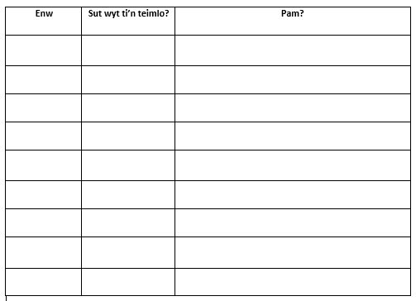
Appendix 1
Appendix 2- Learning journal 6.2.20
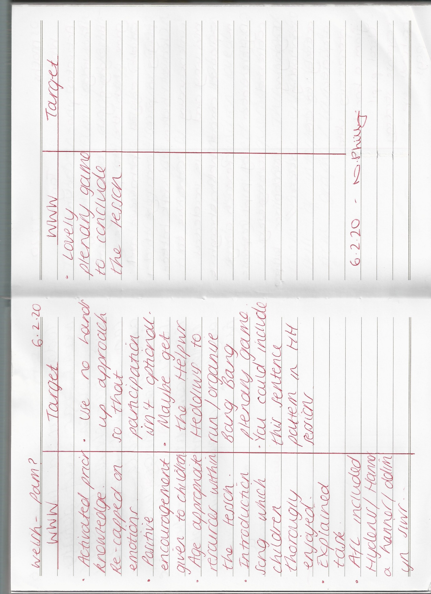

Appendix 3- Evidence of correction of learner’s work.
(Higher ability)
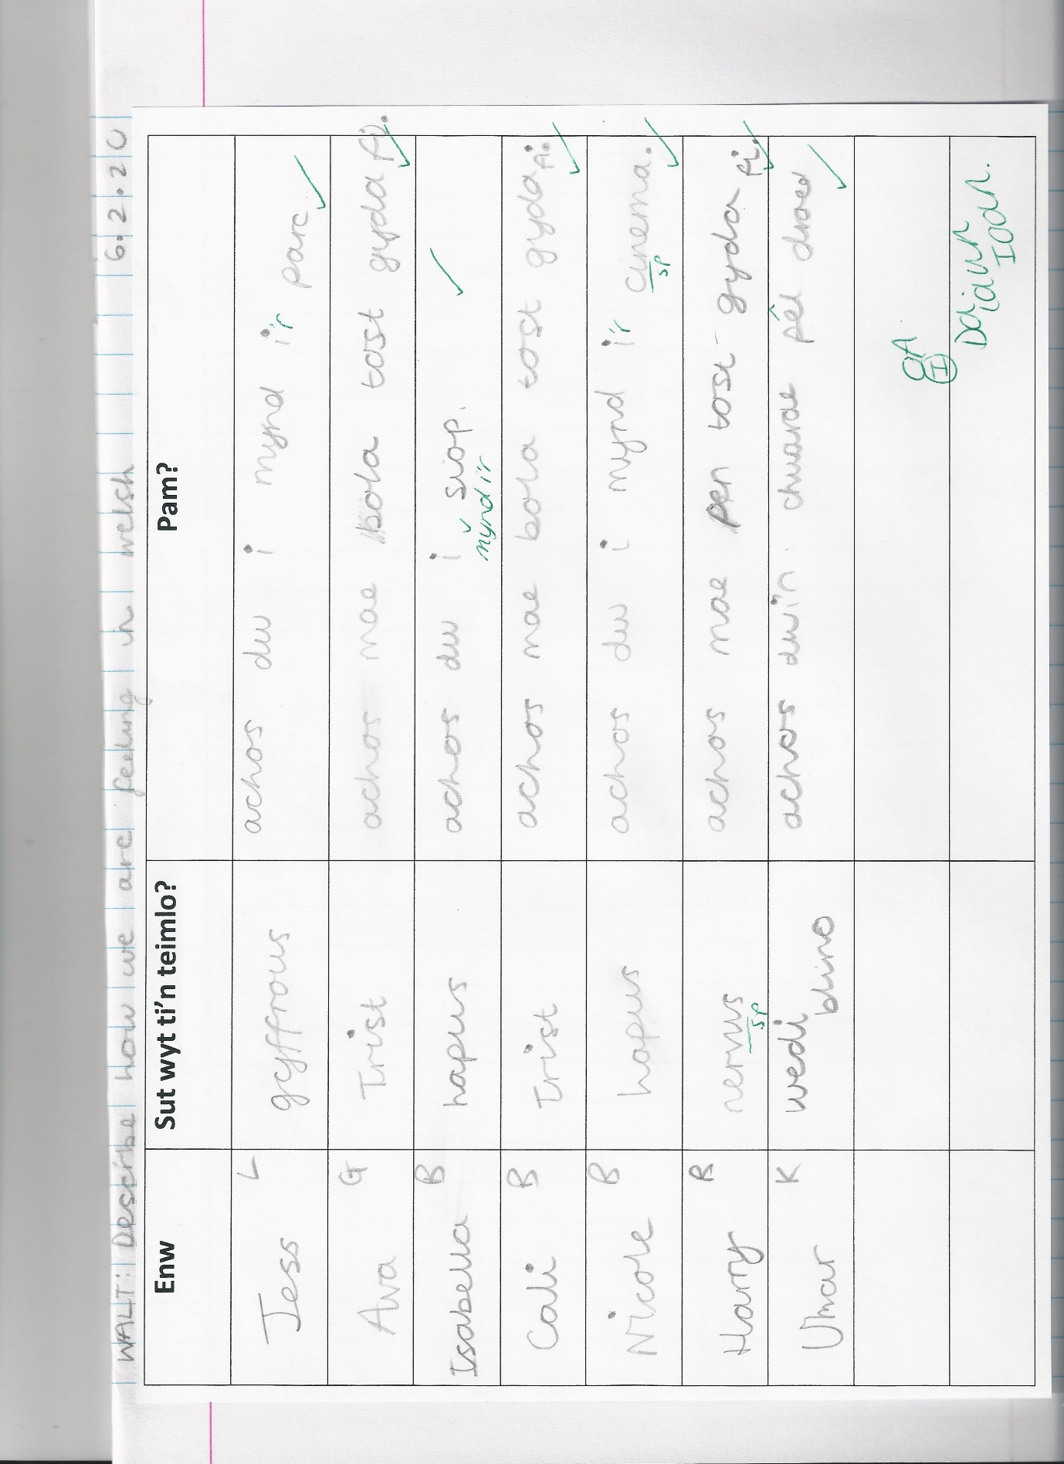

(Average ability)
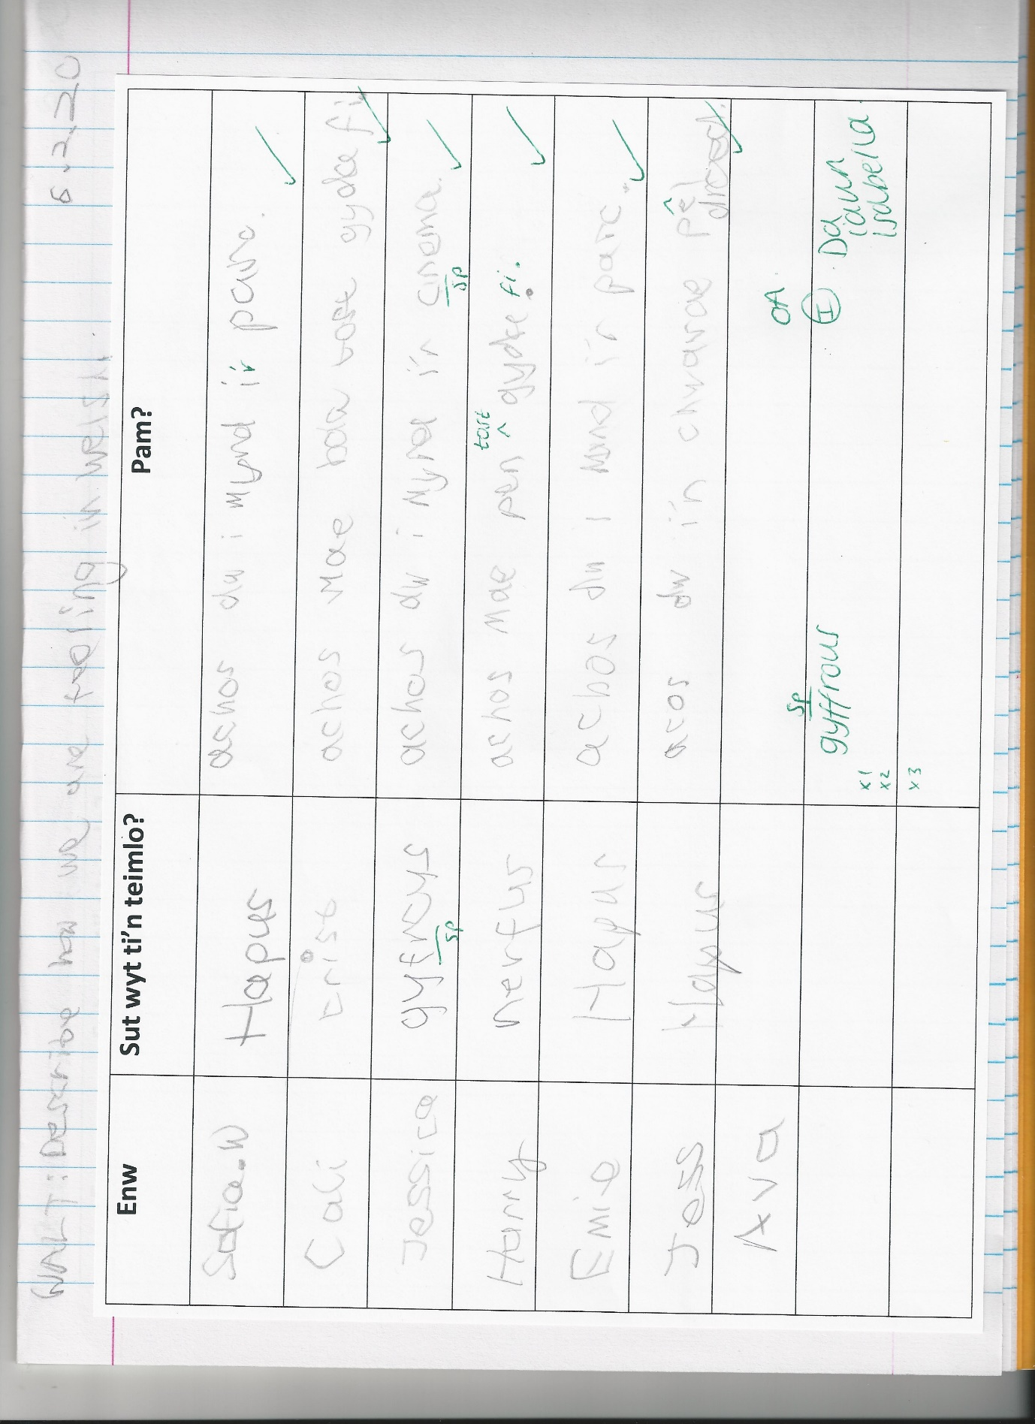

(Lower ability)


