

Nicola Louise Bragg – 1910223

BA Business and Management

Lecturer: Glenn Behenna

BMSP:5002 - The Inter-Cultural Workplace

The Cultural Context and Broader Environment, How External and Internal Factors Impact Business in Concern of Morrisons PLC

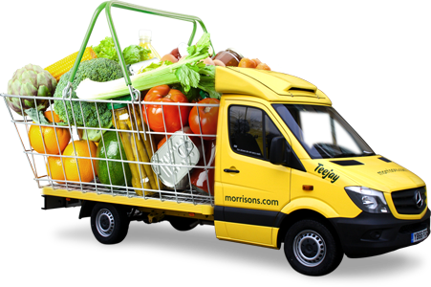


Contents
- Executive Summary
- Introduction
- Organisational Context
- Stakeholders
- Analysis
- SWOT
- Morrisons SWOT Analysis
- PESTLE
- Morrisons PESTLE Analysis
- Organisational Culture
- Human Resource Management
- Conclusion
- Recommendations
- References

Executive Summary
Business is a rollercoaster it flows in different ways and is impacted by internal/external environments as well as influence from culture. Within this report Morrions with be investigated and analyzed to find its place in the current market. To discover whether they fulfill corporate promise. Finding out what Morrisons is really about. Ultimately compared and contrasted to theorists. Summarising to produce several recommandations of improvement.
Introduction
The main purpose of this report is to critically asses the culture context and the wider business environment of Morrisons. The company will be deeply investigated, to obtain organisational context. A thorough analysis will be performed to identify internal and external factors influencing the way of which professionals work. In addition Organisational Culture and Human Resource Management will be measured to attain true values/intentions. All sectors will be supported with relevant facts reported by Morrisons, linked with academic literature. Thus summerization and recommendations.
Organisational Context
Morrisons provides service. They specialize in: retail, food on/offline, manufacturing, logistics, marketing, buying, finance, IT, Engineering, FMCG, human resources, and fresh produce. Have their own manufacturing facilities with more trained employees than any other supermarket which gives close control over food standards. And a online delivery service. Founded in 1899 by William Morrison. Sir Ken Morrison then took over the business from his father, aged twenty-one. 1958 first shop opened in Bradford; three checkouts, self service options and prices on products. The first supermarket opened in 1961 offering fresh fruit, vegetables and met along with free parking. 1967 becomes a public company. 1980 first production factory was built for fresh foods. Distribution centre was established in 1988. 2014 online shopping is developed. 2016 Awarded Retailers of The Year. And employ over 110,000 people in 500 stores around the UK including one in Hong Kong. Contain two websites one for corporate information and one for consumer shopping. (LinkedIn, 2021, Morrisons Corporate, 2021).
Annual Report and Financal Statement (2014) Corporate (2021) Show Morrisons was/and still is the worlds fourth largest group with 11.8 million people passing through, 59% of fresh food is produced by themselves. Their performance: £1,086 million in capital expenditure and ivestments, £2,817 million in closing net debt. 25.2p in underlying earnings per share and 13p full year dividend. Morrisons core convictions during this period were “Value is forever, Food focused not generalist, Experiential over purely functional, Skills not just drills, General merchandise – clicks not bricks and Multi-format and Multi-channel.”
Presently 110,000 staff still serve over 11 million people each week. Net debt £2,458 million. Full year dividend 8.77p. Profit £405 million before tax up 3% from 2018/19. Over the years strategic planning has become vital to independent retail stores becoming a core point of progression for a company. Nowadays Morrison’s priorities are fix, rebuild, grow, and most recently added Sustain. To “be more competitive, to serve customers better, find local solutions, develop popular/useful services, to simplify and speed up the organization, to make core supermarkets strong again” and become naturally digital (Preliminary Results, 2020).
Stakeholders
Individuals or groups that can make or break a business they rely upon the organisation to meet one’s own targets. They exert power and influence actions made within the company. Identifying stakeholders help towards strategic planning of management (Ethier Associates, 2009).
Depicted is a diagram of Morrison’s Stakeholders.
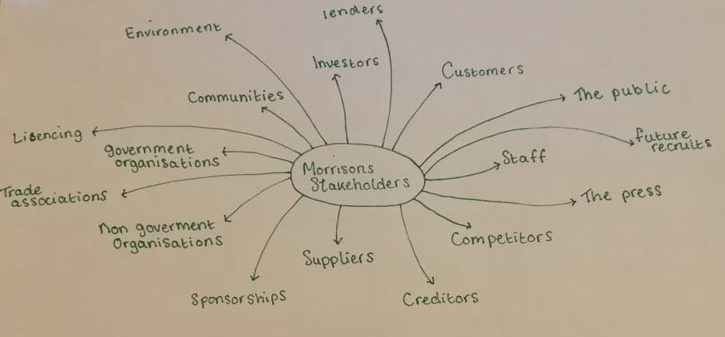
“Organisational context should consider issues both internal and external that have bearing upon the delivery of value to stakeholders.” To understand Morrison’s organizational context IS055001 defines that an organization must identify external and internal factors to help management systems achieve the objectives set by the business to further success (Structured Changed, 2017).
Analysis
SWOT
Technique develop during the 1960’s SWOT analysis uncovers both internal and external issues impacting upon a business, it examines negative and positive attributes to find how to compete in the market. A SWOT can be used to problem solve, make decisions, personal development planning, product/competitor evaluation, and to use with strategic planning must link to PESTLE. The advantages this tool brings is flexibilty and simple structure. Identifying Strengths and weaknesses, ecourages strategic thinking, helps to build on opportunities to expolit them and maintain strengths. It can anticipate future threats to minise/avoid impact. Below is Morrisons 2007 and 2020 SWOT Analysis, they will be compared and explained in futher depth (CIPD, 2020).
Morrison’s 2007 SWOT Analysis
Strengths
Strong market position: Morrisons has a great price promise to its customers by keeping its costs of products down especially in a compeitive price war market. Vertically integrated operations: The stratergy whereby Morrisons owns and/or controls it suppliers and distributors to control their value. Extensive range of food products and services: As it can be noted upon arrival within a Morrisons store they have a varied range of products avaiable whether this be fresh meat, fish, fruit, vegetables, bakes. Frozen/ambiant food products, household cleaning, animal food/care, alcohol, tobacco, clothwear, stationary.
Weaknesses
Lack of presence in the online channel: During 2007 the move to online services was not so aparent as it is now. At this time Morrisons would have been getting to grips with their online presence and ensuring it was being generated to a high standard. Geographic concentration: Morrisons was trying to expand but not too far from where their customer base was, in doing so it created clusters of shops taking away opportunity for new customers to connect. Weak presence in convenience store: It’s about creating an identify and not having staff around on the shop floor can make an establishment feel cold and a customer feeling detatched from the organisation.
Opportunities
Increasing demand for organic products: With growing trends in health for UK citizens this enables Morrisons to expand and discover new suppliers/products. Growing demand for pharmacy products: As Morrisons becomes a store for all consumers as well as their wants and needs, needs need to be met and a pharmacy is one of those wants. Growth in private label markets: As the company increases in size not all of their products can be produced by themselves, out-sourcing a manufacturer can cut costs but also save time.
Threats
Rising labor wages in UK: This is good for the workers but can put a strain on resources for Morrisons, it could mean that staff have less hours or potential job loss. High interest rates in UK. Intense compeition: Morrisons aren’t the only large supermarket, their compeition is huge with the likes of ASDA, Sainsburys, Tesco. This means that constant reviewing of the market must be done to ensure Morrisons keep up to date with challenges from compeitiors that may arise (MarketLine, 2020).
Morrisons 2020 SWOT Analysis
Strengths
Differentiating through market Street, Vertically integrated operations, Strong operational capabilities, Food making skills with strong distribution network and an efficent supply chain: Morrisons pride themselves in the skills that their employees accquire. Highly customer orientated with ‘My View’ features and ‘More Card’ programme, Large product portfolio and customisation.
Weaknesses
Product recalls: Can be very detremental for a company. Recalls are in accordend with Trading Standards. Morrisons should do more to improve quality from their suppliers or their own distribution facilities. Limited geographic presence: Following from 2007 analysis it indicates that this issue has not been solved, Morrisons is still suitated within locations that draw revenue, aforementioned neglect new opportunities which connects to delayed response to changes: If Morrisons have not been able to achieve this target it shows their incompetence for change. Weak loyalty programme: It can be remembered how vouchers usto flow out of the reciept machine for little savings and quirks, advertised everywhere! Now it is pushed under the rug and barely talked about this could impact the companies ability to gain more custom especially for those who need that little influx of discounts to make their money go further as they claim to keep their costs down for consumers.
Opportunities
Online retail market: Now the COVID19 Pandemic is in its prime, securing a succesful online presence can help the business tackle limited geographical presence digitally rather than physcially by offering a delivery service to those further afeild. Establishing a global presence and become largest grocery retailer: A huge opportunity for Morrisons to concer, to guarantee success rigorous scrunity and understanding must be performed and materialised into core structure if they want to fulfill this opportunity it must be a collaborative effort through all stores. Move into non-food retailing: Morrisons have actively secured a good service of food products whether they be fresh or ambiant, moving into an area that they are not familiar with gives the opportunity to expand and make new connections. E-commerce boosting growth in pandemic conditions. Convience, online and discount channels are fastest growing sectors.
Threats
Highly compeitive environment: Referring back to 2007 analysis this is still a major inconvience and always will be. New innovative ideas will need to constantly emerge to keep this threat at bay, not doing so could impact on future development. Increasing technological risks, Changing rules and regulations/Uncertainty upon Brexit: Rules and regulations are always changing so having a team that continuely re-asseses these can ensure the company is up to date with legislation exclusively with Brexit in process (MarketLine 2020, SWOT and PESTLE 2020).
Comparing the analysis from 2007 to 2020 Morrison’s had great aspirations to achieve. 2007 is very basic compared to the detailed version of 2020’s. In 2007 Morrison’s was still trying to make its way into the market to be competitive. The goals set were there to push the company where it needed to be, 2020 they have established their main areas but are critiquing them in more detail to get better results whilst curating new fortunes. A 6 monthly/yearly review of a SWOT analysis can show how a company is changing and combating its weaknesses/threats.
PESTLE
PESTLE goes deeper than SWOT by looking into certain sectors it helps fine tune a businesses goal. PESTLE can empower decisions within the workplace and guide strategic business planning and people strategies, workforce and marketing planning, product development, and organisational change. The tool advantages is it brings a greater/deeper understanding of the wider business environment, can facilitate cost effectiveness, develop strategic thinking as well as external. Along with SWOT it identifys future threats that can impact a business to reduce/avoid them and gives opportunities for expliotion. Disadvantages; insufficent amount of data may be used, having too much data can cause paralysis, data can be based on assumptions which later become baseless, momentum in change can make it hard for a company to asses future developments that may affect the organisation. Changing factors in the business environement means this tool will need frequent use to keep up to date unlike a SWOT (CIPD, 2020).
Morrison’s PESTLE Analysis
Political: Brexit a major political event which has created a lot of uncertainty due to changes in policies and regulations, Huge impact due to multiple government legislation on UK food retailers.
Economical: Brexit caused significant fluctuations in currency and created inflationary pressures, Oil price rise resulted in various household budget tighter for consumers.
Social: Rising age population presents various business opportunities, Growing education and health of consumers in UK.
Technological: Investment in technology helped in reducing the wasted effort and cost making the business more efficient and responsive to customers, Use of digital data to inform the business to identify the emerging trends and better serve customers, Continuous focus on research and development to build in-house software and systems.
Legal: Complies with food safety and legal standards like FSA targets on campylobacter levels, 1000 ethical trade auditswere undertaken in 2016 to ensure integrity, The company has policies and legal guidance to support compliance with several regulations.
Environmental: Operational carbon emissions were reduced by 26.9% and aim for 30% by 2025, Reduced use of poly boxes in supply chain by launching returnable ‘bins’ for fish products, Zero waste was directed to landfill in the manufacturing sites, Offering plastic free fruit and vegetable options (SWOT and PESTLE 2021).
Organisational Culture
Jaques (1951) first introduced the idea of culture in relation to business description, analysis and development in group behaviours.
Organisational Culture is so important as it highlights what matters, gives a company a clear purpose. Having an intercultural workplace can not only bring positives like efficiency, new contacts, improved employee engagement, elevate productivity, strong brand identity, healthy team environment, overall moral, better customer service, low turnover, new languages, greater understanding, increased knowledge, awareness, new cultures, new markets and team work but can also bring negatives; friction caused due to lack of understanding, low work moral/motivation, language barriers, cost of training/development and being able to source new recruitments with the right skill set (Indeed, 2021).
Depicted below are factors that can impact a company’s culture.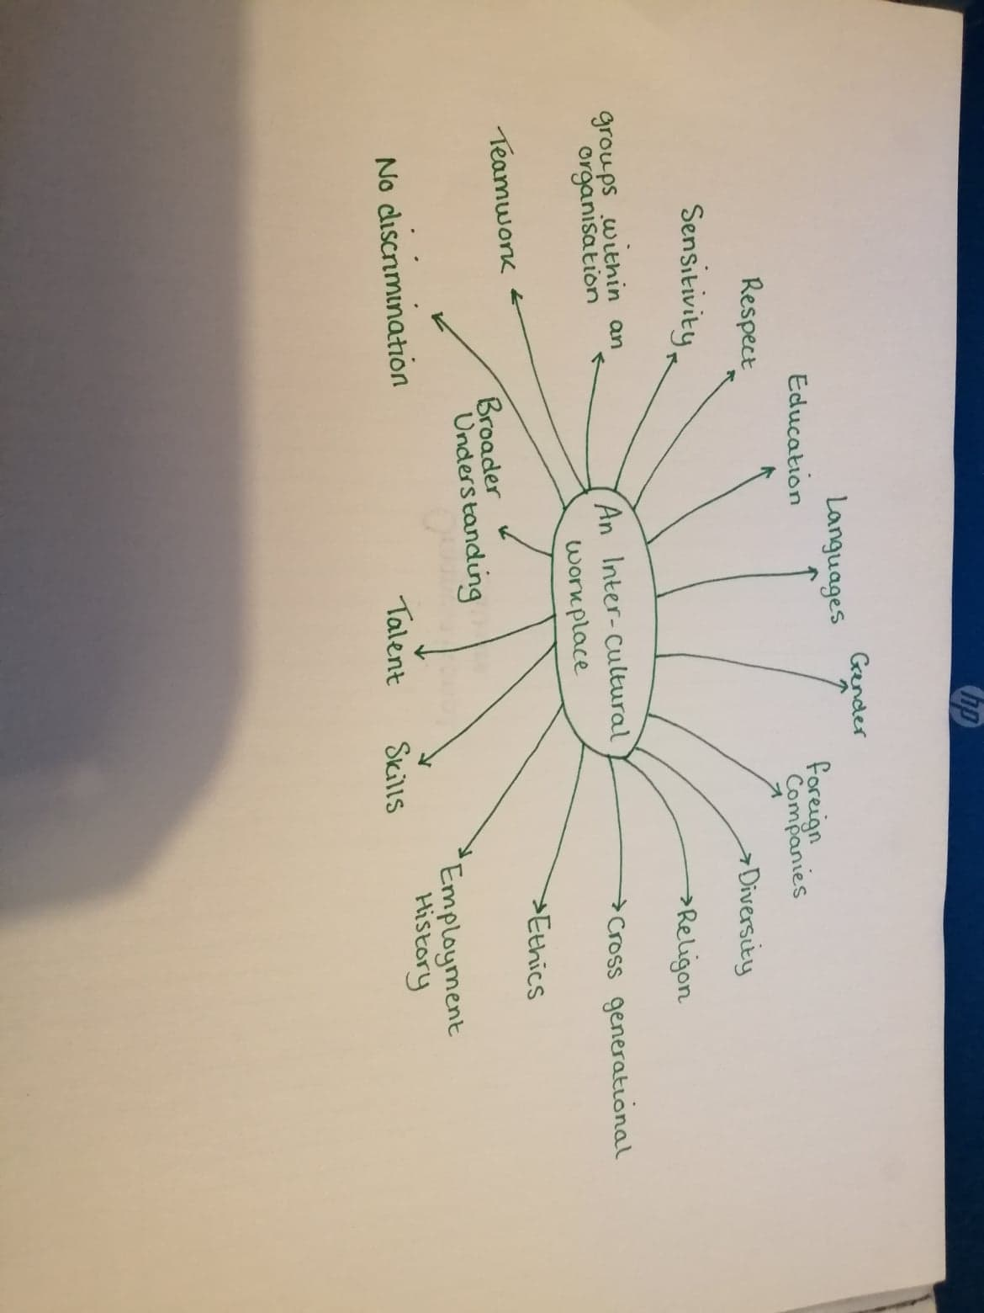
With over 110,000 colleages Morrisons culture should be vast, but it is highly difficult to obtain their true cultural aspects in a sense of being. Applying Handys Model through Riley (2021) it states that organisational culture is split into four categories: Power, Role, Task and Person. Organisations can follow one or more of these groups. It can be determined that Morrisons acts on mainly the Role culture many roles are available and you are trained to what your role desires. It is noted that Power culture plays a part in this as those who are higher up, dictate what must be done to keep up with daily goals and targets. On the other hand Schien (2016) describes that sometimes organisations mission statements/values relating to the behavioural artifacts don’t match. Leading to the theory “culture is a three level phenomana. Artifacts espoused values that may or may not fit with the behaviour and the underlying assumptions that really drives the behaviour.” Unfortunately Morrisons haven’t provided a true self explanitation of their culture but research suggests they paint a picture of a friendly-face high spirited tight-intergrated team who support customers with trying to keep cost of products down. They strive to do things better and provide career experience “you won’t find anywhere else” (Morrisons Corporate, 2021).
LinkedIn (2021) provides great insight into the atmosphere and general running of the franchise. Unfortunately it is hard to find positives with ex-staff and current staff stating Morrisons only care about profits and the recent pandemic has only higlighted this problem. Staff are unhappy, no organisation and no teamwork. On the other hand others have described it as “hard working environment but friendly.” Employees of Morrisons have conflicting statements surrounding work life balance with some stores sticking well to shifts and others stating “contracts mean nothing,” “work till you drop.” Staffs pay gets reviewed every year. They employee from ages eighteen to sixty-two. With this being said does Morrisons add up in Schiens model? No! The assumptions driving the behaviour are poor, this could be down to lack of communication, a bad framework for managing, management focusing more on goals rather than employees well-being and welfare. Ravasi, Schultz (2006) also argue that behaviours are guided by shared assumptions. And that these traits should be passed on to new recruits for them to feel, think and perceive the company. Morrison’s future recruitments when looking at previous employee comments may be swayed not to apply; this could dramatically affect turnover percentage and should be thought more of a core value (Indeed 2021).
Human Resource Management
Every business issue becomes a people issue. Human resources is the management of people to drive success. It analysis’s an establishments environment along with developing jobs to suit the organisations needs. This can be by developing skills, providing training. To be effective in this line of work you must have the correct skills and capability to grasp the understanding of how important this role is, how to manage, motivate and find workers. Communication, collaboration, innovation, understanding the organisation, being empathtic and listening to an organisation are all great skills a human resource manager should attain. Processes and mechanisms can affect workers successfulness so having a manager that understands these wants/needs can help workers get to the right place. The organisation must be viewed as a system in order to re-organise/re-structure for worker success (International Hub, 2017).
Morrisons responsibilities are to practice and uphold policies and values, obtain a healthy working environment, create and nourish harmonious relationships between the organisation and workers, maintain staff relations by keeping them satisfied/motivated, identify job vacancies and to hire and properly develop/train individuals (DeskLib, 2021).
Upcoming trends that can affect the nature of a Human Resource Manager are; analytics: with ever changing issues and factors, collecting and analyzing data to improve success must be re-viewed and tailored as much as possible, many companies are not utilising their data to their advantage, newly developed tools are now becoming accesible. Evolving technology: Human Resource professionals must get to grips with this expanding technology departments that can influence procedures are Robotic Process Automation, Artifical Intelligence, and Virtual Reality. New work: perceptions of work are changing, alternative trends and developments are shaping this new era, its relevant to inspiring change and becoming a truly indispensable employee. Holacracy: a new version of power, how it is equally distributed between colleages for freedom and self-management still focused on the companies purpose. Gig economy: grants freedom and flexibility with freelancing, and short-term contracts rain over long term. Teal organisation: empowered to be authentic based on wholeness, self-management and purpose regarding organisation evolution. Focus on employees experiences/engagement: Coming into 2021 mental health is a high priority especially alongside the pandemic, talking, listening and understanding all of your employees needs/wants makes a individual feel valued and connected with the establishment (Sympa, 2021).
Conclusion
To clarify everything that has been stated so far Morrisons is a long standing company which specialise in retail to the homes of millions. That pride themselves in career training, customer service and keeping consumer purchase costs low. Through identification of Stakeholders then SWOT and PESTLE analysis factors are discovered that influence the running of service. Their organisational culture can be hard to materialise but can be linked to models which show some structure and stability. Human Resources play a huge part in organising the business structure and capability success of workers, Morrison’s key responsibilities have been established along with trends impacting and changing the dynamic, and how Human Resource Managers should respond. Following on from the conclusion three reccomendations will be given to help further success for Morrisons.
Recommendations
- Teamwork/Communication
Thourough research has shown challenges impacting Morrisons are turnover/organisation due to the pandemic ultimately it has effected the overall moral and communication. Statements by staff confirm the stress and ignorance of those high in power more concerned about goals and profits. A recommendation box should be installed for colleages to voice their concerns/improvements anonymously for Human Resources management to review on a weekly basis and raise with those in higher power. More activities/outtings should be developed to reinstate the strong bond Morrisons states it delivers with teamwork.

- Clear Mission Statement and Values
Mission/Value statements are becoming a crucial tool for changing consumer needs/wants to justify where to spend their money. Consumers want to know what the company is truly about and whether they are upholding those beliefs. Having just a small paragraph with key points when either visiting online or within store can give consumers insight into culture/marketing and what the company deems as important.

- Employee Culture/Value Promise
Throughout investigation little information was administered around the true culture/values of the team and network within Morrisons. Customers know they are a team/friendly/approachable but that is limited information which a lot of companies state. Having a statement explaining these topics can make employees and consumers feel connected and attached to something more than just a retail store. Having Human Resources accesible to this information can ensure that core values/culture are being upheld leading to company/consumer satisfaction.

References
CIPD (2020) PESTLE Analysis Factsheet
Available at: https://www.cipd.co.uk/knowledge/strategy/organisational-development/pestle-analysis-factsheet#7992 (Accessed: 21 February 2021)
CIPD (2020) SWOT Analysis Factsheet
Available at: https://www.cipd.co.uk/knowledge/strategy/organisational-development/swot-analysis-factsheet#8016 (Accessed: 21 February 2021)
DeskLib (2021) Human Resource Management - Morrisons
Available at: https://desklib.com/document/human-resource-management-hfyr/ (Accessed 22 February 2021)
Edgar H Schein (2004) Organizational culture and leadership
Available at: https://www.worldcat.org/title/organizational-culture-and-leadership/oclc/54407721 (Accessed 22 February 2021)
Ethier Associates (2009) Strategic Importance of Stakeholder Management
Available at: https://www.ethier.ca/library_docs/Strategic_Importance_of_Stakeholders_Management.pdf (Accessed 22 February 2021)
Elliot Jaques (1951) The Changing Culture of a Factory
Available at: https://books.google.co.uk/books/about/The_Changing_Culture_of_a_Factory.html?id=aSGEEq3jbckC&redir_esc=y (Accessed 21 February 2021)
Indeed (2021) 8 Reasons Why Organizational Culture is Important
Available at: https://www.indeed.com/career-advice/career-development/why-organizational-culture-is-important#:~:text=Here%20are%20seven%20reasons%20why%20organizational%20culture%20is,in%20their%20work%20duties%20and%20interactions%20with%20others. (Accessed 22 February 2021)
Indeed (2021) Questions and Answers about Wm Morrisons Supermarkets
Available at: https://uk.indeed.com/cmp/Wm-Morrisons-Supermarkets/faq (Accessed 22 February 2021)
International Hub (2017) Is Human Resource Management the right career for you?
Available at: https://www.youtube.com/watch?app=desktop&v=Jp7oM9mAIXQ&feature=youtu.be (Accessed 22 February 2021)
Jim Riley (2021) Handy Handy’s Model of Organisational Culture
Available at: https://www.tutor2u.net/business/reference/models-of-organisational-culture-handy (Accessed 22 February 2021)
LinkedIn (2021) Morrison’s
Available at: https://uk.linkedin.com/company/morrisonsjobs (Accessed: 20 February 2021)
MarketLine (2021) Wm Morrison Supermarkets, PLC SWOT Analysis
Available at: https://whel-primo.hosted.exlibrisgroup.com/primo-explore/fulldisplay?docid=44UWTSD_ALMA51168998300002421&context=L&vid=44WHELF_UWTSD_VU1&lang=en_US&search_scope=CSCOP_EVERYTHING&adaptor=Local%20Search%20Engine&tab=tab1&query=any,contains,Wm%20Morrison%20Supermarkets%20PLC%20SWOT%20Analysis&mode=basic (Accessed 22 February 2021)
Morrison’s Corporate (2021) Company History
Available at: https://www.morrisons-corporate.com/about-us/company-history/ (Accessed: 20 February 2021)
Morrison’s Corporate (2021) Annual Report and Financial Statements 2013/14
Available at: https://www.morrisons-corporate.com/globalassets/corporatesite/investor-centre/financialreports/documents/2013-14/morrisons_annualreport13-14_complete.pdf (Accessed: 21 February 2021)
Morrison’s Corporate (2021) Preliminary Statement 2020
Available at: https://www.morrisons-corporate.com/globalassets/corporatesite/2020-03-18---prelims-announcement---final-combined.pdf (Accessed: 21 February 2021)
Ravasi, D. Schultz, M. (2006) Responding to Organizational Identity Threats: Exploring the Role of
Organizational Culture
Available at: https://journals.aom.org/doi/10.5465/amj.2006.21794663 (Accessed 22 February 2021)
Schein Edgar Schein (2016) Schein Edgar Schein Explains Culture Fundamentals - Excerpt
Available at: https://www.bing.com/videos/search?q=edgar+schein+culture&&view=detail&mid=B08F91CC6C1AA2B8F58FB08F91CC6C1AA2B8F58F&&FORM=VRDGAR (Accessed 22 February 2021)
Structured Change (2017) Understanding the Context of an Organization
Available at: https://www.bing.com/videos/search?q=what+is+organisational+context&&view=detail&mid=6BFA83501EC688FFDAED6BFA83501EC688FFDAED&&FORM=VRDGAR (Accessed: 21 February 2021)
SWOT and PESTLE (2020) Morrison’s SWOT and PESTLE Analysis
Available at: https://www.swotandpestle.com/morrisons/ (Accessed 21 February 2021)
Sympa (2021) Emerging HR Trends in the 2020s – The future of HR
Available at: https://www.sympa.com/insights/guides-and-reports/top-hr-trends-in-2020/?hsa_ver=3&hsa_src=o&hsa_tgt=kwd-71400084293081:loc-188&hsa_ad=&hsa_cam=6741316544&hsa_mt=b&hsa_grp=1142393229361765&hsa_net=adwords&hsa_kw=%2Bhuman%20%2Bresources%20%2Btrends&hsa_acc=3392229530&msclkid=5701d7efee3a1c0ccaffb7dc94d2f2e0&utm_source=bing&utm_medium=cpc&utm_campaign=6_UK%20MQL&utm_term=%2Bhuman%20%2Bresources%20%2Btrends&utm_content=hr-trends-2020_human%20resources%20trends (Accessed 22 February 2021)

