
(Source: Stonebridge, 2022)
A Handbook for Early Years Practitioners
The Importance of Effective Communication during Transitions

Rhiannon Williams 2203313 ECEY4001
Contents

Introduction: Transitions P. 3

Needs of the Child P. 5

Role of the Adult P. 7

Partnerships P.

Interventions P.

Proposed Outcomes P.

Reference list P.

Introduction: Transitions

Purpose of this handbook
This handbook is aimed at early years practitioners working within a childcare setting with children aged 2-3. The purpose of this handbook is for practitioners to use to increase their knowledge and give guidance on the importance of effective communication during children’s transitions. Early years practitioners can use this guidance to better their understanding on how to manage a child’s transition from an early years nursery to starting primary school. This handbook will look at transitions, needs of the child, role of the adult, partnerships, interventions, and proposed outcomes for the children.

What is Transition
Allingham (2011) defines transition as forms of change that can disrupt a child’s routine which they are familiar with. This change can be as simple as new staff members to become familiar with, or the child being collected or brought to the setting by someone new. Similarly, Burnham (2016a) defines the term ‘transition’ as times of transformation and change, and it may take some time for children to adjust to times of change whether they are gradual or sudden.
As stated by Trodd (2012) most studies on children’s experiences of transitions focus more on structural changes. These results are then used to develop guidance for parents and practitioners in result that they can better support children in a more effective way. The aim is to make transition process as easy and ongoing as possible.

Brooker (2008) believes the transition process can become a positive educational experience for any child by practitioners. According to Fabian and Dunlop (2006) it is important for practitioners to understand that children’s daily transitions can be varied and practitioners should be aware of the effects on children and parents in the early years. Following this, effective management is another way of supporting these transitions as practitioners can use a range of communication techniques to make the transition more worthwhile for everyone. As stated by Robinson (2008) reflecting on transitions can help practitioners make connections between a child’s mental health and behaviour since a child’s response to change can depend on how processed their entire life experience.

Bronfenbrenner
Bronfenbrenner’s model offers an effective framework of development which is a detailed model which allows attention to all complex systems of experience within early education while also emphasizing on realism, dynamism, and complexity of daily living (Hayes, O’Toole, and Halpenny, 2017).

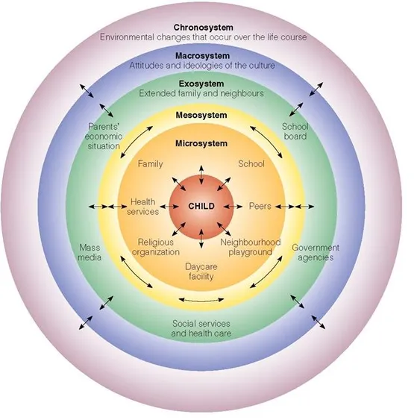

Bronfenbrenner acknowledged that there are several components to a developing child’s life that will have an impact and effect on a child’s life. Bronfenbrenner’s research was considered to have larger influencing components and the context of development in addition to individual development. Bronfenbrenner created the ‘Ecological Systems Theory’ and based this on the dynamic interactions that the environment has on an individual who is still developing (Guy-Evans, 2020).

Needs of the Child

Taking an inclusive approach can help you recognise and meet the needs of all individual children within the provision, taking note of their individual learning starting points. Children should have the option to decide if they want indoor and outdoor play and be able to make their own decisions on where they want to learn. They should have the opportunity to fully engage in their education and learning without being disturbed. A practitioner must support each child’s basic needs and be aware of their role in identifying and supporting each individual child’s learning needs and interests within the learning environment. Practitioners must ensure that the learning environment is supportive and that all individuals of the group’s needs are satisfied through provision (Drake, 2014).

Harvard University (2017) points out that brain architecture is influenced by an interaction known as ‘serve and return’. Neural connections can be developed and built in a child’s brain which promotes the development of communication and social skills. This can occur when an adult responds to an infant or young child’s babbles, gestures, or cries in an appropriate way.

The Welsh Government (2021a) believe that every individual child has the right to high quality education that maintains high standards, and this must be suitable for each child’s individual needs, and can enable them to achieve their full potential and accomplish the best results possible. By working with children, you learn that all children learn differently and at different speeds, some children can find it difficult to do some things other children could find easy to do. These are just parts of the normal development of a child, but by modifying teaching strategies and with a little support, encouragement, and additional support, significant improvements can be made.

Maslow’s Hierarchy of Needs
According to SimplyPsychology (2018) Maslow’s Hierarchy of Needs is a theory of psychology that includes a five-tier model describing human needs. This theory is often displayed as tiers within a pyramid. The needs at the bottom of the hierarchy must be achieved first before a child can move up the pyramid.
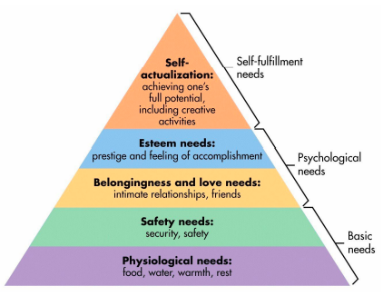

These five needs include:
- Physiological needs,
- Safety needs,
- Belongingness and love needs,
- Esteem needs,
- Self-actualization

Source: (SimplyPsychology, 2018)
SimplyPsychology (2018) state that everyone has the capability and the motivation to climb the hierarchy to the level of self-actualisation. Unfortunately, due to the basic needs not being met progress is frequently delayed. An individual’s position in the hierarchy may change as a result of life events including loss of a job or divorce. As a result of this, not all individuals will move through the hierarchy in a straight line but may change back and forth between the various needs of the hierarchy.
According to Medcalf, Hoffman ad Boatwright (2012) Maslow thought that the reason people were unable to move up towards self-actualisation was because of obstacles created by society were in their way.

Role of the Adult

As stated by the Welsh Government (2021b) the role of the practitioner in supporting children is particularly important as this will potentially be a child’s first experience in education outside of home and family. As a practitioner, they should ensure every child has a safe and positive experience and feels included. Practitioners working within early years settings will have different job roles and responsibilities.
The best individuals for young children are those who genuinely care about every child’s welfare. When early years practitioners and parents have a great understanding of knowledge in child development, it brings that commitment to life and result in realistic expectations. Early years practitioners must become familiar with the variety of theories put forth to explain child development (Lindon, 2012).

According to Burnham (2016b) the EYFS focuses on the child as a whole and includes four guiding principles that practitioners should be mindful of when working with children. These four principles include:
- Every child is unique, who is always learning and who is capable of being strong, confident, and self-assured.
- Through positive interactions with practitioners, children can grow stronger and more self-reliant.
- Children learn and grow effectively in supportive environments.
- Children grow and learn in various ways and at different speeds.

Key workers and staff responsibilities
Robinson (2008) explains that not only do key workers explain the importance of their role for children and babies, but also freely discuss the difficulties of implementation and staff responses to a more personalised approach to care. According to the key worker system, each child has an individual person who shows a great interest in them. This does not include one-to-one communication between children and a practitioner as this would be unrealistic but does imply a practitioner showing interest in a small group of children.

Practitioners are becoming more involved in child development and must further develop their skills in the following areas:
- Having relationships with children and their parents,
- Knowing how children learn and develop in unique and diverse ways,
- Practice addressing the needs, learning preferences, and interests of all children,
- Working with parents, caregivers, and the community,
- Collaborate with other professionals in the early years field and outside of it.

Parents
It is evident that parents understand their children better than anyone and have access to information that no teacher or other practitioners have access to. It is important for practitioners to acknowledge, value and actively seek out what each child is interested in, capable of, or suffers with. This should be communicated in an equal exchange in which parents to practitioners can discuss parts of their children’s behaviour that may be challenging to understand and address (Smidt, 2015).

Partnerships

Working in partnerships offers a chance for need to be fulfilled both collectively and individually, which means the needs of families can be handled in a coordinated way. Children, families and communities are able to receive access to a variety of support and developmental services which is a key component of partnership working.

Interventions

Proposed Outcomes

Reference list
Adam (2022) ‘The Stonebridge Collage Guide to Becoming an Early Years Practitioner’. Available at: The Stonebridge College Guide to Becoming an Early Years Practitioner | Stonebridge Associated Colleges Blog. (Accessed: 20th November 2022).
Brooker, L. (2008) Supporting Transitions in the Early Years. England: McGraw-Hill Education.
Allingham, S. (2011) Transitions in the Early Years: A practical guide to support transitions between early years settings and into key stage one. Luton: Andrews UK.
Trodd, L. (2012) Transitions in the Early Years: Working with Children and
Families. London: SAGE Publications Ltd.
Fabian, H. and Dunlop, A. (2006) Informing Transitions in the Early Years. England: McGraw-Hill Education.
McLeod, S. (2018) Maslow’s Hierarchy of Needs. Available at: Maslow's Hierarchy of Needs (canadacollege.edu). (Accessed: 21st November 2022).
Medcalf, N. and Hoffman, T. and Boatwright, C. (2012) ‘Children’s dreams viewed through the prism of Maslow’s Hierarchy of Needs’, Early Child Development and Care, 183(9) p.1324-1338.
Drake, J. (2014) Planning for Children’s Play and Learning. London: Routledge.
Harvard University (2017) Available at: Serve and Return (harvard.edu). (Accessed: 28th November 2022).
Hayes, N. O’Toole, L. and Halpenny, A. (2017) Introducing Bronfenbrenner: A Guide for Practitioners and Students in Early Years Education. London: Routledge.
Guy-Evans, O. (2020) Bronfenbrenner’s Ecological Systems Theory. Available at: Bronfenbrenner's Ecological Systems Theory (simplypsychology.org). (Accessed: 28th November 2022).
Welsh Government (2021a) Meeting the needs of all children. Available at: Meeting the needs of all children - Help for early years providers - GOV.UK (education.gov.uk). (Accessed: 28th November 2022)
Welsh Government (2021b) Meeting the needs of all children. Available at: Meeting the needs of all children - Help for early years providers - GOV.UK (education.gov.uk). (Accessed: 28th November 2022)
Burnham, L. (2016a) How to be an Outstanding Early Years Practitioner. London: Bloomsbury Publishing Plc.
Burnham, L. (2016b) How to be an Outstanding Early Years Practitioner. London: Bloomsbury Publishing Plc.
Robinson, M. (2008) Child development 0-8: a journey through the early years. England: Open University Press.
Lindon, J. (2012) Understanding child development: 0-8 years. 3rd ed. Oxon: HODDER.
Smidt, S. (2015) Observing Young Children: The Role of Observation and Assessment in Early Childhood Settings. Oxon: Routledge

