


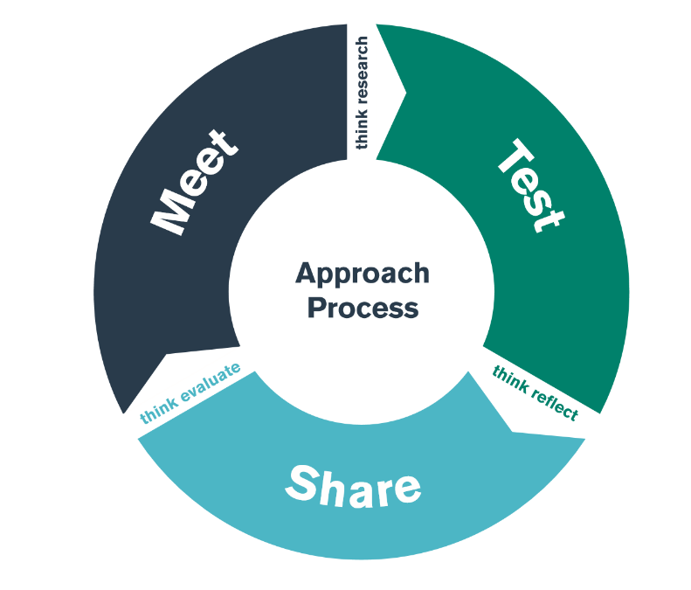

Bridging
BA3
Welsh Language

MEET day 21 February 2024 Lead Schools
TEST days 22 February – 5 March 2024 Placement Schools
SHARE day 24th January 2024 Lead Schools

Student-Teacher Enquiry Evidence Record

11th -25th November 2020

What is the purpose of this bridging activity?

Through this bridging experience, you will develop an understanding of how the Welsh language is developed in schools.

MEET DAY: Wednesday 21 February 2024
In the lead school.
During the MEET day you will develop an understanding of Welsh language promotion.

- You will look at Welsh Government policy and Estyn documents to see the national drive behind the importance of bilingualism.
- You will learn how the Lead School implements and promotes this.
- You will choose and develop an activity to try whilst on placement, in the TEST phase.

TEST phase: 22 February – 5 March 2024

- Develop your understanding of Welsh language within your placement school.
- Implement your activity and test it as many times as possible to judge the value and success of the resource.
- Evaluate how this is developing your own Welsh language skills.
- Prepare a blog (using a template on the Tanio’r Ddraig website) to present your findings.
- Which of the standards have you chosen to link this learning to?
- Remember to include a degree of criticality by making links to any research, reading, or theory you have encountered.
- You can provide a summary of your blog in the first two sections of an experience template.

SHARE: Wednesday 6 March 2024
In the lead school
- You will present your blog which should discuss your findings and reflections from this bridging experience
- Remember to include a degree of criticality by making links to any research, reading, or theory you have encountered.
- Participate well in discussions with your peers.

Reading

Essential linked reading:

https://www.estyn.gov.wales/thematic-report/support-welsh-initial-teacher-education-how-initial-teacher-education-partnerships

https://www.gov.wales/sites/default/files/publications/2018-12/cymraeg-2050-welsh-language-strategy.pdf

TEST PHASE - OBSERVATION NOTES

Welsh within the school | Your ability | The activity
Have you identified how your school promotes the Welsh language? | Have you incorporated what you have learned in Cymraeg I Bawb? Does your confidence or ability improve over the test period? | Were you fully confident in delivering the activity? Did the children engage? What did you notice?
EXPERIENCE TEMPLATE
SHARE DAY BLOG

- What did you do and why?
Describe your professional experience. You may wish to refer to your role or involvement, why you had engaged in this experience and the intended outcomes. You can also mention any particular professional standards you had chosen to focus on.

- What have you learned?
You might want to consider some of the following: why is this experience important or relevant? How does it relate to your overall learning, development and/or use of the standards? Did it meet the intended outcomes? Any lessons learned? What are the implications for colleagues and learners? How will you share what you’ve learned?

- What Next?
Is there anything you intend to do as a result of this experience? You might want to consider some of the following questions: Are there any specific actions that you will take? What would you do in similar circumstances in the future? Is there anything you intend to change? Do you have plans for any further learning or development opportunities? If so, who or what can help - using the standards, people, written resources, online materials, workshops etc? How will you share what you’ve learned?

TARGET

What area do you want to develop in your own practice?
TIMESCALE

When do you want to achieve this by?
RESOURCES

What do you need to help you achieve this? Who do you need to talk to/observe? What do you need to research?
SUCCESS CRITERIA/
OUTCOME

How will you judge whether it has been successful or not? What impact do you hope to see in teaching and learning? What research/literature is this based on?
MONITORING/
EVALUATION

How will you check that you have successfully achieved your target? Lesson observation? Book scrutiny? Pupil voice?

 |  | Standard  Title | QTS Descriptor
Pedagogy |  | Pedagogy - Refining Teaching
Pedagogy | Refining Teaching | Managing the learning environment | The teacher understands the importance and demonstrates the effective establishment and ongoing management of the learning environment, in promoting positive learning habits and behaviours that meet the four purposes and are understood by learners in that context.
Pedagogy | Refining Teaching | Assessment | The range of purposes and practices for assessment is understood and articulated.
Pedagogy | Refining Teaching | Differentiation | The teacher demonstrates knowledge, understanding and  experience of high expectations and effective practice in meeting  the needs of all learners, whatever their different needs.
Pedagogy | Refining Teaching | Recording and reporting | The teacher produces appropriate, timely and accurate records and reports and gives feedback to facilitate a deeper understanding of learning and enhance the learning experience.
Pedagogy | Refining Teaching | Involving partners in learning | The importance of positive involvement of parents/carers and other partners is understood and opportunities are taken to observe and evaluate processes.
Pedagogy |  | Pedagogy - Advancing Learnings
Pedagogy | Advancing Learning | Four purposes for learners | The teacher demonstrates a knowledge and understanding of the needs of all learners in planning, preparation and teaching, ensuring that the four purposes are the drivers for learners’ experiences.
Pedagogy | Advancing Learning | Exploiting subject disciplines in areas of learning | The teacher demonstrates a knowledge and understanding of relevant pedagogies and disciplines within and across subject content, areas of learning and cross-curricular themes, and plans appropriately.
Pedagogy | Advancing Learning | Blended learning experiences | The teacher understands the selection, use and justification of a range of imaginative teaching approaches for the benefit of each learner.
Pedagogy | Advancing Learning | Real life, authentic contexts | The teacher demonstrates an understanding of the use of real life, authentic contexts for learning being provided as a natural part of the learning experience. This extends the learner’s cultural, linguistic, religious and socio-economic experience and illustrates applications of concepts and abstracts in practice.
Pedagogy | Advancing Learning | Progression in learning | The teacher demonstrates an understanding of how learning develops incrementally and tangentially, building on prior experience and learning, and plans for progress in learning based on this.
Pedagogy | Advancing Learning | Cross-curricular themes | The teacher knows, understands and engages with the principles of curriculum design and innovation, with development of crosscurricular themes relevant to areas of learning and justifies decisions.
Pedagogy |  | Pedagogy - Influencing Learners
Pedagogy | Influencing Learners | Challenge and expectations | The teacher provides appropriate levels of challenge and expectations for the range of student abilities and characteristics, motivating learners to achieve.
Pedagogy | Influencing Learners | Listening to learners | The teacher demonstrates a willingness to seek, listen to and take account of the views of learners in order to engage and encourage them as active participants in their own learning.
Pedagogy | Influencing Learners | Learners leading learning | In planning and delivery, the teacher demonstrates an awareness of the importance of encouraging learners to reflect upon their own learning.
Pedagogy | Influencing Learners | Sustained effort and resilience in learners | The teacher promotes and secures learners’ self-motivation and self-direction in their learning.
Pedagogy | Influencing Learners | Reflection on learning | In planning, the teacher demonstrates awareness of the importance of encouraging learners’ reflection and evaluation around behaviours and outlooks for learning.
Pedagogy | Influencing Learners | Learning outcomes and well-being | The teacher raises awareness of how high-quality learning experiences and performance outcomes lead to improved learning and a heightened sense of well-being.

Collaboration | Collaboration
Collaboration | Seeking advice and support | The teacher actively seeks and engages with support from a range of formal and informal sources. This includes observation and team teaching, whilst demonstrating increasing levels of independence.
Collaboration | Working with in-school colleagues | Organised and constructive work with a range of colleagues to enhance learners' experience is a consistent feature of the teacher's practice. Reflection on developing expertise is structured as a personal or a collaborative process, as appropriate.
Collaboration | Supporting and developing others | The teacher develops high quality relationships with colleagues in order to have a positive impact on learners' experiences within the school.
Collaboration | Enabling improvement | There are examples of improvement in outcomes following the teacher's seeking and adoption of advice.
Professional Learning | Professional Learning
Professional Learning | Wider reading and research findings | The teacher demonstrates increasingly confident understanding of the theories and research about assessment, pedagogy, child and adolescent development and learning relevant to planning and day-to-day practice.
Professional Learning | Professional networks and communities | The teacher has an informed understanding of the contribution of research, including small scale action research, to the development of practice.
Professional Learning | Continuing professional learning | The Professional Learning Passport influences the ongoing critical reflection and learning of the teacher and is developmental in prompting further professional growth.
Professional Learning | Welsh language skills | There is a commitment to incremental development of personal skills in the use of the Welsh language.
Innovation | Innovation
Innovation | Offering expertise | The teachers models an increasing repertoire of teaching techniques, as expertise emerges and flourishes, in order to inform and enhance the development of others.
Innovation | Developing new techniques | Research on cognitive, social, emotional and physical development has a positive impact on pedagogy. The teacher can demonstrate how professional discernment and critical analysis are brought to bear in shaping developing practice.
Innovation | Evaluating the impact of changes in practice | The teacher actively seeks support and advice from colleagues in developing innovative approaches within the classroom so that their impact can be evaluated, analysed and shared.
Leadership | Leadership
Leadership | Taking responsibility for self | The teacher demonstrates professional attitudes and behaviours, developing positive relationships with learners, parents/carers and coleagues which illustrate a personal commitment to the fundamental principles of equity and of maximising the potential of all learners.
Leadership | Exercising corporate responsibility | Contractual, pastoral, health and safety, legal and professional responsibilities are known and understood by the teacher.
Leadership | Leading colleagues, projects and programmes | The teacher's understanding of, and commitment to, leading learning is demonstrated through collaborative experiences in school and other contexts.
Leadership | Supporting formal leadership roles | The teacher demonstrates an understanding of the nature of responsibilities within and across teams and of the contributions individuals make towards the school's ethos and the successful fulfilment of the school's vision.

BRIDGING – CHECKLIST

 | What to do? | When? | Notes
1 | - Try to arrange a brief meeting with the Lead for the Welsh Language within your school.  - Discuss how the language is promoted.  - Discuss with your class mentor how you will implement your activity as much as possible (daily if possible).  - Decide how you will implement it and with which children (whole class? Group?)  - Consider how you will measure progress of the children, the success of the activity and your own engagement with the Welsh language over the test period. | Between 22nd February – 5th March
2 | Prepare a blog on your findings and reflections to share with the Network Leader, Curriculum Tutor and peers on the SHARE day. You will have uploaded this to the Tanio’r Ddraig website before hand. When you are not taking part in your groups' presentations on the SHARE day, you should take part in meaningful activity. This could be completing your experience template for your PDP, reading, Welsh Portfolio. | By Wednesday 6th March 2024. | This will be in your Lead School.  - A presentation of your blog that you upload to the website.  - Experience Template format must be followed (first two questions - see STEER document)  - Your blog should discuss your findings and reflections from this bridging experience  - Remember to include a degree of criticality by making links to any research, reading, or theory you have encountered.
3 | Complete your personal target in the STEER booklet. |  | Complete question 3 of experience template.
4 | Upload your completed experience template to your PLP. |  | Ensure that your impact statements (questions 2 and 3) are specific to the standard you are exemplifying.

