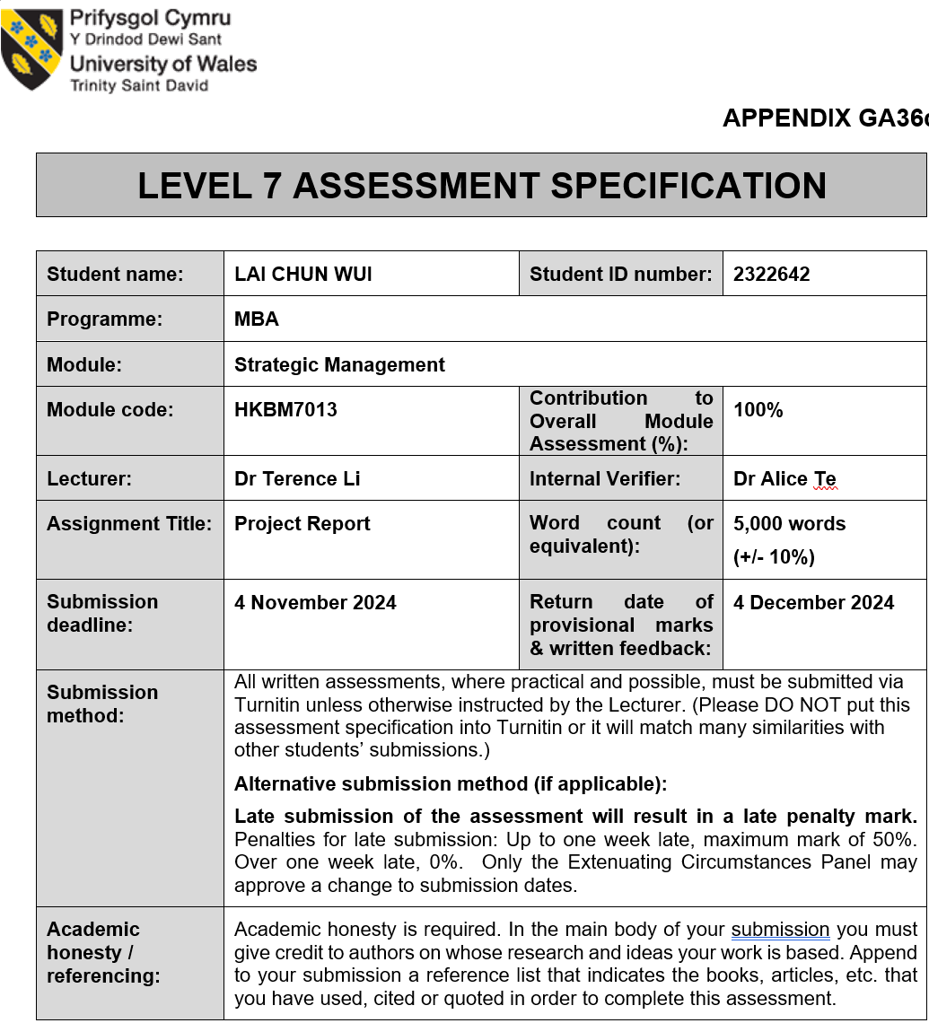
Table of Contents

 |  |  | Page
1. | Introduction and Study Focus
 | 1.1 | Background | 4
 | 1.2 | Objective | 4
 | 1.3 | Focus | 4
 | 1.4 | Coverage | 4-5
 | 1.5 | Importance | 5
2. | Analysis of H&M's Vision, Mission, and Values (VMV)
 | 2.1 | Vision | 5
 | 2.2 | Mission | 6
 | 2.3 | Values | 6
 | 2.4 | How VMV Influences H&M’s Strategic Choices | 6
 | 2.5 | Whether Current Strategies Fulfill the VMV | 7
3. | H&M's Macro and Micro Analysis in Hong Kong
 | 3.1 | Why Macro and Micro Analysis? | 8
 | 3.2 | Macro Analysis: PESTEL Analysis
 |  | 3.2.1 Political Factors | 8
 |  | 3.2.2 Economic Factors | 8
 |  | 3.2.3 Social Factors | 8
 |  | 3.2.4 Technological Factors | 9
 |  | 3.2.5 Environmental Factors | 9
 |  | 3.2.6 Legal Factors | 9
 | 3.3 | Micro Analysis: Porter's Five Forces Model
 |  | 3.3.1 Threat of Industry Competitors | 9
 |  | 3.3.2 Threat of New Entrants | 10
 |  | 3.3.3 Threat of Substitutes | 10
 |  | 3.3.4 Bargaining Power of Suppliers | 10
 |  | 3.3.5 Bargaining Power of Suppliers | 10
 |  | 3.3.6 Competitive Strategies for H&M | 11
4. | A Value Chain Analysis of H&M in the Hong Kong Market
 | 4.1 | Supply Chain Management and Product Design | 12
 | 4.2 | Sales and Market Positioning | 12
 | 4.3 | Customer Interaction and After-sales Service | 12
 | 4.4 | Technology Application and Innovation | 12-13
 | 4.5 | Localization and Customization Strategies | 13
 | 4.6 | Conclusion | 13
5. | H&M's Balanced Scorecard Analysis: Hong Kong Market
 | 5.1 | Financial Perspective | 14
 | 5.2 | Customer Perspective | 14
 | 5.3 | Internal Processes Perspective | 14
 | 5.4 | Learning and Growth Perspective | 15
 | 5.5 | Conclusion | 15
6. | Conclusion
 | 6.1 | Conclusion | 16
 | 6.2 | Recommendations
 |  | 6.2.1 Strengthen Data-Driven Supply Chain Management | 16
 |  | 6.2.2 Enhance Customer Interaction and Loyalty Programs | 16
 |  | 6.2.3 Strengthen Internal Process Coordination and Standardization | 17
 |  | 6.2.4 Strengthen Cost Control and Optimize Resource Allocation | 17
 |  | 6.2.5 Promote Product Innovation and Localization Strategies | 17
 |  | - Implementation Plan with Gantt Chart | 17
 |  | - Supply Chain Optimization | 18
 |  | - Enhancing Customer Experience | 18
 |  | - Strengthening Internal Processes | 18-19
 |  | - Cost Control and Efficiency Growth | 19
 |  | - Innovating for Revenue Expansion | 19
 | Reference List |  | 20-21

1. Introduction and Study Focus
1.1 Background
H&M Group, established in 1947, has emerged as one of the leading global fast fashion brands, boasting more than 143,000 employees and operations across 75 markets (H&M Group, 2023a). In the ever-changing market environment, H&M leverages its unique strategic positioning and Vision, Mission, and Values (VMV) to steer its development. Tallant (2009) highlights that VMV, as a core element of strategic direction, helps companies effectively define their brand identity, establish competitive differentiation, and communicate their purpose to both internal and external stakeholders. As a global brand, H&M’s strategic direction not only affects its overall market position but also directly impacts the operational outcomes in various regional markets, such as Hong Kong (Sustainability Magazine, 2023).

1.2 Objective
This study aims to analyze how H&M’s VMV influences its strategic choices, particularly focusing on its application in the Hong Kong market. Specifically, it will investigate how H&M’s current strategies achieve its brand positioning and growth objectives, including its ambitions for sustainable development, digital transformation, and global market expansion (H&M Group, 2023b). Notably, H&M's strategic choices are emblematic within the global market, especially with commitments such as aiming to use 100% sustainable materials by 2030 and achieving carbon neutrality by 2040 (Edrawmind, 2024; H&M Group, 2023a).

1.3 Focus
The research primarily concentrates on H&M’s strategic applications in the Hong Kong market. As a significant fashion consumption market in Asia, Hong Kong has a large demographic that values fashion and quality. H&M's performance in this market can represent the adaptability of its global strategies to regional nuances. By examining the Hong Kong market, deeper insights into how H&M implements its brand VMV in this specific context and continues to maintain competitive in the fast fashion industry can be gained (H&M Group, 2023b; Comparably, 2024).

1.4 Coverage
The study will include a multi-layered analysis as follows:
Introduction and Background: Introduces H&M’s brand history and market positioning, and analyzes the role of its VMV.
Macro and Micro Analysis: Begins with a PESTEL framework to scrutinize the external environmental challenges H&M faces, followed by Porter’s Five Forces model to assess its internal competitive advantages and market position.
Balanced Scorecard Analysis: Evaluates the effectiveness of H&M’s strategies from financial, customer, internal processes, and organizational capabilities perspectives.
Value Chain Analysis: Provides an in-depth examination of H&M’s supply chain and value creation processes, with suggestions for improvements.
Gantt Chart: Displays the recommended strategy implementation process and timeline based on research findings.
Conclusions and Recommendations: Offers strategic advice at both corporate and operational levels, summarizing the long-term impact on the company.
Gantt Chart: Displays the recommended strategy implementation process and timeline based on research findings.

1.5 Importance
This research holds significant practical relevance, especially in the context of the fast fashion industry's gradual shift towards sustainable development. For H&M, this study will facilitate a deeper understanding of how VMV drives its strategic development and provides recommendations for applying these strategies in the Hong Kong market. Additionally, it offers a reference for other fashion brands, demonstrating how VMV can influence regional markets through strategic adjustments. Ultimately, this research will deliver a concrete analytic framework and propose viable improvement measures within the competitive environment of the fast fashion industry (H&M Group, 2023a; Sustainability Magazine, 2023; Edrawmind, 2024).

2. Analysis of H&M's Vision, Mission, and Values (VMV)
2.1 Vision
H&M's vision, "to lead the transition to circular and renewable fashion and to become a fair and equal company," showcases the brand's commitment to environmental and social responsibility (H&M Group, 2023). As part of its objectives, H&M is dedicated to achieving full carbon neutrality by 2040, including adopting a range of emission reduction measures in its supply chain and operations. These include reducing supply chain carbon emissions, enhancing energy efficiency, and vigorously promoting the use of eco-friendly materials (Fashion United, 2024; Sustainability Magazine, 2023). As of 2023, H&M has achieved the goal of 85% of its materials coming from renewable or sustainable sources, with a 22% reduction in carbon emissions already accomplished (H&M Group, 2023).

This vision also demands H&M's commitment to social responsibility, particularly in supply chain management. To ensure labor rights, H&M collaborates with partners, governments, and NGOs to advance fair trade and human rights standards (Fashion United, 2024). Through close cooperation with supply chain partners, H&M not only ensures its social image but also further promotes fairness and inclusivity throughout the fashion industry (Sustainability Magazine, 2023).

2.2 Mission
H&M's mission is "to offer fashion and quality at the best price," aimed at attracting a broader consumer base through the democratization of fashion (Comparably, 2024). Achieving this mission relies not just on price competitiveness but also on maintaining high-quality and innovative products. To this end, H&M invests heavily in digital transformation and supply chain management. The company emphasizes rapid market response, especially in expanding sales channels on digital platforms, thus effectively enhancing the consumer shopping experience (Fashion United, 2024). H&M also employs a highly flexible supply chain strategy, optimizing design, manufacturing, and logistics to achieve rapid production and delivery, ensuring consumers can enjoy the latest fashion products at affordable prices (H&M Group, 2023).

2.3 Values
H&M's values reflect the brand's corporate culture, particularly in terms of fairness, collaboration, and continuous improvement. Core values include "trust," "teamwork," "entrepreneurial spirit," "constant improvement," and "cost consciousness." These values foster a spirit of collaboration and innovative thinking within the company, enabling H&M to adapt efficiently to rapidly changing market demands (Mission Statement, 2023). The company also emphasizes its commitment to diversity and inclusivity, striving to provide fair employment opportunities and promote a diverse corporate culture. These values also set high standards for external supply chain partners, ensuring their operations align with the brand's social and environmental goals (H&M Group, 2023).

2.4 How VMV Influences H&M’s Strategic Choices
H&M's VMV plays a crucial role in its strategic choices. For example, in sustainability, H&M's environmental goals drive the creation of a green supply chain, promoting the use of recycled materials and reducing carbon emissions. In 2023, the company made significant progress in material sustainability, with 85% of materials coming from renewable or sustainable sources, and plans to achieve 100% sustainable material usage by 2030 (H&M Group, 2023). Additionally, the company actively participates in the circular economy model, such as implementing recycling programs to reduce waste throughout the product life cycle (Sustainability Magazine, 2023).

Digital transformation is another key strategy, with H&M expanding online sales channels to respond to rapidly changing consumer needs. The company has not only enhanced the digital shopping experience but also improved supply chain transparency, which helps increase production and delivery efficiency and enhances customer service (Fashion United, 2024). H&M continues to refine its supply chain management systems, which achieve greater production flexibility through data analysis and technological innovation (Comparably, 2024).

2.5 Whether Current Strategies Fulfill the VMV
H&M's current strategies largely fulfill its VMV. For example, in sustainability, the company reduced supply chain carbon emissions by 22% in 2023 and is pushing towards achieving 100% sustainable material usage by 2030 through the introduction of more renewable materials (H&M Group, 2023). H&M has also made significant efforts in diversity and inclusion, particularly in supply chain management and employee diversity, which support its values of fairness and strengthen the brand's social responsibility image (Sustainability Magazine, 2023). Overall, the successful implementation of these strategies allows H&M to establish a sustainable competitive advantage in the fiercely competitive market and earn consumer trust in the brand's social responsibility (Fashion United, 2024).

3. H&M's Macro and Micro Analysis in Hong Kong
3.1 Why Macro and Micro Analysis?
In a dynamic market environment like Hong Kong, macro and micro analyses help H&M grasp the overall and industry-specific competitive landscapes, enabling the formulation of comprehensive market response strategies. Macro analysis allows the company to understand the main external environmental factors affecting its operations, such as economic conditions, policies, and consumer. Micro analysis focuses on internal industry competition, helping H&M understand its market position and competitive pressures, supporting the development of targeted competitive strategies).

3.2 Macro Analysis: PESTEL Analysis
3.2.1 Political Factors
Hong Kong's stable political environment is attractive for foreign brands like H&M. However, geopolitical tensions, particularly between China and the US, increase uncertainty in trade and supply chain management. As Hong Kong strengthens economic ties with mainland China, H&M should establish flexible supply chains to mitigate potential policy shifts and reduce dependency on a single market (Hong Kong Economy, 2024).

3.2.2 Economic Factors
Hong Kong's economy is expected to grow by 2.5% to 3.5% in 2024, with moderate inflation around 1.7% (Hong Kong Economy, 2024). This reflects potential growth in the retail sector as consumer demand gradually recovers. However, ongoing high living costs and global economic uncertainties continue to pressure consumer spending. In the short term, H&M can attract price-sensitive consumers through promotional activities. In the long term, H&M should optimize its supply chain to reduce operational costs and maintain competitiveness in Hong Kong's high-cost market (Hong Kong Economy, 2024).

3.2.3 Social Factors
Environmental awareness and demand for socially responsible brands are increasing among Hong Kong's young consumers. H&M's "Conscious" eco-friendly product line aligns well with this trend. H&M should amplify marketing efforts for this line to cater to young consumers' preferences for sustainable products. In the short term, promoting eco-friendly products can enhance market appeal; long term, H&M should invest more in sustainable materials to strengthen its brand image and customer loyalty.

3.2.4 Technological Factors
Hong Kong's highly developed digital infrastructure supports robust e-commerce and mobile payment systems. As consumer demand for digital shopping experiences grows, H&M can enhance its online platforms and use data analytics to improve customer service. In the short term, enhancing digital marketing can help precisely target consumer needs; long term, investing in AI and big data can further improve supply chain efficiency and customer satisfaction.

3.2.5 Environmental Factors
With strengthening environmental regulations and growing consumer focus on sustainability, H&M can enhance its market image in Hong Kong by incorporating more eco-friendly materials and advancing circular economy practices, such as product recycling and reuse. In the short term, ensuring compliance with local environmental standards is crucial; longer term, a sustained environmental strategy can enhance H&M’s competitiveness among eco-conscious consumer.

3.2.6 Legal Factors
Hong Kong's rigorous legal system demands strict compliance with labor rights and intellectual property protections. H&M must ensure its supply chain adheres to local labor and business regulations. In the short term, strengthening supplier oversight can prevent legal disputes; longer term, enhancing CSR initiatives can further boost consumer trust and brand image (Hong Kong Economy, 2024).

3.3 Micro Analysis: Porter's Five Forces Model
H&M's Micro Analysis Using Porter's Five Forces in Hong Kong
Porter's Five Forces (Porter, 1979) framework provides a structured approach to evaluate H&M's competitive environment in the Hong Kong market. By analyzing existing competitors, new entrants, substitutes, suppliers, and buyers' bargaining power, this model helps to understand H&M's market position and inform strategic responses.

3.3.1 Threat of Industry Competitors
The fast fashion market in Hong Kong is intensely competitive, with H&M facing pressure from brands like Zara and Uniqlo. These competitors have flexible supply chains that can quickly adapt to changes in consumer demand. H&M maintains its competitive edge through a strategy of low-cost production and rapid product turnover. Additionally, H&M is actively promoting eco-friendly products, such as the "Conscious" collection, to cater to the growing demand for sustainable fashion among younger consumers. However, as consumers increasingly demand higher quality and environmental standards, H&M will need to enhance its supply chain efficiency and product innovation to maintain its market position.
3.3.2 Threat of New Entrants
Despite the high rental costs and mature market conditions in Hong Kong, which act as barriers to entry, the proliferation of e-commerce has lowered the threshold for new brands entering the market through online sales. To combat the threat from new entrants, H&M relies on its strong brand recognition and a loyal customer base. By focusing on digital transformation and expanding its online presence, H&M enhances its appeal among younger consumers. For long-term security, the brand could further develop localization strategies and diversify its product range to solidify its market share and fend off competition from new brands.

3.3.3 Threat of Substitutes
The increasing consumer demand for eco-friendly and sustainable products in Hong Kong positions second-hand clothing and clothing rental services as significant substitutes to H&M's offerings. To address this challenge, H&M promotes a circular economy model, actively engaging in product recycling and reuse initiatives. These efforts not only help H&M reduce its environmental impact but also strengthen its eco-friendly brand image in the market. Furthermore, by investing more in eco-friendly products, H&M aims to attract environmentally conscious consumers, thus mitigating the impact of substitutes on its sales.

3.3.4 Bargaining Power of Suppliers
H&M's extensive global supply chain affords it significant bargaining power over suppliers. Through large-scale purchasing and long-term partnerships, H&M can negotiate lower costs for raw materials, maintaining competitive pricing. However, as the demand for sustainable materials increases, some suppliers gain greater bargaining power. To address this shift, H&M is gradually building a more flexible and sustainable supply chain system, collaborating with multiple suppliers to ensure a stable supply of eco-friendly materials and reduce dependency on any single supplier.

3.3.5 Bargaining Power of Buyers
Hong Kong consumers are notably price-sensitive, particularly during economic fluctuations. H&M attracts price-sensitive buyers through promotions and discounts, effectively enhancing its appeal, especially to younger customers. In the long term, H&M should focus on strengthening brand loyalty and improving product quality to lessen consumer price sensitivity. By implementing loyalty programs and personalized promotions, H&M enhances its connection with customers, boosting loyalty and reducing the pressure from buyers to lower prices.

3.3.6 Competitive Strategies for H&M
Cost Leadership Strategy: H&M’s cost leadership is evident in its application of a global supply chain and automated production technologies. Mass purchasing and standardized product designs allow it to offer products at lower unit costs. Additionally, by optimizing logistics and warehouse management, H&M further reduces operational costs, enabling it to maintain competitive pricing in Hong Kong's high-cost market.
Current Actions and Implementations: H&M is currently focusing on promoting eco-friendly products and enhancing digital transformation in the Hong Kong market. The ongoing promotion of the "Conscious" collection meets consumer demand for sustainable products, while actively expanding online sales improves the shopping experience, thereby boosting the brand's competitive edge.
Profit Potential and Pricing Strategy: H&M's profit potential stems from its low-cost production model and successful promotion of eco-friendly products. By controlling costs, H&M sets attractive pricing in Hong Kong, particularly appealing to the younger demographic. H&M plans to further promote a circular economy model, attracting consumers through environmental innovations, thus enhancing its long-term profitability.
Non-Zero-Sum Game Impact: H&M's competition in the Hong Kong market is not entirely a zero-sum game. By promoting eco-friendly products, H&M not only enhances its own brand image but also drives the sustainable development demand within the fast fashion industry. This non-zero-sum strategy allows H&M and its competitors to collectively increase market demand, ultimately achieving a win-win scenario.

4. Value Chain Analysis of H&M in the Hong Kong Market
H&M's value chain analysis is crucial for understanding its competitive position in the Hong Kong market. By integrating supply chain management, procurement, and customer interactions, H&M has achieved efficient retail management and adapted to the growing e-commerce demands in Hong Kong.

4.1 Supply Chain Management and Product Design
H&M's supply chain management is a pivotal component of its value chain. The company leverages data analytics to manage inventory and demand, minimizing supply chain delays and enhancing market responsiveness. As reported by Topkee (2024), H&M actively utilizes artificial intelligence in design and production processes to predict consumer trends, ensuring precise targeting of consumer preferences. This value-driven strategy not only strengthens H&M's competitive edge in Hong Kong but also enhances operational cost-efficiency.

4.2 Sales and Market Positioning
With the rapid growth of e-commerce in Hong Kong, H&M relies on digital marketing strategies and value-based search technologies to attract and retain consumers. We Are Social (2024) notes that Hong Kong's social media penetration rate is 86.2%, with major platforms including Facebook and Instagram. H&M uses these platforms to reach a large consumer base in Hong Kong, adjusting promotional strategies in real-time to adapt to changing consumer trends. Additionally, Fastlane Global (2024) highlights the increasing demand for instant shopping in Hong Kong's e-commerce, suggesting that H&M could strengthen its O2O (Online to Offline) strategies to maximize market reach and boost sales.

4.3 Customer Interaction and After-sales Service
H&M's customer interaction strategy focuses on digital experiences to enhance consumer engagement. The adoption of platforms like WhatsApp for customer service allows consumers direct contact with support, enhancing convenience and loyalty. Think with Google (2024) emphasizes the impact of visual search among Hong Kong consumers, suggesting that H&M could further use this technology to optimize product displays, making it easier for consumers to search for products visually, thus enhancing the shopping experience.

4.4 Technology Application and Innovation
To further enhance its competitive edge, H&M continues to invest in technology applications. Topkee (2024) points out the significance of automation and predictive AI in H&M’s digital marketing strategy. This technology allows H&M to adjust advertising campaigns automatically based on consumer demands, ensuring precision in marketing efforts. Furthermore, Trade Club (2024) mentions that Hong Kong consumers prefer multiple payment options, suggesting that H&M should consider introducing diverse payment solutions to meet consumer payment preferences.

4.5 Localization and Customization Strategies
In Hong Kong's diverse market, H&M needs to employ localization and customization strategies to maintain competitiveness. GlobalData (2024) notes that Hong Kong's e-commerce market has grown rapidly since COVID-19, projected to reach HK$22.6 billion in 2024. To capitalize on this growth, H&M could adjust to changes in Hong Kong consumer preferences, such as showcasing more localized content on social media and launching marketing campaigns tailored to Hong Kong consumer habits.

4.6 Conclusion
H&M's value chain strategy in the Hong Kong market effectively demonstrates the importance of digital transformation and market localization. Through data-driven marketing and value-based search technologies, the brand has strengthened customer interactions and continued to expand its brand influence through digital platforms, successfully enhancing its competitive position in the Hong Kong market.

As Hong Kong's e-commerce and instant shopping demands grow, H&M's adoption of O2O strategies has increased the diversity and flexibility of sales touchpoints, catering to local consumer preferences. Additionally, the high reliance on social media and digital payments among Hong Kong consumers provides H&M with opportunities for localization and technological innovation. By flexibly using digital tools like WhatsApp, the brand achieves convenient customer service, further enhancing consumer loyalty. Technologies such as visual search allow consumers to find desired products more conveniently, improving the online shopping experience.

Overall, H&M has implemented a diversified strategy in the Hong Kong market, using localization and innovative technologies to meet consumer trends. As the market develops rapidly, the brand will need to continue innovating in technology and strategy to maintain its competitive advantage and market leadership.

5. H&M's Balanced Scorecard Analysis: Hong Kong Market
H&M exhibits strong brand influence and market share in the Hong Kong market. By evaluating the brand’s strategy through the Balanced Scorecard (BSC), we can better understand its strengths and areas for improvement across four perspectives: Financial, Customer, Internal Processes, and Learning and Growth.

5.1 Financial Perspective
Financially, H&M performs well in the Hong Kong market, benefiting from its efficient operational model and multi-channel sales strategy. The rapid growth of the e-commerce market in Hong Kong has enabled H&M to successfully attract a large customer base through its integrated online and offline sales model. Data indicates that Hong Kong consumers are increasingly inclined towards online shopping, which presents growth opportunities for H&M’s online sales. Additionally, by reducing inventory backlog and precise market positioning, H&M maintains its cost advantage and enhances overall financial performance. This robust financial operating model provides a stable foundation for the company’s ongoing competition in the market.

5.2 Customer Perspective
In the highly digitalized Hong Kong market, H&M’s customer interaction strategy demonstrates a keen attention to local customer needs. Hong Kong consumers heavily rely on social media, and H&M engages with consumers through major social platforms to enhance brand awareness and customer loyalty. While the brand has extensive social media exposure, there is still room for improvement in real-time response and enhancing customer interaction. By improving the responsiveness and personalization of customer services, H&M can better meet customer needs and further strengthen the customer experience.

5.3 Internal Processes Perspective
H&M’s management of internal processes is primarily reflected in the efficiency of its supply chain and the speed of product design. H&M uses data analytics in its design and production processes to anticipate market trends, thereby reducing the risk of inventory backlog and increasing the speed of product updates. This efficient supply chain management model shows an advantage in the Hong Kong market, allowing H&M to quickly adapt to local consumer demands and fashion trends. However, as market demands change and consumers increasingly demand immediacy in products, H&M could consider further optimizing internal processes, particularly in product distribution and logistics, to enhance its operational flexibility and market responsiveness.

5.4 Learning and Growth Perspective
In terms of learning and growth, H&M focuses on enhancing employee efficiency and customer service quality through innovative technologies. The company encourages employees to undergo digital skills training to better handle demands related to digital marketing and online sales. As the digital transformation accelerates in the Hong Kong market, H&M needs to strengthen its employees’ technical skills to keep up with the rapidly evolving digital marketing needs. Additionally, ongoing training for employees will help improve the overall level of service, thereby strengthening the brand’s image in customers' minds.

5.5 Conclusion
Through the analysis of the four perspectives of the Balanced Scorecard, H&M displays certain competitive advantages in the Hong Kong market, but there is still room for improvement. Financially, the brand maintains a stable performance; in terms of customers, enhancing customer service and brand loyalty is key to increasing its market share; optimizing internal processes will help adapt to faster market demand changes; and ongoing training for employees will ensure competitiveness in digital transformation. If H&M can further optimize these aspects, it will continue to consolidate its position and maintain growth momentum in the competitive Hong Kong market.

6. Conclusion
6.1 Conclusion
Synthesizing this analysis, H&M's strategic direction in the Hong Kong market aligns overall with its VMV (Vision, Mission, and Values), particularly excelling in enhancing customer experience and data-driven decision-making. H&M is committed to "sustainable fashion" and "customer-centricity," demonstrating responsiveness to consumer needs, driving market innovation, and strengthening brand image in this highly digitalized Hong Kong market. However, according to the Balanced Scorecard evaluation, there are still areas for improvement in supply chain efficiency, internal process coordination, and cost control. These shortcomings not only affect H&M's operational efficiency but also limit its potential for further expansion in the Hong Kong market. With the rapid growth of e-commerce and increasing competition in Hong Kong, H&M needs to become more flexible and efficient to better cater to local consumer needs and continue strengthening its market position. Through continuous improvement and resource optimization, H&M can consolidate its competitive advantage in the Hong Kong market and further achieve the long-term sustainable growth promised in its VMV.

6.2 Recommendations
Based on the results of this evaluation, the following recommendations can further support H&M's growth and improvement in the Hong Kong market:

6.2.1 Strengthen Data-Driven Supply Chain Management
H&M can further utilize data analytics to achieve more precise demand forecasting and inventory management. By applying data-driven processes to every link in the supply chain, not only can inventory backlog be effectively reduced, but also costs and waste, while improving market responsiveness. It is recommended to regularly evaluate supply chain processes and adjust flexibly to rapidly respond to market demand changes, especially during seasonal product peaks or sudden high demand, which will help improve customer satisfaction and enhance brand competitiveness.

6.2.2 Enhance Customer Interaction and Loyalty Programs
Consumers in the Hong Kong market highly depend on social media and instant interaction. It is recommended that H&M increase the frequency and depth of interaction on social platforms to strengthen the connection between the brand and customers. In addition to improving the responsiveness of instant customer service, optimizing loyalty programs can promote customer repurchase. For example, consider launching a loyalty points system or specific discount offers designed for the Hong Kong market, and optimize personalized promotions through data analysis to meet the diverse needs of local consumers.

6.2.3 Strengthen Internal Process Coordination and Standardization
In terms of internal processes, H&M should enhance communication and collaboration between departments to improve operational efficiency. To achieve this goal, it is recommended to optimize and promote standardized processes and use automation technology to reduce delays in information transmission. Cross-departmental collaboration can not only shorten response times but also ensure consistency in implementing market strategies, enhancing internal management efficiency and flexibility.

6.2.4 Strengthen Cost Control and Optimize Resource Allocation
Cost control in the Hong Kong market is key to H&M's future sustained growth. It is recommended that the company establish precise cost monitoring mechanisms, regularly review expenses, and adjust resource allocation flexibly according to market changes. At the same time, it is necessary to strengthen control over non-essential expenditures, reallocating more funds into growth projects such as new product development or local market marketing activities to enhance the company's long-term profitability.

6.2.5 Promote Product Innovation and Localization Strategies
To meet the increasingly diverse needs of the Hong Kong market, H&M should further promote product innovation, developing new product lines with local features. For example, based on the fashion preferences and purchasing trends of Hong Kong consumers, launch market-demand-aligned limited products or special edition designs. This move will not only enhance the brand's appeal but also expand its local market share and drive revenue growth.

6.2.6 Implementation Plan with Gantt Chart
The following Gantt Chart details the specific implementation steps for H&M in the Hong Kong market, each step aimed at addressing the deficiencies identified in the Balanced Scorecard and achieving its VMV goals:
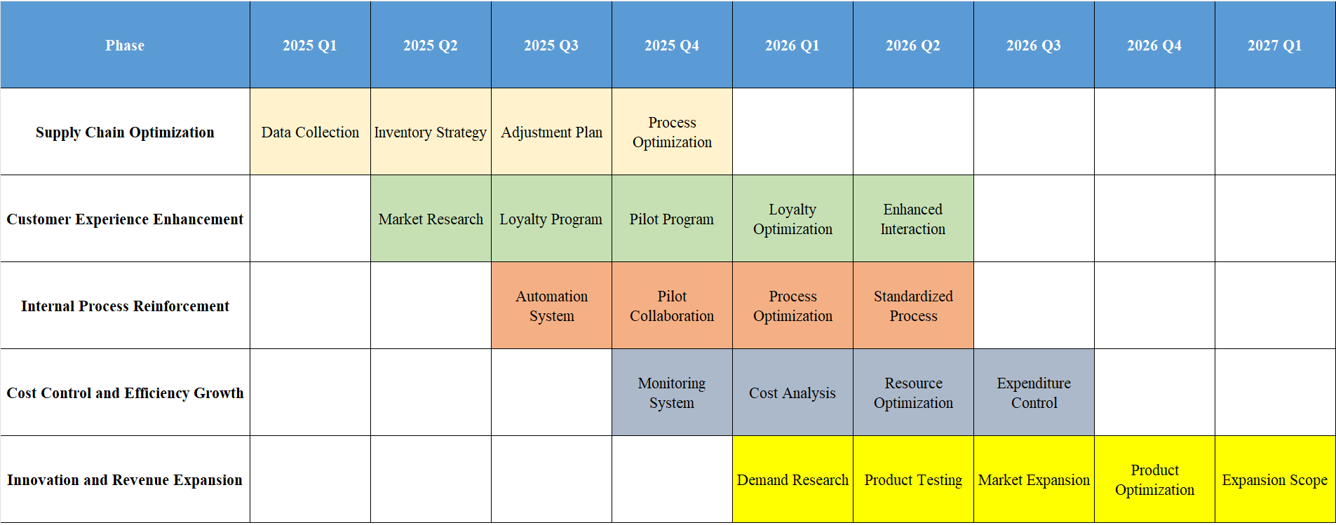
(Created by the author)
Detailed Action Plan
(i) Supply Chain Optimization
Q1 2025: Begin collecting sales and inventory data to assess current status and identify initial areas for improvement.
Q2 2025: Develop inventory strategies based on Q1 data analysis to better align with projected sales trends and consumer demand.
Q3 2025: Adjust replenishment plans based on ongoing sales trends and inventory levels to maintain optimal stock levels, avoiding understocking or overstocking.
Q4 2025: Implement process improvements aimed at reducing inventory backlog and increasing responsiveness to market changes.

(ii) Enhancing Customer Experience
Q2 2025: Launch market research to gather insights into customer preferences, satisfaction levels, and loyalty drivers.
Q3 2025: Revise and improve the customer loyalty program based on the insights gathered from the market research.
Q4 2025: Test the new loyalty program enhancements in select markets or segments and collect feedback.
Q1 2026: Implement enhancements to the loyalty program and customer interaction strategies to improve engagement and retention rates.

(iii) Strengthening Internal Processes
Q3 2025: Introduce marketing automation tools to streamline marketing efforts and improve campaign efficiencies.
Q4 2025: Pilot cross-departmental process collaboration to enhance workflow between departments.
Q1 2026: Process Optimization
Q2 2026: Standardize successful processes and expand them across the company to optimize internal communication and operational efficiency.

(iv) Cost Control and Efficiency Growth
Q4 2025: Establish a cost monitoring system to provide transparent and detailed insights into financial operations.
2026 to 2027: Conduct quarterly cost analyses to identify and eliminate non-essential expenses, reallocating savings to support growth initiatives and enhance profitability.

(v) Innovating for Revenue Expansion
Q1 2026: Initiate a demand survey to identify gaps in the product line and opportunities for new products that meet emerging market needs.
Q2 2026: Begin pilot testing of new products developed based on demand survey findings.
Q3 2026: Refine products based on pilot feedback and prepare for broader market rollout.
2026 to 2027: Gradually expand the product line to increase revenue, aligning new offerings with market trends and consumer preferences.

This Gantt chart plan clearly displays H&M's strategy improvements within the Hong Kong market. Each step is aimed at strengthening H&M's market position, enhancing brand loyalty, and ensuring strategic alignment with the company's VMV. This structured approach not only addresses immediate operational efficiencies but also sets a foundation for sustainable growth and market leadership in a competitive landscape.


