

UWTSD MBA HKBM7009
(UWMBA-30013-2022-1-SS)
HKBM7009 Global Business Challenges

An Analytical Study on Exploring Investment Opportunities in a Global Financial Market: The United Kingdom

Student Name | ： | Lui, Ka Man Kathleen
Student ID Number | ： | 2133986
Date of Submission | ： | 26 Feb 2023
Lecturer | ： | Dr. Che Cheong Poon

UWTSD MBA (May/Nov 2022 intakes)
HKBM7009 Global Business Challenges

Assignment Title:
An Analytical Study on Exploring Investment Opportunities in a Global Financial Market: The United Kingdom

“I, Lui Ka Man (Student ID: 2133986), certify this work is the result of my own investigations, except where otherwise stated. All references have been duly cited”

Signed: 
Date: 26 Feb 2023

Synopsis

Company LF is a Hong Kong jewellery company which has suffered from poor business performance and capital loss since the pandemic (COVID-19) in 2019. LF has little financial investment experience and lack of management about its capital to create additional income for the company. Under the global business challenge in nowadays world, LF need to expand its financial profile and explore investment opportunities in the UK stock market so that it can have a good income statement and improve company’s profile. This report is going to analyze the situation of LF, the UK stock market, the expected return and risks, and recommend an investment plan for LF.

Table of Contents

 |  |  |  | Page
1 Introduction |  |  |  | 1
1.1 | Research motivation and objectives
1.2 | Research framework
2 Company Background |  |  |  | 3
2.1 | Company profile
2.2 | Current investment portfolio and investment performance
2.3 | The global business challenges and the rationale for exploring investment opportunities in the UK financial markets
3 Characteristics of the chosen global stock market |  |  |  | 9
3.1 | A comparison of the stock price index movement between the UK stock market and Hong Kong
3.2 | The UK stock market profile
3.3 | The economic prospect
4 Analysis and discussion |  |  |  | 13
4.1 | Investment return
 | 4.1.1 |  | Capital return
 | 4.1.2 |  | Income return
 | 4.1.3 |  | Equity premium
4.2 | Investment risk
 | 4.2.1 | Stock price volatility
 | 4.2.2 | Market risk
 | 4.2.3 | Exchange rate risk
4.3 Cost and benefit of investing in the UK stock market
5 Conclusion and recommendations |  |  |  | 23
5.1 | Conclusion
5.2 | Recommendations
References |  |  |  | 25

1 Introduction

This report analyzes the challenges and opportunities of the global stock market and then puts forward a strategic recommendation for the company to expand its global business of stock investment in UK.

1.1 Research motivation and objectives

The research motivation is to find out the additional channel for company LF to get extra earnings for the company besides its original business. The report identifies the detailed investment decision of the UK stock market and suggests to LF so that the company can conduct a diversification strategy which is closely aligned with the global trend.

This report is based on the research question of (1) To justify Company LF can generate reasonable profits from the UK stock market and (2) justify the investment in UK stock market can diversify the risk LF’s existing financial portfolio.

In 2022, Hong Kong stock market performed poorly under the weak sentiment in the global IPO market. Hong Kong Exchanges and Clearing Market (HKEX) welcomed 69 new listings and raised HKD $87.8 billion as of 30 Nov (HKEX, 2022) which sounds to be good, but the Hong Kong benchmark index (The Hang Seng Index) suffered a 15% annual loss this year (SCMP, 2022). According to Hong Kong Trade Statistics (2021), Hong Kong’s jewellery exports rebounded rapidly by 65% from 2021 to 2022 after a 20% decline in 2020. Nevertheless, we expected that Hong Kong Jewellery industry will recover after the phasing out of COVID-19 restrictions. In addition, the investment performance of the UK stock market is better than that in Hong Kong in 2022. This urge company LF to consider about the global financial investment in order to manage the financial risk in a post-Pandemic environment.

The research objective is to help Company “LF” diversify its business through overseas stock investment in order to ensure a financial income for the company. In the light of this, this analytical report aims to explore the investment opportunities overseas through global stock market so that it can help LF to manage the asset properly.

In the hope to formulate an appropriate financial investment portfolio diversification strategy which is closely aligned with the global trend, three research objectives are identified as follow:
1) To examine the specific factors that influence the UK stock price
2) To identify the expected return and risk of the UK stock market
3) To suggest the amount of capital and the timeline of the investment in the UK stock market

1.2 Research framework

To achieve the above-mentioned research objectives, a list of relevant data has been collected such as company background, situation analysis and the UK stock market’s characteristics and performance. The analytical methods that have applied are profitability and growth analysis.

The report first briefly describes the company background and the characteristic of the chosen global stock market (The UK). Then, it analyzes the investment return and risk with the quantitative and qualitative evidence. In the end, it provides recommendation for the company.
2 Company background

LF is a jewellery retailer in Hong Kong. It was established in 1991. It operates its business in 10 countries and regions and have over 1800 retail stores. It involves in business areas including sourcing, designing, wholesaling, trademark licensing and retailing of gold, platinum and gem-set jewellery products (LF, 2021). LF has its own financial management department responsible for managing its money in terms of safety, yield and liquidity.

2.1 Company profile

Company LF is one of the leading Jewelry companies in Hong Kong. In the past 3 years (2020-2022), LF was gradually caught up the drastic drop of revenue caused by the outbreak of COVID 19. The revenue of LF in 2022 has achieved +32.5% comparing to 2021 (LF, 2022). However, the pandemic still affects the business environment of LF because of the social distancing policy, restriction in traveling and the global economic recession. There is a need for LF to explore the area of making profits from stock market.

In 1997, LF listed the company on the Main Board of The Stock of Exchange of Hong Kong Limited. It raised HK$95 million of net proceeds. It opened more retail outlets and registered the trademark in both Hong Kong and mainland China. It captured the potential business opportunity in mainland’s gold market at the time of growing economy. As of 2022, current value of LF (as of 31 Mar 2022) is 581 million shares at HKD$19.1 (Yahoo Finance, 2022).
LF was facing great business challenge since 2019 under the impact of COVID-19 pandemic. The total revenue for 2022 has dropped by 19% comparing to 2018 (Pre COVID-19 period) and the trend has continuously dropped for 5 years since 2018 (Figure 1).

The demand for luxury jewellery dropped when the income of people under COVID-19 has been affected (Figure 2). The price and the quantity of luxury jewellery dropped. In Hong Kong, LF’s business relies on the sales from tourists which mainly came from mainland China. As travel restriction and social distancing policy are still active for a long period of time in Hong Kong, LF expanded China’s market by adding 224 stores there to make profits for the company.

The findings show that Hong Kong’s economy does not perform well so Hong Kong stock market also become weak. The jewellery industry in Hong Kong also has a weak performance that also affect company LF’s business. LF should consider managing its assets properly by overseas stock investment and make profits for the company.

Figure 1 LF’s revenue from 2018 to 2022
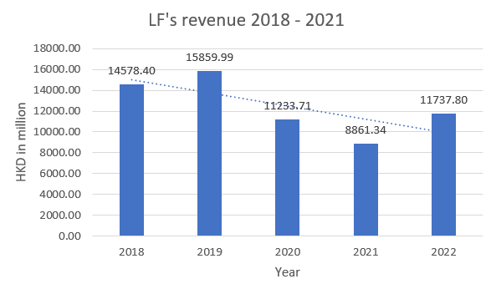
Source: Extracted from the company’s annual report, various years

Figure 2 Demand and Supply of Hong Kong jewellery under COVID-19
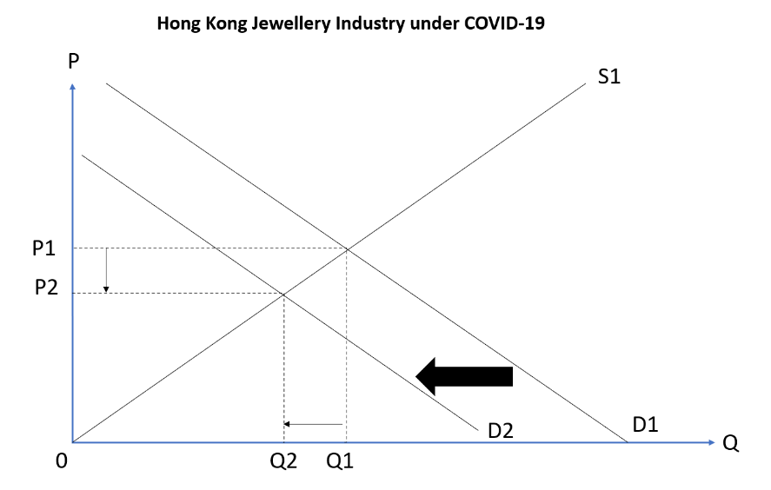
Source: Constructed by author

2.2 Current investment portfolio and investment performance

LF’s current investment portfolio is mainly in the areas of Hong Kong, Mainland China, Macau, Korea, Singapore, Malaysia, Cambodia, Australia, Canada and the United States. LF’s income relies on the business revenue in different global markets and the revenue from property investment in Hong Kong and Mainland China.

For the LF’s business revenue in global markets in 2022, 43% comes from Hong Kong, Macau and Overseas market while 57% come from Mainland China and the segment profit is 11% and 89% respectively (LF, 2022). For the investment property, it comprises of leasehold land and buildings and the revenue comes from long-term rental yields and the capital appreciation. In 2022, LF’s property investment in domestic market (Hong Kong) is 29% while foreign country (Mainland China) is 71% (Figure 3). By comparing to 2018, LF’s strategy had a nearly balanced investment in both places while in 2022 it has shifted its focus from Hong Kong to Mainland China. There is a tendency that LF prefers overseas investment over domestic investment.

Figure 3 Investment portfolio of the LF
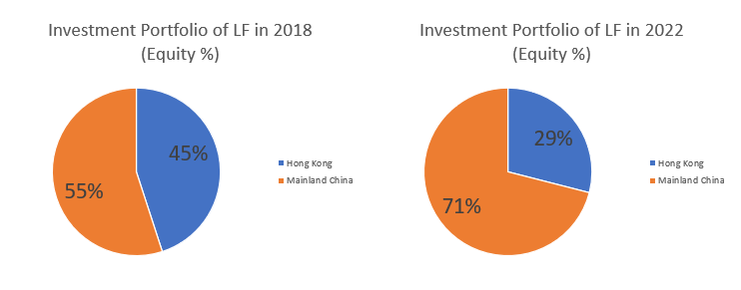
Source: Extracted from company’s annual report, various years

Figure 4: Components of the financial income of LF in 2022
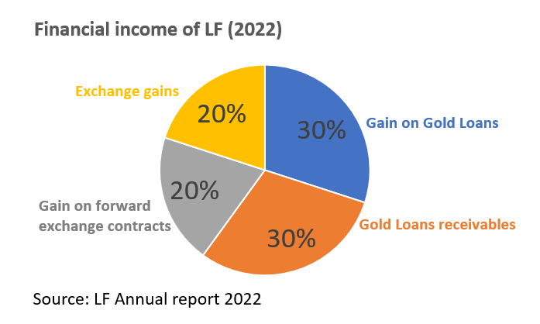
Source: Constructed by author

Table 1: Cost Structure of LF in 2022
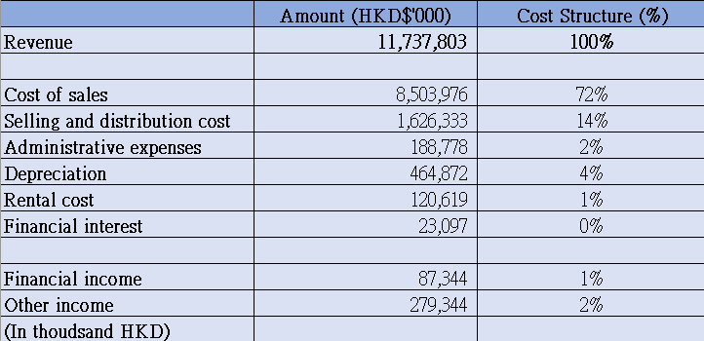
Source: Extracted from the company’s annual report, various year

Under the impact of the COVID-19 crisis, LF has great challenge to manage the financial statement because of the weak economy and drastic drop in sales revenue. Looking into the cost structure of LF in 2022 (Table 1), the cost of sales and selling and distribution cost has already taken up 86% of the revenue so LF has a great pressure cost control. When looking into the financial income in 2022 (Figure 4), it mainly comes from gain on gold loans and gold loans receivables, gain on forward exchange contracts and exchange gains but it is only 1% of the revenue (Table 2). Also, other income comes from government subsidies (COVID-19 subsidies by Hong Kong government) and rental income from LF’s properties investment but it is only 2% of the revenue. LF maintains a weak financial statement at this moment. This means LF should pursue stock investment in order to get more earnings.

2.3 Global business challenges and the rationale for exploring investment opportunities in the UK stock market

The global business challenge of investment in international market is the economic risk that may affect the expected investment return. Besides making profits from the overseas stock market, the company may need to consider the exchange rate to the home country currency. Another challenge is the type of international market that the company is choosing. Emerging market tends to be more volatile than developed market and may have a wider range of potential profits but it may also lead to a lot of investment uncertainties such as political upheaval and financial troubles. Developed market like the UK stock market, there are many world-leading companies and many of those pay high dividends and reported good average yield percentage in the past. To generate a profitable passive income for company LF, the UK stock market can be a good choice.

3 Characteristics of the UK stock market

The UK is the chosen stock market for Company LF. It is chosen because it is ranked 3rd place in the distribution of countries with largest stock market worldwide as of January 2022 by share of total world equity market value (Statista, 2022). The UK stock market can be seen as high potential in the global stock markets. Cboe UK 100 Index (BUK100P) comprised of the largest 100 UK issuers ranked by their full capitalizations. It is a price return index for the usage in the creation of index tracking funds, derivatives and performance benchmark.

3.1 A comparison of the stock price index movement between the UK stock market and Hong Kong

Hang Seng Index (HSI) is the representing index of Hong Kong while Cboe UK 100 (BUK100P) is the representing index of the UK. From the available historical data of the period 2010 to 2022, the comparison of HSI and BUK100P shows that there is discrepancy in the stock performance in the period of 2018 to 2022. From figure 1, the price of HSI has dropped drastically since 2021 while BUK100P has raised back to 2018 level (Pre-COVID period). This implies that the UK market is on its good pace of recovery while Hong Kong stock market is deteriorating continuously.

The correlation matrix of HSI and BUK100P is 0.55 from 2010 to 2022 while the matrix is 0.11 from 2018 to 2022 (Table 1) (Higham, 2002). The correlation coefficients can fall between -1 and +1. If the correlation value is positive, the two variables tend to increase and decrease together. However, correlation matrix of HSI and BUK100P has a low number of 0.11 from 2018 to 2022 so it shows that it may be worth the time to invest in the UK stock market because of the risk diversification between Hong Kong and the UK.

Figure 1 Comparison of Hong Kong (HSI) and The UK (BUK100P) stock price from 2010 to 2022
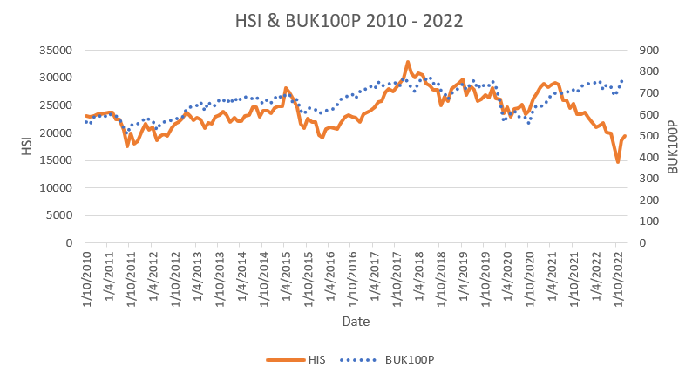
Source: Calculated from HSI and BUK100P stock price from 2010 to 2022

Table 1 Correlation of Hong Kong (HSI) and The UK (BUK100P) index
 | Time Period
 | 2010-2022 (12 Years) | 2018-2022 (5 Years)
BUK100P vs. HSI | 0.55 | 0.11
Source: Calculated from HSI and BUK100P stock price from 2010 to 2022

3.2 The stock market profile

Cboe UK 100 (BUK100P) has a total market capitalization of £2,114,897 (Cboe, 2023). Number of constituents is 98. 1-Year return rate of BUK100P is 4.99%. and 5-Year return rate is 3.09%. This shows that expected return of investing in BUK100P is attractive. The Top 5 Performers are International Consolidated Airlines Group SA, JD Sports Fashion PLC, Howden Joinery Group PLC, Auto Trader Group PLC and Burberry Group PLC (Table 2). The industry weights the most are finance (18%), energy (17%) and consumer non-cyclicals (17%) (Figure 2).

Table 2 Listing companies’ profile in BUK100P
Top 5 Performers | Country | Industry | 1 month return (%)
International Consolidated Airlines Group SA | Spain | Airline | 35.44
JD Sports Fashion PLC | UK | Fashion | 27.81
Howden Joinery Group PLC | UK | Kitchen supplier | 22.92
Auto Trader Group PLC | UK | Auto | 21.10
Burberry Group PLC | UK | Fashion | 20.84
Source: Cboe, 2023

Figure 2 Sector weights in BUK100P
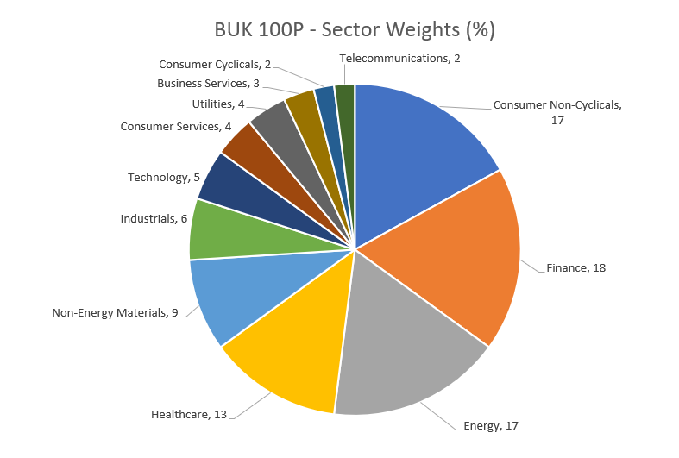
Source: Cboe, 2023

3.3 The economic prospect

The economic prospect could be determined by the inflation rate and the Real Gross Domestic Product.

Firstly, the inflation rate of the UK is 9.1% in 2022 (IMF, 2022). It has raised by nearly 4 times the rate in 2018 which is 2.5%. The high inflation occurs because of the increase in money supply relative to the level of productive output in the UK (Doan, 2020). It implies the purchasing power of British Pound declines.

Secondly, Real Gross Domestic Product (GDP) measures the economic growth from one period to another and adjusted for inflation or deflation (Gordon, 2014). The real GDP growth rate of the UK is 3.6% in 2022 (IMF, 2022). Compared to 2018, the real GDP growth rate has increase by 2 times (from 1.7% to 3.6%) and the trend of the economic growth in the UK seems to be recovering and the business opportunity also looks appealing.

The high inflation rate means rising price of goods and services, corporations’ profits and growth margins may be hit and it can affect investor confidence and hold less stocks so the stock price will go down. However, the real GDP growth rate increases which means UK firms on the whole are performing positively. It suggests for more reinvesting which will lead to higher future earnings and stock prices.

4 Analysis and discussion

After examining the factors that influence the UK stock price, the below discuss about the expected return and risk of the UK stock market in order to provide a holistic view of the investment plan.

4.1 Investment return
Investment return measures the effectiveness or profitability of the investment choice. It can measure the efficiency of the UK stock investment.

4.1.1 Capital return

Capital return refers to the gains when the investment is sold for more than its purchase price (Beaumont and Begemann,1997).

The total equity of Company LF is HKD$11,324,224,000 as at 31 March 2021. With the assumption of taking the financial income from 2022 amounted HKD$87,344,000, which is 0.77% of the total equity to invest in the UK stock market in 2023. With the exchange rate of 1:0.10 exchange rate (Google Finance, 2023), the capital for investment is £8,734,400.

The closing price of BUK100P on 2 Feb 2023 is 781.59 and the number of share that LF can invest is 11,175 shares. With the reference of the past 66 days (as of 2 Feb 2023), the rate of return is +9.39% (Invest Tech, 2023). If company LF invest in BUK100P on 2 Feb 2023, the expected capital return is going to be £820,133 after 66 days of investment.

Table 1 Capital return of the UK stock investment
Capital return | Item | Amount
Capital return | Capital for investment from LF  (1:0.10 HKD to GBP) | HKD$87,344,000  =£8,734,400
Capital return | Stock price as of 2 Feb 2023  (Source: Yahoo Finance, 2023) | £781.59
Capital return | Number of shares LF can purchase | 11,175 shares
Capital return | Rate of return  (past 66 days) | +9.39%
Capital return | Expected stock price  (after 66 days) | 781.59*(1+9.39%)  =£854.98
Capital return | Capital gain | (854.98-781.59)*11,175  =£820,133
Source: Constructed by author

4.1.2 Income return

Investment income refers to the profits from interest payment, dividends and any other profits made through the investment vehicle.

CBOE dividend distributes quarterly and the most recent dividend amount was £0.50 per share on 30 Nov 2022 (Tip Tanks, 2023). The dividend yield is 1.59%. The record dates are end of Feb, May, Aug and Nov while the payment dates are 15th of Mar, Jun, Sept and Dec. LF can invest in Feb 2023 and entitle to the dividend payout in Mar.

If company LF invest in BUK100P, the expected income return is going to be £5,587.58.

Table 2 Income return of the UK stock investment
Income return | Item | Amount
Income return | Dividend amount | £0.50 per share
Income return | Number of shares LF can purchase  (Feb 2023) | 11,175 shares
Income return | Dividend payout  (Mar 2023) | 11,175 shares * $0.50  =£5,587.58
Income return | Income return | £5,587.58
Source: Constructed by author

4.1.3 Equity premium

Equity premium is the difference between the return on a stock and return on a bond (Fama and French, 2002). It can be calculated by total return on stock (RS) minus the treasury bill rate (RTB).
Equity Premium = RS - RTB
= [CRS + IRS] – [Inflation + Real interest rate]
= [CRS – Inflation] + [IRS – Real interest rate]
RS is the total return on stocks
CRS is capital return (i.e., capital gain)
IRS is income return (i.e., dividends)
RTB is the Treasury bill return (i.e., interest rate on zero risk investment)
(Jorion and Goetzmann, 1999)

Total return on stock (RS)
= capital return (CRS) + income return (IRS)
= £820,133 + £5,587.58
= £825,720.58

Treasury Bill rate (RTB)
=Inflation + Real Rate
= 9.1% + (-2.20%)
= 6.9%

Equity Premium
= RS – RTB
=[CRS + IRS] - [Inflation + Real Rate]
= (9.39% +1.59%) – (9.10% + -2.20%)
= 10.98% - 6.90%
= 4.08%

The equity premium is £825,720.58*4.08% = £33,689.40. By utilizing the historical rate of return of BUK100P, it shows a positive and attractive expected stock returns in 66 days of investment. However, this is a calculation over a risk-free rate so Company LF should also consider about the investment risk.

Company LF can earn £820,133 after 66 days of investment with the capital of £8,734,400. The return on investment (ROI) is 9.39% which is very attractive. In addition, the dividend yield is 1.59% and distribute quarterly. It is a very stable return during the investment. The equity premium is £33,689 and it set a good portfolio return expectation and determine the asset allocation. To summarize, the expected return of investing in the UK stock market is good.

4.2 Investment risk

Investment risk is the risk associated with financial transactions and it could imply potential for financial loss and uncertainty about the investment choice.

4.2.1 Stock price volatility

Volatility measures the dispersion of returns for a given security or market index (Denizer, Lyigun and Owen, 2000). The higher the volatility, the riskier the security. BUK100P has a smaller coefficient of variation (CV) of 9.83% compared to 13.56% in HSI (Table 1). The period before COVID and after COVID also aligns that the CV of BUK100P is smaller than HSI. Also, BUK100P has a smaller volatility compared to HSI in figure 1. Therefore, the price movement of BUK100P tends to be smaller and stays relatively stable. For a beginner of the UK stock investment like company LF, a low volatility stock is preferrable.

Figure 1 Volatility of stock price index movements in HSI and BUK100P from 2010 to 2022
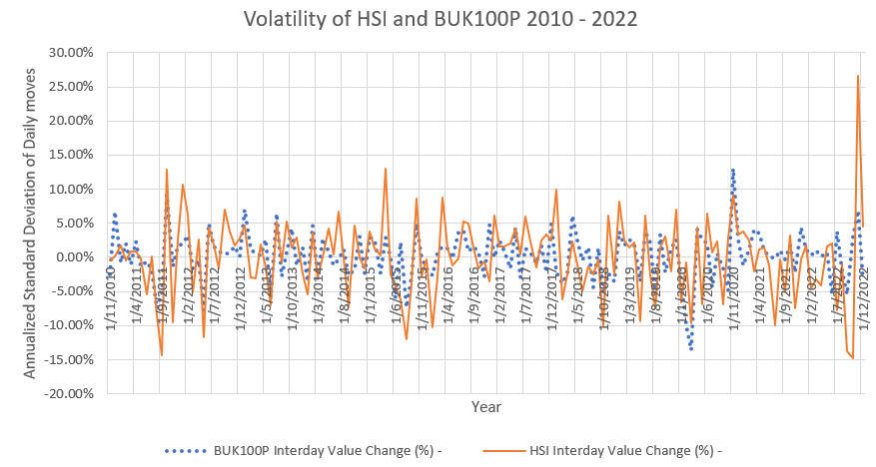
Source: BUK100P and HSI’s stock price, various years

Table 1: Coefficient of variation of HSI and BUK100P from 2010 to 2022
Coefficient of variation (CV) | BUK100P | HSI
All time (2010-2022) | 9.83% | 13.56%
Before COVID-19 (2010-2018) | 9.98% | 13.15%
After COVID-19 (2019-2022) | 8.34% | 13.78%
Source: Calculated from BUK100P and HSI’s stock price from 2010-2022

4.2.2 Market risk

The performance of the entire market can affect the investment. The variables can be inflation and interest rate. Inflation of the UK is 9.10% and the nominal interest rate is 4.00% in 2023 (Trading economics, 2023) and it is at 5-year high level (Figure 2). 9.10% inflation rate has become its highest level for 40 years.

High inflation can make stock investment costly so it is giving certain risk to company LF to invest in the UK stock market. However, stocks tend to be more volatile when inflation is elevated so riskier investment can bring potential higher return. Value stocks can perform better under high inflation because their prices have not kept up with the peers. Nevertheless, high inflation will cause damage to the economic growth and employment in the UK and hurts stock market in general. The stock price can become lower.

High interest rate can affect the UK stock market because the borrowing becomes more expensive for businesses. It can affect the earnings of the business and the revenue drop can cause its stock price drop as well. Then, the key index will drop and it can affect the investors. The investment seems to be risky in this situation. There are exceptional cases that high interest rate is beneficial to the business such as financial industry. Examples like banks, mortgage companies, insurance companies can earn more when interest rate moves higher. By looking at figure 2, UK has an exceptional high inflation rate in 2022 when compared to 2018 to 2021, and the interest rate has been raised accordingly in order to lower the inflation rate as its monetary policy. If high interest rate sustains, it can hurt the UK stock market and the stock price can become lower.

According to the forecast by IMF (BBC, 2023), the UK is expected to be the only country to shrink in 2023 across all the advanced and emerging economies because of its complex issues in the UK, such as high energy prices, rising mortgage costs, increased taxes and persistent worker shortages. If UK is predicted to be shrinking in 2023, it will imply that the UK companies make less money and a higher unemployment problem may be arisen. It can affect UK stock price to become lower and it will be unfavorable for LF to invest in the UK stock market in 2023. The current UK prime minister Rishi Sunak has pledged to halve inflation by the end of 2023 and the energy price rises has forecasted to be slowdown as the post-pandemic supply problems ease. End of 2023 or early 2024 could be a better period for UK stock investment.

Figure 2 Inflation and interest rate of the UK from 2018 to 2022

Source: Rate Inflation, 2018-2022; Country Economy, 2023

4.2.3 Exchange rate risk

Exchange rate risk refers to the risk that the investment and profitability of a company may be affected by the change of the exchange rates between currencies (Cushman, 1983). The risk will be caused by currency volatility.

The exchange rate of British Pound (GBP) to Hong Kong Dollar (HKD) is HKD$9.46 (Bloomberg, 2023) and it is a 5-year low level. In another words, the earnings from investment in GBP may lead to capital loss when it exchanges to HKD. If GBP exchange rate continues to drop, it will be not favorable to the UK stock investment.

Transaction exposure is the uncertainty that involved in international trade and foreign currency. If the company LF involves in the investment in the UK stock market and later the exchange rate become more expensive in the future, the company will bear the capital losses during the transaction.

Exchange rate is hard to predict and company LF can be vulnerable in this situation. One thing can be managed in prior is the timing of entering to the UK stock market. Company LF can check on the monetary policy of the UK that can be linked to consumption spending and investment spending and thus affect UK stock prices. According to the latest monetary policy report, Bank of England has raised the interest rate from 0.1% in Dec 2021 to 4% in Feb 2023, so they expected that the inflation will fall quickly in 2023 (Bank of England, 2023). The Bank of England’s Monetary Policy Committee (MPC) sets monetary policy to meet the 2% inflation target. The monetary policy seems to be favorable to the UK stock investment.

4.3 Cost and benefit of investing in the UK stock market

The return of the investment in the UK stock market is attractive because of the good capital return, stable income return and good equity premium can be generated. The risk evaluation for the investment can see that UK stock has a lower volatility which imply a stable investment. However, the market risks like high inflation rate and high interest rate can lead to lower stock price. The exchange rate risk also can be potential risk that led to capital loss. By evaluating the cost and benefit, the UK stock market is worth to invest but company LF has to choose a better timing.

5 Conclusion and recommendations
After analyzing the challenges and opportunities of the UK stock market, it can conclude that return of the investment is attractive while the investment risk is high in the time period of early 2023.

5.1 Conclusion

With the detailed analysis, Company LF can generate a reasonable profit by investing in UK stock market but it may not diversify the risk of LF’s existing business due to the unfavorable economy forecast of the UK in 2023.

The factors of affecting UK stock price are the inflation rate, the interest rate and real GDP. The expected return of investing in the UK stock market is attractive which has a good return on investment but the risks are the expected inflation rate, expected interest rate and the exchange rate risk. In terms of risk diversification, investing in UK stock market in early 2023 will only increase the risk of the finance of company LF. However, in terms of profit generation, the choice of investing in UK stock market is preferrable.

5.2 Recommendations

The strategic recommendation for company LF is to go for the decision of investing in the UK stock market with a better timing. As the inflation and interest rate is high now and it leads to potential stock price drop, it is recommended that LF can expand its global business of stock investment in UK in quarter 4 (Oct – Dec) of 2023 which has a lower risk of investment.

The limitation of this report is that there are some uncontrollable factors such as political factor that can also affect the stock price. There are complex issues in the UK such as high energy prices, rising mortgage costs, increased taxes and persistent worker shortages. These are all the unfavorable factors and affect the investor’s confidence.

References
BBC (2023). UK expected to be only major economy to shrink in 2023 – IMF. Available at: https://www.bbc.com/news/business-64452995 (Accessed: 15 Feb 2023).

Beaumont, M. & Begemann, E. (1997). Measuring associations between working capital and return on investment. South African Journal of Business Management, 28(1), pp. 1-5.

Bloomberg (2023). GBP-HKD X-Rate. Available at: https://www.bloomberg.com/quote/GBPHKD:CUR (Accessed: 5 Feb 2023).

Cboe (2023). Cboe UK 100 Index January 2023. Available at: https://cdn.cboe.com/resources/europe/indices/factsheet/buk100p-factsheet.pdf (Accessed: 3 Feb 2023).

Cushman, D. O. (1983). The effects of real exchange rate risk on international trade. Journal of international Economics, 15(1-2), pp. 45-63.

Denizer, C., Iyigun, M. F. & Owen, A. L. (2000). Finance and Marcoeconomic Volatility (No. 670). World Bank Publications.

Doan, D. (2020). Money supply and inflation impact on economic growth. Journal of Financial Economic Policy, 12(1), pp. 121-136.

Dornbusch, R. (1985). Purchasing power parity.

Fama, E. F. & French, K. R. (2002). The equity premium. The Journal of Finance, 57(2), pp. 637-659.

Google Finance (2023). HKD/GBP. Available: https://www.google.com/finance/quote/HKD-GBP?sa=X&ved=2ahUKEwjwpJf83Y_9AhUhgMYKHeniB2MQmY0JegQIBxAd (Accessed: 12 Feb 2023).

Gordon, R. J. (2014). A new method of estimating potential real GDP growth: Implications for the labor market and the debt/GDP ratio (No. w20423). National Bureau of Economic Research.

Higham, N. J. (2002). Computing the nearest correlation matrix—a problem from finance. IMA journal of Numerical Analysis, 22(3), pp. 329-343.

HKEX (2022). HKEX IN 2022: YEAR IN REVIEW. Available at: https://www.hkex.com.hk/News/News-Release/2022/221220news?sc_lang=en#:~:text=During%202022%2C%20HKEX%20welcomed%2069,capital%20raised%20during%20the%20period. (Accessed: 11 Jan 2023).

IMF (2022). Real GDP Growth. Available at: https://www.imf.org/external/datamapper/NGDP_RPCH@WEO/GBR
(Accessed: 2 Feb 2023).

IMF (2022). Inflation rate, average consumer prices. Available at: https://www.imf.org/external/datamapper/PCPIPCH@WEO/GBR (Accessed: 2 Feb 2023).

IMF (2022). Implied PPP conversion rate. Available at: https://www.imf.org/external/datamapper/PPPEX@WEO/GBR (Accessed: 2 Feb 2023).

Invest Tech (2023). UK100 (CBOE) (BUK100P.L) Complete report. Available at: https://www.investtech.com/main/market.php?CompanyID=44113301&product=241 (Accessed: 3 Feb 2023).

Jorion, P., & Goetzmann, W. N. (1999). Global stock markets in the twentieth century. The journal of finance, 54(3), pp. 953-980.

LF (2018). Annual Report 2018. (Accessed: 29 Jan 2023).

LF (2022). Annual Report 2022. (Accessed: 11 Jan 2023).

Rate inflation (2023). UK inflation summary. Available at: https://www.rateinflation.com/inflation-rate/uk-inflation-rate/ (Accessed: 15 Feb 2023).

SCMP (2022). Goodbye to 2022 stock pain as Hong Kong market looks for a fresh restart with China reopening bets. Available at: https://www.scmp.com/business/china-business/article/3205013/hong-kong-stocks-set-finish-year-upbeat-mood-amid-optimism-about-chinas-growth-outlook (Accessed: 11 Jan 2023)

Statista (2022). Countries with largest stock markets globally 2022. Available at: https://www.statista.com/statistics/710680/global-stock-markets-by-country/ (Accessed: 22 Feb 2023).

Trading economics (2023). United Kingdom Interest Rate. Available at: https://tradingeconomics.com/united-kingdom/interest-rate (Accessed: 4 Feb 2023).

Tip Ranks (2023). Cboe Global Markets (CBOE) Dividend Date & History. Available at: https://www.tipranks.com/stocks/cboe/dividends (Accessed: 3 Feb 2023).

Yahoo Finance (2022). LF historial price. (Accessed: 29 Jan 2023).

