
APPENDIX GA36b

LEVEL 5ASSESSMENT SPECIFICATION

Student name: | Cerys Elizabeth Gulley | Student ID number: | P151440
Programme: | HND/BSc in Civil Engineering and Environmental management
Module: | Civil Engineering Technology 2
Module code: | M5X01869 | Contribution to Overall Module Assessment (%): | 50%
Lecturer: | Dr Keerthi Ranasinghe | Internal Verifier: | Dr Juan Ferriz-Papi
Assignment Title: | Civil Engineering Case Study | Word count (or equivalent): | 2500
Submission deadline: | 11th December 2018 | Return date of provisional marks & written feedback: | 14thDecember 2018
Submission method: | All written assessments, where practical and possible, must be submitted via Turnitin unless otherwise instructed by the Lecturer. (Please DO NOT put this assessment specification into Turnitin or it will match many similarities with other students’ submissions.)  Alternative submission method (if applicable):  Late submission of the assessment will result in a late penalty mark. Penalties for late submission: Up to one week late, maximum mark of 40%. Over one week late, 0%. Only the Extenuating Circumstances Panel may approve a change to submission dates.
Academic honesty / referencing: | Academic honesty is required. In the main body of your submission you must give credit to authors on whose research and ideas your work is based. Append to your submission a reference list that indicates the books, articles, etc. that you have used, cited or quoted in order to complete this assessment.

Module Learning Outcomes
(from module syllabus)
- Evaluate methods and techniques used in tunneling activities
- Examine methods and techniques used in hydraulic and marine structures
- Compare and contrast methods and techniques used in highway construction and railway works

TASK DESCRIPTION

You are required to select a civil engineering project/task of your own choice and submit a report on this based on the following general guidelines. You may add/delete/expand this to suit your selected civil engineering project/task.

1. Introduction
a. General background to the project
b. Why the project was necessary
c. Were there any problems that needed solving before/during/after the project?
d. Historical significance
2. Design aspects
a. Environmental factors
b. Appreciation of the problems
c. Loadings if any
d. Structure
3. A schematic to highlight the design
a. You may use section drawings
b. You may use sketches
c. You may use annotated pictures (please give references where necessary)
4. Construction materials and methods
a. Identify the different materials and/or components used
b. Identify the construction methods and machinery used
c. Justify their selection
5. Discussion/Conclusions
a. Advantages/disadvantages of the construction methods used
b. Alternative methods available
c. MOST IMPORTANT – What you learned from studying this project

You may choose your civil engineering project/task from the list below, or from your industry experience.

- Three Gorges Dam
- Canadian Pacific Railway
- London Underground
- Coastal Defences
- Hoover Dam
- Retaining Walls
- Golden Gate Bridge

Write a report of approximately 2500 words following the above guidelines. It is recommended to add photographs and your own schemes, drafts and drawings. You should differentiate properly your own contribution from other authors. If any images or documents used are not yours, you should reference them using the Harvard Referencing System. Additionally, include an abstract with the most relevant features about your work (not more than 150 words).

You will also have to do a presentation in class about your work (between 5 to 10 minutes long).
GUIDANCEFOR Students IN THE COMPLETION OF TASKS

NOTE: The guidance offered below is linked to the five generic assessment criteria overleaf.

- Engagement with Literature Skills
Your work must be informed and supported by scholarly material that is relevant to and focused on the task(s) set. You should provide evidence that you have accessed an appropriate range of sources, which may be academic, governmental and industrial; these sources may include academic journal articles, textbooks, current news articles, organisational documents, and websites. You should consider the credibility of your sources; academic journals are normally highly credible sources while websites require careful consideration/selection and should be used sparingly. Any sources you use should be current and up-to-date, mostly published within the last five years or so, though seminal/important works in the field may be older. You must provide evidence of your research/own reading throughout your work, using a suitable referencing system, including in-text citations in the main body of your work and a reference list at the end of your work.

Guidance specific to this assessment:

- Knowledge and Understanding Skills
At level 5, you should be able to demonstrate: sound knowledge and critical understanding of the well-established concepts and principles of the subject area and the way in which those principles have developed; knowledge of the main methods of enquiry in the discipline. Knowledge relates to the facts, information and skills you have acquired through your learning. You demonstrate your understanding by interpreting the meaning of the facts and information (knowledge). This means that you need to select and include in your work the concepts, techniques, models, theories, etc. appropriate to the task(s) set. You should be able to explain the theories, concepts, etc. meaningfully to show your understanding. Your mark/grade will also depend upon the extent to which you demonstrate your knowledge and understanding.

Guidance specific to this assessment:

- Cognitive and Intellectual Skills
You should be able to critically analyse information, and propose solutions to problems arising from that analysis, including the critical evaluation of the appropriateness of different approaches to solving problems. Your work must contain evidence of logical, analytical thinking, evaluation and synthesis. For example, to examine and break information down into parts, make inferences, compile, compare and contrast information. This means not just describing what! But also justifying: Why? How? When? Who? Where? At what cost? At all times, you must provide justification/evidence for your arguments and judgements. Evidence that you have reflected upon the ideas of others within the subject area is crucial to you providing a reasoned and informed debate within your work. Furthermore, you should provide evidence that you are able to make sound judgements and convincing arguments using data and concepts, with an understanding of the limits of knowledge, and how this influences analyses and interpretations. Sound, valid conclusions are necessary and must be derived from the content of your work. Where relevant, alternative solutions and recommendations may be proposed.

Guidance specific to this assessment
- Practical Skills
At level 5, you should be able to use/deploy a range of established techniques within the discipline, and apply underlying concepts and principles outside the context in which they were first studied, including, where appropriate, the application of those principles in an employment context. You should be able to demonstrate how the subject-related concepts and ideas relate to real world situations and/or a particular context. How do they work in practice? You will deploy models, methods, techniques, and/or theories, in that context, to assess current situations, perhaps to formulate plans or solutions to solve problems, or to create artefacts, some of which may be creative. This is likely to involve, for instance, the use of real world artefacts, examples and cases, the application of a model within an organisation and/or benchmarking one theory or organisation against others based on stated criteria. You should show awareness of the limitations of concepts and theories when applied in particular contexts.

Guidances pecific to this assessment:
- Transferable Skills for Life and Professional Practice
Your work must provide evidence of the qualities and transferable skills necessary for employment requiring the exercise of personal responsibility and decision-making. This includes demonstrating: professional development to advance existing skills and acquire new competences that will enable you to assume significant responsibility within organisations; that you can initiate and complete tasks and procedures, whether individually and/or collaboratively; that you can use appropriate media to effectively communicate information, arguments and analysis in a variety of forms to specialist and non-specialist audiences; fluency of expression; clarity and effectiveness in presentation and organisation. Work should be coherent and well-structured in presentation and organisation.

Guidances pecific to this assessment:

Student FEEDBACK FORM

This section details the extent to which the assessment criteria are demonstrated by you, which in turn determines your mark. The marks available for each category of skill are shown. Lecturers will use the space provided to comment on the achievement of the task(s), including those areas in which you have performed well and areas that would benefit from development/improvements.
Generic Assessment Criteria | Marks available | Marks  awarded
1. Engagement with Literature Skills
.
2. Knowledge and Understanding Skills

3. Cognitive and Intellectual Skills

4. Practical Application Skills

5. Transferable Skills for Life and Professional Practice

Assessment Mark (Assessment marks are subject to ratification at the Exam Board. These comments and marks are to give feedback on module work and are for guidance only until they are confirmed. ) | Late Submission Penalties (tick if appropriate) |  | %
 | Up to 1 week late (40% Max) |  | %
 | Over 1 week late (0%) |  | %

Case Study
Analysis of the existing seawalls and proposals for beach defences in Swansea Bay

By
Cerys Elizabeth Gulley

Submission Date: 4th December 2018
Module: Civil Engineering Technology 2
Module Code:M5X01869

Contents
Contribution to Overall Module Assessment (%): 0
1. Introduction 8
1.1 Mean Sea Levels 8
1.2 Consequences of Rising Sea Levels 8
2. Swansea Bay Coastline 10
2.1 Governors and their Roles 10
2.3 Coastal Risk Management Programme 11
3. Current Defences 12
3.2 Concrete Steps 13
4. Suggestions 17
4. Conclusion 19
5. References 20
6. Bibliography 23

1. Introduction
Coastal defences are crucial to protecting our shorelines around the United Kingdom and are under pressure with rising sea levels and surges in adverse weather (Mathiesen, 2018). In South Wales, particularly Swansea Bay, there have been discussions about the current coastal defences and consultations over a Tidal Lagoon being constructed (Swansea.gov.uk, 2018).
1.1 Mean Sea Levels
Within the last century sea levels have been surging faster than anticipated and reports to have stated that the situation has deteriorated significantly since the 1970's (oceanservice.noaa.gov, 2016). Scientists published a report in Nature Climate Change deducing that escalation in mean sea levels (MSL) was primarily driven by aerosols, greenhouse gas emissions (GHG) and the burning of fossils fuels as well as a slight influence by the natural climate (bbc.co.uk, 2016). Dr John Church, a sea-level rise expert for the Commonwealth Scientific and Industrial Research Organisation (CSIRO) stated these factors had become “a dominant force, contributing to 70% of rise in sea levels from 1970 to the present day” (csiropedia.csiro.au, 2010).
1.2 Consequences of Rising Sea Levels
Anthropogenic factors and GHG emissions have negatively affected the Earth's climate which has altered its weather patterns dramatically and adversely causing many countries to see an increase in flash floods, higher river flows, sea level rises and frequent storms (LIFE Project, 2009, pp6) with forecasts for circumstances to continually degrade (Figure 1).
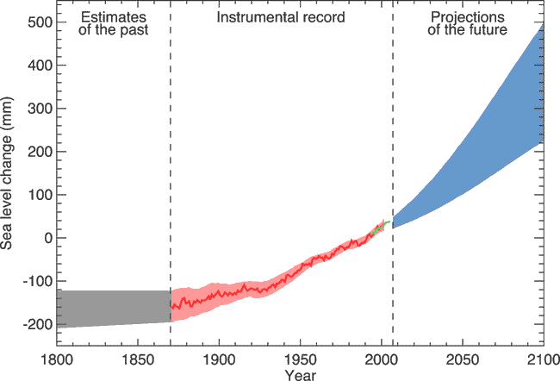

(Figure 1: A graph illustrating the increase in sea levels over the century. coolgeography.co.uk)

Due to recurrent and larger quantities of rainfall the UK had difficulty dealing with exacerbated rates of flooding in drainage, sewers, water tables, fluvial, pluvial and coastal flooding and the damage that it causes (LIFE Project, 2009, pp6). In recent years, particularly along the south coast of Wales, maintenance costs of defences to stop over-topping and extreme flooding has risen and alternative solutions have been investigated meticulously (ncbi.nlm.nih.gov, 2014). The more recent £1.3 billion solution for defending the Swansea Bay coastline by implementing a clean power lagoon sea structure has caused great controversy over wildlife, the economy and ethics, which has left the project in limbo (Vaughan, 2018). However, the local council, Carwyn Jones (First Minister of Wales) and investors believe the project should go ahead as it would provide clean energy, create many local jobs during and after construction as well as providing a new recreational area for the public (BBC News, 2018).

2. Swansea Bay Coastline
Swansea is a low-lying coastal area comprising of limestone and sand/mudstone in South Wales that has diverse defences along its coast including natural dunes and man-made structures (Naturalresources.wales. 2018). Under the Flood and Water Management Act 2010 and Flood Risk Regulations 2009 Swansea Council are liable for the management of flood risk and infrastructure development along the coastline (Swansea.gov.uk. 2018).

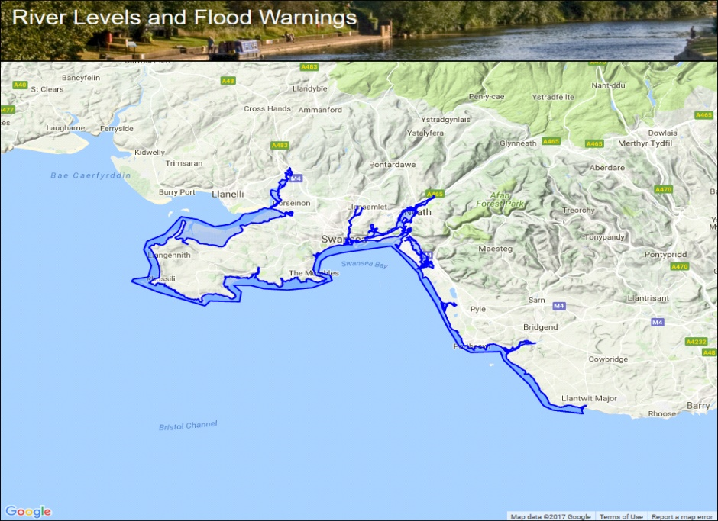
(Figure 2: A map of Swansea Bay displaying a coastal flood alert and the extent of potential flooding (Riverlevels.uk. 2018).
2.1 Governors and their Roles
Under the Flood and Water Management Act (2010) managing and funding the risk of flood and coastal erosion lies with the Welsh Government, Natural Resources Wales (NRW) and local authorities (assemblyinbrief, 2016). Their purpose is to protect the community, businesses and environment from the ramifications of coastal flooding and erosion by investing in projects which are designed to protect the area in a sustainable manner (assembly.wales, 2016). Figure 2 highlights the coastal flood alert and the extent of potential flooding along Swansea Bay (Riverlevels.uk. 2018).
2.2 Damages
Recent storms have caused extensive damage along the South Wales coastline (Parry, 2018) amounting to approximately £8.1 million (assemblyinbrief, 2016). However, NRW stated that “74,000 properties along the coast were at risk of flooding but did not due to many years of investment and maintaining current coastal defences” (Naturalresources.wales. 2018).
2.3 Coastal Risk Management Programme
This year a £256 million investment into flood and coastal erosion risk management will be implemented by the Coastal Risk Management Programme (Gov.wales. 2018). Following the review of NRW the programme initiated a two-stage plan where the objective is to reduce the risk to homes and businesses by firstly assessing impacts of flooding and secondly recommending any improvements to local authorities (Engineersvblogspot, 2018). Despite the opportunity to gain economic, environmental and social benefits the programme has inconsistent support from the Welsh Government and European Investment Bank who continue to cut funds (assemblyinbrief, 2016).
Coastal management involves evaluating the area at risk and implementing a strategy that will protect the land with as little interference as possible (Swansea.gov.uk. 2018). The council have guidelines which have four coastal defence options, from which one must be selected for each segment of the Bay (Swansea.gov.uk. 2018).
The options are as follows (Gov.wales. 2018):
1) Do-Nothing - An approach where no intervention is required in order to maintain the section of coast and doing nothing should still be priced and put into the project for comparison.
2) Hold the existing defence line – Maintain the coastline in its current position using soft defence approaches. I.e. natural sand dunes.
3) Advance the existing defence line – Implement a forward movement of the shore towards the sea.
4) Retreat the existing defence line – Implement a retraction of shoreline in order to construct a harder defence approach with the intention of reducing coastal erosion/flooding. I.e. concrete structured wall.

3. Current Defences
The Coastal Risk Management Programme encourages the development of soft engineering (sand dunes, salt marshes etc) with the intention of working with nature (geography.learnontheinternet.co.uk, 2016). Along the Bay there are many types of defences which were designed to limit interference with the surrounding environment and these include vertical walls, curved walls, steps, groynes and natural dunes (Swansea.gov.uk. 2018) much like its neighbour Aberavon Bay further east along the South Wales coastline.
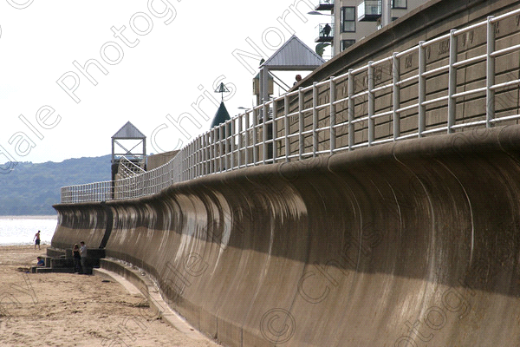
3.1 Curved Face Seawalls
These types of walls are designed to absorb, reflect and withstand high wave action effects but are greatly used despite being expensive as they are effective for many years (The Constructor. 2018). This defence has been placed near residential buildings on the east side of the Bay as it provides strength and security for residents (Figures 3 and 4).
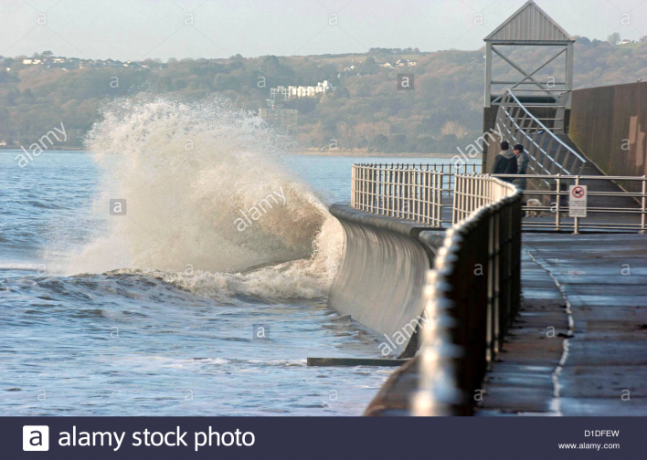
(Figure 3 and 4: A picture of the curved face seawall and when it is reflecting waves on the east side of Swansea Bay. Limited, A. 2018).
Sometimes the foundation materials erode away due to scouring or over-topping so sheet piling or boulders are used in the design of the wall in order to provide stability and form a solid foundation for the coastal defence (Figure 5).

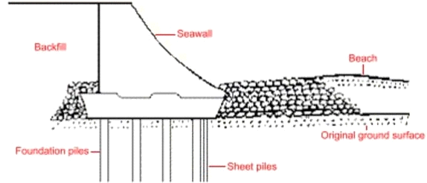

(Figure 5: Illustration of curved face seawall and its components. The Constructor. 2018).

This structure has large construction costs and also carries a high maintenance cost (S-cool.co.uk. 2018). These structures have been used in a variety of areas but recently it has been noted that water with a high saline content (sea water) has been eroding the defence at a quicker rate and thus reducing their life span (The Constructor. 2018).

3.2 Concrete Steps
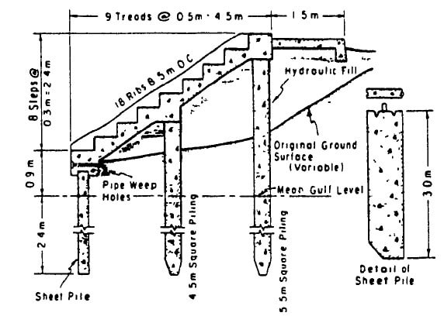
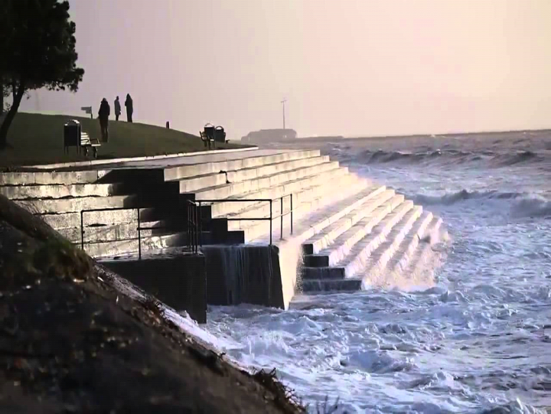
Further down the beach, more towards the centre of the Bay lies a concrete step structure which is another form of a hard engineering coastal defence as can be seen by Figures 6 & 7 below (The Constructor. 2018). They are designed to reflect moderate wave action and are cheaper to construct than the curved face wall (The Constructor. 2018).
(Figure 6 and 7: (left) concrete steps at Swansea Bay, (right) illustration of the design of the structure (Limited, A. 2018).

They comprise of reinforced concrete sheet piles with tongue – and - grove joints and the space between the piles is filled with either grout or lined with geotextile fibre to keep out sand but allows some sea water through as it prevents hydrostatic pressure (Se-coastalgroup.org.uk. 2018).
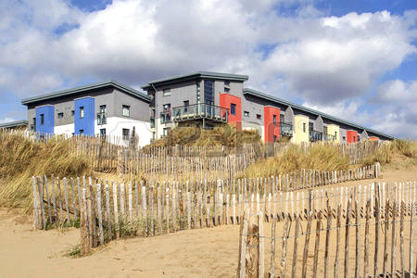
3.3 Dunes
Although the coast is a natural defence sometimes it needs encouragement to help develop its natural barricade (Se-coastalgroup.org.uk. 2018). This can be done by planting marram grass in fenced off areas to create sand dunes (Figure 8).
(Figure 8: Fenced area with growing marram grass constructed by residential buildings for a natural defence. Gulley 2018).
Marram grass has extremely long roots which reach down through the sand into the water table whilst also growing upwards through the ever growing sand dune and binding it together (S-cool.co.uk. 2018). This technique relies on the wind and wave action pushing sand up the beach towards the land in order to replenish eroded shorelines (S-cool.co.uk. 2018). It is fairly easy to implement, is cost effective as there is little maintenance involved and it also acts as a filter to remove vital nutrients and pollutants from the sea water. However, this method of coastal defence could not be applied along the main part of Swansea Bay as it takes a considerable time to establish this system and it does not bare well high wave energy environments (Se-coastalgroup.org.uk. 2018).
3.4 Groynes
A groyne is a vertical barrier that extends from the beach out towards the sea and is designed to capture sand through longshore drift (sea comes in at 45º and goes out at 90º; sand is captured as it is coming in with the sea) (Se-coastalgroup.org.uk. 2018). Groynes can be constructed out of wood as seen in Figure 9, stone or concrete depending on the size, permeability and the natural size of the beach (The Constructor. 2018).

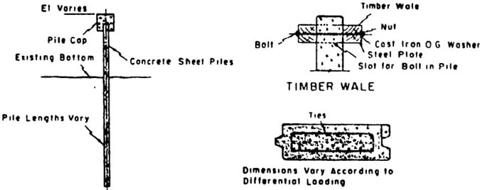
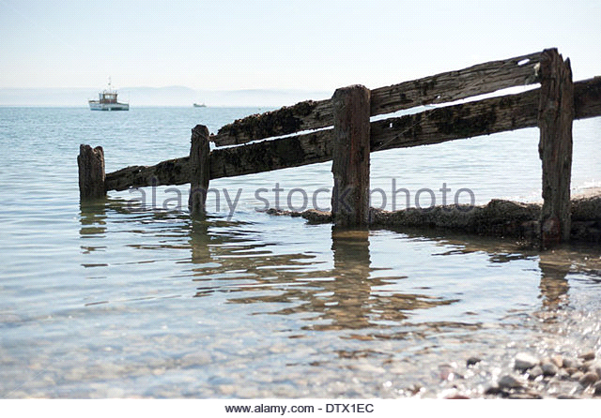
(Figure 9 and 10: (left) Damaged wooden groyne on Swansea beach, (Right) illustrations of groyne design. Limited, A. 2018)
With current plans to build a tidal lagoon around Swansea Bay it is unlikely that new groynes will be installed (Naturalresources.wales. 2018). Despite preventing longshore drift and
being cheaper than concrete sea walls, the groynes were not developed with sustainability in mind (Gov.wales. 2018) and although they've conserved the beach for tourism, their life span was very short due to being made from timber and they were expensive to maintain (Swansea.gov.uk. 2018).
3.5 Vertical Seawalls
Vertical seawall structures are designed to absorb high wave impacts and are best in areas where there are large waves for long periods of time, such as the Mumbles (Swansea.gov.uk. 2018). They can be constructed from concrete, steel, stone or timber (Se-coastalgroup.org.uk. 2018) and in Swansea they are constructed with concrete (Figure 11). Even though the wall is made from concrete, is quite robust and has a good life span, it has been facing a lot of discrepancy lately by the local authorities as sea water has been breaching the top of this design and flowing into the highways and traffic, causing complications with drainage (Gov.wales. 2018).

With rising sea levels water is spilling over the top and across the pavement into the roads, which has led to flooding as the sewage system cannot cope with the extra water (assembly.wales, 2016). However, this issue is expected to be minimised if/when the tidal lagoon is built as it will limit the amount of high waves hitting the wall (SouthWalesSMP).

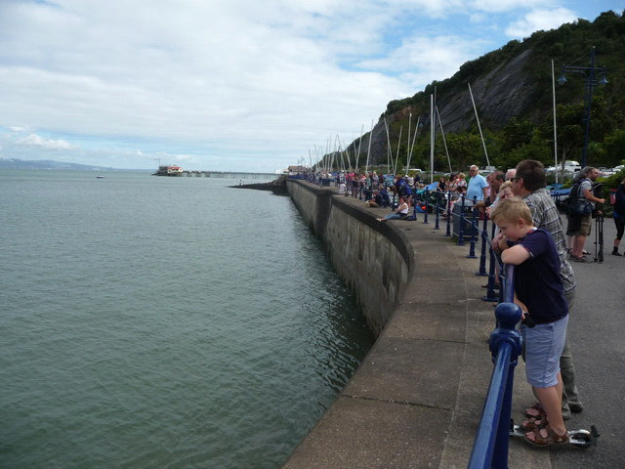
(Figure 11: Vertical Wall on the west side of Swansea Baby. Limited, A. 2018)
In the short term these types of sea defences are practical and have a life span of up to 50 years but the ongoing maintenance is costly and they often cause greater erosion problems by scouring the beach (The Constructor. 2018).

4. Suggestions
Swansea Bay has diverse and appropriate structures down its coastline but in recent years with more aggressive storms and rising MSL the defences have been struggling to protect the coast (coolgeography.co.uk). Yet, a few miles to the east Port Talbot's beach has very similar structures and hasn't had the same problems with flooding despite having higher wave action (npt.gov.uk, 2016).
Through researching coastal defence designs and comparing Port Talbots use of natural and man-made defences to Swansea's, there are some suggestions that could be considered for any future developments in Swansea.
1) Boulder Barriers – They are used to absorb high impact wave energy and the mixture of boulder sizes aids the build-up of beaches (Figure12).
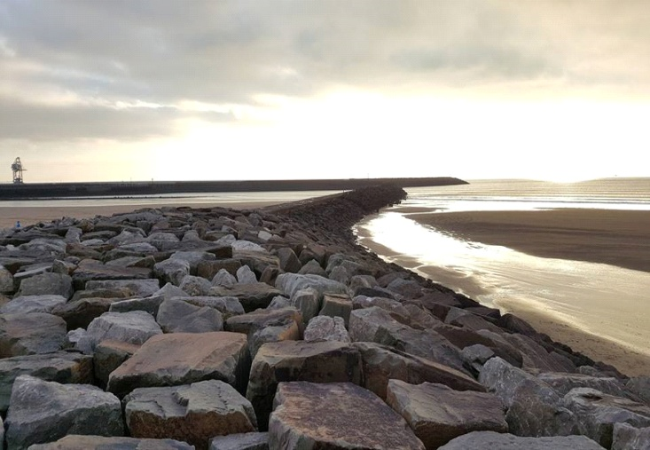
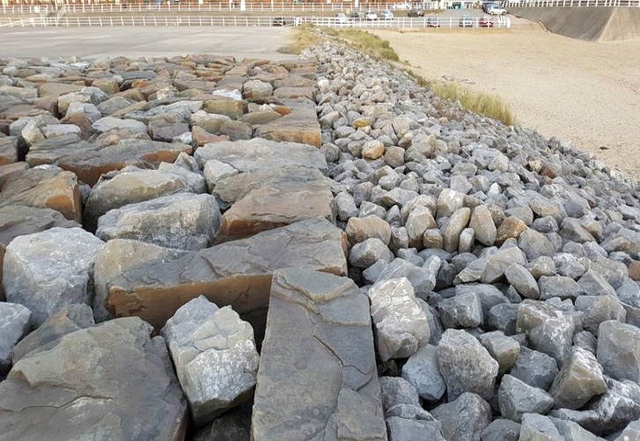
(Figure 12 and 13: (left) Boulders. Gulley, 2017, (right) Boulder Groyne. Gulley,2017)
These boulders offer a natural defence against erosion and can also be arranged to form a stone groyne (Figure 13) that again aids the build-up of the beach. The size of the rocks does mean that transportation costs are high, however, maintenance is almost negligible in comparison to the one in Swansea and this design would not be difficult to introduce to the Bay (southwalescoast.org, 2016).
2) Curved Face and Step Seawall – This defence structure is a combination of the curved face seawall and concrete step seawall (Figure 14). Its ability to reflect high wave energy, maintain strength and ductility is what makes this design adequate for its setting (ncbi.nlm.nih.gov, 2014).

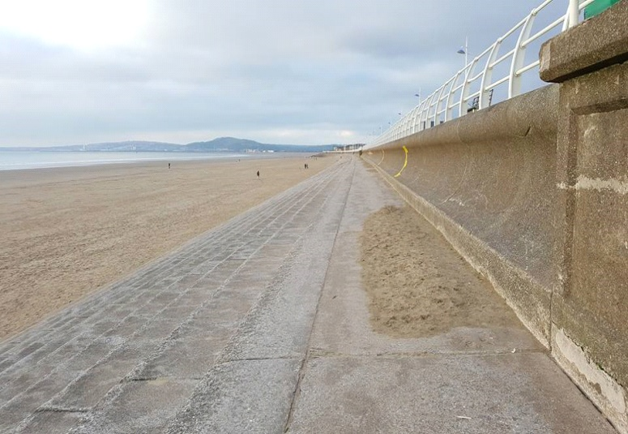
(Figure 14: Curved Face and Step Seawall, Port Talbot. Gulley, 2017).
Implementing this design in Swansea Bay would come with great difficulty and cost as whole segments of existing sea defences would have to be removed. On the other hand, short term expenses would be outweighed by long term benefits and profits as overall maintenance costs of the Bay would be significantly reduced (Swansea.gov.uk. 2018).
That being said, any suggested developments would not be required if the Tidal Lagoon project goes ahead and it would create a breakwater that would lower the high impact waves which are causing the most problem along Swansea Bay (Swansea.gov.uk. 2018).

4. Conclusion
Building bigger and better coastal defences is not always possible and alternative measures to manage erosion and flooding along the coastline need addressing through public awareness.
As campaigned by NRW the continuous evolution along the Bay should be monitored and any new developments such as the Tidal Lagoon should be welcomed. At this moment in time Swansea Bay is managed sufficiently and the use of soft and hard engineering techniques is currently working and with an ever-increasing tourism there in an even greater need to maintain coastal defences.
Adaptation and mitigation is key to reducing the long-term effects of erosion/flooding along the UK's coastlines and new developments such as the tidal lagoon will provide renewable energy and new technologies that will also aid in reducing the effects of GHG emissions and anthropogenic influences.

5. References
(oceanservice.noaa.gov, 2016). Is sea level rising?. Available at http://oceanservice.noaa.gov/facts/sealevel.html. [Accessed 23 Nov 2018].
(bbc.co.uk, 2016). Sea-level raises factors unravelled. Available at http://www.bbc.co.uk/news/science-environment-36029753. [Accessed 23 Nov 2018].
(csiropedia.csiro.au, 2010). Will we need to adapt to rising sea levels. Available at
https://csiropedia.csiro.au/we-will-need-to-adapt-to-rising-sea-levels/. [Accessed 12 Nov 2018].
(BBC News, 2018) Swansea tidal lagoon 'will still happen'. [online] Available at: http://www.bbc.co.uk/news/uk-wales-south-west-wales-42659742 [Accessed 1 Dec 2018].
(unep.org, 2017). Climate Change Mitigation. Available at http://www.unep.org/climatechange/mitigation/. [Accessed 11 Nov 2018].
(coolgeography.co.uk). Coastal Flooding & Sea Level Rise Causes. Available at http://www.coolgeography.co.uk/GCSE/AQA/Coastal%20Zone/Sea%20level%20rise/Sea%20level%20rise.htm [Accessed 15 Nov 2018].
(SouthWalesSMP) South Wales SMP - SMP, Welcome. [online] Available at: http://www.southwalescoast.org/ [Accessed 4 Dec 2018].
(Riverlevels.uk. 2018). Swansea Bay and the Gower coast. [online] Available at: https://www.riverlevels.uk/flood-warning-swansea-bay-and-the-gower-coast#.WpydGpPFKHo [Accessed 11 Nov 2018].

(LIFE Project, 2009, pp 6). The Life Handbook: Long-term Initiatives for Flood-risk Environments. [Accessed 6 Nov 2017].

(Vaughan, 2018) Government indecision leaves £1.3bn Swansea tidal lagoon project in limbo. [online] the Guardian. Available at: https://www.theguardian.com/environment/2018/jan/11/welsh-tidal-lagoon-project-in-limbo-government-indecision [Accessed 3 Dec. 2018].

(ncbi.nlm.nih.gov, 2014). Coastal flood damage and adaptation costs under 21st century sea-level rise. Available at https://www.ncbi.nlm.nih.gov/pmc/articles/PMC3948227/. [Accessed 13 Nov 2018].

(assemblyinbrief, 2016). In Brief: Managing flood risk. Available at https://assemblyinbrief.wordpress.com/tag/flooding/. [Accessed 2 Dec 2018].

(assembly.wales, 2016). Coastal Flood and Erosion Risk Management in Wales. Available at
http://www.assembly.wales/laid%20documents/agr-ld10723/agr-ld10723-e.pdf [Accessed 14 Nov 2018].
(npt.gov.uk, 2016). Local Flood Risk Management Strategy Executive Summary. Available at
https://www.npt.gov.uk/pdf/LFRMS_ENVT1668_Local_Flood_Risk_Management_Strategy_Summary.pdf. [Accessed 14 Nov 2018].

(Parry, 2018) A flood alert has been issued in coastal areas across Wales. [online] walesonline. Available at: https://www.walesonline.co.uk/news/local-news/flood-alert-been-issued-coastal-14099377 [Accessed 9 Nov. 2018].
(Gov.wales. 2018). Welsh Government|Flood and coastal erosion. [online] Available at: http://gov.wales/topics/environmentcountryside/epq/flooding/?lang=en [Accessed 8 Nov 2018].
(Naturalresources.wales. (2018). Natural Resources Wales / Flood and coastal erosion risk in Wales. [online] Available at: https://naturalresources.wales/evidence-and-data/research-and-reports/reports-evidence-and-data-on-flooding/flood-and-coastal-erosion-risk-in-wales/?lang=en [Accessed 8 Nov. 2018].
(Engineersvblogspot, 2018) ICE. [online] Engineersv.blogspot.com. Available at: http://engineersv.blogspot.com/2014/05/ [Accessed 9 Nov 2018].
Swansea.gov.uk. (2018). Swansea - Drainage and coastal management. [online] Available at: https://www.swansea.gov.uk/article/5390/Drainage-and-coastal-management [Accessed 13 Nov 2018].
(geography.learnontheinternet.co.uk, 2016). Coastal Management. Available at
http://www.geography.learnontheinternet.co.uk/topics/coastal_management.html [Accessed 21 Nov 2018].

(The Constructor. 2018). Types of Coastal Protection Structures and their Details. [online] Available at: https://theconstructor.org/structures/coastal-protection-structures/14020/ [Accessed 5 Nov 2018].
(S-cool.co.uk. 2018). Coastal Management Strategies | S-cool, the revision website. [online] Available at: https://www.s-cool.co.uk/gcse/geography/coasts/revise-it/coastal-management-strategies [Accessed 15 Nov. 2018].

(Limited, A. 2018). Stock Photo - Swansea, UK. 17th December 2012. Early morning walkers watching the waves crash into the waterfront sea wall at Swansea Marina this morning at high tide. Credit: Phil Rees. [online] Alamy. Available at: http://www.alamy.com/stock-photo-swansea-uk-17th-december-2012-early-morning-walkers-watching-the-waves-52543313.html [Accessed 15 Nov. 2018].
Se-coastalgroup.org.uk. (2018). [online] Available at: http://www.se-coastalgroup.org.uk/wp-content/uploads/2012/02/Coastal-Defences.pdf [Accessed 25 Nov. 2018].

southwalescoast.org, 2016. Coastal Processes and Shoreline Behaviour. Available at
http://www.southwalescoast.org/smp/files/SMP_2012/FINAL%20SMP2%20Report%20and%20Appendices%20PDF%20version/Appendix%20C%20Baseline%20Process%20Understanding/Annex%20A1%20Coastal%20Processes%20and%20Shoreline%20Behaviour/Annex%20A1%20REPORT.pdf. [Accessed 21 Nov 2018].
(Mathiesen, K. 2018). Extreme weather already on increase due to climate change, study finds. [online] the Guardian. Available at: https://www.theguardian.com/environment/2015/apr/27/extreme-weather-already-on-increase-due-to-climate-change-study-finds [Accessed 19 Nov. 2018].

( Swansea.gov.uk. 2018). Swansea - Drainage and coastal management. [online] Available at: https://www.swansea.gov.uk/article/5390/Drainage-and-coastal-management [Accessed 11 Nov. 2018].

6. Bibliography
(Stock Photos. 2018). [online] Available at: https://www.123rf.com/stock-photo/swansea_bay.html [Accessed 2 Dec. 2018].
(Mmbfc.co.uk, 2018) Mumbles Motor Boat & Fishing Club. [online] Available at: http://mmbfc.co.uk/Shore-Marks-1.php [Accessed 11 Nov. 2018].

Bolwell, J. (2018). On the sea wall in Mumbles (C) Jeremy Bolwell. [online] Geograph.org.uk. Available at: http://www.geograph.org.uk/photo/3609865 [Accessed 5 Nov. 2018].
YouTube. (2018). Big Waves & Stormy Seas in Swansea Bay - January 6th, 2014.. [online] Available at: https://www.youtube.com/watch?v=U9M7AsSCks8 [Accessed 10 Nov. 2018].

Bqlive.co.uk. (2018). ECA backs first minister’s offer for tidal lagoon development. [online] Available at: http://www.bqlive.co.uk/energy/2018/01/16/news/eca-backs-first-ministers-offer-for-tidal-lagoon-development-29982/ [Accessed 12 Nov. 2018].
(Alamy.com, 2018).Wooden Posts Of Groyne Stock Photos & Wooden Posts Of Groyne Stock Images - Alamy. [online] Available at: http://www.alamy.com/stock-photo/wooden-posts-of-groyne.html [Accessed 15 Nov. 2018].

Swansea.gov.uk. (2018). Swansea - Drainage and coastal management. [online] Available at: https://www.swansea.gov.uk/article/5390/Drainage-and-coastal-management [Accessed 15 Nov. 2018].

Bellis, K. (2018). Torrential rain causes flash flooding across Wales. [online] walesonline. Available at: https://www.walesonline.co.uk/news/wales-news/torrential-rain-causes-flash-flooding-14184518 [Accessed 23 Nov. 2018].
(Naturalresources.wales. 2018).[online] Available at: https://naturalresources.wales/media/674504/mca-26-swansea-bay-and-porthcawl_final.pdf [Accessed 9 Nov. 2018].
(Tingle, A. 2018). Flood Maps. [online] Flood.firetree.net. Available at: http://flood.firetree.net/?ll=44.5905,-17.5781&z=14 [Accessed 17 Nov 2018].

