







Associated British Foods Plc

Module: Managing Market Change Code: & BMMB7026

Student Name and Id Harsh Shah (2421969)
Lahiru Chathuranga (2414277)
Manish Koirala (2410889)
Muhammad Zaryab (2423275)
Samuel Dhinakaran (2416236)


Name:- shah Harsh Ashishbhai Student id:- 2421969

ASSOCIATED BRITISH FOODS
PLC’s Marketing Challenge

CHANGES IN CONSUMER BUYING BEHAVIOUR IN RETAIL


Introduction to Associated British Foods PLC

▶ Associated British Foods PLC (ABF) is a diversified international conglomerate with significant interests in ingredients, food, and retail (Associated British Foods PLC, 2023).
▶ Within its portfolio, the retail segment is exclusively represented by Primark, which contributes 100% of the segment's revenue and over 60% of the group's total profit, making it ABF's most significant consumer-facing operation (Associated British Foods PLC, 2023, p. 12).

PRIMARK INTRODUCTION


▶ Primark is now one of Europe's largest and fastest-growing clothing retailers, with a leading market position in the UK in terms of sales volume and a rapid expansion in the United States (Primark, 2023). It now has 451 stores across 18.8 million square feet of selling space in 17 countries as of 2024 and employs more than 82,000 colleagues internationally (Primark, 2023). Founded by Arthur Ryan in 1969 when it launched its first store in Dublin, Ireland, the city remains the
location of Primark's international headquarters today (Primark, 2023).

Driving Forces of Change in Consumer Behavior at Primark
- Digital-First Expectations
73% of UK consumers anticipate online-offline seamlessness (Deloitte, 2023, p. 17). Primark's delayed e-commerce launch (2021) creates competitive vulnerability (Financial Times, 2021).
- Sustainability Imperative:
65% of global consumers prefer green brands (NielsenIQ, 2022, p. 9).
ABF's goal for 2025 of 100% sustainable packaging mirrors market pressure (ABF, 2023, p. 23).

- Post-Brexit Economic Pressures:
Sterling depreciation increased apparel importation by 15% (Office for National Statistics,
2022).
Forced price increases threaten Primark's value proposition (Bloomberg, 2023).

- Experience Economy:
60% of Gen Z favors in-store experience over transactions (McKinsey & Company, 2024, p. 31).
Physical stores remain the main engagement channel for Primark (Primark, 2023).

Impact On Marketing Management

Behaviour Shift | Marketing Challenge | Data Insight
Price Sensitivity | Margin compression post-  Brexit | Basic apparel category losses due to 5% price hikes in 2023 (ABF, 2023, p. 45)
Digital Integration | Lag in omnichannel engagement | Only 25% of marketing budget allocated to digital channels (Deloitte, 2022, p.  17)
Ethical Consumption | Trust deficit in fast fashion | 50% sustainable packaging  achieved; 2025 target remains unmet (ABF, 2023,  p. 23)









SWOT Analysis
STRENGTHS
by 2027
Global Scale: 432 stores in the USA and Europe → Rapid rollout of initiatives (ABF Report, 2023).
Primark Cares: 100% sustainable cotton
WEAKNESS
Supply Chain Complexity: ”Traceability to Tier 3 suppliers remains challenging.” Price Constraints: "Balancing ethics with affordability, purchase margins“ (Bloomberg, 2023).
THREATS
OPPORTUNITIES
Circular Models: Testing in-store
recycling in 10 markets.
Digital Engagement: Enhancing the app
to communicate ethics
Reputation Risk: Greenwashing
accusations could damage trust. Competitor Pace: H&M/Zara lead in resale infrastructure ( Primark, 2023)

Strategic Recommendations
▶ Omnichannel (Seamless shopping experience ) Enhancement:-
Action: - Implement AI-driven personalization systems
output:- Increase e-commerce contribution in total revenue
▶ Dynamic Pricing Model:
Action:- Establish real-time localized pricing models (e.g., regional adjustments reflecting
import cost differentials)
Output:- Mitigate post-Brexit import cost inflation while retaining price-sensitive market
segments.
▶ Sustainability Communication:-
Action:- Integrate eco-initiatives (e.g., "Fashion with Purpose“ campaign)
Output:- Close the gap in sustainable packaging or fabric.
▶ Supply Chain Resilience: -
Action:- Adopt activity-based pricing mechanisms with suppliers to distribute Brexit- related risks
Output:- Enhance operational agility against customs disruptions and cost volatility

References
▶ Associated British Foods PLC (2023) Annual Report 2023. Available at: https://www.abf.co.uk/investor- centre/reports. (Accessed: 16 June 2025).
▶ Primark (2023) Primark Company Information. Available at: https://www.primark.com/en/our-company. (Accessed: 16 June 2025).
▶ Deloitte (2023) Consumer Trends 2023: The Future of Retail. Available at:
https://www2.deloitte.com/uk/en/pages/consumer-business/articles/retail-trends.html. (Accessed: 16 June 2025).
▶ Financial Times (2021) Primark’s E-Commerce Delay Leaves It Vulnerable. Available at:
https://www.ft.com/content/7f3b06b5-fc20-4c85-b86b-0274db7f1934. (Accessed: 16 June 2025).
▶ NielsenIQ (2022) Green Brands Report 2022. Available at: https://nielseniq.com/global/en/insights/report/2022/the-
rise-of-green-consumerism/. (Accessed: 16 June 2025).
▶ Office for National Statistics (2022) UK Trade: Goods and Services, October 2022. Available at: https://www.ons.gov.uk/economy/nationalaccounts/balanceofpayments/bulletins/uktrade/october2022. (Accessed: 16 June 2025).
▶ Bloomberg (2023) Sterling Weakness Pushes UK Apparel Prices Higher. Available at: https://www.bloomberg.com/news/articles/2023-03-15/uk-retailers-hit-by-sterling-drop. (Accessed: 16 June 2025).
▶ McKinsey & Company (2024) The Gen Z Consumer Pulse: Retail in 2024. Available at: https://www.mckinsey.com/industries/retail/our-insights/gen-z-and-the-future-of-shopping. (Accessed: 16 June 2025).




Name:- Lahiru Chathuranga Dissanayake
Student ID:- 2414277

MANAGING MARKETING CHANGE

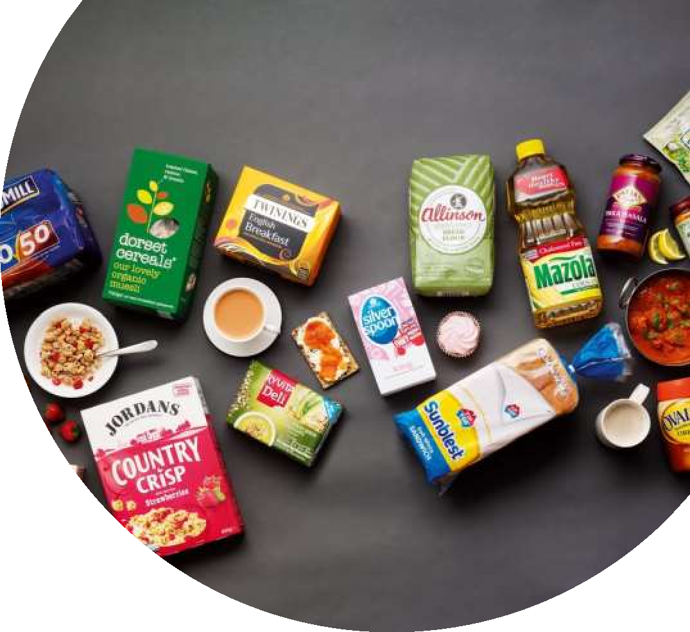
INTRODUCTION – ABF PLC
Company Overview
Associated British Foods plc (ABF) – FTSE100 multinational.
Operates in 56 countries with 138,000 employees (ABF, 2024).

Group revenue
- £20.1bn; adjusted operating profit £1.998bn.
(Associated British Foods, 2025)
Grocery Division
- Includes global and regional brands - Twinings, Patak’s, Blue
Dragon, Jordans, Dorset Cereals.

- Grocery revenue (2024) - £4.24bn, 21% of group total.

Focus of Study
Impact of climate change and sustainability on ABF Grocery’s marketing strategies.

11

ABF’S INDUSTRY & GROCERY DIVISION
ABF’s Industry & Grocery Division Porter’s Five Forces Analysis
Aspect | Details
Key Segments | Retail, Grocery, Ingredients,  Sugar, Agriculture
Grocery Revenue  (FY2024) | £4.24 billion (21% of total group  revenue)
Major Brands | Twinings, Ovaltine, Patak’s, Blue  Dragon, Jordans, Dorset Cereals, Mazola
Market Presence | Europe, North America, Asia,  Australia
Brand Highlights | Twinings – #1 UK tea; Jordans – #1 granola brand in Western  Europe
Grocery Workforce | ~17,000 employees globally
Strategic Focus | Strong brand equity, global  presence, high consumer trust

Force | Description | Impact Level
Competitive Rivalry | High competition from Nestlé, Unilever, private labels, and local brands. | High
Supplier Power | Moderate – dependent on agricultural inputs; climate risk affects sourcing. | Medium
Buyer Power | Strong retail buyers (Tesco, Walmart) demand low prices and ESG compliance. | High
Threat of Substitutes | Increasing preference for local, organic, and plant- based alternatives. | Medium
Threat of New  Entrants | Low due to brand loyalty, scale, and regulatory compliance costs. | Low

12

Definition & Relevance of the Issue
Sustainability
Meeting today’s needs without compromising future
generations. (Danciu, 2013)

Climate change
Long-term global shifts in temperature and weather
patterns affecting crop supply.
Relevance to ABF
- Climate change disrupts agricultural supply chains— over 70% of ABF’s grocery inputs (e.g., tea, oats, spices) rely on climate-sensitive crops (ABF, 2024).

- 76% of global consumers now consider brand sustainability in purchase decisions, pressuring ABF to adapt marketing strategies and product development

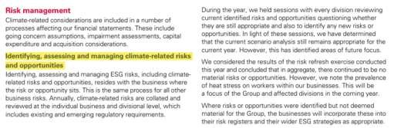
Figure 01 - Climate-related risks
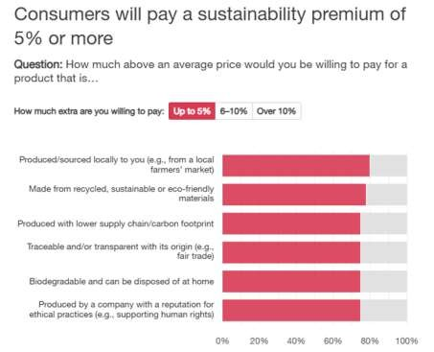
Sources : Adapted from Associated British Foods plc. (2024)

(PwC, 2024).
Issue for marketing

ABF must align product, branding, and campaigns with
sustainability expectations”

Brand sustainability in purchase decisions
Sources : Sources : PwC, 2024
13

Why This Is a Marketing Issue for ABF
- Consumer expectations are shifting – 47% of global buyers prefer
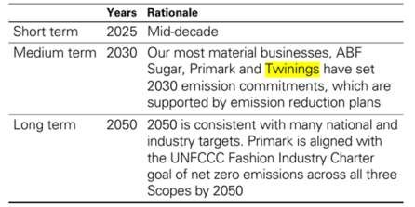
products aligned with sustainability values (PwC, 2024).

- Retailers demand ESG compliance, influencing shelf placement, pricing strategy, and long-term brand partnerships.

- Competitors like Unilever and Nestlé actively market their low-carbon
and ethical brands, pressuring ABF to keep pace.

- Twinings has committed to becoming carbon neutral by 2030 and uses
recyclable materials (ABF, 2024).

- Jordans and Dorset cereals promote biodiversity farming under the 'Big Five for Nature' initiative.

- Marketing teams must communicate sustainability credentials clearly, using storytelling, eco-labels, and transparent sourcing to meet consumer and stakeholder expectations.

Emission commitments
Sources : Adapted from Associated British Foods plc. (2024)

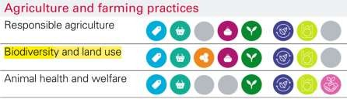
Biodiversity and land use
Sources : Adapted from Associated British Foods plc. (2024)

14

Challenges Arising from Climate & Sustainability Pressure
PESTLE Analysis
- Supply chain vulnerability
Factor | Description & Impact
Political | Global and regional regulations such as the EU Deforestation Regulation (2023) and UK Plastic Packaging Tax mandate traceability and sustainable sourcing. ABF  must adapt to avoid fines and maintain retail partnerships.
Economic | Inflation in energy and agricultural commodities raises production costs. In FY2024, ABF cited rising input costs across tea and cereals, particularly due to energy volatility  (ABF, 2024, p. 14).
Social | Sustainability is a growing concern: 76% of global consumers prefer sustainable brands (PwC, 2024). Brand transparency, eco-labels, and ethical sourcing are now key  marketing drivers.
Technological | Investment in eco-packaging tech and supply chain traceability (e.g., blockchain pilots) is essential for  competitive advantage and consumer trust.
Legal | ABF must comply with strict ESG disclosure requirements (e.g., CSRD in the EU), which increases reporting  complexity across global brands (ABF, 2024, p. 40).
Environmental | Climate change affects sourcing of tea, spices, and cereals. ABF supports regenerative agriculture to build resilience;  e.g., Twinings' farms in Kenya (p. 19).

Climate shocks like droughts in East Africa disrupt Twinings’ tea sourcing and quality consistency (ABF, 2024, p. 19).

- Regulatory compliance
New EU Deforestation Regulation (EUDR) impacts Patak’s and Blue Dragon, which rely on spice and palm-based ingredients.

- Brand risk
Consumers expect proof—ABF must ensure claims (e.g., recyclable packaging by Twinings) are backed by traceable, verified data to protect brand credibility.

- Operational adaptation
Investing in eco-packaging, renewable energy,
sustainable farming 15

Challenges Arising from Climate & Sustainability Pressure Cont……
Strengths | Weaknesses
Strong brand portfolio – e.g., Twinings (UK’s1 tea) and Jordans (leading granola brand in W. Europe) (ABF,  2024, p. 7). | Complex supply chains with exposure to climate-sensitive crops like tea and spices.
Longstanding commitment to sustainability (e.g., Twinings’ net zero plan, regenerative agriculture projects  in Kenya and Thailand – p. 19). | ESG efforts vary by brand; lack of a unified sustainability narrative across the grocery segment.
Global market reach and consumer  trust across Europe, Asia, and North  America. | Some packaging and sourcing  strategies still dependent on fossil  fuels and non-recyclable materials.
Transparent ESG reporting and  governance frameworks (p. 40). | High cost of compliance with  evolving international regulations  (EUDR, UK plastic tax).
Opportunities | Threats
Rising consumer demand for eco- friendly and ethical brands – 76% globally prefer sustainable products  (PwC, 2024). | Competitors (e.g., Unilever, Nestlé) aggressively market sustainable alternatives and gain market share.
Expansion of carbon labelling and green packaging could differentiate  ABF’s offerings. | Climate shocks and geopolitical risks threaten ingredient sourcing and  logistics.
Leverage digital traceability tools (e.g., blockchain for transparency) to enhance consumer confidence. | Increased scrutiny of greenwashing claims could damage brand reputation if sustainability efforts lack  verification.

The grocery division of Associated British Foods encounters essential difficulties because of climate change and sustainability requirements. The supply chains of Twinings and Jordans face disruption because of climate- sensitive crops such as tea and oats while the EU Deforestation Regulation requires enhanced traceability.

The market demands sustainable branding because 76% of consumers now choose products with environmental responsibility.

The SWOT and PESTLE tools show how brands face risks from greenwashing and the difficulty of matching genuine sustainability with market competition and regulatory requirements.

16

ABF’s Current Change Management Approach

- Devolved ESG structure
Each grocery brand manages sustainability independently
through divisional teams.

- Twinings
Committed to net-zero by 2030 with carbon offset and recyclable packaging initiatives (ABF, 2024, p. 12).

- Patak’s – Project SPICE
Supports climate-smart spice farming in India to build
resilience

- Low-carbon investments
Logistics shifts to biofuel; eco-packaging piloted for Jordans and Dorset Cereals.

- Strengths
Brand-level flexibility, local relevance, CEO compensation
linked to ESG progress.

- Weaknesses
Inconsistent messaging, limited group-wide coordination, no
unified Grocery ESG identity.
Kotter’s 8-Step Model – ABF Grocery Division (Climate &
Sustainability)

Step | Application at ABF | Examples
1. Create Urgency | Recognized climate change as  a strategic risk to supply  chain and brand trust. | Annual reports highlight climate-  related sourcing challenges and  sustainability risk disclosures.
2. Build a Coalition | Formed brand-level ESG  teams across divisions to lead  local initiatives. | Twinings and Patak’s sustainability  managers coordinate region-  specific programs.
3. Form a Vision | Set bold net-zero and nature-  positive objectives. | Twinings targets carbon neutrality  by 2030; regenerative farming  goals established.
4. Communicate the  Vision | Used sustainability reports  and green branding to inform  stakeholders. | Twinings’ recyclable packaging  campaigns and ESG highlights  published annually.
5. Empower Action | Enabled action via investment  in renewables and employee  ESG training. | Solar and biomass energy in UK  and Thailand; sustainability  workshops for staff.
6. Create Quick Wins | Launched anaerobic digesters  and carbon offset schemes. | Twinings carbon credits; Dorset’s  wildlife-friendly cereal farming.
7. Build on the Change | Scaled successful projects  across multiple brands in the grocery division. | Regenerative practices extended to  Jordans and Blue Dragon supply chains.
8. Anchor in Culture | Embedded ESG targets into  KPI frameworks and executive incentives. | CEO bonuses linked to ESG goals;  brand managers report ESG progress quarterly.
(Burnes, 2014)

Strategic Recommendations for ABF Grocery Division

Strategy | Recommendation | Examples
Centralised  Messaging | Develop a unified ABF-wide sustainability narrative for all grocery brands. | Launch a shared ESG  platform (e.g., “Sustainably ABF”) across Twinings, Jordans, Patak’s.
Eco-Innovation | Expand product offerings aligned with sustainability values. | Introduce plastic-free cereal packs (Jordans); organic spice lines (Patak’s  Organic).
Transparent  Labelling | Use environmental  impact indicators on  packaging. | Add carbon footprint labels  on Twinings tea and Dorset  cereals.
Tech Investments | Improve traceability and audit reliability. | Use blockchain to verify origin of tea, oats, and spices, aligned with EUDR  rules.
Retail Engagement | Collaborate with retailers to boost ESG visibility. | Partner with Tesco or Carrefour for co-branded “Sustainably Sourced”  shelves.
Monitor & Refine | Define measurable interim ESG goals and track outcomes. | Set 2026 packaging and 2028 carbon milestones; publish in annual reports and websites.

References
  - Aaker, D., 2015. Brand personalities are like snowflakes. Marketing News, 49(7), pp.20–21. [Full text available at:
EBSCOhost Business Source Complete].
  - Associated British Foods, 2025. Investors. [online] Available at: https://www.abf.co.uk/investors [Accessed 30 May 2025].
  - Bieling, G., Stock, R.M. and Dorozalla, F., 2015. Coping with demographic change in job markets: how age
diversity management contributes to organisational performance. Zeitschrift für Personalforschung, 29(1), pp.5–30.
  - Buchanan, D.A. and Badham, R.J., 2008. Power, Politics and Organisational Change. 2nd ed. London: Sage
Publications.
  - Burnes, B., 2014. Managing Change. 6th ed. Harlow: Pearson.
  - Cameron, E. and Green, M., 2015. Making Sense of Change Management: A Complete Guide to the Models, Tools and Techniques of Organisational Change. 4th ed. London: Kogan Page.
  - Danciu, V., 2013. The future of marketing: an appropriate response to the environment changes. Theoretical and
Applied Economics, 20(5), pp.33–52.
  - Foreman, J., et al., 2014. The performance implications of planning, implementation, and evolution of firms’
customer and competitor orientations. Journal of Marketing Theory and Practice, 22(4), pp.349–366.
  - Hayes, J., 2014. The Theory and Practice of Change Management. 4th ed. Basingstoke: Palgrave Macmillan.
  - Kotter, J.P., 2009. Leading Change. Mass: Harvard Business Essentials.
  - PwC, 2025. Decision points: Sharpening the pre-purchase consumer experience. [online] Available at:
https://www.pwc.com/gx/en/industries/consumer-markets/consumer-insights-survey.html [Accessed 30 May 2025].

19




THANK YOU

Name:- Manish Koirala
Student ID:- 2410889

Agriculture – A Driver of Marketing Change

ABF operates globally in agriculture through its brands (Silver Spoon, AB Sugar, Allied
Mills, and even Primark’s cotton sourcing).

Agricultural practices directly impact:
product availability & quality standards

Brand perception (especially around ethical sourcing and environmental sustainability)

Marketing teams must now consider origin, ethics, and impact of agricultural ingredients.

Key Challenges in Agriculture for ABF

Climate Change
Impact
- Crop yield unpredictability (e.g., droughts, floods).
- Need for resilient crop
varieties.
Sustainable
Sourcing
- Pressure to move away from unsustainable palm oil, cotton, and sugar practices.
- Deforestation and biodiversity loss concerns.
Supply Chain
Complexity
- Pressure to move away from unsustainable palm oil, cotton, and sugar practices.
- Deforestation and biodiversity loss concerns.
Consumer &
Retailer Pressure
- UK and EU retailers now demand traceable, certified ingredients.
- Consumers demand transparency: “Where did this come from? Is it fair trade?

ABF’s Response & Change Management
  - Current Initiatives:
▶ Sustainable Agriculture Program – promotes efficient water, soil, and pest management.
▶ AB Sugar: Targets to reduce water use and improve biodiversity on farms.
▶ Primark Sustainable Cotton Program– working with female farmers in India, Pakistan, and Bangladesh.
▶ Investment in precision farming and local farmer training.

  - Change management model:

Step | Example at ABF
Unfreeze | Recognized pressure from consumers and regulators.
Change | Partnered with NGOs, launched sustainable sourcing initiatives.
Refreeze | Embedding sustainable practices into supply chain operations.

Evaluation and Recommendations

Strengths:
- Long-term investment in farmer education.
- Public sustainability goals and corporate reporting.
- Emphasis on biodiversity and climate-smart agriculture.

Weaknesses:
- Still depends on high-volume conventional farming.
- Not all sourcing is traceable or certified.
- It isn’t easy to monitor compliance across all suppliers.

Recommendations:
- Broaden use of blockchain or QR code tech to trace ingredients from farm to shelf.
- Publish third-party audits of farms.
- Introduce climate resilience training to all supplier regions.
- Accelerate certification schemes (e.g., RSPO, Fair Trade, Better Cotton Initiative).

References

▶ ABF Sugar. (2018). ABF Sugar | World leading sugar business | Global Mind, Local Champions. https://www.abfsugar.com/sustainability/global-mind-local-champions.php
▶ Associated British Foods (2024). Associated British Foods plc - Responsibility. https://www.abf.co.uk/responsibility.
▶ Beschorner, T. (2013). Creating Shared Value: The One-Trick Pony Approach. Business Ethics Journal Review, 1(17), pp.106–112. https://doi.org/10.12747/bejr2013.01.17
▶ Fao.org. (2021). The state of the world’s land and water resources for food and
agriculture | Land & Water | Food and Agriculture Organization of the United Nations | Land & Water | Food and Agriculture Organization of the United Nations. https://www.fao.org/land- water/solaw2021.
▶ IPCC (2022). Climate Change 2022: Impacts, Adaptation and Vulnerability. IPCC Sixth
Assessment Report. https://www.ipcc.ch/report/ar6/wg2/.
▶ Kotter, J. (1996). Leading Change. Competitive Intelligence Review, 8(2).Primark (2023).
▶ Primark Cares (UK) | homepage. https://corporate.primark.com/en-gb.

Thank you



Name:- Muhammad Zaryab
Student ID:- 2423275

The Impact of Climate Change and Sustainability on the Sugar Department of Associated British Foods plc
An E xploration of E nvironmental Challenges and S trategic Adaptation

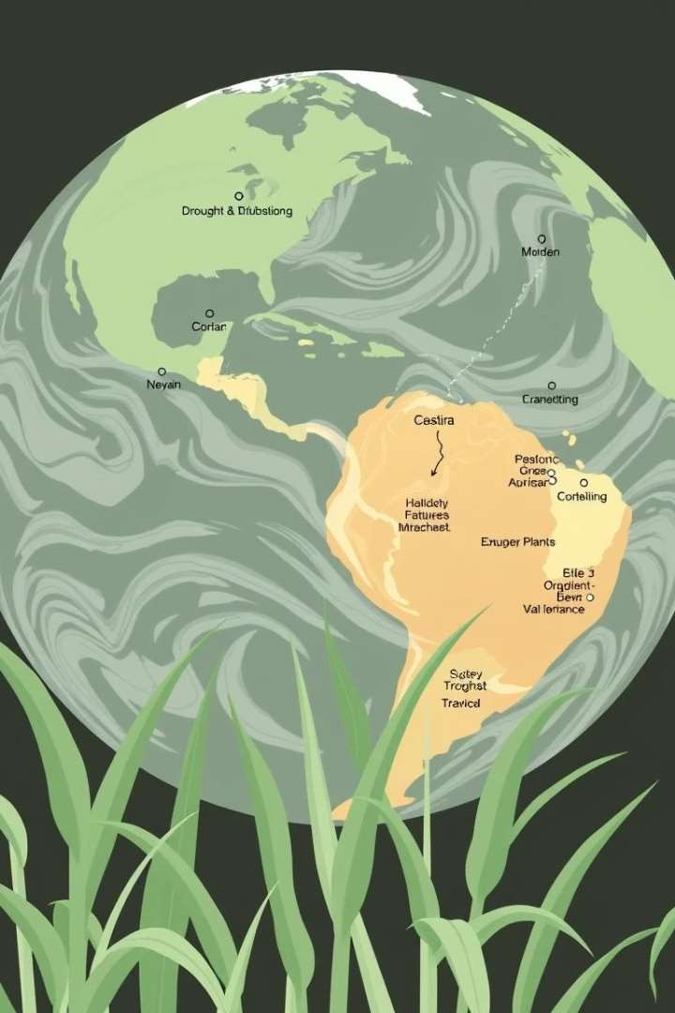
Understanding the Issue: Climate Change and Sustainability

Climate change is a global threat to agriculture and food production

The sugar industry faces severe risks from extreme
weather and environmental degradation

Sustainability is now central to business survival and
competitive advantage

This presentation examines how ABF’s Sugar Department is responding

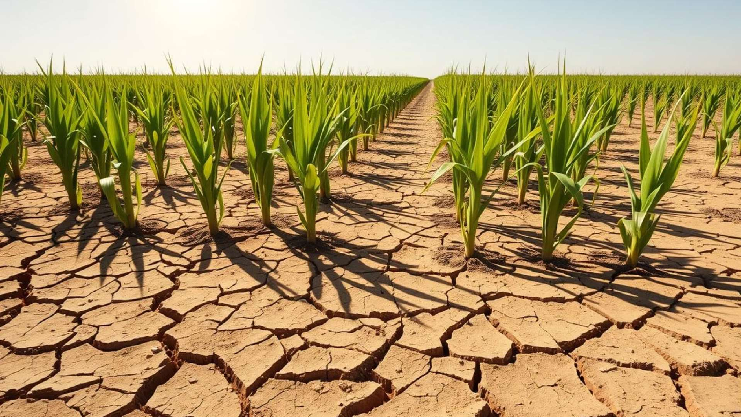











Climate Change Impact on S ugar Production

Crop Yield Volatility
Rising Operational Costs
E rratic rainfall and severe droughts significantly reduce
sugarcane crop yields . This directly impacts raw material
availability.
Increased water and energy scarcity drive up production expenses. E fficient resource management becomes paramount for sugar processors.
Land Productivity Decline
Supply Chain Vulnerability
Soil degradation, intensified by climate change, diminishes land fertility. This threatens long-term agricultural sustainability.
E xtreme weather events cause disruptions throughout the supply chain. This impacts logistics, processing, and market delivery.

Sustainability Strategies by ABF Sugar


Water Efficiency
Smart irrigation s ys tems conserve water usage. This
optimises sugarcane cultivation.
Bioenergy Utilisation

Sugarcane bagasse generates clean bioenergy. This
reduces fossil fuel dependence.


Soil Health
Robust monitoring ensures fertile soil. Crop rotation
enriches natural productivity.
Low-Carbon Farming

Investments target practices that lower emissions. This
reduces the overall carbon footprint.

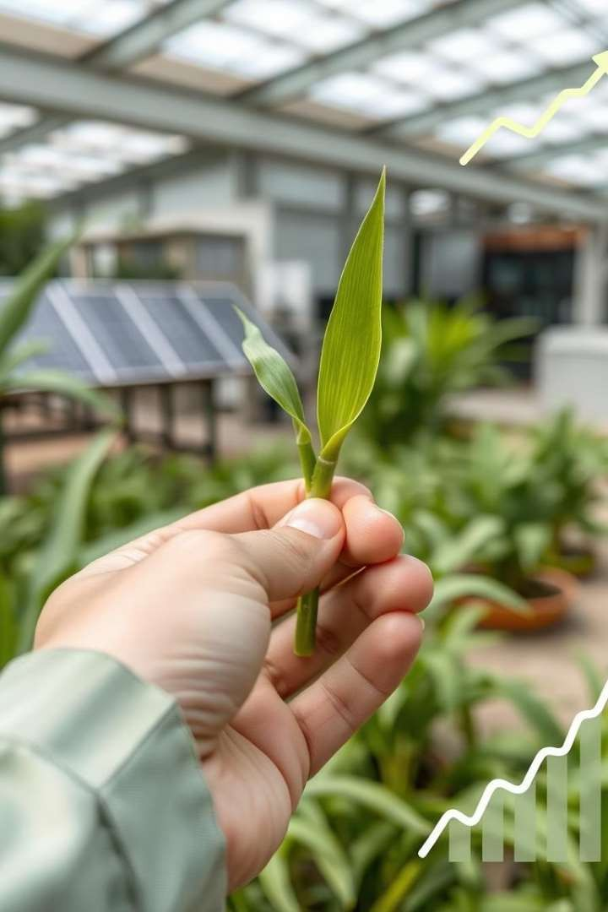
How Sustainability Drives Innovation and Growth


Meeting ESG expectations from investors and regulators

Enhancing brand trus t and cons umer loyalty Opening access to green finance and subsidies Gaining edge through s us tainable innovations



Ongoing Barriers and Long- Term S trategy
High costs of transitioning to sustainable systems Need for global cooperation and standard policies
Continuous investment in innovation and tech
Future focus: carbon neutrality and regenerative
farming

Key Takeaways and Strategic Recommendations

Climate change is a real and urgent threat to sugar production
ABF Sugar has taken commendable sustainability actions
Continued innovation is essential for long- term survival
Recommend increased collaboration with farmers, use of AI, and stricter ESG reporting

References
- Associated British Foods plc. (2023). Sustainability Report. [Online] Available at:
https://www.abf.co.uk
- International Sugar Organization. (2023). The Impact of Climate Change on Global Sugar Supply.
- Smith, J. (2022). Sustainable Agriculture and Climate Resilience. London: Green Earth Press.
- DEFRA. (2022). UK Agricultural Emissions and Water Use Statistics.
- FAO. (2021). Climate-smart agriculture for sugarcane. [Online] Available at:
https://www.fao.org







Student Name & ID: Samuel Dhinakaran Arumugaraj & 2416236
Module & Code: Managing Market Change & BMMB7026
Organisation Name: Associated British Foods Plc Assignment Topic: Planning for Marketing Drivers of Change




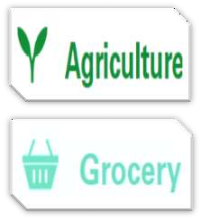

Business Operations Overview


1,38,000
56 Countries

ABF Ingredients: value- added products to the food, health and nutrition, pharmaceutical…
Kingsmill, Jordons, High 5, Sliver Spoon, Primark…

USA-1990
AB Mauri: Yeast and bakery ingredient production
Acquisitions
- Ryvita
- Fine Fare
- Twinings
- British
Sugar
- Elephant
Atta
Bakery-1935
ANZ-1950

Garfield Weston- UK

Issue driving marketing change








- A notable trend, challenge, or external pressure compelling businesses to modify their marketing strategies.
-Changing Consumer Behaviour
-Technological Advancements
-Environment, Social& Governance
-Economic Pressures & Global Events
The company delivers long-term benefits: To people, suppliers, communities, customers and the environment.

Force Field Analysis: Driving Vs Restraining

Changing Consumer Behaviour
Toward healthier, cleaner, and more transparent food choices (Innova Market Insights, 2023).
-Refrain from use of synthetic additives/preservatives.
-Minimally processed, free from artificial components

Drive: Trend of plant-based diets and alternative protein sources is gaining momentum, anticipated to expand rapidly in the near future (AB Enzymes, 2025).

Restrain: Transitioning to natural ingredients can lead to high costs associated with R&D, manufacturing, and procurement(ABF, 2024).

Digitalisation & Technological Advancements Innovation propels efficiency, catering to both cost- consciousness and sustainability (PwC, 2023).
- Eliminates a significant amount of manual data handling, compile the sample data and complete the analyses cut
from hours to seconds.
Drive: DigiReDI Program- AI introduction and helps to make product development faster.

Restrain: Transitioning to an Industry 4.0 framework, characterized by AI, cloud technologies, and sensor integration, demands significant capital outlay(PwC, 2023).

Environment, Social & Governance
Company emphasizes sustainability, ethical responsibility, and regulatory compliance in its production, sourcing, and marketing activities.

Drive: Palm oil traceability, wheat, reduced water use (ABF, 2024).

Restrain: ESG audits, certifications (like RSPO, ISO 14001), and technology upgrades can be expensive (PwC, 2023).

Reference
AB Enzymes (2025) Enzymes for Plant-based Food Production. Available at: https://www.abenzymes.com/en/your-industry/plant- based-food/ (Accessed: 10 June 2025).
ABF (2024) Annual Report and Accounts 2024. Associated British Foods plc. Available at: https://www.abf.co.uk/investors/reports (Accessed: 09 June 2025).
Innova Market Insights (2023) Top Trends in Clean Label Foods. Available at: https://www.innovamarketinsights.com (Accessed: 12 June 2025).
PwC (2023) Digital Transformation in Food Manufacturing. PricewaterhouseCoopers. Available at: https://www.pwc.com (Accessed: 12 June 2025).

