LCCB4005
The Global Business Environment

Environmental Analysis of
Automobile Industry
Ford Motor Company

Assignment 1

Student Name : Florentina Fistoleanu
Student ID : 2115309

Table of Contents
Introduction 3
Overview of Ford Motor 4
Challenges of Ford Motor’s internal and external business environment 4
PESTLE analysis of Ford Motor Company 8
Porter’s five force of Ford Motor Company 11
Value chain of Ford Motor Company 12
Conclusion 13
References 14

Introduction
International enterprises are leveraging the advantages of globalization to the greatest extent possible. They are extending their operations beyond the limitations of the air, sea, and land. Businesses strive to expand into worldwide markets to increase their financial growth and market share. Even though internal markets provide a plethora of potential, firms confront several problems and roadblocks when trying to grow their operations (Lundqvist et al., 2012). It is confronted with issues that are related to both the micro and macro environments of the organization. According to expert experts, the social, legal, environmental, and technical elements all offer hurdles to the multinational corporation's operations. This study focuses on the difficulties that Ford Motor Company had in expanding its operations around the world.

Overview of Ford Motor
In 1903, Henry Ford established Ford Works in Dearborn, Michigan, which is still the location of the company's headquarters today. Additionally, commercial cars are available for purchase from the company (Ivanco, 2017). For its part, Ford Motor Company has invested in a Brazilian carmaker that has an 8% market share and works with a total of 12 independent brands.
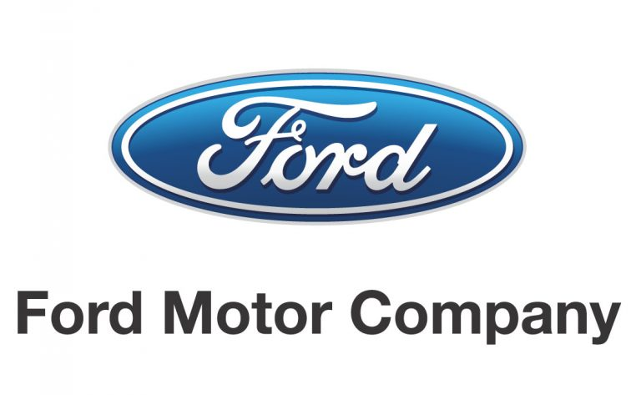
Figure 1 – Ford Motor Company logo (Gottschalk and Kalmbach, 2007)
A combination of geographic and demographic segmentation, as well as psychographic characteristics, is used to suit the needs and expectations of customers in both developed and emerging markets. This company has a differentiated approach to adapt to the individual requirements of each consumer.

Challenges of Ford Motor’s internal and external business environment
Internal factors – Strength
Ford's brand, worldwide operations, and research and development projects all play a role in the company's competitive advantages. This section of the study discusses the organization's features (internal strategic elements) that contribute to its operations being successful (Edmunds, 2013). Ford Motor Company has the following advantages:
- A well-known and well-known brand
- A worldwide supply chain
- It's important to have efficient innovation processes.
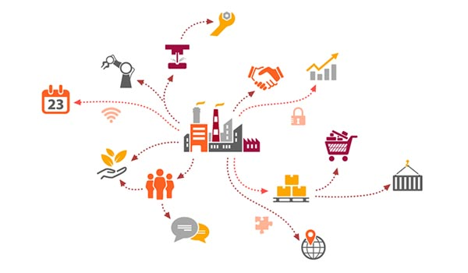
Figure 2 – Ford Motors supply chain (Das et al., 2017)
Ford has a positive reputation in the global automotive industry because of its well-known brand name and devoted customer base. To support its global operations, Ford also has a global supply network in place.
Internal factors – Weakness
Ford's shortcomings, as compared to its competitors, are a consequence of the company's fundamental limitations. Identifying organizational constraints or weaknesses, which are internal strategic factors that limit a company's capacity to expand its business, is part of the SWOT analysis process (Conklin, 2013).
The following are some of Ford's biggest flaws.
- The manufacturing network has a limited worldwide reach.
- In comparison to rivals, expenses are higher.
- Processes of the invention that are too slow
It is one of Ford Motor Company's weaknesses because it has a restricted number of production facilities, especially when compared to Toyota, which has a broad international network of manufacturing facilities.
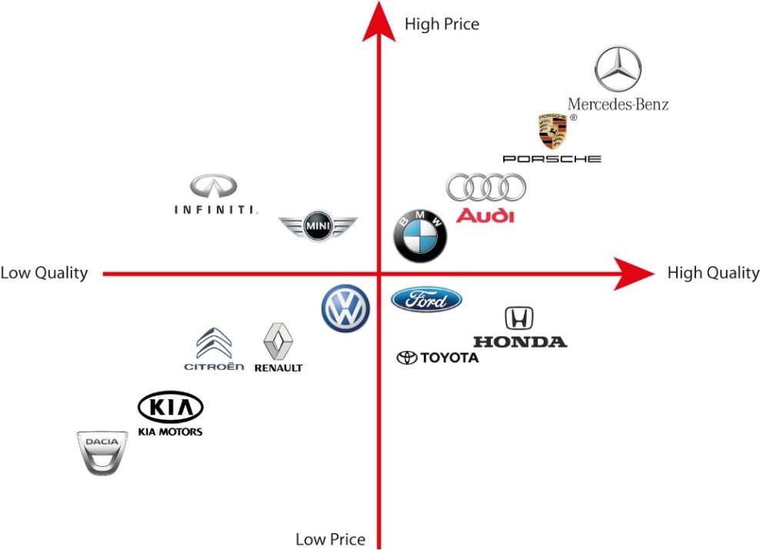
Figure 3 – Market position of automobile companies (Candelo, 2009)
Ford's financial troubles have been exacerbated further by the closure of many of the company's production facilities in Europe in recent years. a division of Ford Regardless of the fact that Ford has improved its innovation efficiency in recent years, the company's costs and prices remain much higher than those of rivals like Toyota, and its disruptive innovations are significantly slower to adapt to new or rising trends (West, 2010).
External factors - Opportunities
These prospects are associated with Ford's development and growth. External strategic elements that aid in corporate development are the subject of this section of the SWOT analysis. Ford has several changes, including the following:
- The penetration of new markets around the world to achieve global expansion
- Progress via the creation of new products
- Management of the supply chain in a cost-effective manner
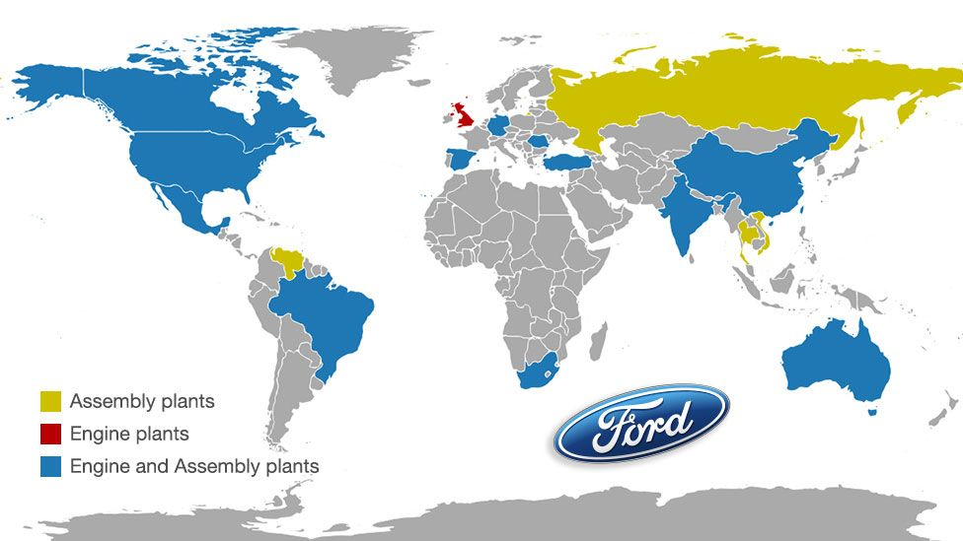
Figure 4 – Ford’s global mapping of production (Warner, 2010)
To grow and expand, Ford Motor Company will need to increase market penetration as well as product development. Also, by increasing its supply chain, Ford will be able to achieve greater economies of scale and lower manufacturing costs, which would help it improve its financial position.
Externa factors – Threats
Competition and energy prices throughout the globe pose a danger to Ford's business. This component of the SWOT analysis identifies and discusses the external strategic aspects that might have a negative impact on the company's success. Ford Motor Company has been threatened with the following:
- The competitive competition that is aggressive and aggressive in nature
- Firms from the high-tech sector have begun to enter the market.
- Oil prices are constantly fluctuating.
Ford is facing competition from aggressive marketers and technology innovators like General Motors and Toyota. Technology businesses like Google and Apple, who are working on driverless cars that might eventually compete with Ford's products, pose a threat as well (Rychtyckyj, 2007). Furthermore, the volatility of the oil price harms the sales performance of Ford goods, the vast majority of which are powered by internal combustion engines. Ford must innovate to sustain its competitive edge, as shown by this section of the SWOT analysis.

PESTLE analysis of Ford Motor Company
Political Factors that impact Ford Motor Company
Politics has an important part in determining the long-term profitability of Ford Motor Company in a given country or area. Terrorism is only one of several hazards that Ford Motor Company is exposed to since it operates in some nations where the auto industry is a major player. If Ford Motor Company plans to enter or invest in a new market, it may do a comprehensive study on the following:
- Auto manufacturers are a significant economic sector that has had a lengthy period of political stability.
- The option of a military invasion is being discussed.
- Corruption is a major source of worry, especially in the Consumer Goods market.
- The bureaucracy of the government, as well as its participation in the automotive manufacturing industry
- In the law, there is a framework for enforcing contracts.
Economic factors that impact Ford Motor company
Microeconomic factors such as the consumer price index, mortgage rate, interest rate, currency rate, and the business cycle influence aggregate demand and investment in an economy. When it comes to microenvironmental factors, such as competition standards, microenvironmental variables have a significant impact on a firm's competitive advantage (Rubenstein, 2014). Ford Motor Company should examine the following economic considerations while doing a PESTEL analysis:
- Automobile manufacturers – a major industry - have a highly skilled staff.
- The economic sector's average degree of education
- The economy's cost of labour and productivity
- The beginning of the business cycle (e.g., prosperity, recession, recovery)
- The rate at which the economy grows.
Social factors that impact Ford Motor company
An organization's culture is influenced by the culture of the society in which it operates. Ford Motor Company marketers need to have a common understanding of the market's customers to create effective marketing messages for Auto Manufacturers - Major industry consumers in that market.

Figure 5 – Ford’s customer base (Morrison, 2017)
Ford Motor Company's PESTEL study should include consideration of the following social factors:
- The nation's demographic and educational level
- Society's class, power, and hierarchical structures.
- Degree of education as well as standard in the Ford Motor Company's sector
- Culture
Technological factors that impact Ford Motor company
A broad spectrum of enterprises are being affected by technological advancements. The transportation industry offers as a great illustration of this principle. Over the preceding five years, the industry has experienced fast transition, with incumbent enterprises receiving little opportunity to react. Uber and Lyft are the leading participants in the taxi industry at the present time. It's no secret that technology businesses such as Google and Tesla are having a significant impact on the vehicle industry, and this is no exception.

Figure 6 – Ford’s technology support (Maxwell and Drummond, 2010)
- Ford's rivals have made significant technological advances in the last several years.
- The influence of technology on product offerings
- Automotive Manufacturers - A Major Industry: The Effects on Cost Structure
- Consequences for the consumer goods industry's value chain
Environmental factors that impact Ford Motor company
There are several norms or environmental practices in multiple sectors, and the revenue of a corporation operating in multiple markets may be impacted by the variances in norms or environmental standards in each market. Individual states, even within the same nation, may have drastically different environmental and liability laws than one another. This is especially true for the United States (Manning, 2008). The renewable energy industry obtains significant tax incentives from a large number of European nations, which is equivalent to the tax cuts received by the United States.The following are some of the environmental challenges that a corporation should take into account before beginning operations:
- Weather
- Climate change
- Laws regulating environmental pollution
- Recycling
- Waste Management in the Consumer Goods sector
Legal factors that impact Ford Motor company
Intellectual property rights are not effectively protected in many countries legal systems and organizations. Before entering these markets, a firm should carefully examine the risk of its secret sauce and, as a result, its whole competitive edge being stolen (Lundqvist et al., 2012). A few legal issues to keep in mind while entering a new market for Ford include:
- Anti-trust legislation in the automotive sector, as well as the nation as a whole.
- a statute prohibiting discrimination in the workplace
- Intellectual property law includes copyright and patents.
- e-commerce and consumer rights

Porter’s five force of Ford Motor Company
Competitive Rivalry
As a result, Toyota and other leading rivals are constantly inventing and selling their products. Ford has no choice but to contend with them. Despite Ford's dominance in the vehicle industry, many companies chose to compete with the company rather than close their doors.
Bargaining Power of Ford’s Customers/Buyers
As a result, Toyota and other leading rivals are constantly inventing and selling their products. Ford has no choice but to contend with them. Despite Ford's dominance in the vehicle industry, many companies chose to compete with the company rather than close their doors.
Bargaining Power of Ford’s Suppliers
Ford is subject to considerable but limited pressure from suppliers as a result of the constrained supply and the small number of suppliers available to the company (Ivanco, 2017). The reason for this is that these suppliers do not own or control Ford's distribution and sales of their goods since they do not have forward vertical integration with the company.
The Threat of Substitutes or Substitution
There are a variety of alternatives to Ford products, including public transportation and bicycles. These options, however, are not always available or appropriate in certain locations or situations, which is a problem. Ford's customers may easily switch to these replacements if they so want, but many are unable to do so because they still actually owe on their automobile loans.
The threat of New Entrants or New Entry
To run and maintain their operations and facilities, companies such as Ford invest a great deal of time and money. New entrants are less likely to enter the market because of these expenses (Gottschalk and Kalmbach, 2007). A strong brand like Ford takes time and money to build, which makes it tough for new entrants to compete effectively with industry titans like General Motors.

Value chain of Ford Motor Company
This section of the value chain for Ford Motor Company is divided into various sections. Product planning and design are two of the most critical aspects of the manufacturing process (Edmunds, 2013). The corporation is introducing the notion of a new car at this specific period. Meanwhile, management should concentrate its efforts on the development of fuel-efficient automobiles that would appeal to a wide range of customers. This strategy is critical at a time when more customers are becoming more worried about the price of gasoline.
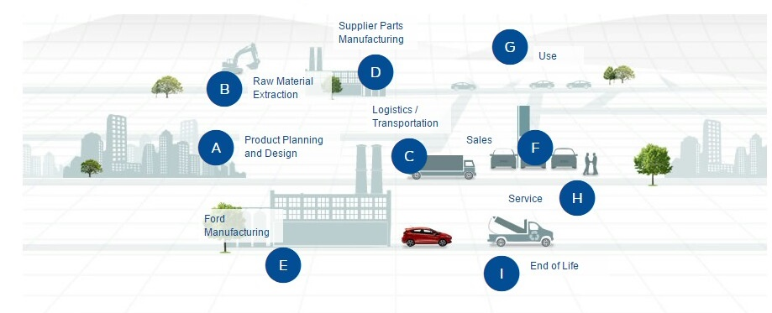
Figure 7 – Ford Motor Company’s value chain (Conklin, 2013)
Additionally, by emphasizing its brand identity, a business may add additional value to the equation. They must emphasize the fact that Ford Motor Company has been serving the consumer market for more than a hundred years (Das et al., 2017). This method may be particularly effective in gaining clients in developing economies such as China and India. These are the most important recommendations that may be offered.

Conclusion
Ford Motor Company seems to be able to handle the present issues it faces, according to a recent report. Due to foreign competition and a rise in product recalls, this company is experiencing challenges. There are, nevertheless, many vital skills that should be taken into account (Candelo, 2009). The firm has the ability to provide new products that will appeal to a broad spectrum of clients. In addition, by focusing on quality control procedures, the firm may reduce losses while simultaneously attracting new clients. The talents and financial resources of the organization are critical for the successful introduction of new goods.

References
Candelo, E. (2009). Marketing Innovations in the Automotive Industry.
Conklin, D. (2013). The global environment of business. SAGE.
Das, S., Sekar, A., Chen, R., Kim, H., Wallington, T., and Williams, E. (2017). Impacts of Autonomous Vehicles on Consumers Time-Use Patterns. Challenges, 8(2), 32. https://doi.org/10.3390/challe8020032
Edmunds, H. (2013). The Ford Motor Company Archives. The American Archivist, 15(2), 99-104. https://doi.org/10.17723/aarc.15.2.p5971k54100456rm
Gottschalk, B., and Kalmbach, R. (2007). Mastering automotive challenges. Kogan Page.
Ivanco, A. (2017). Fleet analysis of headway distance for autonomous driving. Journal Of Safety Research, 63, 145-148. https://doi.org/10.1016/j.jsr.2017.10.009
Lundqvist, L., Button, K., and Nijkamp, P. (2012). The automobile. Edward Elgar.
Manning, P. (2008). The technology of policing. New York University Press.
Maxwell, G., and Drummond, S. (2010). Automotive industry.
Morrison, J. (2017). The global business environment. Palgrave Macmillan.
Rubenstein, J. (2014). A profile of the automobile and motor vehicle industry.
Rychtyckyj, N. (2007). Intelligent Systems for Manufacturing at Ford Motor Company. IEEE Intelligent Systems, 22(1), 16-19. https://doi.org/10.1109/mis.2007.13
Warner, A. (2010). Strategic analysis and choice. Business Expert Press.
West, P. (2010). Organizational Learning in the Automotive Sector. Routledge.

