

L7: Artificial intelligence
(ACCA7026)

January Submission Assignment: Handwritten Digits Recognition

MSc Data and Artificial Intelligence

Wales Institute for Science and Art (WISA)
University of Wales Trinity Saint David

Lecturer: Dr Mohamed Bennasar
January 14th, 2022

Abstract

With the wide application of computers, plenty of data need to be stored in computers for processing. Handwritten number recognition can easily recognize handwritten digits and provide them to the computer, so it has become a research hotspot. In this paper, based on the study of handwritten number recognition related work, four machine learning algorithms including KNN, SVM, DT and RF are proposed to solve the problem by MATLAB. The experimental results show that KNN has the highest recognition accuracy of 96.91% and shorter training time among these algorithms. In the future, feature extraction and deep learning algorithms can be applied to improve the accuracy of recognition so as to achieve the application in post office, bank and other scenarios.

Table of Contents

1. Introduction 4
2. Related work 5
3. Methodology 6
3.1 Data sources 6
3.2 Classifiers 7
4. Results and discussion 8
5. Conclusion 10
References 10
Appendix 11

Introduction
With the wide application of computer technology, it has become common for people to use computer to type and input. But in some cases, messages may be written and stored by hand as a safe and convenient way. A method needed to be invented to automatically convert handwriting into information that computers could easily utilize. Handwritten digits recognition is a subdivision field of image recognition [1], which uses computers to process and analyze handwritten digital images to identify different target numbers. It has great practical engineering value and is widely applied in bank bills, postal codes, statistical statements and other aspects [2].
Machine learning is widely used in handwritten digits recognition because it could learn the rules of things by training large amounts of data. Specifically, it is the classification function of machine learning, including support vector machines (SVM), tree-based algorithms, Bayesian networks (BN), K-nearest neighbor (KNN) and artificial neural networks (ANN) [3]. Although machine learning has been commonly utilized in this field, the comparative analysis of different methods is still needed, which is conducive to the improvement of the accuracy of recognition and the expansion of application scenarios.
This paper first analyzes and summarizes the relevant work of handwritten number recognition by machine learning. On this basis, the machine learning methods studied in this paper are proposed. Then Mixed National Institute of Standards and Technology (MNIST) database is used as the data source to train and verify the proposed means. In this process, the influence of adjusting individual algorithm parameters on its performance is discussed. Finally, the prediction accuracy and operation speed of different machine learning algorithms are compared to find out algorithm with the best performance.

Related work
KNN is a simple non-parametric classification method, which belongs to supervised learning in machine learning. Makkar et al. [4] used KNN method to achieve classification after reading MNIST data set and conducting Gaussian distribution test on it. The result shows that the accuracy of classification is 96.2%, which proves that this method is simple and effective. In order to improve the performance of KNN, Tiwari et al. [5] smoothed and de-noised MNIST data sets, and then extracted structure and statistical features, which achieve the recognition rate of 96.3%. Besides, feature extraction could be added to enhance the classification effect. Five feature extraction methods including template matching, histogram projection, zoning, end point detection and gradient histogram are utilized in [6]. And it shows that the template matching performs the best with an accuracy of 97%.
SVM is a kind of generalized linear classifier that classifies data binary by supervised learning method. Tuba et al. [7] used four projection histograms respectively to extract features from MNIST data sets and selected SVM for classification. The experimental results show that the recognition effect of Y-axis projection histogram is the best, and its recognition rate is 94.68%. Except this approach, another four feature extraction techniques such as box method, diagonal distance, mean and gradient operation are proposed to increase the SVM accuracy by 97.16 % [8]. In recent research [9], it is found that the block based discrete cosine transform (DCT) zigzag coefficients lead to a higher recognition rate 98.76%, which is the direction of future work.
Decision tree is a tree-like model that goes from the observations about one thing to conclusions about the target values. Compared with other machine learning methods, this method is more explanatory. Lavanya et al. [10] made a comprehensive comparison on the use of hoeffding tree, decision tree and random forest for handwritten digit recognition. Based on the key parameters including digital classification instances, error rate and classification time, it is found that hoeffding tree is the most effective in modeling time, accuracy, recall rate and confusion matrix. There are some ways to modify the performance of DT algorithm. In [11], an active belief DT is proposed to solve the uncertainty of learning methods. It shows that under the condition of lack of real label knowledge, few training examples and low image feature dimension, the experiment using MNIST handwritten digital benchmark data still achieves good classification performance. In addition, combining kinds of classifiers is a promising direction. For example, ensemble decision tree combined with neural network is proposed in [12], which can classify the MNIST dataset up to 84%.

Methodology

3.1 Data sources
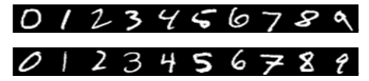
The Modified National Institute of Standards and Technology (MNIST) database is a subset of the NIST database with a large number of handwritten digital images. It contains 70,000 images, of which 60,000 and 10,000 were used for training and testing, respectively. The numbers were handwritten by 250 different people, 50 percent high school students and 50 percent census bureau workers. Some samples are displayed in Figure 1. Each image is labeled with a number from 0 to 9, equal to its center number. Because of its large amount of data, easy to use and authenticity, it is usually used to complete the training of image processing systems or machine learning algorithms.
Figure 1 Some samples in MNIST data set [13]
In this data set, the handwriting digital images have been well preprocessed, such as size standardization and formatting. In term of standardization, the original black and white image from NIST needs to be dimensioned while maintaining its original aspect ratio in order to fit into a 20x20 pixel box. In this process, the processed images will contain gray level values due to the anti-aliasing effect of the normalization algorithm. As for formatting, the location of the pixel center of mass is first determined by calculation. Then the images are shifted to the center of the 28x28 field. So it is a good database that allows the users to spend minimal effort on preprocessing and formatting.
In this paper, the data is loaded into MATLAB to train and test the classification algorithms. All images in the MNIST dataset are two-dimensional images, i.e. (28, 28, 1) and each pixel value of the image is between 0 and 255. In order to simplify and decompose the input data, they are divided by 255.0 to realize the normalization of these pixel values. And obtain the result of input feature range is between 0.0 and 1.0. Besides, the labels in the MNIST dataset are numbers between 0 and 9, which are used to describe the number assigned to the figure. The tags are represented by one-hot encoding, for example, converting the output value of 4 to an array of 0 and 1, which is [0, 0, 0, 0, 0, 0, 0, 0].

3.2 Classifiers
Based on the above summary of relevant work and characteristics of the data set, four common machine learning classifiers are selected to realize handwritten digit recognition in MATLAB.
1. KNN algorithm contains a sample data set, in which each data corresponds to a label, that is, the corresponding between the data and its category. When an unknown category of data is entered, the algorithm will calculate the relationship between each feature of the data and the corresponding features of all the data in the sample data set. The specific calculation method is as follows:
Then, the calculation results are sorted from small to large, and the first K nearest data are selected to judge the category that occurs most frequently and take it as the category of input data.
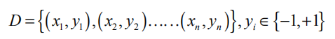
2. SVM is a linear classifier defined in feature space with maximum classification interval, whose goal is to find the optimal classification surface that can achieve the above requirements. It is based on the idea of finding a hyperplane that best divides a dataset into two classes. In the case of linearly separable, if there are m samples in a certain sample set, that is:
where xi represents the i^{th} sample in the feature space and Yi represents its classification result. The core of support vector machine is to find an optimal classification surface (W*x+b=0) in the feature space of sample set T. The classification surface should maximize the classification interval, which is the distance between the samples closest to the surface and the surface.
3. Decision tree (DT) contains three common algorithms for training, which include greedy algorithm (ID3: Iterative Dichotomiser 3) and the improved version of greedy algorithm (C4.5: successor of ID3) and classification and regression tree algorithm (CART). Different algorithms will affect the effect of prediction classification model, so it is important to know them characteristics. The biggest difference between them is that ID3 algorithm adopts information gain to select tree forks, C4.5 algorithm adopts gain rate, and CART algorithm adopts Gini impurity. DT consists of three components: 1) Nodes to represent each feature, at each note the value of the feature is tested using logic relations. 2) Branches the connect the nodes. The branching has to be binary. Therefore, the two branches can be True/ False, Yes/ No, or 1/0. 3) The last nodes at the bottom of the tree are called leaves classify the data points. To build up a DT, the nodes, and the branches should be defined firstly. Then identify the root node, and the order of the child nodes. If an attribute has more than two possible values, binary decision should be taken.
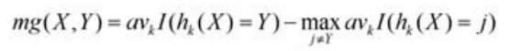
4. Random forest (RF) is an ensemble machine learning method, which uses multi-base estimator to predict and classify samples after training. And it introduces random attribute selection in the training of decision tree, which directly results in that the performance of this algorithm is better than that of single decision tree algorithm. RF can be interpreted as a few independent variables (X1, X2…) on the system dependent variable Y. The edge function is:
RF will randomly extract some values from the independent variables mentioned above when determining the classification nodes of decision tree, to ensure that each decision classification tree constructed has different possibilities as much as possible. In addition, when constructing the classification tree, the selection operation is carried out in the way of putting back. Some of them will be re-selected and some will not be selected. The samples that are not selected can be used as validation sets to perform "out-of-bag estimates" of the generalization capability of the classifier. Therefore, each decision tree learner in the random forest can be distributed independently without affecting each other, which greatly improves the running speed of the whole model.

4. Results and discussion
In order to compare the performance of the above four machine learning classifiers in handwritten numbers recognition, this paper carries out simulation on Lenovo Xiaoxinpro-13ARE notebook computer (CPU: AMD Ryzen 7-4800U, memory: 16.00GB, system: Windows10). By using MATLAB and its machine learning and image processing installation package, the experimental simulations of KNN, SVM, DT and RF are carried out, and the best recognition rate is obtained respectively.
As for the parameter adjustment of these algorithms, KNN chooses the default setting of the system, DT uses CRAT algorithm to train the binary classification decision tree, and SVM utilizes multi-classification support vector machine for automatic adjustment of the Kernel Scale and standardization. Especially, in the process of RF parameter tuning, it is found that when the number of trees is from 1 to 10, there is a large gap between the training results. But when this number is over 20, the training results improve not significantly, and the training time becomes much longer. This indicates that with the increase of the number of base estimators, the size of system memory is occupied and the time spent in training prediction will also increase correspondingly. Therefore, the largest number of estimators should be selected within the maximum memory and training time that the system can accept. Therefore, on the premise of considering both training time and recognition efficiency, 50 trees were selected as the number of base evaluators in the RF.
The overall experimental results are shown in Table 1, and the detailed recognition information namely confusion matrix for each algorithm is shown in Figure 2. It can be seen from the simulation data that the recognition rate of the four algorithms in handwritten digit recognition exceeds 85%, among which KNN algorithm has the highest recognition rate of 96.91%, DT algorithm has the lowest recognition rate of 87.82%.
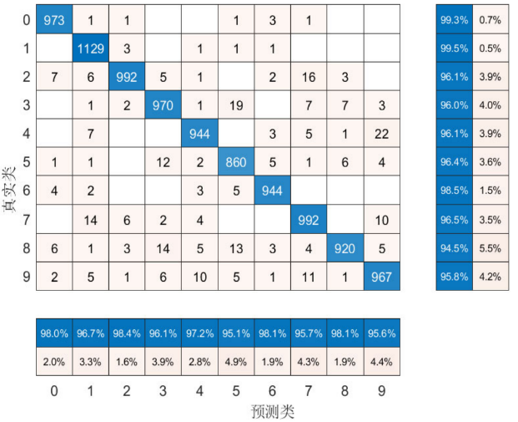
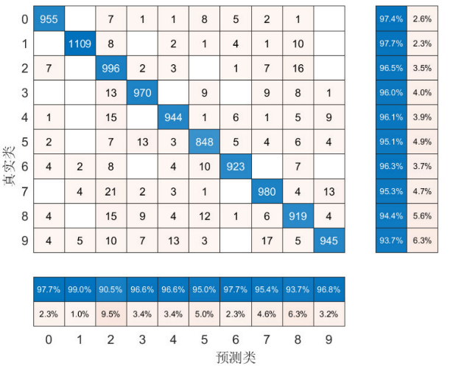
Table 1 The simulation results of four algorithms
Algorithm | KNN | SVM | DT | RF
Accuracy | 96.91% | 95.98% | 87.82% | 96.77%
Training time | short | long | short | long
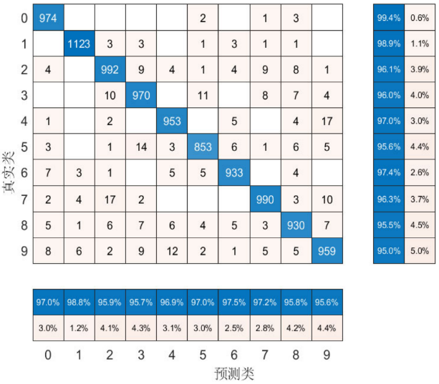
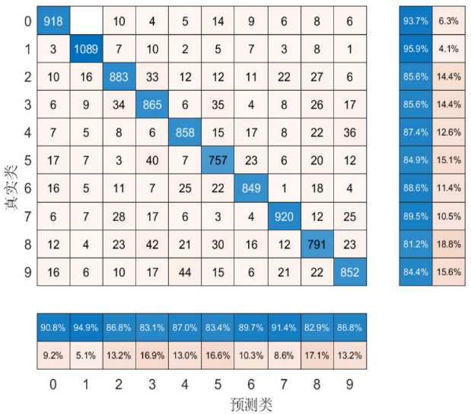
- (b)
- (d)
Figure 2 The confusion matrix of (a) KNN, (b) SVM, (c) DT and (d) RF
In general, KNN has the advantages of simple calculation, high recognition accuracy, short running time, but it has high memory requirements and is sensitive to irrelevant functions and data size; SVM is suitable for processing small samples and has high classification accuracy. When SVM processes large samples, it has a high kernel function mapping dimension, heavy calculation and long operation time which is not satisfying; When the DT is used as a classifier, its calculation speed is fast. But the classification effect is not good, because it is not sensitive to the missing median value and the process of irrelevant feature data may produce over-fitting phenomenon; However, RF can improve the disadvantage of single decision tree and significantly enhance the accuracy of recognition with a longer processing time.

5. Conclusion
The application of machine learning algorithms in handwritten number recognition is discussed in this paper. On this basis, four machine learning classifiers including KNN, SVM, DT and RF are proposed to realize handwritten digits recognition by MATLAB. It can be seen from the experimental simulation results that KNN has the highest recognition accuracy of 96.91% and a short calculation time, while DT has a poor recognition accuracy of 87.82%. In addition, the selection of built-in algorithms and algorithm parameter settings is also discussed. Overall, this paper provides reference for researchers and potential users who want to use machine learning algorithm for handwriting recognition. And more feature extraction or deep learning algorithms can be used to improve the accuracy of recognition in the future.

References
[1] H. Xiao and C. Liu, "Handwriting digit recognition based on extension engineering," 2009 Chinese Control and Decision Conference, 2009, pp. 2915-2918, doi: 10.1109/CCDC.2009.5192803.
[2] S. N. Srihari and E. J. Kuebert, "Integration of hand-written address interpretation technology into the United States Postal Service Remote Computer Reader system," Proceedings of the 4th International Conference on Document Analysis and Recognition, 1997.
[3] A. K. Agrawal, A. K. Shrivas, and V. k. Awasthi, "A Robust Model for Handwritten Digit Recognition using Machine and Deep Learning Technique," 2021 2nd International Conference for Emerging Technology (INCET), 2021.
[4] T. Makkar, Y. Kumar, A. K. Dubey, Á. Rocha and A. Goyal, "Analogizing time complexity of KNN and CNN in recognizing handwritten digits," 2017 Fourth International Conference on Image Information Processing (ICIIP), 2017, pp. 1-6, doi: 10.1109/ICIIP.2017.8313707.
[5] R. R. Tiwari, APARNAVISHWANATH, and D. Wadhone, "Handwritten digit recognition using back propagation neural network&K-nearest neighbour classifier,” International Journal of Electrical Electronics & Data Communication, vol. 1, no. 5, 2013.
[6] S. N. Shivani J, "Analysis of Performance of KNN Classifier in Recognition of Handwritten Digits," International Journal of Advance Research in Engineering, Science & Technology, vol. 5, no. 3, pp. 349-353, 2018.
[7] E. Tuba and N. Bacanin, "An algorithm for handwritten digit recognition using projection histograms and SVM classifier," 2015 23rd Telecommunications Forum Telfor (TELFOR), 2015, pp. 464-467, doi: 10.1109/TELFOR.2015.7377507.
[8] G. Katiyar and S. Mehfuz, "SVM based off-line handwritten digit recognition," 2015 Annual IEEE India Conference (INDICON), 2015, pp. 1-5, doi: 10.1109/INDICON.2015.7443398.
[9] B. El qacimy, M. Ait kerroum and A. Hammouch, "Handwritten digit recognition based on DCT features and SVM classifier," 2014 Second World Conference on Complex Systems (WCCS), 2014, pp. 13-16, doi: 10.1109/ICoCS.2014.7060935.
[10] K. Lavanya, S. Bajaj, P. Tank and S. Jain, "Handwritten digit recognition using hoeffding tree, decision tree and random forests — A comparative approach," 2017 International Conference on Computational Intelligence in Data Science(ICCIDS), 2017, pp. 1-6, doi: 10.1109/ICCIDS.2017.8272641.
[11] Z. Li, L. Ma, X. Ke and Y. Wang, "Handwritten digit recognition via active belief decision trees," 2016 35th Chinese Control Conference (CCC), 2016, pp. 7021-7025, doi: 10.1109/ChiCC.2016.7554464.]
[12] R. Larasati and H. KeungLam, "Handwritten digits recognition using ensemble neural networks and ensemble decision tree," 2017 International Conference on Smart Cities, Automation & Intelligent Computing Systems (ICON-SONICS), 2017, pp. 99-104, doi: 10.1109/ICON-SONICS.2017.8267829.
[13] W. Liu, J. Wei, and Q. Meng, "Comparisions on KNN, SVM, BP and the CNN for Handwritten Digit Recognition," in 2020 IEEE International Conference on Advances in Electrical Engineering and Computer Applications (AEECA), 2020.

Appendix
clear
clc
close all

load("Xtrain.mat")
load("Ytrain.mat")

% One-hot encoding
train_label = vec2ind(train_y')-1;

% KNN , accuracy =0.9691
Mdl = fitcknn(train_x,train_label);

% DT , accuracy =0.8782
%Mdl = fitctree(train_x,train_label);

% SVM , accuracy=0.9598
%t = templateSVM('KernelFunction','rbf','KernelScale', 'auto', 'Standardize', 1);
%Mdl = fitcecoc(train_x,train_label,'Learners',t);

% RF
%t = templateTree('MaxNumSplits',5000,'Reproducible',true);
%numTrees = 50;
%Mdl = fitcensemble(train_x,train_label,'Method','Bag','Learners',t,'NumLearningCycles',numTrees);%accuracy=0.9677

load("Xtest.mat")
load("Ytest.mat")
test_label = vec2ind(test_y')-1;

predict = predict(Mdl,test_x);
temp = predict-test_label';
sum = 0;
for i = 1:length(test_label)
if(temp(i)==0)
sum=sum+1;
end
end
accuracy = sum/length(test_label)
confusionchart(test_label',predict,'RowSummary','row-normalized','ColumnSummary','column-normalized')

