

LOCATION: Swansea | LLEOLIAD: abertawe
LEVEL 7 | LEFEL 7
EXAMINATION PERIOD | CYFNOD ARHOLIADAU
January 2018 | IONAWR 2018

MODULE CODE: M7X01701
Network Security
TIME: 2 HOURS (Use 1 ½ NOt 1.5 for time)

answer THREE quESTION out of FOUR

Equipment or materials required – Basic Calculator
Adnoddau neu ddefnyddiau sydd eu hangen – Cyfrifiannell Sylfaenol

ANSWER THREE QUESTIONS

Q1.

- Examine the output from the scanning tool shown in Figure 1 and describe what services are running and what security implications these may have for this particular network.
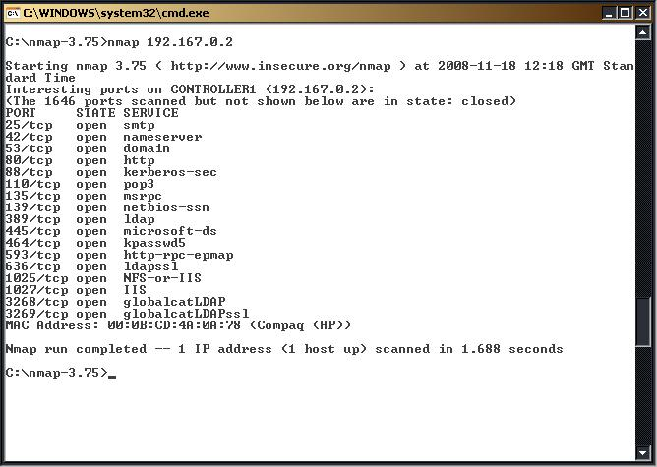
Figure 1: Output of Scanning Tool
- marks)
Solutions:
From the output of the scanning tool (nmap), it is clear that there are a number of ports open on this end system. The security implications vary depending on the service that is enabled.
The ports that are open are:
25 smtp
42 nameserver
53 dns
80 http
88 kerberos
110 pop3
135 msrpc
139 netbios-ssn
389 ldap
445 microsoft-ds
464 kpasswd5
593 http-rpc-epmap
636 ldapssl
1025 NFS-or-IIS
1027 IIS
3268 globalcatLDAP
3269 globalcatLDAPssl.

There are 17 ports open on the target system. This system is running SMTP (mail) through to a global naming service on port 3269. With this number of ports open a hacker will have seventeen ports to banner grab from. The weakest ports are likely to be the ones with the oldest versions of services (as they are more likely to be vulnerable). For example, the services running on ports 593 and 1027 are likely to be vulnerable. Both Microsoft's RPC systems and IIS services have been compromised and if appropriate versions they may be susceptible to vulnerabilities.

[Students may focus on other ports and vulnerabilities, which in general will be awarded mark for salient point.
However, marks are awarded for indicating that there are 17 ports open and this represents a significant range for an attacker to target.]

- As a security tester, one of your daily task is to research new tools that will help you to perform your duties. It has been noted that some open sources tools your company used lack simplicity and clarity or do not meet the company’s expectation. Your IT Director asks you to research new or improved products on the market.
Inform your IT Director on four port-scanning tools that might be useful to the company. Different port scans might elicit different information; your report should include the port scan types such as SYN, ACK, FIN, etc.
(15 marks)
Solution:
Scanning refers to a set of procedures for identifying hosts, ports, and services in a network. Scanning is one of the components of intelligence gathering for an attacker to create a profile of the target organisation. When check for open ports:
- Synchronize – is also called SYN, is used to initiate a connection between hosts.
- Acknowledgement – is also called ACK and is used in establishing a connection between host
- PUSH – is called PSH and instructs receiving system to send all buffer data immediately
- Urgent – it is also called URG and states that the data contained in the packet should be processed immediately
- Finish – is also called FIN and tells the remote system that there will be no more transmissions
- Reset – is also called RST and is use to reset a connection

Scanning can be Vulnerability, network and port scanning. Four types of port scanning tools are:
Nmap – is a free open source utility for network exploration. Network administrators can use Nmap for network inventory, managing service upgrade schedules and monitoring host or service uptime. Attacker can use Nmap to extract information such as:
- Live host on the network
- Services (application name and version)
- Operating systems and versions
- Types of packet filter/firewalls.
Nessus – Well known cross platform, open source tool with command line and GUI interfaces. It is a security and auditing tool that scan ports and services and exposes any vulnerability.
Unicornscan – Can handle TCP, ICMP, and IP port scanning, it optimizes UDP scanning beyond the capabilities of any other port scanning tools. This is included in Kali along with a web-based Unicornscan analysis tool.
SAINT – generally known as Security Administrator’s integrated network tool. It gathers information regarding what type of operating system is running and which ports are open. Attackers can detect vulnerabilities on any target in a non-intrusive manner. There are four steps to a SAINT:
- Find targets – Host is alive
- Port scan – HTTP service running
- HTTP vulnerability check
- Report – execute summary, detailed technical reports, recommended fixes, trend analysis
Hping – performs ping sweep, many security testers use it to bypass filter devices by injecting crafted or otherwise modified IP packets. It is also use for security auditing and testing firewall and networks. It runs on both Windows and Linux OS.
(Other types of scanning tools discuss are accepted)

Q2.

- As a qualified ethical hacker you have been consulted by Tecomex Forensics Ltd to conduct a real life penetration testing on http://cupstc.com or http://tecomex-forensics.com. Explain the types of pentests you would carry out on these websites. Diagrams may be used. Your solutions should include the following:
  - List of vulnerabilities that you want to targeted at the websites. Defend your choice.
  - At least 5 attack tools that you will be using and briefly tell their purposes.
  - Outline your penetration testing in a few steps, say 1-4.
  - Briefly explain the difference between Penetration Testing and vulnerability Assessment.
  - Give a brief description of your contingency plan before commencement of penetration testing.
(25 marks)

Solutions:

- (5 marks to this answer or any similar answer given)
There is no exact answer to this question. Unless the client can furnish the pentester with clues as to what happened during a recent hacker attack, the best starting point is to check at well known portals like SANS or the OWASP (Open Web Application Security Project) for the latest web vulnerabilities. The OWASP releases 10 worst web vulnerabilities every year. The worst web vulnerabilities for 2016 are as follows:

#1: Injection flaws
#2: Broken Authentication
#3: Cross Site Scripting (XSS)
#4: Insecure Direct Object References
#5: Security misconfiguration
#6: Sensitive data exposure
#7: Missing function level access control
#8: Cross Site Request Forgery (CSRF)
#9: Using components with known vulnerabilities
#10: Unvalidated redirects and forwards

- (5 marks for any five or more)

There are no definitive answer to this question as there are hundreds of penetration testing tools out there. The essence of the question is to test the student's knowledge of common pentest tools available. Some of these tools are free but the best ones come at a premium.

Penetration Testing Tool | Usage | License Type
1. Faradays | Web scanner. | Free/Premium License
2. Qualys | Web scanner. | Free/Premium License
3. Metaspoilt | Web scanner that byepasses web security systems to unleash payload. | Free/Premium License
4. Kali Linuux | A suite of comprehensive Open Source Penetration Testing tools and environment in Ubuntu Linux. | Free
5. Netsparker | This tool can also help exploit SQL injection and LFI (local file induction | Premium License
6. Nessus | Sensitive data searches, IPs scan, website scanning etc. and aids in finding the “weak-spots”. | Free/Premium License
7. Burpsuite | It mainly works wonders with intercepting proxy, crawling content and functionality, web application scanning etc. | Premium License
8. Acunetix | Acunetix is essentially a web vulnerability scanner targeted at web applications. It provides SQL injection, cross site scripting testing, PCI compliance reports etc | Premium License
9. BeEF | It takes advantage of the fact that an open web-browser is the window(or crack) into a target system and designs its attacks to go on from this point on | Free
IBM Appscan | A scanner that identifies problem areas and suggests remedial actions | Premium License

- (5 marks)
Penetration testing strategy vary from one scenario to the other, depending on the size of the IT infrastructure to be tested (how many nodes), the scope (variants of tests to be done), the severity of recent attacks sustained etc. However, a general outlook should be something like this:

Step #1. Make a list of vulnerabilities/potential problem areas that would cause a security breach for the system to be tested. Refer to OWASP 10 worst vulnerabilities.
Step #2. Where possible, identify the list of issues to be tested and rank them in the order of priority/criticality.
Step #3. Devise penetration tests that would work (attack the target system) from both within the network (White box) and outside (Black box) to determine if you can access data/network/server/website unauthorized.
Step #4. If the unauthorized access is possible, the system has to be corrected and the series of steps need to be re-run until the problem areas are fixed.

- (2 marks)

Difference between Penetration Tesing and Vulnerability Assessment: Penetration Testing is not the same as vulnerability testing. The intention of Vulnerability Assessment is just to identify potential problems, whereas Penetration Testing is to attack those problems using various tools and methods.

- (8 marks)
Contingency Planning is a MUST for every Penetration Testing session. It is essentially putting a strategy in place to deal with unforeseeable events that may occur as a result of the Penetration Testing exercise. Remember, a penetration test is a full blown attack on the system using tools that may be more dangerous than those of hackers. It is a common sense list of what needs to be done when things go wrong. A typical contingency plan will be as follows:

1. Identify all stake holders of the system to be tested. Organise briefing meetings and collect contact details of key personnel to be contacted in the event of emergency.

2. Draw a master plan of actions to take in all possible eventualities.

3. Create a reliable backup of the system to be tested.

4. Take back up of databases, intellectual properties and website templates separately.

5. Test that the backups can be restored before commencing penetration test.

6. Perform penetration test at incremental level. Never perform full blown test from the onset.
(25 marks)

Q3.

- In reference to the types of Penetration Testing, explain the differences between the following:
- marks)

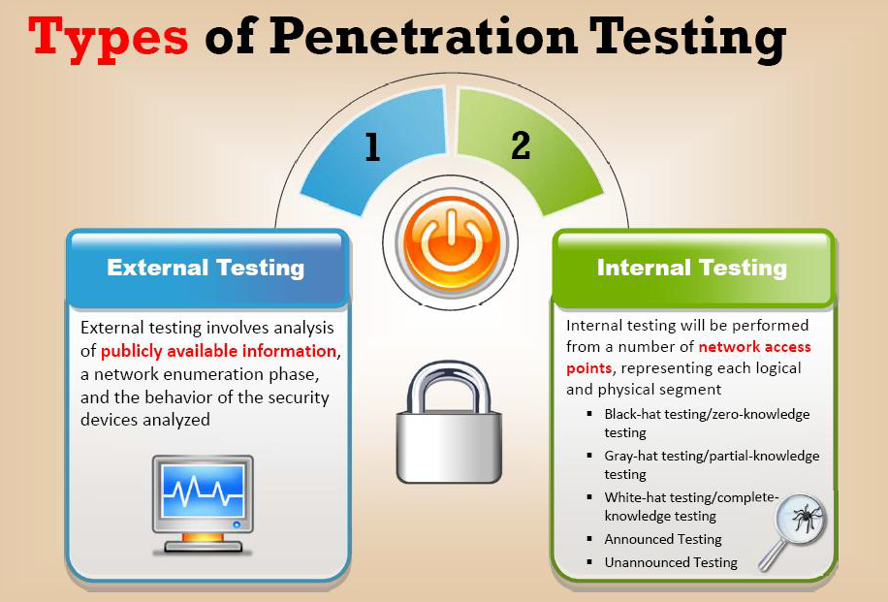
  - External and internal testing
Solutions:
(5 marks)

  - Black-box and white-box testing
Solutions:
(5 marks)

Black-box:
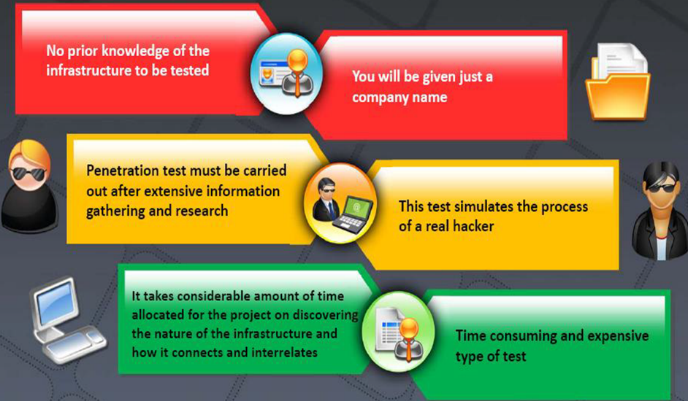
White-box:
- Complete knowledge of the infrastructure that needs to be tested is known
- The test simulates the process of company’s employees
- Information is provided such as:
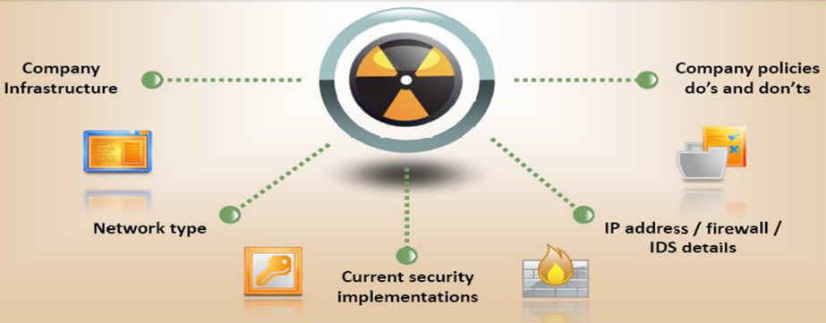

  - Announced and unannounced testing
Solutions:
(5 marks)

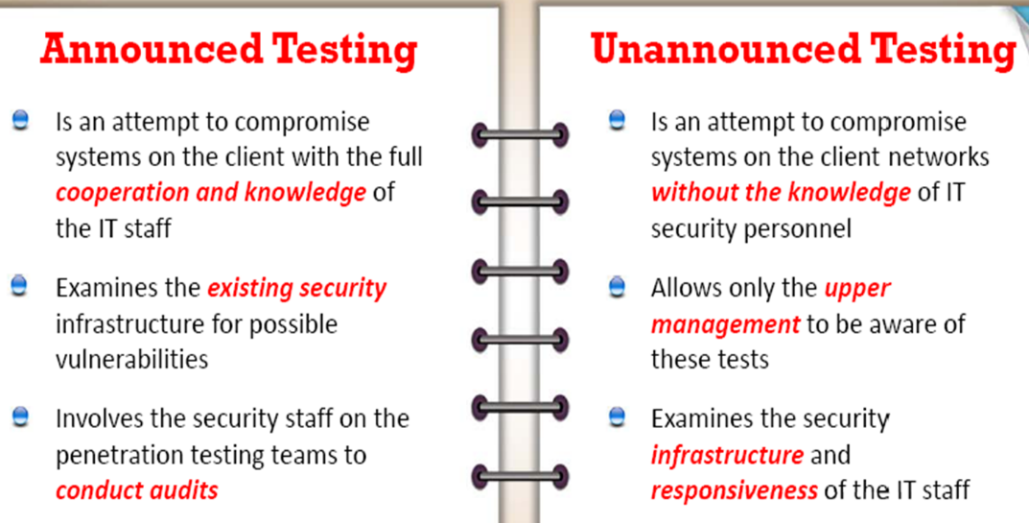
  - Automated and manual testing
Solutions:
(5 marks)

Automated:
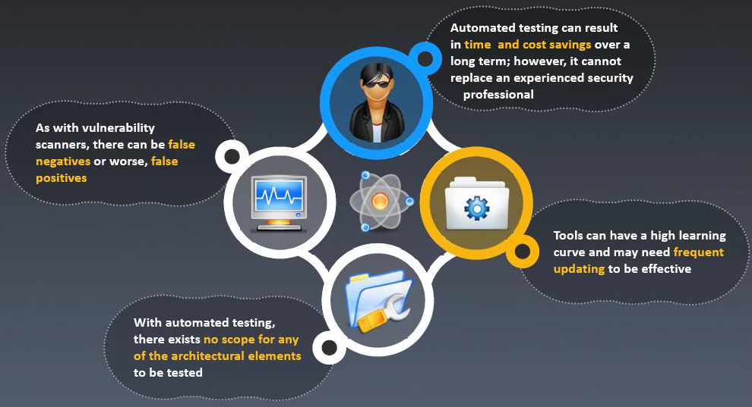
Manual:
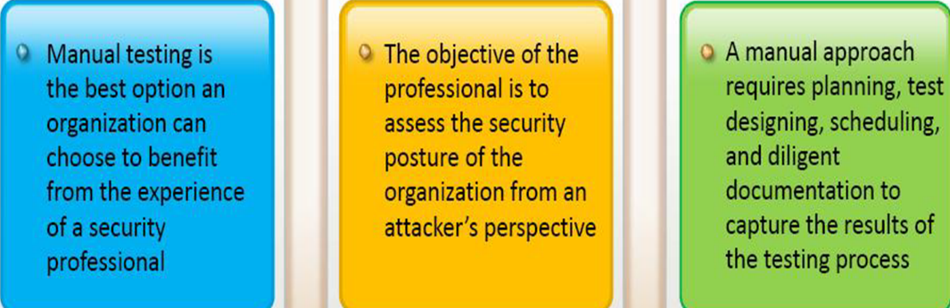

- Explain the purpose of a penetration testing Service Level Agreement (SLA)
- marks)
Solutions:
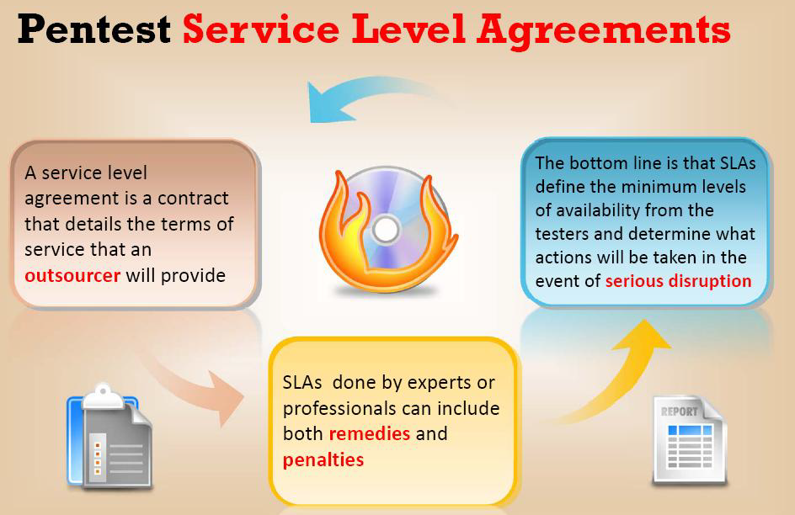

Q4.

- The first step in creating a security policy for a company network is to define and acceptable use policy (AUP).
  - Construct an example of a policy mapping.
(5 marks)
Solution:

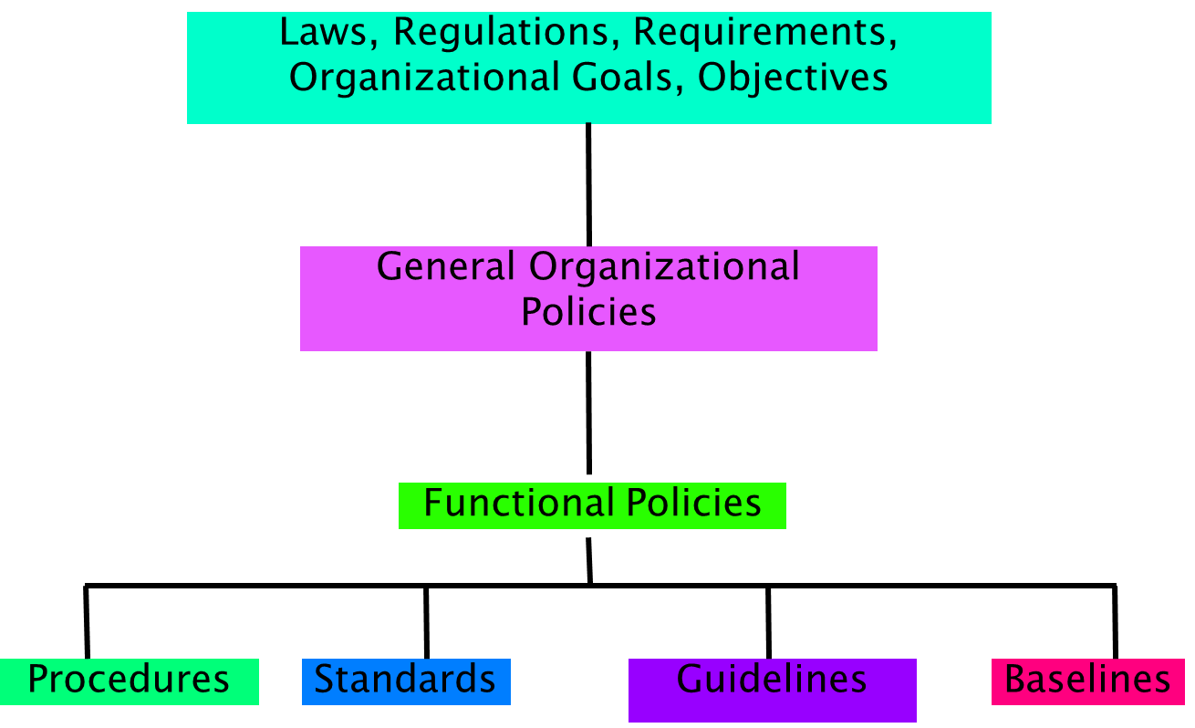

  - Outline what is expected to be written in a security policy.
(5 marks)
Solutions:
(Five or more points below will give full marks)
- Created and maintained to mitigate existing and new kinds of attacks.
- Enforce a structured, informed, consistent approach to securing the network.
- Designed to address the following:
  - Business needs
  - Threat Identification
  - Risk analysis
  - Security needs
  - Industry-recommended practices
  - Security operations
- Business needs:
  - What does the organization want to do with the network?
  - What are the organizational needs?
- Threat identification - What are the most likely types of threats given the organization’s purpose?
- Risk analysis:
  - What is the cost versus benefit analysis of implementing various security technologies?
  - How do the latest security techniques affect the network environment and what is the risk if they are not implemented?
- Security needs:
  - What are the policies, standards, and guidelines needed to address business needs and risks?
- Industry-recommended practices:
  - What are the reliable, well-understood, and recommended security practices that similar organizations currently employ?
- Security operations:
  - What are the current procedures for incident response, monitoring, maintenance, and auditing of the system for compliance?

  - What are some of the wrong assumptions you should avoid when writing a security policy?
(5 marks)
Solutions:
(Five or more points below give full marks)
There are guidelines to help you avoid making wrong assumptions:
- Expect that any aspect of a security system might fail.
- Identify any elements that fail-open. Fail-open occurs when a failure results in a complete bypass of the security function
- Try to identify all attack possibilities.
  - Use top-down analysis of possible system failures, which involves evaluating the simplicity and probability of every attack on a system.
  - Known an attack tree analysis.
- Evaluate the probability of exploitation. Focus on the resources that are needed to create an attack, not the obscurity of a particular vulnerability.
- Assume that people make mistakes.
- Attackers might not use common and well-established techniques to compromise a system.
- Check all assumptions with other people. Peers might have a fresh perspective on potential threats and their probability.

  - List the ten step approach in writing a policy.
(10 marks)
Solutions:
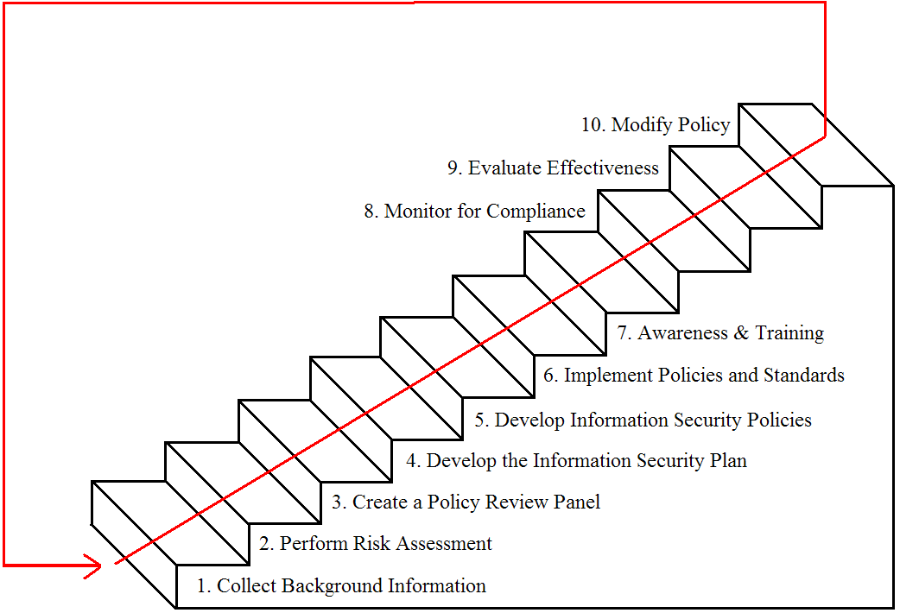

Diwedd/End

