  Component One:  What are the key skills required when working in the housekeeping team? 750 words (+/- 10%)  Contribution to Overall Module Assessment: 25% | Student No: | 2206811
 | Module Title: | Hotel Placement- Operating Hotel Facilities
 | Module Code: | BMIH4006
 | Lecturer: | Lolla Villard

Introduction
The housekeeping department plays a vital role in the hospitality industry and has a direct impact on the comfort and satisfaction of guests. Efficient housekeeping practices are not just restricted to attention to detail when it comes to cleanliness but also emphasise having a helpful and friendly attitude and a professional appearance (Datu et al., 2020).

Critical Skills Required by the Housekeeping Team
Verma et al. (2020) have argued that the housekeeping department requires a range of skills in order to be successful. It is undeniable that a crucial requirement for the sector of housekeeping is efficient communication. For tasks to be properly completed, communication by the members of the housekeeping team must be concise. In addition, effective communication skills are a must for quick comprehension, and guests request fulfilment. Further clarity and professionalism in communication decrease any uncertainty or confusion that could develop along the process. Furthermore, having strong communication skills may help with both conflict resolution and misunderstanding prevention. Conflicts may be resolved in a positive and constructive manner through active listening and thoughtfully resolving queries (Radzi et al., 2020). Apart from this, Datu et al. (2020) have argued that housekeeping team members need to be capable of problem-solving. To avoid occurrences of issues or guest complaints in the future, the team must be skilled enough to be able to provide long-term solutions to issues. For instance, the cleaning crew might make sure that rooms are regularly cleaned and up to standards. The staff must develop problem-solving skills in order to identify chances for long-lasting adjustments and solutions.
The importance of time management is made evident by the need to perform tasks efficiently while also making sure that the guest rooms are perfectly clean. By using efficient time management strategies, employees can boost productivity, lower stress levels, and improve customer satisfaction. To provide visitors with a clean, secure environment, programmes that establish new cleaning practices and hygiene standards need to be put into place. To further manage time effectively and intelligently, the staff must make use of a number of tools and services, including automated timetables and checklists (Shahane and Fernandes, 2021). Liu et al. (2021) are of the view that detail orientation is an essential skill for housekeeping employees in the hotel industry, which involves paying special attention to the small details that have a significant impact on how delighted customers are. By taking into account each visitor's particular preferences and demands, the focus should be to offer experiences that are distinctive and unforgettable. However, doing so also requires having the necessary multitasking skills.

Reflection – Application of Theoretical Knowledge
Throughout the module, I have been able to learn different concepts and strategies associated with housekeeping and hospitality management. I agree with the fact that the housekeeping department plays a crucial role in overall guest satisfaction, and therefore, one must be skilled enough to do so. Reflecting on my knowledge and skills, I have come to know that if I got the opportunity to work in the housekeeping department, I would be able to ensure the efficient application of my communication and listening skills. However, at the same time, I have also realised that I also need to work on my weak areas, such as time management and multitasking. As far as the application of theoretical knowledge is concerned, I believe that I am aware of the major role and responsibilities that must be fulfilled by those associated with the housekeeping department. Besides this, I have also got the benefit of being aware of new technology now utilised in the housekeeping department. In addition, I will also be able to apply my communication skills to keep employees engaged and satisfied so that they can perform their tasks efficiently.

Industry Examples
Several hotels in the hospitality industry have adopted new ways of making their housekeeping areas better. For instance, Marriott has launched a global cleanliness council to promote high standards of cleanliness (Marriott, 2020). Besides this, Hilton Hotels has placed greater emphasis on on-demand housekeeping services based on the perspectives of comfort and flexibility of guests. The purpose is to encourage people to call the front desk and make requests for which the staff members are readily available (Goldstein, 2021). Four Seasons is another well-known hotel that is also considered great for its housekeeping, considering it at the heart of all guests’ satisfaction. The hotel has ensured that the employees are equipped with proper skills and has further considered well at the core of its housekeeping (Four Seasons, 2023).

Conclusion
The housekeeping department plays a crucial role in overall guest satisfaction if employees have the desired skill set. Communication, problem-solving, time management and multitasking are among some of these skills, which serve as the building block of the housekeeping function. Several hotels emphasise the necessity of skill development with regard to the housekeeping department.

Word Count

Component Two:
Contribution to Overall Module Assessment: 25%
In this scenario – You have just been promoted to the team leader for a floor within the hotel. A guest complained that on their arrival, their room had not been properly cleaned. Create an action plan and answer the following questions.

Problem | Why did it happen? | What are you going to do? | How will you prevent this from happening in the future? | What measures would you introduce to improve team effectiveness?
The room needed to be cleaned adequately as the guests arrived. | It happened due to a need for more communication and interaction among the members regarding room cleaning (Awan et al., 2021). | I am going to apologise first and ask them to wait in the waiting area or room where the room will be cleaned in a few minutes. | It will be prevented in order to happen in future mainly by supervising work and ensuring that there is communication taking place. | In order to improve team efficiency, communication will be made essential (Knezevic Cvelbar et al., 2021)
There was a lack of communication that the room was not cleaned. | There needed to be more communication as employees were not friendly enough to talk about a problem with room cleaning (Knezevic Cvelbar et al., 2021). | Hence, I will apologise to the customer for waiting. Hence, I will turn to employees and be strict with them (Knezevic Cvelbar et al., 2021). | It will be prevented with the help of proper communication channels to be done in order to ensure communication. | Training will be provided to all staff on their related tasks and skills in order to ensure the best work and services (Knezevic Cvelbar et al.,
needed to show better employees showed bad attitude in terms of different services. | The employees were not in a calm mood. Hence, they did not differentiate between personal and professional work-life balance. Therefore, the employees are at fault here. | I will check for a bad attitude and talk to employees about giving a lousy attitude. Hence, I will tell them strictly that this behaviour is not allowed (Tiong et al., 2021).  I will also apologise to the guest and ask them to forgive the employee. | It will be prevented by hiring people with good attitudes, which can differentiate between personal and professional life. Training the newcomers is also essential (Awan et al., 2021). | Hence, I introduce that to improve team effectiveness; there is a need to showcase a good attitude, which will be supervised (Liladrie, 2021).
The room did not have new bedsheets, towels, soap, etc. | It happened due to the employees' need to recheck to see if the new and fresh items were provided in the room. | I will ensure the guests wait for some time, and the necessities will be rechecked and replaced accordingly (Awan et al., 2021). | Hence, all the amenities will be closely checked before the guest arrives. Therefore, the team leader or supervisor will recheck it. | The amenities will be ensured in terms of the arrival of guests. Hence, after they go, it will be changed.
The guest was rude as the room was not cleared. | The guest was rude due to the lack of duty done by the employee. Hence, the guest has lost patience in not cooperating with the hotel and its employees (Kim and Han, 2022). | If the guest is rude about the room not being cleaned. Hence, the employee will be asked to do it again. The complimentary items work best in these kinds of cases. | It will be prevented with the help of guests not being rude and happy with all the items provided. Hence, more hard work will be done (Liladrie, 2021). | If guests are rude, report them to senior management or try talking to them first (Knezevic Cvelbar et al., 2021)

Component Three:
Contribution to Overall Module Assessment: 50%
Your task is to create and prepare a presentation following the detailed scenario provided below.

As the floor housekeeping manager and given the recent guest complaints, you need to put together a basic training presentation for your colleagues within the housekeeping team to get the best out of them, ensure that brand standard is being achieved and that Health and Safety procedures are also being followed.

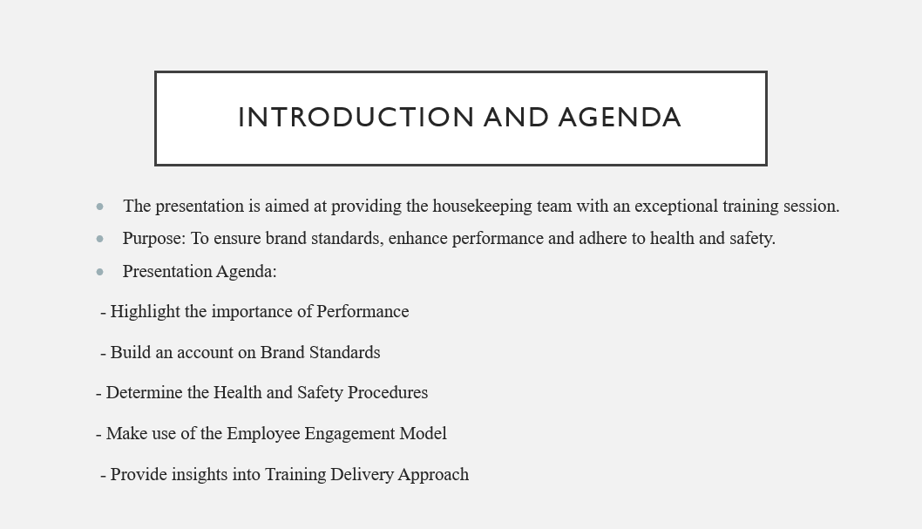

Training Notes: This serves as an introduction to the training session for the housekeeping team at Hotel Trinity. The presence of colleagues and the decimated staff will help improve performance and services. The prime purpose of the training is to enhance performance, promote health and safety procedures and maintain consistency in achieving brand standards.
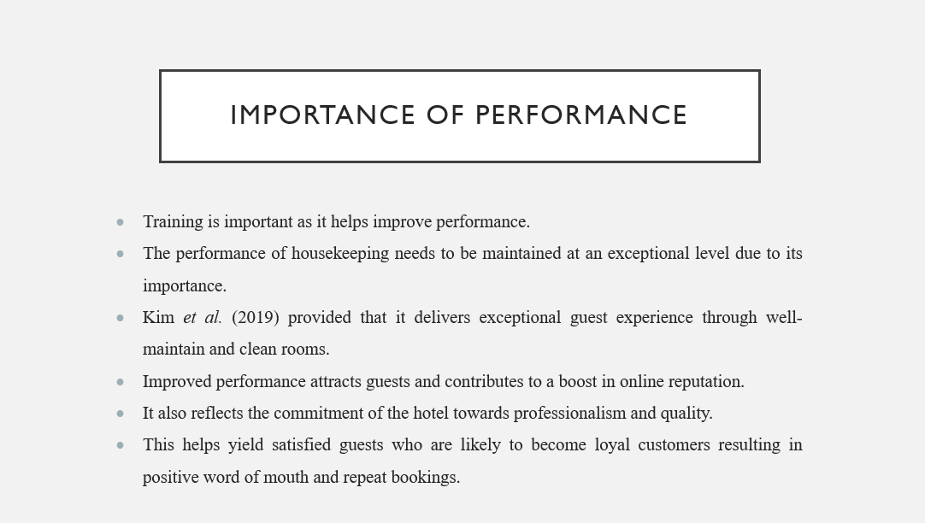

Training Notes: The slides assisted in delving into the importance of performance in the role of housekeeping. This is essential as it has a direct association with guests' performance. Housekeeping plays a major role in making the guest's experience memorable and building an online reputation, and attracting new customers. A level of professionalism and signs of continuous improvement are visible by prioritising performance.

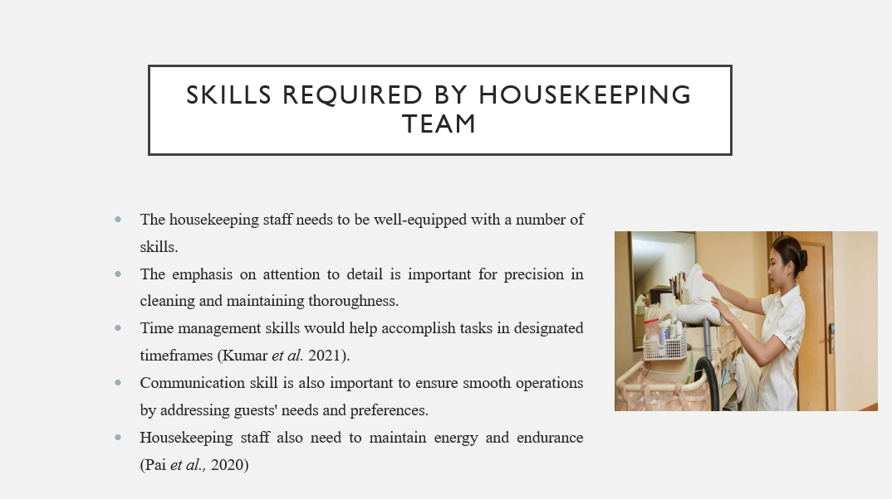

Training Notes: The importance of skills is visible in the job role of housekeeping staff to delve into a pleasing experience. Attention to detail, communication, time management and endurance and physical stamina are among the key skills that aid in addressing the guest's needs and meeting their request promptly.
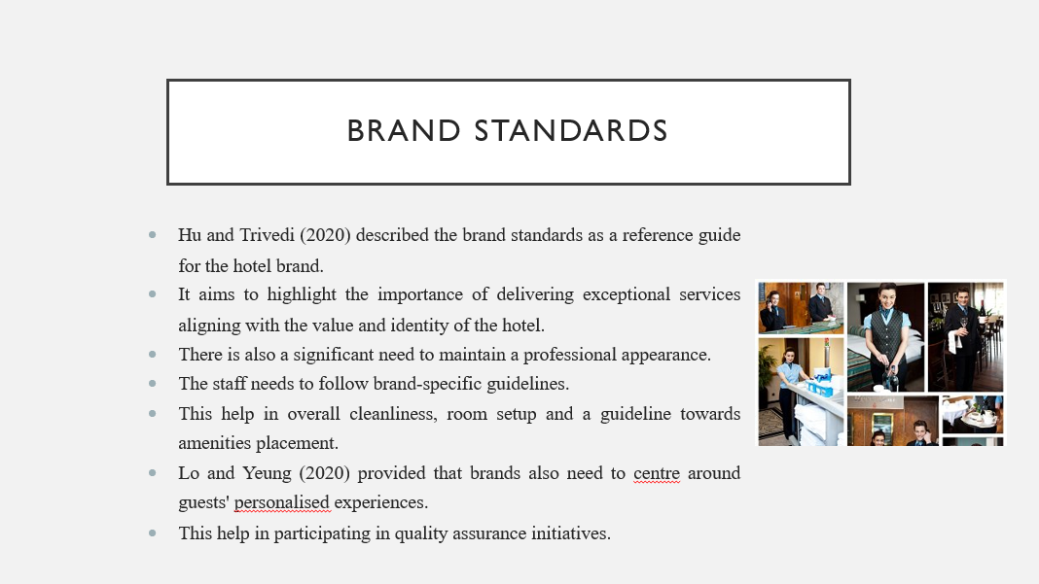

Training Notes: The slide explores the concept of brand standards. Housekeeping staff works towards the maintenance of brand standards by ensuring consistency in operations and function; this help maintains the brand identity of the hotel and creates a professional image encouraging a personalised guest experience.

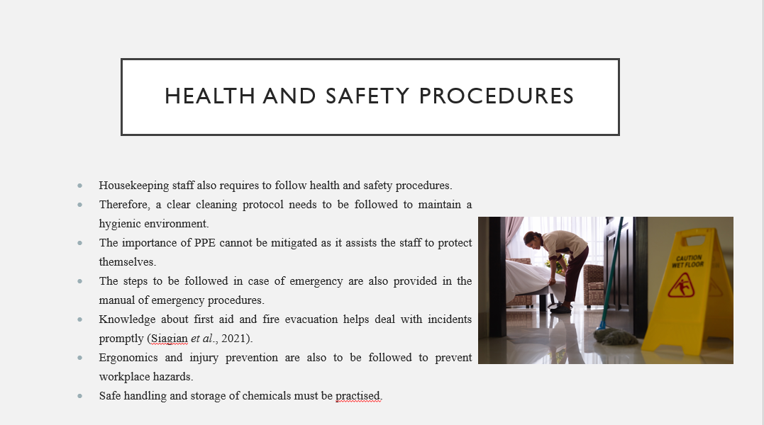

Training Notes: The slide aims to cover the importance of health and safety procedures that housekeeping staff needs to follow. By emphasising the significance of adhering to safety and cleaning protocols, a hygienic environment can be maintained.

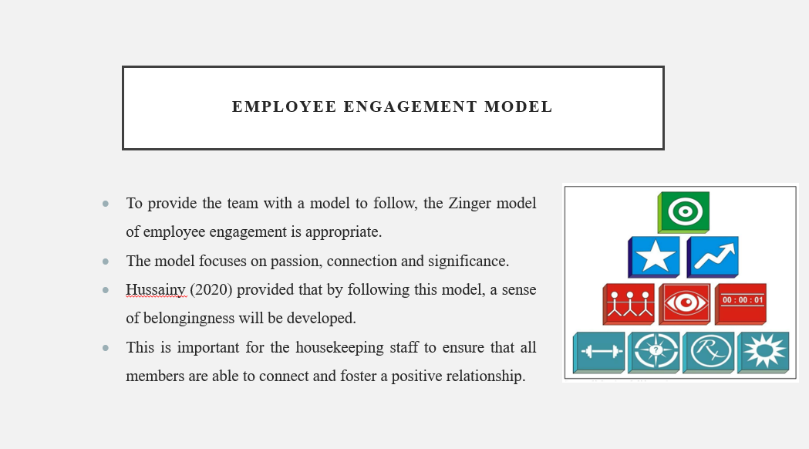

Training Notes: The slide introduces the Zinger Model of Employee Engagement, which focuses on increasing the commitment of the workers towards their organisation and staying engaged.

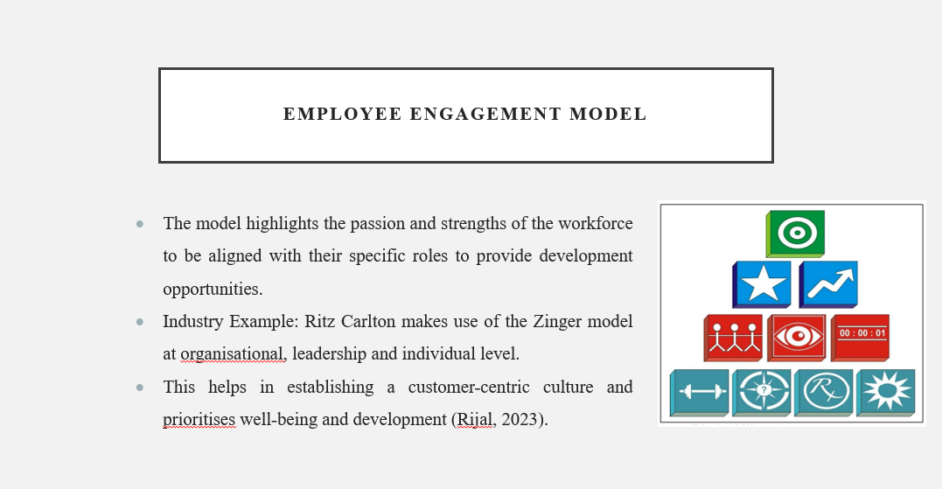

Training Notes: The Ritz-Carlton serves as a profound example that showcases successful employee engagement initiatives. Therefore, the housekeeping staff needs to adhere to the principles of the Zinger model to enhance their engagement.

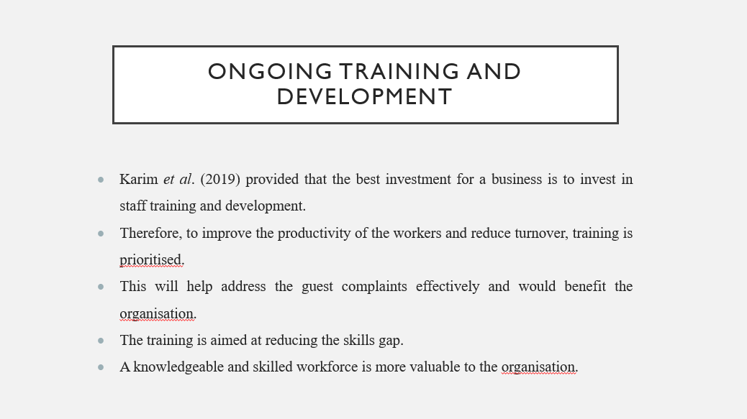

Training Notes: The housekeeping team has been trained to meet the best standards of the hotel. However, the ongoing training will work to highlight the skills gap and will ensure to yield positive guest experiences.
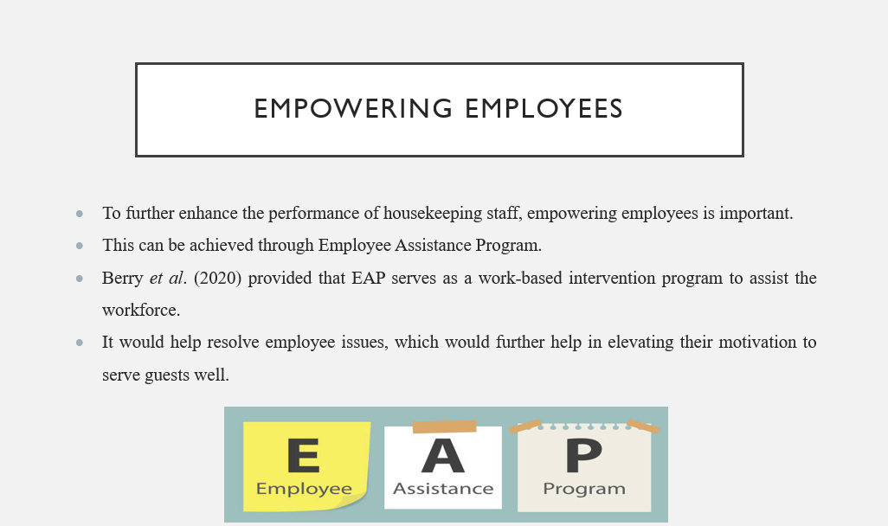

Training Notes: The slides highlight the importance of empowering employees and ensuring that their performance is up to the mark. Therefore, the EAP program seems to be effective in this regard.

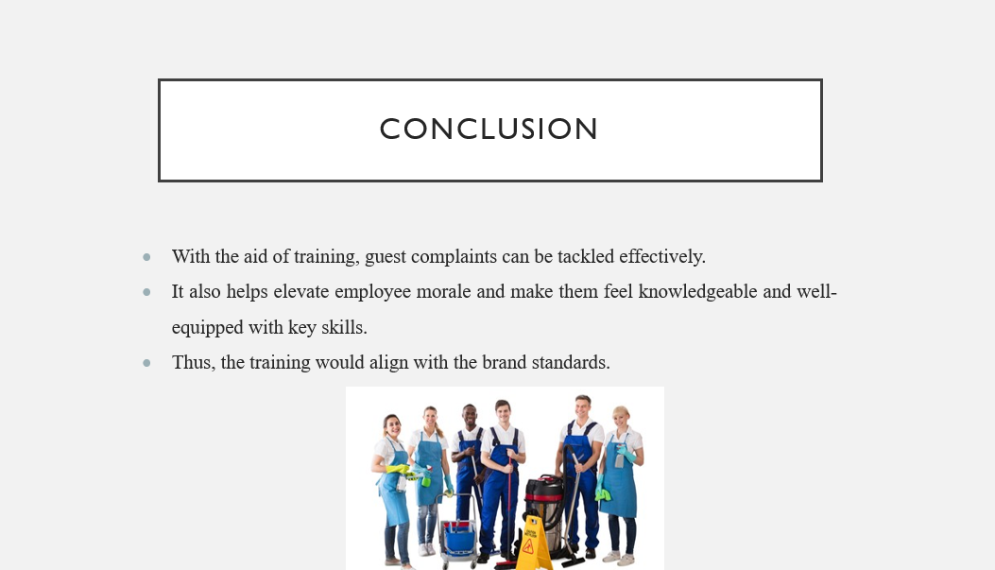

Training Notes: Overall, the training program is focused on the housekeeping staff to enhance their knowledge and understanding. The training would help yield skilled workers with an ultimate focus on improving the guest experience.

References
Awan, M.I., Shamim, A. and Ahn, J., 2021. Implementing 'cleanliness is half of the faith in re-designing tourists and experiences and salvaging the hotel industry in Malaysia during the COVID-19 pandemic. Journal of Islamic Marketing, 12(3), pp.543-557.
Berry, L., Mirabito, A.M. and Baun, W.B., 2020. What's the hard return on employee wellness programs? (pp. 2012-2068). SSRN.
Datu, Y.A., Limantoro, S.W., Soelistiyowati, E., Hardjanto, T.D. and Fuadi, Y., 2020. ESP Test For Hotel Front Office: Is It A Need? PEOPLE: International Journal of Social Sciences, 6(1), pp.690-704.
Four Seasons, 2023. Five ways to create your own Four Seasons World At Home, Four Seasons Press Room. Available at: https://press.fourseasons.com/abudhabi/trending-now/creating-a-four-seasons-experience-at-home/ (Accessed: 09 June 2023).
Goldstein, M., 2021. As hotels like Hilton make daily housekeeping optional, will it damage the hotel product? Forbes. Available at: https://www.forbes.com/sites/michaelgoldstein/2021/07/19/hotels-like-hilton-drop-daily-housekeeping-will-it-annoy-customers/?sh=442823f87205 (Accessed: 09 June 2023).
Hu, F. and Trivedi, R.H., 2020. Mapping hotel brand positioning and competitive landscapes by text-mining user-generated content. International Journal of Hospitality Management, 84, p.102317.
Hussainy, S.S., 2020. Review on motivational theories & models: Its application for employees' retention in organisations. International Journal of Business and Applied Social Science, 6(1), pp.40-46.
Karim, M.M., Choudhury, M.M. and Latif, W.B., 2019. The impact of training and development on employees’ performance: an analysis of quantitative data. Noble International Journal of Business and Management Research, 3(2), pp.25-33.
Kim, J.J. and Han, H., 2022. Saving the hotel industry: Strategic response to the COVID-19 pandemic, hotel selection analysis, and customer retention. International Journal of Hospitality Management, 102, p.103163.
Kim, J.J., Lee, Y. and Han, H., 2019. Exploring competitive hotel selection attributes among guests: An importance-performance analysis. Journal of Travel & Tourism Marketing, 36(9), pp.998-1011.
Knezevic Cvelbar, L., Grün, B. and Dolnicar, S., 2021. “To clean or not to clean?” Reducing daily routine hotel room cleaning by letting tourists answer this question for themselves. Journal of Travel Research, 60(1), pp.220-229.
Kumar, S., Ghosh, S. and Mondal, B., 2021. Training-up during COVID-19 in hotel housekeeping operations in selected hotels of Kolkata. Indian Journal of Hospitality Management, 3(1), pp.89-95.
Liladrie, S., 2010. ‘Do not disturb/please clean room’: hotel housekeepers in Greater Toronto. Race & Class, 52(1), pp.57-69.
Liu, J., Cho, S., Yang, S. and Xue, C., 2021. How and when does multitasking affect the customer orientation of hotel employees? Journal of Hospitality and Tourism Management, 47, pp.335-342.
Lo, A. and Yeung, M.A., 2020. Brand prestige and affordable luxury: The role of hotel guest experiences. Journal of Vacation Marketing, 26(2), pp.247-267.
Marriott, 2020. Marriott International Launches Global Cleanliness Council to promote even higher standards of cleanliness in the age of covid-19, Marriott International Newscenter. Available at: https://news.marriott.com/news/2020/04/21/marriott-international-launches-global-cleanliness-council-to-promote-even-higher-standards-of-cleanliness-in-the-age-of-covid-19 (Accessed: 09 June 2023).
Pai, A., Manjunath, M., Kowshik, C.S., Ayedee, N., Malarout, N. and Naik, N., 2020. SOFT SKILLS AS A KEY COMPETENCY FOR THE FUTURE LEADERS OF THE HOSPITALITY INDUSTRY. PalArch's Journal of Archaeology of Egypt/Egyptology, 17(9), pp.4341-4355.
Radzi, S.H.B.M., Ying, T.Y., Abidin, M.Z.Z. and Ahmad, P.A., 2020. The effectiveness of board games towards soft skills development for higher education. Elementary Education Online, 19(2), pp.94-106.
Rijal, R., 2023. Factors Influencing Employee Retention in the Nepalese Tourism and Hospitality Sector. Nepalese Journal of Hospitality and Tourism Management, 4(1), pp.1-20.
Shahane, R. and Fernandes, M., 2021. To Study the Training Program Implemented by the Housekeeping Department for Onboarding Staff in a Post-Pandemic World and its Impact on Employee Motivation. Atithya: A Journal of Hospitality. 19(2), pp.94-106.
Siagian, R.A., Berybe, G.A. and Panjaitan, T.W., 2021. Crisis Management in Managing Hotels in Labuan Bajo during the Covid-19 Pandemic. Budapest International Research and Critics Institute-Journal (BIRCI-Journal), 4(3), pp.4163-4172.
Tiong, Y.Y., Sondoh Jr, S.L., Tanakinjal, G.H. and Iggau, O.A., 2021. Cleaner operations in hotels: Recommendation for post-pandemic green recovery. Journal of cleaner production, 283, p.124621.
Verma, P., Singh, M. and Aggarwal, N., 2020, June. The Effect of Next–Level Housekeeping via Technology on the Perceptions of the Hospitality Aspirants. In 2020 8th International Conference on Reliability, Infocom Technologies and Optimisation (Trends and Future Directions)(ICRITO) (pp. 1150-1156). IEEE.

