Introduction

This dissertation aims to look at the wellbeing of staff within the call centre environment. Looking on majority of online recruitment websites, Swansea always has a high demand for call centre staff so this research will focus on the well-being of staff in the call centre. From well established companies to ‘pop-up’ call centres this dissertation will look at the difference in call centres and what can be done to help improve the role for the wellbeing of the staff.

An integrated approach to health and well-being can nurture heightened levels of employee engagement while fostering a workforce where people are committed to achieving organisational success (CIPD, 2018).

From ‘first job’, to ‘job for now’ and ‘forever job’ call centres employ a vast amount of people from varied backgrounds. But there are many different forms of the type of business. Dependant on the company there could be many departments or not been open long, be a cold calling sales firm to a recognised company. Back in the PPI saga in 2010 call centres were popping up looking for money hungry individuals to extract a fee for checking a claim. These types of call centres can have a large effect on well-being from being pushed to sell, to going home without a position within the company for varied reasons. On the other hand, professional companies who are there to provide an informational service could see that sitting down all day is not great for their staff and have found better ways of keeping their staff productivity high. Throughout this dissertation there will be analysis on the well-being of staff within these call centres.

Literature review

The literature review will focus on documents and research that investigate working in a call centre. From staff well-being to the harsh target work they are required to achieve, at what point does there become a balance between work and life without the extra stress.
Call centres first landed in the UK in 1989. Microsoft was the first company in the UK to open a call centre and their business has thrived since then (Call Centre Helper, 2018). The UK is the second country in the word to have the most call centres with the USA being first. But with 6,200 call centres and over 4% of the population working in this industry are we affecting our well-being? Or are some call centres just not cut out for staff?
Looking back to a BBC news report in 2004, where is describes a call centre as working in a Victorian ‘satanic’ mills, has much changed since then? With call centre jobs being ten for a penny there are plenty of workers hungry for money but, with most call centres paying only minimum wage and with the targets being so high are staff setting themselves up to fail? Sitting down is not a job for everyone, especially when the work is repetitive, however, this article points out how staff feel powerless and tied to their desks and with only a few seconds between calls and multiple hang ups, the stress builds up as the day goes ahead. Linked to this article is multiple opinions of those who work(ed) in a call centre this will be useful for the research as it provides personal experiences. Although this piece of work was published in 2004 it is still valid to provide a historical background. Another article published in 2003 shows an evaluation of work design and well-being (BBC News, 2004). With both these articles published in the early 2000’s has the tiring and tedious industry changed? Or are people brushing their feelings aside for an easy cash flow.
Looking at the 2003 report put together by the University of Sheffield which looked at 36 call centres and 1,141 members of staff shows that the risk of mental health problems are higher for call handles and job related well-being is lower compared to other occupations studied (Sprigg, et al., 2003).
With every call recorded, monitored and your work being watched carefully, are we signing up to an army type regiment with headphones? With strict scripts to adhere too and a daily, weekly and monthly targets to achieve, are call centre staff fully aware of the potential stress and depression that could only be one call away.
With stress levels rising in the UK, looking from 2003 to 2018 not much has changed in the telephonic world. reading an article in The Guardian, reporter Jamie Woodcock worked in a call centre for six months and documented what he discovered (Woodcock, 2017). Woodcock described the call centre like a panopticon of the 18th century by Jeremy Bentham. His report highlights the stress, bullying and the constant monitoring of staff. A highlight would be to obtain an early finish by hitting targets rather than get bonuses or decent flexible working policies. The effect of a dangled carrot that was entirely on the manager’s terms. With staff turnover costing the UK call centre (CC) market over £1.1billion per year, when will CC realise that the money could be better spent on employee engagement as opposed to hiring new, fresh and naive agents (Leonard, 2017). Another article that has a similar view to Woodcock is a journal article written by Taylor, et al. (2003) in their article they look at the effect of call centres on health and wellbeing. By also describing the call centre environment as a panopticon that causes occupational ill-health and that the sector need to radically redesign the call centre for future workers (Taylor, et al., 2003).

There are other sources that will be looked at including books, newspaper article and surveys with those working in call centres. Also qualitative research will be carried within call centres in the west Glamorgan region.

Aims and objectives

The aim is to look at the rise in call centres around the UK and how a simple ‘talking’ job can affect well-being in the workplace. This will include looking into management styles in call centres and how staff are treated on a daily basis. Another focus will be on how the workload affects the agent and the amount of ‘mind numbing’ calls can produce daily impacts on workplace well-being.

- To see how people that are working in call centres are affected by their jobs
- To investigate how people are drawn into call centre work
- To compare and contrast the varied call centre backgrounds
- To examine how smaller call centres can improve the wellbeing of their staff
- What is the companies values and are they willing to help staff wellbeing

Rationale

The reason to look at this is the amount of work related stress and unhappiness in call centres. Call centres employ 4% of the UK workforce, but some call centres are there to make as much money as they can minus the stress and issues they put their staff through (Ward, 2016). Some call centres may not pay you. When it comes to call centre life there is a lot of job uncertainty, often thoughts such as ‘will I hit my targets this week’, ‘will I still have my job if I miss my targets’. With this in mind It is time to look at what could be done to improve the work life within the walls of a call centre. It is important to look to improve wellbeing within the workplace, with health and wellbeing being on the rise less and less people will want to be chained to a desk with a head piece. By looking at wellbeing, call centres could improve their work place for their business benefits but more importantly their staff.

Methodology

Research is a “systematic investigation into and study of materials and sources to establish facts and reach new calculations” (Oxford Dictionary, 2018). By carrying out research, it will open up a wider picture for more understanding and a better quality of work. No better answers can come from direct research using a blend of qualitative and quantitative aspects, by getting direct answers from those that are working in this environment.
“Qualitative research is primarily exploratory research. It is used to gain an understanding of underlying reasons opinions and motivation” (Silverman, 2016). By using this method, it will provide insight into the life of call centre workers and hear first-hand how the position may be affecting their life in some way.
“Quantitative research is a structured way of collecting and analysing data obtained from different sources” (Silverman, 2016). By collecting data from a different variation of call centres, some with amusements for staff and other “pop up” call centres that may not care about their staff welfare. It will bring together the various opinions that workers have regarding their company and their day to day work-life. After collecting the information, it will be expressed as statistical data to see the majority opinion and if this varies between each call centre.
Primary and secondary research will also be conducted to triangulate the results. Back in 2013 when the call centre programme started on BBC Three, it showed a fun side of working in a call centre, the staff they had and how they liked them to be. But by completing the programme, it highlighted the issues of working in a call centre. Since filming Neville Wilshire sacked the majority of his workforce and has been in trouble with the law regarding his company (Turner, 2016). By looking at his call centre as one example, it can show the disregard bosses have towards their staff. This is a side people do not see with call centres.

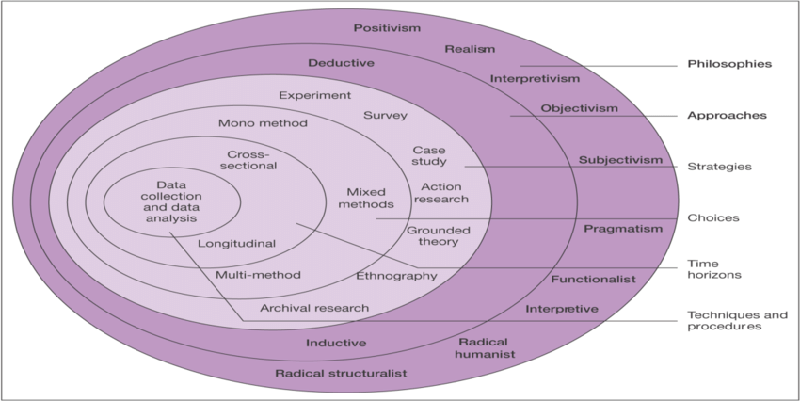
(Saunders, et al., 2009)

By using the onion, it will illustrate the channels available. Each layer of research will eventually form the dissertation through using various methods. The onion starts from the techniques and heads all the way up to philosophies. The onion also allows the research to take on different directions and angles to achieve a varied result across all the businesses looked at. Through this dissertation the stages are –
- Cross sectional – by using cross sectional study it will highlight information from a snapshot of a particular group being interviewed. By doing it this way we can see any risk factors and outcomes.
- Mixed methods – to gain a varied outcomes of data collecting and the varied responses.
- Survey – by using questions and answers, the data collected will show the majority opinion or outcome of the survey.
- Inductive – the reason for using inductive research is to see if there is a generation of new theory emerging from the data collected.
- Direct realism – by using direct realism the data will show the independence of reality from the human mind (Terrell, 2015).

Gantt Chart

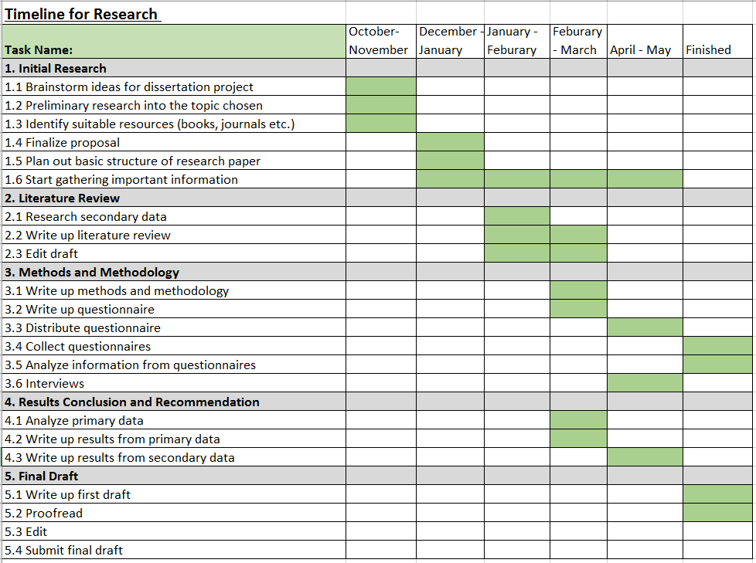

References
BBC News, 2004. UK call centres branded 'satanic'. [Online]
Available at: http://news.bbc.co.uk/1/hi/business/3376803.stm
[Accessed 23 October 2018].
Call Centre Helper, 2018. The history of the call centre. [Online]
Available at: https://www.callcentrehelper.com/the-history-of-the-call-centre-15085.htm
[Accessed 02 November 2018].
CIPD, 2018. Well-being. [Online]
Available at: https://www.cipd.co.uk/knowledge/culture/well-being
[Accessed 01 November 2018].
Leonard, R., 2017. Three reasons for high turnover in the contact centre. [Online]
Available at: https://cxm.co.uk/three-reasons-high-turnover-contact-centre/
[Accessed 28 October 2018].
Oxford Dictionary, 2018. The Dictionary. Oxford: Oxford Dictionary.
Saunders, M., Lewis, P. & Thornhill, A., 2009. research methods for business students. fifth ed. London: Pearson Education.
Silverman, D., 2016. Qualitative Reseach. London: SAGE.
Sprigg, C., Smith, P. & Jackson, P., 2003. Psychosocial risk factors in call cantres: An evaluation of work design and well-being, Sheffield: Health and Safety Executive.
Taylor, P., Baldry, C., Bain, P. & Ellis, V., 2003. `A Unique Working Environment': Health, Sickness and Absence Management in UK Call Centres. New Technology work and employment , 15(1), pp. 2-18`.
Terrell, S., 2015. Writing a Proposal for Your Dissertation. New York City: Guilford Publications.
Turner, R., 2016. Call centre boss Nevil Wilshire admits data protection offence in court. [Online]
Available at: https://www.walesonline.co.uk/news/wales-news/call-centre-boss-neville-wilshire-11438712
[Accessed 08 November 2018].
Ward, C., 2016. 4% of UK workers employed in contact centres. [Online]
Available at: https://www.mycustomer.com/service/contact-centres/4-of-uks-workforce-employed-in-contact-centres
[Accessed 12 November 2018].
Woodcock, J., 2017. As a call centre worker I saw how employees are stripped of their rights.. The Guardian, 16 Feburary.

