

Student name: Mercy Inyang
Student ID: 2426168
Module name: Introduction to physiology
Module code: BMHP5023
Lecturer name: Hussain Shaila
Assessment: 1 case study of diabetes

INTRODUCTION
As a practice nurse in a GP surgery, gathering comprehensive, person-centred information is essential when supporting patients diagnosed with diabetes mellitus. Effective assessment enables tailored care planning, promotes self-management, and reduces the risk of long-term complications such as neuropathy, nephropathy, and cardiovascular disease (American Diabetes Association, ADA, 2024). The assessment should include clinical data such as Hb1c levels, fasting plasma glucose, blood pressure, lipid profile, body mass index (BMI), and current medication adherence. HbA1c is particularly important because it reflects average blood glucose control over approximately 3 months and guides treatment adjustments (Diabetes UK,2023). In addition to biomedical data, lifestyle behaviours must be explored, including dietary habits, physical activity levels, smoking status, alcohol intake, and sleep patterns. Evidence shows that lifestyle modification significantly improves glycaemic control and reduces insulin resistance, particularly in type 2 diabetes (NICE, 2022).
Understanding the patient’s knowledge of their condition is equally important. Many patients attend diabetic clinics without fully understanding hyperglycaemia, hypoglycaemia, or the importance of blood glucose monitoring. Education should therefore include explanation of target glucose ranges, recognition of symptoms of hypo- and hyperglycaemia, and safe use of glucometers. Structured education programmes such as DAVID have demonstrated improvements in self-efficacy and metabolic outcomes (Davis et al, 2008).
Psychosocial factors must also be assessed. Emotional distress, financial pressures, cultural dietary practices, and health literacy levels can influence adherence to treatment plans (Powers et al, 2020). A person-centred approach, based on partnership and shared decision-making, improves engagement and long-term behaviour change (NMC, 2018). Motivational interviewing techniques can help patients identify realistic goals for smoking cessation, weight reduction, or increased physical activity. Smoking cessation is particularly important, as smoking significantly increases cardiovascular risk in people with diabetes (WHO, 2023). Referral to local stop smoking services and discussion of nicotine replacement therapy may be appropriate. Similarly, dietary advice should emphasise balanced carbohydrate intake, reduced saturated fat intake, and increased fibre, aligning with national nutritional guidance (Diabetes UK, 2023). Encouraging at least 150 minutes of moderate-intensity physical activity per week can improve insulin sensitivity and glycaemic stability (Colberg et al, 2016).
Regular follow-up is crucial to evaluating progress, reinforcing education, and adjusting care plans. Collaborative goal setting, documented care plans, and annual reviews support continuity of care and help prevent complications (NICE,2022). Ultimately, effective diabetes management in primary care requires holistic assessment, evidence-based education, and empowerment strategies that enable patients to manage their blood glucose levels safely and confidently. This essay will focus on type 2 diabetes. In 2021, there were 4.1 million people living with a diagnosis of diabetes; 90% of these people have type 2 diabetes, which costs the NHS around £10 billion a year.
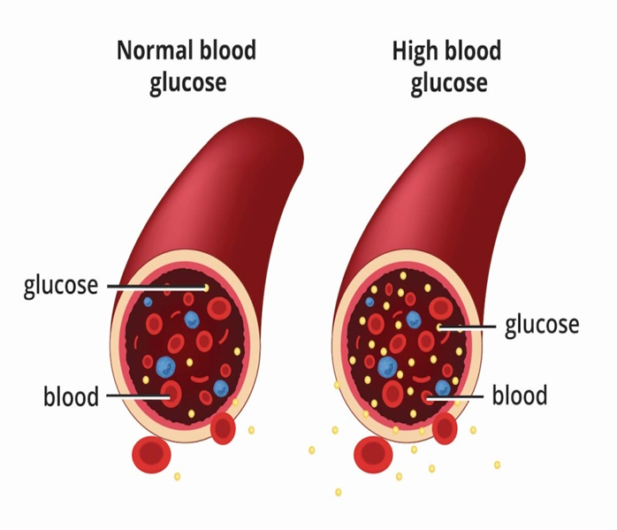
Diagram 1: Visual representation based on information provided by the national institute of Diabetes and Digestive and Kidney Diseases (2022)

DIABETES
Diabetes is a long-term health condition where the body has difficulty controlling the amount of glucose (sugar) in the blood. This happens either because the body does not produce enough insulin, or because it cannot use insulin properly. Insulin is a hormone that helps move glucose from the bloodstream into the body’s cells, where it is used for energy. When this process doesn’t work as it should, glucose builds up in the blood instead of being used by the body. Over time, high blood glucose levels can lead to symptoms like tiredness, increased thirst, and more serious health problems if not managed properly.
TYPE 1 DIABETES
Type 1 diabetes is a disease where the body’s immune system attacks and destroys the beta cells in the pancreas. As a consequence, the body is unable to produce insulin and require lifelong insulin therapy (ADA, 2024). The condition is most often diagnosed during childhood or teenage years, although it can develop at any stage of life.
TYPE 2 DIABETES
Type 2 diabetes is the most widespread form of diabetes. It develops when the body becomes insulin-resistant or when the pancreas does not produce enough insulin to keep blood glucose levels within a normal range (WHO, 2023). Example in diagram 1.
Around 4.8 million individuals in the UK are currently living with type 2 diabetes, making it a significant concern. This represents around 6% of the population, or roughly one in every sixteen people. Most diabetes cases in the UK are type 2, and the condition is strongly associated with rising obesity levels. Projections suggest that the amount of people with diabetes could increase to 5.3 million by 2025, with diabetes continuing to rise at a notable rate (Gov.UK, 2025).

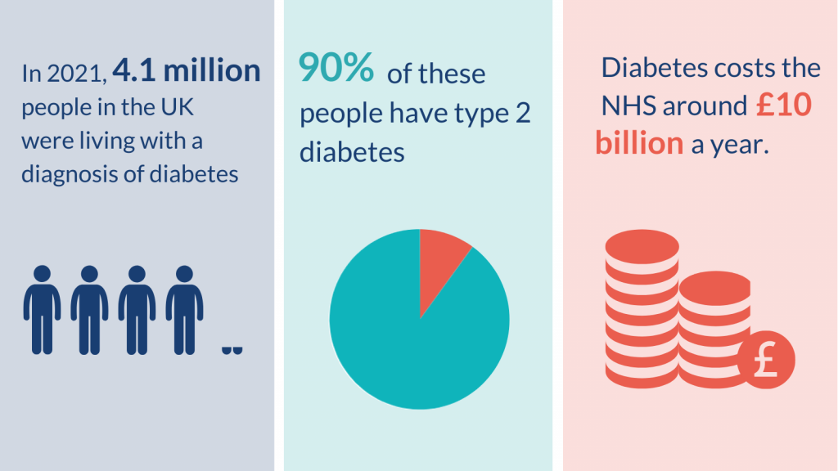
Diagram 2: (National Institute of Health and Care Research, 2021)

THE RISK FACTORS OF DIABETES
Type 2 diabetes develops from a mix of modifiable and non-modifiable risk factors. Age and genetics are key non-modifiable influences; risk increases with ageing, and having a family history of the condition raises the likelihood of onset. (NIDDK). Certain ethnic groups, including South Asian, Black, African and African-Caribbean populations, are at elevated risk, partly due to biological and social factors. (Diabetes UK) Excess body weight and central obesity are among the strongest modifiable determinants because fat accumulation promotes insulin resistance. GOV. UK. Physical inactivity and unhealthy dietary patterns, such as consuming high-calorie processed foods, further increase risk by contributing to overweight and metabolic dysfunction. Diabetes.UK.
Other contributors include previous gestational diabetes, hypertension, and smoking, which are associated with impaired glucose regulation and cardiovascular strain. Diabetes.UK. Addressing these behavioural and clinical factors through lifestyle intervention can help prevent or delay type 2 diabetes.

BLOOD SUGAR REGULATION
Blood sugar levels are controlled by a natural feedback system involving the pancreas, liver, and different hormones working together. After eating, when glucose levels rise, the pancreas releases insulin from its beta cells, helping glucose move into body tissues and be stored in the liver as glycogen, which brings levels back down to normal (Hall & Hall, 2021). When blood sugar levels drop, the pancreas responds by releasing glucagon from alpha cells, which signals the liver to break down stored glycogen and release glucose back into the bloodstream (NHS, 2023). Hormones like adrenaline and cortisol can also increase blood sugar levels, especially during times of stress (Openstax, 2022). Altogether, these processes help keep glucose levels steady so the body and brain have a constant supply of energy (Diabetes UK, 2024).
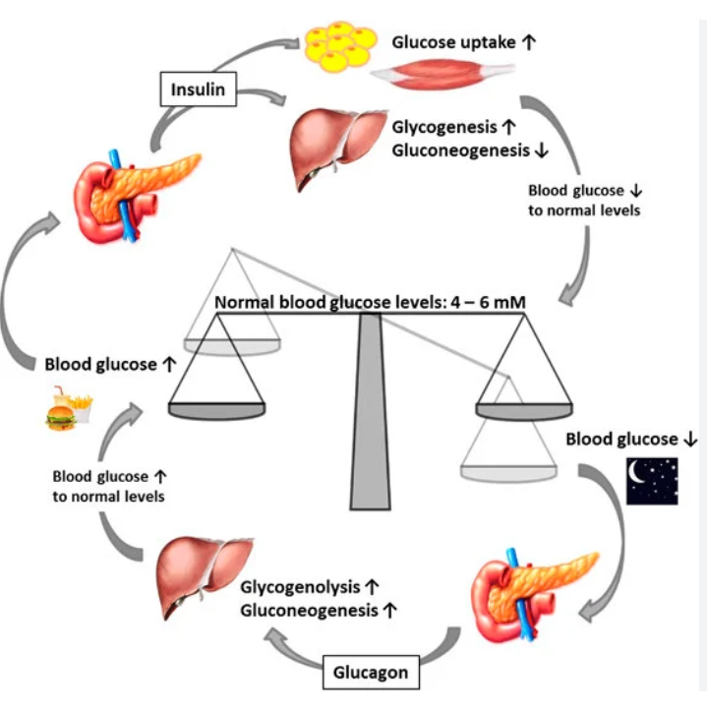

CELLULAR METABOLISM
Cellular metabolism is the way the body’s cells break down nutrients to produce energy. Glucose acts as the main source of fuel, while oxygen is needed for the process to work efficiently. Once glucose enters a cell, it is first broken down in the cytoplasm through a process called glycolysis, which produces a small amount of energy in the form of ATP along with a substance called pyruvate. When oxygen is available, pyruvate moves into the mitochondria, where it goes through further stages known as the Krebs cycle and the electron transport chain, generating most of the body’s ATP (NHS, 2023). This energy is vital for important functions such as muscle movement, nerve signalling, and building proteins.
Oxygen plays a key role by acting as the final receiver of electrons during energy production. If there is not enough oxygen, the body switches to a less efficient method, producing lactate and far less ATP. This shows how closely glucose and oxygen work together to keep the body functioning properly. In individuals with Type 2 diabetes, the body does not respond well to insulin, meaning glucose cannot enter cells as effectively. Even when there is a high level of glucose in the blood, cells may still lack the energy they need, which can lead to tiredness (NHS, 2023). Over time, consistently high glucose levels can also cause damage by increasing inflammation and stress within the body, affecting blood vessels and nerves (Diabetes UK, 2023).
Recent public health data in the UK highlights that obesity can worsen these metabolic issues, as increased fatty acids in the body can interfere with how insulin works (OHID, 2022). This shows that Type 2 diabetes is a complex condition involving multiple metabolic processes, rather than simply being caused by high sugar levels. Understanding how cellular metabolism works helps explain why keeping glucose levels within a healthy range is so important, as glucose is essential for energy, but too much of it can be harmful to the body’s cells.

RECORDING AND TRACKING SUGAR LEVELS IN THE BLOOD FOR DIABETES
Monitoring blood glucose is central to safe diabetes management. NICE (2022) recommends structured self-monitoring for individuals using insulin or at risk of hypoglycaemia, and that HbA1c testing should be conducted regularly to assess long-term control.
HbA1c reflects average blood glucose over approximately three months and is used to evaluate treatment effectiveness (NHS, 2022). Maintaining HbA1c within the target range significantly reduces the risk of complications (NICE, 2022).
Self-monitoring allows patients to identify patterns and understand how diet, activity and medication affect glucose levels. Diabetes UK (2023) highlights that informed self-management improves confidence and adherence.
However, monitoring must be meaningful. Over-testing without education may increase anxiety without improving outcomes. Therefore, practice nurses play a critical role in teaching patients how to interpret results.
Failure to monitor can delay identification of hyperglycaemia, increasing risk of complications such as diabetic kidney disease (Kidney Care UK, 2023). Given that diabetes is a leading cause of kidney failure in the UK, proactive
REASONS FOR TRACKING SUGAR LEVEL AND DENGERS OF NOT TRACKING
Tracking blood sugar helps to determine glucose targets which help to reduce likely symptoms of high and low blood sugar, and avoid long-term diabetes complications. (Thomas K. Mathew; Muhammad Zubair; Prasanna Tad, 2023)
- It helps to provides Insights into Glycemic Control
- Tracking sugar level help in Treatment Adjustments
- Tracking sugar level help to determine when Lifestyle Modifications is needed.
- It also helps to determine personalized diabetes management
- With effective tracking, monitoring blood sugar levels allows you to detect and prevent hyperglycemia (high blood sugar) episodes.
- Adequate blood sugar tracking can help to Preventing Long-term Complications.

5. RECOMMENDATIONS

Weight Management
NICE (2022) recommends structured weight-loss interventions for overweight adults. Even modest weight loss improves insulin sensitivity.

Healthy Eating

The NHS Eatwell Guide promotes balanced intake of whole grains, vegetables and reduced free sugars (NHS, 2023). Public Health England (2018) identifies excess sugar as a contributor to obesity and metabolic disease.

Physical Activity
Adults should aim for 150 minutes of moderate-intensity activity weekly (Department of Health and Social Care, 2019). Exercise improves insulin sensitivity and cardiovascular health.

Smoking Cessation
Smoking increases cardiovascular risk in people with diabetes (NHS, 2022). Referral to NHS Stop Smoking Services should be offered.
Structured Education
NICE (2022) recommends structured education programmes such as DESMOND. Education improves self-efficacy and glycaemic control.
Importantly, social determinants such as deprivation influence outcomes (OHID, 2022). Therefore, holistic, person-centred care is required.

6. CONCLUSION

Diabetes is a complex metabolic and endocrine disorder with significant implications for UK primary care. Effective blood glucose regulation relies on coordinated hormonal activity involving insulin and glucagon. When disrupted, chronic hyperglycaemia damages tissues and increases cardiovascular risk. At a cellular level, glucose and oxygen are essential for ATP production. However, excess glucose results in metabolic harm. Monitoring blood glucose through self-testing and HbA1c measurement enables early intervention and reduces complications. Evidence-based management includes weight control, balanced diet, physical activity, smoking cessation, medication adherence and structured education. However, long-term success depends on addressing broader social determinants and empowering individuals to take active roles in their care.
REFERENCES
American Diabetes Association (2024). Standards of care in diabetes—2024. Diabetes Care, 47(Suppl. 1), pp. S1–S350. Available at: https://professional.diabetes.org/standards-of-care (Accessed: 1 March 2026).

British Heart Foundation (2023) Diabetes and heart disease. Available at: https://www.bhf.org.uk (Accessed 19 March 2026).
Colberg, S.R., Sigal, R.J., Yardley, J.E., Riddell, M.C., Dunstan, D.W., Dempsey, P.C., Horton, E.S., Castorino, K. and Tate, D.F. (2016) Physical activity and exercise in type 2 diabetes. Diabetes Care, 39(11), pp. 2065–2079. Available at: https://pubmed.ncbi.nlm.nih.gov/27926890/ (Accessed: 1 March 2026).
Diabetes UK (no date) Drivers of type 2 diabetes. Available at: https://www.diabetes.org.uk (Accessed: 1 March 2026).
Diabetes UK (no date) Ethnicity and risk of type 2 diabetes. Available at: https://www.diabetes.org.uk (Accessed: 1 March 2026).
Diabetes UK Risk factors for type 2 diabetes, including lifestyle factors. Available at: https://www.diabetes.org.uk (Accessed: 1 March 2026).
Department of Health and Social Care (2019) UK Chief Medical Officers’ Physical Activity Guidelines. Available at:.https://www.gov.uk/government/publications/physical-activity-guidelines-uk-chief-medical-officers-reportd (Accessed 27 March 2026).
Diabetes UK (2023) Diabetes complications. Available at: https://www.diabetes.org.uk (Accessed 17 March 2026).
Diabetes: A consensus report. Diabetes Care, 43(7), pp. 1636–1649. Available at: https://pubmed.ncbi.nlm.nih.gov/32513817/ (Accessed: 1 March 2026)
Davies, M.J., Heller, S., Skinner, T.C., Campbell, M.J., Carey, M.E., Cradock, S., Dallosso, H.M., Daly, H., Doherty, Y., Eaton, S., Fox, C., Oliver, L., Rantell, K., Rayman, G., Khunti, K. and for the DESMOND Collaborative (2008) Effectiveness of the diabetes education and self-management for ongoing and newly diagnosed (DESMOND) programme. BMJ, 336(7642), pp. 491–495. Available at: https://www.bmj.com/content/336/7642/491 (Accessed: 2 March 2026).
Diabetes UK (2023) Diabetes and lifestyle management. London: Diabetes UK. Available at: https://www.diabetes.org.uk/ (Accessed: 3 March 2026).
Diabetes UK (2023). Monitoring your blood glucose. Available at: https://www.diabetes.org.uk (Accessed 19 March 2026).
GOV.UK (2019) Health matters: preventing type 2 diabetes. Available at: https://www.gov.uk (Accessed: 1 March 2026).
NHS (2023) Type 2 diabetes. Available at: https://www.nhs.uk/conditions/type-2-diabetes/ (Accessed 29 March 2026).
NHS (2023) Blood glucose levels. Available at: https://www.nhs.uk (Accessed 29 March 2026).
NHS (2023). How the body uses energy. Available at: https://www.nhs.uk (Accessed 29 March 2026).
NHS (2023) HbA1c test. Available at: https://www.nhs.uk (Accessed 29 March 2026).
NHS (2023) The Eatwell Guide. Available at: https://www.nhs.uk (Accessed 16 March 2026).
NICE (2022) Type 2 diabetes in adults: management (NG28). Available at: https://www.nice.org.uk/guidance/ng28 (Accessed 16 March 2026).
NICE (2022) cardiovascular disease prevention. Available at: https://www.nice.org.uk (Accessed 16 March 2026).
NHS England (2019) NHS Diabetes Prevention Programme. Available at: https://www.england.nhs.uk (Accessed 17 March 2026).
National Institute for Health and Care Excellence (NICE) (2022) Type 2 diabetes in adults: management (NG28). London: NICE. Available at: https://www.nice.org.uk/guidance/ng28 (Accessed: 21 February 2026).
Nursing and Midwifery Council (NMC) (2018) The code: Professional standards of practice and behaviour for nurses, midwives and nursing associates. London: NMC. Available at: https://www.nmc.org.uk/standards/code/ (Accessed: 23 February 2026).
National Institute of Diabetes and Digestive and Kidney Diseases (no date) Risk factors for type 2 diabetes. Available at: https://www.niddk.nih.gov (Accessed: 1 March 2026).
NHS Scotland (no date). Type 2 diabetes risk factors overview. Available at: https://rightdecisions.scot.nhs.uk (Accessed: 1 March 2026).
Office for National Statistics Prediabetes and diabetes risk data. Available at: https://www.ons.gov.uk (Accessed: 1 March 2026).
Office for Health Improvement and Disparities (2022) Diabetes profile. Available at: https://fingertips.phe.org.uk (Accessed 16 March 2026).
Powers, M.A., Bardsley, J., Cypress, M., Duker, P., Funnell, M.M., Hess Fischl, A., Maryniuk, M.D., Siminerio, L., Vivian, E. and Diabetes Care Education and Support Writing Group (2020). Diabetes self-management education and support in adults with type 2
Public Health England (2018) Sugar reduction report. Available at: https://www.gov.uk((Accessed 18 March 2026).
Powell, M. (2022). Diabetes services: Putting People at the Heart. [online] NIHR Evidence. Available at: https://evidence.nihr.ac.uk/collection/diabetes-putting-people-at-the-heart-of-services/ [Accessed 27 Mar. 2026].
Royal College of Nursing (2022) Diabetes nursing guidance. Available at: https://www.rcn.org.uk (Accessed 3 March 2026).
UK Government (2023) Health inequalities data. Available at: https://www.gov.uk (Accessed 17 March 2026).
World Health Organisation (2023) Diabetes fact sheet. Geneva: WHO. Available at:https://www.who.int/news-room/fact-sheets/detail/diabetes (Accessed: 1 March 2026).

