

MANAGEMENT ECONOMICS

Assignment Title | Assesment Component 1 (Essay)
Module Name | Management Economics
Module Code | LCBB 5003
Program of Study | BA Business Management
Student Name | George Valentin Priboi
Student ID Number | 2029732
Lecture’s Name | Vasilios Tavlaridis

Table of Contents
Introduction 3
Explanation of the market structure 3
Conclusion 12
References 13

Introduction
“Market structure” is one of the concepts that help in differentiating the industries operating in the market based on the nature of the products and services being offered by them associated with the level of competition. Therefore, it is the salient feature that affects the attitude and behaviour of the companies and the relevant results obtained by working in the specific structure of the market (Corporate Finance Institute, 2022). The purpose of the essay is to analyse the different market structures and how the market structures affect managerial decisions are analysed with the help of different companies or industry examples. With the help of different economic theories, the market structures are evaluated.

Explanation of the market structure
There are various market structures where organisations can operate. Therefore, the type of market structure affects the behaviour of the organisation and generates the number of profits according to the performance in the respective market structure (Economics Online, 2020). As per the market structure, the organisation identifies the number of firms that are similar to them, their respective market share and other characteristics that affects the competition level in the marketplace.
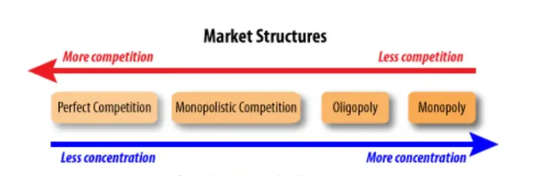
Figure 1: Market Structure
(Source: Economics Online, 2020)

- Perfect competition: This market structure is characterised by the fact that various numbers of buyers and sellers sell similar or identical products of the same nature. As a result, the products of different companies act as a substitute for the buyers. In this market structure, the buyers know the type and nature of the products being sold by the companies and the prices offered to them. In this scenario, the prices are set by the companies concerning the supply and demand aspects (Corporate Finance Institute, 2022). The demand concept states that the buyers will purchase the product and services at any given price offered by the company. In addition, the supply concept states that the sellers will decide the proportion of supply related to the product and services in the market as per their stated prices (Bccs, 2022). However, the article of Silwady (2022), states the various characteristics that the “perfect competition market” has which are as follows. As it is said, firstly, it has many sellers and buyers, the buyer is having knowledge regarding the prices, and the products offered. In addition, the organisation is free to enter and exit the market. Further, as per the condition of the market and the prices set the vital “factors of production such as land labour and capital” can be changed (Silwady, 2022).
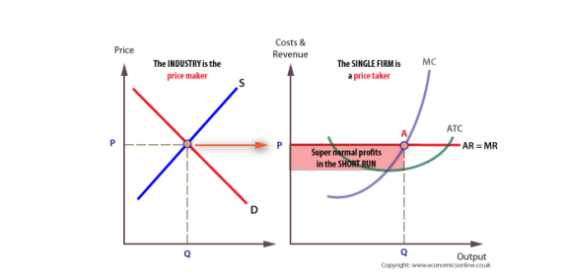
Figure 2: Perfect competition in the short run
(Source: Silwady, 2022)
It is observed from the graph that a single organisation is categorised as a "price taker" as they set prices by referring to the respective industry and the market in which they are operating. The market will thus signify the demand and the supply are equal. Therefore, the single organisation will have to offer this price and cannot change it further. Concerning the "perfect competition market structure", in the short run, the organisation can make "super-normal profits or losses".
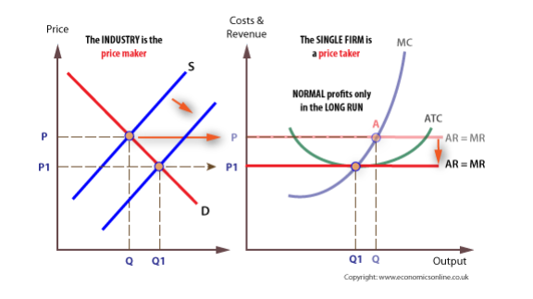
Figure 3: Perfect competition in the long run
(Source: Silwady, 2022)
It is observed from the graph that when there are no entry and exit barriers in the market, as a result, when there is an entry in the market the industry supply curve shifts to the right. This indicates that the prices have declined which diminishes the aspect of the “super-normal profits” of the organisation.
By analysing the “perfect competition market structure”, it is evaluated that “online shopping” acts as a perfect competition market. By using the internet facility consumers can compare and contrast the prices of the product and services and this also depicts that there are many buyers and sellers of the products and services (Boyce, 2022). For example, EBay Company offers different types of products on their website whereas consumers can compare the prices of the products with different competitors such as Alibaba, Amazon and others. There are little to no differences in the prices quoted. Therefore, to remain perfectly competitive in the market, the organisation eBay has to take informed decisions, which will benefit them. Therefore, the company in their website has implemented certain features, which will depict the ratings of the product, comments from the consumers and accurate prices after taking all the necessary charges (Chang, 2010). This indicates that with the help of developing their websites with salient characteristics will make the consumers make informed decisions and lead the company to the perfect competition market.

- Monopoly: This market structure is characterised by the fact that the entire industry is having a solo company. Thereby depicting that it is having no other competitors and represents itself as the standalone seller of the products. In this particular market, the salient characteristics are the ownership of the respective product, services and resources, patent rights, copyrights, set-up costs for the company and others. With the above-said characteristics, the monopoly market restricts potential companies to enter the market (Corporate Finance Institute, 2022). However, other characteristics define the industry to be operating in the monopoly market. In the monopoly market, the sole organisation decides the product and service prices that they will sell to the consumers. The monopoly organisation can change the respective price of the product. Therefore, the organisation operates in an elastic market, if the price set for the product is high then it will sell a minimum quantity of products whereas when the organisation keeps the price low then sell a high quantity of products (Social Sci Libre Texts, 2022).
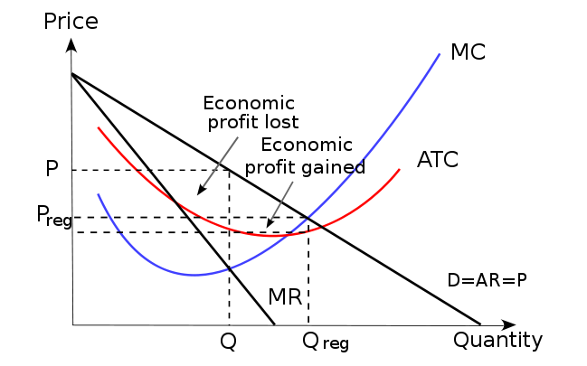
Figure 4: Monopoly graph
(Source: Social Sci Libre Texts, 2022)
The above graph depicts the monopoly market position, where P denotes the price of the product, and P reg indicates the price changes. In addition, Q denotes the level of output and Q reg indicates the change in the level of output.
By analysing the market structure of a monopoly, it is observed that a suitable example for this type of market is "Microsoft" company. It is analysed from the news article in Time (2014) that Microsoft Company was considered a monopoly. The managerial decision taken by the company has restricted the other competitors to enter the market. With the patent rights, the other rival companies do not have the opportunity to develop similar kinds of software. The company is having around “80% of patents filed in multiple countries” (Microsoft Legal, 2022). Another decision taken by the company was to provide “Internet Explorer” software to the consumer who is buying the “Windows operating system”, this created a competitive advantage over other rivalries trying to enter the market such as “Netscape”.

- Monopolistic competition: In this type of market structure, the industry consists of various organisations, which offer similar types of products and services but with certain modifications differentiate themselves from the other organisations in the same industry (Corporate Finance Institute, 2022). This indicates that the companies are selling similar products but with certain, distinct features which makes them different from others. The organisation can differentiate their products and services in the physical appearance of the items, the location of selling the products and services, intangible properties and the product perception (Hutchinson, 2022). With the help of these factors, the organisation can differentiate the products and services offered to the consumers. However, Akter et al. (2022), have stated more of the characteristics that determine that the organisation is under the monopolistic competition market structure. The characteristics such as it consist of several organisations, and each organisation offers similar but "differentiated products", freedom of entry and exit from the market and the competition among the rivalries is based on the product or services price, quality and product and services marketing.
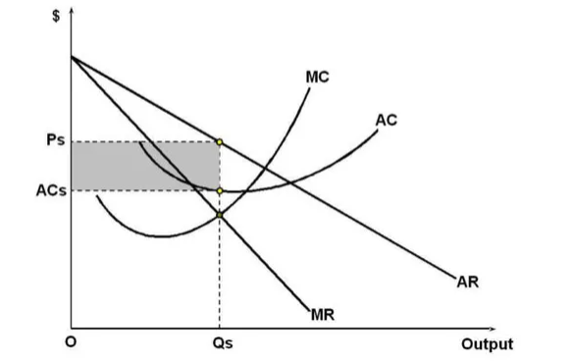
Figure 5: Short-run monopolistic competition graph
(Source: Boyce, 2022)
In the short run, the organisation can maximise their profits when the “marginal revenue” is equal to the “marginal cost” (Boyce, 2022). For this, the organisation needs to produce such quantity where the “marginal revenue” is exceeding the “marginal cost”, thereby the organisation must maintain this and should expand their production process as each unit of marginal is generating a profit by increasing the revenue of the organisation than the cost. This indicates that the organisation is making “super-normal profits” in the short run.
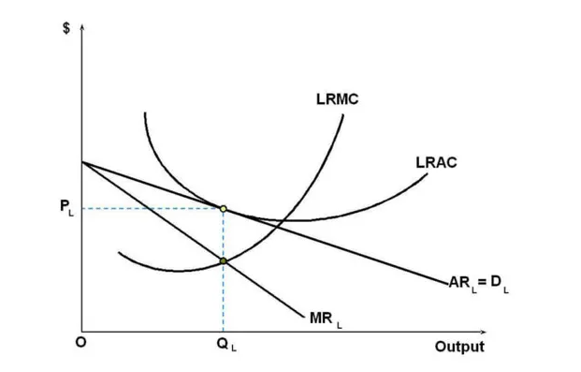

Figure 6: Long-run monopolistic competition graph
(Source: Boyce, 2022)
In the long run, many organisations have entered the market which has increased the competition. As a result, the demand for the respective organisation's products or services has declined as the consumers switched to others. This leads to the shifting of the demand curve to the left. However, the organisation is still aiming to maximise the profits, therefore increasing the production level, which will lead to “marginal revenue” equal to the “marginal cost”. The above graph indicates an intersection point at PL, where the organisation sells the product at the price where the curve of demand intersects them. After this point, the organisation will produce no profit.
By analysing the market structure of monopolistic competition, the best example of this type of structure is the hotel industry. Each hotel industry needs to decide upon the factors and the services offered by them are unique and different from other hotels, which would attract potential customers to their properties. For example, one of the prestigious brands “Waldorf Astoria” has implemented certain changes. This brand is having around “32 hotels in 14 countries” (Hotel Tech Report, 2022). They have decided to offer, “personalised services” to the customers and provides “luxurious facilities” to the guest, which includes offering “golf courses” in their various properties. One of the other iconic brands of the hotel industry is JW Marriott, which has around “110 properties in 29 countries” (Hotel Tech Report, 2022). To differentiate their services from the other hotel group they have decided to provide “one-of-a-kind experiences”. This includes spa treatments for the couples to art and craft classes for the kids. The customers of this brand are “enrichment seekers”.

- Duopoly: In this market structure, two renowned competitors have grabbed the market share by providing a similar type of products and services. The main elements of this category are how the interaction process takes place between the organisation and how it affects them (Corporate Finance Institute, 2022). This indicates that the big players in the industry are considered in this category who is having the same market share. As a result, both companies are having healthy competition and indulge themselves in the innovation process to create unique products for the consumers.
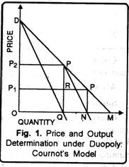
Figure 7: The Cournot Duopoly
(Source: Kumar, 2022)
As per this model, developed by "Augustin Cournot", emphasizes the products and services quantity, which is produced by the company (Kumar, 2022). As per the "Cournot Duopoly" model, the quantity will form the competition between the two organisations in the same industry. This indicates that it ignores the prices of the products and services and concentrates on the accessibility of the product volume. Therefore, both organisations makes desired changes in the production process to reach the level of equilibrium for attaining an equal market share.
An appropriate example of this type of market structure is the “carbonated beverage industry”. It is observed that the marketplace is full of Coca-Cola and Pepsi products, which cover around 75% of the market share (Blackstone and Darby, 2012). Therefore for creating an impression in the customer's mind Coca-Cola company has hired “Olympic boxer Marlen Esparza” to feature in their advertisement (Rafael, 2022). In addition, the other competitor, which is the Pepsi Company, opted for wrestler “Henry Cejudo” to advertise their products (Cambridge University Press, 2022).

- Oligopoly: In this market structure, there are few companies in the particular industry that provides similar kinds of products or services to the consumers. This indicates that as the number of competitors is limited in the industry it will have a significant influence on the activities and their performance (Corporate Finance Institute, 2022). The organisations operating in the oligopoly market constantly have to monitor the prices set by the other competitors to increase the profits of their own company. This indicates that when one of the organisations in the same industry reduces the prices of the product or services to attract customers or to attain maximum sales growth revenue, which will lead to a war in the prices between a similar organisation in the same industry. However, it has been found that the organisation do not generally indulge in price wars rather they invest more of their resources and money into the research and development processes in improving the products and services and indulge in advertising practices that will indicate the unique qualities offered in the respective product or services when compared to the competitors.

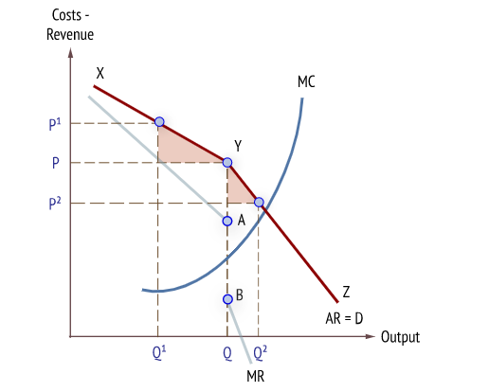
Figure 8: Oligopoly Graph
(Source: Learn Economics, 2022)
The organisation operating in the oligopoly market, are “interdependent” with each other (Learn economics, 2022). This indicates that the company's product or services are elastic to demand when there is an increase in the prices and inelastic to demand when there is a reduction in the prices of the product or services. From the above graph, the P denotes the price of the item and depicts that the “changes in the cost” do not impact the prices of the items as long as “marginal costs” stays between point A and B. In addition, when the “marginal cost” curve moves beyond this point, there is no effect on the prices.
By observing the characteristics of the oligopoly market, the relevant examples of this market structure are Unilever and Tesco Company. Both companies offer grocery and other related items to the consumers and indulge themselves in the improvement of the products and services that will attract the customers. The managers of the respective organisation have undertaken certain measures that enhanced their value in the customers' mind-set. From the annual reports of Unilever (2021), it has been found that they have committed themselves to sustainability practices. To protect nature and improve climate actions the company has changed their course of operations and declared that by the year 2039 there will be zero emissions in its value chain. In addition, “25% of the plastics” will be recycled by the year 2025. Thereby improving the health condition of the individuals “95% of the packaged ice cream” will have not more than 22g of sugar in total by the year 2025. In comparison to this, Tesco PLC is involved in the innovation segment, which will improve the product quality and enhance the sustainability of the products. From the reports of Tesco PLC (2022), it has been observed that in ready-to-go meals they have increased the number of vegetables along with that developed packaging solutions that are sustainable.

Conclusion
From the above discussion, it can be concluded that the market structure plays a vital role in the performance of the company. In this regard, the organisation needs to choose the market structure very cautiously as it will affect the performance and sales of the respective organisation. In addition, the strategies of operating the business organisation and the level of competition in each market segment differ which needs to be evaluated by the organisation in which segment they want to retain.

References
Akter, K., Mieszkowska, N., Kadalie, R., Barsade, S.G., Sheridan, S., Sarker, A.R., Siddiquei, A. and Faysal, M.M.T.M., 2022. A Study on The Concept of Monopolistic Competition. Authorea Preprints.
Bccs.bristol.sch.uk. 2022. [online] Available at: <https://bccs.bristol.sch.uk/media/1308/bs-chapter3.pdf> [Accessed 12 October 2022].
Blackstone, E. A. and Darby, L. F., 2012. The Case of Duopoly. [online] Available at: <https://www.cato.org/regulation/winter-2011-2012/case-duopoly#evidence-from-sectors-served-by-two-dominant-firms> [Accessed 12 October 2022].
Boyce, P., 2022. Monopolistic Competition | Definition and 7 Examples | BoyceWire. [online] BoyceWire. Available at: <https://boycewire.com/monopolistic-competition/> [Accessed 12 October 2022].
Boyce, P., 2022. Perfect Competition Definition (5 Characteristics, 3 Examples) - BoyceWire. [online] BoyceWire. Available at: <https://boycewire.com/perfect-competition-definition/> [Accessed 12 October 2022].
Cambridge University Press, 2022. Seven - Coca-Cola Versus Pepsi. [online] Available at: <https://www.cambridge.org/core/books/competitions-new-clothes/cocacola-versus-pepsi/44D635EB159F751E4443F21B2A8751AC#> [Accessed 12 October 2022].
Chang, J., 2010. eBay: towards a perfectly competitive market. International Business & Economics Research Journal (IBER), 9(3).
Corporate Finance Institute. 2022. Duopoly. [online] Available at: <https://corporatefinanceinstitute.com/resources/knowledge/economics/duopoly/> [Accessed 12 October 2022].
Corporate Finance Institute. 2022. Market Structure. [online] Available at: <https://corporatefinanceinstitute.com/resources/knowledge/economics/market-structure/> [Accessed 12 October 2022].
Corporate Finance Institute. 2022. Market Structure. [online] Available at: <https://corporatefinanceinstitute.com/resources/knowledge/economics/market-structure/> [Accessed 12 October 2022].
Corporate Finance Institute. 2022. Monopolistic Competition. [online] Available at: <https://corporatefinanceinstitute.com/resources/knowledge/economics/monopolistic-competition-2/> [Accessed 12 October 2022].
Corporate Finance Institute. 2022. Oligopolistic Market. [online] Available at: <https://corporatefinanceinstitute.com/resources/knowledge/economics/oligopolistic-market-oligopoly/> [Accessed 12 October 2022].
Economics Online. 2020. Market structures. [online] Available at: <https://www.economicsonline.co.uk/business_economics/competition_and_market_structures.html/> [Accessed 12 October 2022].
Hotel Tech Report. 2022. Hotel Brands & Chains: Marriott, Hyatt, Hilton, IHG (Who Owns What?). [online] Available at: <https://hoteltechreport.com/news/hotel-brand-guide> [Accessed 12 October 2022].
Hutchinson, E., 2022. 8.4 Monopolistic Competition. [online] Pressbooks.bccampus.ca. Available at: <https://pressbooks.bccampus.ca/uvicecon103/chapter/8-3-monopolistic-competition/> [Accessed 12 October 2022].
Kumar M., 2022. 4 Types of Duopoly Models (With Diagram). [online] Available at: <https://www.economicsdiscussion.net/duopoly/4-types-of-duopoly-models-with-diagram/7364> [Accessed 12 October 2022].
Learn-economics.co.uk. 2022. Oligopoly - Market Structures | Learn economics. [online] Available at: <https://www.learn-economics.co.uk/Oligopoly.html> [Accessed 12 October 2022].
Microsoft Legal. 2022. Microsoft Patents | Microsoft Legal. [online] Available at: <https://www.microsoft.com/en-us/legal/intellectualproperty/patents#:~:text=Microsoft's%20patent%20portfolio%2C%20like%20our,of%20patent%20laws%20and%20procedures.> [Accessed 12 October 2022].
Rafael, D., 2022. Amateur female boxer Esparza joining pro ranks. [online] ESPN. Available at: <https://www.espn.in/boxing/story/_/id/18279659/marlen-esparza-signs-multi-year-promotional-deal-golden-boy> [Accessed 12 October 2022].
Silwady, E., 2022. The notion of perfect competition for consumers and producers, and the role of price flexibility in such a context [online] Available at: <https://www.hse.ru/data/2014/06/24/1310207108/essay_Ezees%20Silwady.pdf> [Accessed 12 October 2022].
Social Sci Libre Texts. 2022. 11.1: Introduction to Monopoly. [online] Available at: <https://socialsci.libretexts.org/Bookshelves/Economics/Book%3A_Economics_(Boundless)/11%3A_Monopoly/11.1%3A_Introduction_to_Monopoly> [Accessed 12 October 2022].
Tesco PLC, 2022. Annual report 2022. [online] Available at: < https://www.tescoplc.com/media/759057/tesco-annual-report-2022.pdf > [Accessed 12 October 2022].
Time. 2014. 15 years ago a judge ordered Microsoft to split. [online] Available at: <https://time.com/3553242/microsoft-monopoly/> [Accessed 12 October 2022].
Unilever.com. 2022. Annual Report 2021 [online] Available at: <https://www.unilever.com/files/92ui5egz/production/e582e46a7f7170fd10be32cf65113b738f19f0c2.pdf> [Accessed 12 October 2022].

