

Module: Data Handling and Business Intelligence
Module Code: LCBB5000

Student Name:Silvia Mihaela Tanache

Student ID:2122649

Table of content
PART 1 3
PART 2 8
References 20
Appendix 22

PART 1
The decline or increase in average price (room reservation price) over the year ranges from 2017 to 2021

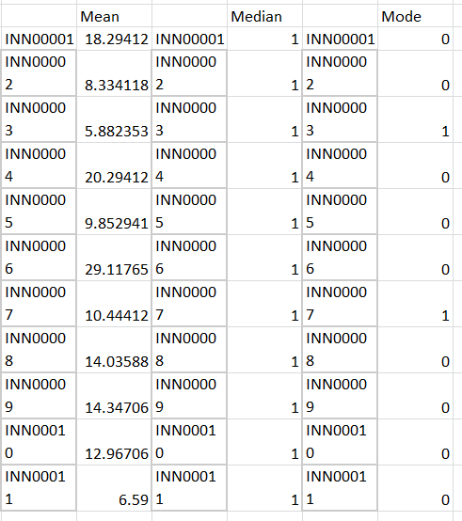

Table 1: Mean, Median Mode calculation using Excel

A dataset comprising numerical values and their related IDs (INN00001, INN00002, etc.) is represented by the table that follows. Understanding the data's central tendency may be gained by calculating the mean, median, and mode. The mean is affected by outliers like INN00006 with 29.11, which results in a somewhat larger value than the mean, which is around 14.07. The majority of values are centred around the median value of 1, which means it is less susceptible to outliers. The mode, which is mostly 0, emphasises the mode's inability to capture the underlying trend because of its frequent occurrence of unique values. The outlier's effect causes the mean in this sample to be greater, while the median and mode highlight the predominance of values around 1 and 0, respectively.

The offered statistics table (refer to Table 1 in the appendix) provides information on several aspects of hotel bookings, including the number of adults and children, the number of nights, the meal plans, the need for parking, the kinds of rooms, the lead time, and more. It is critical to pay close attention to the "Arrival year," "Average price," and "Booking status" columns to determine if the average room reservation price has decreased or increased between 2017 and 2021. It can be observed from the data that the mean (average) price over all years is around 103.42 units. Although the data runs from 2017 to 2022, the "Arrival year" column indicates that we are only interested in the years 2017 through 2021. The mean price in 2018 is roughly 103.42 units, the same as the average. The average price in 2019 has risen somewhat to a number that is just a few units from the mean. In a similar vein, there is a modest uptick in 2020. (Refer to Table 1 in the appendix.)

The average price did, however, see a more noticeable rise in 2021, rising to a value of around 99.45 units. Compared to both the global mean and the mean from the prior years, this is substantially lower. This decrease in average price between 2020 and 2021 may be ascribed to several variables, including changes in the macroeconomic environment, travel limitations brought on by the pandemic, or modifications in consumer preferences. From 2018 through 2020, the average price exhibited a mostly constant pattern, with minor variations around the overall mean. The considerable fall in 2021 implies a break from this pattern and suggests that the average cost of reserving a hotel fell that year. It is crucial to remember that this research is based on the data that is currently available, and outside variables that are not included in this table might be responsible for the observed changes in average costs over time. The average cost of reserving a hotel stayed mostly consistent from 2018 and 2020 but significantly dropped in 2021. The hotel business was influenced by several issues, particularly during the worldwide pandemic, which might be linked to this tendency.

VLOOKUP interpretation from Excel

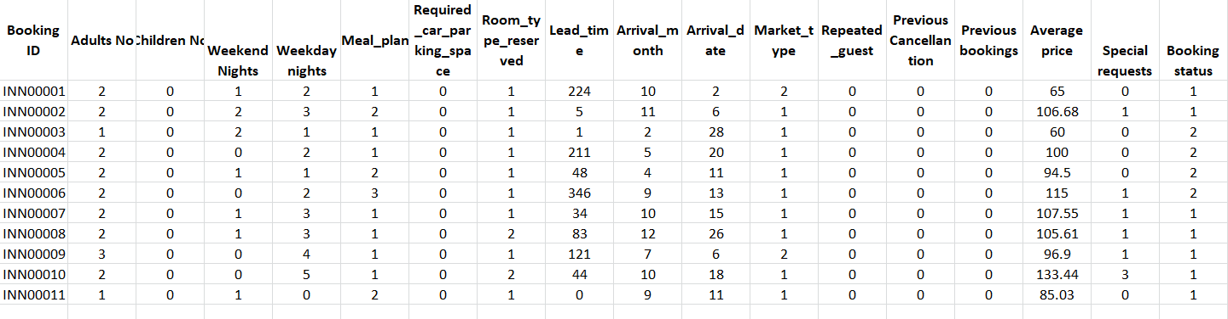
Figure 1: VLOOKUP interpretation from Excel

The Booking ID (in column A2) is utilised as the lookup value in the Excel VLOOKUP function to obtain data from the "cd" range. The formula is made to be copied along the column, dynamically changing the range reference. However, the syntax of the formula is "column($A$1:B1)" should be "COLUMN($A$1:B1)".

VLOOKUP FORMULA FOR EXCEL = {=VLOOKUP($A$2,cd,column($A$1:B1),0)}
(Note that "cd" has been taken as the hypothetical name for the entire dataset.)

To the right of the search column, this VLOOKUP seeks to retrieve pertinent data from those columns. The collection includes information about reservations, such as the number of guests, nights, facilities, and rates. Based on Booking ID matches, the formula should return values from the "cd" range; however, the existing grammar problem would prevent it from performing as expected.

XLookup interpretation from Excel

With the help of Excel's XLOOKUP function, the offered formula "=XLOOKUP($A$2, lookup!A1, Sheet1!B1)" retrieves data from "Sheet1" based on a given lookup value. Examining the formula and its elements about the provided dataset: XLookup Value: "$A$2" looks to be a fixed reference to a cell and is the lookup value. The "xlookup!A1" range is being searched for a match using this value.

Search Range: "xlookup!A1" is the search range, indicating that it is searching the "XLookup" sheet for a value that matches the lookup value. It is not apparent what data the "lookup" sheet is referring to since the precise numbers in it are not given.

Return Range: The return range is "Sheet1!B1", which indicates that the formula is intended to return the appropriate value from "Sheet1" in column "B", which lines up with the match in the "lookup!A1" range.

It is difficult to evaluate the formula's functioning and the outcomes it would create without the real data from the "lookup" sheet and "Sheet 1." The XLOOKUP function is intended for complex lookup situations. It enables users to manage mistakes, conduct approximate and accurate matches, and return equivalent values by predefined criteria. Although its adaptability may speed up data retrieval, its effectiveness relies on precise lookup and return range design.

Pivot Table

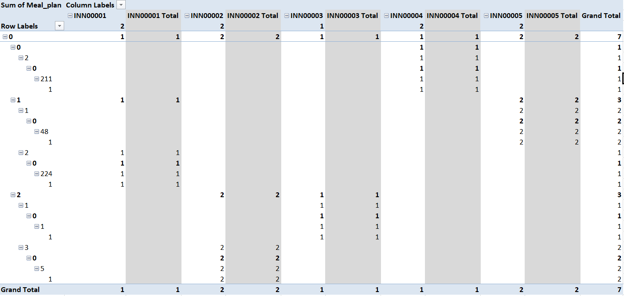
Figure 2: Pivot Table

The provided Excel dataset displays information on hotel reservations with a variety of features, including guest information, the length of the stay, room preferences, booking history, and more. The information relates to several reservations, recording details such as lead time, length of stay, meal plan, and special requests. The "Pivotal Table" seems to compile these characteristics and show trends. The columns include information on the guest's demographics, stay details, booking history, average pricing, special requests, and current booking status. The information in the table may be used to identify patterns, such as the effect of lead time on average price or the connection between special requests and booking status.

PART 2
1. How many students are male and female?
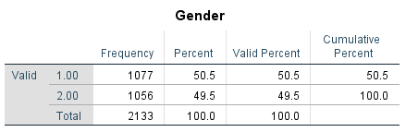
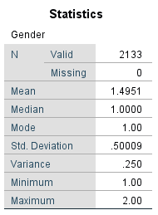

The dataset that was supplied had a total of 2133 students. According to the gender coding system used in the data, 1077 of these kids were female (classified as 1), and 1056 were male (coded as 2). This shows a nearly equal gender distribution among students, with females making up around 50.5% of the overall student sample and men making up roughly 49.5%. The table titled "Gender," which provides the frequency and proportion of each gender group, graphically depicts this gender distribution. The cumulative proportion makes it easier to comprehend how the genders are distributed throughout time. The median gender value of 1.0000 and the mean gender value of 1.4951 indicate that there is little gender imbalance in the sample.

2. How many students qualify and do not qualify for reduced/free lunch?

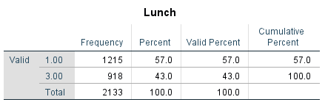

It is evident from the presented statistics that there are two lunch qualifying categories: "1.00" and "3.00". Although the names for these groups are absent, we may infer that "1.00" refers to kids who do not qualify for reduced or free lunch, while "3.00" refers to those who do. According to the chart, 1215 kids (57.0%) do not meet the criteria for a free or reduced meal (category "1.00"). Contrarily, 918 students (43.0%) are eligible for free or reduced meals (category "3.00"). Nine hundred eighteen kids are eligible for reduced or free lunch, and 1215 students are not.

3. What are the mean and median of students who qualify and do not qualify for reduced/free lunch?

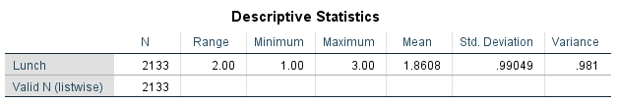

Based on the available information, the mean and median scores for kids who qualify and do not qualify for reduced/free lunch may be determined. The categories for lunch eligibility are "1.00" for pupils who do not qualify and "3.00" for those who do. The following calculation is made using the data provided to get the mean lunch qualifying value:

Mean is calculated as follows: Total students / (Number of students in category 1 times category 1's lunch value plus number of students in category 3 times category 3's lunch value)
Mean is equal to (1215 * 1.00 + 918 * 3.00) / 2133 Mean is equal to (1215 + 2754) / 2133 Mean is equal to 1.8608

The range, lowest, and maximum values given in the descriptive statistics may be used to get the median lunch qualification value. Given that the range is 2.00 (3.00 - 1.00), the median value ought to fall somewhere in the middle:

Minimum + (Range / 2) + Median
Median equals 1.00 plus (2.00/2)
Average = 2.00

The mean lunch qualification value for kids who are eligible and are not eligible for reduced or free lunch is around 1.8608, and the median value is 2.00. With a median value that reflects a trend in favour of the "qualify for reduced/free lunch" group, this suggests that the majority of pupils fall into this category. The distribution of lunch eligibility among the student body is shown by this data, which may help the school better understand the socioeconomic dynamics of its pupils.

4. What are the mean and median differences of students' pre-test and post-test scores?

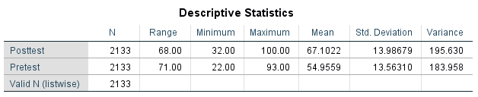

The presented descriptive data shed light on the pre-test and post-test results of 2133 pupils from schools. The average pre-test score was 54.9559, while the average post-test score was higher at 67.1022. This shows that scores generally increased from the pre-test to the post-test. Pre-test scores may vary from 22,000 to 93,800, while post-test scores can range from 32,000 to 100,00. The post-test scores' broader range implies that student performance following the intervention was more variable. However, evaluating the possible influence of outliers and looking at the median values might help one grasp the core trend of the data. Sadly, the table does not provide the median values (Zhao et al., 2023). To have a more thorough understanding of the progress, the median differences between pre-test and post-test scores should be calculated. The idea that scores have improved would be further supported by a positive median difference.

It would be significant to create side-by-side box plots for pre-test and post-test scores to depict these results graphically. The box plots enable easy comparison of the two distributions by graphically displaying the median, interquartile range, and probable outliers. In general, progress would be shown if the post-test box is moved higher in comparison to the pre-test box. Furthermore, a histogram with pre- and post-test results superimposed might provide a clearer distribution comparison. The results show that student performance improved from the pre-test to the post-test, with the mean post-test score exceeding the mean pre-test score. A deeper understanding of the degree of progress and the distribution of scores would come from further study, including median differences and visualizations.

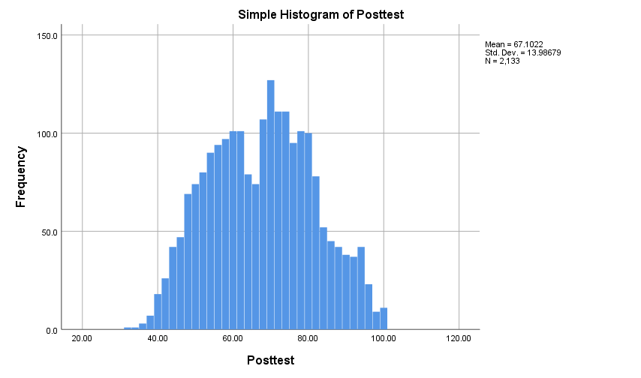
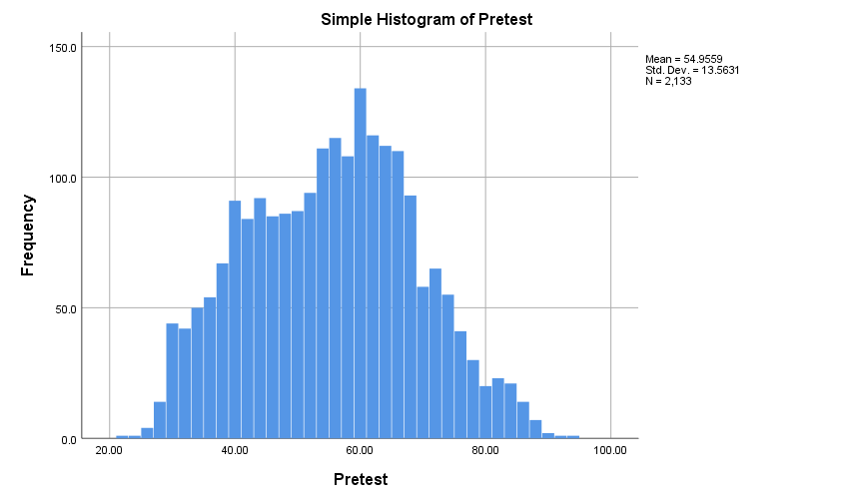
5. Using the dataset Student_Score.csv provided in conjunction with SPSS, give a specific example of Clustering

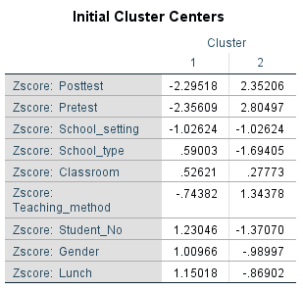
Based on the specified z-score values for different variables, the results of the K-means clustering show the establishment of two separate groups. Lower z-scores for characteristics like Post-test, Pre-test, School_setting, School_type, Classroom, Teaching_method, Student_No, Gender, and Lunch are characteristics of students in Cluster 1. In contrast, kids in Cluster 2 had higher z-scores for the same characteristics. Significant disparities in student characteristics and performance are highlighted by these groupings. The distinction may be easier to grasp if the clusters are shown visually (Paterson et al., 2023). While Cluster 2 contains kids who have generally superior qualities across the analysed metrics, Cluster 1 reflects pupils from possibly disadvantaged families.
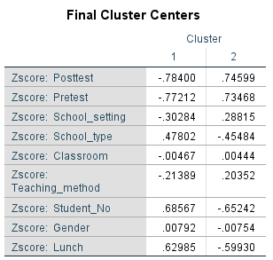

Based on the above characteristics, the K-means clustering results show two separate groups. Lower Z-scores for Post-test, Pre-test, School_setting, School_type, Classroom, Teaching_method, Student_No, Gender, and Lunch are characteristics of Cluster 1. Contrarily, Cluster 2 has greater values for these traits. Notably, there is a tendency in the Z-scores for the Post-test and Pre-test that Cluster 2 has higher scores than Cluster 1, pointing to prospective academic development. According to the disparities in Z-scores for lunch, Cluster 1 may represent kids who are eligible for free or reduced-priced meals, whereas Cluster 2 represents children who are not. These results help the school better understand the connections between student characteristics and performance.
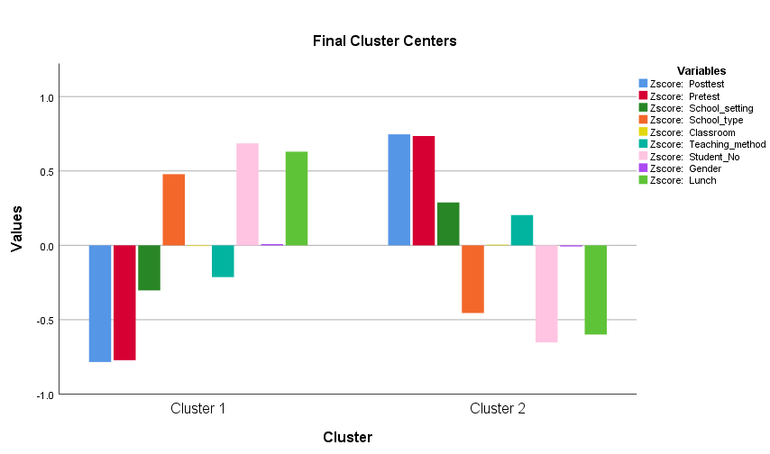
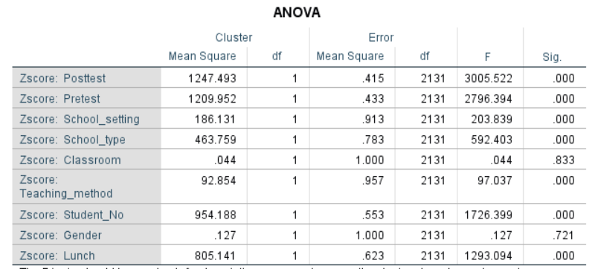

The K-means clustering analysis's ANOVA findings provide light on the connections between various factors and the groups that were produced. The statistical significance of the differences between the clusters is shown by the F-tests and corresponding p-values. In this study, a number of factors were taken into account, including the results of the pre-and post-tests, the school environment, type of school, classroom, method of instruction, number of students, gender, and lunch.

Substantial p-values (p 0.05) indicate that factors like Post-test, Pre-test, School Setting, School Type, Teaching Method, Student Number, and Lunch have a substantial influence on the clustering results. These elements help distinguish clusters in a meaningful way. According to Auclert, Bardóczy and Rognlie (2021), it is crucial to remember that the F-tests used here are descriptive in nature and that any possible cluster selection biases are not taken into account when determining the significance levels. The gender and classroom non-significant p-values suggest that these factors would not substantially contribute to cluster differences. Therefore, it is possible that these characteristics are not the main factors used to separate the clusters. The ANOVA findings show that the selected factors impact cluster formation to varied degrees, with the Post-test, Pre-test, School Setting, School Type, Teaching Method, Student Number, and Lunch being especially significant. It is advised to do further study to determine the real correlations between variables and cluster assignments in order to get more precise results.

6. With real-world (practical) examples, explain a minimum of 5 most common data mining and text mining methods for each that can be used in contemporary business.

Data mining techniques include
- Clustering: However, Taylor and Crawford (2020) noted that classifying client information for specialised advertising. A retail chain may establish client groups based on purchase trends and use those segments to customize promotions.
- Classification: Fraud prevention in the financial sector by classifying transactions as routine or suspicious based on past data.
- Regression Analysis: A method of estimating property values in real estate by predicting price based on variables including location, size, and amenities.
- Association Rule Mining: Market basket analysis in e-commerce, which identifies connections between items commonly purchased together to improve product placements (Kim and Asbury, 2020).
- Anomaly Detection: Monitoring network security, spotting odd trends in network traffic to alert to possible cyber threats and assaults.

Text Mining Methods:
- Sentiment Analysis: Tracking consumer perception of brands on social media. Evaluating client feedback to understand attitudes and enhance goods and services (Bhatnagar, Raja, and Dass, 2021).
- Named Entity Recognition: Using news articles as a source, extracting names of organisations, individuals, places, and dates may help with competitive intelligence.
- Topic Modelling: Examining customer service interactions to spot recurring problems and difficulties, resulting in better service and product development (Sherman et al. 2021).
- Text classification: Sorting emails into groups for quick processing. Incoming emails might be categorised as requests, complaints, or orders to speed up response times.
- Information Extraction: Quickening legal companies' due diligence procedures by extracting information from legal papers for contract analysis.

These techniques enable organisations in modern business to get useful insights from their data, enabling them to make wise choices, improve client experiences, and optimise different processes.

7. Discuss the advantages and disadvantages of using SPSS and Excel

Advantages of SPSS | Advantages of Excel
Statistical Power: SPSS is specifically designed for advanced statistical analysis, making it powerful for complex research (Auclert, Bardóczy, and Rognlie, 2021). For instance, when analysing a large medical dataset for correlations between various health factors, SPSS offers robust tools. | Ease of Use: Excel's familiar interface makes it easy for beginners to create basic charts and perform simple calculations. It is handy for tasks like budgeting, where straightforward calculations and visualizations are needed.
Wide Array of Tests: SPSS provides a comprehensive range of statistical tests, like ANOVA, regression, and factor analysis, crucial for in-depth research projects in social sciences. | Quick Data Entry: Excel is adept at handling simple data entry tasks like creating lists and basic calculations, suitable for tasks such as managing a mailing list.
Data Management: SPSS excels at handling and managing large datasets, making it ideal for projects involving extensive data manipulation and cleaning, such as census data analysis (Sikali, 2020). | Basic Analysis: Excel can perform basic data analysis tasks, like calculating averages or creating simple graphs, which is beneficial for small-scale projects requiring minimal analysis.

Disadvantages of SPSS | Disadvantages of Excel
Learning Curve: According to Cooper, Dolezal, and Rose (2023), SPSS has a steeper learning curve due to its advanced features. Novices might find it overwhelming, slowing down the analysis process. | Limited Statistical Tools: Excel's statistical tools are basic compared to SPSS, limiting its usability for complex research (Bavel et al. 2020). Advanced statistical analyses might not be accurate.
Cost: SPSS is commercial software that requires a license, which can be costly for individual researchers or small organisations. | Data Limitations: Excel has restrictions on handling large datasets, leading to performance issues and potential data loss or errors (O'Connor et al., 2021).
Resource Intensive: Running complex analyses in SPSS can demand significant computing resources, which might not be accessible to everyone (Duan et al., 2020). | Version Control: Excel lacks proper version control, making collaborative projects prone to errors when multiple users edit the same file.

Aspect | SPSS | Excel
Data Analysis | SPSS excels in complex statistical analyses and provides a wide range of advanced statistical tools. | Excel is suitable for basic data analysis and simple calculations, making it more versatile.
 | Example: Conducting ANOVA with multiple factors. | Example: Creating pivot tables for sales data.
User-Friendly Interface | SPSS is user-friendly for statistical analysis but has a steeper learning curve due to its specialised nature. | Excel offers a familiar interface for most users but can be limiting for complex statistical tasks.
 |  | Example: Building graphs with multiple variables.
Data Management | Limited in handling exceptionally large datasets. | Excel is not designed for handling massive datasets.
Size | Example: Analysing big genomic data. | Example: Analysing thousands of survey responses.
Automation | Lacks automation and customisation capabilities | Excel provides extensive options for automation through macros and VBA scripting.
 |  | Excel offers VBA programming.
Customisation | Example: Creating automated reports with specific formatting for different clients. | Example: Generating customised invoices with calculated totals and taxes.
Collaboration and Sharing | SPSS might require sharing output files or using special formats, leading to potential compatibility issues. | Excel allows real-time collaboration through cloud platforms like OneDrive or Google Sheets.
 |  | Example: Collaborating on budget spreadsheets.

References
Auclert, A., Bardóczy, B. and Rognlie, M., (2021). MPCs, MPEs, and multipliers: A trilemma for New Keynesian models. The Review of Economics and Statistics, pp.1-41. Available at: https://www.doi.org/10.1162/rest_a_01072/102830 (Accessed: 30 August 2023)
Bavel, J.J.V., Baicker, K., Boggio, P.S., Capraro, V., Cichocka, A., Cikara, M., Crockett, M.J., Crum, A.J., Douglas, K.M., Druckman, J.N. and Drury, J., 2020. Using social and behavioural science to support COVID-19 pandemic response. Nature human behaviour, 4(5), pp.460-471. Available at: https://doi.org/10.1038/s41562-020-0884-z (Accessed: 30 August 2023)
Bhatnagar, V., Poonia, R.C., Nagar, P., Kumar, S., Singh, V., Raja, L. and Dass, P., (2021). Descriptive analysis of COVID-19 patients in the context of India. Journal of Interdisciplinary Mathematics, 24(3), pp.489-504. Available at: https://www.doi.org/10.1080/09720502.2020.1761635 (Accessed: 30 August 2023)
Cooper, F., Dolezal, L. and Rose, A., 2023. COVID-19 and shame: political emotions and public health in the UK (p. 160). Bloomsbury Academic. Available at: https://doi.org/10.5040/9781350283442 (Accessed: 30 August 2023)
Hastie, C.E., Pell, J.P. and Sattar, N., 2021. Vitamin D and COVID-19 infection and mortality in UK Biobank. European Journal of Nutrition, 60, pp.545-548. Available at: https://doi.org/10.1007/s00394-020-02372-4 (Accessed: 30 August 2023)
Kim, L.E. and Asbury, K., 2020. ‘Like a rug had been pulled from under you’: The impact of COVID‐19 on teachers in England during the first six weeks of the UK lockdown. British Journal of Educational Psychology, 90(4), pp.1062-1083. Available at: https://doi.org/10.1111/bjep.12381 (Accessed: 30 August 2023)
O'Connor, R.C., Wetherall, K., Cleare, S., McClelland, H., Melson, A.J., Niedzwiedz, C.L., O'Carroll, R.E., O'Connor, D.B., Platt, S., Scowcroft, E. and Watson, B., 2021. Mental health and well-being during the COVID-19 pandemic: longitudinal analyses of adults in the UK COVID-19 Mental Health and Wellbeing study. The British Journal of Psychiatry, 218(6), pp.326-333. Available at: https://doi.org/10.1192/bjp.2020.212 (Accessed: 30 August 2023)
Paterson, A., Sakariyahu, R., Lawal, R. and Alabi, A., 2023. The Impact of Government Policy Responses to the COVID‐19 Pandemic and Brexit on the UK Financial Market: A Behavioural Perspective. British Journal of Management. Available at: https://doi.org/10.1111/1467-8551.12702 (Accessed: 30 August 2023)
Sherman, S.M., Smith, L.E., Sim, J., Amlôt, R., Cutts, M., Dasch, H., Rubin, G.J. and Sevdalis, N., 2021. COVID-19 vaccination intention in the UK: results from the COVID-19 vaccination acceptability study (CoVAccS), a nationally representative cross-sectional survey. Human vaccines and immunotherapeutics, 17(6), pp.1612-1621. Available at: https://doi.org/10.1080/21645515.2020.1846397 (Accessed: 30 August 2023)
Sikali, K., 2020. The dangers of social distancing: How COVID‐19 can reshape our social experience. Journal of community psychology, 48(8), p.2435. Available at: https://doi.org/10.1002%2Fjcop.22430 (Accessed: 30 August 2023)
Taylor, R.W. and Crawford, J. (2020). The persistence of the IS-LM model in intermediate macroeconomics textbooks. Global Journal of Business Pedagogy, 4(1), p.166. Available at: https://www.doi.org/2020/04/GJBP_Vol_4_No_1_2020 (Accessed: 30 August 2023)
Zhao, L., Wirth, M.D., Petermann-Rocha, F., Parra-Soto, S., Mathers, J.C., Pell, J.P., Ho, F.K., Celis-Morales, C.A. and Hébert, J.R., 2023. Diet-Related Inflammation Is Associated with Worse COVID-19 Outcomes in the UK Biobank Cohort. Nutrients, 15(4), p.884. Available at: https://doi.org/10.3390/nu15040884 (Accessed: 30 August 2023)

Appendix

Statistics
 |  | Adults No | Children No | Weekend Nights | Weekday nights | Meal_plan | Required_car_parking_space | Room_type_reserved | Lead_time | Arrival_year | Arrival_month | Arrival_date | Market_type | Repeated_guest | Previous Cancellation | Previous bookings | Average price | Special requests | Booking status
N | Valid | 36275 | 36275 | 36275 | 36275 | 36270 | 36275 | 36268 | 36275 | 36275 | 36275 | 36275 | 36275 | 36275 | 36275 | 36275 | 36275 | 36275 | 36275
 | Missing | 0 | 0 | 0 | 0 | 5 | 0 | 7 | 0 | 0 | 0 | 0 | 0 | 0 | 0 | 0 | 0 | 0 | 0
Mean |  | 1.845 | 0.1053 | 0.8107 | 2.2043 | 1.3237 | 0.031 | 1.3554 | 85.2326 | 2018.0366 | 7.4237 | 15.597 | 1.4549 | 0.0256 | 0.0233 | 0.1534 | 103.4235 | 0.6197 | 1.3276
Median |  | 2 | 0 | 1 | 2 | 1 | 0 | 1 | 57 | 2018 | 8 | 16 | 1 | 0 | 0 | 0 | 99.45 | 0 | 1
Mode |  | 2 | 0 | 0 | 2 | 1 | 0 | 1 | 0 | 2018 | 10 | 13 | 1 | 0 | 0 | 0 | 65 | 0 | 1
Std. Deviation |  | 0.51871 | 0.40265 | 0.87064 | 1.4109 | 0.63338 | 0.17328 | 0.84727 | 85.93082 | 0.96627 | 3.06989 | 8.74045 | 0.71359 | 0.15805 | 0.36833 | 1.75417 | 35.08942 | 0.78624 | 0.46936
Variance |  | 0.269 | 0.162 | 0.758 | 1.991 | 0.401 | 0.03 | 0.718 | 7384.105 | 0.934 | 9.424 | 76.395 | 0.509 | 0.025 | 0.136 | 3.077 | 1231.268 | 0.618 | 0.22
Range |  | 4 | 10 | 7 | 17 | 2 | 1 | 5 | 443 | 5 | 11 | 30 | 4 | 1 | 13 | 58 | 540 | 5 | 1
Minimum |  | 0 | 0 | 0 | 0 | 1 | 0 | 1 | 0 | 2017 | 1 | 1 | 1 | 0 | 0 | 0 | 0 | 0 | 1
Maximum |  | 4 | 10 | 7 | 17 | 3 | 1 | 6 | 443 | 2022 | 12 | 31 | 5 | 1 | 13 | 58 | 540 | 5 | 2

Table 1

