
Component 1: Design and Implementation of a Relational Database System
Introduction to Web and Database Concepts - ACCA4023

Sadhana Jha

student - Anna Leontieva -2509324
July 1, 2026
UNIVERSITY OF WALES TRINITY SAINT DAVID

Contents
Scenario Analysis 2
Entity Relationship Diagram (ERD) 2
1. List of attributes and their descriptions 2
2. List of relationships and their meaning. 5
3. ER diagram: 6
Normalization 7
Sample Data Population 9
Query Development 10
Testing and Validation 11
Design Decisions and Future Work 15
1. Design Decisions: 15
2. Future Work: 15
References: 16

Scenario Analysis
The AutoPark Management System requires a centralized database to replace its existing manual record-keeping system. Currently, customer details, vehicle information, parking slot allocation, bookings, and payment records are maintained manually, resulting in inaccurate records, misplaced information, double-booking of parking spaces, and delays in daily operations. A Microsoft Access database will automate these processes, improve efficiency, and provide reliable reporting for management.

Entity Relationship Diagram (ERD)
Entity-Relationship Diagram (ERD) is a visual tool used to design and organize a database. It shows the entities (tables), their attributes (columns), and the relationships between them. ERDs help developers understand how data is connected before creating the database.
The main components of an ERD are entities, attributes, and relationships. Each entity represents an object, such as a student or customer, and contains attributes that describe it. Relationships show how entities are linked, such as one customer placing many orders.
ERDs improve database planning by reducing errors, preventing duplicate data, and making the database easier to understand and maintain. They also help developers communicate the database structure clearly.
ERD is an essential part of database design because it provides a clear blueprint for organizing data efficiently and accurately [1] .

List of attributes and their descriptions
Entities are the basic building blocks of a database. An entity is any real-world object, person, place, event, or concept about which information is stored. In a relational database, an entity is usually represented as a table, with each row representing a record and each column representing an attribute of that entity.
Each entity has attributes that describe its characteristics. For example, a student entity may have attributes such as Student ID, Name, and Email. A primary key is used to uniquely identify each record in the entity.
Entities are connected through relationships. For example, a student can enroll in many courses, while a course can have many students. These relationships help organize data and allow different tables to work together efficiently.
There are several types of entities, including strong entities, which have their own primary keys, and weak entities, which depend on another entity for identification. Associative entities are used to connect many-to-many relationships.
Entities are essential for organizing and managing data in a database. They help reduce data duplication, improve accuracy, and make it easier to store, retrieve, and update information. Understanding entities is an important part of designing an effective database system [2] .

Main Entities
ParkingSite - stores details of every parking location
Primary Key: SiteID
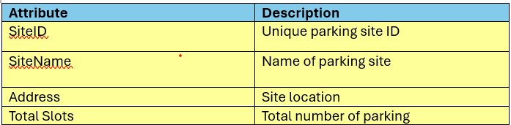
ParkingSlot - stores information about individual parking slots
Primary Key (PK): SlotID
Foreign Key (FK): SiteID
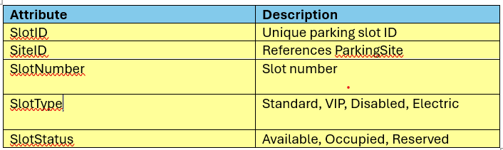

Customer - stores vehicle owner information
Primary Key (PK): CustomerID
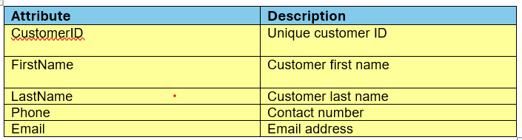

Vehicle - stores vehicle details
Primary Key (PK): VehicleID
Foreign Key (FK): CustomerID
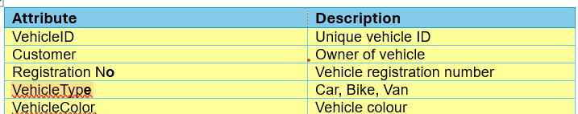

Booking - records every parking session.
Primary Key (PK): BookingID
Foreign Keys (FK): CustomerID VehicleID SlotID
Attribute | Description
BookingID | Unique booking ID
CustomerID | Customer making booking
VehicleID | Vehicle parked
SlotID | Assigned parking slot
EntryTime | Vehicle entry time
ExitTime | Vehicle exit time
BookingDate | Date of booking
BookingStatus | Active, Completed, Cancelled

Payment - stores payment information
Primary Key (PK): PaymentID
Foreign Key (FK): BookingID
Attribute | Description
PaymentID (PK) | Unique payment ID
BookingID (FK) | Booking being paid for
Amount | Parking fee
PaymentDate | Date of payment
PaymentMethod | Cash, Card, Mobile
PaymentStatus | Paid, Pending

List of relationships and their meaning.

Relationships are connections between tables in a relational database. They help organize data, reduce duplication, and maintain data accuracy.
There are four main types of database relationships. A one-to-one relationship links one record in a table to one record in another table, such as a person and their passport. A one-to-many relationship allows one record to be associated with many records, such as one customer placing many orders. A many-to-many relationship allows multiple records in one table to relate to multiple records in another, such as students enrolling in many courses. This relationship is implemented using a junction table. A self-referencing relationship occurs when a table relates to itself, such as employees reporting to managers.
Database relationships are created using primary keys and foreign keys. A primary key uniquely identifies each record, while a foreign key connects related tables.
Database relationships are essential for organizing data, maintaining consistency, and improving the efficiency of database systems [3
] .
Explanation of Relationships for Scenario
A Parking Site can contain many Parking Slots, but each slot belongs to only one site.
A Customer may own multiple Vehicles, while each vehicle belongs to only one customer.
A Customer can make many Bookings over time.
A Vehicle can have many parking bookings on different dates.
A Parking Slot can be used in many bookings over time, but only one booking can occupy it at a given moment.
Each Booking results in a single Payment, and each payment corresponds to one booking.

Cardinality
Relationship | Cardinality
ParkingSite → ParkingSlot  Customer → Vehicle  Customer → Booking  Vehicle → Booking  ParkingSlot → Booking  Booking → Payment | One-to-Many (1:M)  One-to-Many (1:M)  One-to-Many (1:M)  One-to-Many (1:M)  One-to-Many (1:M)  One-to-One (1:1)

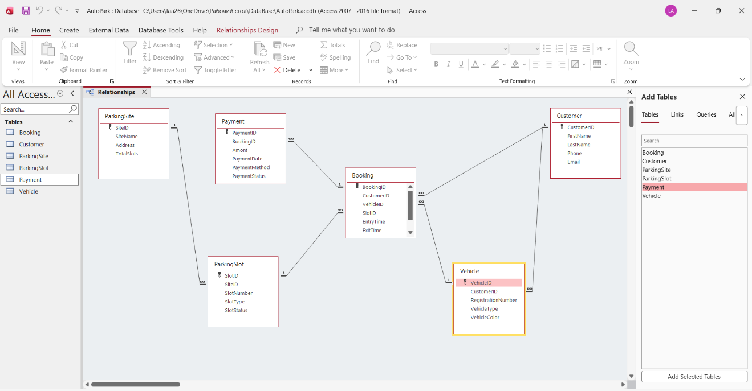

ER diagram:

Database Entity-Relationship (ER) Diagram is a visual tool used to design and organize a database. It shows the entities (such as students, customers, or products), their attributes (such as name or ID), and the relationships between them.
The main components of an ER diagram are entities, attributes, and relationships. Entities represent objects, attributes describe their properties, and relationships show how the entities are connected. ER diagrams also include primary keys and foreign keys to identify records and link related tables.
ER diagrams help developers plan databases, reduce data duplication, improve data organization, and make database systems easier to understand and maintain. They are widely used in schools, hospitals, businesses, and e-commerce systems [4] .
ER diagram is an important part of database design because it provides a clear visual representation of data and its relationships, making database development more efficient and accurate. 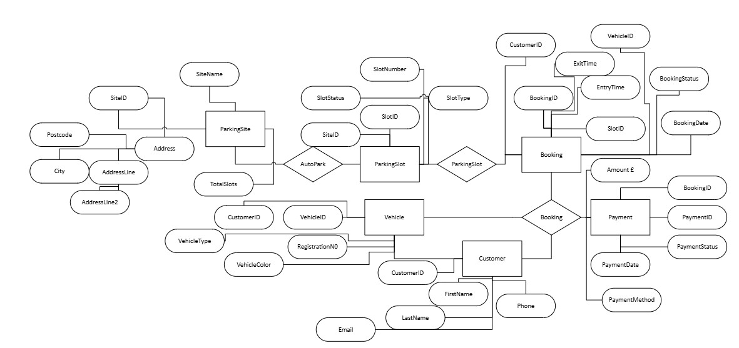

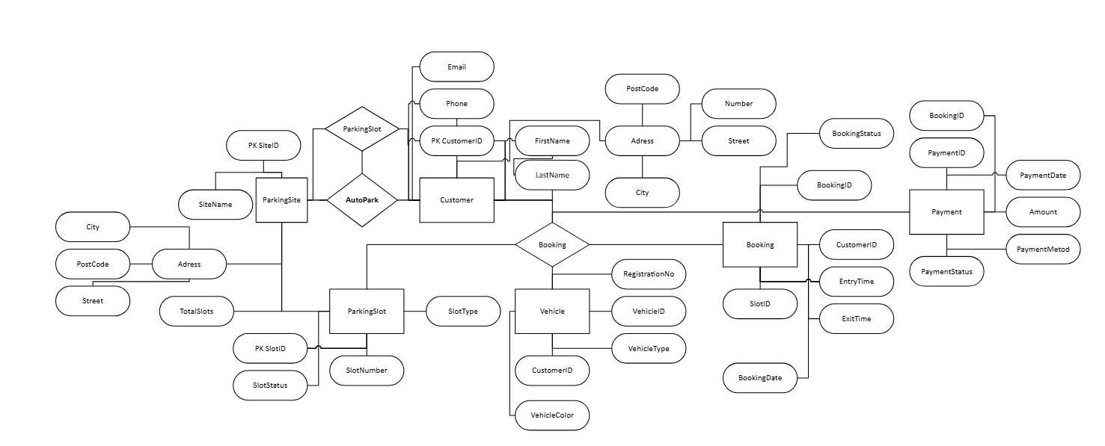

Normalization

Normalization is the process of organizing data in a relational database to reduce redundancy and improve data integrity. It involves dividing large tables into smaller, related tables and connecting them using primary and foreign keys. This helps prevent duplicate data and ensures that the database remains accurate and efficient.
Normalization is carried out through a series of normal forms. The First Normal Form (1NF) ensures that each column contains only atomic values and removes repeating groups. The Second Normal Form (2NF) removes partial dependencies so that all non-key attributes depend on the entire primary key. The Third Normal Form (3NF) eliminates transitive dependencies, ensuring that non-key attributes depend only on the primary key.
The main advantages of normalization include reduced data duplication, improved consistency, easier maintenance, and prevention of insertion, update, and deletion anomalies. However, normalization may increase the number of tables and SQL joins, which can affect query performance.
Database normalization is an essential database design technique that improves the organization, accuracy, and reliability of data. Most database systems are normalized up to Third Normal Form (3NF), providing a good balance between efficiency and performance [5] .
Relational Schema
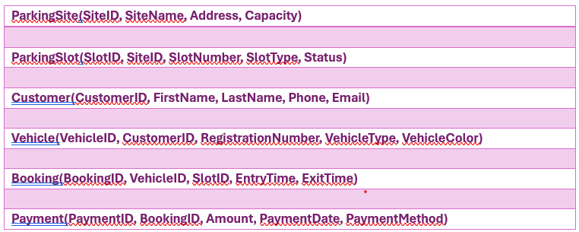
CustomerID | FirstName
CustomerID | LastName
CustomerID| Phone
CustomerID| Email
VehicleID | RegistrationNumber
VehicleID | VehicleType
VehicleID | VehicleColor
BookingID | VehicleID
BookingID | SlotID
BookingID | EntryTime
BookingID | ExitTime
PaymentID |BookingID
PaymentID | Amount
PaymentID | PaymentMethod
PaymentID | PaymentDate
BOOKING
| BookingID | CustomerID | VehicleID | SlotID | EntryTime | ExitTime
PAYMENT table is
| PaymentID | BookingID | CustomerName | Amount |

Primary Key and Foreign Key Relationships

Table Primary Key Foreign Key
Customer | CustomerID
Vehicle | VehicleID | CustomerID
Parking Site | SiteID
Parking Slot | SlotID | SiteID
Booking | BookingID | CustomerID,VehicleID,SlotID
Payment | PaymentID | BookingID

Sample Data Population

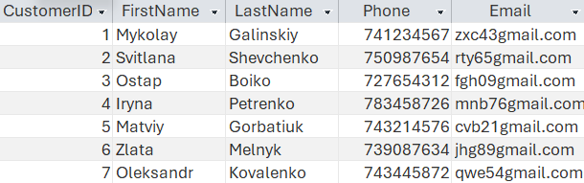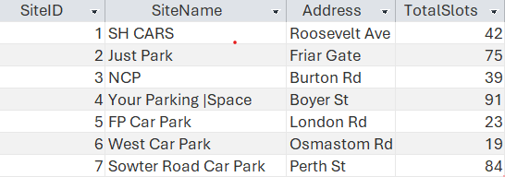

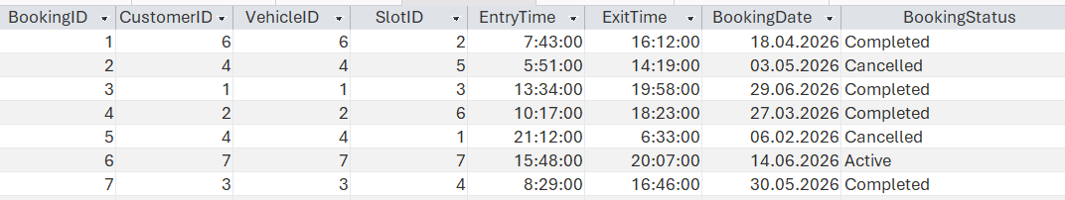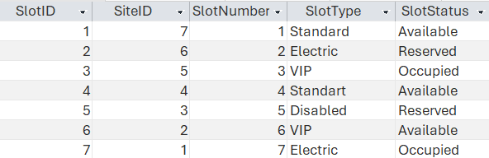
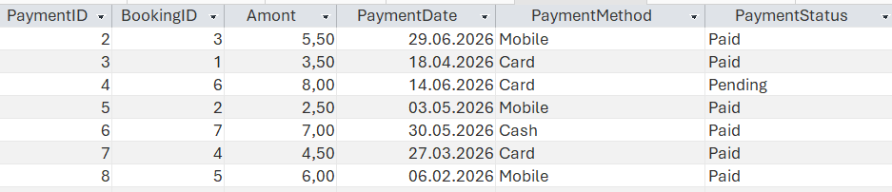

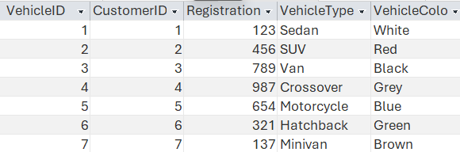

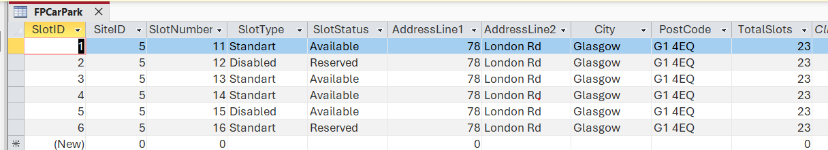

Query Development (3 Queries)
Query is a request used to retrieve, add, update, or delete data in a database. It allows users and applications to communicate with a database management system (DBMS) and access information quickly and efficiently.
Database queries are widely used in schools, hospitals, banks, and online businesses to search for records, manage data, and generate reports. They save time, improve accuracy, and make it easier to handle large amounts of information.
Database queries are essential for managing and accessing data efficiently. They play an important role in modern computer systems and help organizations make better use of their information [6] .
Steps to create a Query
I identified the table I wanted to work with.
Chose the columns (fields) I wanted to display.
Specified conditions (if needed) to filter the data.
Wrote the statement.
Executed the query to view the results.
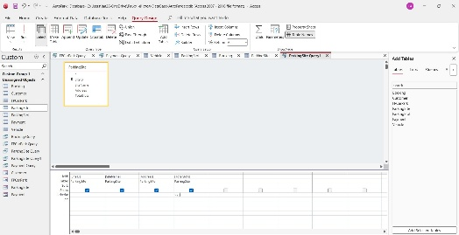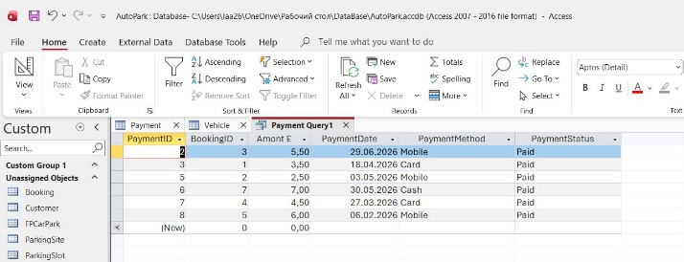
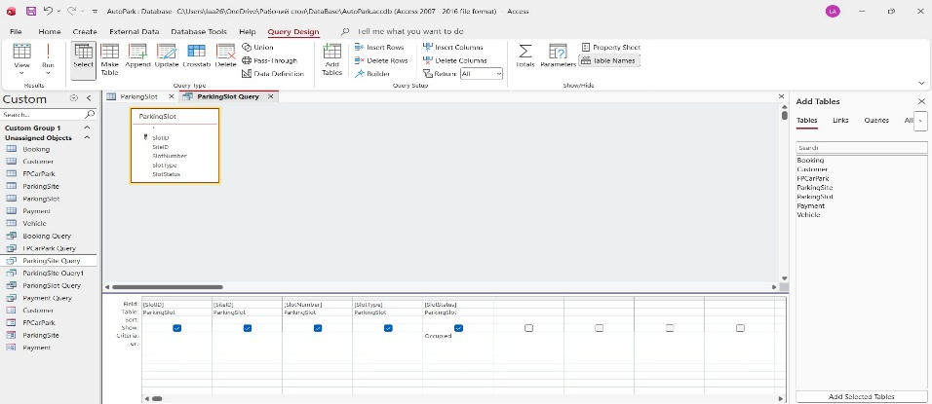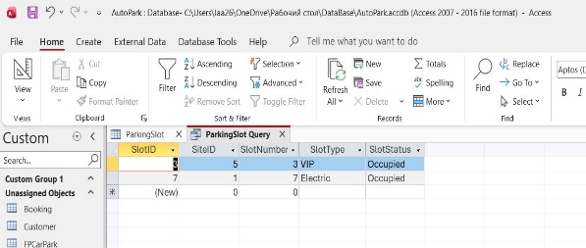
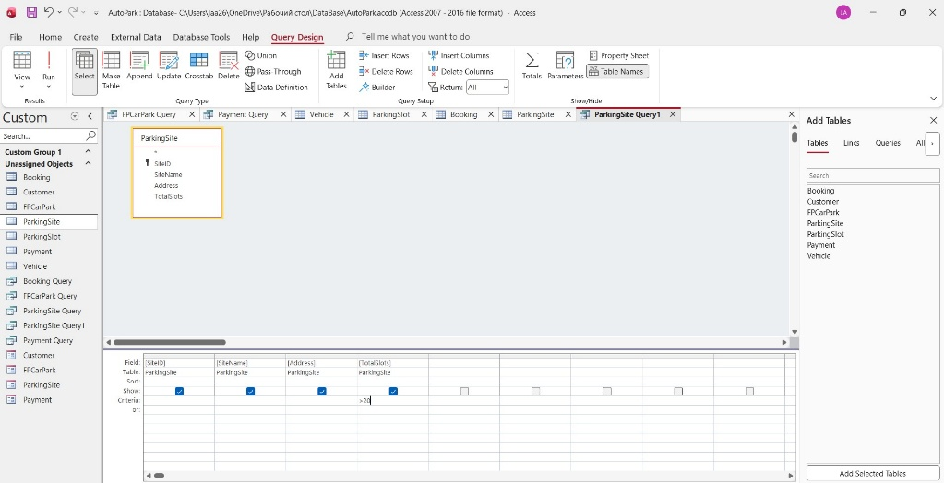

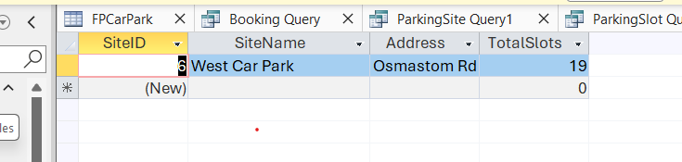

Testing and Validation

Table is a structure in a database that stores data in a rows-and-columns format, similar to a spreadsheet.

Steps about how I created a Table in Microsoft Access:
First, I opened Microsoft Access.
Created a New Blank Database.
Next step to go to the Create tab.
Clicked Table Design.
Entered the field names and chose data types.
Selected the main unique field (for example, SlotID).
Clicked Primary Key to make it unique.
Clicked Save and gave the table a name (for example, ParkingSite).
Switched to Datasheet View to enter records.

Form in Microsoft Access is a tool that helps to create a form step-by-step by allowing to choose the table, fields, layout, and style.

.Steps that I used to create a Form by using Form Wizard:
Opened Microsoft Access and selected the database I wanted to work with.
Clicked the Create tab on the Ribbon.
Selected Form Wizard.
After chose the table or query
In the Tables/Queries list, I selected the table or query I wanted to use.
Chose the fields I wanted to appear on the form.
Used the > button to add selected fields or >> to add all fields.
Selected a form layout.
Entered a form name.
Clicked Finish to create the form
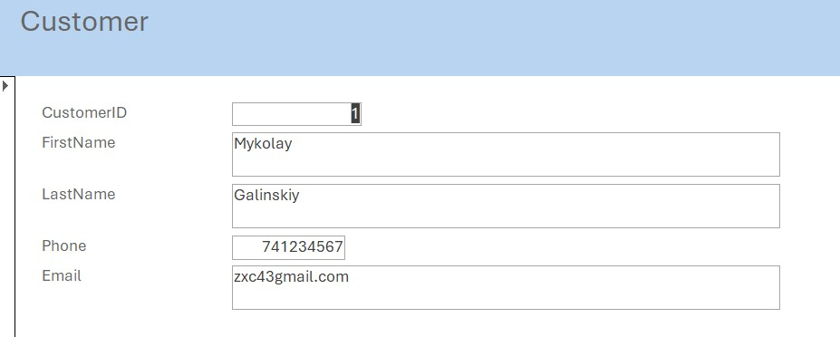
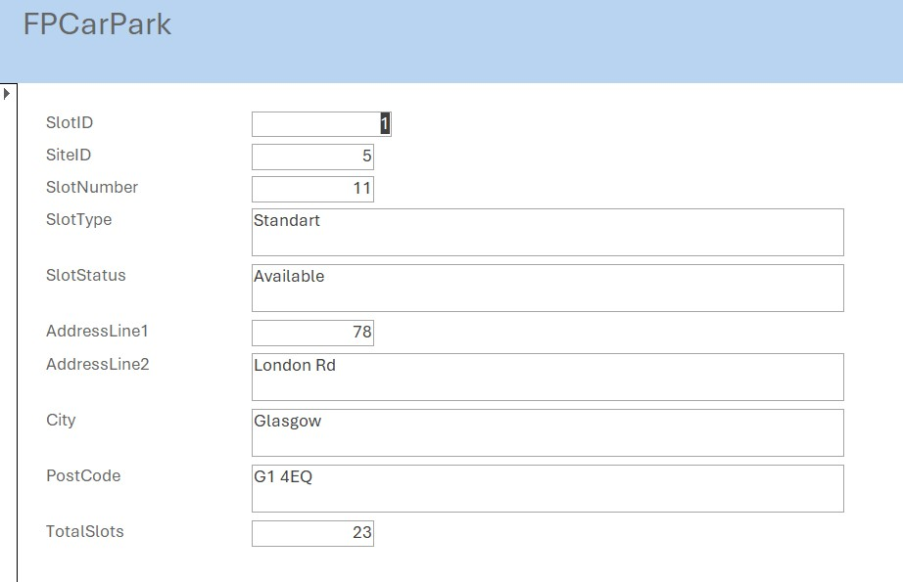

Report is a structured document that presents information stored in a database in a clear, organized, and readable format. Reports are used to summarize, analyze, and present data for decision-making.
Creating Report
Opened the database and selected the table or query.
Next step was to go to Create → Report Wizard.
After selected the fields to include and clicked Next.
After that it was to choose grouping and sorting options.
Selected the layout and entered a report title.
Clicked Finish to create the report.
Saved the report.

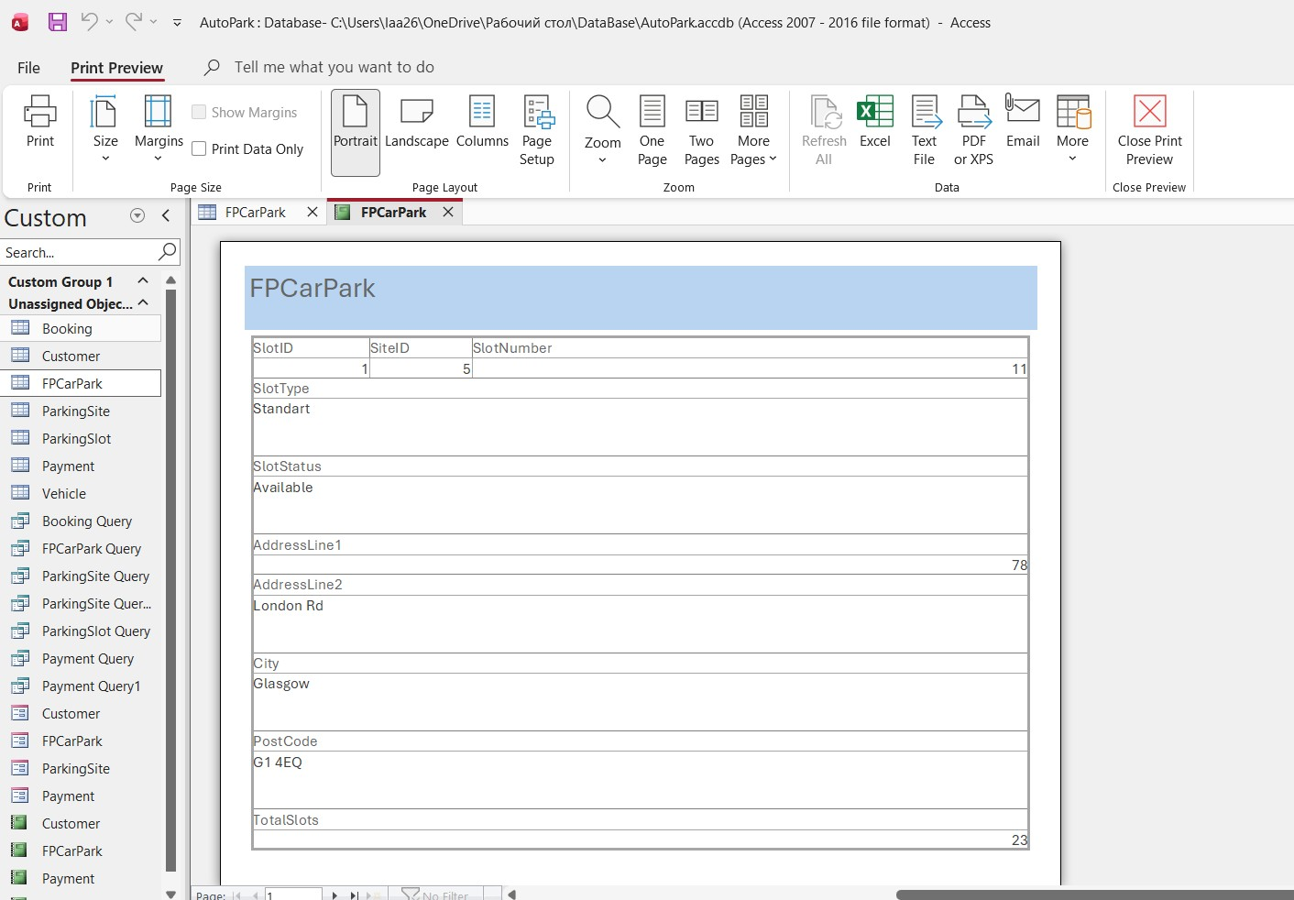
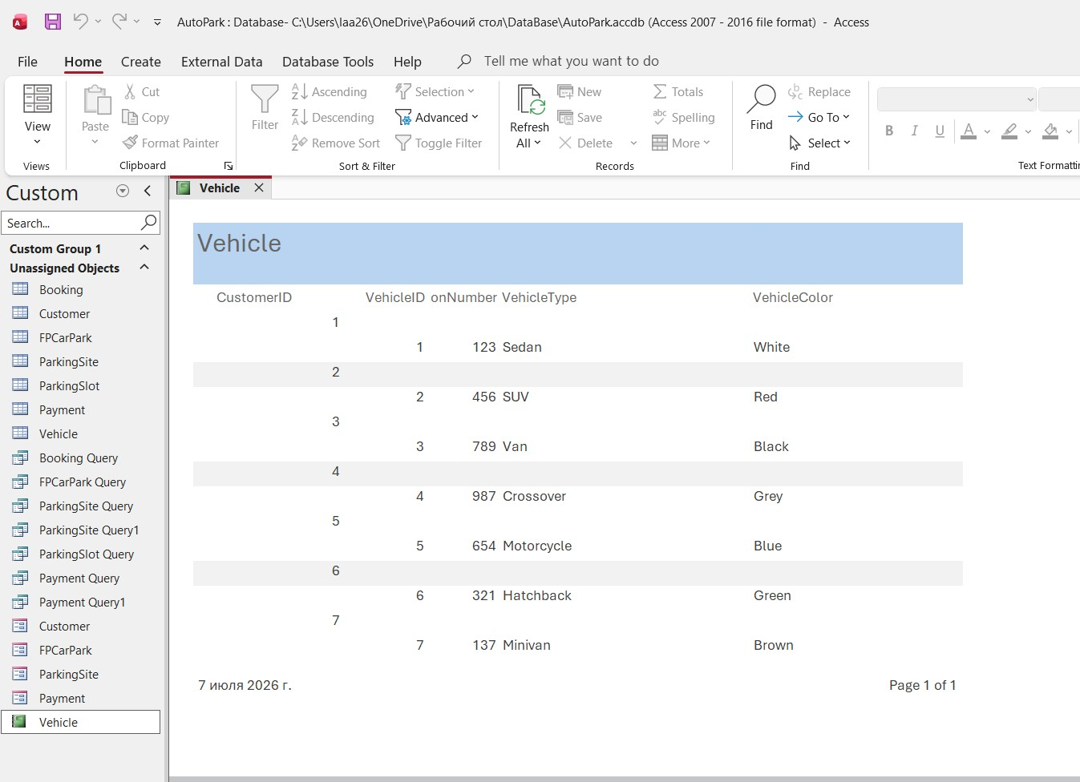

Design Decisions and Future Work
1. Design Decision
The AutoPark Management System database was designed in Microsoft Access to replace the existing manual record-keeping system with a centralized, accurate, and efficient solution. The main objective was to reduce data entry errors, improve parking slot management, and provide management with reliable reports for decision-making.
The database was designed using a relational database model to minimise duplicate data and maintain consistency. Separate tables were created for the main entities.
Each table contains a primary key, while related tables use foreign keys to establish relationships. This ensures that records remain connected and prevents inconsistent or orphaned data.

2. Future Work
Although the current database satisfies the main requirements, several enhancements could be implemented in future versions to improve functionality and scalability.

The AutoPark Management System database provides a structured and reliable solution for managing parking sites, customers, vehicles, bookings, and payments. By replacing manual records with a relational Microsoft Access database, the organisation benefits from improved data accuracy, faster information retrieval, reduced administrative effort, and comprehensive reporting. Future enhancements such as online booking, ANPR integration, cloud deployment, and real-time analytics would further increase the system's efficiency, usability, and scalability.

References:
[1]A. Tezuysal and I. Ahmed, Database design and modeling with postgreSQL and MySQL : build efficient and scalable databases. Packt Publishing, 2024.
[2]T. J. Teorey, Database modeling and design : logical design, 5th ed. Amsterdam ; Morgan Kaufmann Publishers, 2011
[3]S. Roman, Access database design and programming, 3rd ed. Beijing ; O’Reilly, 2002.
[4]I. Baumeister, Access für Einsteiger - Neuauflage für die Versionen 2024, 2021 & Microsoft 365. Bildner Verlag, 2022.
[5]J. L. Harrington, Relational database design and implementation : clearly explained, 3rd ed. Amsterdam ; Morgan Kaufmann/Elsevier, 2009.
[6]T. M. Connolly and C. E. Begg, Database Systems : a practical approach to design, implementation, and management, Sixth, Global edition. Boston: Pearson, 2015.

