DS 1 My Digital Life

Screenshot/Photo 1

This is a photo of my WhatsApp chats with family and friends. I send messages, post pictures and connect with each other in the app on a daily basis.

Screenshot/Photo 2

[This screenshot shows the YouTube app with recommended videos. I watch educational videos, tutorials and entertainment videos on it.

Screenshot/Photo 3

This screenshot shows the Microsoft Teams app. I use this to join class, take tuition and communicate with my mentors.

Screenshot/Photo 4

This screenshot shows one of my playlists on Spotify. I use the app to listen to music, podcasts, and study playlists while working.

Screenshot/Photo 5
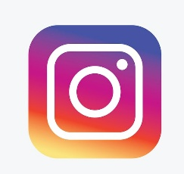
This is a screenshot of my Instagram home feed. It is an application with which I follow creators, topics and friends of interest.

Screenshot/Photo 6

Google Maps with directions to a destination. I use it to locate places, learn about traffic and to route.

My Short Reflection
I am familiar with digital tools in my communication, learning, and daily tasks. The most common apps I use are WhatsApp, Spotify and YouTube, as well as Google Maps, Instagram and MS Teams. I am confident using technology to look up information and complete tasks. I would like to enhance my ability to create presentations and to arrange digital files. Online security and safety, and securing personal information, can be a concern for me at times. This module will help me to become more educated on digital safety and the use of technology effectively. Digital skills are important for me because they can assist me with studying, communication and further opportunities.

Submission Checklist
Before you submit, please check:
​​​ ☒ I added 4–6 screenshots
☒ I wrote short sentences for each screenshot
☒ I wrote my short reflection
☒ My work is my own
☒ My file opens correctly
​​☒ My file opens correctly

