Share your files with ONE drive
One drive is a useful source to share your documents safely online.
- Start by opening a file using browser
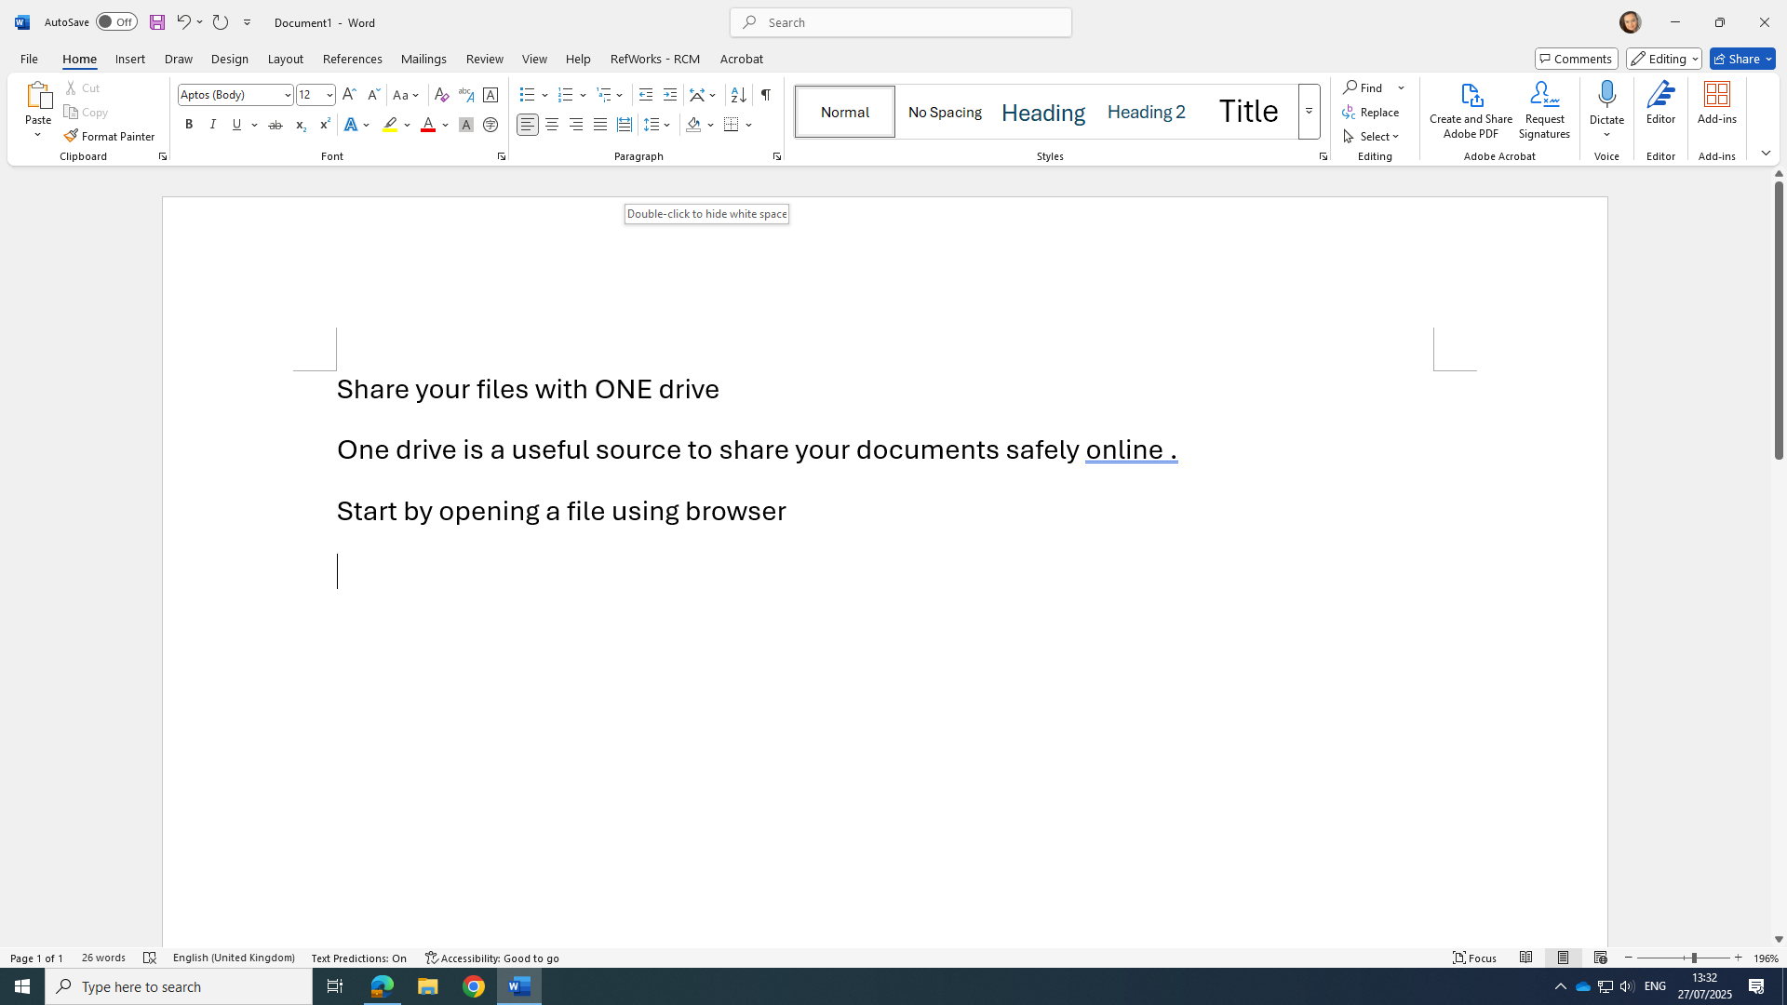
- To share the file, you can simply add the name or email address and share it with anyone you like

